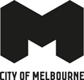

Test Sites 2026
Program outline and application guidelines
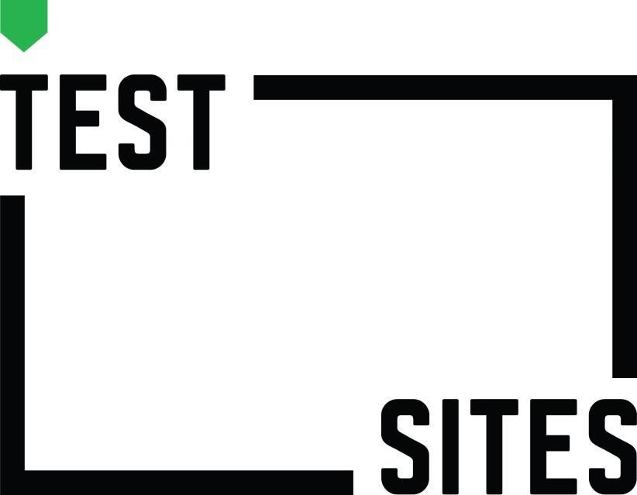
Contents
About Test Sites 4
Program outline 4
Test Sites 2026 Program schedule 5
Stage 1 – Applications 5
Stage 2 – Agreement and funding 5
Stage 3 – Project development 5
Stage 4 – Workshop 3 Presentation 5
Stage 5 – Project acquittal 5
Key dates 6
Who can apply? 6
How do I apply? 6
Interpreter and translation services 6
Accessibility for applicants with disability 6
Technical assistance 7
What kinds of public art project ideas are suitable? 7
Activities not funded 7
Assessment process 7
Selection criteria 8
Sustainable practice 8
Terms and conditions 8
Street art 8
Controversial content 8
Funds management 9
Program dates 9
Insurance 9
Tax advice 9
References 9

About Test Sites
As one of Australia’s cultural capitals, the City of Melbourne has a distinct and unique role to play in commissioning public art that underpins our vision to be a bold, inspirational and sustainable city.
The City of Melbourne’s public art program interprets Melbourne’s unique historical, cultural, social and ecological environments. Through extraordinary public artworks, we reveal our city’s spirit, culture and liveability.
Since 2015, City of Melbourne’s Test Sites program has provided opportunities for around 100 artists to explore and experiment with temporary creative ideas in the public realm. Various iterations of the program have provided project funding, practical advice, professional development, mentor support and workshops for those new to exploring the public realm and spatial practice.
Test Sites 2026 intends to:
- support up to five Victorian artists to develop and test a bold new temporary public art project within the City of Melbourne municipal boundary.
- increase Victorian artists’ capability and confidence to work in the public realm through creative and professional development, support and mentoring.
- engage with the public by offering new experiences, unexpected encounters and challenging perceptions.
- engage with the city, its peoples and sites as a place for creative expression.
- foster new peer relationships.
Test Sites is not designed to support the production and delivery of a resolved or previously presented public art project.
Test Sites 2026 will be produced and delivered by the City of Melbourne’s Creative Urban Places team.

Program outline
- Successful applicants can apply for funding of between $10,000 and $20,000 towards costs associated with the development, production and delivery of testing their project idea and participating in the program.
- During 2026, successful artists will participate in a series of workshops with creative industry experts and join monthly peer group discussions. Artists are expected to engage in individual creative development outside of these meetings (hours at their own discretion) to explore and interrogate their project idea.
- Artists will test their project idea in the public realm between late January and March 2027.
- City of Melbourne’s Creative Urban Places staff will provide supportive mentorships throughout the program.
- Artists will prepare content to profile the work-in-development for inclusion on the City of Melbourne website and/or social media channels.

Test Sites 2026 Program schedule

Stage 1 – Applications
- Complete an application in Smarty Grants.
- You’ll need to outline your idea, provide a budget estimate and other related details.
- Applications will be assessed by a selection panel within two weeks of the closing date.
- Shortlisted artists may be asked to attend an interview.
- Successful and unsuccessful artists will be notified within one week of the assessment period.

Stage 2 – Agreement and funding
- Successful artists will need to sign an agreement.
- Project funding will be paid in three instalments as follows:
  - 40% at planning & development stage (on signing contract)
  - 40% at construction stage once budget is finalised and agreed with City of Melbourne
  - 20% retainer paid after the acquittal report is submitted.

Stage 3 – Project development
Participants will be expected to:
- attend three in-person full day workshops on Saturday 2 May 2026, Saturday 9 May 2026 and Saturday 27 March 2027.
- attend monthly peer group discussions led by City of Melbourne’s Creative Urban Places staff.
- develop a project plan and final budget.
- conduct a project test within the City of Melbourne municipal boundary1 before 31 March 2027.

Stage 4 – Workshop 3 Presentation
At the end of the program participants will:
- present their project to the peer group and members of the City of Melbourne’s Creative Urban Places team.

Stage 5 – Project acquittal
An acquittal report will need to be submitted at the completion of the program for the 20% retainer to be paid.

Key dates
Expressions of Interest open | Tuesday 24 February 2026
Livestreamed information session at 6.30pm AEST | Wednesday 4 March 2026
Applications close at 5pm AEST | Monday 23 March 2026
Successful artists notified | Week of Monday 6 April 2026
Workshop 1 | Saturday 2 May 2026
Workshop 2 | Saturday 9 May 2026
Testing period | By end of March 2027
Workshop 3 – Presentations | Saturday 27 March 2027
Acquittals due | Monday 19 April 2027

Who can apply?
- Artists who are based in Victoria.
- Applications are open to artists working across a diverse range of artforms including but not limited to visual art, photography, film, sound, sculpture, socially engaged practice, performance, installation, collaborative and interactive work, and other hybrid forms or emerging practices.
- The program also supports artists with a studio-based practice who wish to experiment in the public realm.

How do I apply?
- Review these guidelines carefully.
- Preview the application form on Smartygrants
- Contact us with any queries via publicart@melbourne.vic.gov.au.
- Submit your online application via SmartyGrants by the closing date – late applications won’t be accepted.

Interpreter and translation services
Our multilingual information telephone service provides access to translators3 and information in different languages.

Accessibility for applicants with disability
Applicants with disability are encouraged to contact staff to discuss any specific needs or additional support required to apply.

If you are deaf, hearing-impaired or speech- impaired contact us via the National Relay Service on 133 677 (ask for 03 9658 9658).

Technical assistance
Refer to the Help Guide for SmartyGrants technical assistance. The SmartyGrants support desk is open 9am–5pm Monday to Friday on 03 9320 6888 or by email service@smartygrants.com.au.

What kinds of public art project ideas are suitable?
- Ideas that take place in public space within the City of Melbourne municipal boundary1.
- Ideas that involve testing a defined aspect or clear question relating to the project.
- Ideas that are experimental and site responsive.
- Ideas with a strong research methodology that interrogates concepts of public space.
- Ideas that include a clear strategy for communicating the project.
- Ideas presented in a diverse range of art forms are strongly encouraged.

Activities not funded
The following activities will not be funded:
- The presentation of a fully developed project.
- Projects that have been fully realised or previously presented in the public realm.
- Projects that are in pre-production for public presentation.
- Travel and accommodation.
- Ideas that are part of an accredited course of study.
- Activities that take place outside of the City of Melbourne municipal boundary1.
- Applications made by political organisations.
- Activities, projects, programs and events on behalf of a political organisation.
- Proposals from City of Melbourne employees.
- Capital works, facility maintenance and improvements.
- Course fees.
- Parking or other infringement fines.
- Street art or murals projects.
- Illegal graffiti.
- Projects funded through other City of Melbourne programs or grants.

Assessment process
- Applications are assessed by a selection panel made up of industry peers and City of Melbourne’s Creative Urban Places staff.
- Unsuccessful applicants are eligible to re-apply in future rounds.
- Applications are kept confidential, and the contents will not be disclosed to any person outside the application and assessment process.
- The City of Melbourne does not seek to correct errors in applications or supporting material. Applications are assessed as they have been submitted.
- The City of Melbourne reserves the right to request further information in considering any application, as well as the right to reject any application that is ineligible or does not meet the assessment criteria.
- All applicants will be notified of the result of their application via email.

Selection criteria
Applications will be assessed and selected based on the following criteria:
- Ideas that are bold, compelling and clearly articulated.
- Ideas that aim to activate the city in interesting and engaging ways.
- Ideas that are site specific and consider and relate to the proposed site.

Sustainable practice
Applicants are encouraged to ensure materials are sustainable wherever possible, consider lighting and energy use and encourage collaborators to use public and people-powered transport.

Terms and conditions
- Program participants will need to commit to three in person workshops held on Saturday 2 May 2026, Saturday 9 May 2026 and Saturday 27 March 2027, monthly peer group discussions and creative development hours outside of this (at your own discretion).
- Test Sites must not form part of any assessment for an accredited course of study.
- Applications must be submitted online by the published closing date and time. Late submissions won’t be accepted.
- Applications must be for research and development of an idea and not for the presentation of a project or an artwork already intended for public presentation, for example: pre-production support for a festival.
- A maximum of one application per artist or artist group can be submitted.
- Applicants must have acquitted previous grants and have no outstanding debts to the City of Melbourne.

Street art
Street art, including stencils, paste-ups and murals, are not supported by the Test Sites program, although ideas that open a dialogue with existing street art are encouraged. Artists working in this field can plan and produce projects independently with the permission of building owners. Further information about the City of Melbourne’s approach to street art can be found in our Graffiti Management Policy.

Controversial content
Artworks in the public realm must take into consideration the experience of a wide range of people who may encounter the work without warning. While patrons may choose to view explicit or controversial art works in theatres, galleries and other indoor spaces, artists must be sensitive to the experience of people who encounter the work unexpectedly in the public realm.

In deciding if work is appropriate for public space, the City of Melbourne will make a decision about the suitability of each work for the public realm using Australia’s Advertising Standards Code 12 as a guide. The standards state, ‘communications must not portray images or events in a way that is unduly frightening or distressing to children…and must not demean any person or group on the basis of ethnicity, nationality, race, gender, age, sexual preference, religion or mental or physical disability’.
Applicants must discuss any idea containing potentially controversial content with the organisation.

Funds management
The financial support component of Test Sites will be managed by Auspicious Arts. Successful applicants will enter into an agreement with Auspicious Arts, on behalf of City of Melbourne, who will provide further information about the management of funds.

Program dates
The City of Melbourne reserves the right to change the dates and deadlines for any component of Test Sites, including application deadlines and the frequency of application rounds. We also reserve the right to invite artists to participate in Test Sites or other programs.

Insurance
Test Sites projects will be covered under Auspicious Arts Public Liability Insurance. Auspicious Arts hold public liability cover to the value of $20 million. Further information about insurances will be provided to successful applicants.

Tax advice
The Australian Taxation Office may consider payments received through Test Sites as taxable income. The tax office can help with information on tax, including GST. Call 13 28 66 or visit Australian Taxation Office.

References
Public Art Melbourne

Public Art Framework 2021 - 2031

Graffiti Management Policy 5

https://www.melbourne.vic.gov.au/city-maps
https:/melbourne.smartygrants.com.au/TestSites2026
https://melbourne.smartygrants.com.au/TestSites26
https://applicanthelp.smartygrants.com.au/help-guide-for-applicants/
https://www.melbourne.vic.gov.au/residents/home-neighbourhood/graffiti/pages/graffiti-management-policy.aspx
https://www.ato.gov.au/
https://www.melbourne.vic.gov.au/public-art
https://www.melbourne.vic.gov.au/arts-and-culture/strategies-support/Pages/public-art-framework.aspx

