APPLICATION FOR
CAT AND DOG REGISTRATION
11 APRIL TO 10 APRIL ANNUALLY
HOW TO COMPLETE THIS FORM - We encourage all pet owners to register their pet online by visiting www.melbourne.vic.gov.au/pets

1. Fill out all fields using BLOCK LETTERS.
2. Submit the completed form and documents by email, mail or in person.
The City of Melbourne aims to process all applications within 10 working days.
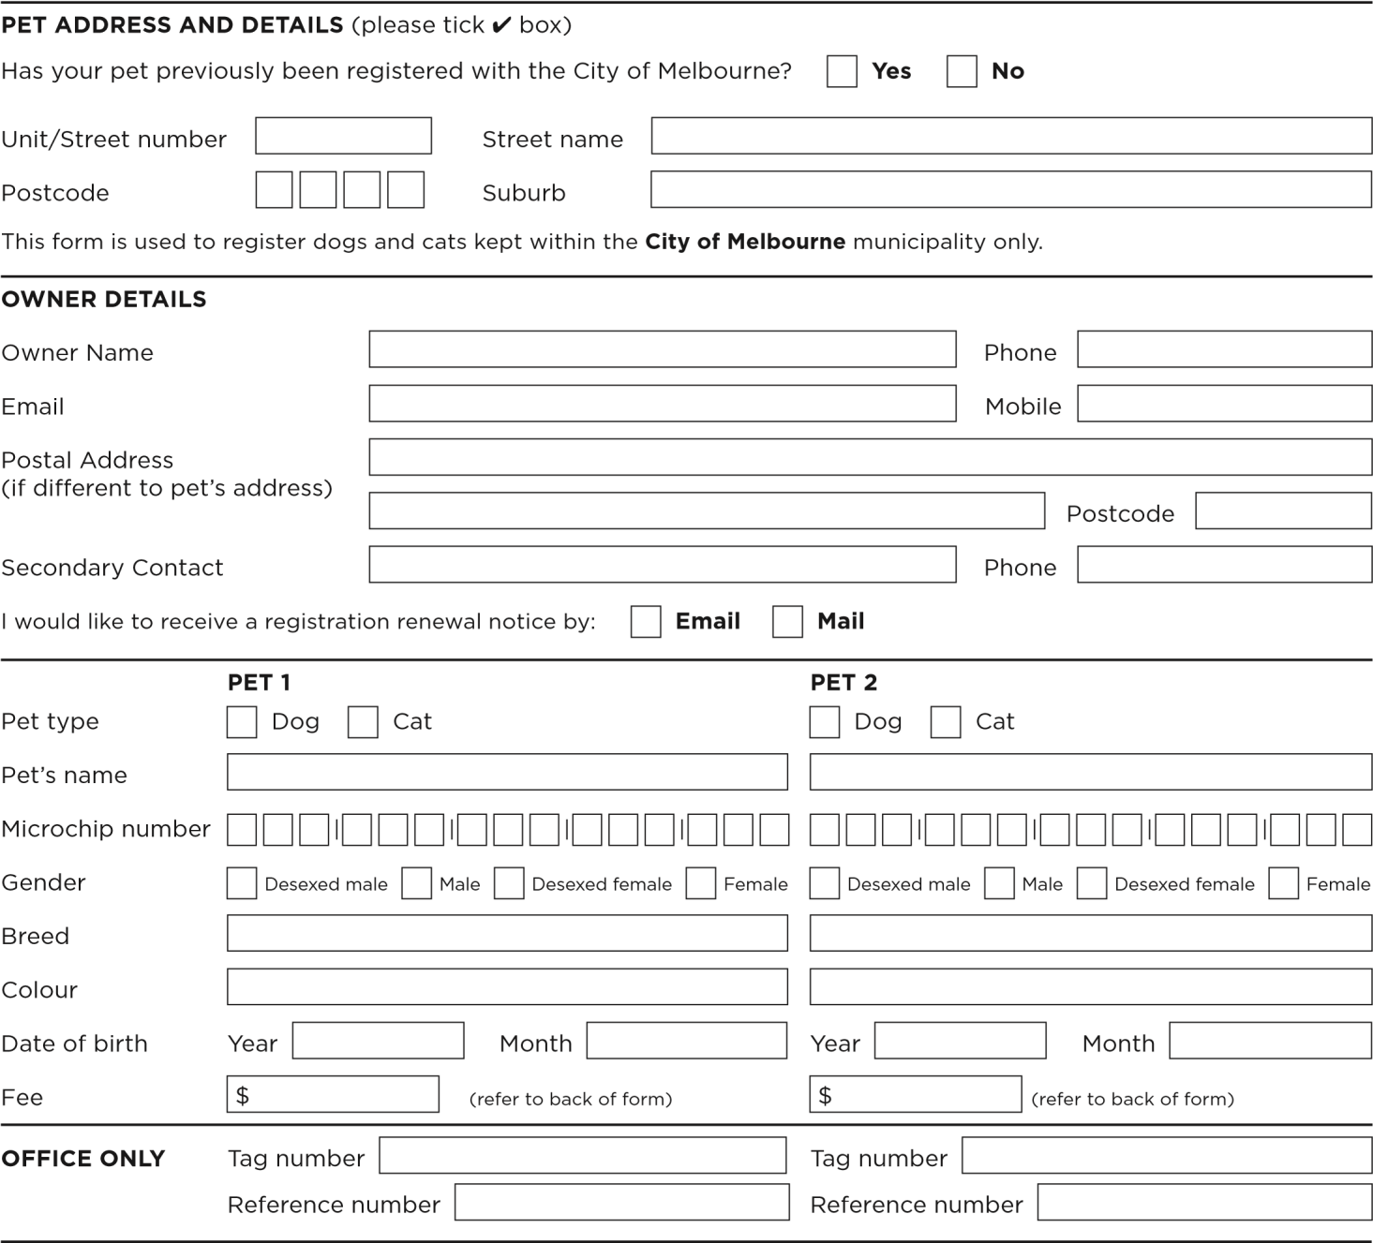
Please note: the application will not be processed unless all details are completed The City of Melbourne aims to process all applications within 10 working days. The City of Melbourne is committed to protecting your privacy. The personal information you provide on this application is being collected by the City of Melbourne for the primary purpose of assessing your eligibility for the selected permit. We may also need to contact you from time to time for directly related purposes. Your personal information will not be disclosed to any external party without your consent, unless required or authorised by law. Failure to provide the information requested, means your permit application cannot be processed. If you wish to gain access to or alter any personal information you have supplied to the City of Melbourne whilst completing this application, please contact us on +61 3 9658 9658. Access our privacy statement at www.melbourne.vic.gov.au

DECLARATION – this section must be completed by all applicants
I declare that the information I have provided is true and correct. I agree that all applications are non-refundable. I declare that my dog is not a restricted breed or declared a dangerous or menacing dog (refer to www.melbourne.vic.gov.au/pets for more information).

METHOD OF PAYMENT
ONLINE | IN PERSON
melbourne.vic.gov.au/pets | Bring completed from and accepted payment method to  Melbourne Town Hall  120 Swanston Street, Melbourne VIC 3000  Business hours, Monday to Friday (Public Holidays excluded)
* EMAIL | + MAIL
We no longer allow completed forms with payment details to be sent via email. | Attach cheque made payable to ‘City of Melbourne’ and mail it to GPO Box 1603 Melbourne 3001

FEES
City of Melbourne committed to providing free pet registration for cats and dogs during the 2026-27 registration period.
All cats in the City of Melbourne must be desexed unless a relevant exemption under section 10B of the Domestic Animals Act 1994 applies. Proof of desexing must be provided when applying to register.
DOGS |  | ANNUAL FEE | CONCESSION FEE | DESCRIPTION
Reduced |  | $0.00 | $0.00 | Any one or combination of the following:  - desexed  - over ten years old  - used for breeding by proprietor of Domestic Animal Business  - registered with applicable organisation  - undertaken obedience training which complies with the regulations  - kept for working stock.  Proof must be provided for all criteria.
Full |  | $0.00 | $0.00 | Dog with none of the above
Other |  | $0.00 | N/A | Restricted breed dog; declared dangerous dog; menacing dog. No concession applies.
Exempt |  | N/A | N/A | Guide dogs used by visually impaired or owned by an approved organisation which trains guide dogs; State or Commonwealth Government dogs.  Proof must be provided.
CATS |  | ANNUAL FEE | CONCESSION FEE | DESCRIPTION
Reduced |  | $0.00 | $0.00 | Any one or combination of the following:  - desexed  - a kitten that is too young to be desexed, but is booked in for desexing when of suitable age  - Is over 10 years old and you have evidence from your vet stating there is a valid medical reason your cat cannot be desexed  - used for breeding by proprietor of Domestic Animal Business  - cat owner is a member of an applicable organisation Proof must be provided for all criteria.
Full fee |  | $0.00 | $0.00 | Cats under 10 years old with evidence from a vet stating there is a valid medical reason the cat cannot be desexed.  Proof must be provided.
 | A reduced registration rate of $8 per dog and cat fostered for the first 12 months the dog or cat is in your care applies. You must be registered with the City of Melbourne as a foster carer to be entitled to this reduced rate. See www.melbourne.vic.gov.au/pets for more information. |  |  |  | Cats and dogs that are currently registered with another municipality within Victoria can be transferred for no fee. Proof must be provided of registration.  If you wish to claim a State Concession (under the meaning of the State Concession Act 2004) see below details.  A State Government levy from the fees collected is used to fund responsible pet ownership programs.

CONCESSION FEES
Reduced fees only apply to the card holders below. Health Care and Concession cards are not accepted.
Pensioner card War widow entitlement TPI entitlement Card no.

Cats and dogs must wear registration tags when outside the owner’s premises. All dogs must be kept on a leash in public places unless in a designated off leash area – for more information visit www.melbourne.vic.gov.au/pets

