CITY OF MELBOURNE
SAFE CITY CAMERAS
PROGRAM

SAFE CITY CAMERAS PROGRAM AUDIT COMMITTEE
REPORT
1 July 2024 – 30 June 2025

CITY OF MELBOURNE
SAFE CITY CAMERAS PROGRAM
AUDIT COMMITTEE

Mr Dean Robertson
Director, City Safety, Security and Amenity
City of Melbourne
PO Box 1603M
MELBOURNE VIC 3000

Dear Mr Robertson

SAFE CITY CAMERAS PROGRAM AUDIT COMMITTEE REPORT

In accordance with the Safe City Cameras Program Audit Committee Terms
of Reference, we submit our Report for the review period 1 July 2024 to
30 June 2025.

Yours sincerely,

Bill Horman AM APM | Margaret Rode | Paul Ryan
Consultant | Governance Professional | Legal Practitioner
Chairman | Member | Member
Appointed Chairman in 2018; (appointed to Committee in 2011). | Appointed to Committee on 18/01/2018. | Appointed to Committee on 21/02/2018.

Signed……………………….. Signed………………………. Signed……..………………

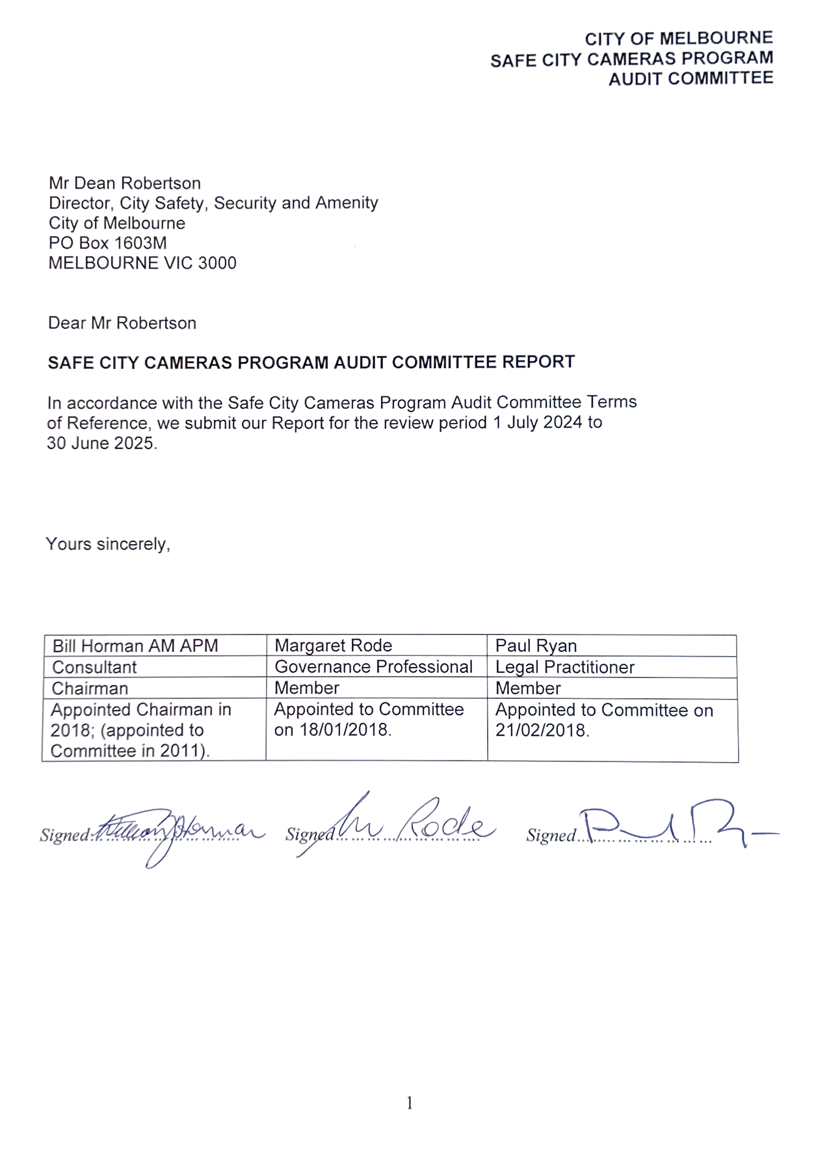

CONTENTS

Introduction 3

- ESTABLISHMENT OF SAFE CITY CAMERAS PROGRAM (SCCP) AUDIT COMMITTEE………………………………………………………………………….…….... 3

- SCCP OPERATIONS DURING FINANCIAL YEAR 2024-2025 ……………………………… 4
Cameras in Operation 4
Mobile Camera Vehicle …………………………………………………………………….. 5
Control Room, Footage & CCTV Product………………………………………………… 6
Product provided to Victoria Police………………………………………..…………..… 6
Dedicated Police Radio Base Station…………………………………………………..... 6
CCTV Product – Dissemination, Tracking and Destruction……………………………... 7
Control Room……………………………………………………………… 7
Security 7
Police Acknowledge Value Partnership with SCCP…………………… 8
CoM’s Response to Public Perception of Community Safety in Melbourne …… 7
MOUs…………………………………………………………………………………………. 8
Public Address Speakers…………………………………………………………………… 8
Control Room contact with Victoria Police Monitoring Assessment Centre 8
Extending Infrastructure and Sharing with Other Parties’ Cameras………………….… 9
City Safety - the Counter-Terrorism Environment and the SCCP………………………. 9
Exercise Safeguard ……………………………………………………………… …… 10
Disparity between Program’s Aims &c Operating Procedures……………………… .. 10
Proposed expansion of the SCCP 10
Complaints………………………………………………………………………………… 10
Freedom of Information………………………………………………………… …… 10
Victorian Auditor-General's Review of CCTV Camera Operations ……………… 11
- SCCP AUDIT COMMITTEE………………………………………………………………….. 11
Independent Role…………………………………………………………………… 11
Membership 2024-2025…………………………………………………………………. . 12
Meetings of SCCP Audit Committee in 2024-2025…………………………………… 12
Support to the SCCP CCTV Audit Committee ……………………………………… …. 12
- SCCP AUDIT COMMITTEE – EXECUTIVE SUMMARY 2024-2025…………… …… . 13
CoM Response to 2024-2025 Review’s Recommendations…………………………… 13
Summary of SCCP activity in 2024-2025…………………………………………… … … 14
Findings 2024-2025………………………………………………………………………… 14
Relationship with Victoria Police………………………………………… ………………… 16
- SCCP AUDIT COMMITTEE RECOMMENDATIONS ……………………..………………. 16
- APPENDICES………………………………………………………………………………….. 17

INTRODUCTION – Change of Reporting Period
Since the inception of the City of Melbourne’s Safe City Camera Program (SCCP),
The independent members of the SCCP CCTV Audit Committee have submitted an Annual Report to the City of Melbourne. The Annual Reports are made available to Council and are ultimately available to the community via the City of Melbourne’s website.

This Report covers the period 1 July 2024 to 30 June 2025

1. ESTABLISHMENT OF THE SAFE CITY CAMERAS PROGRAM & AUDIT COMMITTEE
On 6 December 1995, the City of Melbourne resolved to establish a closed-circuit television system in Melbourne’s Central Business District to be known as the “Safe City Cameras Program” (the Program or SCCP). The City of Melbourne SCCP became operational on 27 February 1997.
From its inception, a SCCP CCTV Audit Committee was established consisting of three independent members (one of whom is appointed as the Chairperson), supported by representatives of Victoria Police and the City of Melbourne.
The inaugural Chairperson was the late Mr Norman Geschke, OBE the then immediate past State Ombudsman. The independent members include a lawyer and a community representative.
The SCCP helps create a safer environment and reduce crime levels by deterring potential offenders, helping in crime detection and providing evidence to assist in investigations and/or in Court proceedings.
The Program’s aims are set out in the Safe City Cameras Program Manual and include:
- aiding in the provision of a safer physical environment in the Melbourne CBD
- assisting police to reduce crime levels by deterring potential offenders
- aiding in early identification of criminal offences
- generally assisting in emergency response.
The operation of the Program is regulated by “Standard Operating Procedures (SOP’s), the “Training Manual” and a Memorandum of Understanding (MOU) with Victoria Police.
The Program Manual incorporates a Code of Practice, Privacy Principles, Product (i.e. copy of CCTV footage) tracking and release provisions and general management processes, including destruction of footage.
The Program uses closed circuit cameras (CCTV) positioned throughout the Melbourne Central Business District (CBD) and Lygon Street, Carlton, monitored 24/7 by Safe City Camera Operators.
The Program is one aspect of the City of Melbourne’s strategy for a safer city. Other aspects include:
- Taxi Ranks monitored by the camera network. Safe City Taxi Rank Program no longer exists
- Supporting the Melbourne Liquor Licensees Accord with Melbourne liquor licensees and coordinating meetings of the Melbourne Liquor Forum
- Victoria Police and City of Melbourne lighting audits
- Promotion of visible police presence throughout the CBD
- Improved transport at night to and from the CBD
- Prohibition of consumption of alcohol in CBD public places
- Education, information and awareness campaigns
- Liaison with various Resident Associations in the municipality
- Local Safety Committee meetings - Neighbourhood Policing (Melbourne East and Melbourne West)
- Southbank Safety and Security Committee
- Assisting Building Emergencies as part of Council’s municipal building surveyor functions
- Assisting emergency services and statutory agencies during emergency incidents as part of follow-up or live investigations; and
- Regular Emergency Management Exercises developed and coordinated by the City of Melbourne with involvement of representatives of relevant agencies.
- Monitoring crowd crush safety flow during Melbourne Premier Events like New Years Eve

2. SCCP OPERATIONS DURING 2025 AUDIT PERIOD

Cameras in Operation
There was an increased number of cameras to 327 at end of 2024-2025 Financial Year comprising:
- 118 Pan Tilt Zoom Cameras
- 182 Fixed Cameras
- 08 Taxi Rank and Help Point Cameras
- 01 Safe City CCTV Mobile Vehicle
- 18 private cameras (eg Salvation Army and Hosier Lane)
Requests for information regarding the Safe City Cameras’ statistics of incidents may be directed to the Melbourne City Council.
The City of Melbourne’s SCCP website provides a map of locations of the SCCP cameras (it should be understood that the location of cameras is subject to ongoing review and change).

Mobile Camera Vehicle
The Melbourne Safe City Cameras Program has, in addition to fixed cameras, a Mobile Camera Vehicle, introduced in 2009. Since 2022 footage from cameras in the Mobile Camera Vehicle – can be directly fed to the SCCP Control Room. The mobile cameras operate on Thursday, Friday and Saturday nights.

Control Room, Footage & CCTV Product
All fixed cameras feed footage, in real time, to screens located in the SCCP Control Room. Footage is recorded on the Video Management System (“VMS”). VMS screens are monitored 24 hours per day/seven days a week by trained Control Room Operators.
Control Room Operators may transfer incoming footage, in real time to dedicated monitors and control cameras to ensure detailed recording of any event. Control Room Operators notify police by use of a police radio of incidents that they see unfolding and feed footage in real-time to Police Operation Centres.
When major events occur in Melbourne with the State Police Operations Centre (SPOC) in operation, the Victoria Police can select what cameras they want to view - but the Safe City Operators retain actual control of the cameras.
Control Room Operators make electronic or hand-written notes/“running sheets” which are used for inputting the Incident Report in the Incident Management System. Such documents aid subsequent interrogation of the Incident Management System in relation to specific events and retrieval of relevant product (i.e. footage provided to police or others).
Footage in relation to an event is retained on the Council’s server for a minimum of 28 days (the “Holding Period”) after the event. In the absence of a request from Victoria Police or other relevant agencies or individuals, it is then recorded over. Should the Council receive a request for product from a relevant agency or individual within the Holding Period, two copies of the requested footage are made. One copy is provided to the requesting party and the other copy retained by Council for a minimum of two years, after which it is destroyed unless further retained on request e.g. the matter could be relevant to a Coronial Inquest or court proceedings.
Product provided to Victoria Police
In 2016, Victoria Police and CoM agreed that police to whom product was provided would be responsible for its safe storage and ultimate destruction when the product was no longer required by them.
Subsequently a copy of the Victoria Police instructions and procedures was provided to the Audit Committee and the SCCP Program Manual amended to incorporate the agreement.
During the 2024-2025 financial year review period, no misuse or problem associated with product provided to Victoria Police was reported.
The Audit Committee noted that crime statistics are maintained by police, but currently there is no process to match police data with CoM data to show how much footage released to police results in action.
The independent members of the Audit Committee suggest such information could support future funding requests to relevant State Government/stakeholders and recommends this be considered.
Dedicated Police Radio Base Station
The operational benefits for the Safe City Cameras Program in having a dedicated Victoria Police radio base station is evidenced by the increasing number of incidents the Control Room is alerted to via the Victoria Police radio network.

CCTV Product - Dissemination Tracking and Destruction
Product continues to be made available only to those authorised under relevant provisions of the Program Manual and release of product occurs only upon acceptance by applicants of necessary confidentiality, tracking, storage and destruction obligations.

Control Room

Security
Access to the Control Room is strictly limited and controlled in accordance with provisions of the Safe City Camera Program Manual.
During the reporting period the independent members of the Audit Committee visited the control room, examined a representative sample of the Visitor Log-book, received prompt answers to their questions and were satisfied policy and protocols are being followed.
In view of its importance, this Report recommends City of Melbourne continues to provide updates and reassurance to the Audit Committee regarding security and business continuity.

Police Acknowledge Valued Partnership with Safe City Camera Program
The SCCP Control Room staff are in direct radio contact with Victoria Police. SCCP Mobile Camera Vehicle staff are in direct contact with Control Room staff. The Audit Committee’s Reports consistently note there is a very close working relationship between the Control Room Operators and Victoria Police. There is also a close working relationship between Victoria Police and the City of Melbourne management generally in regard to planning and operational matters, particularly relating to safety, security and counter-terrorism strategies and management of emergency responses.
During the reporting period police representatives on the Audit Committee regularly confirmed their appreciation and gave instances of the invaluable assistance the cameras and skilled operators provide. Examples include tracking vehicles entering the CBD where the Police Air Wing cannot, break-ins, armed youths entering and exiting the CBD, graffiti offenders.
On 10 August 2024 the Herald Sun published a piece giving the public an idea of how CoM’s Safe City Cameras and police work together in managing crime and helping keep people and businesses safer. See Appendix B
In 2022 the Audit Committee was particularly pleased to record the exceptional honour and recognition given by the then Victorian Chief Commissioner of Police Shane Patton APM to Mr Craig Buckingham, Security Manager, Security Services, and the Control Room Operators formally acknowledging the value of their work.
The inaugural award of the Victorian Police Company/Business Commendation to the City of Melbourne Safe City Cameras Program was presented in person by Chief Commissioner Patton, in the presence of the then Lord Mayor Sally Capp, police representatives, City of Melbourne management, a number of SCCP Operators and members of the Audit Committee (both past and present members) on 27 October 2022 in the Melbourne Town Hall Commons area.
The citation reads:
“In recognition of the exemplary working partnership with Victoria Police
to improve community safety in Melbourne”.
CoM’s Response to Public Perception of Community Safety in Melbourne
Lord Mayor Nicholas Reece was elected in November 2024. He campaigned strongly on improving Melbourne’s safety and liveability and promised to increase the number of CCTV cameras. See Appendix C Sun Herald article “On Edge in City of Fear” published 22 February 2025.
During the reporting period the Audit Committee noted
- a comprehensive budget presentation for the coming four years including costs to provide additional cameras, the necessary system upgrade and the potential use of AI. The independent members of the Audit Committee encourage and support CoM’s efforts to involve the Victorian Departments of Justice and Transport, utility providers for infrastructure eg poles, businesses and privately owned CCTV in maximizing the cost effectiveness and interoperability required to meet the needs of the future
- a comprehensive presentation on the CoM’s longitudinal Social Indicators Survey which included 2024 data showing not only drops in perceptions of safety both day and night, but also in food security
- the CoM initiative in conjunction with Unison and Co-health to address homelessness in the CBD. Make Room is a boarding house model providing secure supported housing for those experiencing homelessness until they can access long term secure housing
- a joint CoM and Vic Pol initiative Operation Brightside to address begging
- the CoM’s pilot program to employ security guards to accompany Local Laws Officers which began in March 2025 and was extended to July 2025. The Audit Committee awaits with interest the outcome of the program.
MOUs
Current in 2025 were City of Melbourne Memorandum of Understanding (MOU) with Victoria Police and Emergency Management Victoria.

Public Address Speakers for Emergency Situations
A Memorandum of Understanding between Victoria Police and Emergency Management Victoria (EMV) was signed in 2017 utilizing the SCCP hardware with public address speakers fitted onto cameras at CBD locations to be used in emergency situations.
The speakers can be used to provide an audible warning sound and a message from Victoria Police to the public in an emergency situation. The speakers were not required to be used during July 2024-June 2025 other than for regular testing purposes.

Control Room Contact with Victoria Police Monitoring Assessment Centre
Since December 2016, the Victoria Police Monitoring Assessment Centre (MAC) has been able to select live-feeds from CCTV cameras in the CBD.
In view of the importance of the role of the Victoria Police MAC, its relationship with the SCCP and the live-use of SCCP footage, the Audit Committee maintains its interest in being kept informed as to any relevant impacts on the arrangements.
The Chairman and Audit Committee members visited the Victoria Police Monitoring Assessment Centre in 2018, 2019 and in 2023 and were provided with a detailed overview of its operations, access and use of the live SCCP camera coverage.
In 2022 City of Melbourne procured an extra five years’ Agreement for the use of optic-fibre cable from a telecommunications company from 2023 to 2028. This fibre is used to connect thirty-nine different points in the field of coverage back to the Safe City Control Room, and one of those links is the main link into City West Police Station.
Extending Infrastructure and Sharing with Other Parties’ Cameras
In 2023 agreement was reached between City of Melbourne and the Victorian Department of Justice for provision of additional SCCP cameras north along Lygon Street into Carlton and Argyle Square. This initiative was strongly supported by businesses and residents of Carlton and supported by the SCCP CCTV Audit Committee. The cameras became operational in the first half of 2024, including the first solar powered cameras. Appendix D is a press cutting from the Herald Sun dated 6 April 2025 indicating the benefits.
City Safety, Counter-Terrorism, Major Emergencies and the SCCP
Major incidents in past years involving vehicles posing a threat to the lives and safety of CBD users, demonstrated the importance of the SCCP in prevention, deterrence, critical incident response and providing footage to form part of the police investigation as well as evidence when matters are before the Coroner or criminal prosecutions proceed to Court from any acts of terrorism, crimes or serious incidents.
Police representatives have commented very favourably on the improved speed of communication and supply of footage following the introduction of “Evidence.Com” software and online procedures.
Exercise Safeguard
A multi-agency Emergency Management Exercise – Exercise Safeguard – was organized and coordinated by the City of Melbourne on 23 May 2025. This simulated emergency provided representatives from multiple relevant agencies the opportunity to demonstrate their knowledge, skill and experience while identifying areas for improvement. Two independent members of the Audit Committee attended as observers and were impressed with the standard of the exercise and the valuable benefits of such exercises.
The exercise highlighted the crucial role played by City of Melbourne’s Safe City Cameras Program in assisting police. The Audit Committee Chair subsequently sent messages of congratulations to participating police officers who ably demonstrated throughout the exercise their high level of mastery of police protocols and procedures and their ability to lead and make appropriate decisions in the face of uncertain and rapidly evolving danger. Coincidentally, an almost identical incident occurred in a major Melbourne shopping centre the following week.
Disparity between Program’s Aims & Operating Procedures
At the Audit Committee Chair’s request meeting agendas include reports by City of Melbourne management of any complaints, freedom of information requests or disparities between the Program’s Aims and Operating Procedures, etc. During the reporting period the independent members of the Audit Committee received assurances by management that there were none.
In the 2022 Audit Report, the independent members requested the opportunity to review, with the City of Melbourne, the SCCP manuals and procedures to ensure they reflect important changes and are up to date. In April 2024 the independent members were given, and took, the opportunity to provide input and await the final review by a consultant. It was appreciated that the Chair was provided with the opportunity to meet with the consultant.
Proposed Expansion of the SCCP
Subsequently the independent chair of the Audit Committee was given an opportunity see the consultant’s report and to make both a written submission and to speak at the 6 May 2025 Future of Melbourne Committee meeting where proposals to widen the scope of the Safe City Cameras Program (in support of Local Laws and procedures) were tentatively approved.
The independent members look forward to receiving the Council’s decisions in due course with respect to any updated policies and procedures as once approved by Council, the Audit Committee will address isuues relevant to its role with regards to the Policy Manual, SOPs, training as relevant to its auditing role.
Capital funding for 2025-2026 as endorsed by Council in June 2025 included $1,52m upgrade for renewal of cameras, servers, switches and design and $540,000 for CCTV expansion (Metro Tunnel Stations (25 upgraded cameras and cyber).
Complaints
The City of Melbourne website provides advice for members of the public to facilitate complaints about the Program operation.
The SCCP Manual sets out a process by which complaints can be made about the operation of the Program.
Any complaint lodged against the SCCP is the subject of focus by the Audit Committee.
No complaints were received during the period July 2024 – June 2025.
Freedom of Information
FOI requests lodged relevant to the SCCP are also subject of focus by the Audit Committee.
Five (5) Freedom of Information requests were received during the period July 2024–June 2025 and dealt with appropriately.

Victorian Auditor-General’s Review of CCTV Camera Operations

During 2018 the Victorian Auditor-General’s Office (VAGO) carried out an extensive review of the Public Safety and Corporate CCTV cameras of a number of local governments including the City of Melbourne’s Safe City Cameras Program.
The VAGO report “Security and Privacy of Surveillance Technologies in Public Places - September 2018” can be found here:
https://www.audit.vic.gov.au/sites/default/files/2018-09/20180919-Surveillance-Technologies-in-Public-Places.pdf
While the VAGO report was generally favourable, the Audit Committee noted there were areas where the SCCP (Public Safety CCTV) was not fully compliant and made recommendations addressing those issues. The recommendations have been progressively implemented and reported on.
The independent members of the Audit Committee are mindful that the Auditor General may revisit local government operations of CCTV in light of rapid changes in technology and the challenge of managing community expectations regarding safety, security and privacy.
This Report recommends that in 2024-2025 the Audit Committee, in conjunction with City of Melbourne, ensures that management’s reporting to the Committee, and the independent members’ inquiries and site inspections reflect the Program’s updated policies, manuals and operating procedures.

3. SCCP AUDIT COMMITTEE
Independent Role
The City of Melbourne made the operation of the Safe City Cameras Program operation subject to audit against its protocols and operating procedures by an independent committee called the Melbourne Safe City Camera Audit Committee. The Audit Committee is required to report to the City of Melbourne annually pursuant to the Committee’s Terms of Reference. The Report is available to the public.
Independent auditing of the Program’s operation is intended to:
- ensure compliance between the Program’s operation and the parameters set out in the Operations and Training Manual and the Program Manual;
- promote public confidence in the Program by making its operation transparent and accountable;
- ensure the Program’s efficient, effective operation and management;
- support continuous improvement of the program through consideration and implementation of Audit Committee recommendations; and
- identify any incidents of non-compliance with the terms of the Operations and Training Manual or the Program Manual.
From inception, the City of Melbourne SCCP Audit Committee has been and continues to be independent of the Program operation.
Membership 2024-2025
During the 2024-2025 audit period, the SCCP Audit Committee’s three independent members were long-serving member Mr Bill Horman AM APM who was appointed Chairman, with 2018 appointees, Ms Margaret Rode (Governance Professional and Community Representative) and Mr Paul Ryan (Solicitor). Chairman Mr Bill Horman was a member of the then Melbourne Safe City Executive when the Safe City Cameras Program was conceived and established.
Meetings of SCCP Audit Committee July 2023 – June 2024
During the Financial Year 2024-25 the SCCP Audit Committee met on six occasions on the following dates;
- 13 August 2024
- 22 October 2024
- 10 December 2024
- 11 February 2025
- 8 April 2025
- 10 June 2025
Between formal Committee meetings, the Chairman communicated with the independent and other members of the Audit Committee by phone as emails. The independent members meet periodically for general Catch-Up meetings.
A schedule of meetings and attendees is Appendix A.

Support to SCCP Audit Committee
The Audit Committee wishes to express its appreciation for support throughout the audit period, provided by:
- Mr Dean Robertson, City of Melbourne Director City Safety, Security and Amenity
- Ms Christine Drummond, City of Melbourne Emergency Management Coordinator
- Mr Craig Buckingham, City of Melbourne Security Manager
- Ms Jacynta Khuu, Executive Assistant to Dean Robertson, Director City Safety, Security and Amenity
- Victoria Police, the biggest single-user of the Program’s product, was represented at all meetings of the SCCP Audit Committee, significantly enhancing discussions and providing valuable feedback on police use of Product and police interaction with the Control Room. The Police representatives report at each meeting outlining some aspects of crime and particular incidents involving the police and the SCCP Control Room.
Police representatives, generally of Inspector or Senior Sergeant rank, from Melbourne West and Melbourne East Police Stations attend the meetings, depending on rosters and police operational demands. Continuity of police representation is viewed as important by the Audit Committee members.

Of particular value to the Committee are Mr Buckingham’s monthly Program Management Reports containing statistics, comparisons, and commentary on notable incidents.

Also of value are the police reports. The Audit Committee notes the regular police praise and appreciation of the timely assistance and expertise of the SCCP Operators.

- SCCP AUDIT COMMITTEE – EXECUTIVE SUMMARY 2023-2024

City of Melbourne Response to Recommendations in the 2024 Audit Report
At each Audit Committee meeting, the City of Melbourne reported on the progress towards completion of each of the Report’s recommendations.

Summary of SCCP activity in 2023-2024
The Audit Committee found that the Safe City Cameras Program operated efficiently and effectively throughout the review period, notably increasing the number of incidents reported during what could have been a disrupted period of transition from Securecorp to National Protective Services
During the review period, the SCCP recorded a total of 5,905 incidents, down from 5,986 in the same period in 2022-3.
The five (5) most reported incident categories during the reported period 2024-25 are shown
below, together with figures in the same category during the financial year 2023-24.

Incident Category | 2024-5 | 2023-4
Assault | 1155 | 1,181
Theft/Attempted Theft | 1405 | 1,068
Public Order | 823 | 796
Traffic-related matters | 693 | 703
Welfare Checks | 313 | 369
Note: Drug-related matters | 88 | 137

Police representatives reported on the challenge of policing the increased number, size and frequency of demonstrations and associated disruption in the city during the reporting period.

Findings July 2024 – June 2025
The Safe City Cameras Program Audit Committee reviewed the operation of the Melbourne Safe City Cameras Program for the period 1 July 2024 to 30 June 2025 in accordance with its Terms of Reference and the relevant provisions of both the Program Manual and the Training Manual.
The Committee reports the following findings:
- Following CoM appointment in 2024 of a new contractor to provide camera operators and systems there was an initial drop in the success rate of providing requested footage to police. This gradually improved to comparable past levels. The independent members of the Audit Committee were advised increased staffing has benefitted the wellbeing and productivity of the operators.
- Emergency Management Exercise Safeguard, and police reports to committee meetings throughout the year highlighted the invaluable assistance provided to police by the Safe City Cameras and their highly skilled operators.
- The Chair, on behalf of the Audit Committee, made a supporting submission and attended the City of Melbourne Council’s Future of Melbourne Committee meeting in April 2025 which approved expanding the cameras’ remit to include identification of breaches of Council rules and regulations.
- The Safe City Cameras’ role in ensuring the safety and amenity of the city is growing exponentially. The Committee noted the appropriately enhanced budget submission prepared by the Director of City Safety, Security and Amenity and his team for the immediate term.
However, the Committee urges the City of Melbourne to seriously and urgently plan, in partnership with the Department of Justice and other stakeholders for the scale, sophistication and funding required for the future, including Melbourne 2050.
- Interconnectedness with other CCTV systems and cost-effective introduction of innovative technology are areas for consideration, while ensuring the City of Melbourne retains appropriate control for what comes within its responsibility for the City’s liveability and wellbeing.
- Management reported regularly to Committee meetings and provided assurances that:
    - No instances of disparity between the Program’s aims, protocols and operating procedures.
    - No complaints about the Program were made during June 2024 – July 2025.
    - No evidence of failure by SCCP staff to observe security protocols and standard operating procedures as set out in the Training Manual.
    - The Program and its operations were effectively and efficiently managed and coordinated.
    - There were no new major events requiring the supply of cameras into either the Melbourne Events Operations Centre or the State Government Operations Centre.
    - No evidence that Control Room Operators’ entries on the Program Management System failed to comply with the requirements set out in the provisions of the Operations and Training.
    - No evidence of access to the Control Room outside the scope of the standard operating procedures and security protocols.
    - Program staff maintained professional, cordial, efficient and effective interaction with authorised persons including police, other stakeholders and members of the public who visited the SCCP Control Room.
    - No evidence of improper dissemination or use made of any Product.
    - No members of the public or stakeholders raised any public interest issues.
    - Five (5) Freedom of Information requests were received and dealt with appropriately.

Relationship between Victoria Police and SCCP Personnel
The relationship between Victoria Police and the SCCP is crucial to its effectiveness and, ultimately, city safety and security. The independent members of the Audit Committee encourage ongoing senior level police participation in the Committee to ensure that the effectiveness of this relationship continues.
The Audit Committee notes and commends the high level of professionalism, communication and co-operation between Control Room Operators and members of Victoria Police and other emergency services personnel.

5. 2025 SCCP AUDIT COMMITTEE’S RECOMMENDATIONS
The following recommendations are put forward by the Audit Committee for consideration by the City of Melbourne, Victoria Police and the SCCP Audit Committee in 2025.
- The City of Melbourne provides the Audit Committee with final approved SCCP manuals, policy and procedures to assist the independent members’ site visits, agenda items for the purpose of monitoring and reporting.
- The City of Melbourne continues to provide the Independent Members of the Audit Committee with regular briefings on strategic planning and budgeting for the Safe City Cameras Program and the opportunity to view and have input as appropriate.
- The City of Melbourne maintains independent oversight of the operations of its Safe City Cameras Program into the future.
- The City of Melbourne continues to provide updates and reassurance to the Audit Committee regarding security and business continuity.
- The City of Melbourne consults with VicPol on how matching police crime statistics with CoM data to show how much footage released to police results in action, which could support funding requests to relevant stakeholders.
- The City of Melbourne continues to actively engage with all stakeholders to enhance interoperability and cost effectiveness of CCTV across the city.
- The Independent Members of the Audit Committee to visit the Victoria Police Monitoring Assessment Centre during the 2025-26 reporting period.
- The Independent Members of the Audit Committee visit Melbourne East Police Station during the 2025-2026 reporting period to audit protocols and procedures in relation to SCCP CCTV footage including destruction.
- The Independent Members of the Audit Committee visit Melbourne West Police Station during the 2025=2026 reporting period to audit protocols and procedures in relation to SCCP CCTV footage including destruction.
- The Audit Committee, in consultation with the City of Melbourne and Victoria Police develops a process of and criteria for Commendation for meritorious service or outstanding work within the Safe City Camera Program.
- The Audit Committee, in conjunction with the City of Melbourne, to ensure the management’s reporting to the Committee and the Independent Members’ inquiries and site inspections reflect the Program’s updated policies, manuals, training and operating procedures.

ATTACHMENTS:
Appendix A: Schedule of CCTV Audit Committee Meetings and Membership July 2024 – June 2025

Appendix B: Herald-Sun article, 10 August 2024 – “Now Showing: A Catalogue of City Crime”.

Appendix C: Herald-Sun article, 22 February 2025 - “On Edge in City of Fear”

Appendix D Herald-Sun article, 6 April 2025 – “Cameras Keeping Eyes on Lygon Street”

APPENDIX “A”

SCHEDULE OF MEETINGS JULY 2023 – JUNE 2024 – DATES AND ATTENDANCE

Member | 13/08/24 | 22/10/24 | 10/12/24 | 11/02/25 | 08/04/25 | 10/06/25
BH | Y | Y | Y | Y |  | Y
MR | Y | A | Y | Y |  | Y
PR | A | Y | Y | Y |  | Y
CD | Y | Y | Y | Y |  | Y
CB | Y | Y | Y | Y |  | Y
DR | Y | Y | Y | Y |  | Y
JK | Y | Y | Y | Y | Y | Y
DW | Y | A | Y | A |  | A
Y-KY | Y | A | A |  | Y | Y
AJ | A | Y | A | A | A | A
AM |  | Y | A | Y
DH |  | Y | A
TC |  |  |  | Y
JV | Y

INDEPENDENT MEMBERS
BH BILL HORMAN (Chair)
MR MARGARET RODE
PR PAUL RYAN

CITY OF MELBOURNE
CD CHRISTINE DRUMMOND
CB CRAIG BUCKINGHAM
DR DEAN ROBERTSON
JK JACYNTA KHUU

VICTORIA POLICE
DW DARREN WALLIS Senior Sergeant
Y-KY YEW-KWEE YIP Sergeant
AJ ANTHONY JOHNSON Senior Sergeant
DH DALE HUNTINGTON Inspector
AM ARTHUR MAKRIDIS Senior Sergeant
TC TANYA CONNOLLY Senior Sergeant
JV JAMES VASS, Acting Sergeant

APPENDIX “B”

City of Melbourne article, March 2024:
“How we’re helping keep Melbourne safe”

How we're helping keep Melbourne safe
We’re investing in critical safety infrastructure, lighting and cameras.
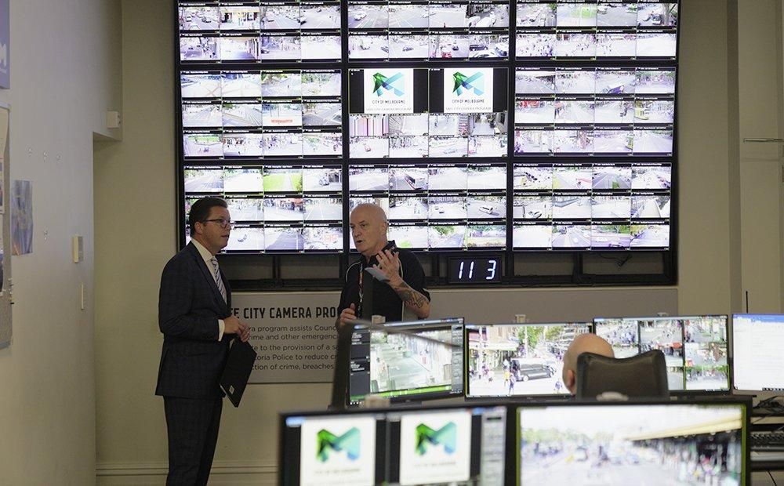

As the third most liveable city in the world, we take safety and security seriously here in Melbourne.

For us, safety is at the core of our renowned liveability status.

If people don’t feel safe, they won’t want to live, work or visit here.

While Victoria Police provides policing services to the community, the City of Melbourne invests in safety and security infrastructure within the city and in our security teams and their ability to collaborate with police and other emergency services.
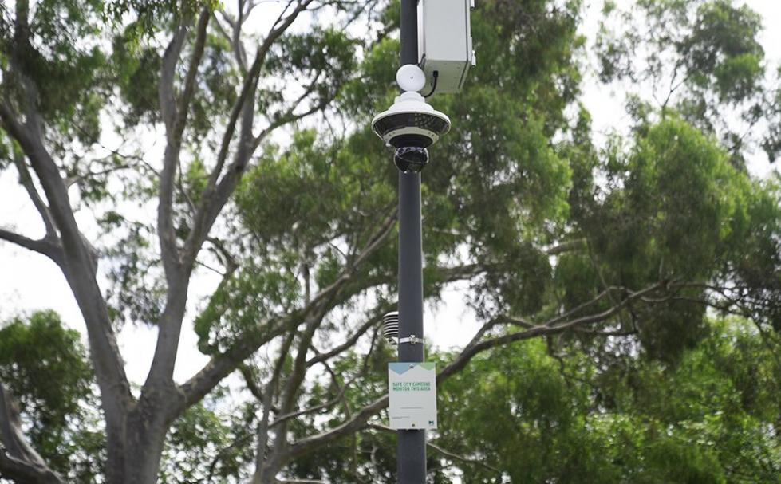
The first of the new CCTV cameras installed in Carlton
Investment in safety and security
This year, we’re investing $6 million in critical safety infrastructure and resources, including more safety lighting to reduce antisocial behaviour at night.

In partnership with the Victorian Government, we’re currently expanding our closed-circuit television camera network into new neighbourhoods like Carlton with eight cameras to be installed in key locations like Lygon Street and Argle Square by July.

We’ve also upgraded our safe city cameras in the CBD, along with upgrading lighting in key precincts such as Bourke Street, between Exhibition and Spring streets.

We know police can’t be everywhere at once but this network of closed-circuit TV surveillance cameras helps create a safer environment and reduce crime levels by deterring potential offending and helping in crime detection.
The cameras operate in areas where antisocial behaviour or criminal activity is historically more likely to occur.
Signage is placed in the monitored areas to alert the community of the surveillance.
Our specially trained security contractors in our Safe City Cameras Program Control Room monitor these cameras 24 hours a day, seven days a week, recording incidents and alerting police.
The footage can also be viewed at police stations and on officers’ devices when responding to an incident.
In the past decade, the Safe City Cameras Program has:
- Recorded 47,258 incidents
- Provided 9,706 copies of recorded footage to Victoria Police
- And transferred 30,160 occurrences of live vision to police.

What started with 23 cameras in 1995 and a team of one has grown to a slick operation of 254 cameras and a mobile CCTV car, plus 11 dedicated contract security staff, comprising two round-the-clock operators and a full-time technician and apprentice.

And we’re not stopping there. In May, we’re adding a Safe City Supervisor role from Monday to Friday.

This will enhance our proactive monitoring capability on the streets, improve training of existing and new Safe City Operators, streamline our administrative functions by processing police applications for footage faster, and provide us with a resource to constantly look at improvement of the system and operations.
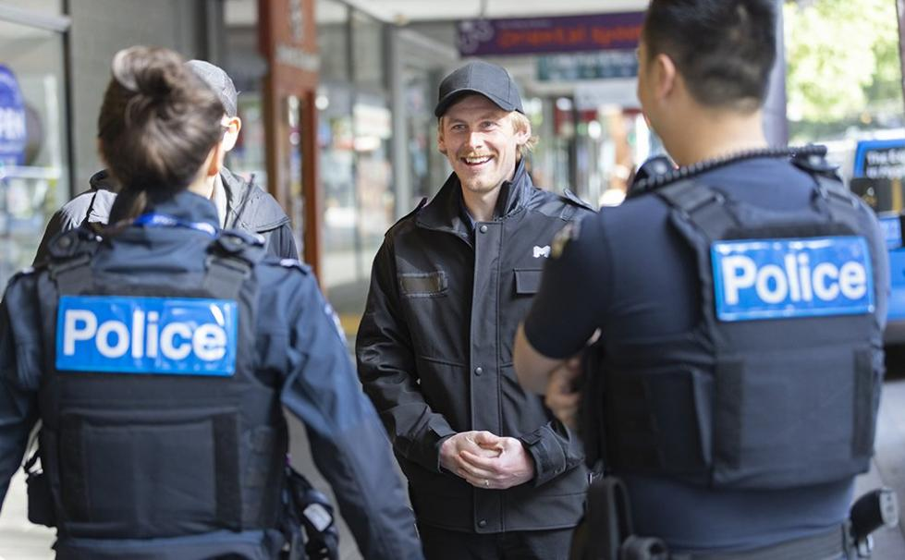
We’ll soon be employing a Safe City Supervisor to assist with providing CCTV camera footage to police

Our Safe City CCTV Car, which operates from 10pm to 6am on Friday and Saturday nights, will also be expanded to Thursday nights this year.

This vehicle is fitted with 360-degree CCTV surveillance cameras to record in real-time with electronic media downloaded at the end of each shift.

The car’s movements are directed via the Safe City Control Room and tasked to jobs where our permanent cameras can’t view for example, if there’s an incident in a small laneway.

This means we are able to report live incidents of crime, with accurate descriptions and paths of travel, to triple 000 and support police responses.

This is just one example of our collaborative efforts with emergency services across the city.

Trends we’re seeing in Melbourne
We constantly identify and respond to emerging security trends.
One of these is an increase in high-level criminal damage and arson in some of our main amenity blocks in our parks.

Thanks to our security team’s innovative approach, we’re trialling an environmental sensor the HALO that can detect smoke, spray paint and yelling to alert us of the date and time of incidents for potential monitoring.

The sensor is linked to our CCTV management system.

Already, on two occasions footage has been provided to police from arson events in an amenity block in South Yarra; and incidents of arson have reduced in the past five months.
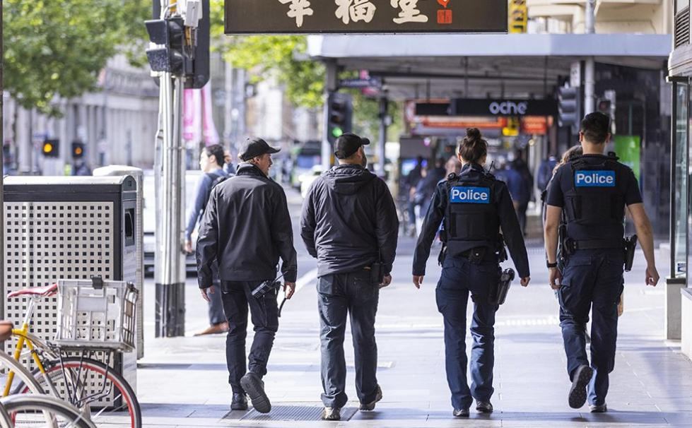
Our local laws team works closely with Victoria Police to ensure the city is safe for traders and visitors

Security and supporting our business community

Our investment in security infrastructure is not only about liveability, it’s also about supporting our business community.

We know that security done well supports local business, and gives customers the confidence to visit our local traders.
That’s why we work with our business community, encouraging them to maintain their own security equipment such as lighting, CCTV cameras, door hardware and signage to enhance the perception of safety in and around a property.

This also includes reporting faulty public lighting, dumped rubbish, graffiti or overflowing bins so we can rectify this as soon as possible.

We know our traders are busy, which is why we have a hotline (9658 9658) and online reporting tool to make this as easy as possible.

There’s certainly an impetus to invest in safety and safety maintenance.

Our security teams find there’s a correlation clean, well maintained and managed properties generally promote better behaviour from people interacting in those areas.

APPENDIX “C”

Herald-Sun article, 10 August 2024
“Now Showing: A Catalogue of City Crime”.

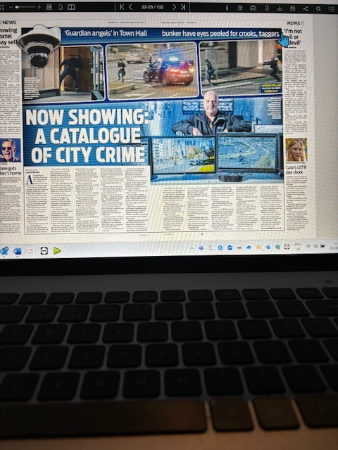

APPENDIX “D”

Keeping an eye out across the city, on 220 cameras
Here the Spirit of Christmas takes a back seat, which is why a giant blow-up koala had to be deflated to avoid blocking cameras.
By John Silvester
Sunday Age – NAKED CITY - DECEMBER 23, 2022
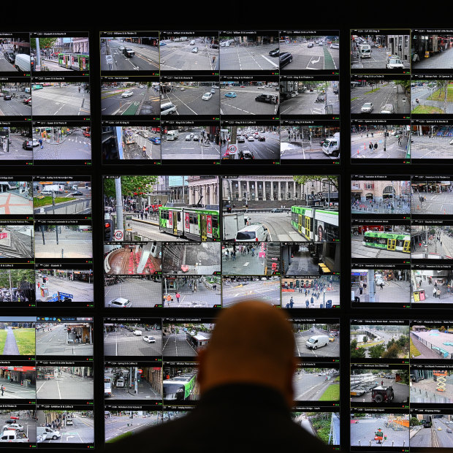
The number of monitoring screens was tripled after the 2017 Bourke Street tragedy.CREDIT:JOE ARMAO

Hidden inside Melbourne’s 155-year-old town hall sits a secure, high-tech room where two experienced security officers scan their computer screens, expecting the unexpected.
On the front wall is a bank of more than 100 screens showing images beamed from 220 security cameras dotted around the city.
On one, we see an ambulance pull up, lights flashing. On the electronic wall, triple-zero operators patch in to see if more help is needed.
The screens show live shots down St Kilda Road to the Shrine, people leaving Flinders Street Station and workers going about their daily business.
Just outside is a high-profile council-controlled private security vehicle — equipped with five fixed cameras and one 360-degree camera to patrol Melbourne lanes not covered by the cameras attached to buildings and poles.
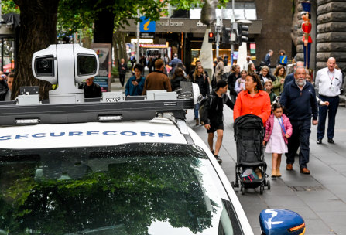
The Safe City camera car that puts electronic eyes down blind spots.CREDIT:JOE ARMAO

One night when an idiot tried to mount the footpath to run someone over, the intended victim was able to jump on the camera car for safety. It was designed to deter crime, but not that way.

To the side of the room is Victoria’s oldest gold safe, now transformed into the electronic engine room, filled with blinking computers and thousands of hours of video recordings.
This is the command centre of Melbourne’s Safe City operation — designed as an early alert for everything from exuberant crowds to a terrorist assault.
Following the 2017 Bourke Street attack that killed six and injured 27, the camera network was tripled and a public address system added to warn of future threats.

After last week’s shameful soccer pitch invasion, police went to the room to look at footage of the hooligans as they entered and left the stadium. It will be part of the eventual evidence packages presented in court, proving what morons ignore: you can run, but you can’t hide.
Next week on New Year’s Eve, when an estimated 500,000 people will roll into Melbourne for the fireworks, the cameras will look for crowd crushes and alert police and council crowd controllers to divert people from dangerous bottlenecks.
With five major celebration points, the cameras will scan for lost kids and dangerous flashpoints as well as the over-refreshed and the under-prepared.
Here, the spirit of Christmas takes a back seat, which is why a giant blow-up koala had to be deflated to avoid blocking cameras. Trees are also pruned to make sure there are no blind spots.
The cameras pinpoint violence, with operators immediately alerting police. They know the city by heart and don’t need to look at a map, knowing not only the street but the exact number of the location.
In 1995, the City of Melbourne resolved to set up the Safe City program by installing 23 cameras. It is now central to all public events.
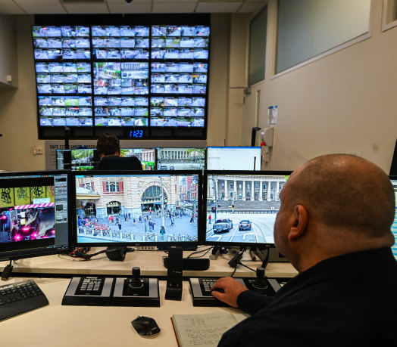
Looking for trouble. Inside the monitoring room.CREDIT:JOE ARMAO

Lord Mayor Sally Capp says: “It is making a big difference and is now absolutely fundamental to the security and safety of Melbourne.”
It is now a way of life. There are hundreds of private security cameras in the city and the first instinct of many is to whip out their phones to record anything that moves. Even private cameras around the Salvation Army’s Project 614 support centre in Bourke Street can be patched in when needed.
Compare that to the outcry when a handful of cameras were installed in 1981, supposedly to monitor traffic, before the Commonwealth Heads of Government Meeting.
City police Inspector Jamie Templeton says the cameras are part of an investigator’s bag of tricks and provide real-time intelligence.
This year, there have been 5012 incidents in the city, with police receiving valuable footage in 1444 cases.
In the past decade, the Safe City Cameras Program recorded 43,427 incidents, and provided 8025 copies of footage.
In the same time, it provided triple-zero operators with live vision nearly 30,000 times.
There can be no more tragic and graphic example of the use of CCTV in a criminal investigation than the 2018 murder of Eurydice Dixon, who was stalked for nearly five kilometres before being attacked in Princes Park, Carlton.
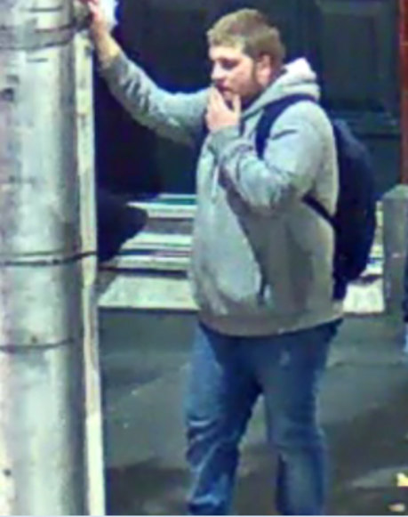
Jaymes Todd on the night he killed Eurydice Dixon. He was caught on multiple cameras as he stalked her for nearly an hour.CREDIT:VICTORIA POLICE

The offender, Jaymes Todd, then 20, spotted her outside Flinders Street Station and followed her for nearly an hour.
He trailed about 15 seconds behind her, occasionally stopping and pretending to roll a cigarette to conceal his real intentions.
He handed himself in within 12 hours after police released images of the suspect, and Todd’s friends contacted him.
The cameras couldn’t save Dixon, but they did stop Todd from reoffending.
Increasingly CCTV is becoming the central plank to prosecutions because the camera doesn’t lie.
A few weeks ago, Aaron Ong was found guilty of the 2019 ambush murder of fruiterer Paul Virgona (his co-offender Josh Rider had earlier pleaded guilty) in a case where the prosecution relied heavily on CCTV.

Templeton says if the footage does not capture the crime, it can still identify the offender through clothing and car registration details. And tattoos can be a cop’s best friend.
It can be the alibi-buster when the suspect says they weren’t there. “There you are walking from Flinders Street Station or getting out of your car,” Templeton says.
The experienced operators become electronic time travellers, working back from the incident frame by frame to see the exact movement of suspects from the time they enter the city until they commit a crime.
Even when a crime is not captured, the offenders can be. If there are a series of burglaries, the cameras are used to check car registrations to identify potential suspects.
Templeton says when police are called, the live feed is patched through to the officers’ computer tablets, ensuring they are better prepared for what they will confront. “It gives us situational awareness and lets us know how many people we need.”
A veteran of city policing, Templeton uses the cameras during protests to get police to potential trouble spots.
The cameras, he says, stop crime because many would-be offenders know their images will be captured. “It covers every corner and has been a game changer.”
He says it is also valuable when there have been complaints against police because it provides more comprehensive coverage than body-worn cameras — a little like going upstairs at a Test match for a video review.
The cameras are just one club in the bag and, Templeton says, police can’t rely on them exclusively. You need to talk to people, gather facts and make your own judgments.
At the back of the room are two old-fashioned blue folders, one marked Missing Persons and the other POI (Persons of Interest).
Craig Buckingham, Security Manager for the City of Melbourne, says they are contacted “every second day” about runaway wards of the state and have a 75 per cent pick-up rate: “We know where to look.”
Dean Robertson, the council’s Director of City Safety, Security and Amenity, says a regular complaint of city residents and regulars is the lack of visible police patrolling.
He says the cameras add a constant presence and send police to where they are needed, leading to less wasted resources.
Instead of a call from the public followed by general duties police arriving to assess a violent incident, specialist units such as the Critical Incident Response Team can immediately be dispatched when seconds matter.
It is a world away from the old days, when detectives would leave the Russell Street “Bullring” to go to the View Room, a theatrette where the freshly arrested would be paraded catwalk-style and told to turn left and right, so the cops would be able to recognise them if they saw them in the street.
The best cop was the legendary Reg “Eagle-Eye” Henderson, who carried a book with hundreds of photos of the most wanted. He managed to arrest more than 300 simply by recognising them in the street.
Now police can look at image after image captured on the screens and produce absolute evidence to present in court.

