
Neighbourhood Planning Framework
Contents
Introduction 3
Strategic context 5
Neighbourhood Planning Framework Overview 5
Diagram 1: Neighbourhood Planning Framework Overview 6
1. The community experience 7
Listen 7
Explore 7
Realise 7
Diagram 2: Neighbourhood planning process community experience 7
2. The process within City of Melbourne 8
Collect and sort knowledge 8
Filter, test and refine 8
Understand and act 8
Diagram 3: Neighbourhood planning process within City of Melbourne 9
Diagram 3 text description 10
3. Engaging community and collecting knowledge 11
Diagram 4: Neighbourhood Portal and Knowledge Bank 12
Understanding success 13
Defining our success 13

Introduction
Our city is a dynamic municipality made up of a broad set of neighbourhoods, each with its own unique characteristics and needs – from densely populated urban environments, such as the central business district, to more residential areas, such as Kensington, Carlton and South Yarra.
In 2021, City of Melbourne commenced work on a Neighbourhood Model to strengthen how we understand and work with different communities across our city as we emerge from the impacts of COVID-19. Using a place-based approach, we are seeking to better understand the strengths, needs and priorities of residents, students, businesses, workers and visitors across the municipality, and to use this knowledge to guide our work. Ensuring opportunity of access and participation of diverse voices, views and people is key as we embed this work through neighbourhood planning processes and projects, developed in partnership with our communities.
The Neighbourhood Model aims to:
- deeply understand community strengths and needs to drive our work and advocacy
- work with communities to build a vision for their locality
- activate communities to lead their own change
- ensure participation and visibility for diverse voices, views and people
- create safe spaces for community to connect and go to when they need support
- identify the connections between neighbourhood needs and city-wide responses.
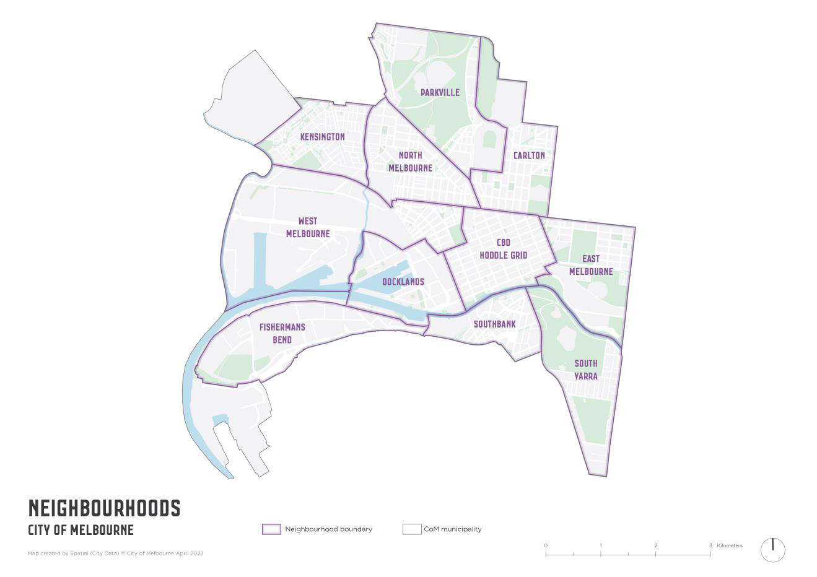
To ensure the Neighbourhood Model supports the City of Melbourne to connect with, understand and respond to community, the following principles will guide our approach.
- Evidence-driven: Our decisions are driven by evidence and informed by inclusive engagement that is truly representative of the community
- Reflective: We commit to consistently pursue improvement through iteration and learning
- Partnership: We actively seek to partner with community and other organisations, considering the micro and macro to respond to the present and plan for the future
- Embedded and aligned: We adopt a whole of organisation approach which aligns to Council strategy and acknowledges each work area’s valued expertise
- Transparency: We commit to transparent and open two-way engagement with our community on the issues that matter most to them.
In order to deliver on these aims and principles, the Neighbourhood Model has several interconnected components that are discussed in this document and described below. The components include the Neighbourhood Planning Framework, Neighbourhood Portals, Neighbourhood Partners and the Knowledge Bank.
- Neighbourhood Planning Framework: The Neighbourhood Planning Framework details the continuous cycle of listening to community and connecting the knowledge we gather to inform Council work, investment and advocacy. The Neighbourhood Planning Framework does not replace existing Council operational planning processes or other municipal and local structure plans, instead it will complement and enhance existing processes.
- Neighbourhood Portals: To support this continuous cycle of listening and responding to community, the Council will develop Neighbourhood Portals in the form of interactive online web pages for each neighbourhood, which provide up-to-date location specific information to community and serve as a key communication channel between community and the organisation. These will include information on the strengths and priorities identified by each neighbourhood, details of projects planned or underway, demographic data, links to community resources and showcase community stories. The Portals will also provide a place for community to interact with the Council and their Neighbourhood Partner.
- Neighbourhood Partners: Neighbourhood Partner roles have been established for the neighbourhoods across the municipality. These roles aim to connect with a diverse range of community members to build relationships, understand local priorities, bring people together and support community-led initiatives. Our Neighbourhood Partners will also play an important role in sharing community insights and knowledge with the community through the Neighbourhood Portals and in the organisation through the Knowledge Bank to inform short and long-term planning.
- Knowledge Bank: With the Neighbourhood Portals acting as the one-stop-shop for community about their neighbourhoods, a Knowledge Bank is being developed to support greater understanding of community ideas, priorities and concerns within the organisation. The Knowledge Bank is a repository of community data from across the organisation that gathers and analyses community input from across multiple sources to provide an accurate, current and centralised picture of what is happening across different neighbourhoods. Staff can search by neighbourhood and topic to find out what’s already been said and access existing data gathered from different forms of engagement with community about projects and issues relevant to their work.

Strategic context
Implementing the Neighbourhood Model is a Major Initiative in the Council Plan 2021-25 under the Access and Affordability strategic objective. The Neighbourhood Framework articulates how the Neighbourhood Model will be integrated and supportive of existing governance, planning and budget frameworks.
The framework is aligned with the City of Melbourne’s Community Engagement Policy, the governance principles identified in the Local Government Act 2020 and the Inclusive Melbourne Strategy’s ambition to deliver more inclusive and sustainable outcomes for our city through shared problem-solving, open dialogue and meaningful participation.
The implementation of the Neighbourhood Model and Framework will support progress against Goal 16 (Peace, Justice and Strong Institutions) of the Sustainable Development Goals (SDGs), assisting to ‘Ensure responsive, inclusive, participatory and representative decision-making’ within the City of Melbourne.

Neighbourhood Planning Framework Overview
The Neighbourhood Planning Framework does not operate in isolation. It forms a critical part of our Neighbourhood Model, helping us to deeply understand our communities and engage them in shaping our current and future plans.
The organisation already collects and acts on knowledge from across the community, but it is not readily accessible beyond the point of engagement or held in a way that continually informs plans, strategies and actions.
The purpose of the planning framework is to create a continuous cycle that connects the knowledge we gather to the plans we make and the actions we prioritise. This framework helps direct the knowledge we hold across the organisation to bring it to life and embed it in our practice.
To articulate how it will work, we have set out diagrams on the following pages that show how the community will experience the framework, the components that work together to support the collection and management of knowledge, as well as how we will use the knowledge to inform our actions.

Diagram 1: Neighbourhood Planning Framework Overview
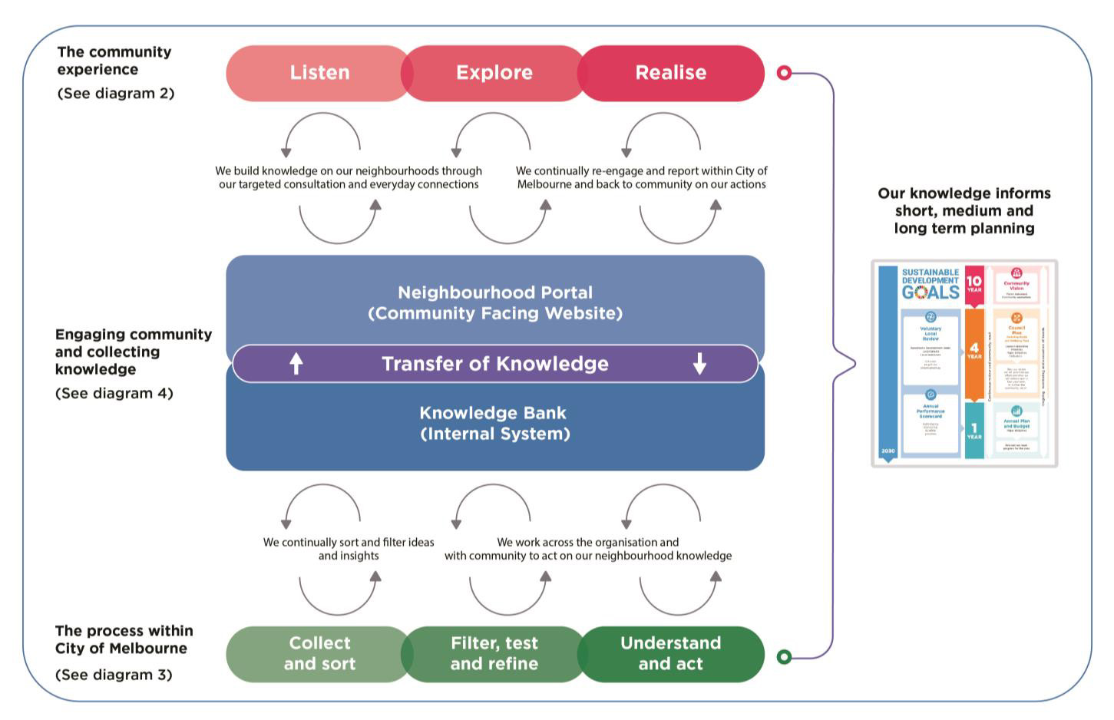

1. The community experience
The community experience is a critical component of the Neighbourhood Planning Framework and its design. For our community, it will be experienced through a continuous cycle of listening (Listen), exploration (Explore) and realisation (Realise):

Listen
Through our neighbourhood engagement, community consultations, stakeholder conversations, customer feedback and the Neighbourhood Portals, our community will be able to engage and provide input on issues that matter most to them. We will be constantly listening to community voices through these channels and responding.

Explore
As our knowledge of what the community has told us grows, we will further explore the recurring ideas, themes, opportunities, and issues that arise. Some of this exploration will include simple engagements with community followed by quick actions, while others will be more in-depth conversations over a longer period and resulting responses in future Council Plans and budgets. Through the exploration process we will continuously communicate about what is happening, when decisions have been made and why we have taken certain actions.

Realise
As we identify relevant responses, our community will see this come to life through direct initiatives in their neighbourhoods and new partnerships with community organisations, businesses, philanthropic organisations and/or other partners to deliver outcomes. Results may also include advocating on the issues that we cannot address by ourselves or community-led action to drive change. Again, we will continue to communicate what is happening and how what we are hearing translates into actions.

Diagram 2: Neighbourhood planning process community experience
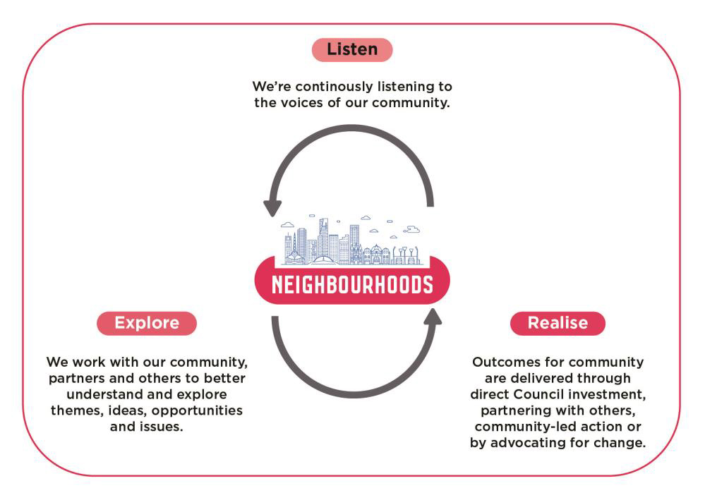

2. The process within City of Melbourne
The process provides detail on the steps we will follow, the decisions we make and the actions that happen. It will be a continuous cycle of listening and assessing gathered knowledge; filtering it down; testing its relevance and alignment to our existing and future goals; and helping navigate these ideas and actions to where they can be implemented against relevant Council plans and budgets.
The process within City of Melbourne can be broken down into three overarching stages:

Collect and sort knowledge
Through our Neighbourhood Partners, the Neighbourhood Portals and from interactions the community has with the City of Melbourne, we are continually collecting knowledge from our community. Our process will embed a rhythm that will see our Neighbourhood Partners working with community and the organisation to sort and categorise the data and ideas we gather and identify recurring themes and insights to direct next steps.

Filter, test and refine
Working with and alongside colleagues from across the organisation, we will action any issues raised through our customer complaints and feedback mechanisms, communicate work already underway, seek to better understand and assess potential new ideas and identify next steps. There may be some themes and initiatives that are assessed and may not be feasible for a variety of reasons. When this occurs, we will be transparent and communicate to community and stakeholders why a decision to not proceed was made.

Understand and act
This stage in the process acknowledges the importance of exploring any new ideas that emerge and clarifying our understanding within the organisation and with our community. We will deep dive and refine what is being asked for or needed and, where appropriate, identify the areas within the City of Melbourne to work through and embed within current or future Council and Branch plans, operational budgets, or capital works initiatives.
Some of these initiatives may require advocacy, establishing partnerships with others, co-designing with community or supporting the community to act themselves. Importantly, there will be continuous reporting back to community on the actions we are taking and the decisions that are made, whether through Council reporting, the Neighbourhood Portals or through direct engagement with community and stakeholders.

Diagram 3: Neighbourhood planning process within City of Melbourne

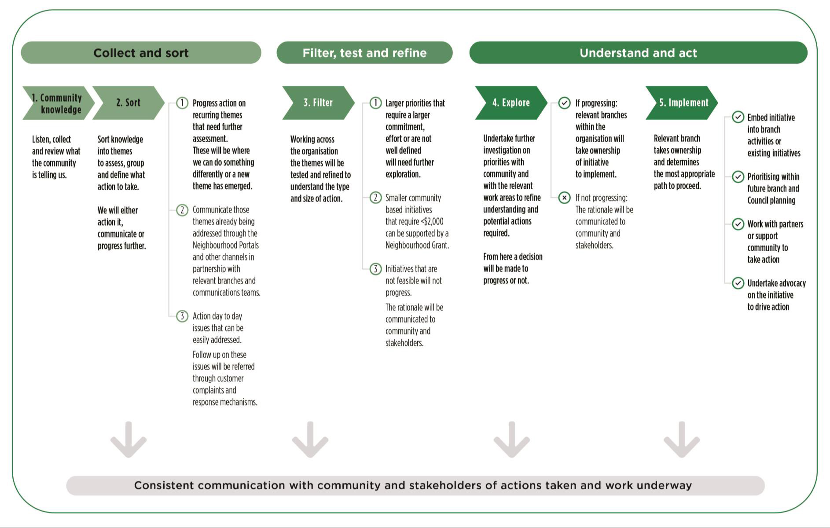

Diagram 3 text description

Collect and sort
- Community knowledge: Listen, collect and review what the community is telling us
- Sort: Sort knowledge into themes, to assess group and define what action to take. We will either action it, communicate or progress further
  - Progress action on recurring themes that need further assessment. These will be where we can do something differently or a new theme has emerged
  - Communicate those themes already being addressed through the Neighbourhood Portals and other channels in partnership with relevant branches and communications teams
  - Action day to day issues that can be easily addressed. Follow up on these issues will be referred through customer complaints and response mechanisms

Filter, test and refine
- Filter: Working across the organisation the themes will be tested and refined to understand the type and size of action.
  - Larger priorities that require a larger commitment, effort or are not well defined will need further exploration.
  - Smaller community-based initiatives that require < $2,000 can be supported by a Neighbourhood Grant.
  - Initiatives that are not feasible will not progress. The rationale will be communicated to community and stakeholders.

Understand and act
- Explore: Undertake further investigation on priorities with community and with the relevant work areas to refine understanding and potential actions required. From here a decision will be made to progress or not.
  - If progressing: relevant branches within the organisation will take ownership of initiative to implement.
  - If not progressing: the rationale will be communicated to community and stakeholders.
- Implement: Relevant branch takes ownership and determines the most appropriate path to proceed
  - Embed initiative into branch activities or existing initiatives.
  - Prioritising within future branch and Council planning.
  - Work with partners or support community to take action.
  - Undertake advocacy on the initiative to drive action.
Overarching all steps is consistent communication with community and stakeholders of actions taken and work underway.

3. Engaging community and collecting knowledge
Underpinning the community experience and the process within City of Melbourne are the Neighbourhood Portals and the Knowledge Bank.
The community-facing Neighbourhood Portals will be online web pages for each neighbourhood, which provide location-specific information and communication channels between community and the organisation. Internally within City of Melbourne, the Knowledge Bank will be a repository of information drawn from (in time) a range of sources, including neighbourhood engagements, project consultations, external community data and the everyday feedback we receive. The Knowledge Bank will be used to inform planning and action across the Council.
Our approach will evolve during the implementation of the current Council Plan:
Phase 1: Involves building and testing the approach to engaging our neighbourhoods – through ‘Participate Consultations’.
Phase 2: Involves gathering knowledge from staff across Council through their regular engagement with community in the intermediate term.
Phase 3: Our long-term ambition is to embed real-time knowledge where our engagement with community and gathering feedback shifts from a passive to active approach where data can be sought and captured in real time.

Diagram 4: Neighbourhood Portal and Knowledge Bank
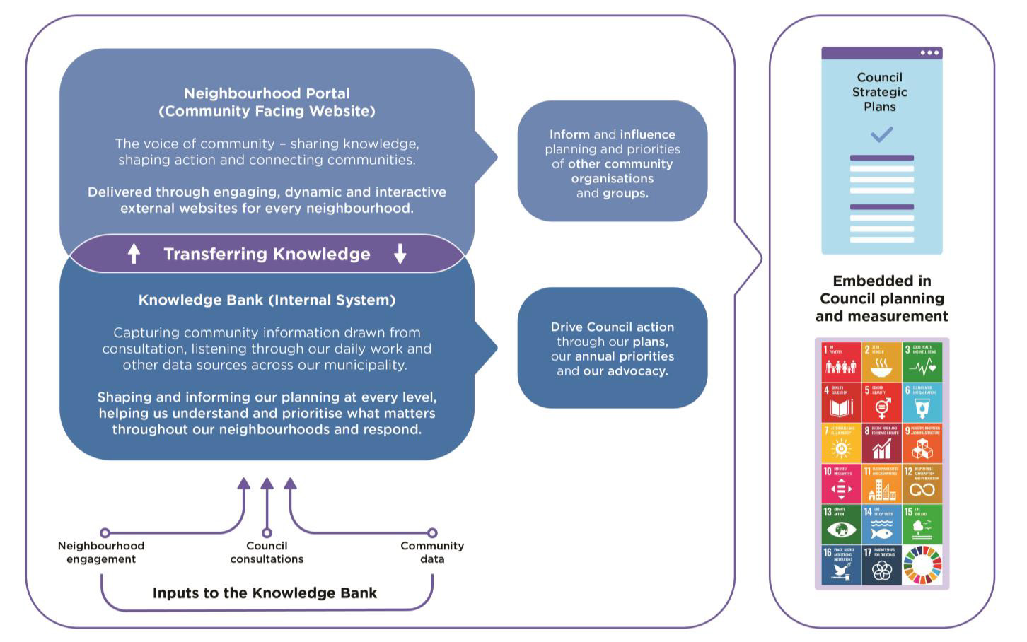

Understanding success
The purpose of the Neighbourhood Planning Framework is to create a continually growing and developing repository of community knowledge that can inform our plans and actions. Its success will be driven by not just what we create as a technology solution and process, but by how it is embedded within practice, culture and behaviour.

Defining our success
The following outcomes are the starting point for what will define our success:
- Embedded in practice: Community voice will be demonstrably informing Council Plans, commitments and actions drawn from our Knowledge Bank. The Neighbourhood Planning Framework is recognised and used as a critical input at all levels of Council planning and decision-making.
- Trusted partnership: Partnership between us and community where we all play a part in the change we want to see, to make our city the best possible place to live, work and visit.
- Enabling community-led action: We will see new partnerships and community-led initiatives emerge.
- Community knowledge: Members of our community will have more channels to engage with, be informed by and understand initiatives in their neighbourhood.
As part of the Neighbourhood Model implementation, a measurement and evaluation plan will be developed to ensure it is delivering against the intended outcomes. This will include periodic reviews of the Neighbourhood Planning Framework.

