
Green Factor Tool
Guidance Note
29 April 2025

Acknowledgement of Traditional Owners
The City of Melbourne respectfully acknowledges the Traditional Owners of the land we govern, the Wurundjeri Woi-wurrung and Bunurong Boonwurrung peoples of the Kulin and pays respect to their Elders past and present. We acknowledge and honour the unbroken spiritual, cultural and political connection they have maintained to this unique place for more than 2000 generations.
We accept the invitation in the Uluru Statement from the Heart and are committed to walking together to build a better future.
Contents
Introduction 4
Purpose of this document 4
How to use this document 4
Green infrastructure matters 5
Green infrastructure 5
Ecosystem functions 6
The Green Factor tool 7
What is the Green Factor tool? 7
How was the tool designed? 8
Basic inputs 9
Locate your site 10
About your site 12
Entering the site area 13
Planning permit application 13
Not associated with a planning permit 13
Project information 14
How scoring works 15
The Green Factor Score 15
Specifying green infrastructure elements (vegetation and soil) 16
Base scores 17
Further parameters 17
Example 20
Weighting of ecosystem functions 20
Green factor area 22
How the green factor score is calculated 23
Inputs 23
Scoring 24

Introduction

Purpose of this document
The Green Factor Tool Guidance Note has been prepared by the City of Melbourne to explain how the Green Factor tool works.
The Guidance Note provides:
- An overview of green infrastructure and its key concepts.
- A detailed explanation of the Green Factor tool.
- An explanation of how the parameters, weightings and workings of the Green Factor tool scoring regime achieve a final Green Factor score.
The Guidance Note will support the use of the Green Factor tool in accordance with the Melbourne Planning Scheme.
The audience of the Guidance Note comprises planners, landscape architects, designers and Environmentally Sustainable Design consultants.
The City of Melbourne encourages applicants to discuss their use of the Green Factor tool during pre-application meetings.

How to use this document
The Green Infrastructure Matters section provides a simple explanation of the key concepts of green infrastructure fundamental to the Green Factor tool.
The Green Factor Tool section explains the purpose of the Green Factor tool, how it was developed and how it is used.
The following two sections are intended for users of the Green Factor tool. These sections step out the inputs required and explain how they relate to the scoring regime:
- Basic Inputs steps through the inputs on the About Your Site page.
- How Scoring Works provides an explanation of how the Green Factor score is calculated with reference to a simple example.

Green infrastructure matters

Green infrastructure
As Melbourne becomes a denser city, green infrastructure such as green roofs, walls and facades can provide greening where space is constrained.
Green infrastructure comprises the vegetation, soil and irrigation elements of a development.
This can include trees, plants, soil and raingardens for drainage.
Green infrastructure is an important component of the City of Melbourne’s response to climate change because it cools buildings and public spaces, reduces the risks of flooding and provides habitat for animals.
Green infrastructure also supports the economy by providing attractive and memorable places for people – boosting local business, attracting visitors and improving liveability for residents.
The greening of cities is a pressing concern in Australia and worldwide. Despite growing evidence for the need for urban nature globally, urban flora and green coverage in cities are declining (Bush 2021). While local governments can engage in the management of parks, gardens, streets and other public spaces, much of the loss of urban greenery has occurred in the private realm. Two-thirds of land within the City of Melbourne is privately owned.
To achieve goals of increasing biodiversity, habitats and ecosystem health, it is necessary for nature to be continuous over both private and public land. This continuity creates greater ecosystem function benefits than fragmented elements. To improve urban greenery on private land, several cities have created green infrastructure assessment tools for use in the planning and design of new buildings and developments.

Ecosystem functions
Research into green infrastructure has categorised its benefits into the following ecosystem functions:
- Urban temperature regulation: Vegetation can reduce urban heat and contribute to human thermal comfort.
- Habitat for biodiversity: Vegetation provides habitat for biodiversity.
- Stormwater runoff mitigation: Vegetation and soil can reduce the quantity of stormwater runoff.
- Recreation: Vegetation and green space can provide opportunities for recreation.
- Place values and social cohesion: Vegetation and green space can contribute to the ‘sense of place’ and facilitate social connections.
- Aesthetic benefits: Vegetation and green space can contribute to the aesthetics and beauty of a place.
- Food supply: Vegetation can produce food.

The Green Factor tool

What is the Green Factor tool?
The Green Factor tool allows designers to quantify and benchmark the quality of greening on a building.
The Green Factor tool provides a score which represents the quantity and quality of the green infrastructure of a development, in proportion to the site area. The weighted scoring system allows for the comparison and assessment of projects with varying design features.
Green infrastructure elements are rated according to their ability to achieve the City of Melbourne’s policy objectives which span sustainable building performance, urban ecology and biodiversity, and social health and wellbeing.
The tool’s scoring regime is the culmination of research by a team of ecologists, landscape architects and urban forestry experts from the City of Melbourne, the University of Melbourne and expert consultants. The research drew upon international best practice and local data. The capacity for vegetation elements to achieve outcomes in line with City of Melbourne objectives was defined by the ecosystem functions they provide (see Page 6). The tool is non-prescriptive and allows flexibility for designers across different projects.

How was the tool designed?
The Green Factor tool was designed in collaboration with Hip V. Hype environmental sustainability consultants, with tool and website design by Little Sketches, and input from University of Melbourne and University of Helsinki researchers.
The research process undertook six key steps, as detailed in (Bush, 2021).
- Identifying key infrastructure functions and types
Vegetation was identified in terms of the ecosystem functions that it provides (see Page 6) and by the following types:
- large tree
- medium tree
- small tree
- large shrub
- small shrub
- ground cover
- lawn or turf.
- Prioritising functions
- Researchers held workshops with City of Melbourne staff to identify the role of urban greening alongside existing priorities and objectives, and how to incorporate greening objectives into developments.
- Researching the evidence base
- The researchers created an evidence base for the scores from existing data. Evidence gathered from Melbourne and South East Australia was given a higher weighting to create a context specific dataset.
- Rating the vegetation elements for relative delivery of functions
- Vegetation was rated from zero (no contribution) to three (major contribution) in terms of its ability to provide functions in the local context. Higher rated vegetation provides higher levels of amenity relative to its size than lower rated vegetation. Examples of relevant factors include being indigenous, providing shade, or providing habitat to fauna.
- Peer review
- The outputs of the research were refined through several workshops with landscape architects, urban ecology researchers, and City of Melbourne staff from landscape and planning teams.
- Finalisation of tool design and piloting
- The tool was released in 2020 ahead of the finalisation of Planning Scheme Amendment C376: Sustainable Building Design to the Melbourne Planning Scheme. At the time of release, the use of the tool was voluntary.

Basic inputs
This section steps out the basic inputs prompted by the Green Factor tool about the site and the project. The inputs relating to the green infrastructure elements are covered in the following section.
Before entering the basic inputs, the user should:
- Understand the exact site area and location. If the project is associated with a planning application, it must be the same site area as the planning application.
- Have a draft landscape plan including a schedule of green infrastructure elements, with the following information: Quantity
- Area
- Location on the site
- Species type (indigenous, native, exotic or productive)
- Canopy width of trees
- Height of shrubs
- Depth of soil or substrate.
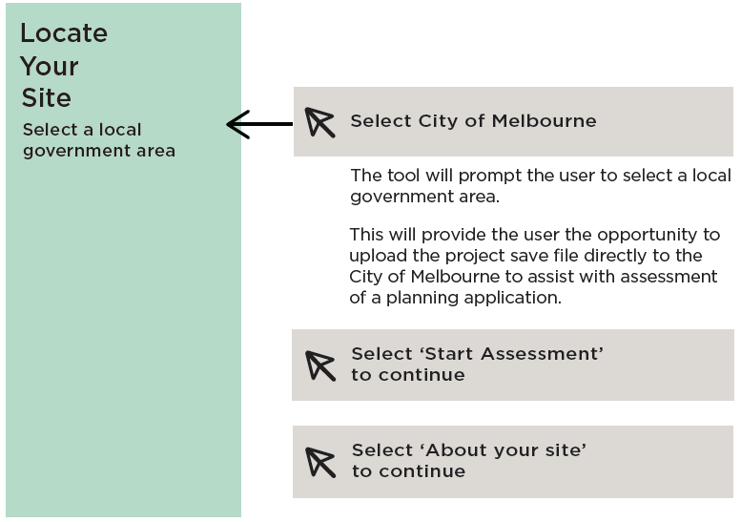

Locate your site
Options:
Select a local government area.
Steps:
- Select City of Melbourne.
The tool will prompt the user to select a local government area.
This will provide the user the opportunity to upload the project save file directly to the City of Melbourne to assist with assessment of a planning application.
- Select ‘Start Assessment’ to continue.
- Select ‘About your site’ to continue.
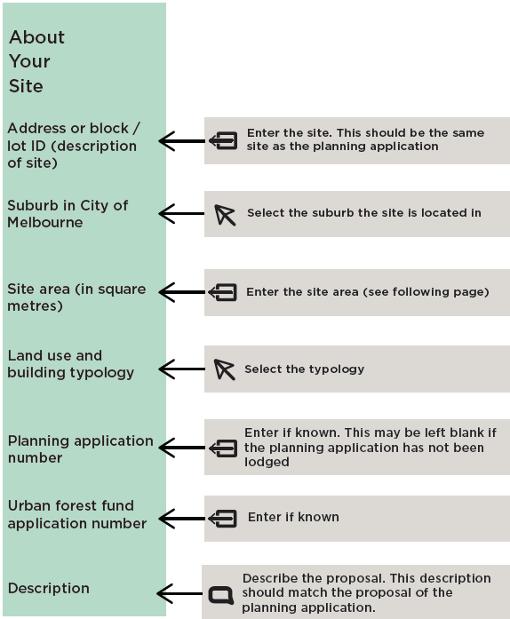

About your site
Options:
- Address or Block/ lot ID (description of site).
- Suburb in City of Melbourne.
- Land use and building typology.
- Planning application number.
- Urban forest fund application number.
- Description.
Steps:
- Enter the site. This should be the same site as the planning application.
- Select the suburb the site is located in.
- Enter the site area (see following page).
- Select the typology.
- Enter the planning application if known. This may be left black if the planning application has not been lodged.
- Ener the urban forest fund application number if known.
- Describe the proposal. This description should match the proposal of the planning application.

Entering the site area
Depending on the situation, your site area will be the site area of the planning application, the area of the planning unit or the project area.

Planning permit application
If the project is associated with a planning permit application, use the site area of the planning application. If the site area is not provided with the certificate of title, then calculations showing site boundary lengths (in metres) and calculated site area (in square metres) should be provided with the application.
If the planning application applies to a smaller area of a larger site then the planning unit should be used and the area (in square metres) should be provided with the application.

Not associated with a planning permit
If the project is not associated with a planning permit application, use the area of the project. If the project area is not the same as the site area on the certificate of title, provide adequate information including the length of project boundaries (in metres), calculated project area (in square metres) and a justification in the ‘Description’ text box that explains why the project is not using the same site area as on the certificate of title.
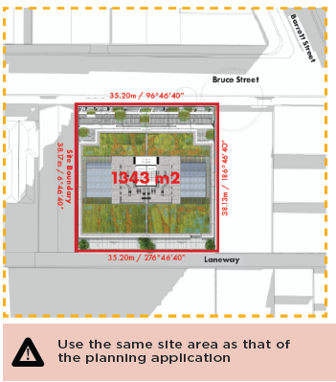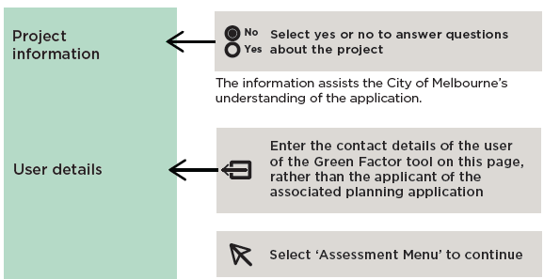

Project information
Options:
- Project information
- User details
Steps:
- Select yes or no to answer questions about the project. This information assists the City of Melbourne’s understanding of the application.
- Enter the contact details of the user of the Green Factor tool on this page, rather than the applicant of the associated planning application.
- Select ‘Assessment Menu’ to continue.

How scoring works

The Green Factor Score
The Green Factor score is a fraction as shown below. The minimum score required is 0.55.
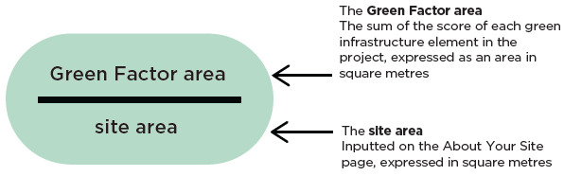
Green factor fraction
The Green factor score is the Green Factor area divided by the site area.
The Green Factor area is the sum of the score of each green infrastructure element in the project, expressed as an area in square metres.
The Site area is inputted on the About your site page, expressed in square metres.

Specifying green infrastructure elements (vegetation and soil)
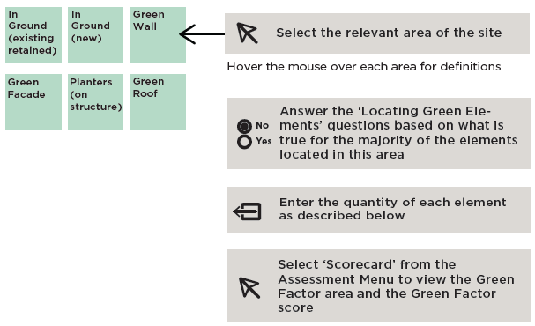Options:
- In Ground (existing retained)
- In Ground (new)
- Green Wall
- Green Façade
- Planters (on structure)
- Green Roof
Hover the mouse over each area for definitions.
Steps:
- Select the relevant area of the site.
- Answer the ‘Locating Green Elements’ questions based on what is true for the majority of the elements located in this area
- Enter the quantity of each element as described below
- Select ‘Scorecard’ From the Assessment Menu to view the Green Factor area and the Green Factor score
Specify a vegetation element by its species type:
- Enter trees by unit (i.e. per tree)
- Enter other vegetation elements by area (square metres)
Specify a soil or substrate element by its depth and area (in square metres).
The section below explains the process by which the green infrastructure elements are scored and the Green Factor area is calculated.
How each green infrastructure element is scored
The tool assesses each green infrastructure element (vegetation and soil) and assigns the element seven raw scores for its ability to perform each of the seven ecosystem functions (see Page 6).
The tool derives the raw scores from the base scores of each element and modifies them by further parameters based on their impact on the delivery of ecosystem functions.

Base scores
Base scores are inherent to the vegetation element itself - i.e. large tree or small shrub (Table 1). Base scores may achieve up to a score of 3.
In the case of soil or substrate, a base score is provided only for the stormwater runoff mitigation function (Table 2). No score is assigned for any other ecosystem function for soil or substrate. See Page 9 for more detail about the process by which the base scores were determined.
Table 1: Vegetation element base scores for each ecosystem function
Ecosystem function | Large Tree – canopy  >10m | Medium Tree – Canopy  6m-10m | Small Tree – Canopy  3m-6m | Climbers | Large Shrub –  Height  >1.5m | Small Shrub – Height  <1.5m | Ground cover | Lawn and Turf
Urban temperature regulation | 3 | 3 | 2.5 | 2.5 | 2 | 2 | 1.5 | 1.5
Habitat for biodiversity | 3 | 3 | 2.5 | 2.5 | 2 | 2 | 1.5 | 0.5
Stormwater runoff mitigation | 1 | 1 | 1 | 0.5 | 0.5 | 0.5 | 0.5 | 0.5
Recreation | 3 | 3 | 2.5 | 2.5 | 1 | 1 | 1 | 2
Place values and social cohesion | 3 | 3 | 3 | 3 | 2 | 2 | 2 | 1
Aesthetic benefits | 3 | 3 | 3 | 3 | 2 | 2 | 2 | 2
Food supply* | 2 | 2 | 2 | 2 | 2 | 2 | 3 | N/A
Food supply scores only apply if the user selects “Productive” species type
Table 2: Soil or substrate base scores for the stormwater mitigation function
Soil element | Base score for stormwater mitigation function
Raingarden | 3
Soil or substrate (over 200mm depth) | 2
Soil or substrate (under 200mm depth) | 0.5

Further parameters
Further parameters influence the delivery of each ecosystem function by the user:
- Selecting the vegetation species type - i.e. indigenous or exotic (Table 3)
- Answering the ‘Visibility and accessibility’ questions (Table 4)
- Selecting the height of the element (Table 5).
- Answering whether a vegetation element on a green wall or green façade is part of a shading strategy (Table 6). Green elements are considered part of the shading strategy if 25% or more of the window area is shaded by greenery.
Table 3: Score impact of selecting vegetation species type
Ecosystem function | Vegetation species type | Scoring impact on base score
Urban temperature regulation | Any | None
Habitat for biodiversity | Indigenous | None
Habitat for biodiversity | Native | Reduces score by 0.5
Habitat for biodiversity | Exotic | Reduces score by 1
Habitat for biodiversity | Productive | Reduces score by 0.5
Stormwater runoff mitigation | Non productive | None
Stormwater runoff mitigation | Productive | Increases climber score by 0.5
Stormwater runoff mitigation | None for all other elements | None for all other elements
Recreation | Any | None
Place values and social cohesion | Indigenous | None
Place values and social cohesion | Native | None
Place values and social cohesion | Exotic | Reduces tree and climber scores by 1.5
Place values and social cohesion | Exotic | Reduces ground cover score by 1
Place values and social cohesion | Exotic | Reduces a shrub score by 1
Place values and social cohesion | Exotic | None for lawn and turf
Place values and social cohesion | Productive | Reduces tree and climber score by 1
Place values and social cohesion | Productive | Increases ground cover score by 0.5
Place values and social cohesion | Productive | None for all other elements
Aesthetic benefits | Any | None
Table 4: Scoring impact of the locating green elements question
Ecosystem function | Visibility and accessibility | Scoring impact on base score
Recreation | Available for occupant use? | If yes, enables the recreation score in Table 1.  If no, the recreation score is zero
Place values and social cohesion | Available for general public use? | If yes, enables the place values and social cohesion score in Table 1  If no, the place values and social  cohesion score is zero
Aesthetic benefits | Visible to the general public? | If yes, enables the aesthetics score in Table 1.  If no, the aesthetics score is zero
Food supply | Any except productive | Score of zero for all elements
Food supply | Productive | Enables food supply score as per Table 1
Table 5: Scoring impact of the height of the element selection
Ecosystem function | Height of the element | Scoring impact on base score
Urban temperature regulation | Ground level or low rise | None
Urban temperature regulation | High rise | Reduces score by 0.5
Habitat for biodiversity | Ground level or low rise | None
Habitat for biodiversity | High rise | Reduces score by 0.5
Table 6: Scoring impact of shading strategy question
Ecosystem function | Part of a shading strategy question | Scoring impact on base score
Urban temperature regulation | No | None
Urban temperature regulation | Yes | For climbers and ground cover, increases score by 1  For small shrubs, increases score by 0.5

Example
A single new tree is inputted by the user as:
- Located in ground (new) area
- That area is
  - Available for occupant use
  - Visible to the general public
  - Available for use by the general public
- The element is a large tree (canopy width > 10 m)
- Indigenous
- One tree
For the purpose of this simple example, no soil or substrate data is entered. However, the type and depth of the soil or substrate should also be selected and its area entered. This will contribute to the stormwater runoff mitigation score as per Table 2. A prompt will notify the user if soil or substrate has not been entered in the area.
The raw scores for this indigenous tree example are shown in Table 7.

Weighting of ecosystem functions
The tool multiplies each raw score by the weighting of each respective ecosystem function. These weightings are listed in Table 8 and are applied consistently to the raw scores of every element.
The tool adds each of the weighted ecosystem function scores together to form a single ‘weight’.
For the tree example, applying the weightings shown in Table 8 to the raw scores (Table 7) results in the weighted scores shown in Table 9.
In this case, the weight totals 2.3.
Table 7: Raw scores for ecosystem functions for the tree example
Food supply | Urban temperature regulation (cooling) | Recreation | Aesthetic benefits | Place values and social cohesion | Habitat for biodiversity | Stormwater runoff (quantity)
0 | 3 | 3 | 3 | 3 | 3 | 1
Table 8: Weighting of ecosystem functions
Ecosystem function | Weighting
Urban temp regulation (cooling) | 25%
Habitat for biodiversity | 20%
Stormwater runoff (quantity) | 20%
Food supply | 10%
Recreation | 10%
Place values and social cohesion | 10%
Aesthetic benefits | 5%
Total | 100%
Table 9: Weighting of ecosystem functions for example tree
Food supply | Urban temperature regulation (cooling) | Recreation | Aesthetic benefits | Place values and social cohesion | Habitat for biodiversity | Stormwater runoff (quantity)
0 | 0.75 | 0.3 | 0.15 | 0.3 | 0.6 | 0.2

Green factor area
The tool provides a Green Factor area score by multiplying the weight by the area of the element.
The tool assumes trees have the canopy areas as shown in Table 10. The assumed canopy sizes cannot be altered by the user. For all elements other than trees, the area is entered by the user.
For climbers located in ground (existing retained) or on a green facade, the Green Factor area score is multiplied by 0.4 to reflect the lower benefit of climber vegetation in these areas. No reduction is applied to a climber on a green wall.
Table 10: Assumed tree canopy area sizes
Area | Tree size | Assumed canopy area
In ground (existing retained) | Small tree | 12sqm
In ground (existing retained) | Medium tree | 24sqm
In ground (existing retained) | Large tree | 40sqm
In ground (new) Planters (on structure)* | Small tree | 6sqm
In ground (new)  Planters (on structure)* | Medium tree | 10sqm
In ground (new)  Planters (on structure)* | Large tree | 15sqm
Only small trees and medium trees may be selected in the planters (on structure) area

How the green factor score is calculated
The total Green Factor score is the sum of the Green Factor area scores for each element, divided by the total site area, rounded to the nearest two decimal places. It is expressed as a decimal.
See the following calculations for how the inputs for a single indigenous large tree achieve a Green Factor score.

Inputs
The user inputs the information below about the single indigenous large tree.
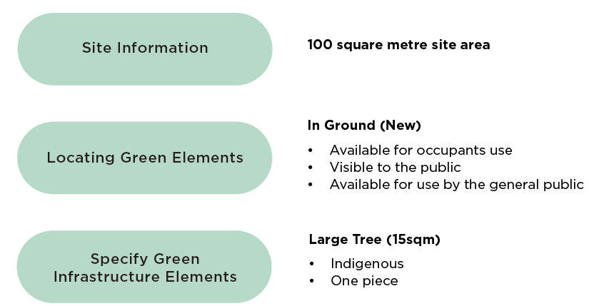
Example options and selections:
- Site information:
  - 100 square metre site area
- Locating green elements:
  - In ground (New)
  - Available for occupants use
  - Visible to the public
  - Available for use by the general public
- Specify Green Infrastructure Elements
  - Large tree (15 sqm)
  - Indigenous
  - One piece

Scoring
This table shows the raw scores for each ecosystem function of the tree in the first row, and the weighted raw scores in the second row. The sum of the weighted raw scores forms the weight.
Table 11: Example weight
 | Food supply | Urban temperature regulation (cooling) | Recreation | Aesthetic benefits | Place values and social cohesion | Habitat for biodiversity | Stormwater runoff (quantity) | Total
Raw score | 0 | 3 | 3 | 3 | 3 | 3 | 1 | 16
Weighted score | 0 | 0.75 | 0.3 | 0.15 | 0.3 | 0.6 | 0.2 | Weight: 2.3
The weight (2.3m) is multiplied by the area of the element to form the Green Factor area. In this case, the area is the assumed canopy size of a large tree, 15sqm. The Green Factor area equals 34.5.
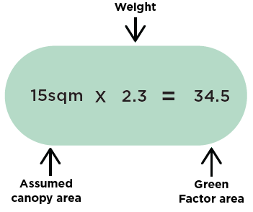
The Green Factor score (0.35) is formed by the total of the Green Factor area scores of all elements (in this case, just the one tree, 34.5) divided by the site area (100).
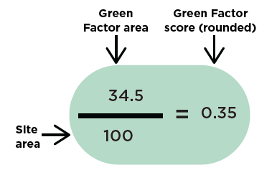

Bush J et al., ‘Integrating Green Infrastructure into Urban Planning: Developing Melbourne’s Green Factor Tool’ in Urban Planning, Vol 6, Issue 1, pp. 20-25 (2021)

