
Green Factor Case Study: The Bruce
14-26 Bruce Street Kensington
August 2025

Acknowledgement of Traditional Owners
The City of Melbourne respectfully acknowledges the Traditional Owners of the land we govern, the Wurundjeri Woi-wurrung and Bunurong / Boon Wurrung peoples of the Kulin Nation and pays respect to their Elders past and present. We acknowledge and honour the unbroken spiritual, cultural and political connection they have maintained to this unique place for more than 2000 generations.
We accept the invitation in the Uluru Statement from the Heart and are committed to walking together to build a better future.

Council Plan 2021-25
The Council Plan 2021-25 sets out our strategic direction and commitment to the community for the next four years. Based on six strategic objectives for our city, this is our detailed plan for our city’s revitalisation and considers the needs of all people who access and experience the City of Melbourne municipality. For more information visit melbourne.vic.gov.au/council-plan
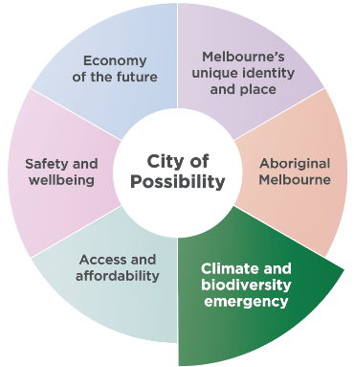
Melbourne is a city setting the standard on climate action. Prioritising our environment and taking urgent action to reduce emissions and waste is key to protecting public health, strengthening the economy and creating a city that mitigates and adapts to climate change.

Contents
Council Plan 2021-25 3
Introduction 6
Green Factor tool 6
Amendment C376: Sustainable Building Design 6
Access the Green Factor tool online at 7
How to use this document 8
Guidance Note Green Factor tool 8
Case Study: The Bruce 14-26 Bruce Street, Kensington 9
Project summary 9
Application details 10
About the site 10
Tips for your Green Factor application: 11
Green infrastructure elements 12
Green Factor input summary 12
Summary of Green Factor inputs 13
Green infrastructure area: In ground (new) 15
In ground (new) 15
Green infrastructure area: Green façade 17
Green façade 17
Floor plan level 01 18
Planting plan detail 01 18
Planting plan detail 02 18
Green infrastructure area: Planters (on structure) 19
Planters (on structure) 19
Floor plan level 01 20
Planting Plan Detail 01 20
Planting Plan Detail 02 20
Green infrastructure area: Green roof 21
Green roof 21
Rooftop Planting Plan 22
Green Factor landscape package 23
Green Factor scorecard 24
Appendix 1: Example town planning landscape package submission 25
Site location and site plan 26
Ground Floor Plan 27
First Floor Plan 28
Second Floor Plan 29
Third Floor Plan 30
Fourth Floor Plan 31
Fifth Floor Plan 32
Sixth Floor Plan 33
Seventh Floor Plan 34
Roof Plan Detail and Aerial Photo 35
Elevations 36
Elevations 37
Section A 38
Detail Sections 39
Planting plan and Green Factor tool table - Ground floor 40
Planting plan and Green Factor tool table - Level 1 41
Planting plan and Green Factor tool table - Level 2 42
Planting plan and Green Factor tool table - Level 3 43
Planting plan and Green Factor tool table - Level 4 44
Planting plan and Green Factor tool table - Level 5 45
Planting plan and Green Factor tool table - Level 6 46
Planting plan and Green Factor tool table - Level 7 47
Planting plan and Green Factor tool table - Rooftop 48
Plant Report 49
Trees and tall shrubs 49
Grassy and strappy plants 50
Shrubs 51
Cascading, trailing and climbing plants 56
Ground covers 58
Plant Schedule Green Roof 61
Plant Schedule Ground Floor Access 69
Green Factor Scorecard 75
Planting Green Roof 76
Plant Façade 77
Images 78

August 2025

Acknowledgements:
Many people contributed to the development of this case study and the Green Factor tool. We are truly grateful and would like to thank all contributors including LOCI Design Collective and Nature Based Consulting for the case study, and HIP V. HYPE, Little Sketches, the University of Helsinki and the University of Melbourne for development of the Green Factor tool. ‘The Bruce’ developers, the Medley Property Group and project team including Carr Architecture, Figurehead and Evergreen.

Disclaimer
This report is provided for information and it does not purport to be complete. While care has been taken to ensure the content in the report is accurate, we cannot guarantee it is without flaw of any kind. There may be errors and omissions or it may not be wholly appropriate for your particular purposes. In addition, the publication is a snapshot in time based on historic information which is liable to change. The City of Melbourne accepts no responsibility and disclaims all liability for any error, loss or other consequence which may arise from you relying on any information contained in this report.

Introduction

Green Factor tool
The Green Factor tool is a free online green infrastructure assessment tool developed by City of Melbourne. It is designed to help landscape architects, designers, planners and developers benchmark and improve greening outcomes for proposed developments. Green Factor supports City of Melbourne’s ambitions to increase the quality and quantity of greening in the private realm. This forms part of our commitment to respond to the climate and biodiversity emergency.
The Green Factor tool offers a simple and iterative process that prompts users to consider green roofs, vertical greening, vegetation retention, rain gardens, canopy trees and biodiversity as part of their design response. City of Melbourne environmental strategies have been used to prioritise the types of greening that will provide the greatest benefit to the public and the environment. The scoring of Green Factor is underpinned by the latest research into the environmental and social benefits of green infrastructure.
Green Factor will help developments to deliver benefits in the following areas:
- urban heat island effect reduction
- biodiversity and habitat provision
- stormwater reduction
- social amenity such as recreation and mental wellbeing
- urban food production
- aesthetic values.

Amendment C376: Sustainable Building Design
The Green Factor tool is part of a larger environmentally sustainable design planning scheme amendment that City of Melbourne is pursuing.
Amendment C376: Sustainable Building Design is a key action from City of Melbourne’s Green Our City Strategic Action Plan. It’s designed to help prioritise sustainable design and green infrastructure in new developments through planning controls in the form of a Design and Development Overlay (DDO).
Amendment C376: Sustainable Building Design states that a Green Factor score of 0.55 should be achieved for new developments and large additions to existing buildings above 1000sqm gross floor area for the purposes of:
- accommodation
- retail
- office
- education
- research and development
- places of assembly.
A Green Factor scorecard must be submitted as part of the landscape documentation for all relevant planning permit applications.
We have undertaken rigorous technical and feasibility assessments with building industry users to test the viability of these requirements in future developments.
The Green Factor tool complements other requirements to achieve ratings in existing, industry recognised Environmentally Sustainable Design (ESD) tools, which demonstrate how developments can achieve industry best practice targets.

Access the Green Factor tool online at
www.greenfactor.com.au
For more information contact
greeningmelbourne@melbourne.vic.gov.au

How to use this document
This document will take you through a Green Factor tool assessment process using the case study of ‘The Bruce’ as a case study of the first ‘as built’ Green Factor tool project. The project is located at 14-26 Bruce Street, Kensington in the Macaulay Urban Renewal Area.
This case study will help you understand what information is required to develop a high-quality Green Factor landscape package as part of your planning application.

Guidance Note Green Factor tool
The Green Factor tool Guidance Note has been prepared by the City of Melbourne to explain how the Green Factor tool works.
The Guidance Note provides:
- An overview of green infrastructure and its key concepts.
- A detailed explanation of the Green Factor tool.
- An explanation of how the parameters, weightings and workings of the Green Factor tool scoring regime achieve a final Green Factor score.
The Guidance Note will support the use of the Green Factor tool in accordance with the Melbourne Planning Scheme.
Access the Guidance Note Green Factor tool at http://www.melbourne.vic.gov.au/green-factor-tool
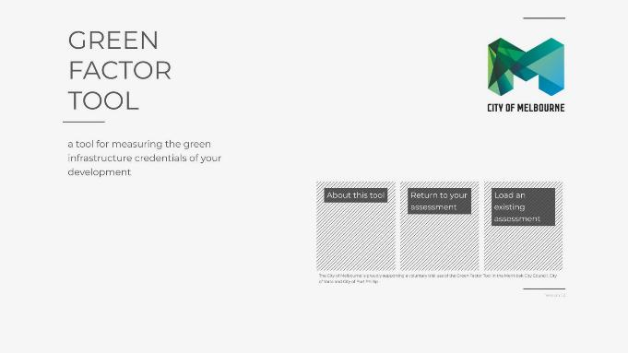

Case Study: The Bruce 14-26 Bruce Street, Kensington

Project summary
Location: 14-26 Bruce Street, Kensington VIC 3031
Development type: Office building
Landscape design: LOCI Design Collective and Nature Based Consulting
Completion date: November 2023
Green Factor score: 0.67
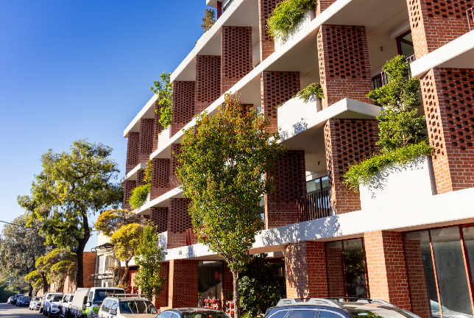
Street view of north elevation showing integration of green infrastructure into the building façade.

Application details

About the site
14-26 Bruce Street, Kensington is a contemporary seven storey office development with onsite car parking. The development features a ‘Tristaniopsis luarina ‘Luscious’ Watergum tree at the main entrance which is complimented by a series of planters on structure that appear in a rhythmic pattern up the façade of the building.
The landscape scheme is crowned with a biodiverse green roof which features two sections of roof top spanning the width of the building located to the north and south of the development. This is split by building services and a solar photovoltaic array which demonstrates multiple sustainability principles can be designed to co-exist and function in an emerging urban environment.
For this case study example, we have adopted the site area provided on the certificate of title which is also the boundary for the planning application.
This project has a site area of 1343 square metres as shown in Figure 1. This site area will be used to calculate the Green Factor score.
Figure 1: 14-26 Bruce Street, Kensington project site boundary. Taken from Appendix 1: Example town planning landscape package submission.
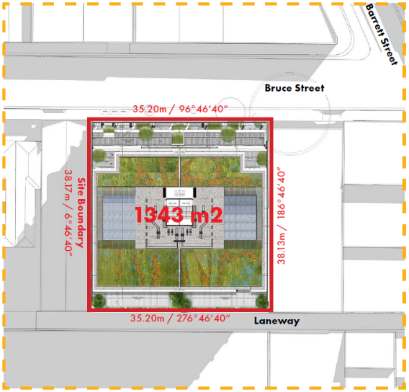

Tips for your Green Factor application:
- The Green Factor tool requires you to provide details about your project site area, location and boundaries, as well as basic specifications of the green infrastructure elements including soil area and plant type, quantities and coverage.
- Keep in mind that the Green Factor tool can be used at different stages of your project.
1. Early concept design: If you’re early in your planning and design process, use the Green Factor tool as part of an iterative process throughout the design phase. Try different inputs to explore how it is possible to increase the quantity (area of greening) and quality (type of green infrastructure inputs) of greening in your project to achieve a high Green Factor score.
2. Final stages of design: If you’re close to lodging your planning application, we recommend having a comprehensive landscape package on hand when using the tool. To achieve a higher Green Factor score, you will likely be focusing on improving the quality of greening (type of green infrastructure inputs) as opposed to making significant changes to the total area of greening within the project site area.
- For typical statutory planning applications, the site area is defined by the certificate of title and associated site boundaries.
- All proposed greening must be located within the site boundary and be external to the building envelope.
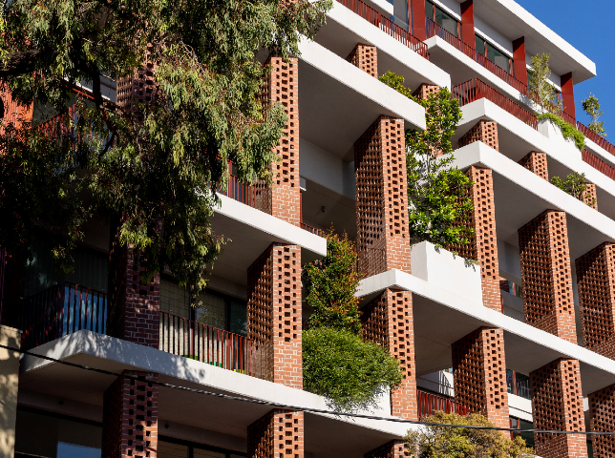
Streetview of north elevation showing green infrastructure between expressed columns.

Green infrastructure elements
Your project’s proposed green infrastructure elements are assigned an ‘area’ for input into the Green Factor tool. The green infrastructure areas relevant to this project are in ground (new), green façade, planters (on structure), and green roof and as described in Table 1.

Green Factor input summary
Figure 2 provides a summary of the green roof inputs submitted for the ‘The Bruce’ project as part of the Green Factor assessment.
The specified green infrastructure elements used here are reflective of the level of detail needed for a Green Factor submission at planning application stage. This includes basic specifications of soil area, plant category, type and coverage, and tree quantities for each area.
Explore the illustrations (Figure 3, Figure 4, Figure 5 and Figure 6) to understand how the green infrastructure elements have been incorporated into the project’s landscape design from a Green Factor perspective.
Table 1: Green infrastructure areas relevant for 14-26 Bruce Street, Kensington.
Green infrastructure area |  | Description
In ground (new) | 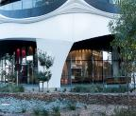 | Proposed green infrastructure growing directly in the ground in either existing or introduced soil of at least 500mm depth.
Green façade | 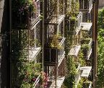 | A green façade is created by growing climbing plants up and across the façade of a building, either from plants grown in garden beds at its base, or by container planting installed at difference levels across the building. Climbing plants can attach directly to the surface of a building or they can be supported on a structure independent of the building.
Planters  (on structure) | 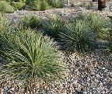 | Planters are on-structure containers consisting of a raised edge with or without a solid base. They can be used at ground level, on balconies or podiums or on roofs. They are different from green roofs and can support small and medium trees with the right soil volume.
Green roof | 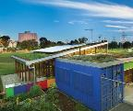 | A green roof is a vegetated landscape built up from a series of layers that are installed on a roof surface. They can be installed layer by layer on the roof (‘loose laid’) or as modular, pre-prepared layers in trays.

Summary of Green Factor inputs
Figure 2: Summary of all greening elements and inputs into the Green Factor tool for ‘The Bruce’, which features green infrastructure areas of in ground (new), green facade, planters (on structure) and a green roof.

Specified Green Infrastructure elements: In ground (new)
Description | Category | Number/Area
Medium tree canopy  (canopy width 6m-10m) | Native | 1 pcs
Small shrub (<1.5m height) | Native | 6 sqm
Ground cover | Native | 5 sqm
Soil or substrate  (over 500mm depth) | Soil | 11 sqm

Specified Green Infrastructure elements: Planters (on structure)
Description | Category | Number/Area
Small shrub (<1.5m height) | Indigenous | 3 sqm
Small tree (canopy width <6m) | Native | 14 pcs
Large shrub (>1.5m height) | Native | 14 sqm
Small shrub (<1.5m height) | Native | 21 sqm
Ground cover | Native | 41 sqm
Large shrub (>1.5m height) | Exotic | 14 sqm
Small shrub (<1.5m height) | Exotic | 7 sqm
Ground cover | Exotic | 3 sqm
Soil or substrate  (over 500mm depth) | Soil | 76 sqm

Specified Green Infrastructure elements: Green façade
Description | Category | Number/Area
Climbers | Native | 94 sqm

Specified Green Infrastructure elements: Green Roof
Description | Category | Number/Area
Small shrub (<1.5m height) | Indigenous | 64 sqm
Ground cover | Indigenous | 128 sqm
Ground cover | Native | 126 sqm
Small shrub (<1.5m height) | Exotic | 16 sqm
Ground cover | Exotic | 64 sqm
Soil or substrate  (200-500mm depth) | Soil | 80 sqm
Soil or substrate  (under 200mm depth) | Soil | 320 sqm

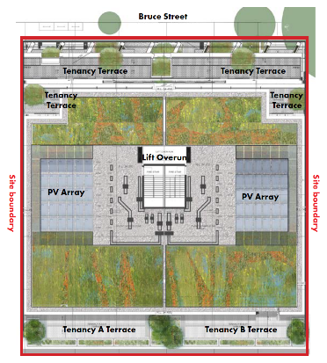

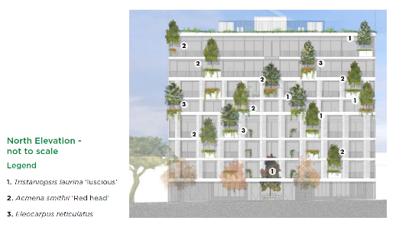
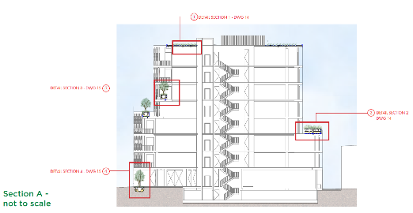

Green infrastructure area: In ground (new)

In ground (new)
This area features a tree, ground cover and small shrubs dispersed at ground floor to the north (entry) and to the south rear car park entries
Across the ground floor vegetation covers 18 square metres.
Figure 3: Illustration of how the green infrastructure elements for ‘In ground (new)’ have been incorporated into the project’s landscape design from a Green Factor perspective.
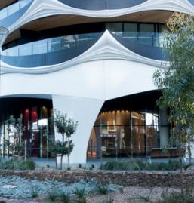

Specified Green Infrastructure elements: In ground (new)
Description | Category | Number/Area
Medium tree canopy  (canopy width 6m-10m) | Native | 1 pcs
Small shrub (<1.5m height) | Native | 6 sqm
Ground cover | Native | 5 sqm
Soil or substrate  (over 500mm depth) | Soil | 11 sqm
By allowing a recessed building entrance at the street front the opportunity for greening exists and the Tristaniopsos laurina ‘Luscious’ medium sized, native tree becomes the focal point and is provided with adequate growing area up through a double height void. The Green Factor tool rewards in ground canopy trees over other forms of greening as the opportunity to improve soil conditions and cool their surrounding area is significant.
The planted area surrounding the tree includes ground cover and small shrubs all of which are visible by building occupants and passers by.
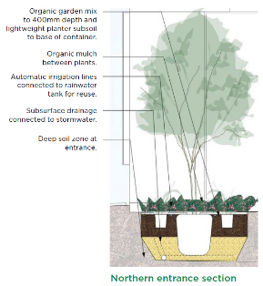
Organic garden mix to 400mm depth and lightweight planter subsoil to base of container.
Organic mulch between plants.
Automatic irrigation lines connected to rainwater tank for reuse.
Subsurface drainage connected to stormwater.
Deep soil zone at entrance.
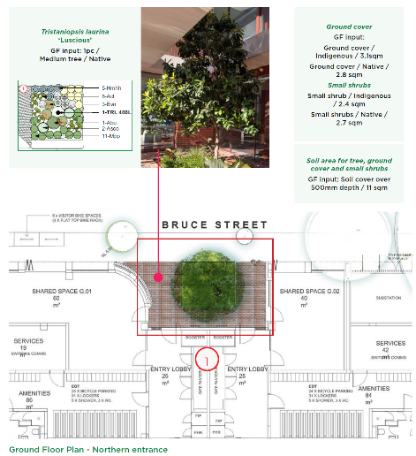

Green infrastructure area: Green façade

Green façade
The landscape design features cascading plants growing from the planters that fill areas within the building’s façade.
The cascading plants have been input as ‘climbers’ that provide 94 square metres of vertical coverage.
Figure 4: Illustration of how the green infrastructure elements for a ‘Green Façade’ have been incorporated into the project’s landscape design from a Green Factor perspective.

Specified Green Infrastructure elements: Green façade
Description | Category | Number/Area
Climbers | Native | 94 sqm

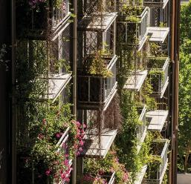

Detail of North Elevation
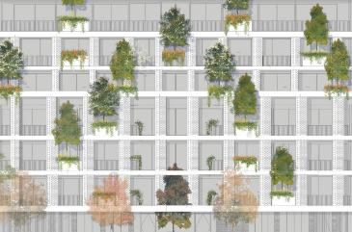

Floor plan level 01
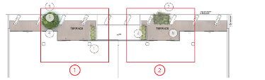

Planting plan detail 01
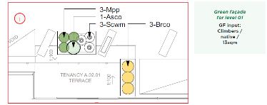

Planting plan detail 02
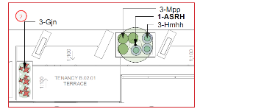

Green infrastructure area: Planters (on structure)

Planters (on structure)
This area features a total of 33 raised planters supporting various small trees, shrubs and ground cover plants.
The planters cover a total area of 76 square metres and feature mainly across the north façade of the building with some located on the terrace to the south elevation.
Figure 5: Illustration of how the green infrastructure elements for ‘Planters (on structure)’ have been incorporated into the project’s landscape design from a Green Factor perspective.

Specified Green Infrastructure elements: Planters (on structure)
Description | Category | Number/Area
Small shrub (<1.5m height) | Indigenous | 3 sqm
Small tree (canopy width <6m) | Native | 14 pcs
Large shrub (>1.5m height) | Native | 14 sqm
Small shrub (<1.5m height) | Native | 21 sqm
Ground cover | Native | 41 sqm
Large shrub (>1.5m height) | Exotic | 14 sqm
Small shrub (<1.5m height) | Exotic | 7 sqm
Ground cover | Exotic | 3 sqm
Soil or substrate  (over 500mm depth) | Soil | 76 sqm

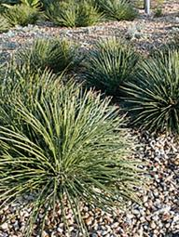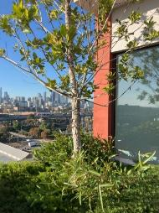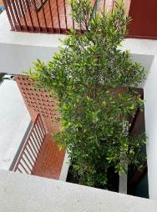

Floor plan level 01
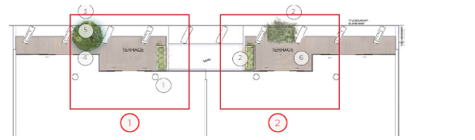

Planting Plan Detail 01
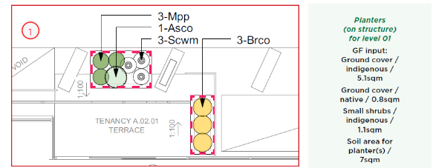

Planting Plan Detail 02
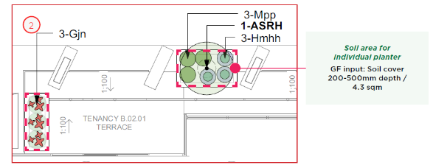

Green infrastructure area: Green roof

Green roof
The landscape design features 287.1 square metres of green roof area covered with lawn and predominantly indigenous shrubs and ground cover plants.
Figure 6: Illustration of how the green infrastructure elements for ‘Green Roof’ have been incorporated into the project’s landscape design from a Green Factor perspective.

Specified Green Infrastructure elements: Green Roof
Description | Category | Number/Area
Small shrub (<1.5m height) | Indigenous | 64 sqm
Ground cover | Indigenous | 128 sqm
Ground cover | Native | 126 sqm
Small shrub (<1.5m height) | Exotic | 16 sqm
Ground cover | Exotic | 64 sqm
Soil or substrate  (200-500mm depth) | Soil | 80 sqm
Soil or substrate  (under 200mm depth) | Soil | 320 sqm
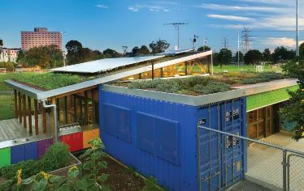
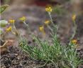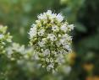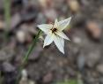
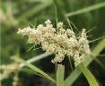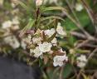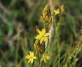

Rooftop Planting Plan
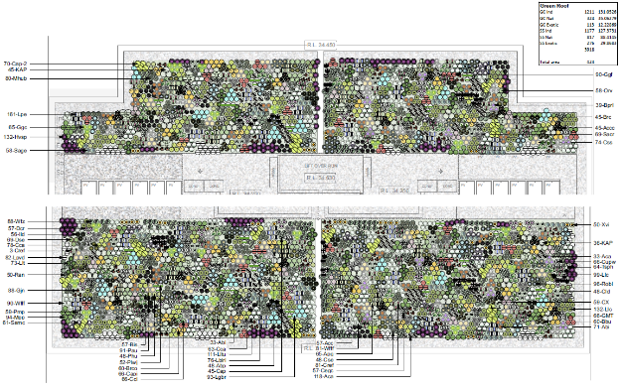

Green Factor landscape package
See Appendix 1 for the example town planning landscape package submission 14-26 Bruce Street, Kensington as part of a Green Factor tool assessment.
This package provides an example of a satisfactory landscape package submission.
Given that this project has been completed, we have also included detailed as-built planting plans and lists in Appendix 1 to support this case study. The level of detail that you submit at planning application stage may not be as comprehensive and complete.
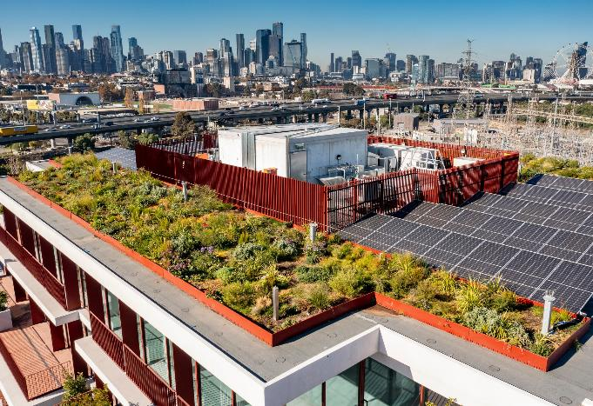

Green Factor scorecard
14-26 Bruce Street, Kensington achieved a Green Factor score of 0.67. This exceeds the requirement to achieve a Green Factor score of 0.55.
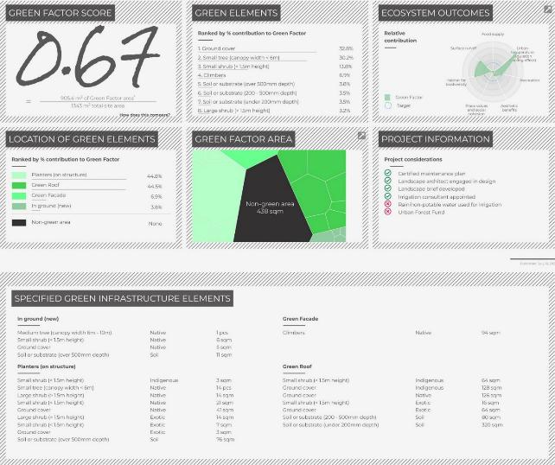

Appendix 1: Example town planning landscape package submission
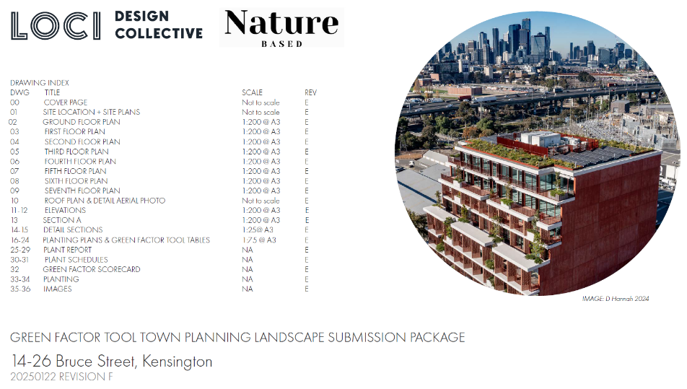

Site location and site plan
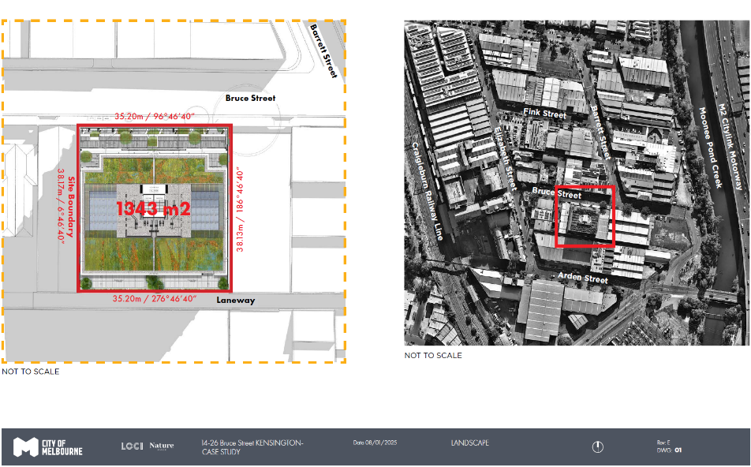

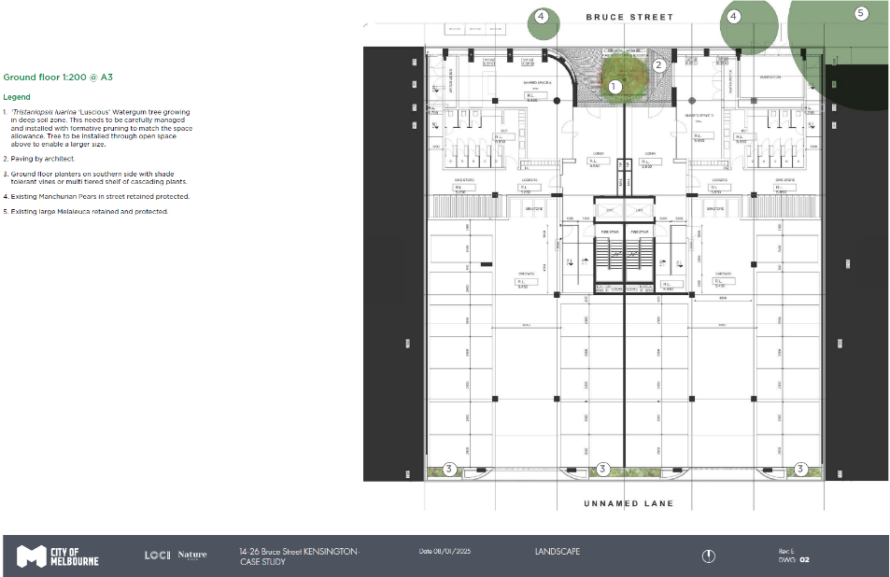
Ground Floor Plan

First Floor Plan
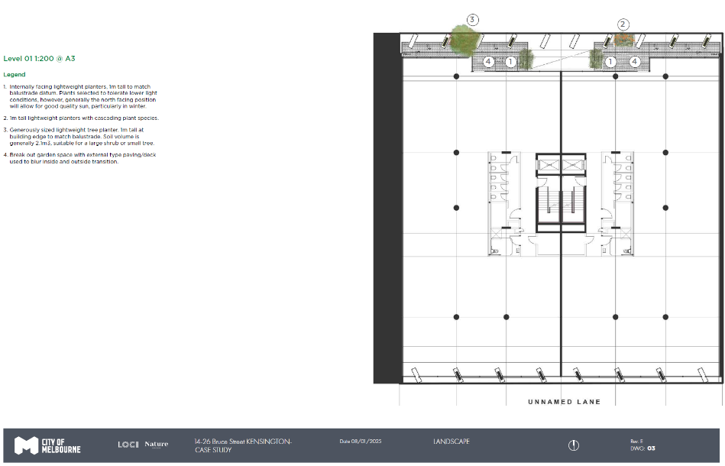

Second Floor Plan
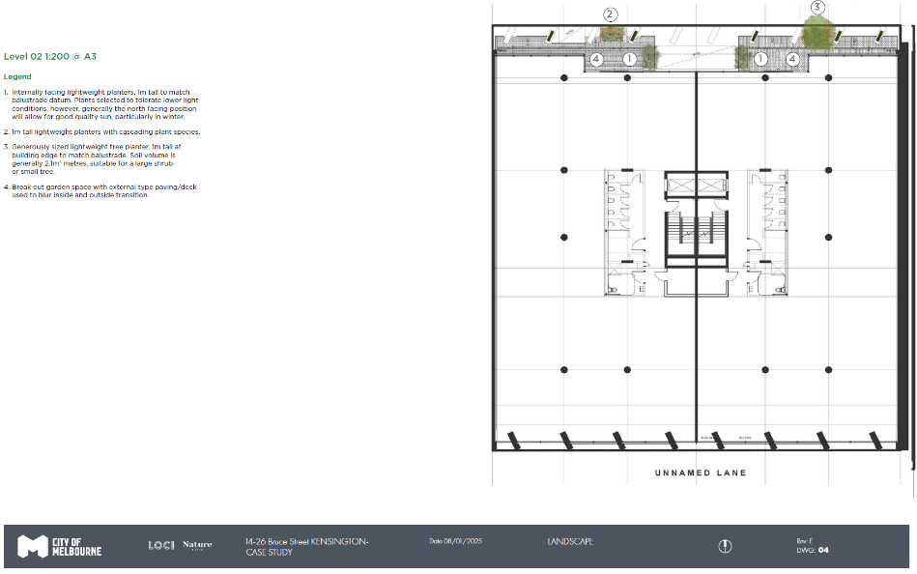

Third Floor Plan
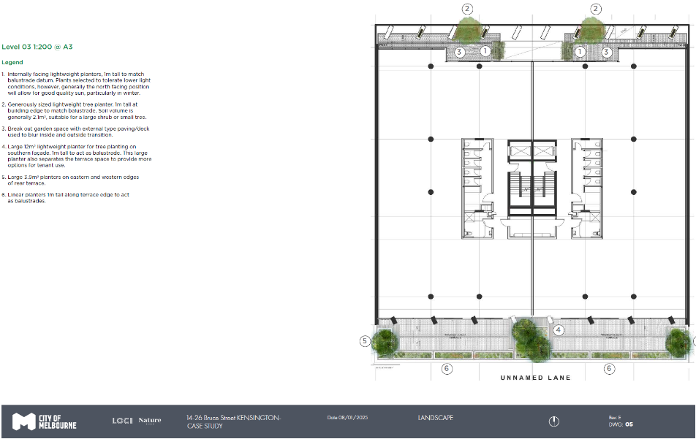

Fourth Floor Plan
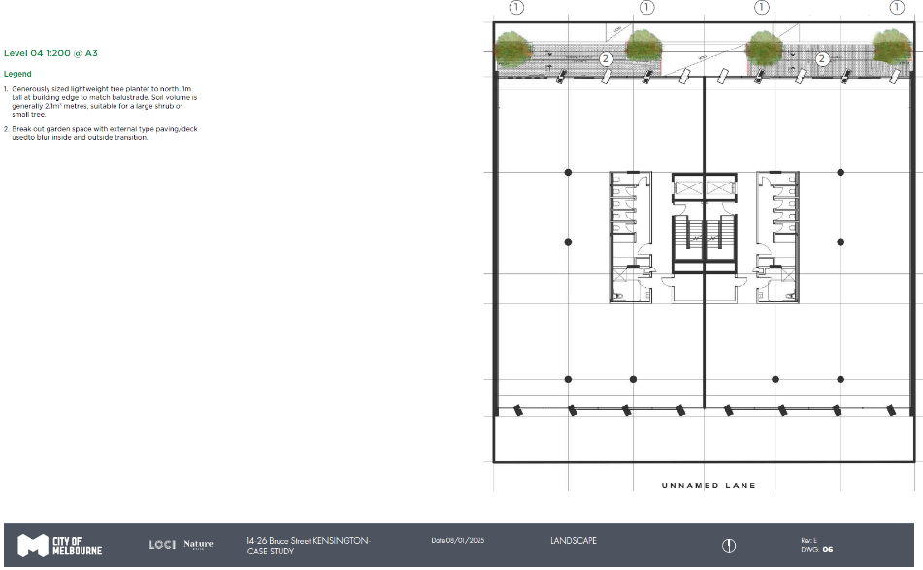

Fifth Floor Plan
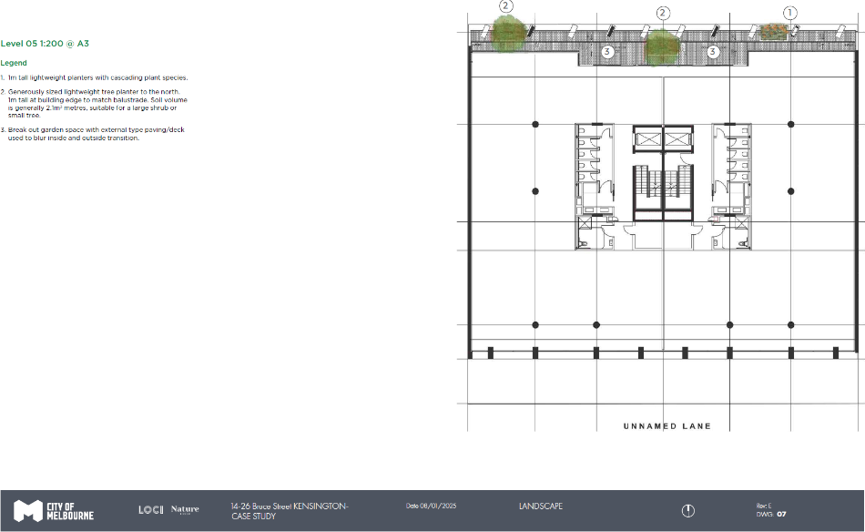

Sixth Floor Plan
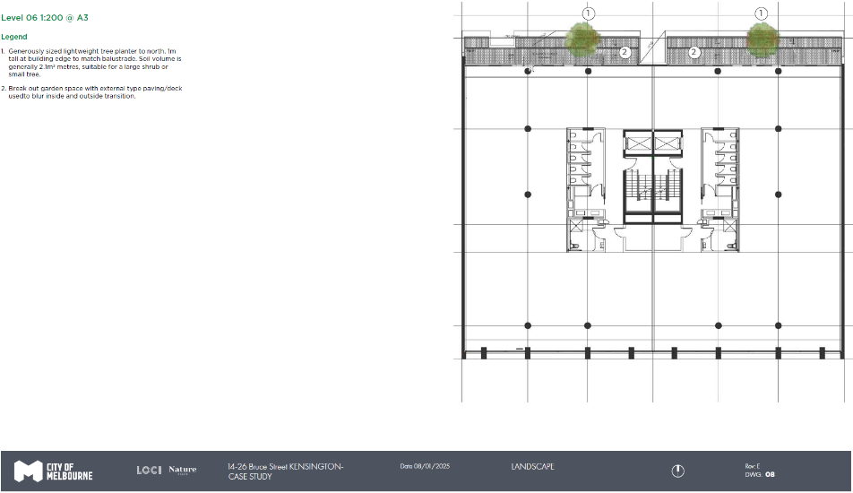

Seventh Floor Plan
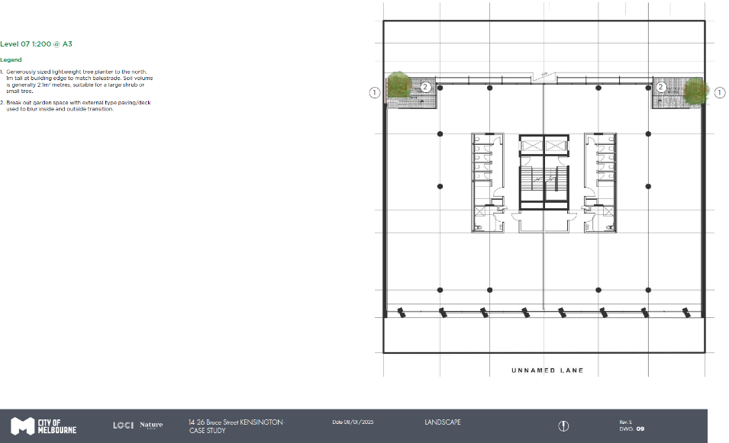

Roof Plan Detail and Aerial Photo
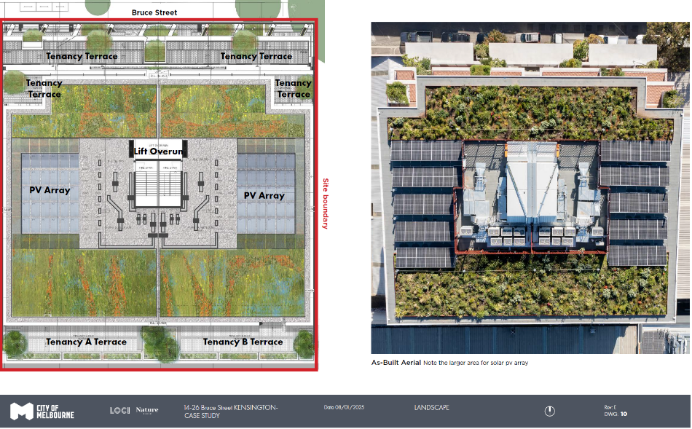

Elevations
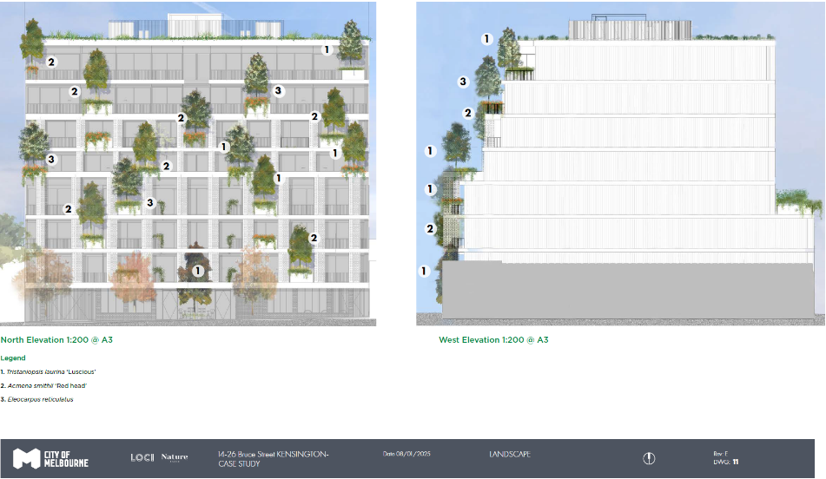

Elevations
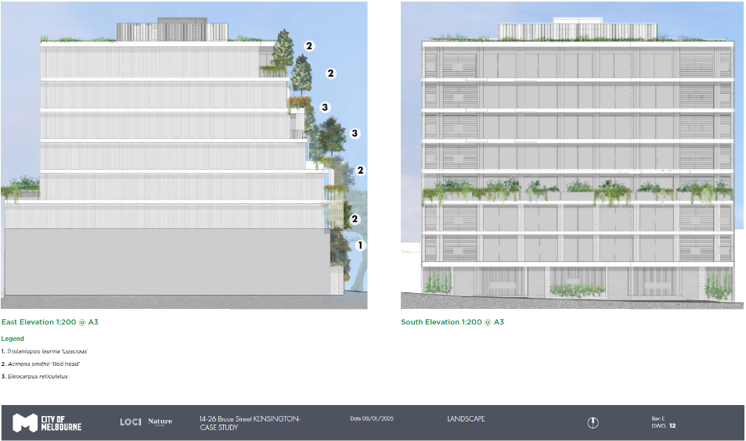

Section A
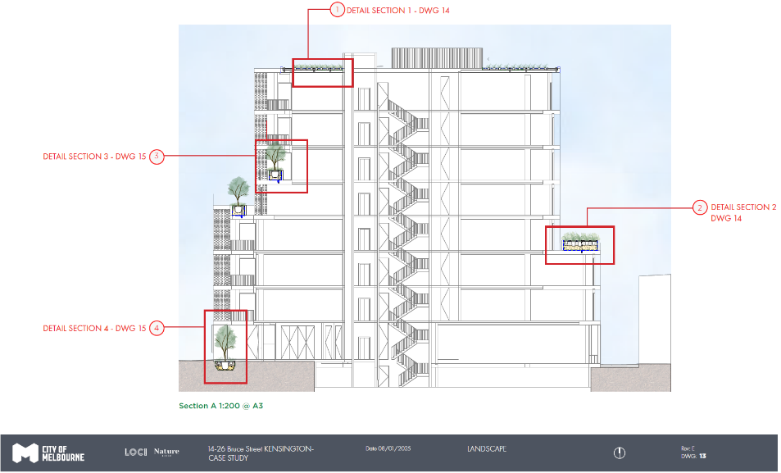

Detail Sections
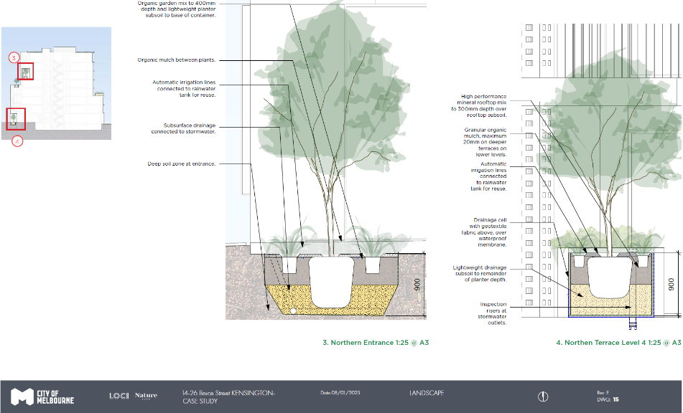

Planting plan and Green Factor tool table - Ground floor
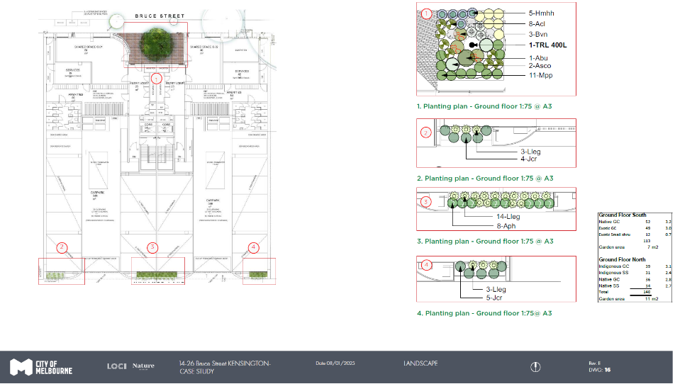

Planting plan and Green Factor tool table - Level 1
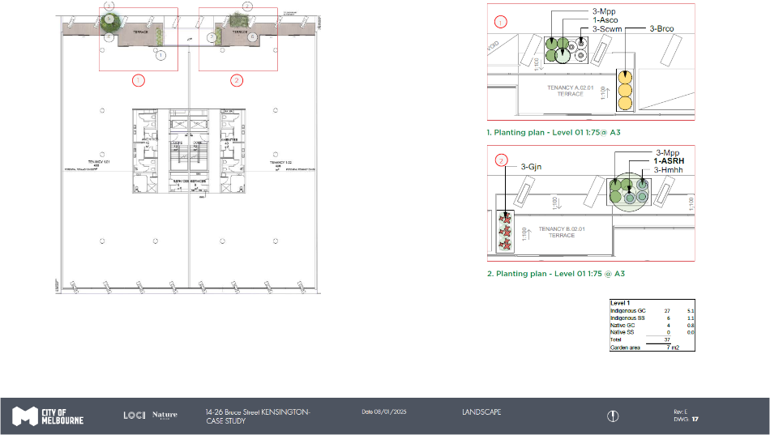

Planting plan and Green Factor tool table - Level 2
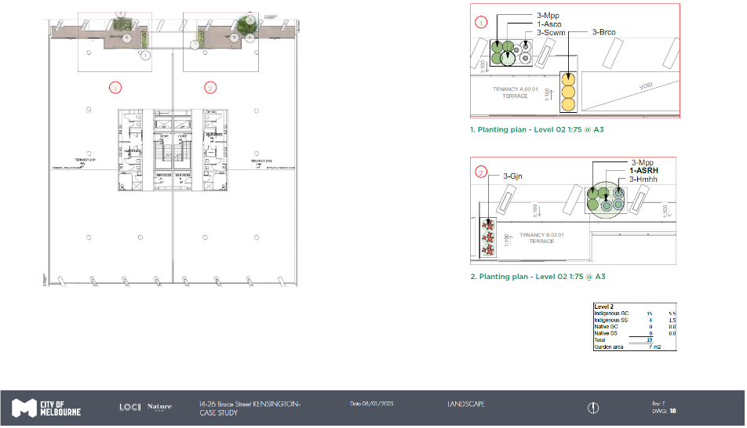

Planting plan and Green Factor tool table - Level 3
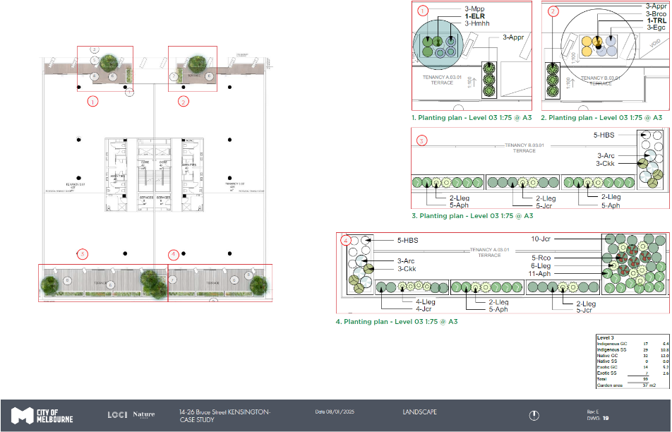

Planting plan and Green Factor tool table - Level 4
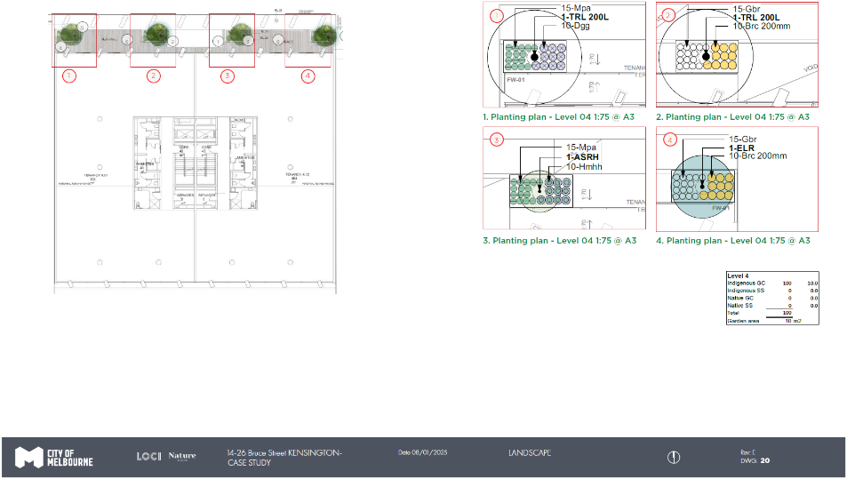

Planting plan and Green Factor tool table - Level 5
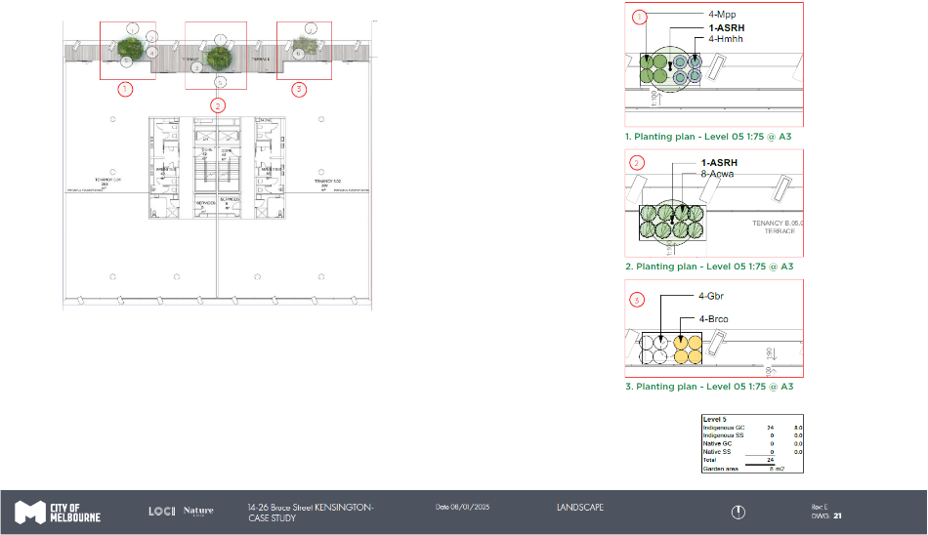

Planting plan and Green Factor tool table - Level 6
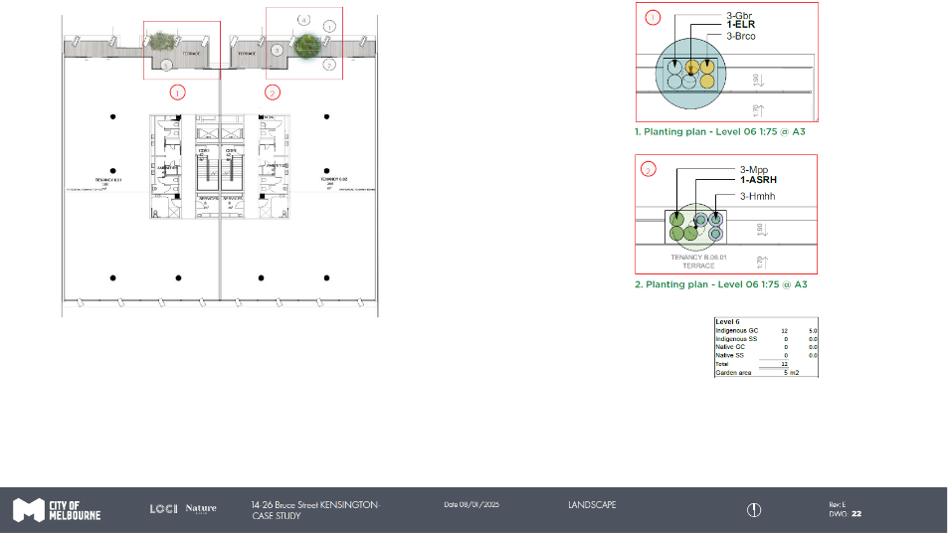

Planting plan and Green Factor tool table - Level 7
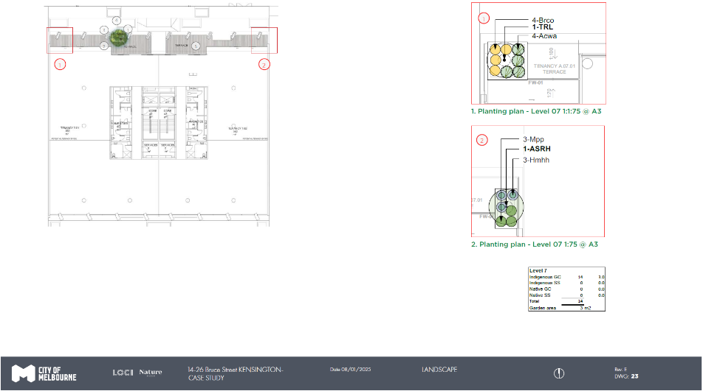

Planting plan and Green Factor tool table - Rooftop
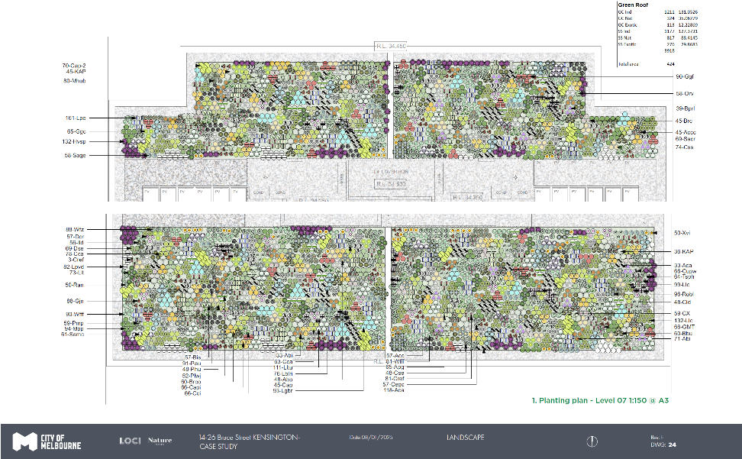

Plant Report

Trees and tall shrubs
Image | Description
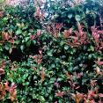 | Code: ASRH  Botanical Name: Acmena smithii ‘Red head’  Common Name: Lilly Pilly  Size: Height 2.0m x Spread 4.0m
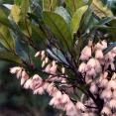 | Code: ELR  Botanical Name: Elaeocarpus reticulatus  Common Name: Blueberry Ash  Size: Height 9.0m x Spread 4.0m
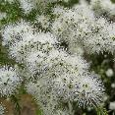 | Code: KAP  Botanical Name: Kunzea ambigua  Common Name: Tick bush  Size: Height 5.0m x Spread 3.0m
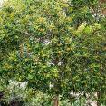 | Code: TRL  Botanical Name: Tristaniopsis laurina ‘Luscious’  Common Name: Watergum  Size: Height 7-12.0m x Spread 5.0m

Grassy and strappy plants
Image | Description
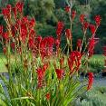 | Code: Abi  Botanical Name: Anigozanthos ‘Bush inferno’  Common Name: Kangaroo Paw  Size: Height 0.6m x Spread 0.5m
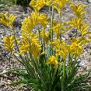 | Code: Abz  Botanical Name: Anigozanthos ‘Bush Zest’  Common Name: Kangaroo Paw  Size: Height 0.6m x Spread 0.5m
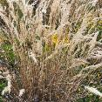 | Code: Aca  Botanical Name: Austrodanthonia caespitosa  Common Name: Wallaby Grass  Size: Height 0.9m x Spread 0.5m
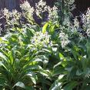 | Code: Arc  Botanical Name: Arthropodium cirratum  Common Name: Renga renga lily  Size: Height 0.6m x Spread 0.6m
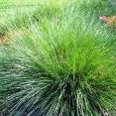 | Code: Lco  Botanical Name: Lomandra ‘Crackerjack’’  Common Name: Mat rush  Size: Height 0.6m x Spread 0.6m
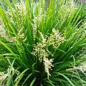 | Code: Lhy  Botanical Name: Lomandra hystrix  Common Name: Mat rush  Size: Height 1.0m x Spread 1.0m
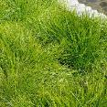 | Code: Llc  Botanical Name: Lomandra ‘Little Con’  Common Name: Mat rush  Size: Height 0.3m x Spread 0.3m
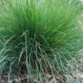 | Code: Lleg  Botanical Name: Lomandra ‘Emerald Grace’  Common Name: Mat rush  Size: Height 0.4m x Spread 0.4m
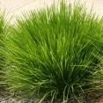 | Code: LLL  Botanical Name: Lomandra ‘Little Lime’  Common Name: Mat rush  Size: Height 0.3m x Spread 0.3m
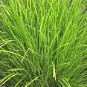 | Code: Lltu  Botanical Name: Lomandra ‘Lime tuff’  Common Name: Mat rush  Size: Height 0.6m x Spread 0.6m

Shrubs
Image | Description
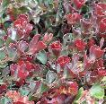 | Code: Accc  Botanical Name: Adenanthos cuneatus  Common Name: Jug Flower  Size: Height 2.0m x Spread 2.0m
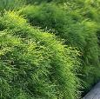 | Code: Ad  Botanical Name: Acacia ‘Limelight’  Common Name: River Wattle  Size: Height 1.2m x Spread 1.0m
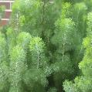 | Code: Asco  Botanical Name: Adenanthos sericea Compact  Common Name: Dwarf woolly Bush  Size: Height 1.2m x Spread 1.2m
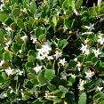 | Code: Abu  Botanical Name: Alyxia buxifolia  Common Name: Sea box  Size: Height 1-2.0m x Spread 2-4.0m
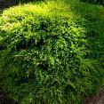 | Code: Bvn  Botanical Name: Baeckea virgata Dwarf Form  Common Name: Dwarf Heath Myrtle  Size: Height 1-1.5.0m x Spread 1-1.5.0m
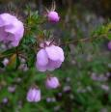 | Code: Brc  Botanical Name: Bauera rubioides  Common Name: River Rose  Size: Height 1.5m x Spread 1.0m
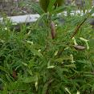 | Code: Bis  Botanical Name: Billardiera scandens  Common Name: Apple berry  Size: Height 1.5m x Spread 3.0m
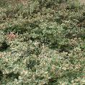 | Code: Cap  Botanical Name: Correa alba prostrate  Common Name: Prostrate White Correa  Size: Height 0.3m x Spread 2.0m
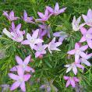 | Code: Cld  Botanical Name: Crowea exalata ‘Green Capre’  Common Name: Waxflower  Size: Height 0.5m x Spread 0.8m
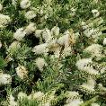 | Code: Cca  Botanical Name: Callistemon citrinus ‘White Anzac’  Common Name: Bottlebrush  Size: Height 0.5m x Spread 3.0m
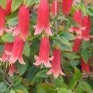 | Code: Cref  Botanical Name: Correa reflexa  Common Name: Native Fuchsia  Size: Height 1.2m x Spread 1.0m
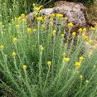 | Code: Cse  Botanical Name: Chrysocephalum semipapposum  Common Name: Clustered everlasting  Size: Height 0.6-1.0m x Spread 0.6-1.0m
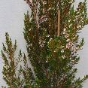 | Code: Cupw  Botanical Name: Chamelaucium ‘Festive red’  Common Name: Wax flower festive red  Size: Height 1.5m x Spread 1.5m
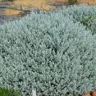 | Code: Egc  Botanical Name: Eremophila glabra ‘compactum’  Common Name: Emu bush  Size: Height 0.5m x Spread 1.5m
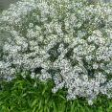 | Code: Emp  Botanical Name: Eriostemon myoporoides ‘Profusion’  Common Name: Long leaf wax flower  Size: Height 1.0m x Spread 1.0m
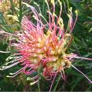 | Code: Gfg  Botanical Name: Grevillea ‘Winpara Gold’  Common Name: Grevillea  Size: Height 2.0m x Spread 2.0m
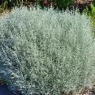 | Code: Lbr  Botanical Name: Leucophyta brownii  Common Name: Cushion bush  Size: Height 1.2m x Spread 1.2m
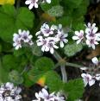 | Code: Pau  Botanical Name: Pelargonium australe  Common Name: Native Geranium  Size: Height 0.5m x Spread 0.5m
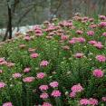 | Code: Pif  Botanical Name: Pimelea ferruginea  Common Name: Rice Flower  Size: Height 1.2m x Spread 1.0m
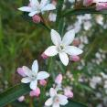 | Code: Pmp  Botanical Name: Philotheca myoporoides ‘Profusion’  Common Name: Wax flower  Size: Height 1.0m x Spread 1.0m
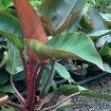 | Code: Prc  Botanical Name: Philodendron ‘Rojo congo’  Common Name: Philodendron  Size: Height 1.0m x Spread 1.0m
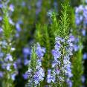 | Code: Robl  Botanical Name: Rosmarinus officinalis ‘Blue Lagoon’  Common Name: Rosemary  Size: Height 1.0m x Spread 1.0m
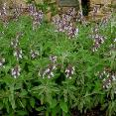 | Code: Sof  Botanical Name: Salvia officinalis  Common Name: Sage  Size: Height 0.9m x Spread 0.9m
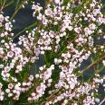 | Code: Tsph  Botanical Name: Thryptomene saxicola ‘FC Payne’  Common Name: Thryptomene  Size: Height 1.5m x Spread 1.5m
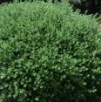 | Code: Wfz  Botanical Name: Westringia fruticosa ‘Zena’  Common Name: Coastal Rosemary  Size: Height 2.0m x Spread 2.0m
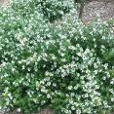 | Code: WfLH  Botanical Name: Westringia fruticosa ‘Zena’  Common Name: Coastal Rosemary  Size: Height 0.3m x Spread 0.7m
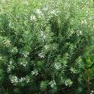 | Code: Wfg  Botanical Name: Westringia fruticosa  Common Name: Coastal Rosemary  Size: Height 2.0m x Spread 0.4m

Cascading, trailing and climbing plants
Image | Description
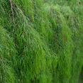 | Code: Acw  Botanical Name: Acacia ‘Waterfall’  Common Name: River Wattle  Size: Height 0.3m x Spread 2.0m
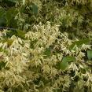 | Code: Aph  Botanical Name: Aphanopetalum resinosum  Common Name: Gumvine  Size: Height 3.0m x Spread 3.0m
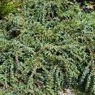 | Code: Appr  Botanical Name: Acacia baileyana ‘Prostrate’  Common Name: Cootamundra Wattle  Size: Height 0.6m x Spread 3.0m
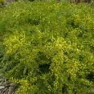 | Code: Apg  Botanical Name: Acacia ‘Wattle Pot O Gold’  Common Name: Wattle  Size: Height 0.4m x Spread 4.0m
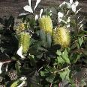 | Code: Brco  Botanical Name: Banksia integrifolia ‘Rollercoaster’  Common Name: Banksia  Size: Height 0.4m x Spread 4.0m
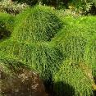 | Code: Cci  Botanical Name: Casuarina ‘Cousin it’  Common Name: Cousin it  Size: Height 0.2m x Spread 2.0m
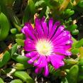 | Code: Dcr  Botanical Name: Disphyma crassifolium  Common Name: Rounded noon flower  Size: Height 0.3m x Spread 1.0m
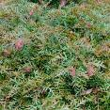 | Code: Gbr  Botanical Name: Grevillea ‘Bronze rambler’  Common Name: Grevillea  Size: Height 0.5m x Spread 0.5m
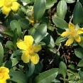 | Code: HBS  Botanical Name: Hibbertia scandens  Common Name: Guinea flower  Size: Height 3.0m x Spread 5.0m
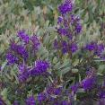 | Code: Hmhh  Botanical Name: Hardenbergia ‘Mini Haha’  Common Name: Hardenbergia  Size: Height 0.3m x Spread 0.1m
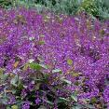 | Code: Hvsp  Botanical Name: Hardenbergia ‘Sea of purple’  Common Name: Hardenbergia  Size: Height 0.3m x Spread 0.1m
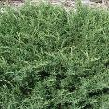 | Code: Jcr  Botanical Name: Juniperus communis ‘Repanda’  Common Name: Prostrate juniper  Size: Height 0.3m x Spread 2.0m
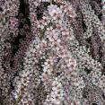 | Code: Scwc  Botanical Name: Leptospermum ‘Pink cascade’  Common Name: Tea tree  Size: Height 0.8m x Spread 1.5m
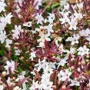 | Code: Mpp  Botanical Name: Myoporum parvifolium ‘Purpurea’  Common Name: Creeping boobialla  Size: Height 0.3m x Spread 2.0m

Ground covers
Image | Description
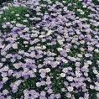 | Code: Bprl  Botanical Name: Brachyscome ‘Mauve delight’  Common Name: Native Daisy  Size: Height 0.3m x Spread 0.6m
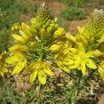 | Code: Bbu  Botanical Name: Bulbine bulbosa  Common Name: Bulbine Lily  Size: Height 0.8m x Spread 0.5m
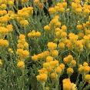 | Code: Capi  Botanical Name: Chrysocephalum apiculatum  Common Name: Yellow buttons  Size: Height 0.3m x Spread 0.5m
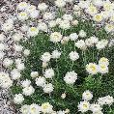 | Code: Cap-2  Botanical Name: Chrysocephalum baxteri  Common Name: Fringed everlasting  Size: Height 0.4m x Spread 0.4m
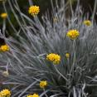 | Code: Css  Botanical Name: Conostylis candicans  Common Name: Cotton heads  Size: Height 0.8m x Spread 0.8m
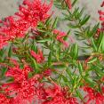 | Code: Gjn  Botanical Name: Grevillea juniperina ‘New blood’  Common Name: Grevillea  Size: Height 0.25m x Spread 1.5m
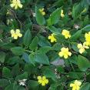 | Code: Ggc  Botanical Name: Goodenia ovata ‘Gold cover’  Common Name: Goodenia  Size: Height 0.3m x Spread 2.0m
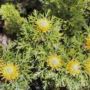 | Code: Ild  Botanical Name: Isopogon ‘Little Drumstick’  Common Name: Drumsticks  Size: Height 0.7m x Spread 0.8m
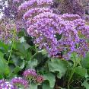 | Code: Lpe  Botanical Name: Limonium perezii  Common Name: Sea lavender  Size: Height 0.6m x Spread 0.6m
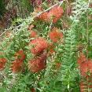 | Code: Mhub  Botanical Name: Melaleuca ‘Ulladulla Beacon’  Common Name: Honey Myrtle  Size: Height 0.5m x Spread 2.0m
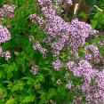 | Code: Orv  Botanical Name: Origanum vulgare  Common Name: Oregano  Size: Height 0.6m x Spread 0.6m
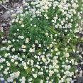 | Code: Ran  Botanical Name: Rhodanthe anthemoides  Common Name: Chamomile Sunray  Size: Height 0.5m x Spread 1.0m
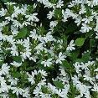 | Code: Scwc  Botanical Name: Scaevola ‘Bondi White’  Common Name: Fairy Fan-flower  Size: Height 0.2m x Spread 0.4m
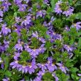 | Code: SaPF  Botanical Name: Scaevola ‘Purple Fanfair’  Common Name: Fairy Fan-flower  Size: Height 0.2m x Spread 0.4m
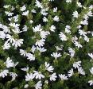 | Code: SaWC  Botanical Name: Scaevola ‘White Carpet’  Common Name: Fairy Fan-flower  Size: Height 0.2m x Spread 0.4m

Plant Schedule Green Roof
ID | Botanical name | Common name | Green Factor Vegetation Type | Origin | Mature Height (m) | Mature Width (m) | In Ground (existing) Quantity | In ground (new) Quantity | Green Wall Quantity | Green Façade Quantity | Planters (on structure) Quantity | Green roof Quantity
Jcr | Juniperus communis 'Repanda' | Carpet Juniper | Ground Cover | Exotic | 0.4 | 2 |  |  |  |  |  | 17
Orv | Origanum vulgare | Pot Marjoram, Oregano | Ground Cover | Exotic | 0.2 | 1 |  |  |  |  |  | 58
Lpe | Limonium perezii | Sea Lavender | Ground Cover | Exotic | 0.5 | 0.5 |  |  |  |  |  | 160
Aca | Austrodanthonia caespitosa | Wallaby Grass | Ground Cover | Indigenous | 0.5 | 0.4 |  |  |  |  |  | 151
Bbu | Bulbine bulbosa | Bulbine Lily | Ground Cover | Indigenous | 0.3 | 0.3 |  |  |  |  |  | 100
Brco | Banksia integrifolia 'Roller Coaster' | Prostrate Coast Banksia | Ground Cover | Indigenous | 0.3 | 3 |  |  |  |  |  | 44
Ggc | Goodenia ovata 'Gold cover' | Goodenia | Ground Cover | Indigenous | 0.3 | 2 |  |  |  |  |  | 65
Llc | Lomandra 'Little Con' | Little Con Mat Rush | Ground Cover | Indigenous | 0.3 | 0.2 |  |  |  |  |  | 200
Mpp | Myoporum parvifolium 'Purpurea' | Creeping Boobialla | Ground Cover | Indigenous | 0.3 | 2 |  |  |  |  |  | 94
HBS | Hibbertia scandens | Snake Vine | Ground Cover | Indigenous | 0.3 | 1 |  |  |  |  |  | 10
KAP | Kunzea ambigua | Prostrate Tick Bush | Ground Cover | Indigenous | 0.4 | 1.5 |  |  |  |  |  | 81
Lltu | Lomandra 'Lime Tuff' | Lime tuff Mat Rush | Ground Cover | Indigenous | 0.3 | 0.3 |  |  |  |  |  | 111
LLL | Lomandra 'Little Lime' | Little Lime Mat Rush | Ground Cover | Indigenous | 0.5 | 0.7 |  |  |  |  |  | 73
SaPF | Scaevola aemula 'Purple Fanfare' | Scaevola Purple Fanfare | Ground Cover | Indigenous | 0.3 | 1.5 |  |  |  |  |  | 69
SaWC | Scaevola albida 'White Carpet' | Scaevola White Carpet | Ground Cover | Indigenous | 0.3 | 1.5 |  |  |  |  |  | 20
Capi | Chrysocephalum apiculatum | Yellow Buttons | Ground Cover | Indigenous | 0.4 | 0.3 |  |  |  |  |  | 100
Cap-2 | Chrysocephalum baxteri | Fringed Everlasting | Ground Cover | Indigenous | 0.3 | 0.3 |  |  |  |  |  | 70
Cap | Correa alba prostrate | White Correa | Ground Cover | Indigenous | 0.3 | 1.2 |  |  |  |  |  | 45
Dcr | Disphyma crassifolium | Rounded Noon-flower | Ground Cover | Indigenous | 0.4 | 0.6 |  |  |  |  |  | 57
Ran | Rhodanthe anthemoides | Chamomile Sunray | Ground Cover | Indigenous | 0.2 | 0.3 |  |  |  |  |  | 50
Ggf | Grevillea 'Winpara Gold' | Compact Grevillea | Ground Cover | Indigenous | 0.5 | 1.5 |  |  |  |  |  | 90
Gjn | Grevillea juniperina ‘New Blood’ | Grevillea juniperina ‘New Blood’ | Ground Cover | Indigenous | 0.5 | 1.5 |  |  |  |  |  | 94
Aph | Aphenopetalum resinosum | Gum Vine | Ground Cover | Native | 0.5 | 2 |  |  |  |  |  | 34
Bvn | Babingtonia virgata nana | Dwarf Baeckia | Ground Cover | Native | 0.5 | 2 |  |  |  |  |  | 3
Cca | Callistemon citrinus 'Anzac' | White Anzac Bottlebrush | Ground Cover | Native | 0.5 | 1.5 |  |  |  |  |  | 141
Cci | Casuarina glauca 'Cousin It' | Cousin It | Ground Cover | Native | 0.5 | 2 |  |  |  |  |  | 66
Bprl | Brachysome multifida 'Mauve Delight' | Cut leaf Daisy | Ground Cover | Native | 0.3 | 0.2 |  |  |  |  |  | 39
Css | Conostylis candicans 'Silver Sunrise' | Grey Cottonheads | Ground Cover | Native | 0.3 | 0.5 |  |  |  |  |  | 80
Cse | Chrysocephalum semipapposum | Clustered Everlasting | Ground Cover | Native | 0.2 | 0.4 |  |  |  |  |  | 32
WfLH | Westringia fruticosa 'Low Horizon' | Coastal Rosemary Low Horizon | Ground Cover | Native | 0.3 | 0.8 |  |  |  |  |  | 171
Robl | Rosmarinus officinalis 'Blue lagoon' | Blue Lagoon Rosemary | Small Shrub | Exotic | 0.8 | 1.5 |  |  |  |  |  | 96
Sof | Salvia officinalis | Sage | Small Shrub | Exotic | 1 | 1.5 |  |  |  |  |  | 58
Hvsp | Hardenbergia violacea ‘Sea of Purple’ | Sea of Purple Hardenbergia | Small Shrub | Indigenous | 0.6 | 1 |  |  |  |  |  | 100
Lco | Lomandra confertifolia rubiginosa 'Crackerjack' | Crackerjack Mat Rush | Small Shrub | Indigenous | 0.7 | 1 |  |  |  |  |  | 40
Lhy | Lomandra hystrix | Green Mat Rush | Small Shrub | Indigenous | 1 | 0.6 |  |  |  |  |  | 53
Lpvd | Leptospermum polygalifolium ‘Pink Cascade' | Prostrate Tea Tree | Small Shrub | Indigenous | 1.2 | 2 |  |  |  |  |  | 80
Bis | Billardiera scandens | Apple Berry | Small Shrub | Indigenous | 1.4 | 1.5 |  |  |  |  |  | 57
Pau | Pelargonium australe | Coastal Geranium | Small Shrub | Indigenous | 0.6 | 1.4 |  |  |  |  |  | 100
Apg | Acacia acinacea 'Pot o' gold' | Gold Dust Wattle | Small Shrub | Indigenous | 1.4 | 1 |  |  |  |  |  | 80
Acl | Acacia cognata 'Limelight' | River Wattle | Small Shrub | Indigenous | 1 | 1 |  |  |  |  |  | 20
Pmp | Philotheca myoporoides 'Profusion' | Wax Flower | Small Shrub | Indigenous | 1.2 | 1.5 |  |  |  |  |  | 62
Accc | Adenanthos cuneatus | Woolly Bush | Small Shrub | Indigenous | 1.4 | 1 |  |  |  |  |  | 23
Abi | Anigozanthos 'Bush Inferno' | Kangaroo paw | Small Shrub | Indigenous | 0.6 | 0.5 |  |  |  |  |  | 33
Abz | Anigozanthos 'Bush Zest' | Kangaroo paw | Small Shrub | Indigenous | 0.6 | 0.5 |  |  |  |  |  | 100
Cref | Correa reflexa | Native Fuchsia | Small Shrub | Indigenous | 1.4 | 1 |  |  |  |  |  | 52
Tsph | Thryptomene saxicola 'Payne's Hybrid' | Payne's Thryptomene | Small Shrub | Indigenous | 1.2 | 1.3 |  |  |  |  |  | 64
Mhub | Melaleuca hypericifolia 'Ulladulla Beacon' | Honey Myrtle | Small Shrub | Native | 0.8 | 2 |  |  |  |  |  | 80
Wfz | Westringia fruticosa 'Zena' | Coastal Rosemary | Small Shrub | Native | 1.4 | 1.5 |  |  |  |  |  | 88
Brc | Bauera rubiodes 'Rose Carpet' | Dog Rose | Small Shrub | Native | 0.6 | 0.8 |  |  |  |  |  | 3
Cupw | Chamalauceum uncinatum ‘Festive Red’ | Festive Red Geraldton Wax | Small Shrub | Native | 1.4 | 1 |  |  |  |  |  | 100
Cld | Crowea exalata | Crowea | Small Shrub | Native | 1.4 | 1.5 |  |  |  |  |  | 100
Ild | Isopogon aneminofolius 'Little Drumsticks' | Little Drumsticks | Small Shrub | Native | 0.7 | 1 |  |  |  |  |  | 56
Pif | Pimelea ferruginea | Pink Rice Flower | Small Shrub | Native | 1 | 0.6 |  |  |  |  |  | 148

Plant Schedule Ground Floor Access

Northern Façade
ID | Botanical name | Common name | Green Factor Vegetation Type | Origin | Mature Height (m) | Mature Width (m) | In Ground (existing) Quantity | In ground (new) Quantity | Green Wall Quantity | Green Façade Quantity | Planters (on structure) Quantity
Brco | Banksia integrifolia 'Roller Coaster' | Prostrate Coast Banksia | Ground Cover/Cascader | Indigenous | 0.3 | 3 |  |  |  | 46
Mpp | Myoporum parvifolium 'Purpurea' | Creeping Boobialla | Ground Cover/Cascader | Indigenous | 0.2 | 1.8 |  |  |  | 60
Gbr | Grevillea 'Bronze Rambler' | Prostrate Grevillea | Ground Cover/Cascader | Indigenous | 0.4 | 2 |  |  |  | 37
Acwa | Acacia cognate 'Waterfall' | Waterfall River Wattle | Ground Cover/Cascader | Indigenous | 0.4 | 1 |  |  |  | 12
Scwc | Scaevola albida 'Bondi White' | Scaevola White Carpet | Ground Cover/Cascader | Indigenous | 0.3 | 1.5 |  |  |  | 13
Appr | Acacia pravissima 'Prostrate' | Wattle | Ground Cover/Cascader | Indigenous | 0.4 | 1.5 |  |  |  |  | 9
Gjn | Grevillea juniperina ‘New Blood’ | Grevillea juniperina ‘New Blood’ | Ground Cover/Cascader | Indigenous | 0.5 | 1.5 |  |  |  |  | 3
Bvn | Babingtonia virgata ‘Nana’ | Dwarf Baeckia | Ground Cover/Cascader | Native | 0.5 | 2 |  |  |  | 4
Accc | Adenanthos cuneatus | Woolly Bush | Small Shrub | Indigenous | 1.5 | 1 |  |  |  |  | 3
Asco | Adenanthos sericeus compacta | Dwarf Woolly Bush | Small Shrub | Indigenous | 0.9 | 1 |  |  |  |  | 1
Egc | Eremophila glabra compact | Emu Bush | Small Shrub | Indigenous | 0.6 | 1 |  |  |  |  | 3
Hmhh | Hardenbergia violacea ‘Mini Haha' | Sea of Purple Hardenbergia | Small Shrub/Cascader | Indigenous | 0.6 | 1 |  |  |  | 33
ELR | Elaeocarpus reticulatus | Blueberry Ash | Small Tree | Indigenous | 5 | 3 |  |  |  |  | 3
ASRH | Acmena smithii 'Red head' | Lillypilly | Small Tree | Native | 5 | 3 |  |  |  |  | 7
Trl | Tristaniopsis laurina 'Luscious' | Water Gum | Small Tree | Native | 5 | 5 |  |  |  |  | 4

Southern Façade
ID | Botanical name | Common name | Green Factor Vegetation Type | Origin | Mature Height (m) | Mature Width (m) | In Ground (existing) Quantity | In ground (new) Quantity | Green Wall Quantity | Green Façade Quantity | Planters (on structure) Quantity
Jcr | Juniperus communis 'Repanda' | Carpet Juniper | Ground Cover/Cascader | Exotic | 0.4 | 2 |  |  | 14
Rco | Lomandra 'Emerald Grace' | Emerald Grace Mat Rush | Ground Cover | Indigenous | 0.3 | 0.3 |  |  | 20
HBS | Hibbertia scandens | Snake Vine | Ground Cover/Cascader | Indigenous | 0.5 | 2 |  |  | 8
Ckk | Casuarina 'Kattang Karpet' | Prostrate She Oak | Ground Cover/Cascader | Native | 0.3 | 1.5 |  |  | 6
Aph | Aphenopetalum resinosum | Gum Vine | Ground Cover/Cascader | Native | 0.5 | 2 |  |  | 26
Arc | Arthropodium cirratum | New Zealand Rock Lily | Small Shrub | Exotic | 0.6 | 0.6 |  |  | 6
Lleg | Philodendron 'Rojo Congo' | Rojo Congo | Small Shrub | Exotic | 0.8 | 1 |  |  | 1

Ground Floor South
ID | Botanical name | Common name | Green Factor Vegetation Type | Origin | Mature Height (m) | Mature Width (m) | In Ground (existing) Quantity | In ground (new) Quantity | Green Wall Quantity | Green Façade Quantity | Planters (on structure) Quantity
Jcr | Juniperus communis 'Repanda' | Carpet Juniper | Ground Cover/Cascader | Exotic | 0.4 | 2 |  | 52
Aph | Aphenopetalum resinosum | Gum Vine | Ground Cover/Cascader | Native | 0.5 | 2 |  | 12
Lir | Liriope Muscari | Lilyturf | Ground Cover | Exotic | 0.4 | 0.4 |  | 49

Ground Floor North
ID | Botanical name | Common name | Green Factor Vegetation Type | Origin | Mature Height (m) | Mature Width (m) | In Ground (existing) Quantity | In ground (new) Quantity | Green Wall Quantity | Green Façade Quantity | Planters (on structure) Quantity
Mpp | Myoporum parvifolium 'Purpurea' | Creeping Boobialla | Ground Cover/Cascader | Indigenous | 0.2 | 1.8 |  | 34
Lbr | Leucophyta brownii | Cushion Bush | Ground Cover | Native | 0.3 | 0.7 |  | 13
Ccan | Conostylis candicans | Grey Cottonheads | Ground Cover | Native | 0.3 | 0.4 |  | 20
Bvn | Babingtonia virgata ‘nana’ | Dwarf Baeckia | Ground Cover/Cascader | Native | 0.5 | 2 |  | 5
Abu | Alyxia buxifolia | Sea Box | Small Shrub | Indigenous | 0.8 | 0.8 |  | 5
Acl | Acacia cognata 'Limelight' | River Wattle | Small Shrub | Indigenous | 1 | 1 |  | 16
Emp | Eriostemon myoporoides 'Profusion' | Long-Leaf Wax flower | Small Shrub | Indigenous | 0.9 | 1.2 |  | 4
Asco | Adenanthos sericeus compacta | Dwarf Woolly Bush | Small Shrub | Indigenous | 0.9 | 1 |  | 3
Wfg | Westringina Fruticosa 'Gina' | Coastal Rosemary | Small Shrub | Native | 1.4 | 1.5 |  | 3
Hmhh | Hardenbergia 'Mini haha' | False Sarsaparilla | Small Shrub/Cascader | Indigenous | 0.6 | 1 |  | 36
Trl | Tristaniopsis laurina 'Luscious' | Water Gum | Small Tree | Native | 5 | 5 |  | 1

Green Factor Scorecard
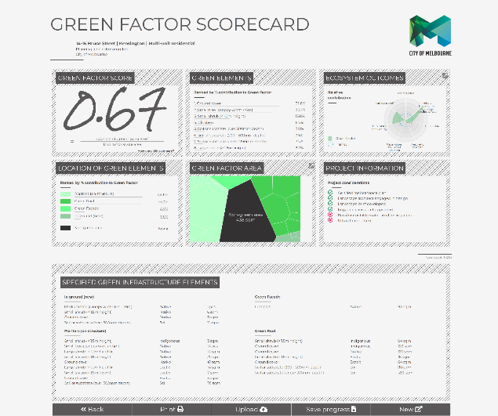

Planting Green Roof
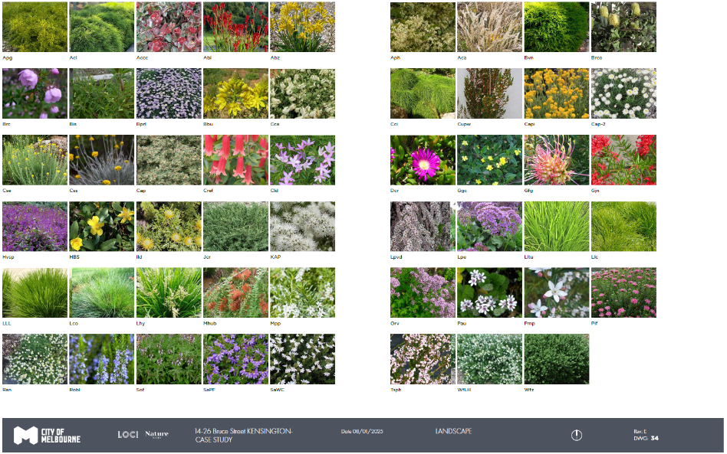

Plant Façade
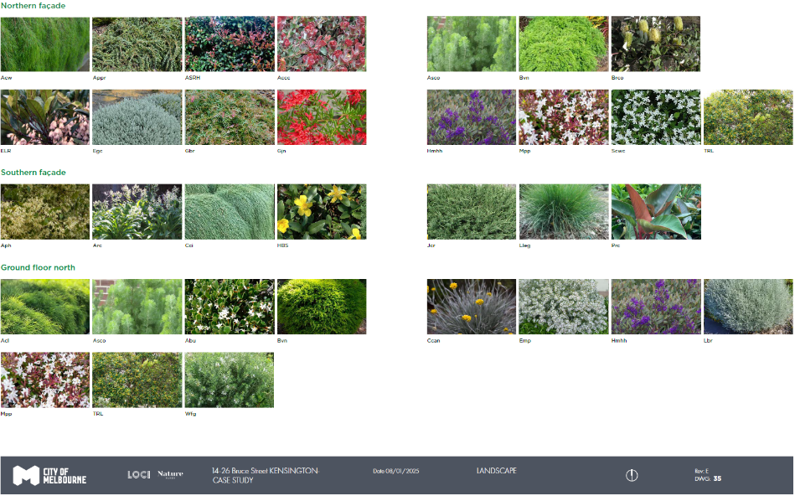

Images
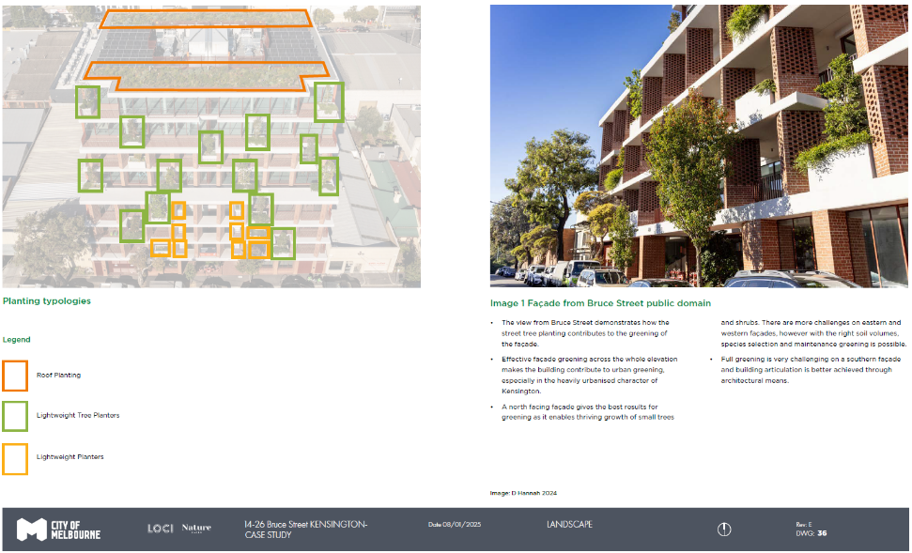
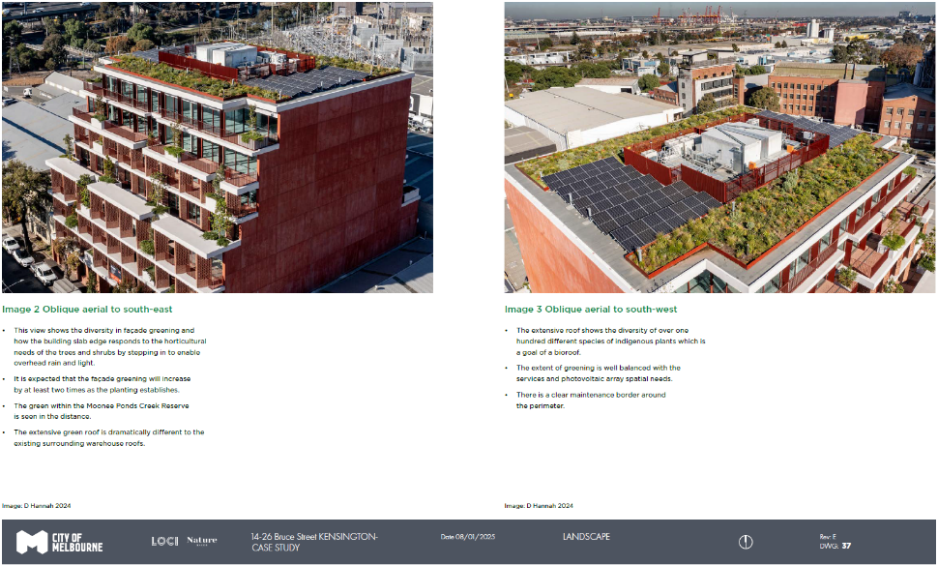

https://www.melbourne.vic.gov.au/council-plan
https://www.greenfactor.com.au/
www.melbourne.vic.gov.au/green-factor-tool

