
Parklet Infrastructure Specifications
Outdoor Dining Parklet Permits August 2025
Contents
Overview 4
Eligibility Criteria 4
Site Specific Eligibility Criteria 4
Traffic Conditions 4
Ineligible streets 4
Tram Corridors – parklets proposed in streets with trams 5
Operation and management of parklets 5
Removal of parklet in certain circumstances 5
Non-compliant parklets 5
How to Apply for a parklet 6
Site Plan 6
Example – Site Plan layout 7
Example – Detailed site plan layout 8
Appendix 1 – Technical design specifications for parklets 9
Structural Safety Elements 9
Risk assessment and road safety audit 10
External elements and buffer clearances 10
Access for emergency vehicles 11
Maximum number of parking bays for parklet conversion 11
Furniture 11
Accessible entrance and path of travel 11
Planting and landscaping 11
Existing tree requirements 12
Lighting in outdoor dining areas 12
Prefabricated and engineered modular parklets 12
Design and selection criteria 13
Weather proofing, shade structures, permanent marquees or enclosures 13
Drainage 13
Maintenance and cleaning 13
Graffiti 14
Umbrellas 14
Traffic management 14
Reserved parking 14
Appendix 2 – Standard designs detailing safety elements to be incorporated in all parklets 15
Type 1: 50km/h speed limit – Parking Space Plan (TYP) 15
Type 2: 20-40km/h Speed Limit adjacent to One-Way Roads 16
Type 3: 20-40km/h Speed Limit adjacent to Two-Way Roads 18
Type 3: 20-40km/h Speed Limit Adjacent to Two-Way Roads continued 19
Type 4: 20-40km/h Speed Limit adjacent to dual lane carriageway 20
Type 4: 20-40km/h Speed Limit adjacent to dual lane carriageway continued 21

Overview
Under the City of Melbourne’s Outdoor dining program, outdoor dining parklets are dining areas created by re-purposing on street parking in front of a hospitality business into a space for dining.
Hospitality venues may select a company listed on the City of Melbourne’s approved list of suppliers to provide and construct parklets infrastructure in accordance with the technical specifications outlined in this document. Traders can select their own suppliers or contractors on the proviso that the technical specifications are adhered to.
Under the Guidelines, the City of Melbourne considers applications to expand into on street parking spaces on a case-by-case basis due to the complexity of city streets, speed limits, traffic conditions and associated safety considerations. To ensure the safety of parklet users, vehicle users and pedestrians the City of Melbourne has developed key criteria to determine site, infrastructure and furniture suitability
All applications to establish on street parking spaces will be assessed on a case-by-case basis and considered against site-specific conditions and the below criteria.
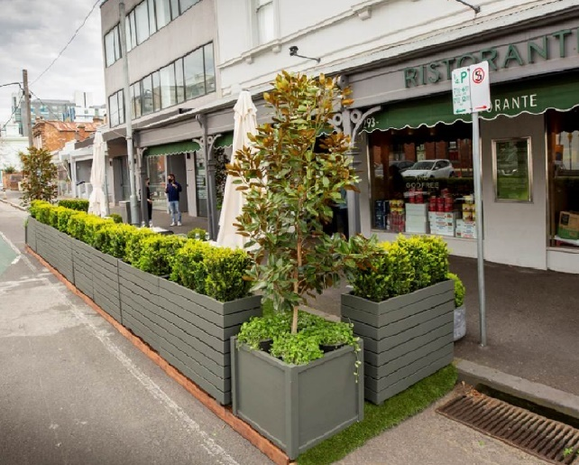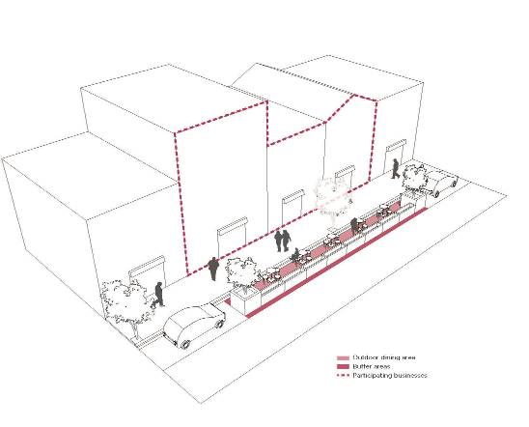

Eligibility Criteria
- Must be an eligible street with specific traffic conditions
- Must satisfy safety and amenity requirements (see technical specifications in appendix)
- Should have support from neighbouring businesses on either side of parklet
- Applications may involve more than one hospitality business requesting multiple consecutive parking bays to be converted into café parklets
- Residential areas and in front of residential building ─ a letter of support from adjacent residential neighbours, or body corporate if in front of a residential apartment block, will help support the application.
Refer to appendix technical specifications and design criteria

Site Specific Eligibility Criteria

Traffic Conditions
Outdoor Dining Parklets may be eligible in streets with:
- Speed limits of 50km/h or less*
- Parallel or 90 degree parking
- Green sign parking spaces (mainly fee parking spaces)
- Straight road geometry ensuring uninterrupted sight lines for drivers
- At least 10m from an intersection (measured from the building line)
- Any parklet within 20m of the departure side of a signalised intersection will be considered on a case-by-case basis

*Any requests in 50km/h streets will be considered on a case-by-case basis for inclusion of mitigating measures to reduce any risk, including temporary speed reductions to 40km/h as part of any traffic management plan or independent road safety audit. Please refer to Appendix.

Ineligible streets
Due to safety reasons and vehicle access issues, streets with the following elements are not suitable:
- streets with speed limits above 50km/h
- arterial roads and roads owned by Department of Transport
- areas obstructing access for deliveries, essential services and emergency vehicle access, access to commercial carparks and residential building carparks
- roads with clearways/tow-away zones or protected cycle lanes
- streets with service/utility access points or storm drains within the parking space, unless furniture is movable, an access point in the platform is provided or no platforms are involved
- spaces designated as loading and disabled zones, unless relocated with the support of traders, affected residents and approved by City of Melbourne
- spaces designated as no-stopping zones, unless approved by City of Melbourne
- construction zones, unless relocated with support of building company and City of Melbourne
- police and emergency vehicle parking.

Tram Corridors – parklets proposed in streets with trams
For applications involving the establishment of parklets on streets with trams, Yarra Trams will be invited to review proposals, site specific designs and associated safety assessments for review and consent. This is to ensure compliance with Rail Safety National Law and health and safety laws for safe tram passenger boarding and alighting under normal and disrupted tram operations. Assessment by Yarra Trams will also ensure adherence to tram engineering standards and minimising costly post-construction amendments. Please refer to separate document Yarra Trams - On Road Hospitality Parklets - Installation on Tram Corridors.

Operation and management of parklets
- Furniture, including the number of tables and chairs that are placed in the outdoor dining area, must match what has been issued on the parklet permit.
- All furniture such as tables and chairs must be removed from parklet at the end of trade each day, unless approved in writing by the City of Melbourne.
- The permit holder must not place condiments / napkins / eating utensils on the tables in the parklet unless diners are seated and are placing an order.
- Outdoor heaters cannot be installed in tree plots and must be a minimum of 2m from trees and planters. No furniture can be installed in a tree plot.
- The parklet must be cleaned and maintained in a neat and tidy condition at all times and in accordance with the operation and management responsibilities in the Outdoor Café Guide.
- Cooking or food preparation is not permitted within a parklet.

Removal of parklet in certain circumstances
A parklet may be required to be removed temporarily or permanently for essential services work, streetscape improvements or other works as required by the City of Melbourne, its contractors or other third-party construction managers. The City of Melbourne will give the permit holder 14 days’ notice or as much notice as possible. In instances where emergency vehicles need access or emergency works such as a burst water main, gas leak or fallen power line, removal of all furniture and equipment is required immediately.

Non-compliant parklets
Any non-compliant parklet installations will require remedy or removal within 14 days and outdoor dining in the parklet will not be permitted until the parklet is fully compliant or otherwise removed. Enforcement action under Council’s Activities Local Law 2024 will apply if corrective action is not followed.

How to Apply for a parklet
Applicants can apply online on the City of Melbourne outdoor dining webpage.
A letter of support from the direct neighbouring businesses and residents (building body corporate if parklet is adjacent to a residential building) is strongly recommended to support applications.

Site plan
A drawn site plan must be submitted with the parklet application and should extend 10m on either side of the parklet footprint. Photos should be included, clearly showing the proposed outdoor dining area, parking space(s), traffic conditions, location relative to buildings, adjacent properties, driveways, residential dwellings or residential buildings and existing features in the footpath.
Parklet plans must show the following elements:
- the restaurant/hospitality venue and its entrance
- adjacent buildings and businesses (include addresses and entrances)
- adjacent residential buildings or dwellings on each side of the outdoor dining proposal and in direct proximity.
- street address/roadway or street name
- traffic and parking conditions in front of property (e.g. loading zone, 1 hour parking, etc.)
- footpath (with width shown), kerb line, driveways, adjacent traffic/ bike lanes
- existing street furniture such as street lights, street signs, parking metres, fire hydrants (any type e.g. fire plug, ‘L’ type, Millcock), sprinkler installations, booster connections and demonstrate a minimum 1 metre clearance around any fire service infrastructure, seats, bicycling parking, utility access points
- street trees, tree pits, grates and landscaped areas
- all dimensions associated with the outdoor dining area
- any part of the outdoor dining area to be sited in front or in direct proximity of neighbouring premises, including dimensions and details of support of application

Design Requirements
To meet building regulations, your application must include the following:
- Architectural Drawings showing design including structure, proposed materials, and colours to be used
- Structural engineering drawings issued by a Building Licensing Authority (BLA) Registered and Endorsed Building Engineer (Civil – Structural)
- Structural engineering computations issued by the same engineer
- A Regulation 126 Certificate of Compliance for the proposed works
- Upon completion, and prior to use, a Certificate of Compliance for Building Work under Regulation 126 (Building Regulations 2018), also issued by a BLA Registered and Endorsed Building Engineer, must be submitted to City of Melbourne Street Trading – Creative Melbourne

Please refer to example site plans below:
Example site plan layout
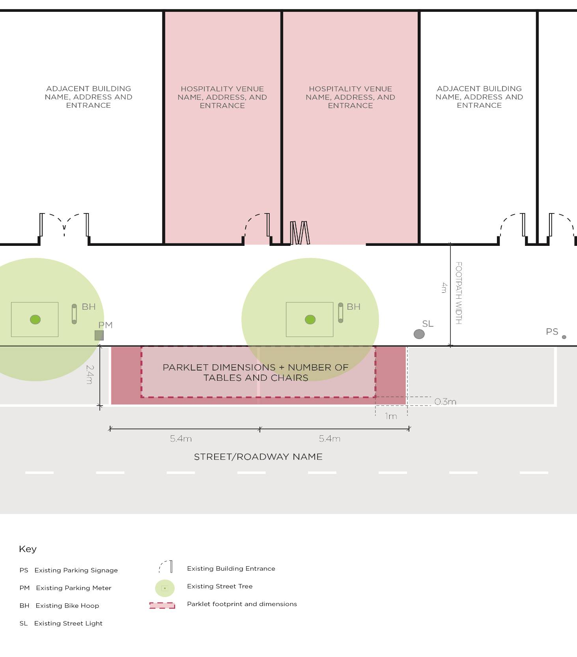

Example – Detailed site plan layout
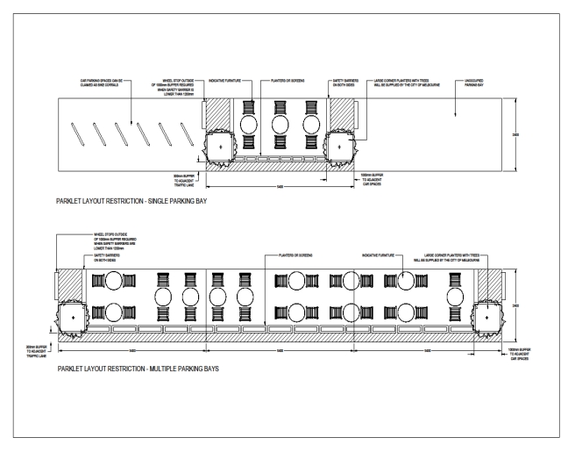

Appendix 1 – Technical design specifications for parklets
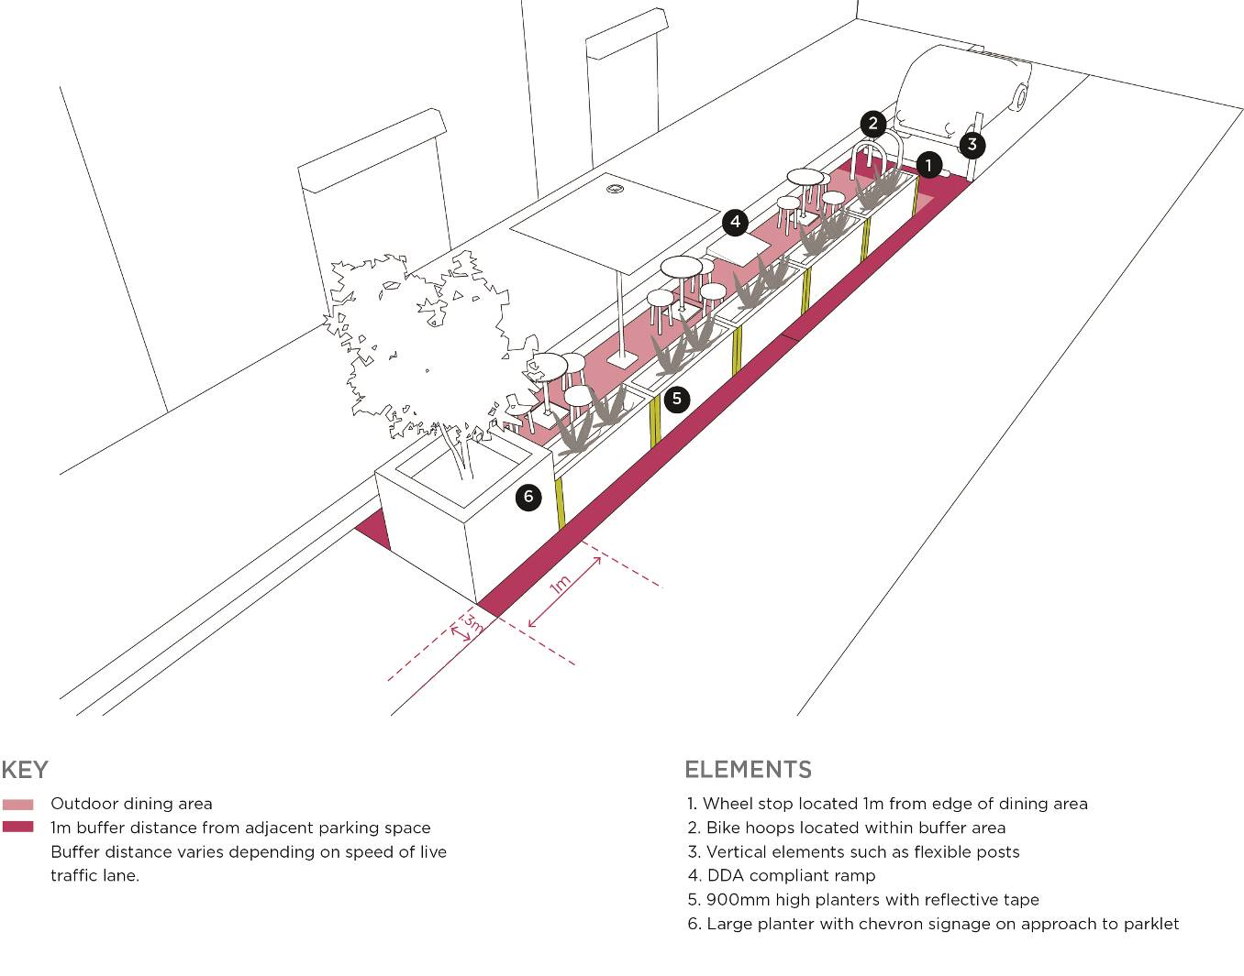
Image description: Diagram example of parklet in a one-way little street with a 20km shared zone. Continuous physical barriers defining the edge of the parklet should be robust and heavy duty. City of Melbourne assesses the safety elements of each proposal on a case-by-case basis, and a safety audit may be required. Based on the outcomes of a safety audit, additional safety elements may be required to ensure that the parklet area is protected from surrounding traffic.

Structural Safety Elements
The City of Melbourne has developed standard designs detailing safety elements to be incorporated in all on road parklets. Please refer to Appendix 2. Any application for a parklet which does not meet all requirements stipulated below may require a road safety audit to support the application. Based on the outcomes of a safety audit, additional safety elements may be required to ensure that the parklet area is protected from surrounding traffic.
- All parklets must be constructed with a platform level to the adjacent footpath. There must be a clear 1.5m accessible path of travel into the parklet. There must be adequate wheelchair turning and resting space.
- The architectural, showing how the parklet will look from a design perspective.
- Engineering design drawings showing how it will be constructed. The design must demonstrate how drainage will be maintained, with a minimum clearance of 600mm from the face of the kerb to the parklet footing, with a suitable bridging platform over the clearance area.
- To ensure visibility to moving traffic and parking cars, café parklets must be buffered using a solid barricade or wheel stop at a desired distance of 1m from the café parklet. This buffer must be within the extent of the parklet. This buffer may also serve as a space for adjacent property owners to accommodate bike storage (e.g. bike hoops).
- A continuous physical barrier of min 900mm height should be provided to live traffic lanes.
- In all eligible streets, café parklets must have a physical structure defining the boundary of the outdoor dining area and provide a physical barrier between moving traffic and the diners.
- All structural elements and barriers must be fixed and heavy duty to ensure safety of diners.
- Large, heavy-duty planter boxes with chevron signage and appropriate barriers will need to be installed at the perimeters of the parking space (intermediate blocks may also be required for parklets exceeding 2 car parking spaces in length).
- Reflective tape or bollards with reflective strips will need to be placed along the edge of the café parklet.
- Parklets must be at least 10m from an unsignalised intersection (measured from the building line).
- Parklets will not be permitted within 20m on the approach side of any signalised intersection.
- Any parklet within 20m of the departure side of a signalised intersection may be considered on a case by case basis and may require a road safety audit to identify any further mitigating measures to reduce any risk.
- All safety elements required to protect the parklet structure must be placed directly onto the road surface and include appropriate friction treatment to minimise the element moving in the event of a vehicle impact.
- All safety elements and designs will be considered on a case-by-case basis.
- Furniture must be of a suitable quality for public use – and not prone to breakage, wind lift or other adverse impacts under reasonably expected conditions.

Risk assessment and road safety audit
Applicants may need to engage independent road safety consultants and undertake independent road safety audits for non-standard and complex applications, or for applications which do not adhere to the guidelines.
All applications to extend into on-street parking spaces will be assessed strictly on a case-by-case basis and considered against site-specific conditions and the criteria in these guidelines.

External elements and buffer clearances
Please refer to standard designs detailing safety elements to be incorporated in all on road parklets. Please refer to Appendix 2.
- For parklets on 10 and 20km/h roads, or on 40km/h roads that have additional separation (i.e. bike lane with established line-marking etc.),heavy duty planter boxes or concrete blocks are required on each corner of a parklet (intermediate blocks may also be required for parklets exceeding 2 car parking spaces in length).. The leading barrier treatment must be fitted with hazard markers and reflective treatments to ensure its visibility to oncoming traffic.
- For partial road closures or parklets on 50km/h roads, concrete jersey barriers must be deployed (in addition to corner treatments) along the length of the parklet, separating the parklet from the live traffic lane.
- Safety, visibility and accessibility should be assessed for day and night conditions.
- Applicant must ensure that the design includes all structural items to be fixed to prevent the risk of flying objects onto the carriageway during windy conditions or for any other reason.
- The use of line-marking to direct traffic away from parklets must be considered at some locations where the width of the adjacent carriageway permits.
- All parklets must be closed adjacent to live traffic lanes to ensure safety of patrons. Entry and exit shall be by the footpath only.
- The parklet will be limited by the car park boundary unless otherwise approved by City of Melbourne.
- The edge of the parklet must be:
- 1.0m from adjacent parking bays
- 0.3m from adjacent traffic/bike lanes where the speed is below 40km/h
- 0.5m from adjacent traffic/bike lanes where the speed is 40km/h or more
- A 3.5m adjacent traffic lane must be provided or maintained
- The sidewalk-facing side of the parklet must be open to allow diners to enter.
- Where there are existing glass screens surrounding an outdoor dining area near the kerb, at least 2 panels of glass screens must be opened up to allow access and permeability into the space.

Access for emergency vehicles
Ensure access to street entrances and lane entrances are not obstructed. Ease of access for fire trucks to access streets and laneways must be maintained at all times to prevent unnecessary delays for fire-fighting crews or other emergency services responding to emergencies.

Maximum number of parking bays for parklet conversion
A maximum of three parking bays will be allocated for parklets per business.

Furniture
- Furniture such as tables and chairs must be durable, comfortable, and cleanable.
- Materials chosen should be of a high quality, cleanable, enduring and environmentally friendly.
- Low quality plastic furniture will not be accepted.
- Low emission, recycled, sustainably sourced and/or locally sourced products are preferred.
- Natural materials and muted finishes are strongly preferred, i.e. steel, aluminium, wood, recycled content concrete, etc. Colours are permitted where a contextual and contributory response can be proven. The purpose of these requirements is to ensure cohesive and curated outcomes for the city and to enable the highest level of engagement and experience for all city users.
- Furniture should be weather resistant, easy to disassemble/relocate and not subject to uplift from wind loads.
- A precinct approach to provide consistent colour and selection of large furniture items such as umbrellas is recommended through consultation with other traders within the street section. This will enhance the visual impact of the new outdoor dining area.
- Moveable tables and chairs also allow temporary furniture to be moved away when the on-street parking parklet is required for other uses.
- Tables should be of a size designed to cater for small group bookings and not permit mixed group bookings to be seated at the same table (as with long bench-style tables).

Accessible entrance and path of travel
- The entrance to parklet must be a minimum of 1.5m wide with no chain or rope privatising the space.
- There must be a clear 1.5m accessible path of travel into the café parklet. This path should connect to the accessible entrance, wheelchair turning and resting space.
- Where it is proposed a parklet is not constructed with a platform level with the adjacent footpath, it is reasonable that the existing road surface be used as the floor of the parklet, provided there is an appropriate DDA compliant ramp providing access to the parklet from the footpath.

Planting and landscaping
- Integrating planter boxes and greenery into the design of the parklet can help soften the edges and create a visually appealing boundary or buffer to the adjacent road.
- Trees in planter tubs must not impact on sight distance available to pedestrians or traffic signal infrastructure. Please refer to plant species and maintenance program under the Outdoor Café Guide.

Existing tree requirements
- No furniture should be placed in the tree plot that could damage the tree and its roots. Furniture Reference Guide and Outdoor Café Guide specify minimum 500mm clearance from the edge of tree pits
- All public trees – the fixing of anything to the trunk or canopy of any public tree is not permitted unless with prior written approval of the City of Melbourne Parks & City Greening Branch.
- All public trees – the pruning of public trees is not permitted.
- All public trees – no outdoor heaters must be placed within the canopy of any public tree.
- All public trees – awnings, parasols or any other overhead coverings must not be in contact with branches within the canopy of any public tree.
- For street tree plots – nothing must be installed or placed within the exposed sections of tree plots. These areas are defined by granitic sand or bonded gravel.
- For reserves and nature strip trees – the use of areas within Tree Protection Zones, as defined by AS4970-2009, is not permitted unless with prior written approval of the City of Melbourne Parks & City Greening Branch.
- For reserves and nature strip trees – the placement of any structure that requires securing to the ground within a Tree Protection Zone is not permitted unless with prior written approval of the City of Melbourne Parks & City Greening Branch,
- Tree trunk or branch protection requirements are in accordance with AS4970 –
- No hard materials in direct contact with the tree bark
- Rubber or soft material used as a buffer (will be considered case by case)

Lighting in outdoor dining areas
- Incorporating lighting in the design of a parklet will encourage the space to be used at night.
- Electrical cords which extend across the footpath are not allowed.
- Low voltage LED solar powered lights with Australian Standard compliance are acceptable.
- Lighting used will need to be water and dustproof to a minimum rating of IP65
- Lighting is not permitted to cast upwards
- No lighting is permitted to be present in, or attached to, trees
- Illuminance is not allowed to exceed 5 lux
- Any lighting installed should not be directed such that it shines directly toward oncoming motorists.
- Lighting should not be flashing or otherwise distracting to motorists and must not be able to be confused for traffic signals.

Prefabricated and engineered modular parklets
Please refer to Furniture Reference Guide.
- Plans and designs of modular parklets will need to be submitted to City of Melbourne for approval and be assessed against the safety and structural requirements contained in this specification.
- Must meet minimum safety and operational standards including ongoing maintenance and drainage requirements.
- Glass is not supported from a traffic safety perspective.
- All pre-made parklets may be considered on a case-by-case basis, as they may require an individual safety assessment and will need to suit the specific site conditions.

Design and selection criteria
The selected pre-fabricated parklet option must comply with the following requirements:
- Fit within the designated parking spaces or zones that are part of the permit.
- Be completely removable from the road surface.
- Allow access to existing services such as fire hydrants, drainage pits and telecommunication covers.
- Allow for drainage underneath the parklet.
- Adhere to the clearance requirements set out in the Outdoor Café Guide.
- Designs containing exposed horizontal members/ beams, may not be suitable from a road safety perspective

Weather proofing, shade structures, permanent marquees or enclosures
- Screens can be used around the parklet area to provide wind protection. Note that transparent screens are allowed to be up to 1500mm high, and solid screens are allowed to be up to 900mm high.
- The use of marquees, plastic awnings or full enclosures is not permitted within a parklet unless otherwise approved by the City of Melbourne. This is to maintain the character of our streets and not introduce unnecessary clutter. If addition protection from the elements is required, consider the use of blankets and heaters (adhering to the specifications laid out in the Furniture Reference Guide.
- The layout of the parklet space may be adjusted to make better use of natural barriers, if present, as long as the overall footprint of the parklet area does not change.
- Building and Engineering approvals may apply

Drainage
- Parklets must not be constructed over drainage, storm water outlets or other external service agency access point service, authority pits (unless otherwise approved by the City of Melbourne).
- Parklets must be designed to allow storm water to drain through the space and avoid flooding and collection of water. The design must demonstrate how drainage will be maintained, with a minimum clearance of 600mm from the face of the kerb to the parklet footing, with a suitable bridging platform over the clearance area.
- Parklets in flood prone areas may not be considered suitable and may not be approved.
- Kerb and channel daily cleaning must be carried out and clearing of upstream gutters of all debris including leaves, cigarette butts and rubbish.

Maintenance and cleaning
- Parklets must be maintained by the permit holder to ensure high level of presentation and cleanliness.
- Rubbish, litter, food scraps and leaves must be removed from within and around the parklet daily. All adjacent areas within 2 metres of the parklet must be cleaned daily, including on top of and within street infrastructure (planter boxes, bollards, concrete block bollards, concrete seats
- Any damage caused to a parklet must be attended to immediately
- A weekly safety inspection to be undertaken and retained (the City of Melbourne may request records as part of compliance checks) include elements such as traffic safety elements, minor repairs, presentation, graffiti, cleanliness, syringes, etc.
- When using gas heaters, please note that the training of nominated staff, maintenance and replacements are the responsibility of the trader. Gas heaters must only be used in well-ventilated outdoor areas, and gas cylinders must be stored in an external and secured area.

Graffiti
Graffiti on parklets will be removed under the City of Melbourne’s graffiti removal service. Permit holders can report graffiti and request removal via the City of Melbourne website or calling Customer Relations (9658 9658)

Umbrellas
- Umbrellas in parklets must not impact on sight distance for pedestrian crossing locations or nearby intersections and associated traffic signal infrastructure, to maximise visibility at all times.
- Umbrellas canopies must be contained within the perimeter of parklet and must not protrude beyond any boundary of the parklet. Note that umbrellas should not interfere with the tree canopy.
- Please refer to umbrella specifications under the Outdoor Café Guide
- Council may consider approving advertising and branding on umbrellas and screens up to a maximum of 33% surface coverage.
- No alcohol branding is permitted.

Traffic management
A Traffic Management Plan (TMP) is required for the installation of parklets. The TMP should be provided by an accredited Traffic Control Company and draw in accordance with Australian Standard AS1742.3. TMP’s should be provided to cover the installation of parklets for the following road conditions:
- 20kmph streets
- 40kmph streets
- 50kmph streets

Reserved parking
The applicant or supplier of infrastructure will be required to reserve parking spaces prior to the installation of parklets and obtain a reserved parking permit through the City of Melbourne’s Reserved Parking scheme.

Appendix 2 – Standard designs detailing safety elements to be incorporated in all parklets

Type 1: 50km/h speed limit – Parking Space Plan (TYP)
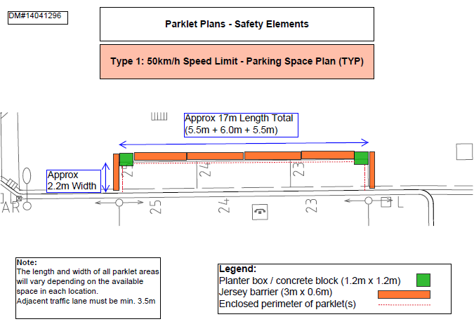

Type 2: 20-40km/h Speed Limit adjacent to One-Way Roads
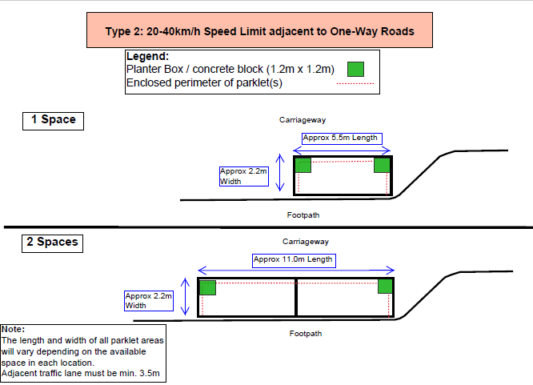

Type 2: 20-40km/h Speed Limit Adjacent to One-Way Road continued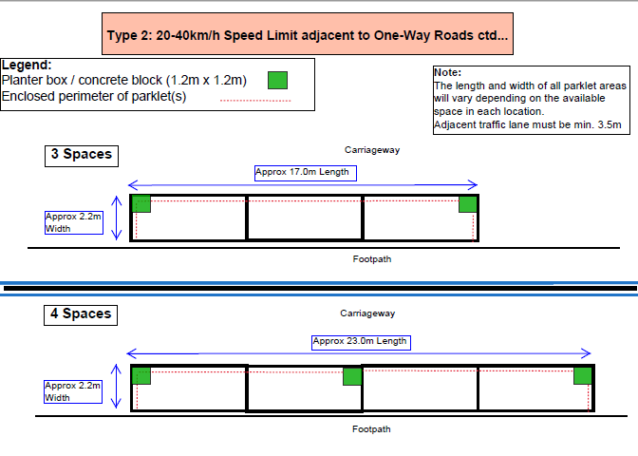

Type 3: 20-40km/h Speed Limit adjacent to Two-Way Roads
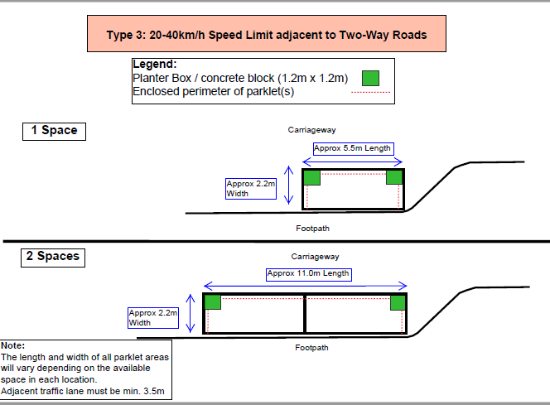

Type 3: 20-40km/h Speed Limit Adjacent to Two-Way Roads continued
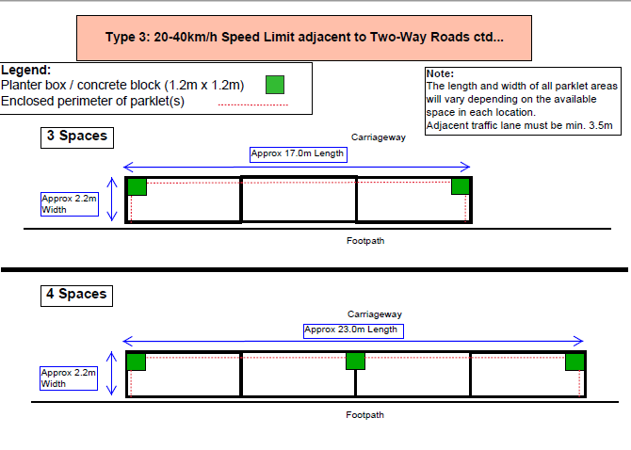

Type 4: 20-40km/h Speed Limit adjacent to dual lane carriageway
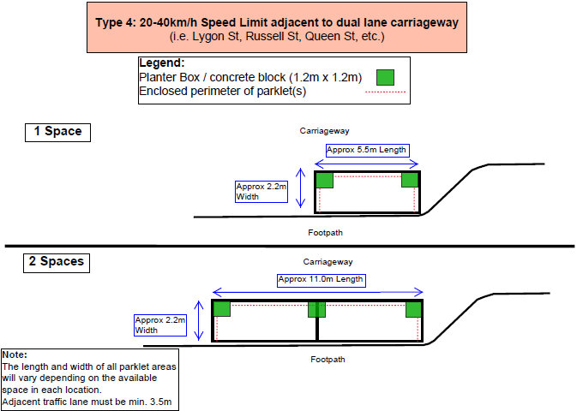

Type 4: 20-40km/h Speed Limit adjacent to dual lane carriageway continued
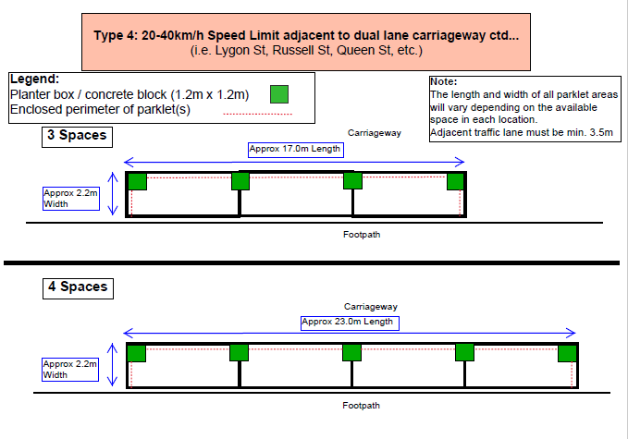

https://www.melbourne.vic.gov.au/outdoor-dining-permits
https://www.melbourne.vic.gov.au/outdoor-dining-permits
https://www.melbourne.vic.gov.au/outdoor-dining-permits
https://www.melbourne.vic.gov.au/outdoor-dining-permits
https://www.melbourne.vic.gov.au/outdoor-dining-permits
https://www.melbourne.vic.gov.au/outdoor-dining-permits
https://www.melbourne.vic.gov.au/outdoor-dining-permits
https://www.melbourne.vic.gov.au/reserved-parking-permits

