
Community Cool Place: West Melbourne Baptist Church and Community Centre
Over summer 2024–25, the City of Melbourne funded five community organisations across the city to operate as Cool Places during severe or extreme heatwaves in Melbourne. The Cool Places were free and open to all community members and residents, offering air-conditioned spaces, snacks, drinks and activities.
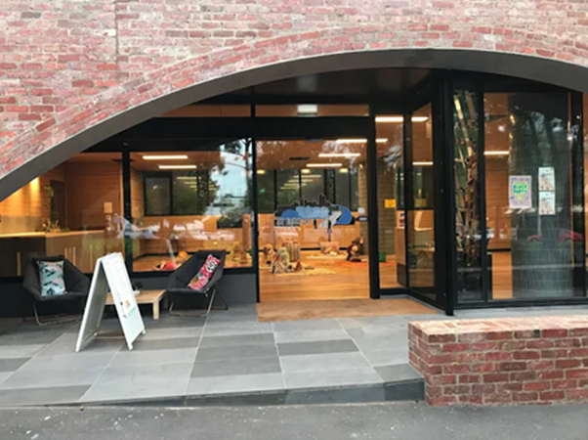
Figure 1: West Melbourne Baptist Church and Community Centre operated as a Community Cool Place funded by City of Melbourne during summer 24–25
West Melbourne Baptist Church and Community Centre, at 4 Miller Street, West Melbourne, received one of the grants. Community Centre Manager Mary-Anne Hess explained how opening as a cool place provided vital relief for more than 100 community members through the sweltering summer.

Why did you apply for the City of Melbourne’s Cool Places grant?
“Our community program consists of many elderly people and migrants, so we thought providing a cool place would be a good thing to do for them,” Mary-Anne said. “Elderly people are at high risk during heat, so we wanted to provide comfort for them.”

It was a scorching summer in Melbourne, with eight days above 37°C and three severe heatwaves. How many times did you open as a Cool Place, and how many people came?
“We opened as a Cool Place five times during extreme heat, with 110 people using the service over the summer. It was a huge success.”
“Most participants were over 60 years old, with ages ranging from 60 to 86 years. They came from 12 cultural backgrounds, including Chinese, Vietnamese, Somali, Macedonian, Indian, Bangladeshi, Australian, Italian, Afghan, Cambodian, Czech, and Egyptian.”
“We opened with extended hours from 8:30 am – 7:30 pm, and people watched movies, played games, did some crafts, talked to each other and rested in the air conditioning. People didn’t want to go home because they didn’t have any air conditioning. Volunteers helped me cover the extended hours.”

What did you use the grant money for?
“We bought some cooling equipment, including a freezer to help cater for the large numbers of people who came through. In our kitchen, we installed a Dyson air cooler to keep our kitchen volunteers cool, so they were able to prepare the food properly.”
“We provided breakfast, lunch, dinner and bottled water during the extreme heat, which we bought with the grant money. The funds also covered staff salary costs and electricity bills. We also dropped people home after the service.”

What was the community’s feedback about the Cool Place?
“Without the grant, we wouldn’t have been able to open during the heatwaves at all,” Mary-Anne said. “The community members were so grateful and hope we open again next year.”
“Nothing else was open in our area during Christmas and January, so a lot of people used the Cool Place. For many, having three meals supplied daily was a huge benefit. Many of the people who came lived in the public housing estate and didn’t have aircon at home, or had air conditioning but couldn’t afford to turn it on.”
Some comments from participants:
“I enjoyed it so much. My Christmas came early.” – Ganesh.
“The Heat Day service is fantastic. Very friendly people.” – Carmelo.
“I wish there are more heat days so I can spend my heat days in an enjoyable environment.” – Faisa.
“I was not able to use the air-conditioning at my home during the hot days, but WMBC allowed me to spend my days in a very friendly and cool environment. I am very grateful to them.” Ahmet.
“We are so grateful to WMBC that they have put the seniors' safety first during the hot days. Fantastic service.” – Guru and Kokila.
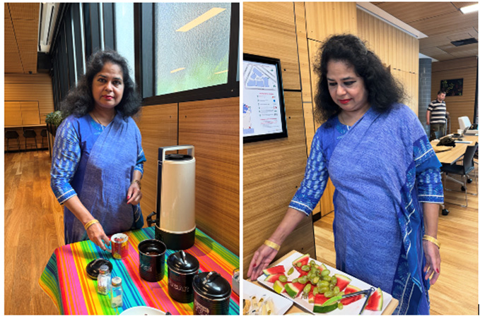
Figure 2: West Melbourne Baptist Church and Community Centre Manager Mary-Anne Hess with drinks and snacks for community members

