
Community Cool Place: Carlton Neighbourhood Learning Centre (CNLC)
Over summer 2024–25, the City of Melbourne funded five community organisations across the city to operate as Cool Places during severe or extreme heatwaves in Melbourne. The Cool Places were free and open to all community members and residents, offering air-conditioned spaces, snacks, drinks and activities.
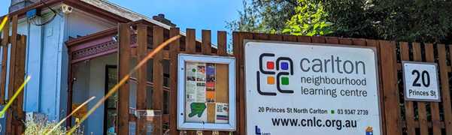
Figure 2: Carlton Neighbourhood Learning Centre operated as a Community Cool Place funded by the City of Melbourne during summer 24–25
Carlton Neighbourhood Learning Centre, at 20 Princes Street, Carlton, successfully applied for one of the grants. Executive Officer Tony Milne said that more than 200 residents and locals used the Cool Place service during the summer’s heatwaves.

Why did you apply for the City of Melbourne’s Cool Places grant?
“We applied for the City of Melbourne’s grant so we could extend our hours and provide a welcoming, cool environment for the community during heat emergencies,” Tony Milne said.
“We know that heat can pose serious health risks, particularly for vulnerable groups such as young children, older adults, people with pre-existing health conditions, and those with disabilities. Having a safe, cool space to retreat to can be lifesaving.”
“In our neighbourhood, we worry about the people living in the Carlton public housing towers, where thousands of residents lack access to air conditioning. They describe the heat as unbearable.”

It was a scorching summer in Melbourne, with eight days above 37°C and three severe heatwaves. How many times did you open as a Cool Place, and how many people came?
“Carlton Neighbourhood Learning Centre opened as a Cool Place seven times from January to March, and around 210 people came through our doors.”
“On a particularly hot day in February, we had almost 100 people attend, including 48 children and eight adults from the public housing towers. They played card games and dominoes, watched a movie and drank cool water in our air-conditioned rooms.”
“Approximately three-quarters of the participants were women from non-English-speaking backgrounds. The vast majority of attendees were from the public housing towers, ranging in age from children under 18 to older community members (aged 61 and above). Eleven people who came reported that they had a disability.”

What did you use the grant money for?
“We were able to cover staffing, electricity and other running costs to opening, specifically to operate as a Cool Place on non-opening days and also to extend our hours during heat emergencies,” said Tony.
“We purchased refreshments, including watermelon, savoury snacks, and icy poles, and provided heat safety education materials.
“Offering taxi transport for residents of the public housing towers made a real difference in enabling the families to attend. Several people said they would not have been able to attend without this support, so covering taxi fees made the program accessible to those who needed it most.”

What was the community’s feedback about the Cool Place?
“We believe in this initiative and would love to see it continue – it provided huge relief from the oppressive heat for those who came along.”
“When participants left, many of them told us how valuable the space was. Usually on hot days, some families living in the Carlton public housing towers cooled down by taking turns in a cold bath. They also said it was hard to keep their kids occupied at home in the heat. At CNLC, they played card games and dominoes, watched a movie, and enjoyed snacks such as watermelon and icy poles, and cool water in a safe, welcoming space.”
“People said it was incredibly valuable to escape the heat. Our next task is to expand how many people know about it.”
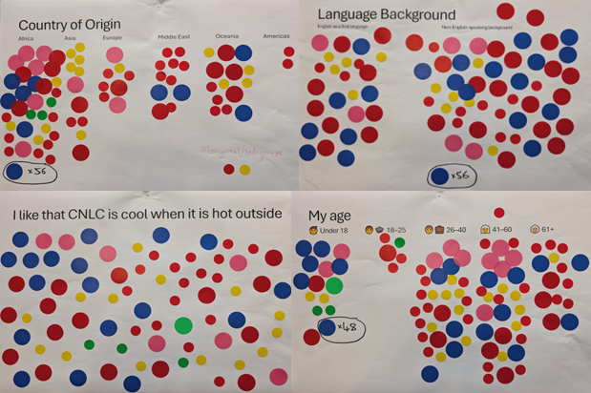
Figure 3: Participants provided feedback on the Cool Place service using sticky dot feedback posters

