
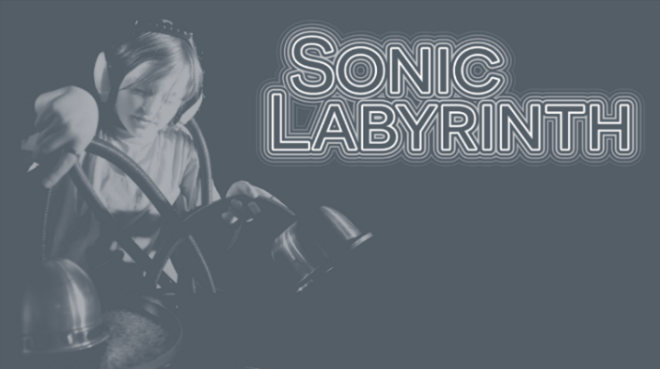
Sonic Labyrinth Exhibition
Social Story
August 2025 – June 2026

What is Sonic Labyrinth?
Sonic Labyrinth is an audio installation in the gallery space at ArtPlay for young people ages 5 and up and their families.
It includes lots of different instruments, objects and equipment that you can play with to make interesting sounds.
But this show is not just about sound and listening – it includes lighting and interactive elements that offer something for everyone.
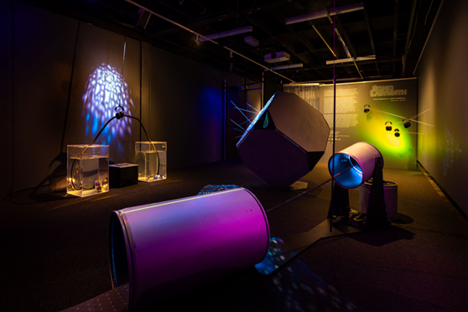

The details
Where: ArtPlay, Birrarung Marr, Melbourne
When: August 2025 – June 2026
Ages: 5 + years and their adults

You might get a train or tram and then walk down the path alongside the Yarra River from Flinders Street station.
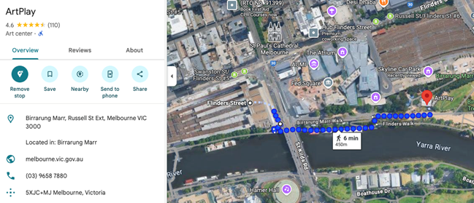
If you come in a car, you might park behind ArtPlay. It is a Wilson Car Park, and the lowest level is approximately a 100 metre walk from the entrance of ArtPlay.
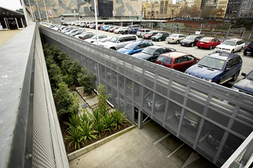

What is Birrarung Marr?

Birrarung Marr is a riverside park on the north bank of the Yarra, between Federation Square and Melbourne Park. Its name, from the Woi Wurrung language, means ‘river of mists’ and reflects the area’s deep cultural significance as an important meeting place for Aboriginal people for thousands of years.
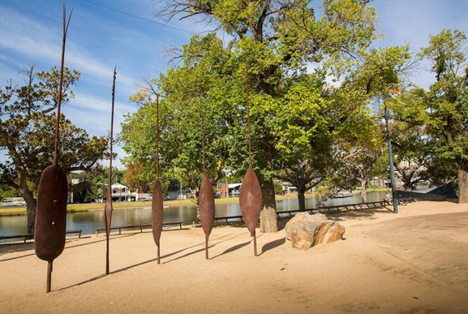

There is a large playground next to ArtPlay. Please note that construction noises may occur from time to time due to the ongoing Greenline Project, which is scheduled for completion by the end of 2025.

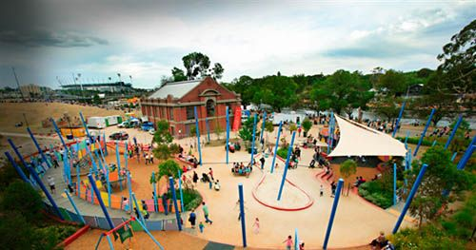

What will happen when I arrive?
Upon arrival at ArtPlay, you will find a wooden ramp and an orange door.
A staff member with a lanyard will greet you in the foyer. They might ask if you are here for a booked program or the Sonic Labyrinth exhibition.
If it’s busy, you might have to wait for a few moments. They will then show you where the exhibition space is and explain all the different parts.
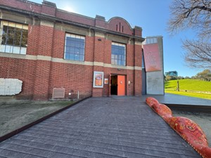
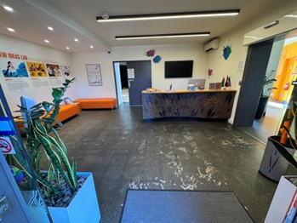

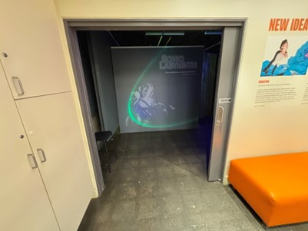

What will we do in Sonic Labyrinth?
You can go to the exhibition with your family or friends. Be careful to move your body safely around other people who are looking at the exhibit.

Entry
There is a slight 3 cm tall entry ramp, and then you have two options:
You can come through the chain curtain (spreading the chains apart). This entry is 1.1 m wide.


You can also navigate the Sonic Web, which requires you to climb through a web of glowing, stretchy strings that make noise when you touch them.

Lighting
The exhibition will be dark, with steady colourful lights on some of the walls and lights that change colours inside some of the instruments.
There are no strobe effects.
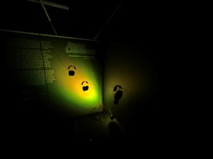
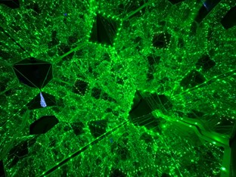
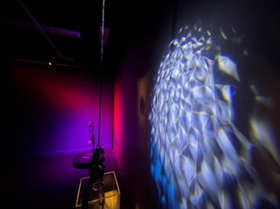

Layout
There will be 6 sound making instruments/objects spaced throughout the gallery for you to explore. There is 1.4 m wide clearance between the stations for you to move around.
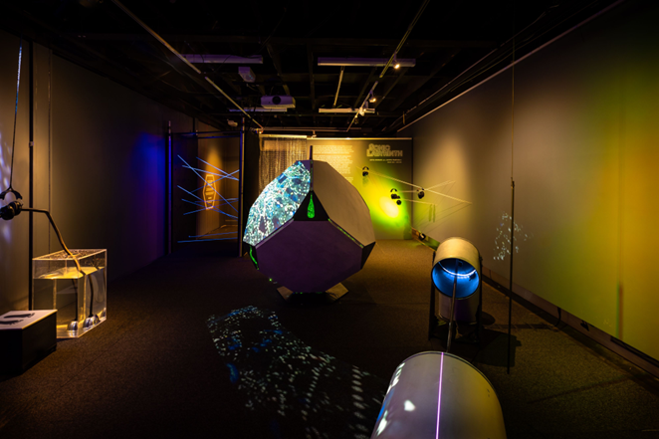

Noise and sound
The space does not have any audio playing in the background, so the only sounds come from when people touch or use the instruments or their voices.
The sounds coming from the different instruments can be loud or quiet. And you might not always know when something loud is about to happen.
One of the instruments has a loud fan that turns on and off when people come close to it, which can be a bit surprising – so please take care.
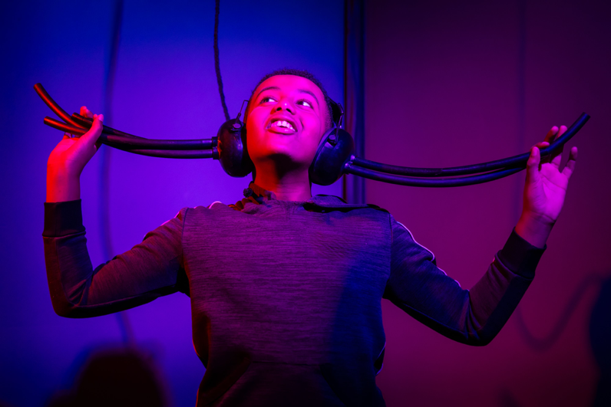
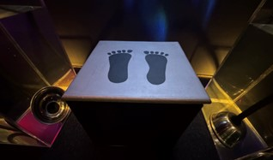
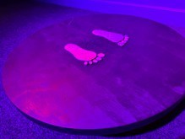
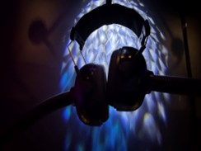
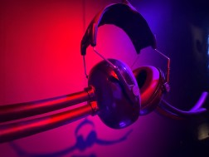
Two of the instruments invite you to put on a pair of special earmuffs, which are adjustable to fit correctly around your head. You can also choose to step onto a platform, but the earmuffs will stretch to reach your ears, so you can try them even if you don’t step up.

One of the instruments has a special lighting effect that changes to match the sounds of a drum that you can hit with your hands or other parts of your body.
You also have the option to crawl inside the drum to feel the vibrations and hear the sounds while someone else plays.
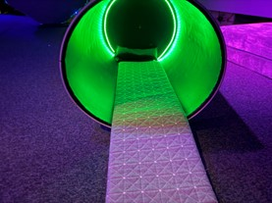
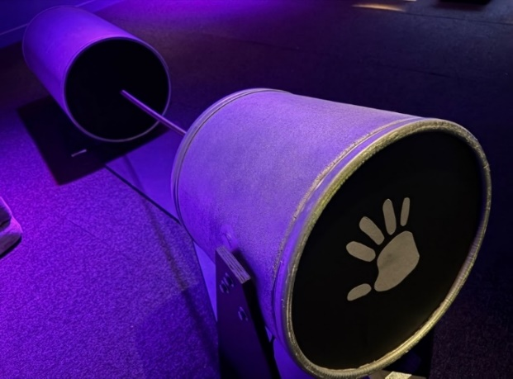
One of the instruments is a box with holes in the corners for you to put your head in and see your face reflected in lots of mirrors.
The holes for your head are either 1 m or 40 cm from the ground. The lights inside change colours, but they don’t flash or strobe.
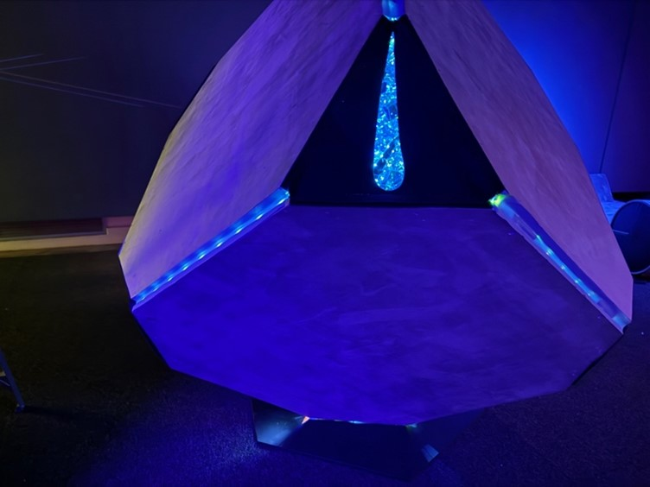
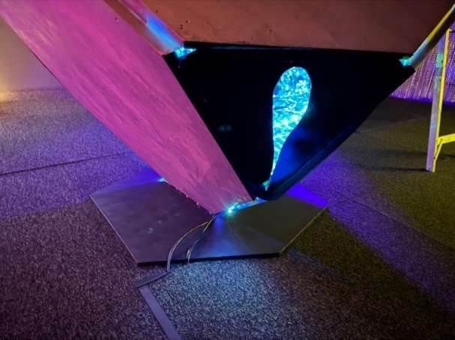

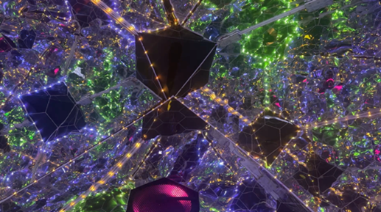
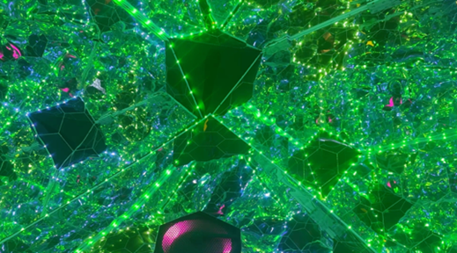
One of the instruments has special earmuffs at different heights (1.4 m, 1 m, and 80 cm). If you put them on and pluck on the strings, you can feel the vibrations humming through the bones in your head.
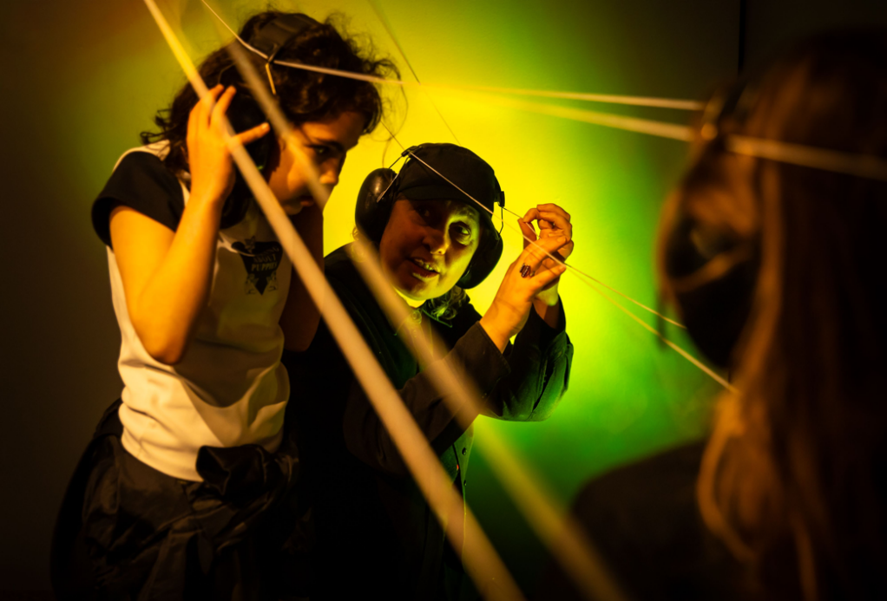
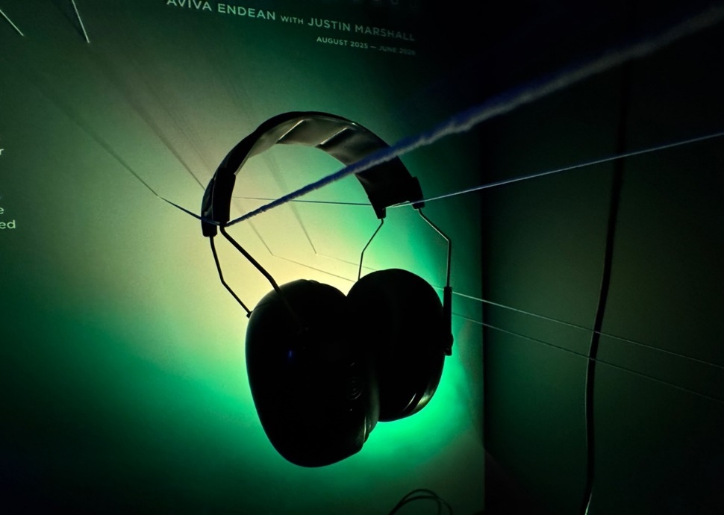

What can I touch?
You can move around the room, you can gently touch the instruments, and you can play with them to explore the sounds they make.
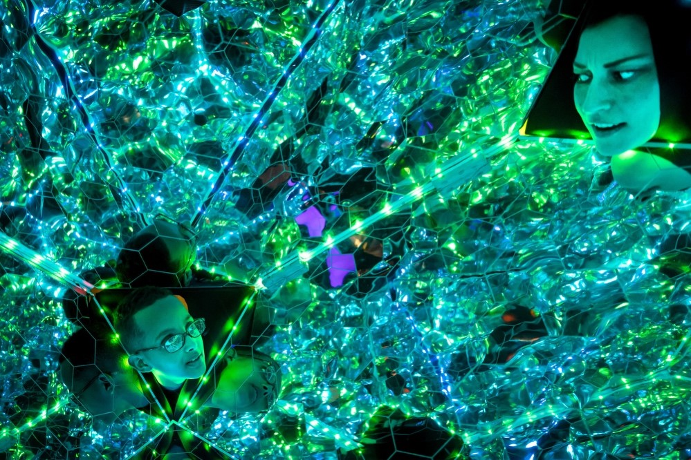
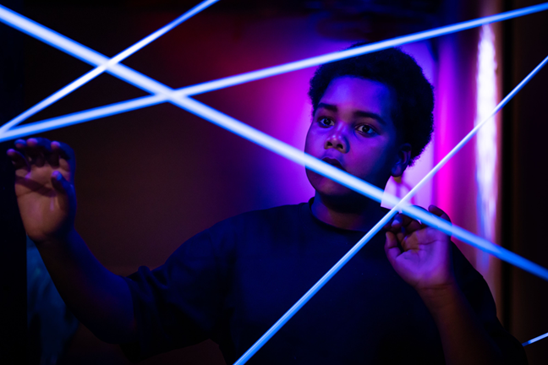
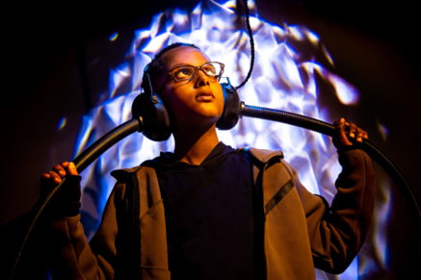



You can sit on the cushions and observe other people playing. You can laugh, shout, sing, or talk.
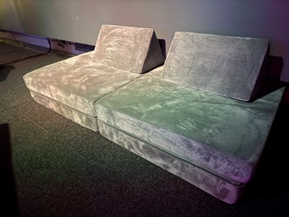

The end of the experience
When you have finished exploring Sonic Labyrinth or if you need a break, you can return to the foyer.
If it’s busy, one of the ArtPlay team members might ask you to move along after about 15 minutes so other people can have a turn.
There are three individual all-gender bathrooms through a glass door to the right of the big desk.
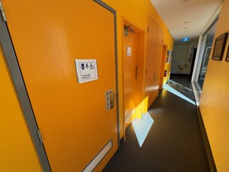
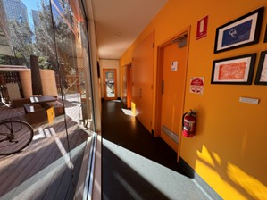

We hope you enjoy Sonic Labyrinth!
