
Green Factor Case Study: narrm ngarrgu Library and Family Services
July 2025

Acknowledgement of Traditional Owners
The City of Melbourne respectfully acknowledges the Traditional Owners of the land we govern, the Wurundjeri Woi-wurrung and Bunurong / Boon Wurrung peoples of the Kulin Nation and pays respect to their Elders past and present. We acknowledge and honour the unbroken spiritual, cultural and political connection they have maintained to this unique place for more than 2000 generations. We accept the invitation in the Uluru Statement from the Heart and are committed to walking together to build a better future.

Council Plan 2021-25
The Council Plan 2021-25 sets out our strategic direction and commitment to the community for the next four years. Based on six strategic objectives for our city, this is our detailed plan for our city’s revitalisation and considers the needs of all people who access and experience the City of Melbourne municipality. For more information visit melbourne.vic.gov.au/council-plan
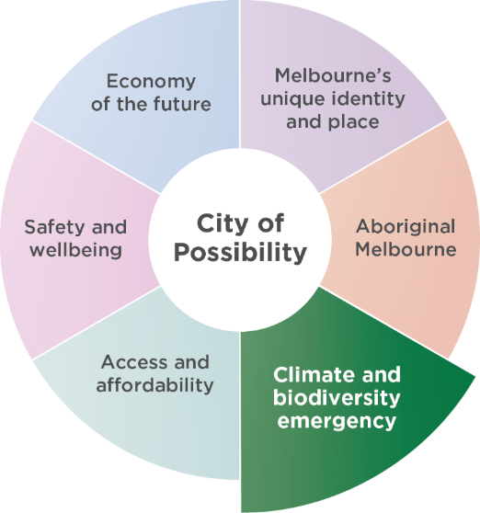

Climate and biodiversity emergency
Melbourne is a city setting the standard on climate action. Prioritising our environment and taking urgent action to reduce emissions and waste is key to protecting public health, strengthening the economy and creating a city that mitigates and adapts to climate change.

Contents
Acknowledgement of Traditional Owners 2
Council Plan 2021-25 2
Climate and biodiversity emergency 2
Acknowledgements 4
Disclaimer 4
Introduction 5
Green Factor tool 5
Amendment C376: Sustainable Building Design 5
Access the Green Factor tool online at 5
How to use this document 6
Case Study: Narrm Ngarrgu Library and Family Services 7
Project summary 7
Application details 8
About the site 8
Tips for your Green Factor application: 8
Green infrastructure elements 9
Green Factor input summary 9
Summary of Green Factor inputs 10
Green Infrastructure area: Planters (on structure) 11
Green Infrastructure area: Green Roof 12
Green Infrastructure area: Green Facade 13
Green Factor landscape package 14
Green Factor scorecard 14
Appendix 1: Example Town Planning Landscape Package Submission 15
Evergreen Trees 24
Shrubs 25
Flowering Perennial Herbs, Ferns and Palms 29
Groundcovers 33
Grasses and Grass-like Forms 34
Climbers 37
Evergreen trees 38
Shrubs 38
Climbers 39
Flowering perennial herbs, ferns and palms 40
Groundcovers 41
Grasses and grass-like forms 41
Lawn 42

July 2025

Acknowledgements
Many people contributed to the development of this case study and the Green Factor tool. We are truly grateful and would like to thank all contributors including Bush Projects, HIP V. HYPE, Little Sketches, the University of Helsinki and the University of Melbourne.

Disclaimer
This report is provided for information and it does not purport to be complete. While care has been taken to ensure the content in the report is accurate, we cannot guarantee it is without flaw of any kind. There may be errors and omissions or it may not be wholly appropriate for your particular purposes. In addition, the publication is a snapshot in time based on historic information which is liable to change. The City of Melbourne accepts no responsibility and disclaims all liability for any error, loss or other consequence which may arise from you relying on any information contained in this report.

Introduction

Green Factor tool
The Green Factor tool is a free online green infrastructure assessment tool developed by City of Melbourne. It is designed to help landscape architects, designers, planners and developers benchmark and improve greening outcomes for proposed developments. Green Factor supports City of Melbourne’s ambitions to increase the quality and quantity of greening in the private realm. This forms part of our commitment to respond to the climate and biodiversity emergency.
The Green Factor tool offers a simple and iterative process that prompts users to consider green roofs, vertical greening, vegetation retention, rain gardens, canopy trees and biodiversity as part of their design response. Our environmental strategies have been used to prioritise the types of greening that will provide greatest benefit to the public and the environment. The scoring of Green Factor is underpinned by the latest research into the environmental and social benefits of green infrastructure.
Green Factor will help developments to deliver benefits in the following areas:
- urban heat island effect reduction
- biodiversity and habitat provision
- stormwater reduction
- social amenity such as recreation and mental wellbeing
- urban food production
- aesthetic values.

Amendment C376: Sustainable Building Design
The Green Factor tool is part of a larger environmentally sustainable design planning scheme amendment that City of Melbourne is pursuing, Amendment C376: Sustainable Building Design.
The amendment is a key action from City of Melbourne’s Green Our City Strategic Action Plan and includes introducing changes to the planning scheme to encourage more green infrastructure within the private realm. This will be achieved through mandated planning controls in the form of a Design Development Overlay. We have undertaken rigorous technical and feasibility assessments with building industry users to test the viability of these requirements in future developments.
Embedded into our proposed Amendment C376 is a minimum mandatory requirement that all new developments must achieve a Green Factor score of 0.55, and existing developments with works resulting in more than 1000 square metres of additional gross floor area should achieve a Green Factor score of 0.55.
Additionally, it will be mandatory that a Green Factor scorecard must be submitted as part of the landscape documentation for relevant planning applications.
The Green Factor tool complements other requirements to achieve ratings in existing, industry recognised Environmentally Sustainable Design tools, which demonstrate how developments can achieve industry best practice targets.

Access the Green Factor tool online at
www.greenfactor.com.au
For more information contact
greeningmelbourne@melbourne.vic.gov.au

How to use this document
This document will take you through a Green Factor tool assessment process using the case study of a City of Melbourne project, narrm ngarrgu Library and Family Services, located in the Queen Victoria Market precinct.
This case study will help you understand what information is required to develop a high-quality Green Factor landscape package as part of your planning application.

Case Study: narrm ngarrgu Library and Family Services

Project summary
Location: narrm ngarrgu Library and Family Services, 141 Therry Street, Melbourne VIC 3000
Development type: Public building
Landscape design: Bush Projects
Completion date: November 2023
Green Factor score: 0.79

Application details

About the site
narrm ngarrgu Library and Family Services is part of the Munro development in the Queen Victoria Market Precinct. The development also features community housing, retail spaces and an underground car park.
The rooftop terrace is located on the third floor, adjacent to the children’s library and family services. The public can access the rooftop terrace during opening hours.
The design team worked alongside First Nations Elders, artists and community to reflect their knowledge systems and bring this warm, welcoming space to life.
For this case study example, we have applied an arbitrary site boundary to this project because it is a retrofit of an existing building.
This project has a site area of 966 square metres as shown in Figure 1. This site area will be used to calculate the Green Factor score.

Tips for your Green Factor application:
- The Green Factor tool requires you to provide details about your project site area, location and boundaries, as well as basic specifications of the green infrastructure elements including soil area and plant type, quantities and coverage.
- Keep in mind that the Green Factor tool can be used at different stages of your project.
1. Early concept design: If you’re early in your planning and design process, use the Green Factor tool as part of an iterative process throughout the design phase. Try different inputs to explore how it is possible to increase the quantity (area of greening) and quality (type of green infrastructure inputs) of greening in your project to achieve a high Green Factor score.
2. Final stages of design: If you’re close to lodging your planning application, we recommend having a comprehensive landscape package on hand when using the tool. To achieve a higher Green Factor score, you’ll likely be focusing on improving the quality of greening (type of green infrastructure inputs) as opposed to making significant changes to the total area of greening within the project site area.
- For typical statutory planning applications, the site area is defined by the certificate of title and associated site boundaries.
- All proposed greening must be located within the site boundary and be external to the building envelope.
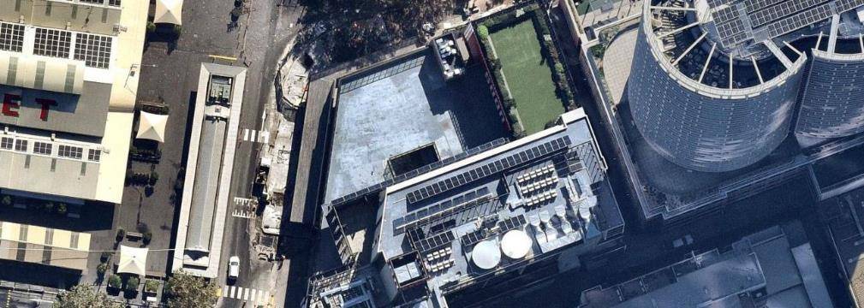
966m2
Figure 1. narrm ngarrgu Library and Family Services project site boundary. Taken from Appendix 1: Example town planning landscape package submission.

Green infrastructure elements
Your project’s proposed green infrastructure elements are assigned an ‘area’ for input into the Green Factor tool. The green infrastructure areas relevant to this project are planters (on structure), green roof and green facade, as described in Table 1.

Green Factor input summary
Figure 2 provides a summary of the inputs submitted for narrm ngarrgu Library and Family Services project as part of the Green Factor assessment.
The specified green infrastructure elements used here are reflective of the level of detail needed for a Green Factor submission at planning application stage. This includes basic specifications of soil area, plant category, type and coverage, and tree quantities for each area.
Explore the illustrations (Figure 3, Figure 4 and Figure 5) to understand how the green infrastructure elements have been incorporated into the project’s landscape design from a Green Factor perspective.
Table 1. Green infrastructure areas relevant for narrm ngarrgu Library and Family Services.
Green Infrastructure area | Description
Planters (on structure) | Planters are on-structure containers consisting of a raised edge with or without a solid base. They can be used at ground level, on balconies or podiums or on roofs. They are different from green roofs and can support small and medium trees with the right soil volume.
Green roof | A green roof is a vegetated landscape built up from a series of layers that are installed on a roof surface. They can be installed layer by layer on the roof (‘loose laid’) or as modular, pre-prepared layers in trays.
Green facade | A green facade is created by growing climbing plants up and across the facade of a building, either from plants grown in garden beds at its base, or by container planting installed at difference levels across the building. Climbing plants can attach directly to the surface of a building or they can be supported on a structure independent of the building.

Summary of Green Factor inputs
QUEEN STREET BELOW
Figure 2. Summary of the Green Factor inputs for narrm ngarrgu Library and Family Services, which is broken down into areas and
specified green infrastructure elements.
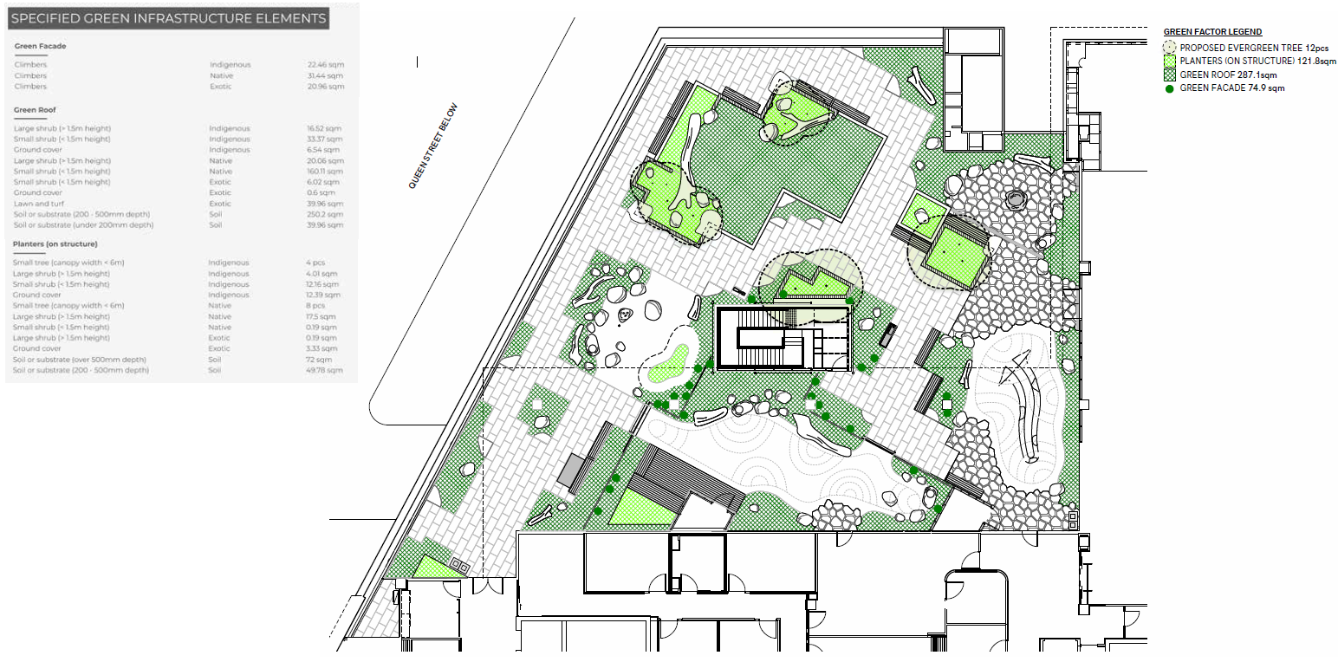

Green Infrastructure area: Planters (on structure)
Figure 3. Illustration of how the green infrastructure elements for ‘Planters (on structure)’ have been incorporated into the project’s landscape design from a Green Factor perspective.
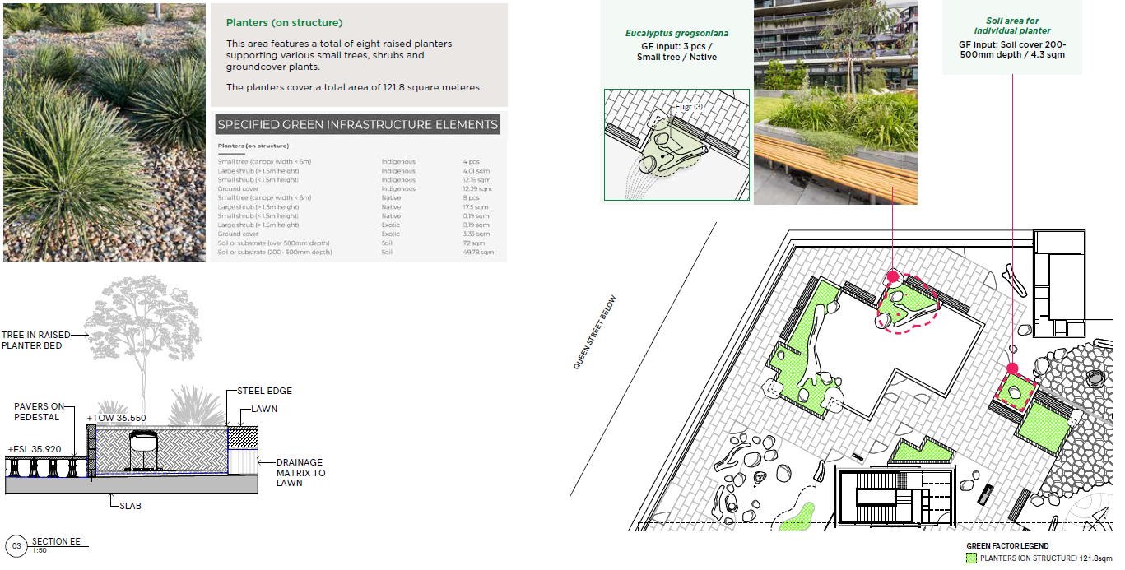

Green Infrastructure area: Green Roof
Figure 4. Illustration of how the green infrastructure elements for ‘Green Roof’ have been incorporated into the project’s landscape design from a Green Factor perspective.
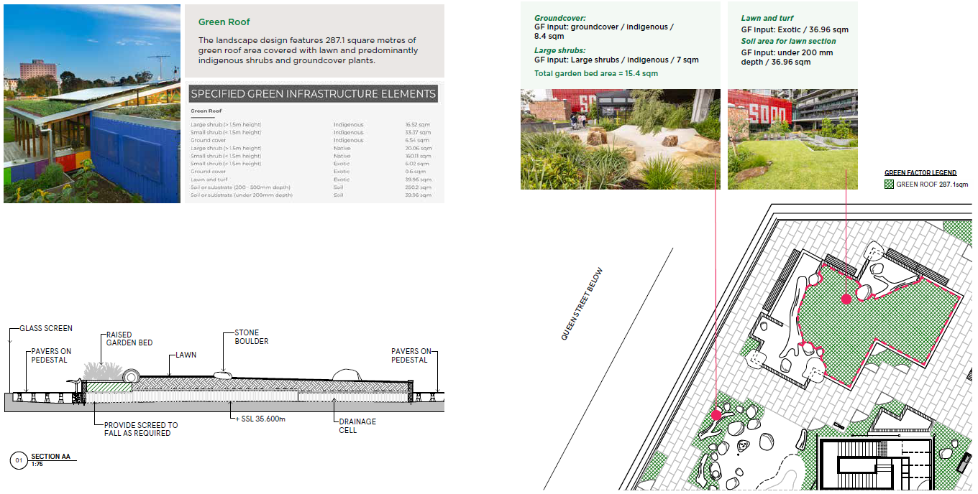

Green Infrastructure area: Green Facade
Figure 5. Illustration of how the green infrastructure elements for a ‘Green Facade’ have been incorporated into the project’s landscape design from a Green Factor perspective.
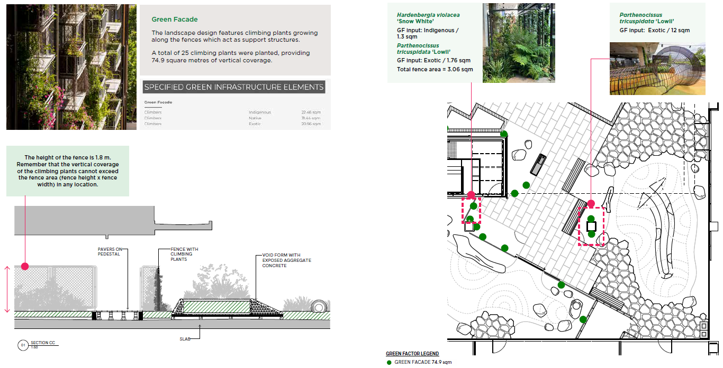

Green Factor landscape package
See Appendix 1 for the example town planning landscape package submission for narrm ngarrgu Library and Family Services as part of a Green Factor tool assessment.
This package provides an example of a satisfactory landscape package submission.
Given that this project has been completed, we have also included detailed as-built planting plans and lists in Appendix 1 to support this case study. The level of detail that you submit at planning application stage may not be as comprehensive and complete.

Green Factor scorecard
Narrm ngarrgu Library and Family Services received a Green Factor score of 0.79. This exceeds this minimum mandatory requirement that all new developments must achieve a Green Factor score of 0.55.
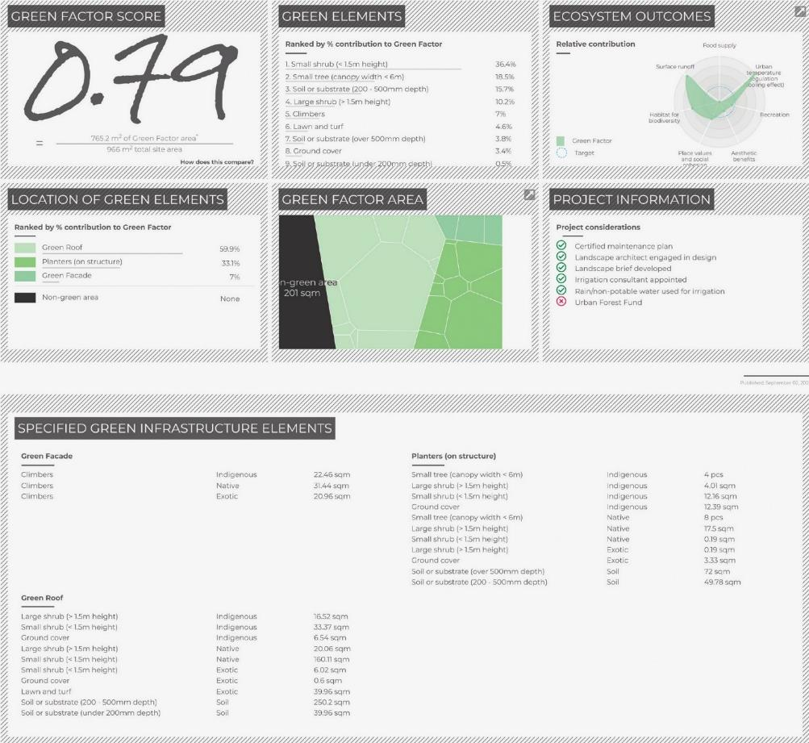
As part of our proposed Amendment C376, it is a minimum mandatory requirement that all new developments must achieve a Green Factor score of 0.55, and existing developments with works resulting in more than 1000 square metres of additional gross floor area should achieve a Green Factor score of 0.55.

Appendix 1: Example Town Planning Landscape Package Submission
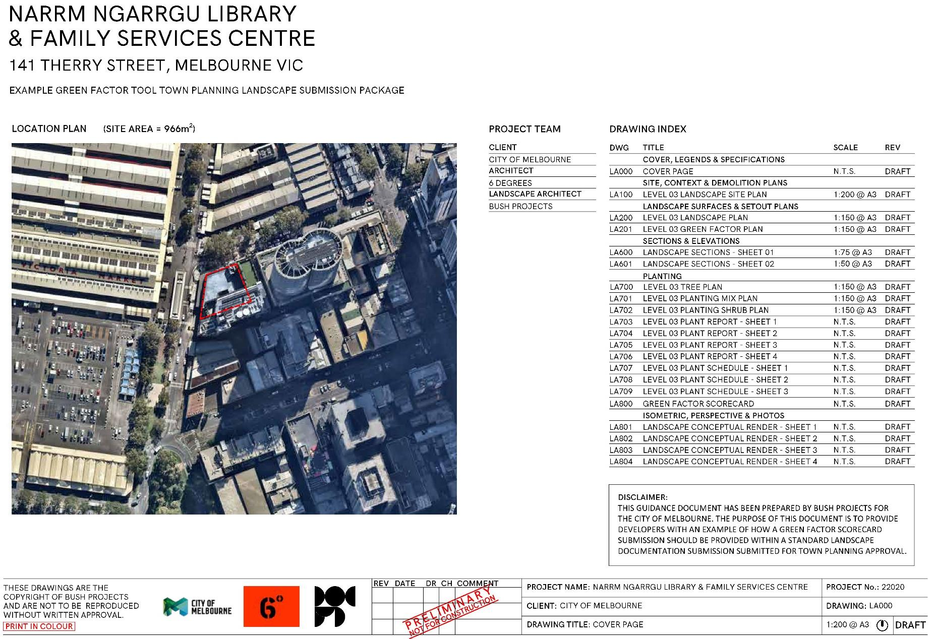
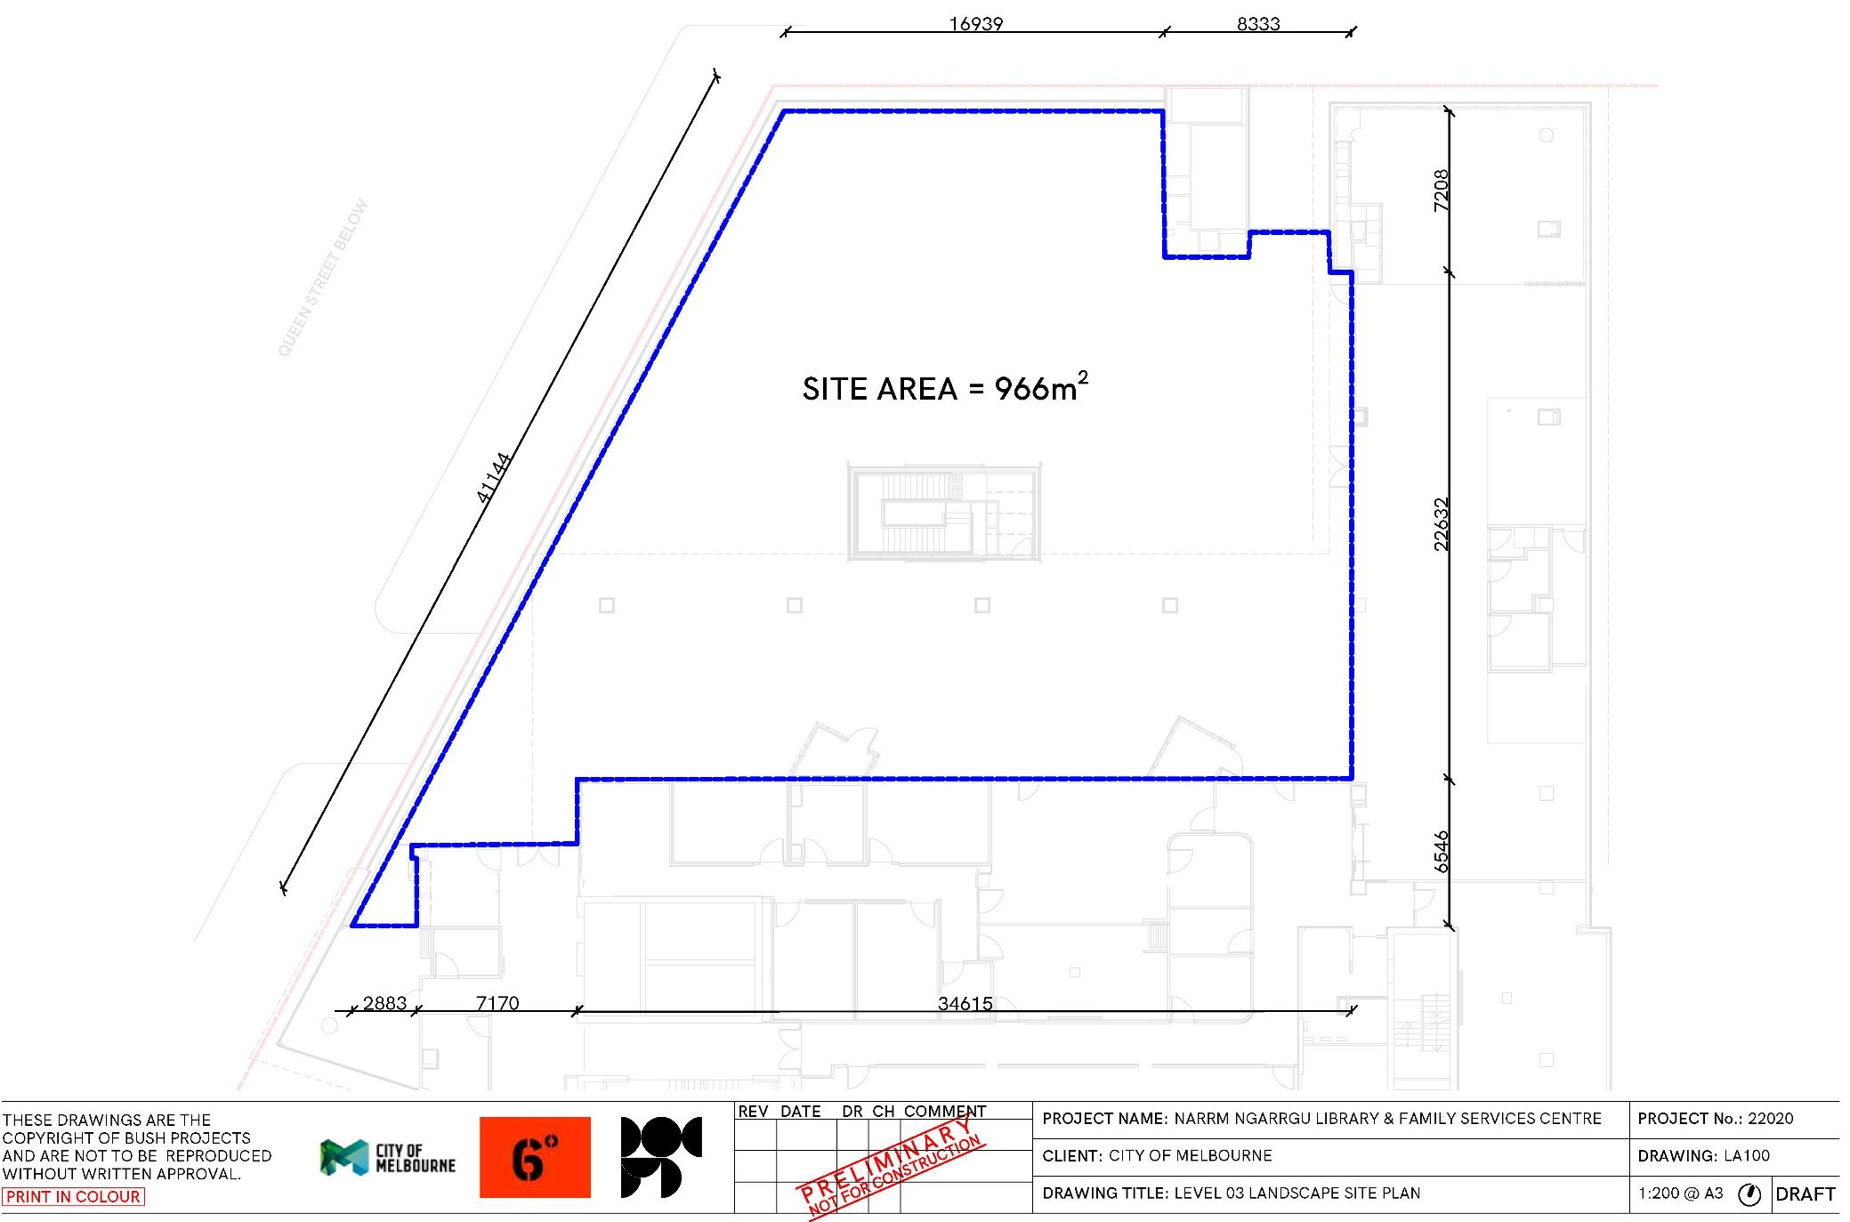
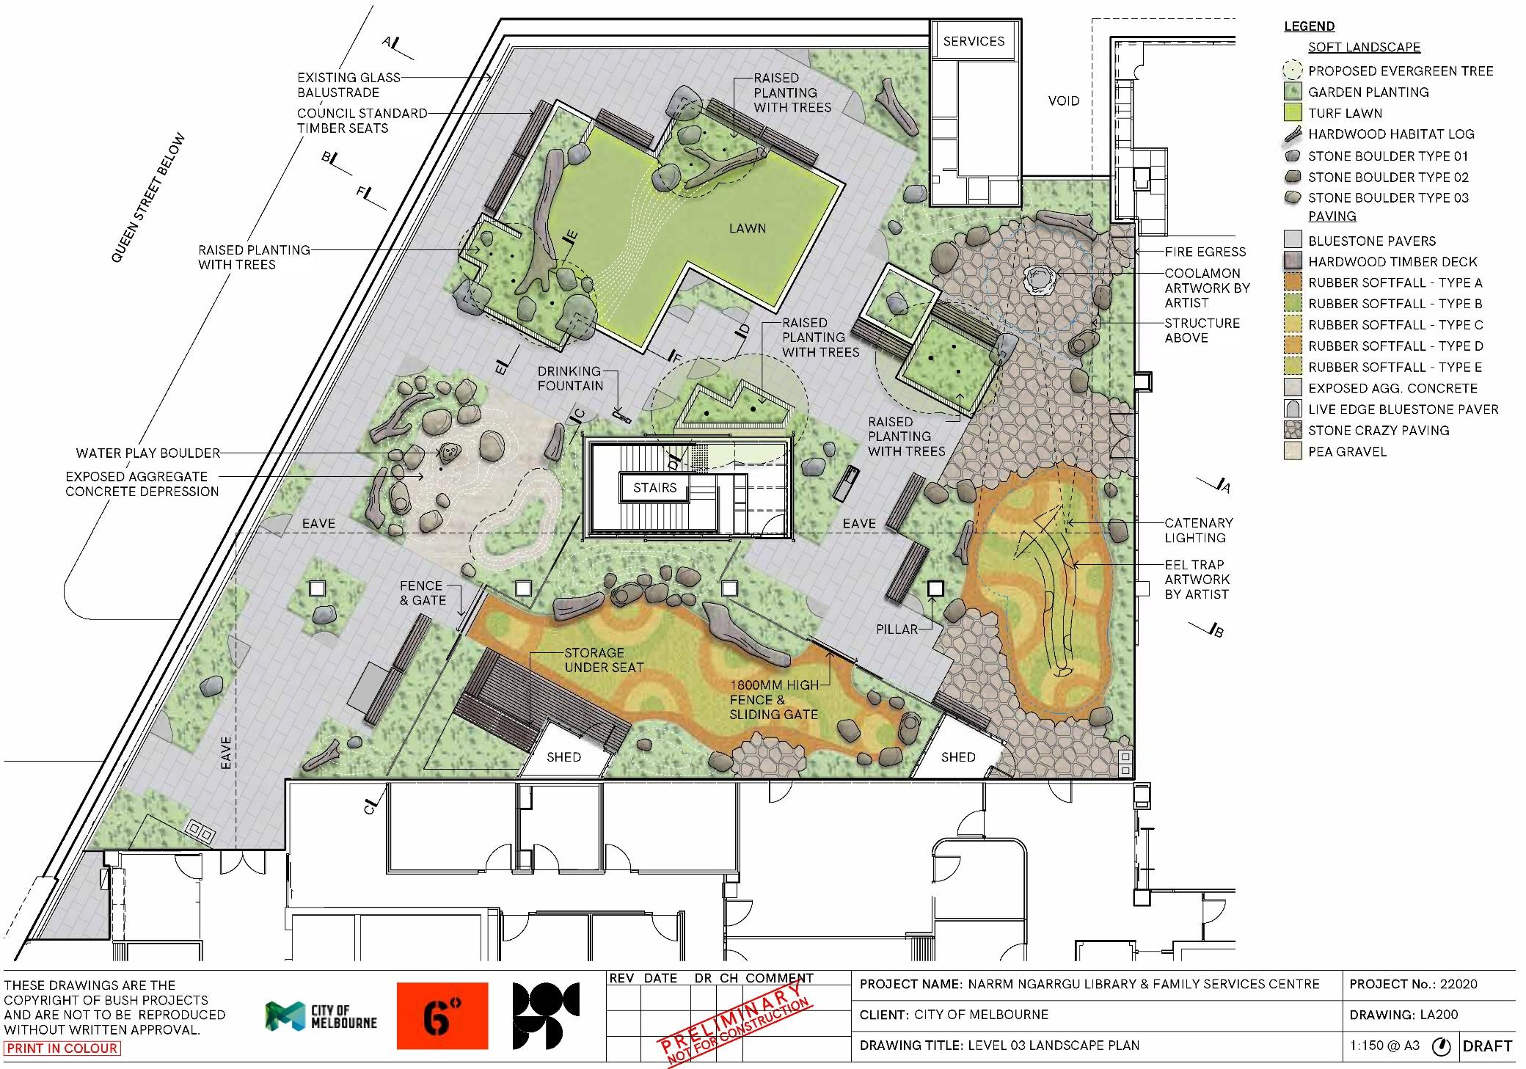
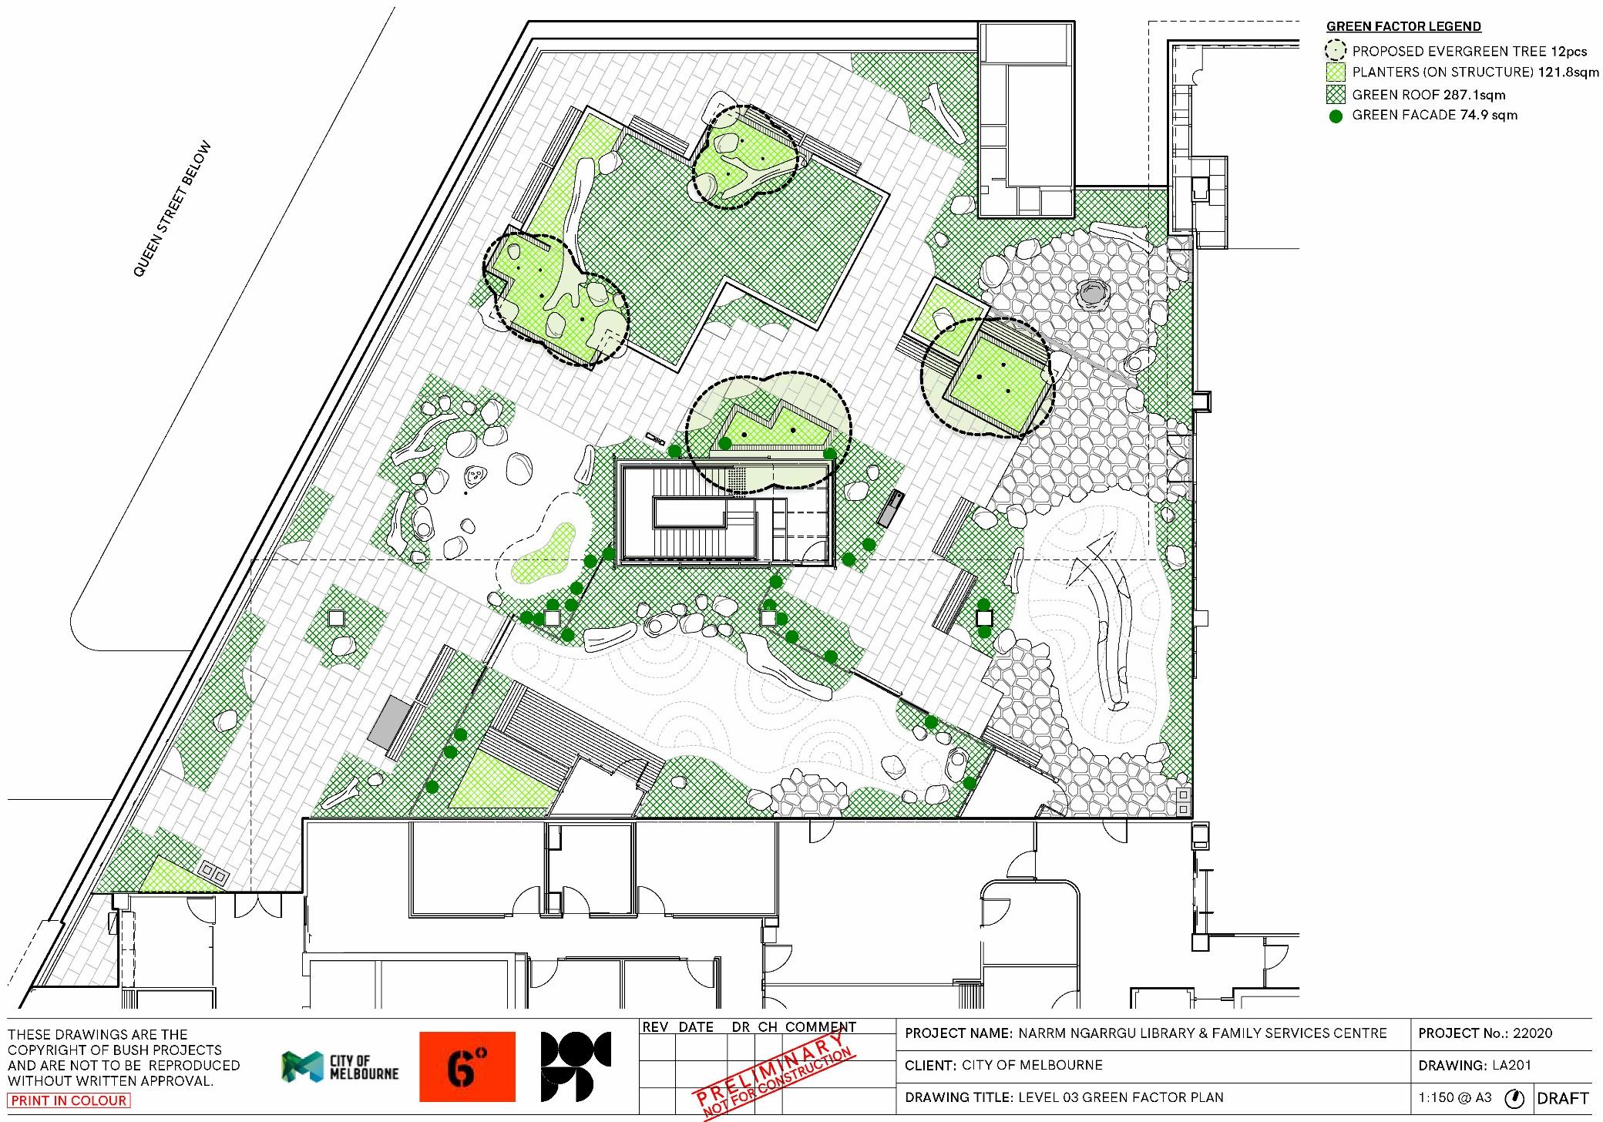
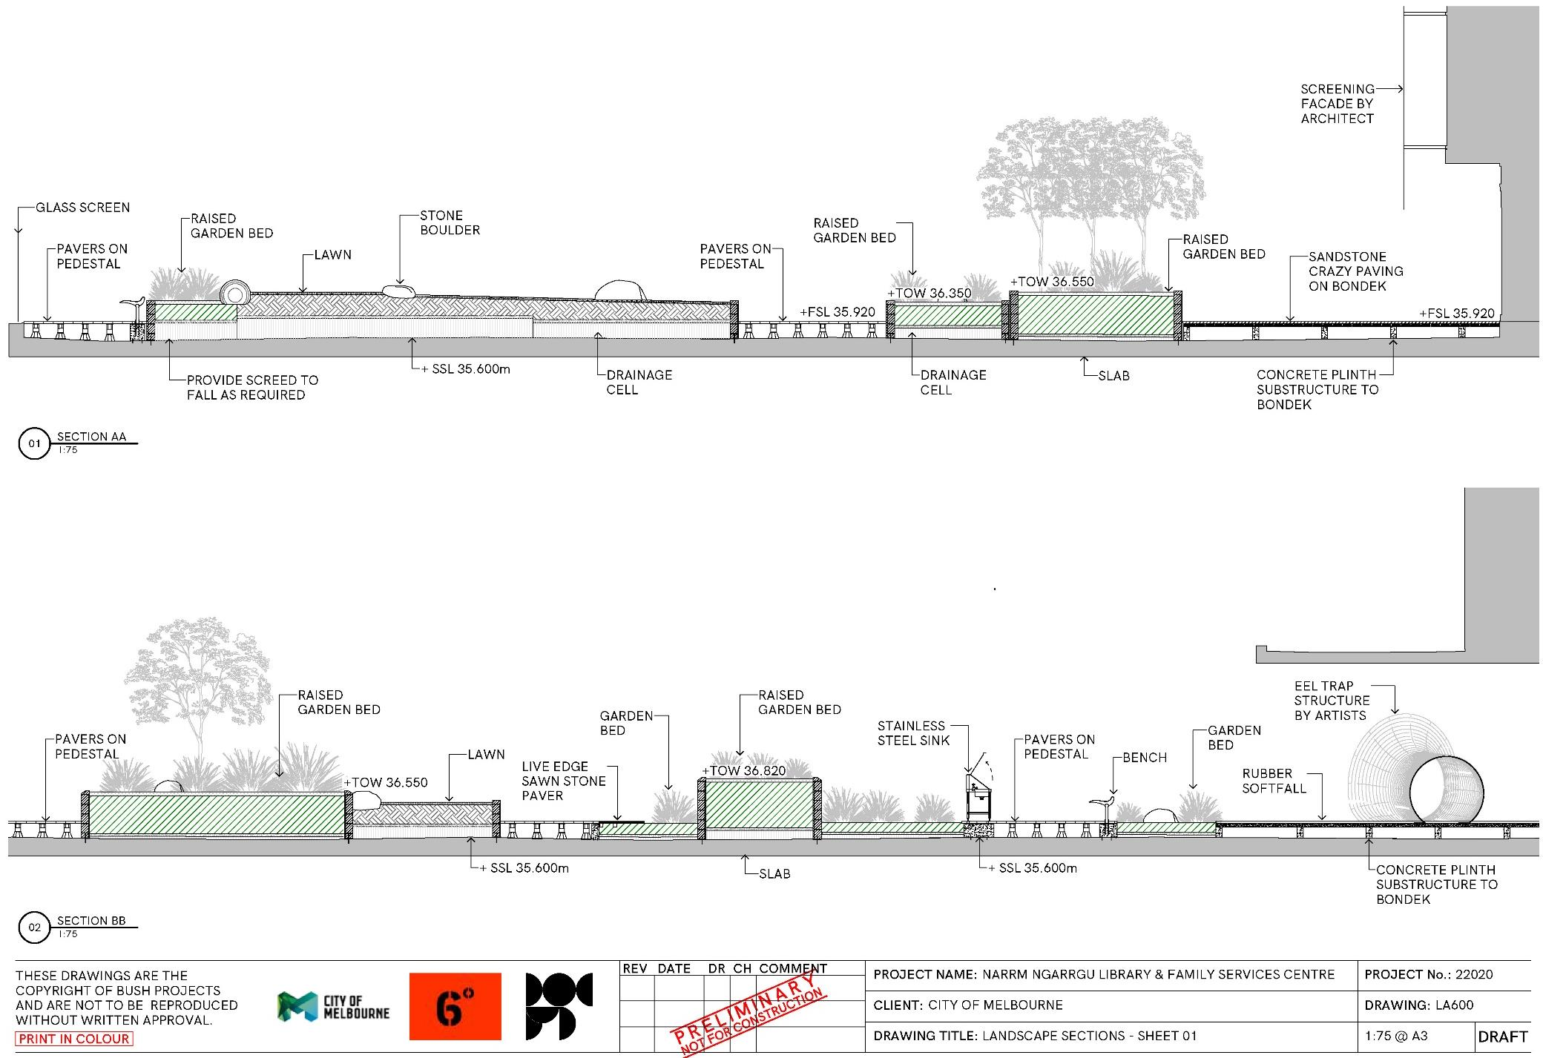
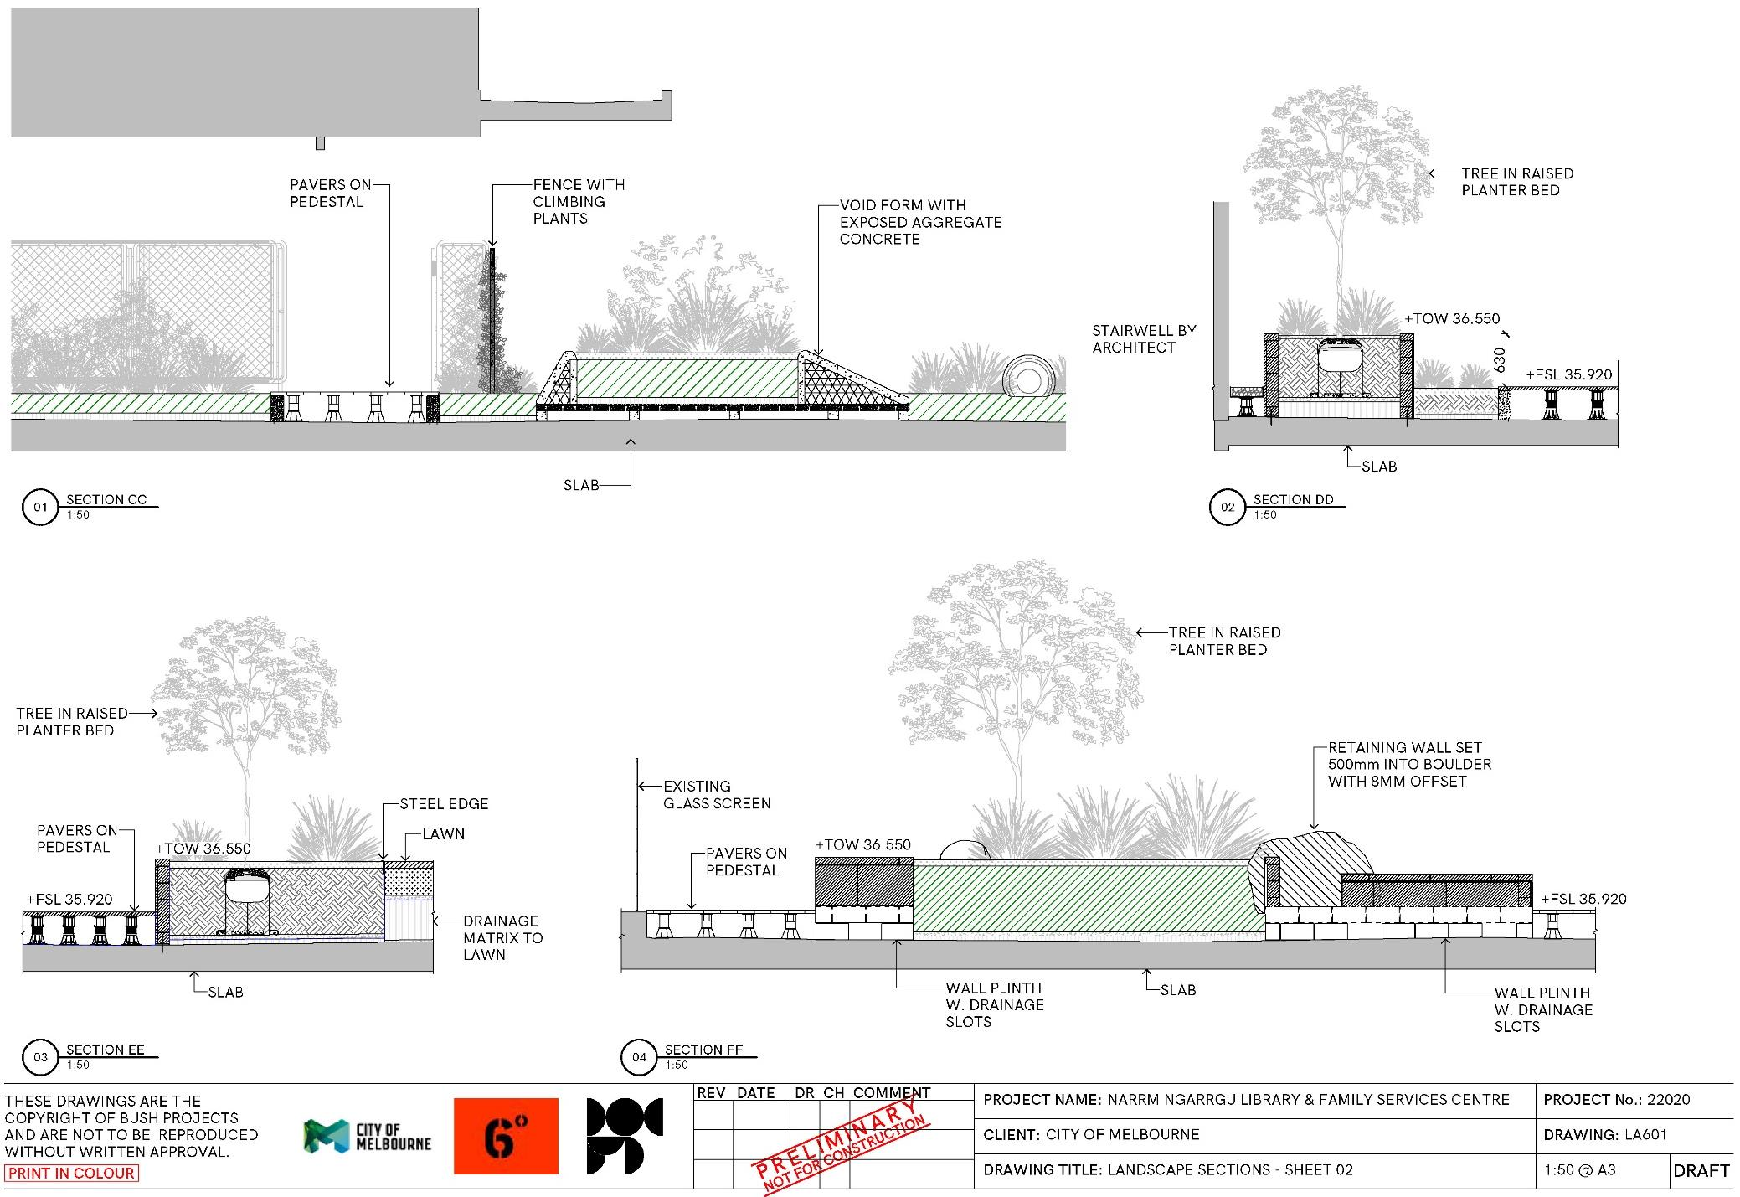
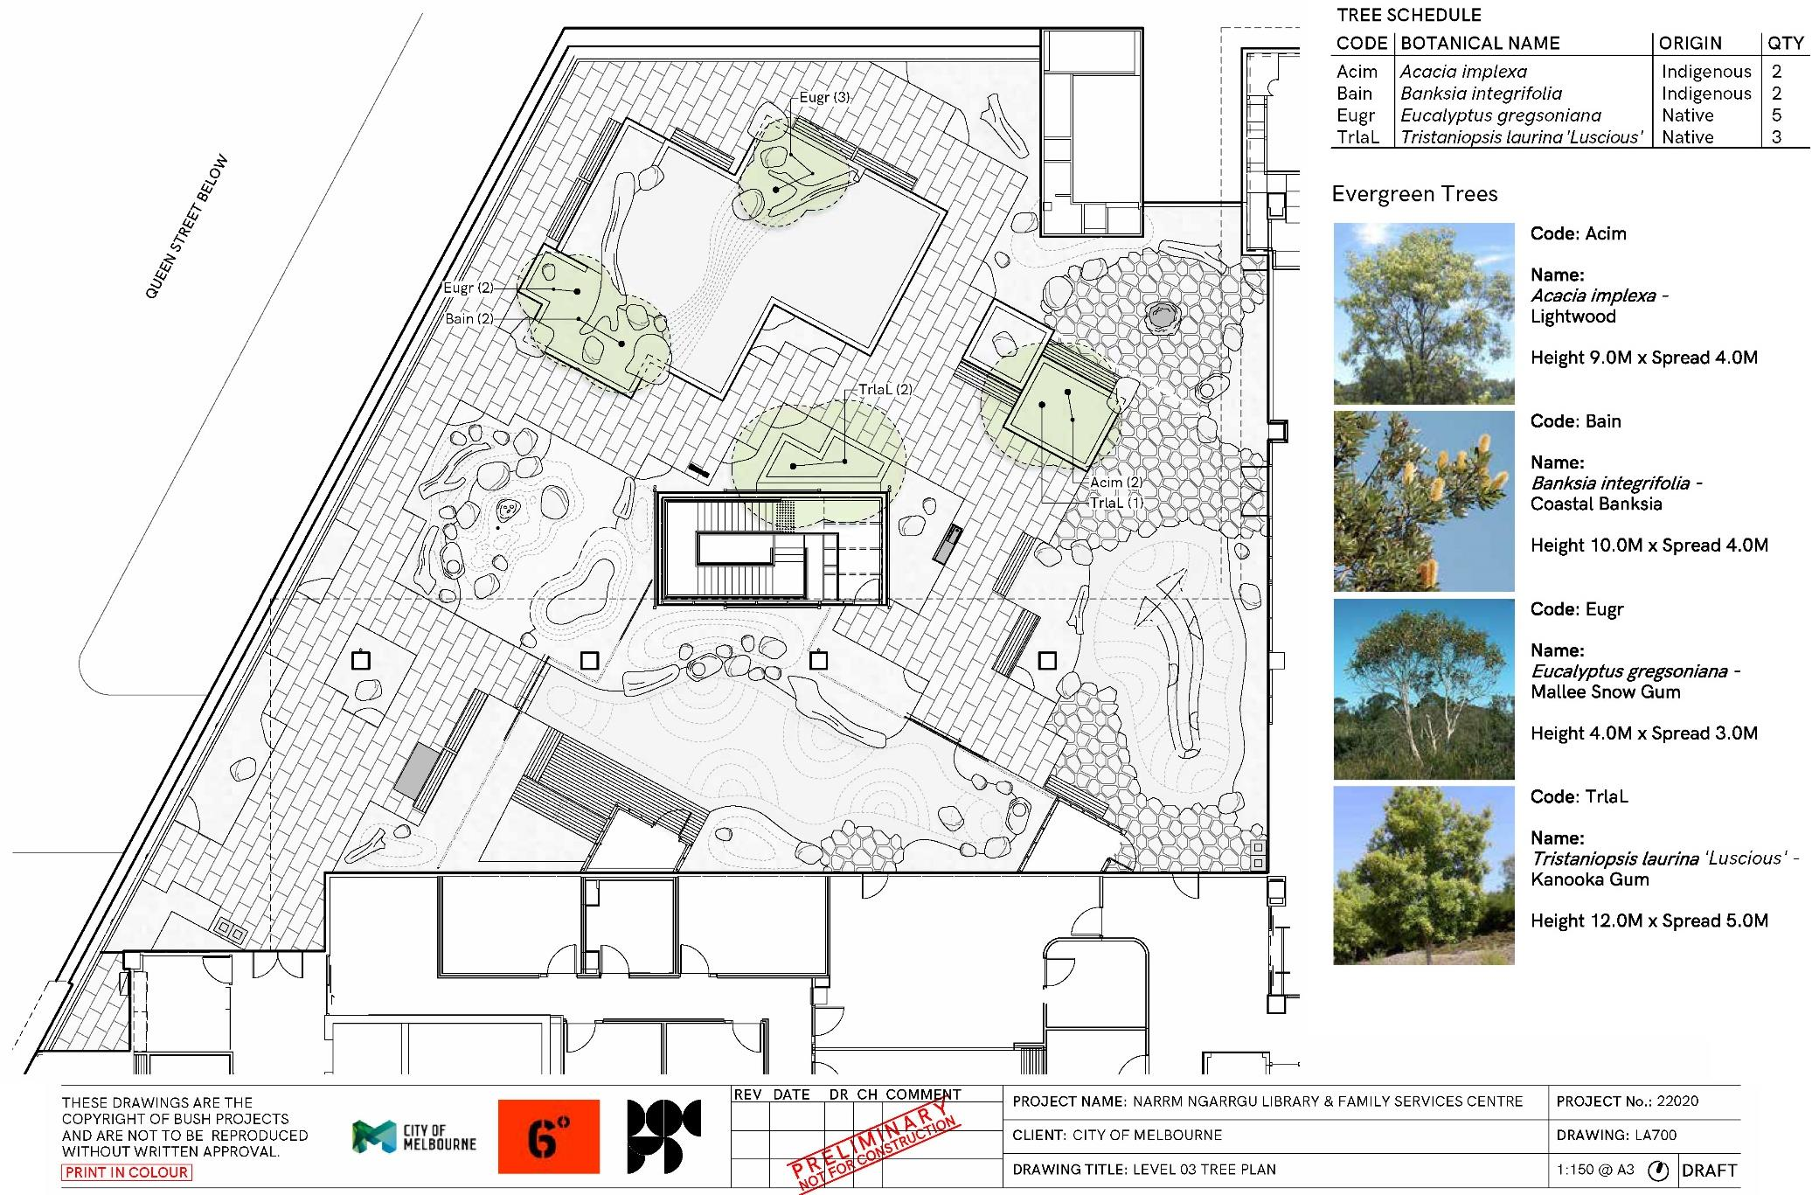
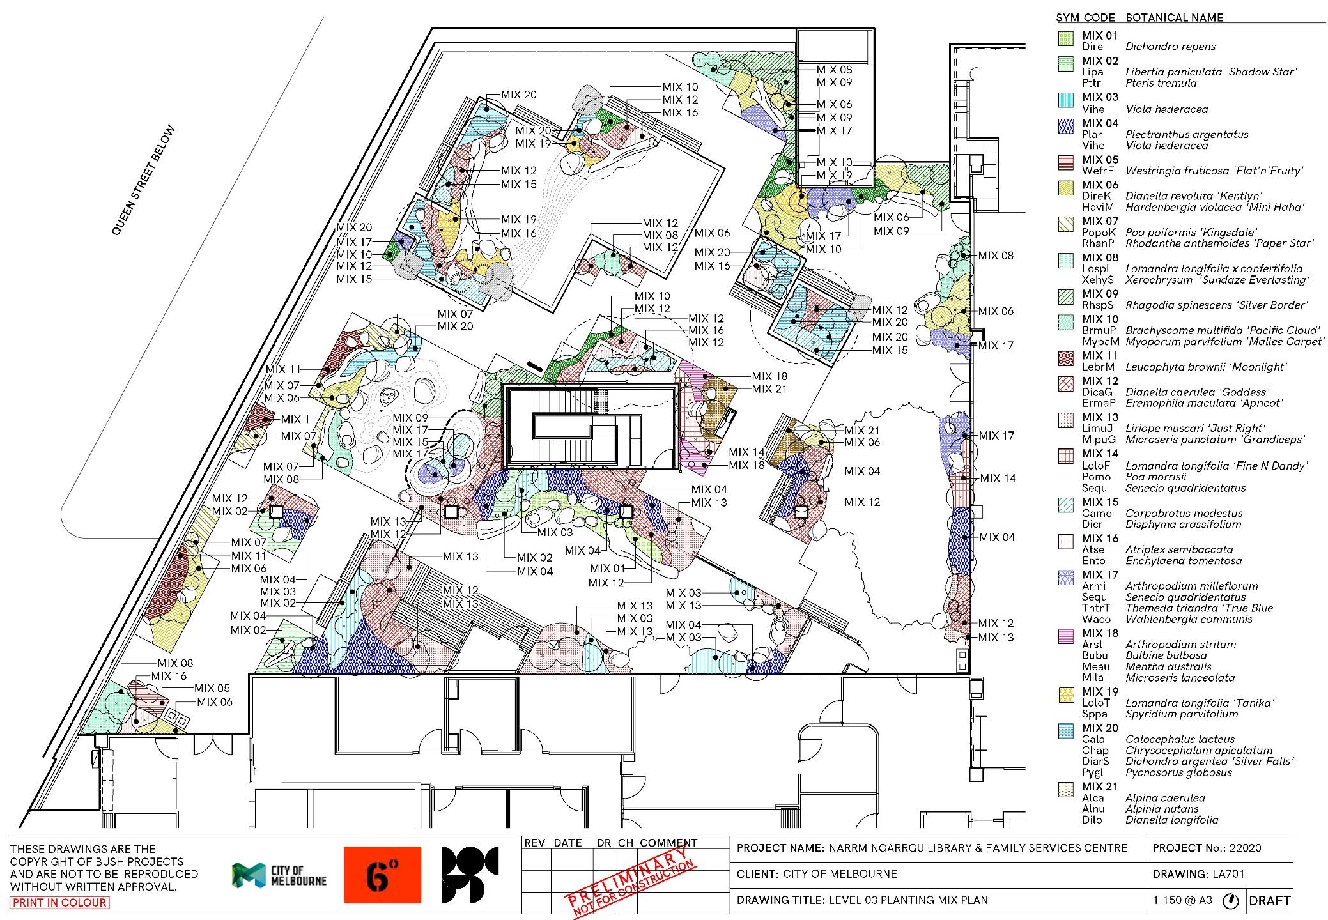
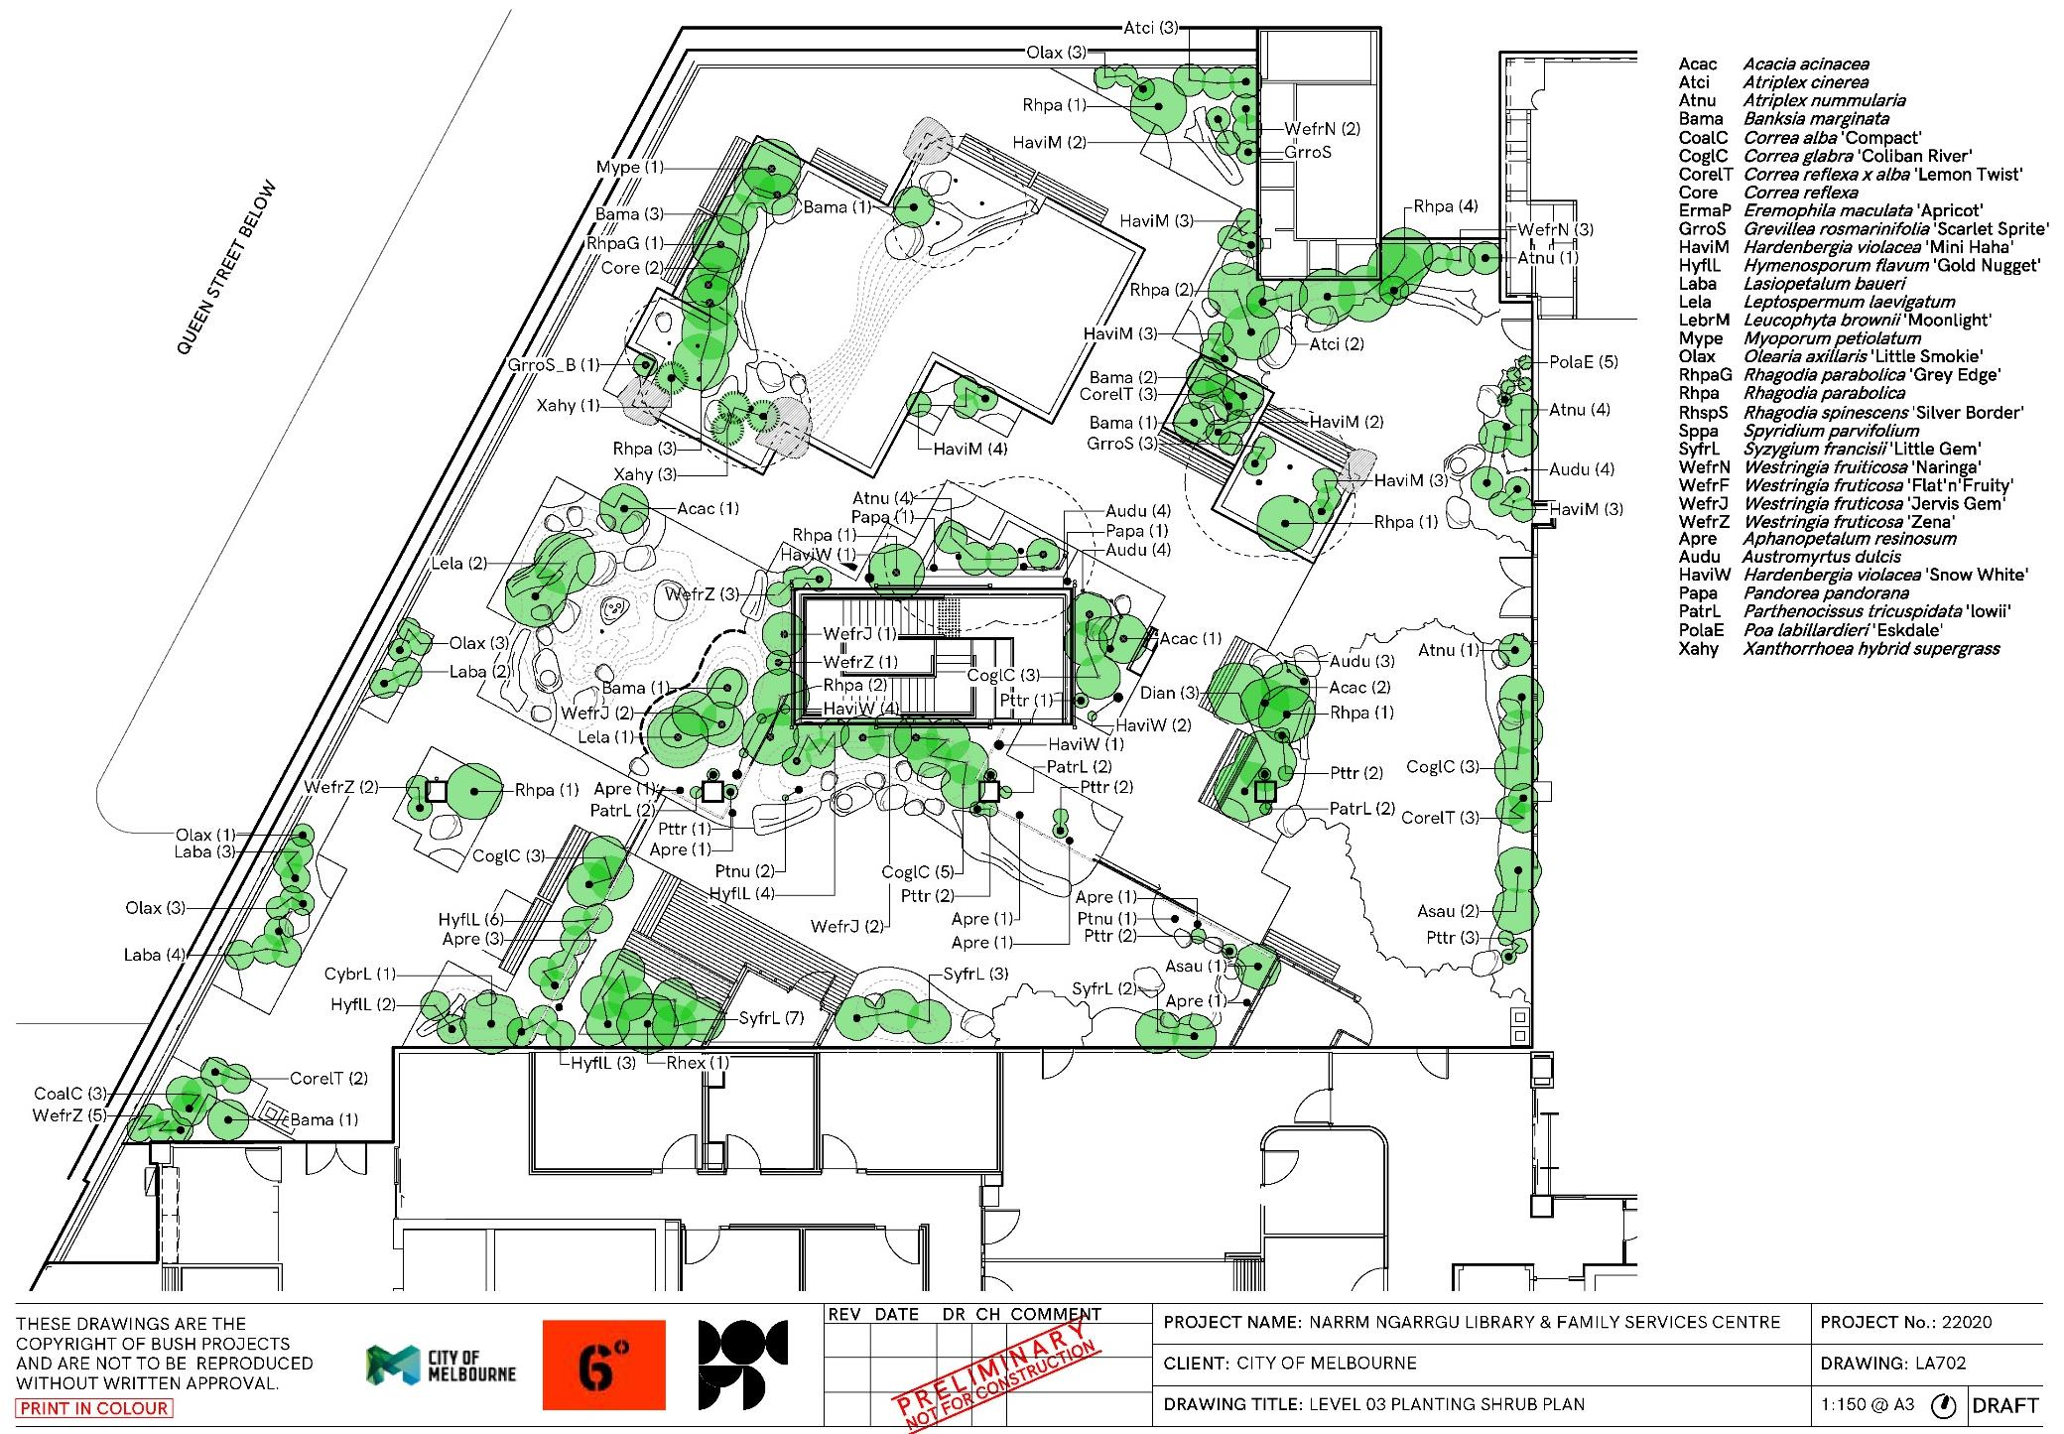

Evergreen Trees
Image | Description
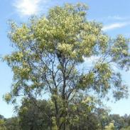 | Code: Acim  Botanical Name: Acacia implexa  Common Name: Lightwood  Size: Height 9.0m x Spread 4.0m
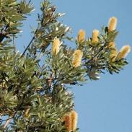 | Code: Bain  Botanical Name: Banksia integrifolia  Common Name: Coastal Banksia  Size: Height 10.0m x Spread 4.0m
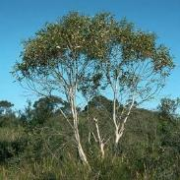 | Code: Eugr  Botanical Name: Eucalyptus gregsoniana  Common Name: Mallee Snow Gum  Size: Height 4.0m x Spread 3.0m
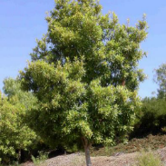 | Code: TrlaL  Botanical Name: Tristaniopsis lauirna ‘Luscious’  Common Name: Kanooka Gum  Size: Height 12.0m x Spread 5.0m

Shrubs
Image | Description
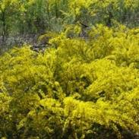 | Code: Acac  Botanical Name: Acacia acinacea  Common Name: Gold Dust Wattle  Size: Height 2.0m x Spread 3.0m
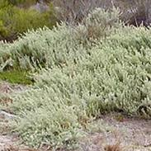 | Code: Atci  Botanical Name: Atriplex cinerea  Common Name: Grey Saltbush  Size: Height 1.5m x Spread 2.0m
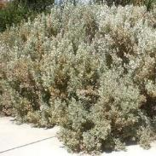 | Code: Atnu  Botanical Name: Atriplex nummularia  Common Name: Old Man Saltbush  Size: Height 1.5m x Spread 2.0m
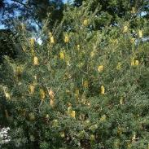 | Code: Bama  Botanical Name: Banksia marginata  Common Name: Silver Banksia  Size: Height 5.0m x Spread 2.5m
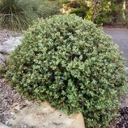 | Code: CoalC  Botanical Name: Correa alba ‘Compact’  Common Name: White Correa  Size: Height 0.4m x Spread 1.2m
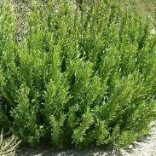 | Code: CoglC  Botanical Name: Correa glabra ‘Coliban River’  Common Name: Rock Correa  Size: Height 1.5m x Spread 1.5m
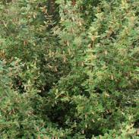 | Code: Core  Botanical Name: Correa reflexa  Common Name: Common Correa  Size: Height 1.5m x Spread 1.5m
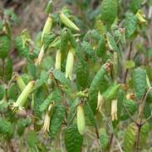 | Code: CorelT  Botanical Name: Correa reflexa x alba ‘Lemon Twist’  Common Name: Native Fuchsia  Size: Height 1.5m x Spread 1.0m
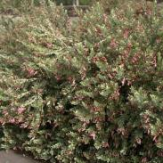 | Code: ErmaP  Botanical Name: Eremophila maculata ‘Apricot’  Common Name: Spotted Emu Bush  Size: Height 1.5m x Spread 1.0m
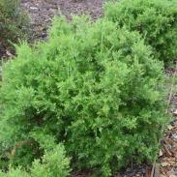 | Code: GrroS  Botanical Name: Grevillea rosmarinifolia ‘Scarlet Sprite’  Common Name: Grevillea  Size: Height 1.0m x Spread 0.8m
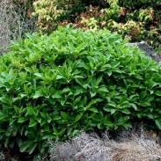 | Code: HyflL  Botanical Name: Hymenosporum flavum ‘Gold Nugget’  Common Name: Native Frangipani  Size: Height 1.0m x Spread 1.0m
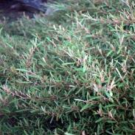 | Code: Laba  Botanical Name: Lasiopetalum baueri  Common Name: Slender Velvet Bush  Size: Height 1.5m x Spread 1.0m
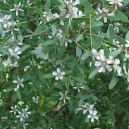 | Code: Lela  Botanical Name: Leptospermum laevigatum  Common Name: Coastal tea Tree  Size: Height 4.0m x Spread 2.5m
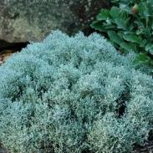 | Code: LebrM  Botanical Name: Leucophyta brownii ‘Moonlight’  Common Name: Cushion Bush  Size: Height 0.5m x Spread 0.5m
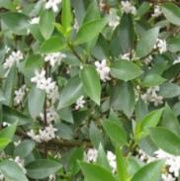 | Code: Mype  Botanical Name: Myoporum petiolatum  Common Name: Sticky Boobialla  Size: Height 2.0m x Spread 2.0m
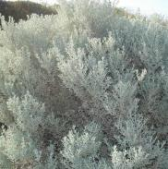 | Code: Olax  Botanical Name: Olearia axillaris ‘Little Smokie’  Common Name: Coast Daisy Bush  Size: Height 1.0m x Spread 1.0m
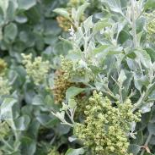 | Code: Rhpa  Botanical Name: Rhagodia parabolica  Common Name: Fragrant Saltbush  Size: Height 2.5m x Spread 2.0m
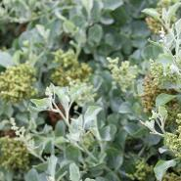 | Code: RhpaG  Botanical Name: Rhagodia parabolica ‘Grey Edge’  Common Name: Rhagodia Grey Edge  Size: Height 1.0m x Spread 2.0m
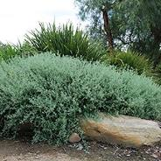 | Code: RhspS  Botanical Name: Rhagodia spinescens ‘Silver Border’  Common Name: Creeping Salt Bush  Size: Height 0.5m x Spread 1.0m
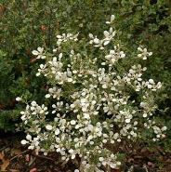 | Code: Sppa  Botanical Name: Spyridium parvifolium  Common Name: Dusty Miller  Size: Height 3.0m x Spread 1.5m
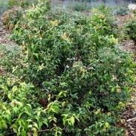 | Code: SyfrL  Botanical Name: Syzygium francisii ‘Little Gem’  Common Name: Lilly Pilly  Size: Height 2.0m x Spread 1.5m
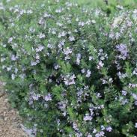 | Code: WefrN  Botanical Name: Westringia fruiticosa ‘Naringa’  Common Name: Coastal Rosemary  Size: Height 1.5m x Spread 1.0m
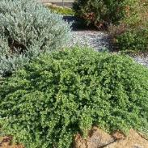 | Code: WefrF  Botanical Name: Westringia fruticosa ‘Flat’n’Fruity’  Common Name: Coastal Rosemary  Size: Height 0.2m x Spread 0.1m
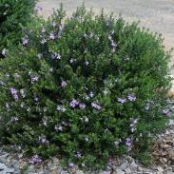 | Code: WefrJ  Botanical Name: Westringia fruticosa ‘Jervis Gem’  Common Name: Coastal Rosemary  Size: Height 1.2m x Spread 1.5m
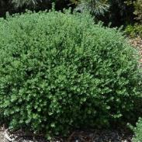 | Code: WefrZ  Botanical Name: Westringia fruticosa ‘Zena’  Common Name: Coastal Rosemary  Size: Height 1.5m x Spread 1.5m
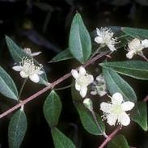 | Code: Audu  Botanical Name: Austromyrtus dulcis  Common Name: Midgen Berry  Size: Height 2.0m x Spread 0.5m

Flowering Perennial Herbs, Ferns and Palms
Image | Description
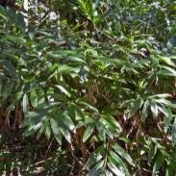 | Code: Alca  Botanical Name: Alpina caerulea  Common Name: Native ginger  Size: Height 1.5m x Spread 1.0m
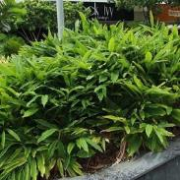 | Code: Alnu  Botanical Name: Alpinia nutans  Common Name: Dwarf Cardamon Ginger  Size: Height 2.0m x Spread 1.0m
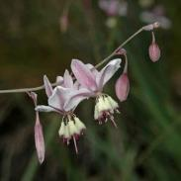 | Code: Armi  Botanical Name: Arthropodium milleflorum  Common Name: Vanilla Lily  Size: Height 1.0m x Spread 1.0m
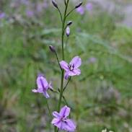 | Code: Arst  Botanical Name: Arthropodium stritum  Common Name: Chocolate Lily  Size: Height 0.6m x Spread 0.1m
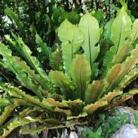 | Code: Asau  Botanical Name: Asplenium australasicum  Common Name: Bird’s Nest Fern  Size: Height 0.5m x Spread 1.5m
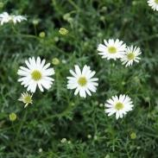 | Code: BrmuP  Botanical Name: Brachyscome multifida ‘Pacific Cloud’  Common Name: Native Daisy  Size: Height 0.5m x Spread 1.5m
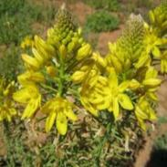 | Code: Bubu  Botanical Name: Bulbine bulbosa  Common Name: Bulbine Lily  Size: Height 0.5m x Spread 0.5m
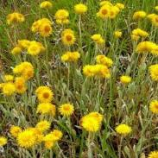 | Code: Chap  Botanical Name: Chrysocephalum apiculatum  Common Name: Common Everlasting  Size: Height 0.3m x Spread 0.3m
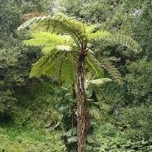 | Code: CybrL  Botanical Name: Cyathea brownii ‘Larrikin’  Common Name: Norfolk Tree Fern  Size: Height 4.0m x Spread 2.0m
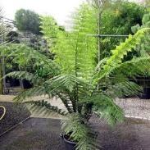 | Code: Dian  Botanical Name: Dicksonia antartica  Common Name: Soft Tree Fern  Size: Height 4.5m x Spread 2.0m
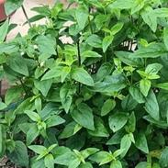 | Code: Meau  Botanical Name: Mentha australis  Common Name: Native River Mint  Size: Height 0.3m x Spread 1.0m
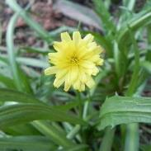 | Code: Mila  Botanical Name: Microseris lanceolata  Common Name: Yam Daisy  Size: Height 0.3m x Spread 0.3m
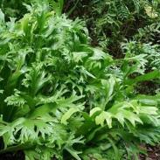 | Code: MipuG  Botanical Name: Microseris punctatum ‘Grandiceps’  Common Name: Elk Fern  Size: Height 0.6m x Spread 0.6m
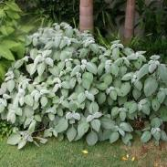 | Code: Plar  Botanical Name: Plectranthus argentatus  Common Name: Silver Plectranthus  Size: Height 1.0m x Spread 4.0m
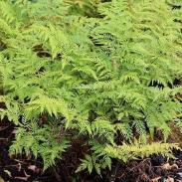 | Code: Pttr  Botanical Name: Pteris tremula  Common Name: Tender Brake Fern  Size: Height 0.8m x Spread 0.5m
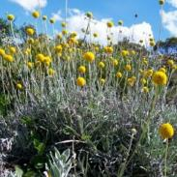 | Code: Pygl  Botanical Name: Pycnosorus globosus  Common Name: Billy Buttons  Size: Height 0.3m x Spread 0.3m
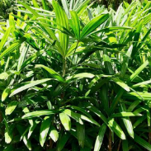 | Code: Rhex  Botanical Name: Rhaphis excelsa  Common Name: Rhapis Palm  Size: Height 2.0m x Spread 2.0m
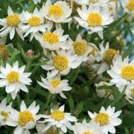 | Code: RhanP  Botanical Name: Rhodanthe anthemoides ‘Paper Star’  Common Name: Chamomile Sunray  Size: Height 0.4m x Spread 0.5m
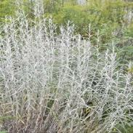 | Code: Sequ  Botanical Name: Senecio quadridentatus  Common Name: Cotton Fireweed  Size: Height 1.0m x Spread 1.0m
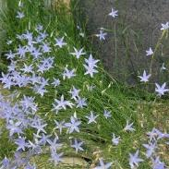 | Code: Waco  Botanical Name: Wahlenbergia communis  Common Name: Tufted Bluebell  Size: Height 0.4m x Spread 0.2m
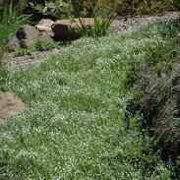 | Code: Cala  Botanical Name: Calocephalus lacteus  Common Name: Milky Beauty Heads  Size: Height 0.2m x Spread 0.3m

Groundcovers
Image | Description
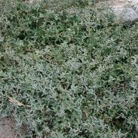 | Code: Atse  Botanical Name: Atriplex semibaccata  Common Name: Creeping Saltbush  Size: Height 0.4m x Spread 1.0m
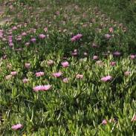 | Code: Camo  Botanical Name: Carpobrotus modestus  Common Name: Inland Pig Face  Size: Height 0.1m x Spread 2.0m
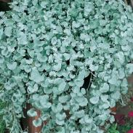 | Code: DiarS  Botanical Name: Dichondra argentea ‘Silver Falls’  Common Name: Dichondra  Size: Height 0.2m x Spread 1.0m
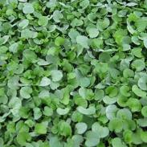 | Code: Dire  Botanical Name: Dichondra repens  Common Name: Kidney Weed  Size: Height 0.2m x Spread 0.2m
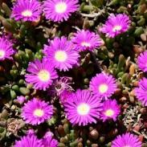 | Code: Dicr  Botanical Name: Disphyma crassifolium  Common Name: Pig Face  Size: Height 0.2m x Spread 0.5m
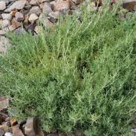 | Code: Ento  Botanical Name: Enchylaena tomentosa  Common Name: Ruby Saltbush  Size: Height 0.5m x Spread 1.0m
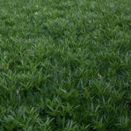 | Code: MypaM  Botanical Name: Myoporum parvifolium ‘Mallee Carpet’  Common Name: Creeping boobialla  Size: Height 0.2m x Spread 2.0m
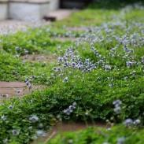 | Code: Vihe  Botanical Name: Viola hederacea  Common Name: Native Violet  Size: Height 0.2m x Spread 0.2m
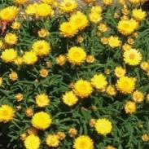 | Code: XehyS  Botanical Name: Xerochrysum hybrid ‘Sundaze Everlasting Gold’  Common Name: Everlasting Daisy  Size: Height 0.3m x Spread 0.5m
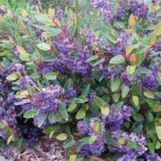 | Code: HaviM  Botanical Name: Hardenbergia violacea ‘Mini Haha’  Common Name: Dwarf Hardenbergia  Size: Height 0.2m x Spread 1.0m

Grasses and Grass-like Forms
Image | Description
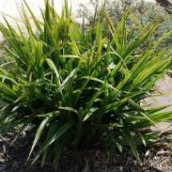 | Code: DicaG  Botanical Name: Dianella caerulea ‘Goddess’  Common Name: Blue Flax Lily  Size: Height 0.5m x Spread 0.5m
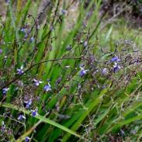 | Code: Dilo  Botanical Name: Dianella longifolia  Common Name: Pale Flax Lily  Size: Height 1.0m x Spread 0.4m
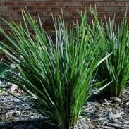 | Code: DireK  Botanical Name: Dianella revoluta ‘Kentlyn’  Common Name: Native Flax  Size: Height 0.8m x Spread 0.5m
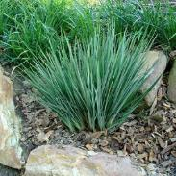 | Code: DireL  Botanical Name: Dianella revoluta ‘Little Rev’  Common Name: Dianella Little Rev  Size: Height 0.3m x Spread 0.3m
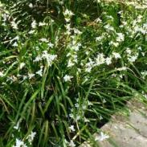 | Code: Lipa  Botanical Name: Libertia paniculata ‘Shadow Star’  Common Name: Grass Flag  Size: Height Spread 0.5m
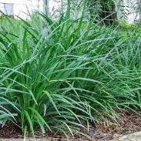 | Code: LimuJ  Botanical Name: Liriope muscari ‘Just Right’  Common Name: Turf Lily  Size: Height 0.5m x Spread 0.5m
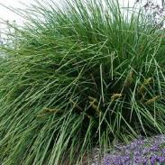 | Code: LoloF  Botanical Name: Lomandra longifolia ‘Fine N Dandy’  Common Name: Mat Rush  Size: Height 1.5m x Spread 1.5m
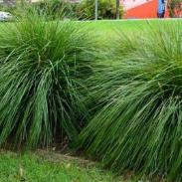 | Code: LoloT  Botanical Name: Lomandra longifolia ‘Tanika’  Common Name: Mat Rush  Size: Height 0.6m x Spread 0.6m
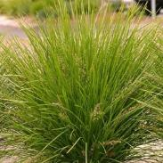 | Code: LospL  Botanical Name: Lomandra longifolia x confertifolia spp. pallida ‘Lime Tuff’  Common Name: Mat Rush  Size: Height 0.4m x Spread 0.4m
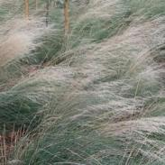 | Code: PolaE  Botanical Name: Poa labillardieri ‘Eskdale’  Common Name: Blue Tussock Grass  Size: Height 0.5m x Spread 0.5m
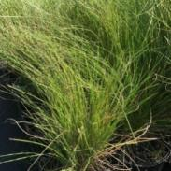 | Code: Pomo  Botanical Name: Poa morrisii  Common Name: Velvet Tussock Grass  Size: Height 0.6m x Spread 0.6m
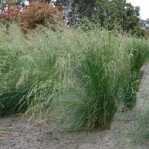 | Code: PopoK  Botanical Name: Poa poiformis ‘Kingsdale’  Common Name: Tussock Grass  Size: Height 0.5m x Spread 0.5m
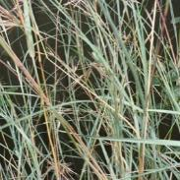 | Code: ThtrT  Botanical Name: Themeda triandra ‘True Blue’  Common Name: Kangaroo Grass  Size: Height 1.0m x Spread 0.5m
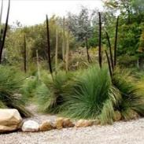 | Code: Xahy  Botanical Name: Xanthorrhoea hybrid ‘supergrass’  Common Name: Grass Tree  Size: Height 2.0m x Spread 2.0m

Climbers
Image | Description
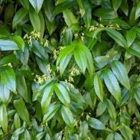 | Code: Apre  Botanical Name: Aphanopetalum resinosum  Common Name: Gum Vine  Size: Height 2.0m x Spread 0.3m
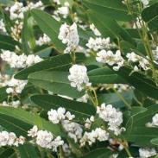 | Code: HaviW  Botanical Name: Hardenbergia violacea ‘Snow White’  Common Name: Hardenbergia  Size: Height 3.0m x Spread 1.5m
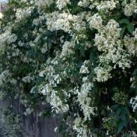 | Code: Papa  Botanical Name: Pandorea pandorana  Common Name: Wonga Wonga Vine  Size: Height 0.2m x Spread 0.2m
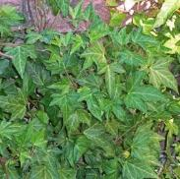 | Code: Papa  Botanical Name: Parthenocissus tricuspidata ‘lowii’  Common Name: Japanese Creeper  Size: Height 3.0m x Spread 2.0m

Evergreen trees
Code | Botanical name | Common name | Green factor vegetation type | Origin | Mature height (m) | Mature width (m) | In ground (existing) quantity | In ground (new) quantity | Green wall quantity | Green facade quantity | Planters (on structure) quantity | Green roof quantity
Acim | Acacia implexa | Lightwood | Small tree | Indigenous | 9 | 4 |  |  |  |  | 2
Bain | Banksia integrifolia | Coastal Banksia | Small tree | Indigenous | 10 | 4 |  |  |  |  | 2
Eugr | Eucalyptus gregsoniana | Mallee Snow Gum | Small tree | Native | 4 | 3 |  |  |  |  | 5
TrlaL | Tristaniopsis lauirna 'Luscious' | Kanooka Gum | Small tree | Native | 12 | 5 |  |  |  |  | 3

Shrubs
Code | Botanical name | Common name | Green factor vegetation type | Origin | Mature height (m) | Mature width (m) | In ground (existing) quantity | In ground (new) quantity | Green wall quantity | Green facade quantity | Planters (on structure) quantity | Green roof quantity
Acac | Acacia acinacea | Gold Dust Wattle | Large shrub | Indigenous | 2 | 3 |  |  |  |  |  | 4
Atci | Atriplex cinerea | Grey Saltbush | Large shrub | Indigenous | 1.5 | 2 |  |  |  |  |  | 5
Atnu | Atriplex nummularia | Old Man Saltbush | Large shrub | Native | 1.5 | 2 |  |  |  |  | 4 | 6
Audu | Austromyrtus dulcis | Midgen Berry | Large shrub | Native | 2 | 0.5 |  |  |  |  | 4 | 11
Bama | Banksia marginata | Silver Banksia | Large shrub | Indigenous | 5 | 2.5 |  |  |  |  | 9
CoalC | Correa alba 'Compact' | White Correa | Groundcover | Indigenous | 0.4 | 1.2 |  |  |  |  |  | 3
CoglC | Correa glabra 'Coliban River' | Rock Correa | Large shrub | Indigenous | 1.5 | 1.5 |  |  |  |  |  | 14
CorelT | Correa reflexa x alba 'Lemon Twist' | Native Fuchsia | Large shrub | Indigenous | 1.5 | 1 |  |  |  |  | 3 | 5
Core | Correa reflexa | Common Correa | Large shrub | Indigenous | 1.5 | 1.5 |  |  |  |  | 2
ErmaP | Eremophila maculata 'Apricot' | Spotted Emu Bush | Large shrub | Native | 1.5 | 1 |  |  |  |  | 9 | 20
GrroS | Grevillea rosmarinifolia 'Scarlet Sprite' | Grevillea | Small shrub | Indigenous | 1 | 0.8 |  |  |  |  | 3 | 2
HyflL | Hymenosporum flavum 'Gold Nugget' | Native Frangipani | Small shrub | Native | 1 | 1 |  |  |  |  |  | 15
Laba | Lasiopetalum baueri | Slender Velvet Bush | Large shrub | Indigenous | 1.5 | 1 |  |  |  |  |  | 9
Lela | Leptospermum laevigatum | Coastal tea Tree | Large shrub | Indigenous | 4 | 2.5 |  |  |  |  | 1 | 2
LebrM | Leucophyta brownii 'Moonlight' | Cushion Bush | Small shrub | Indigenous | 0.5 | 0.5 |  |  |  |  |  | 35
Mype | Myoporum petiolatum | Sticky Boobialla | Large shrub | Indigenous | 2 | 2 |  |  |  |  | 1
Olax | Olearia axillaris 'Little Smokie' | Coast Daisy Bush | Small shrub | Indigenous | 1 | 1 |  |  |  |  |  | 10
RhpaG | Rhagodia parabolica 'Grey Edge' | Rhagodia Grey Edge | Small shrub | Native | 1 | 2 |  |  |  |  | 1
Rhpa | Rhagodia parabolica | Fragrant Saltbush | Large shrub | Native | 2.5 | 2 |  |  |  |  | 4 | 12
RhspS | Rhagodia spinescens 'Silver Border' | Creeping Salt Bush | Small shrub | Indigenous | 0.5 | 1 |  |  |  |  |  | 48
Sppa | Spyridium parvifolium | Dusty Miller | Large shrub | Native | 3 | 1.5 |  |  |  |  | 10 | 6
SyfrL | Syzygium francisii 'Little Gem' | Lilly Pilly | Large shrub | Native | 2 | 1.5 |  |  |  |  | 7 | 5
WefrN | Westringia fruiticosa 'Naringa' | Coastal Rosemary | Large shrub | Native | 1.5 | 1 |  |  |  |  |  | 5
WefrF | Westringia fruticosa 'Flat'n'Fruity' | Coastal Rosemary | Groundcover | Native | 0.2 | 0.5 |  |  |  |  |  | 7
WefrJ | Westringia fruticosa 'Jervis Gem' | Coastal Rosemary | Small shrub | Native | 1.2 | 1.5 |  |  |  |  | 2 | 3
WefrZ | Westringia fruticosa 'Zena' | Coastal Rosemary | Large shrub | Native | 1.5 | 1.5 |  |  |  |  |  | 11

Climbers
Code | Botanical name | Common name | Green factor vegetation type | Origin | Mature height (m) | Mature width (m) | In ground (existing) quantity | In ground (new) quantity | Green wall quantity | Green facade quantity | Planters (on structure) quantity | Green roof quantity
Apre | Aphanopetalum resinosum | Gum Vine | Climber | Native | 2 | 2 |  |  |  | 9
HaviW | Hardenbergia violacea 'Snow White' | Hardenbergia | Climber | Indigenous | 3 | 1.5 |  |  |  | 8
Papa | Pandorea pandorana | Wonga Wonga Vine | Climber | Indigenous | 2 | 2 |  |  |  | 2
PatrL | Parthenocissus tricuspidata 'lowii' | Japanese Creeper | Climber | Exotic | 3 | 2 |  |  |  | 6

Flowering perennial herbs, ferns and palms
Code | Botanical name | Common name | Green factor vegetation type | Origin | Mature height (m) | Mature width (m) | In ground (existing) quantity | In ground (new) quantity | Green wall quantity | Green facade quantity | Planters (on structure) quantity | Green roof quantity
Alca | Alpina caerulea | Native ginger | Large shrub | Native | 1.5 | 1 |  |  |  |  |  | 1
Alnu | Alpinia nutans | Dwarf Cardamon Ginger | Large shrub | Native | 2 | 1 |  |  |  |  |  | 3
Armi | Arthropodium milleflorum | Vanilla Lily | Small shrub | Indigenous | 1 | 1 |  |  |  |  | 4 | 12
Arst | Arthropodium stritum | Chocolate Lily | Small shrub | Indigenous | 0.6 | 0.1 |  |  |  |  |  | 8
Asau | Asplenium australasicum | Bird's Nest Fern | Small shrub | Native | 0.5 | 1.5 |  |  |  |  |  | 3
BrmuP | Brachyscome multifida 'Pacific Cloud' | Native Daisy | Groundcover | Indigenous | 0.3 | 0.5 |  |  |  |  | 6 | 30
Bubu | Bulbine bulbosa | Bulbine Lily | Small shrub | Indigenous | 0.5 | 0.5 |  |  |  |  |  | 8
Cala | Calocephalus lacteus | Milky Beauty Heads | Groundcover | Indigenous | 0.2 | 0.3 |  |  |  |  | 30 | 9
Chap | Chrysocephalum apiculatum | Common Everlasting | Groundcover | Indigenous | 0.3 | 0.3 |  |  |  |  | 58 | 8
CybrL | Cyathea brownii 'Larrikin' | Norfolk Tree Fern | Large shrub | Native | 4 | 2 |  |  |  |  |  | 1
Dian | Dicksonia antartica | Soft Tree Fern | Large shrub | Indigenous | 4.5 | 2 |  |  |  |  |  | 3
Meau | Mentha australis | Native River Mint | Groundcover | Indigenous | 0.3 | 1 |  |  |  |  |  | 8
Mila | Microseris lanceolata | Yam Daisy | Groundcover | Indigenous | 0.3 | 0.3 |  |  |  |  |  | 8
MipuG | Microseris punctatum 'Grandiceps' | Elk Fern | Small shrub | Native | 0.6 | 0.6 |  |  |  |  |  | 20
Plar | Plectranthus argentatus | Silver Plectranthus | Small shrub | Native | 1 | 4 |  |  |  |  |  | 80
Pttr | Pteris tremula | Tender Brake Fern | Small shrub | Indigenous | 0.8 | 0.5 |  |  |  |  |  | 18
Pygl | Pycnosorus globosus | Billy Buttons | Groundcover | Indigenous | 0.3 | 0.3 |  |  |  |  | 42 | 11
Rhex | Rhaphis excelsa | Rhapis Palm | Large shrub | Exotic | 2 | 2 |  |  |  |  | 1
RhanP | Rhodanthe anthemoides 'Paper Star' | Chamomile Sunray | Groundcover | Indigenous | 0.4 | 0.5 |  |  |  |  |  | 11
Sequ | Senecio quadridentatus | Cotton Fireweed | Small shrub | Indigenous | 1 | 1 |  |  |  |  | 9 | 2
Waco | Wahlenbergia communis | Tufted Bluebell | Groundcover | Indigenous | 0.4 | 0.2 |  |  |  |  | 8 | 28

Groundcovers
Code | Botanical name | Common name | Green factor vegetation type | Origin | Mature height (m) | Mature width (m) | In ground (existing) quantity | In ground (new) quantity | Green wall quantity | Green facade quantity | Planters (on structure) quantity | Green roof quantity
Atse | Atriplex semibaccata | Creeping Saltbush | Groundcover | Indigenous | 0.4 | 1 |  |  |  |  | 7
Camo | Carpobrotus modestus | Inland Pig Face | Groundcover | Indigenous | 0.1 | 2 |  |  |  |  | 6
DiarS | Dichondra argentea 'Silver Falls' | Dichondra | Groundcover | Exotic | 0.2 | 1 |  |  |  |  | 34 | 5
Dire | Dichondra repens | Kidney Weed | Groundcover | Indigenous | 0.2 | 0.2 |  |  |  |  |  | 39
Dicr | Disphyma crassifolium | Pig Face | Groundcover | Indigenous | 0.2 | 0.5 |  |  |  |  | 25
Ento | Enchylaena tomentosa | Ruby Saltbush | Small shrub | Indigenous | 0.5 | 1 |  |  |  |  | 15
HaviM | Hardenbergia violacea 'Mini Haha' | Dwarf Hardenbergia | Groundcover | Indigenous | 0.2 | 1 |  |  |  |  | 7 | 50
MypaM | Myoporum parvifolium 'Mallee Carpet' | Creeping boobialla | Groundcover | Indigenous | 0.2 | 2 |  |  |  |  | 6 | 10
Vihe | Viola hederacea | Native Violet | Groundcover | Indigenous | 0.2 | 0.2 |  |  |  |  |  | 124
XehyS | Xerochrysum hybrid 'Sundaze Everlasting Gold' | Everlasting Daisy | Groundcover | Indigenous | 0.3 | 0.5 |  |  |  |  |  | 30

Grasses and grass-like forms
Code | Botanical name | Common name | Green factor vegetation type | Origin | Mature height (m) | Mature width (m) | In ground (existing) quantity | In ground (new) quantity | Green wall quantity | Green facade quantity | Planters (on structure) quantity | Green roof quantity
DicaG | Dianella caerulea 'Goddess' | Blue Flax Lily | Small shrub | Indigenous | 0.5 | 0.5 |  |  |  |  | 178 | 119
Dilo | Dianella longifolia | Pale Flax Lily | Small shrub | Indigenous | 1 | 0.4 |  |  |  |  |  | 22
DireK | Dianella revoluta 'Kentlyn' | Native Flax | Small shrub | Indigenous | 0.8 | 0.5 |  |  |  |  | 10 | 150
DireL | Dianella revoluta 'Little Rev' | Dianella Little Rev | Groundcover | Indigenous | 0.3 | 0.3 |  |  |  |  |  | 1
Lipa | Libertia paniculata 'Shadow Star' | Grass Flag | Small shrub | Native | 0.7 | 0.5 |  |  |  |  |  | 54
LimuJ | Liriope muscari 'Just Right' | Turf Lily | Small shrub | Exotic | 0.5 | 0.5 |  |  |  |  |  | 199
LospL | Lomandra longifolia x confertifolia spp. pallida 'Lime Tuff' | Mat Rush | Groundcover | Indigenous | 0.4 | 0.4 |  |  |  |  |  | 62
LoloF | Lomandra longifolia 'Fine N Dandy' | Mat Rush | Large shrub | Indigenous | 1.5 | 1.5 |  |  |  |  |  | 10
LoloT | Lomandra longifolia 'Tanika' | Mat Rush | Small shrub | Indigenous | 0.6 | 0.6 |  |  |  |  | 18 | 10
PolaE | Poa labillardieri 'Eskdale' | Blue Tussock Grass | Small shrub | Indigenous | 0.5 | 0.5 |  |  |  |  |  | 5
Pomo | Poa morrisii | Velvet Tussock Grass | Small shrub | Indigenous | 0.6 | 0.6 |  |  |  |  |  | 10
PopoK | Poa poiformis 'Kingsdale' | Tussock Grass | Small shrub | Indigenous | 0.5 | 0.5 |  |  |  |  |  | 43
ThtrT | Themeda triandra 'True Blue' | Kangaroo Grass | Small shrub | Indigenous | 1 | 0.5 |  |  |  |  | 8 | 40
Xahy | Xanthorrhoea hybrid 'supergrass' | Grass Tree | Large shrub | Indigenous | 2 | 2 |  |  |  |  | 4

Lawn
Code | Botanical name | Common name | Green factor vegetation type | Origin | Mature height (m) | Mature width (m) | In ground (existing) quantity | In ground (new) quantity | Green wall quantity | Green facade quantity | Planters (on structure) quantity | Green roof quantity
Lawn | Stenotaphrum secundatum 'Sir Walter' | Sir Walter Buffalo | Turf | Exotic |  |  |  |  |  |  |  | 36.96 sqm

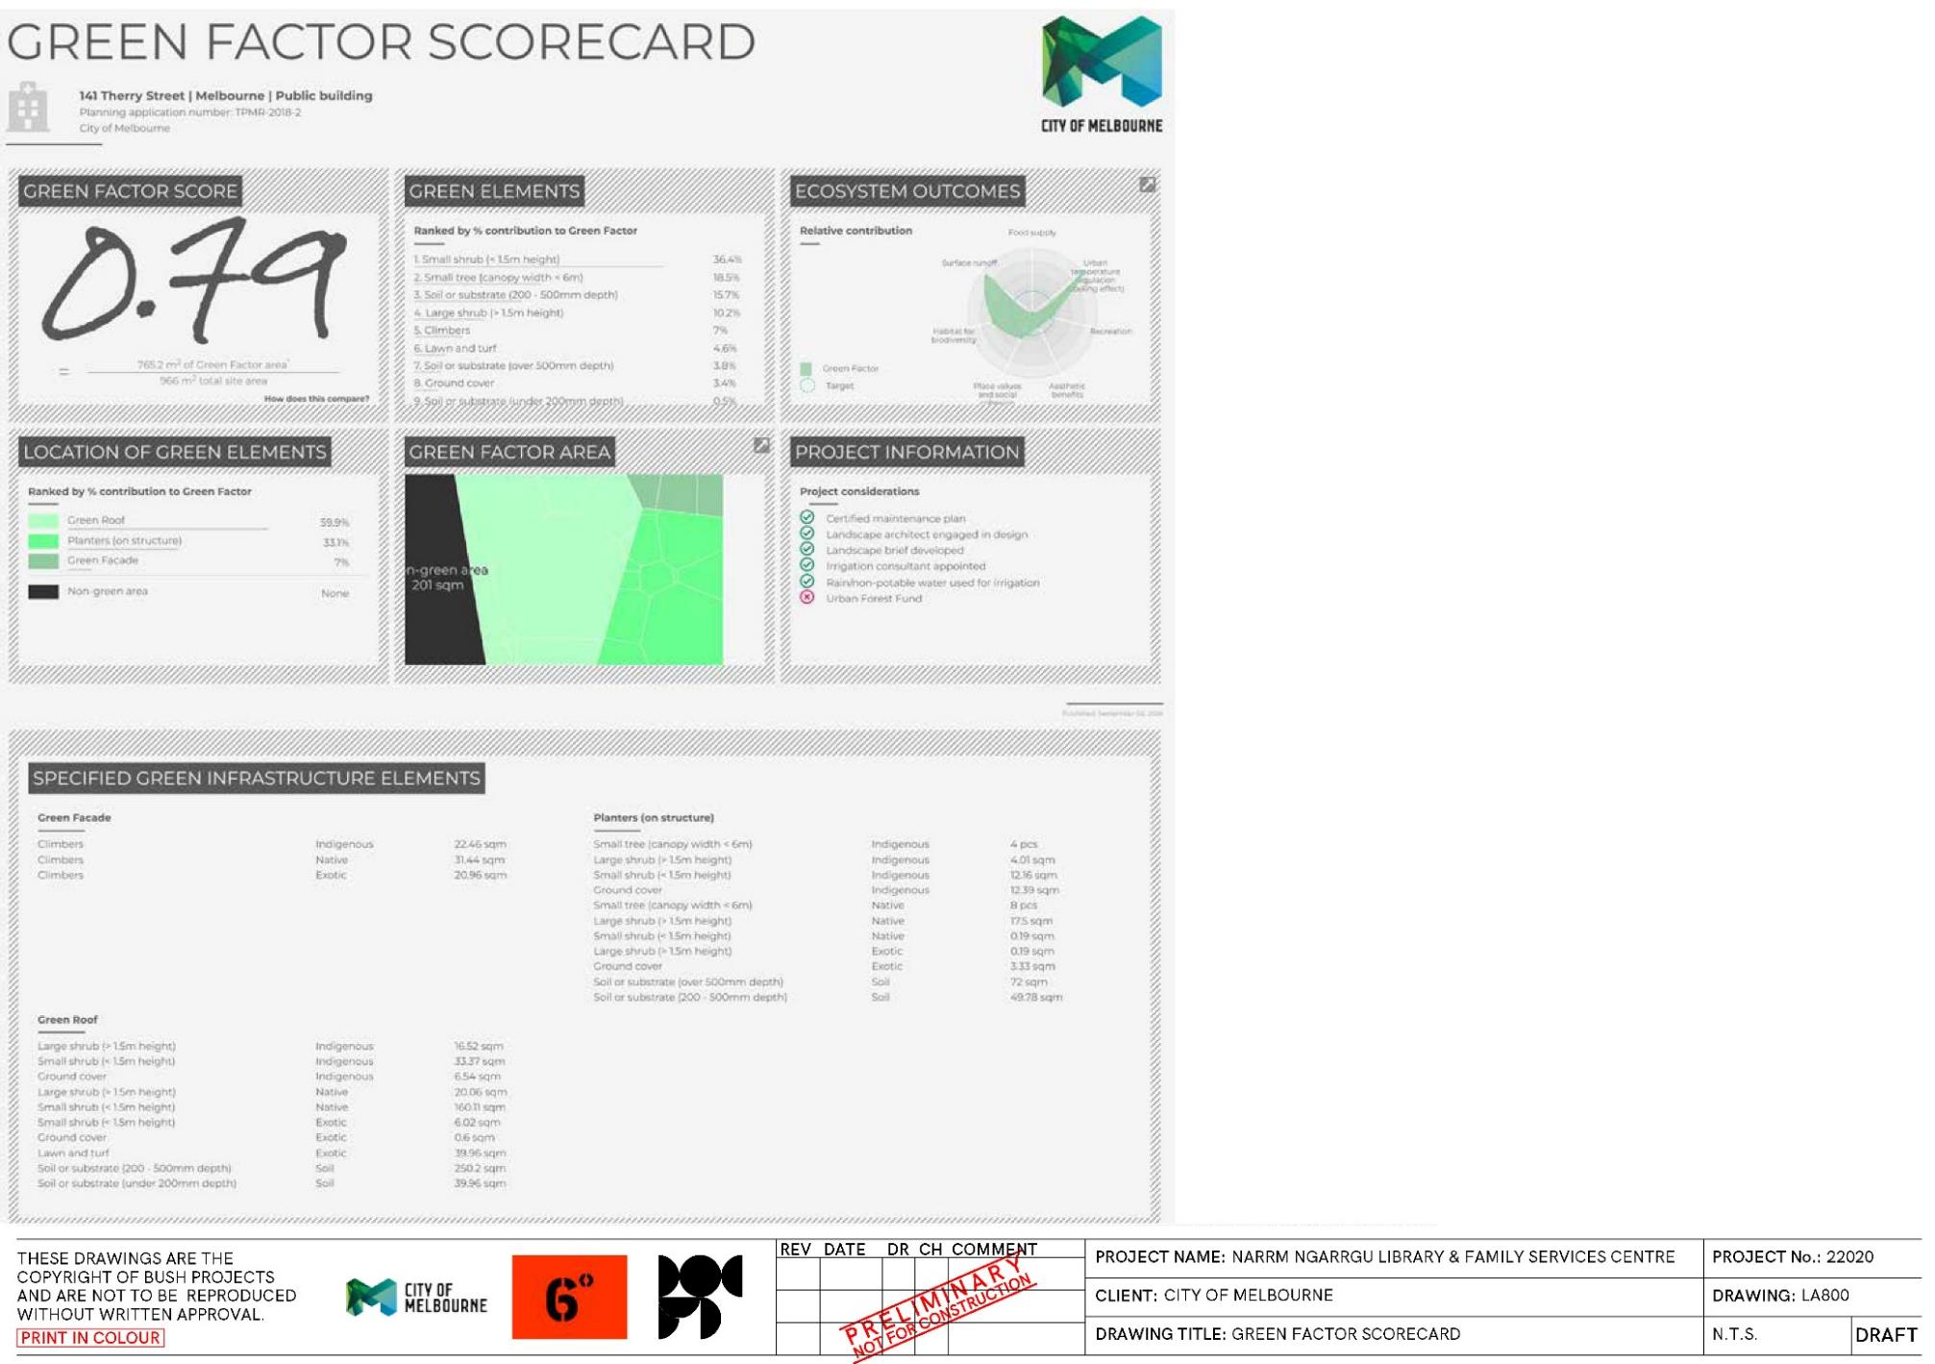
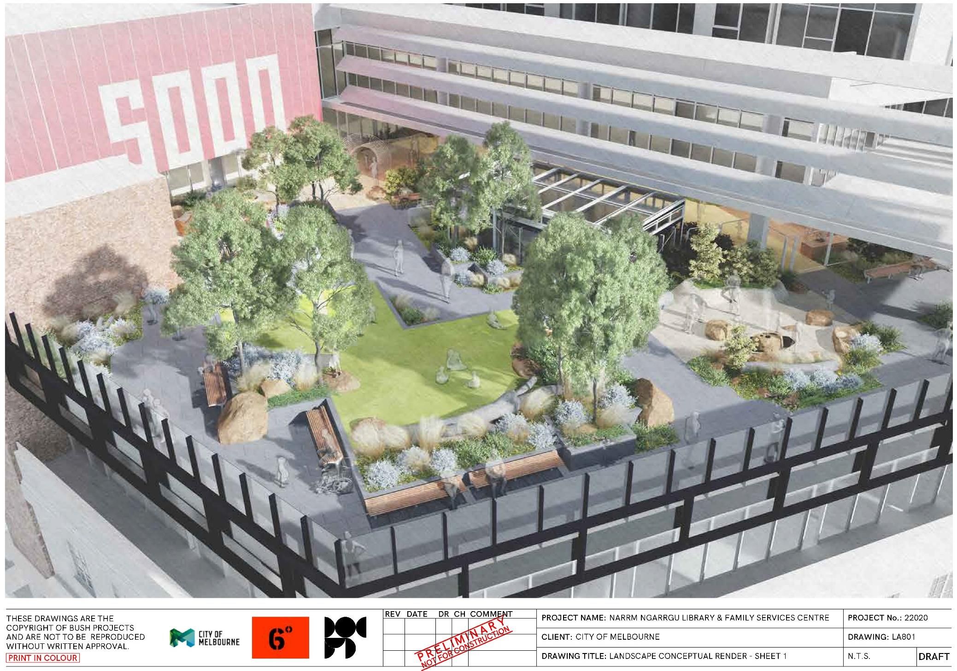
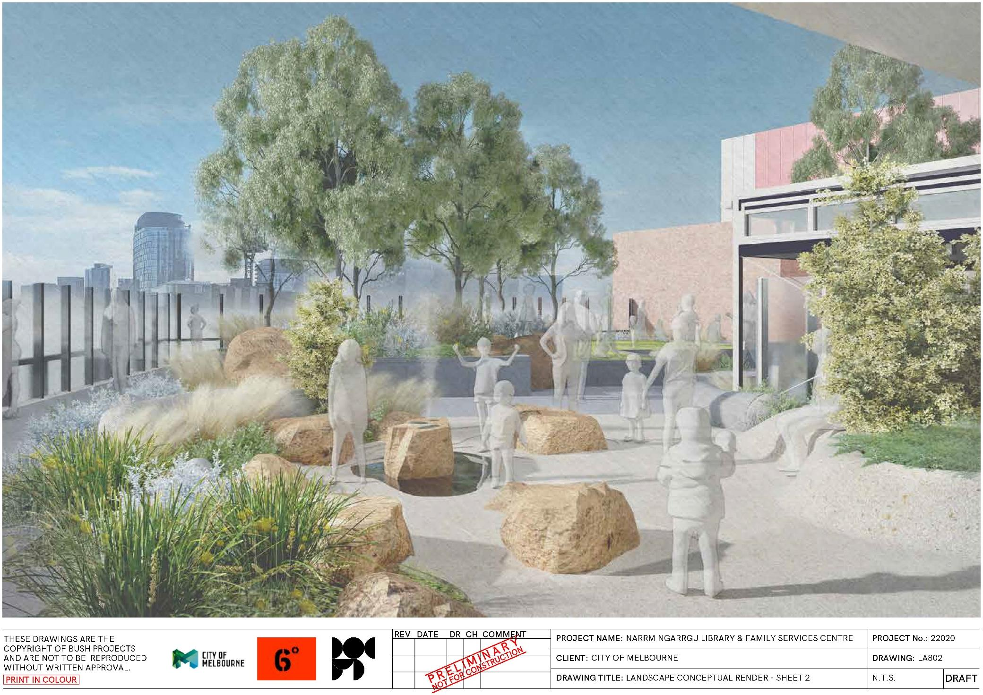
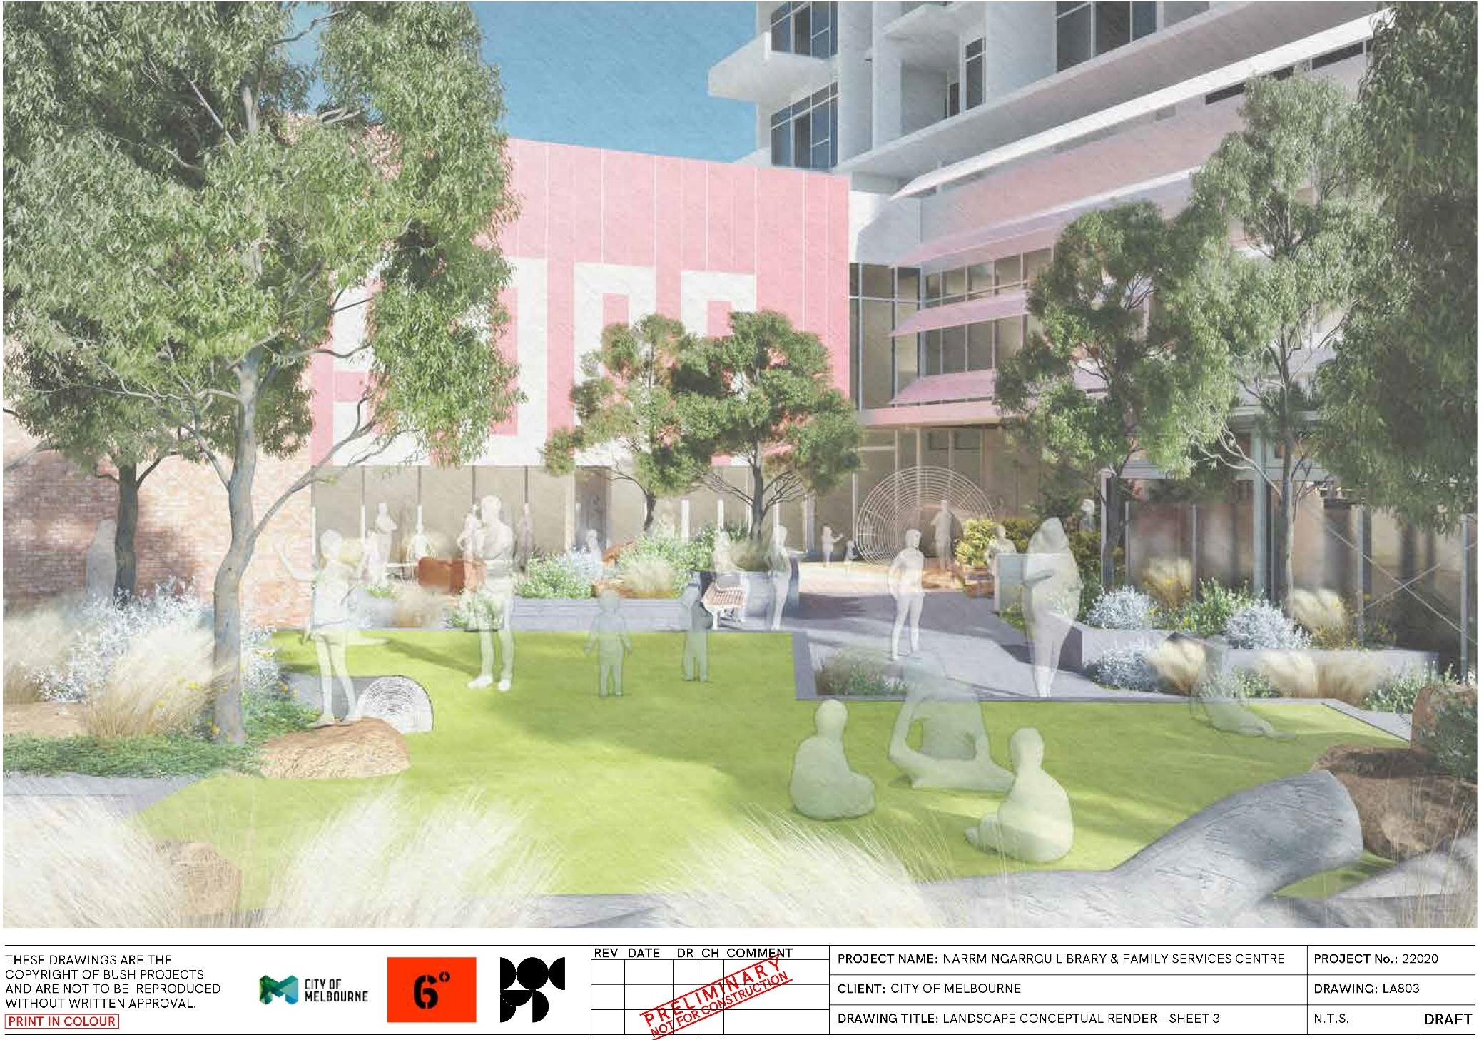
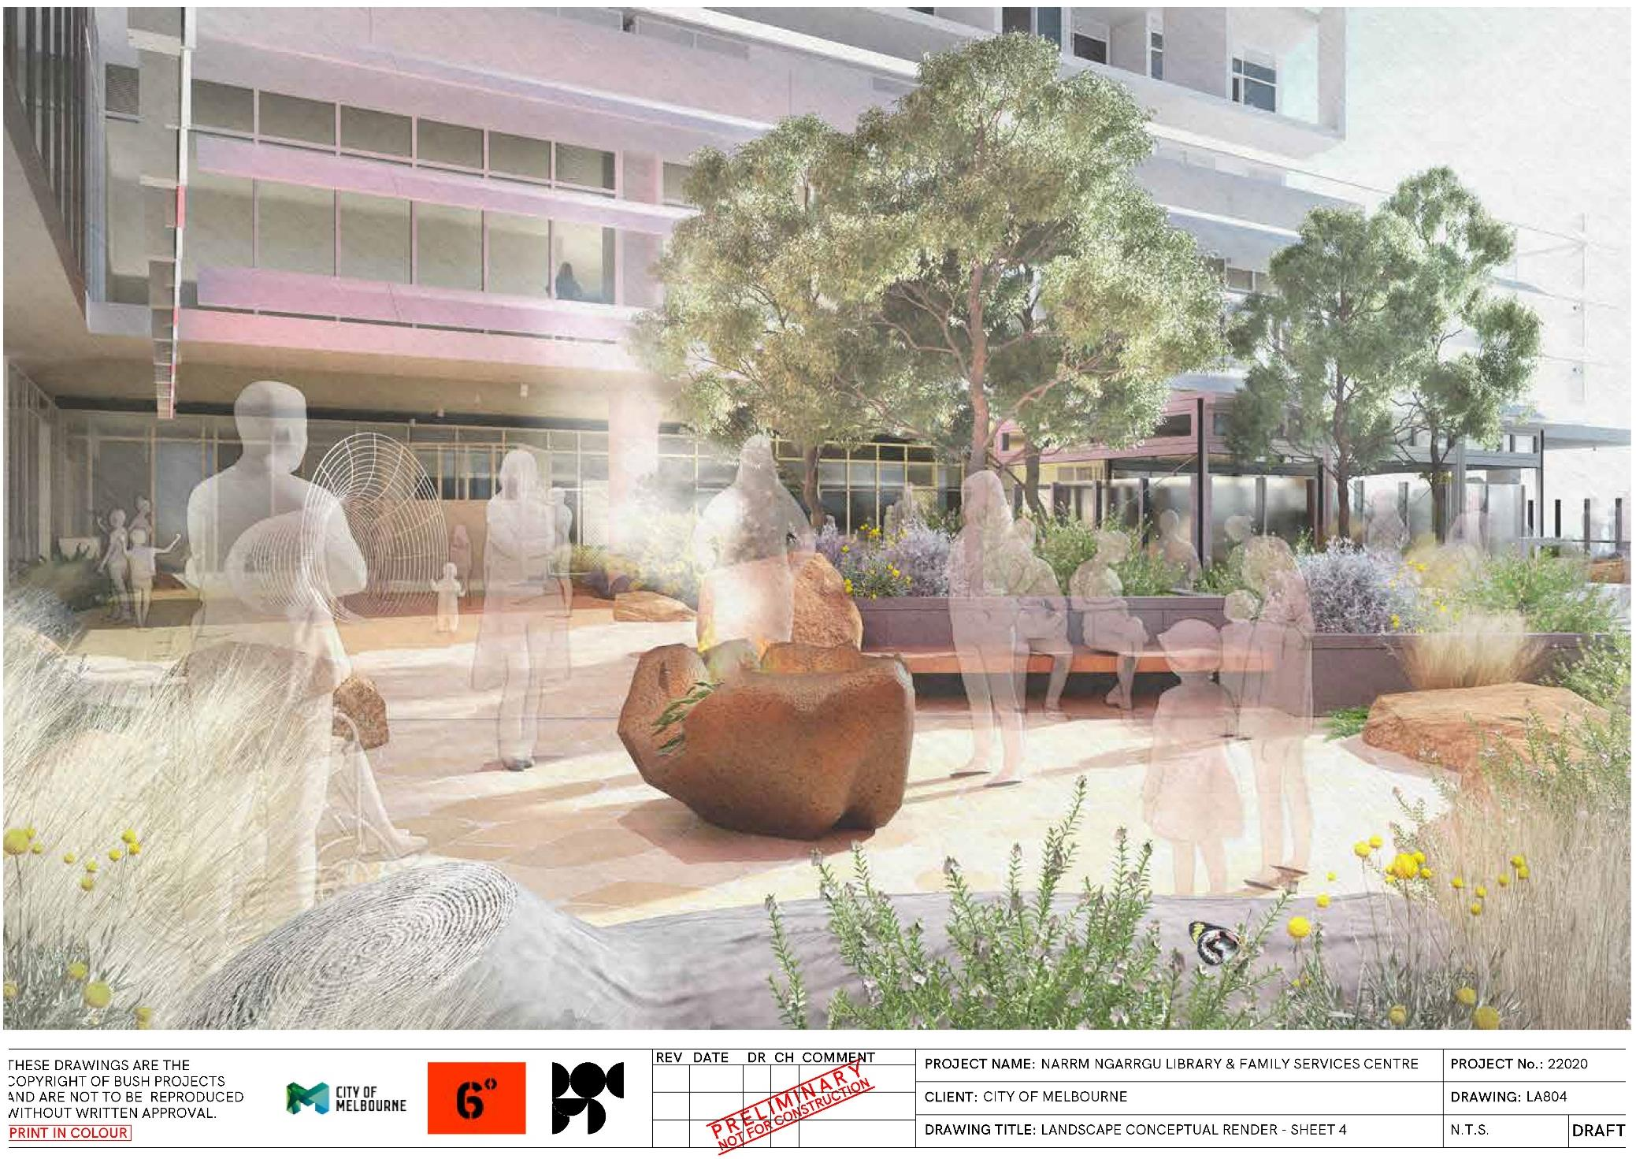

https://www.melbourne.vic.gov.au/council-plan
https://www.greenfactor.com.au

