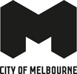
The Melbourne Advantage
Economic development strategy 2030

Acknowledgement of Traditional Owners
The City of Melbourne respectfully acknowledges the Traditional Owners of the land we govern, the Wurundjeri Woi-wurrung and Bunurong / Boon Wurrung peoples of the Kulin and pays respect to their Elders past and present.
We acknowledge and honour the unbroken spiritual, cultural and political connection they have maintained to this unique place for more than 2000 generations.
We accept the invitation in the Uluru Statement from the Heart and are committed to walking together to build a better future.

Contents
Disclaimer 4
Message from the Lord Mayor 5
Executive summary 6
Melbourne’s economic strengths 7
Key opportunities for growth 7
Introduction 10
Ambition for Melbourne 10
Purpose of the ambition 10
Prosperous Melbourne 11
Economic Development: More Than Economics 12
Building prosperity for all 12
Community ownership of the local economy 12
Global competition and local dynamism 12
Local action for global impact: UN Sustainable Development Goals 13
Primary Goals 14
Melbourne’s economy 15
Key industries 15
Melbourne’s highly skilled workforce 17
Precincts 18
Metro Tunnel (2025) 18
Melbourne Arts Precinct transformation 18
Airport Rail Link (proposed for 2033) 18
Melbourne’s changing rhythm 20
Areas for improvement 22
Strengthening Melbourne’s reputation as a global business city. 22
Maximising the benefits of a diverse and youthful population. 22
Supporting the continued growth of Melbourne’s innovation economy. 22
Enhancing access to affordable housing, particularly for key workers. 22
Restoring balance in office accommodation. 22
Improving access to the city to boost economic activity. 22
Strategic opportunities to drive success 23
Strategic Pillar 1: A global powerhouse of in-novation 25
What it involves 25
Why it will make a difference 25
How we will make this happen 25
Alignment to Sustainable Development Goals 26
Jumar Bioincubator: launching Melbourne to the forefront of global biotech 26
Climasens and Melbourne Climate Network 26
Strategic Pillar 2: A magnet for the world’s brightest minds and best enterprises 27
What it involves 27
Why it will make a difference 27
How we will make this happen 27
Alignment to Sustainable Development Goals 28
How Yifei Wang is building Melbourne’s tech future 28
Strategic Pillar 3: Alive with energy 29
What it involves 29
Why it will make a difference 29
How we will make this happen 29
Alignment to Sustainable Development Goals 30
Melbourne tops delegate numbers for international business events in Australia 30
Strategic Pillar 4: Melbourne’s competitiveness 31
What it involves 31
Why it will make a difference 31
How we will make this happen 31
Alignment to Sustainable Development Goals 32
City of Melbourne Business Concierge 32
Strategic Pillar 5: Melbourne’s liveability 33
What it involves 33
How we will make this happen 33
City amenity 34
How we will implement the strategy 35
Tracking our success 36
Related plans and strategies 38
Conclusion 40
Appendix: facts and figures 41
End notes 45

1 July 2025

Disclaimer
This report is provided for information and it does not purport to be complete. While care has been taken to ensure the content in the report is accurate, we cannot guarantee it is without flaw of any kind. There may be errors and omissions or it may not be wholly appropriate for your particular purposes. In addition, the publication is a snapshot in time based on historic information which is liable to change. The City of Melbourne accepts no responsibility and disclaims all liability for any error, loss or other consequence which may arise from you relying on any information contained in this report.

Message from the Lord Mayor
Melbourne is now the biggest and fastest-growing city in Australia. Melbourne is an advanced and prosperous global city. Melbourne is a city of opportunity.
The Melbourne Advantage is an exciting and ambitious economic roadmap to drive Melbourne’s future prosperity.
We are building a bright future powered by knowledge – ready to claim our place as the Asia-Pacific’s city of choice for innovation, talent and liveability.
Melbourne is already Victoria’s economic powerhouse, maintaining an average growth rate of 4.5 per cent over two decades, making it the engine room of the Victorian economy.
Now, we can take it to the next level.
The Economic Development Strategy positions the city as a premier location for doing business, making Melbourne an even more attractive destination for investment and jobs.
The competitive cost of doing business gives Melbourne another edge, with lower commercial rents and other business costs.
The plan secures Melbourne as a magnet for the best and brightest minds and enterprises, by creating pathways for people to excel and enhancing its appeal to global talent.
It cements the city’s reputation as the preferred Asia-Pacific city in which to work, study, live and play by invigorating our vibrancy and economic performance.
This strategy has been shaped by many voices, with extensive engagement across our community. Smart economic development is about building a Melbourne where everyone can thrive, and prosperity is shared by all. This is critical to the city’s long-term success and resilience.
This powerful plan will position us as the Asia-Pacific’s city of choice for innovation, talent and liveability – an exciting journey that only Melbourne is uniquely positioned to take.
When we work together, we can truly shape a strong and successful economy that supports a vibrant culture, thriving innovation and a high quality of life for all – because that’s what our next generation expects and deserve.
Nicholas Reece
Lord Mayor

Executive summary
The City of Melbourne is an economic powerhouse. On less than 38 km² of land, it generates $127 billion in annual economic activity, which is nearly 22 per cent of Victoria’s total output. With a reputation for innovation, diversity and resilience, the city is a magnet for investment, talent and visitors.
Over the past two decades, the City of Melbourne economy maintained an average annual growth rate of about 4.5 per cent, significantly greater than the Victorian average of 2.7 per cent. This has been driven by the city’s knowledge-based economy, world-class retail and hospitality sectors, globally leading universities and a thriving cultural scene of events and activations.
This Economic Development Strategy 2030 proposes a bold ambition: to make Melbourne the Asia-Pacific’s city of choice for innovation, talent and liveability. At the same time, it identifies that economic growth must be reflective of global trends as well as being inclusive and community-driven, so that prosperity is shared by all.
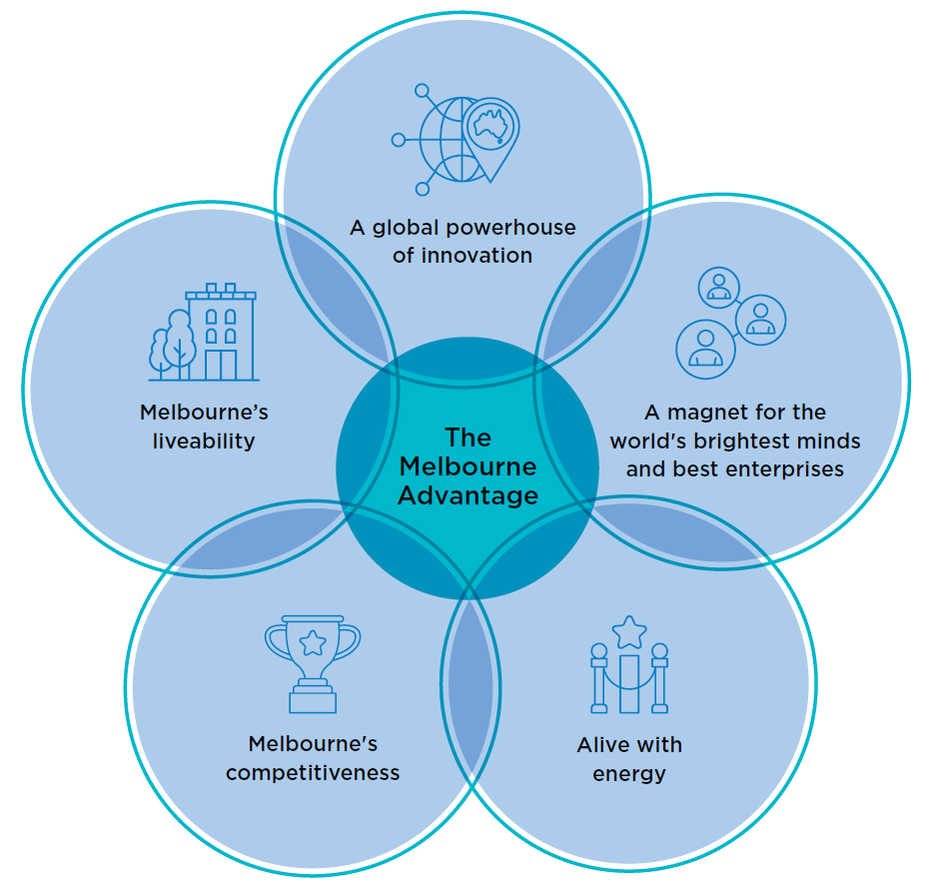

Melbourne’s economic strengths
The City of Melbourne’s strong economy is underpinned by a broad range of industries, a thriving knowledge economy, a diverse, young and talented population, and a central geographic location. Our city is home to leading financial institutions, cutting-edge innovation hubs, and vibrant retail and hospitality precincts. The city is competitive and resilient, built on the interdependence between the knowledge industries in high-rise office buildings and the economic activity taking place in the shops, restaurants and other businesses at street level.
Melbourne must adapt to global competition, shifts in working habits and affordability challenges. This strategy sets out how we can capitalise on opportunities and overcome challenges to secure Melbourne’s future as a global leader in business, culture and innovation.

Key opportunities for growth
This strategy focuses on five key opportunities to strengthen Melbourne’s economy.
Strategic Pillar 1: A global powerhouse of innovation
Strategic Pillar 2: A magnet for the world’s brightest minds and best enterprises
Strategic Pillar 3: Alive with energy
Strategic Pillar 4: Melbourne’s competitiveness
Strategic Pillar 5: Melbourne’s liveability

Strategic Pillar 1: A global powerhouse of innovation
The city’s strengths in innovation will be further enhanced. Melbourne’s strength in innovation through its academic institutions and thousands of start-ups, will be leveraged to create stronger outcomes for all.
Priorities to support this opportunity include:
- Positioning Melbourne as Asia-Pacific’s leading launchpad for startups and scale-ups in health tech, climate tech, digital games, sports tech and education tech.
- Driving social-impact innovation by catalysing investment, building capability, leveraging procurement and amplifying promotion.
- Enhancing Melbourne’s global profile as a premier destination for investment, research and development, entrepreneurship and innovation.
- Establishing Melbourne as a leader in climate mitigation and adaptation technologies by harnessing the economic opportunities from the zero-carbon transition and the circular economy while preparing Melbourne to face the challenges associated with a changing climate.
- Connecting industry, government research and entrepreneurship to accelerate commercialisation and sharpen Melbourne’s competitive edge.
- Realising the potential of Arden, Fishermans Bend and City North innovation districts through strategic infrastructure delivery in partnership with the Victorian Government.
By fostering high-growth industries – particularly in the innovation economy – Melbourne will be an even more attractive destination for investment and jobs, further enhancing its economic resilience and global competitiveness.

Strategic Pillar 2: A magnet for the world’s brightest minds and best enterprises
By creating pathways for underused talent and enhancing its appeal to global talent, Melbourne can secure its position as a magnet for skilled individuals and ensure that all city residents and workers can maximise their potential and access the benefits of the city’s economy.
Priorities to support this opportunity include:
- Positioning Melbourne as Australia’s foremost location for head offices and a hub for research and development.
- Supporting entrepreneurial activity within migrant and diverse communities to boost economic participation and reinforce Melbourne as an inclusive city.
- Advancing Melbourne’s vision to be the world’s leading city for the student experience.
- Enabling a seamless workforce transition for international students through targeted support programs.
- Attracting and retaining global talent by advocating for more favourable migration pathways.
By working towards an inclusive workforce, Melbourne’s economy will provide more opportunities for more people.

Strategic Pillar 3: Alive with energy
Invigorating the city’s vibrancy and economic performance will cement the city’s reputation as the preferred Asia-Pacific city in which to work, study, live and play.
Priorities to support this opportunity include:
- Leveraging new transport links – including five new Metro train stations in 2025 and the future airport rail link – to enhance hyper-connectedness and invigorate city activity.
- Activating the city throughout the year with a world-class public and business events program that celebrates Melbourne’s diversity and global appeal.
- Revitalising underused properties via creative reuse, adaptive conversions and support for net-zero building transitions.
- Enhancing local precinct development by establishing targeted initiatives such as business improvement districts.
- Sustaining a vibrant experience economy by improving the operating conditions for retail, hospitality and live music across the municipality.
A thriving city secures Melbourne’s reputation as a top global destination for business, culture and tourism.

Strategic Pillar 4: Melbourne’s competitiveness
To ensure Melbourne remains a top choice for business, investment and enterprise. Melbourne will sharpen the city’s cost-competitive edge and remove barriers for businesses of all sizes.
Priorities to support this opportunity include:
- Cultivating emerging businesses with targeted investment, streamlined regulation and pilot-innovation initiatives.
- Nurturing Melbourne’s 24-hour economy by adapting regulatory frameworks, aligning Council operations and supporting traders to meet evolving city rhythms.
- Advancing business success through proactive concierge services, clear communication and targeted information.
- Focusing on minimising costs by offering competitive rates, and keeping fees and charges as low as possible. We can also cut red tape, and streamline approval processes for business and development.

Strategic Pillar 5: Melbourne’s liveability
Beyond major economic initiatives, Melbourne must maintain its reputation as one of the world’s most liveable and socially cohesive cities. Success depends on vibrant streetscapes, green spaces, cultural activation, safety, accessibility and high-quality transport.
Priorities to support this opportunity include:
- Ensuring the delivery of well-designed, affordable housing and public transport infrastructure to support key workers and improve neighbourhood accessibility.
- Elevating the creative sector through collaborative platforms, public art programs and accessible, flexible workspaces.
- Enhancing city amenity with dedicated programs to keep Melbourne clean, safe and welcoming for all.
- Aligning city programs, urban design and planning with community values and economic aspirations, including Melbourne’s global connections, public realm investment, sustainability goals and net-zero commitments.
By getting the fundamentals right, Melbourne enhances its economic competitiveness and liveability. By leveraging its strengths, Melbourne can secure its future as a global leader, and ensure that the city’s economic growth is strong, inclusive and shared by all.

Introduction
The City of Melbourne economy had experienced compound average annual growth of over 4.5 per cent, significantly bettering the Victorian average of 2.7 per cent, and the national average of 2.8 per cent.
Melbourne’s economy has rebounded strongly since the pandemic. In 2024, the City of Melbourne’s economy was 13 per cent greater than it was in 2019.
This economic success story, coupled with Melbourne’s emergence as Australia’s largest city, means that the city is replete with opportunity for those residents and businesses who already call it home, as well as creating a compelling case for those yet to move.
The city’s economy is driven by knowledge-related activity, which makes up about two-thirds of output and jobs. This is underpinned by vibrant and globally renowned festivals, events, activations, and retail and hospitality offerings that continue to attract visitors and new residents. The City of Melbourne’s location at the geographical centre of Victoria further creates economic benefits for residents, workers and visitors.
As a city whose influence and impact extends well beyond its borders, our engagement with the world in general and Asia in particular remains a priority. The region contains 12 of Australia’s largest 15 trading partners, accounting for two-thirds of total trade. The connection between Australia’s fastest-growing city and the world’s fastest-growing region presents uncapped opportunities for Melbourne.
This strategy outlines how Melbourne can leverage its strengths, tackle its challenges, and seize emerging opportunities to secure its place as one of the world’s most dynamic and liveable cities.

Ambition for Melbourne
Melbourne
Asia-Pacific’s city of choice for talent, investment and opportunity.

Purpose of the ambition
Melbourne must grow strategically so it stays competitive with peer cities across the world.
As we become more prosperous, it is crucial that economic expansion both reflects and demonstrates the city’s values of fairness and inclusion. All residents, traders, workers, students and visitors should be free to share in our growing prosperity.
As the city pursues this bold vision, we will rely on our values to steward the growth.

Prosperous Melbourne
Melbourne has always been an economic powerhouse. Long before European settlement, First Nations Elders recognised the banks of the Birrarung (Yarra River) as an important meeting place, shaping a tradition of gathering, exchange and prosperity that continues today.
Successive waves of migration have enriched the city, bringing fresh ideas, skills and perspectives. The mid–19th century gold rush and the Eureka rebellion embedded a legacy of both economic opportunity and a strong commitment to fairness. Post-war migration transformed Melbourne into a diverse and globally connected city, strengthening its economic resilience.
Today, Melbourne’s economy is vibrant and multifaceted, anchored by a world-class education sector and a thriving innovation ecosystem. As Australia’s largest and fastest- growing city, Melbourne has demonstrated remarkable adaptability, reflected in strong consumer spending and the lowest shopfront vacancy rate in the country. Its renowned events, culture and live music scenes continue to attract residents and visitors, reinforcing its status as a dynamic global destination.
As Victoria’s capital and economic engine room, the central city is a hub for employment, innovation and investment. While the City of Melbourne spans less than 38 km², its economic impact extends far beyond its borders. Workers earn their income here but spend across the metropolitan region, and businesses generate revenue both locally and globally.
Melbourne’s connectivity fuels its success. With all major transport networks leading into the city, businesses benefit from a deep talent pool, and traders access the largest customer base in the country. The city’s compact design fosters collaboration, with key networks and decision- makers just a short walk or tram ride away.
The lower cost of doing business further strengthens Melbourne’s competitive edge. A recent CBRE report found that commercial rents in Melbourne are around 40 per cent lower than in Sydney, and broader business costs in Victoria are highly competitive (Table 3, Appendix).
With world-class universities, a thriving innovation ecosystem, and an entrepreneurial, diverse population, Melbourne is uniquely positioned to thrive. By building on its strengths, addressing its challenges, and embracing bold, transformative strategies, the city can secure its future as a global leader in innovation, talent and culture.

Economic Development: More Than Economics

Building prosperity for all
Done well, economic development fosters both prosperity and resilience – qualities that became especially important as the city emerged from the pandemic. By diversifying industries, supporting innovation and unlocking the potential of people and places, economic development can help the city to better navigate change and uncertainty.
Economic development isn’t just about numbers and statistics. It’s also about creating opportunities and improving quality of life for individuals and the whole community. A strong, dynamic economy provides access to better jobs, higher incomes and greater opportunities for personal and professional growth. When businesses thrive, they generate employment, invest in local infrastructure and support community services that benefit everyone.

Community ownership of the local economy
Economic development is about building a Melbourne where everyone, including all our diverse communities, can thrive.
Communities should have the opportunity to identify outcomes that will most benefit their lives and help shape economic strategies that align with those ambitions.
When communities take ownership of the tools and policies, a shared vision comes to life. This is critical to the city’s long-term success and resilience.
Effective economic development ensures that growth benefits the entire community while addressing broader challenges, such as climate change. It also ensures that the economy continues to allocate resources effectively to meet demand.
When the community, business and Council work together, we can shape an economy that supports a vibrant culture, secure employment and a high quality of life for all.

Global competition and local dynamism
Residents of other cities around the world undoubtedly feel the same about their homes, creating ambitious agendas for future success, which in turn creates healthy competition for attention, investment and activity.
Melbourne’s peer cities (Figure 1) also aspire and work towards leadership in innovation, business friendliness, high standards of liveability and cultural richness. In this context, planning for inclusive economic growth ensures that Melbourne continues to thrive and remain competitive.
Figure 1: Melbourne’s peer cities, Committee for Melbourne, 2024, Benchmarking Melbourne
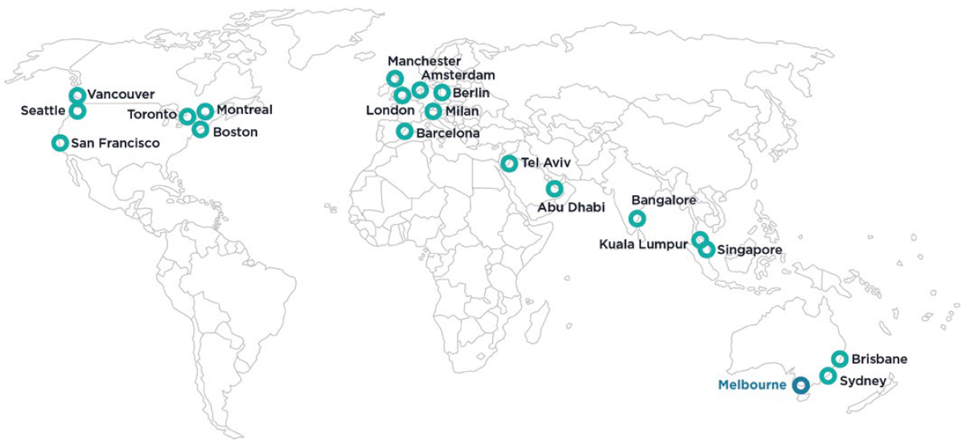

Local action for global impact: UN Sustainable Development Goals
The United Nations Sustainable Development Goals are 17 globally recognised ambitions to progress sustainable development and track performance.
A central theme of the Sustainable Development Goals (the Goals) is to ‘leave no-one behind’. Global support can help to end poverty, protect the planet and ensure all people enjoy peace and prosperity by 2030.
The City of Melbourne has taken the lead and is the first council in Australia to conduct a Voluntary Local Review of the city’s progress towards the Goals. The Sustainable Development Goals are a guiding framework for the City of Melbourne, ensuring our initiatives achieve holistic sustainable development.
The Melbourne Advantage: Economic Development Strategy 2030 defines six primary goals directly aligned with its strategic objectives; see Table 1 which outlines how primary goals are addressed. Achieving the priorities under each pillar can also positively impact other SDG targets with seven additional goals identified as secondary due to their indirect alignment. Both primary and secondary goals are listed under each strategic pillar.
Figure 2: Sustainable Development Goals aligned with this strategy
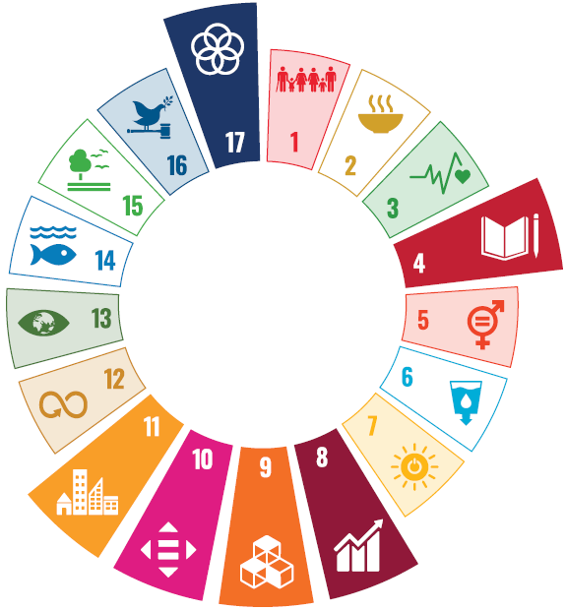
Table 1: Sustainable Development Goals prioritised in the Economic Development Strategy

Primary Goals
The following Goals are most strongly aligned to the strategic objectives set out in this strategy | How the Goal is addressed in the Economic Development Strategy
Goal 4 Quality education  Enabling everyone to study, learn and fulfil their full potential. | This strategy aims to support local and international students to fulfil their full potential, transition seamlessly into the workforce and participate in the economy.
Goal 8 Decent work and economic growth  Creating decent jobs and economic opportunities for everyone. | This strategy is designed to create economic opportunities for all. Our programs and services are designed to be inclusive and to remove barriers to access.
Goal 9 Industry, innovation and infrastructure  Making sure everyone has the infrastructure they need to connect to the rest of the world. | Priorities of this strategy include encouraging innovation, research and enhancing technological capabilities of the municipality with a focus on key sectors.
Goal 10 Reduced inequalities  Reducing the gap between the richest and the poorest. | This strategy identifies that economic growth must be inclusive and community-driven, ensuring that prosperity is shared by all.
Goal 11 Sustainable cities and communities  Putting cities at the heart of sustainable development in an urbanising world. | This strategy supports efforts to ensure Melbourne is one of the world’s most liveable cities – through vibrant streetscapes, green spaces, cultural activation, safety, accessibility and high-quality transport.
Goal 17 Partnerships for the Goals  Strengthening and maximising collaboration with other councils, government agencies, businesses and our local community. | This strategy acknowledges that many areas of focus go beyond municipal boundaries. We are committed to partnering with neighbouring councils, other levels of government and key stakeholders.

Melbourne’s economy

Key industries
Melbourne’s strong economy is driven by its knowledge sector, which accounts for about two-thirds of the city’s total economic activity (see Figure 10, Figure 11 in Appendix). A key factor in this strength is the attractiveness of the central city, which is home to the headquarters of two of Australia’s four major banks, along with a diverse range of firms in financial services, professional and scientific services, and the rapidly growing innovation economy. This includes Melbourne’s globally competitive life sciences sector – centred around Parkville – and features one of Australia’s largest companies, CSL.
While the knowledge sector dominates, its interdependence with the ‘street-level and laneway’ economy is crucial. A vibrant streetscape, engaging activations, world-class restaurants and retail establishments help create an environment where professionals actively choose to work in the central city. In turn, local traders are sustained by the hundreds of thousands of office workers who commute to the city every day.
This symbiotic relationship between the knowledge economy and the street-level economy is the foundation of Melbourne’s economic strength, and the focus of this strategy.
Over the past decade, the industries that have contributed most to economic growth in the City of Melbourne are mainly knowledge-related services (Figure 3 and Table 4 in the Appendix). Just four industries, professional services, finance, computer systems and admin services contributed more than half of the city’s economic growth.
Figure 3: Contribution to the growth of City of Melbourne’s economy over the past decade
(Increase in value-add 2014–15 to 2023–24)
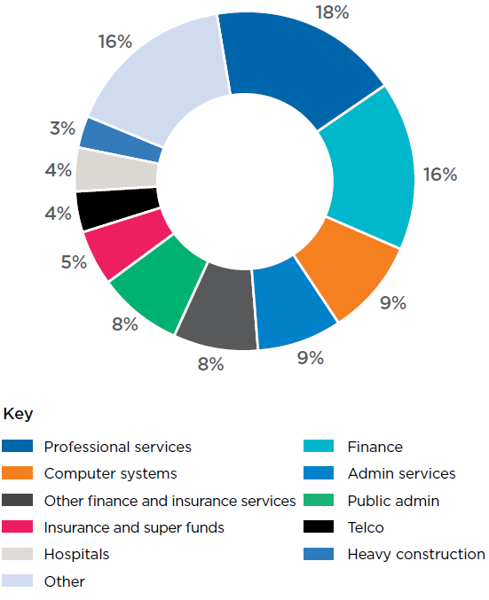
Source: economy.id

Some sectors have enjoyed astonishing growth rates over the decade to 2024. The fastest-growing sectors are mostly associated with the growth of the internet and information technologies. These sectors experienced a two-, three- or even six-fold increase in size over the decade to 2024 (Figure 4).
Figure 4: City of Melbourne’s 10 fastest-growing industries
(Increase in value-add 2014–15 to 2023–24)
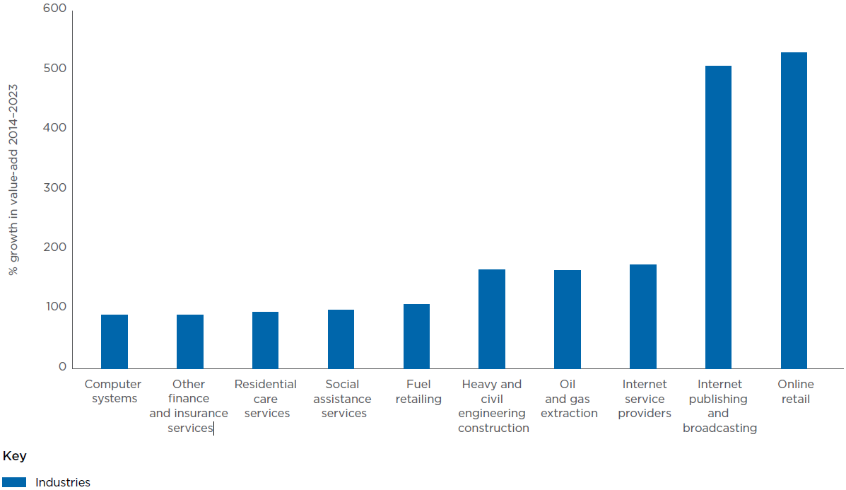
Source: economy.id

Melbourne’s highly skilled workforce
There are more than 650,000 jobs in the City of Melbourne. Given the important role played by the knowledge economy, workers in the City of Melbourne tend to be more highly qualified than workers in the rest of the state. About two-thirds of workers have a bachelor degree or higher (Figure 5). Due both to the skill level of employees and the productivity of Melbourne’s knowledge intensive industries, labour productivity in the City of Melbourne is much higher than elsewhere in Victoria ($184,000 in value-add per worker, compared to $133,000 for Victoria as a whole).
Almost 90 per cent of the city’s workforce lives in other municipalities. The City of Melbourne’s biggest sources of workers are: Merri-bek (29,985 – 6 per cent), Wyndham (28,928 – 6 per cent), Boroondara (23,267 – 5 per cent), Yarra (21,467 – 4 per cent) and Port Phillip (20,818 – 4 per cent).
By ensuring the city is alive with energy, Melbourne will continue to attract the many knowledge workers who live outside the municipality. This will help to sustain the city’s high economic output, and ensure Melbourne stays at the epicentre of Victoria’s knowledge economy.
Figure 5: Qualifications of workers in Melbourne
(2021)
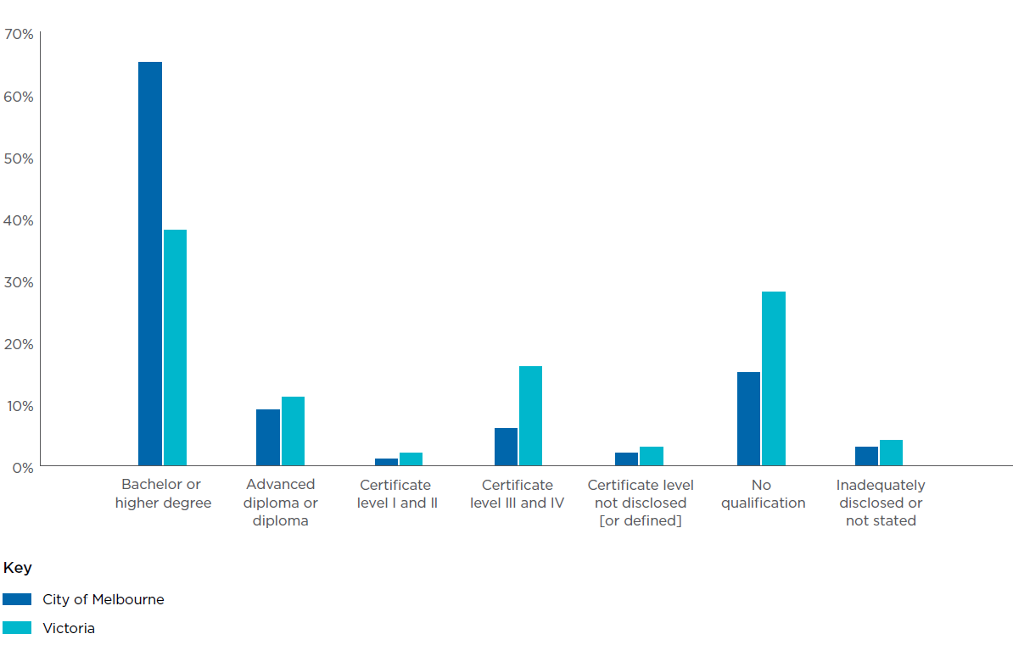
Source: Census 2021 (Australian Bureau of Statistics)

Precincts
One of Melbourne’s greatest strengths is its geography. The city’s physical layout and the mix of different sectors and activity zones across the municipality play a crucial role in its economic success.
Melbourne can also be understood through its many precincts, each defined by its unique street-level activity. The Collins Street East precinct is home to much of the city’s luxury retail, while City North is rapidly evolving to meet the growing demand driven by increasing numbers of international students.
Different industry sectors are also prevalent across the city (Figure 6). Docklands, for example, is dominated by the financial and insurance services sector, while Parkville’s economy is led by healthcare and social services.
Looking ahead, major infrastructure investments will create new opportunities to attract visitors and expand economic activity.

Metro Tunnel (2025)
The five new Metro train stations set to open in 2025 will significantly alter activity levels around each location. Maximising these benefits will be key to ensuring their full economic impact.

Melbourne Arts Precinct transformation
This $1.7 billion expansion to the Melbourne Arts Precinct, which includes construction of The Fox: NGV Contemporary, upgrades to existing heritage theatres and an 18,000 m2 biodiverse public urban garden, which will enhance and reshape the cultural and tourism landscape.

Airport Rail Link (proposed for 2033)
The introduction of a direct rail connection to Melbourne Airport will provide a major boost for tourism, business and broader economic activity. Planning now will help the city fully capitalise on this opportunity.
Figure 6: Largest sectors in City of Melbourne neighbourhoods
(by jobs and value add 2022–23)
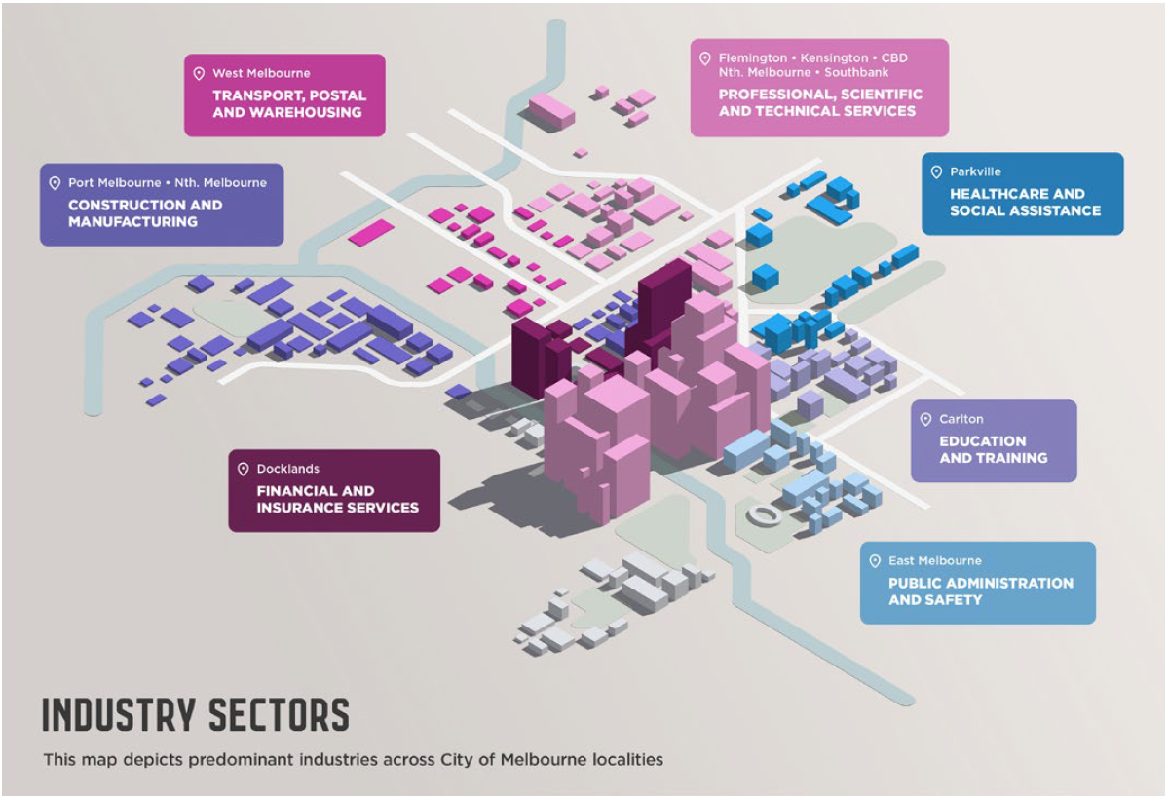
Source: economy.id

Melbourne’s changing rhythm
Changes to the city’s rhythm are a natural feature of its evolution. In recent years weekend activity has risen dramatically (Figure 7a and 7b) with Saturdays now as busy as Fridays (the busiest weekday) and Sunday activity increasing by almost 25 per cent. Evening activity is also heightened, while different times of the year – like school holidays – are busier than ever. Understanding these changes provides the opportunity to plan more confidently for future success.

Figure 7a: Pedestrian activity indexed in the central city
2019
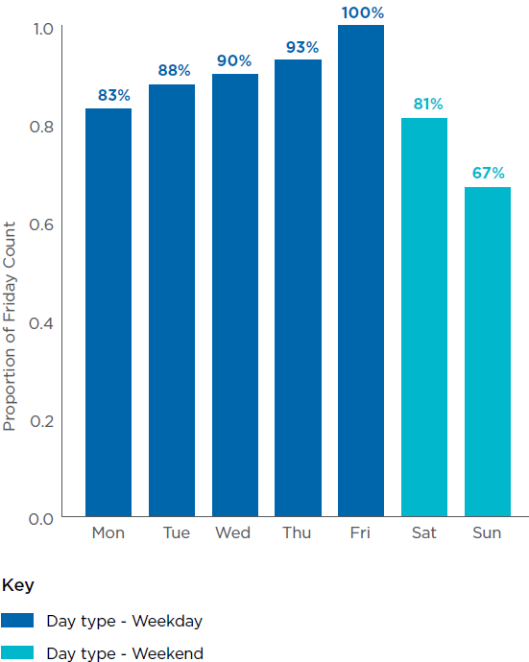
Figure 7b: Pedestrian activity indexed in the central city
2024-25
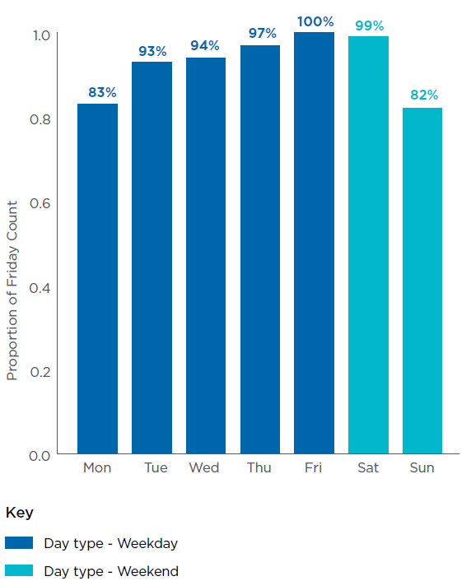

Areas for improvement
Melbourne’s core strengths have played a significant role in its resilience and success. However, certain challenges must be addressed to create new opportunities for growth:

Strengthening Melbourne’s reputation as a global business city.
While Melbourne is well positioned as a global city, competition among peer cities is intensifying. Melbourne’s brand as an events and cultural hub is strong, but its recognition as a leading destination for global business does not yet match its capacity. To remain competitive, the city has an opportunity to reinforce and promote its business brand on the global stage.

Maximising the benefits of a diverse and youthful population.
Stronger pathways can be developed between education and professional engagement for international students and emerging talent. This can enhance workforce integration and strengthen Melbourne’s diverse economy. Improving these linkages will deliver better outcomes for students and maximise the city’s available labour force. Efforts to integrate students more effectively will further strengthen Melbourne’s reputation as the world’s best city for the student experience.

Supporting the continued growth of Melbourne’s innovation economy.
The city takes a proactive role in fostering innovation, particularly in five sectors where it has clear competitive advantages: life sciences, climate technology, sports technology, digital games and education technology. The launch of the Melbourne Climate Network in 2023 demonstrated how city leadership can help seed innovation. Each innovation eco-system faces distinct challenges, from improving capital flow to streamlining procurement processes so that emerging technologies and enterprises can compete on a level playing field. Addressing these challenges will help unlock Melbourne’s full in-novation potential.

Enhancing access to affordable housing, particularly for key workers.
Like the rest of Australia, Melbourne faces ongoing challenges in housing affordability. Expanding access to housing is essential for supporting the city’s workforce. It is also critical to maintain the city’s attractiveness, and find a balance between our residential objectives, the economy and the future needs of industry. A particular focus is needed on housing for the low-income key workers who are essential to the city’s daily operations, such as hospital staff and employees in service industries. Addressing this gap will strengthen both the city’s productivity and liveability.

Restoring balance in office accommodation.
Office attendance continues to recover post pandemic, but a mismatch remains between supply and demand, particularly in certain office stock categories. The ‘flight to quality’ trend has seen tenants favouring higher-standard office spaces, particularly those with strong sustainability credentials. More can be done to enhance the appeal of underused office stock, including repurposing assets that no longer meet market expectations, making the most of planning and building regulations.

Improving access to the city to boost economic activity.
Efficient access to the city is vital for economic development. However, Melbourne’s centrality contributes to congestion. About 43 per cent of vehicle traffic travels through the Hoddle Grid without stopping. Council’s goal is to improve accessibility, encourage greater patronage, and support the city’s long-term liveability and economic vibrancy.

Strategic opportunities to drive success
To maintain Melbourne’s position as a global leader in innovation, talent, and culture, bold and transformative action is re-quired. The focus must be on celebrating and playing to the city’s unique strengths, addressing key challenges, and unlocking new opportunities. By acting decisively, Melbourne can ensure its economy re-mains resilient, its community inclusive, and its future bright.
This strategy rests on five strategic pillars (Figure 8):
- Melbourne is a global powerhouse of in-novation.
- Melbourne is a magnet for the world’s brightest minds and best enterprises.
- Melbourne is alive with energy.
- Melbourne’s competitiveness.
- Melbourne’s liveability.
While these ambitions are presented separately, they are deeply interconnected. For example, Melbourne’s attractiveness as a tourism destination aligns closely with its appeal to businesses, which in turn influences investment, trade and broader economic outcomes.

The City of Melbourne will use its levers, networks and voice to bring about change.
As a local government, the City of Melbourne has some capacity to shape, implement and influence change in the economy. But economic development relies on contributions from a wide range of organisations and levels of government working collaboratively and in harmony.
Accordingly, some of the actions that flow from these five strategic pillars will be delivered directly by the city, some through partnerships, while others will require Council to take on an advocacy role.
Figure 8: The Melbourne Advantage
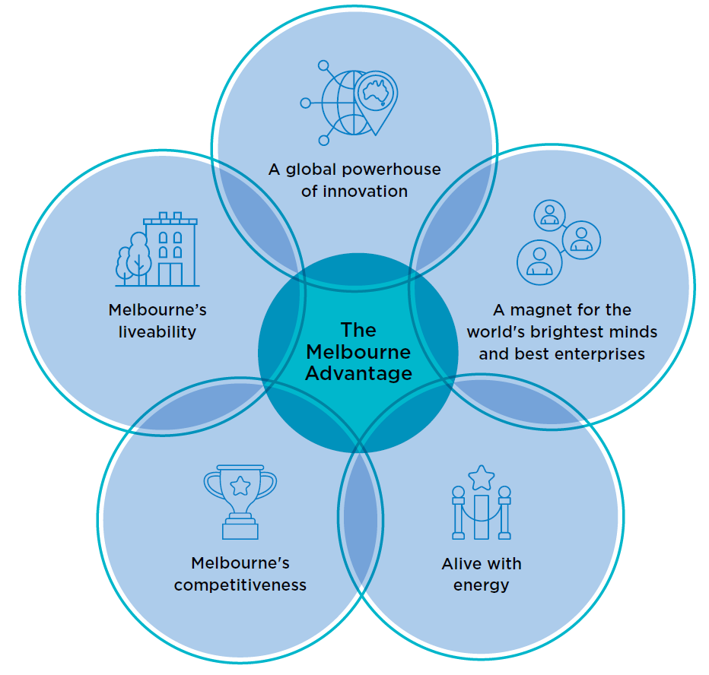

Strategic Pillar 1: A global powerhouse of in-novation

What it involves
Melbourne is a city of ideas and enterprise, where world- class research institutions, high-growth startups and industry leaders come together to drive innovation. Our strengths in priority sectors – such as health technologies, climate tech, digital games, sports tech and education tech – give us a competitive edge in the global economy. By strengthening these sectors, fostering collaboration and attracting investment, Melbourne can generate high-value jobs, improve productivity and develop solutions that address major global challenges.

Why it will make a difference
Innovation is key to economic growth, resilience and prosperity. Melbourne is already a centre for innovation, and over the past four years, the number of startups in Melbourne has grown by nearly 70 per cent.
Realising this opportunity will mean:
- More high-value jobs and regional head-quarters in emerging and fast-growing industries.
- A stronger pipeline between research, commercialisation and industry.
- Increased global investment and trade opportunities.
- A more resilient economy, better equipped to adapt to global shocks.
- Breakthrough innovations that improve quality of life – whether in healthcare, sustainability or technology.
A city that fosters innovation is a city that can compete globally and prosper. By leading in key sectors and embracing new technologies, Melbourne can secure long-term eco-nomic success while improving the lives of its residents, workers and businesses.

How we will make this happen
Our priorities | City of Melbourne role
Position Melbourne as Asia-Pacific’s leading launchpad for startups and scale-ups in health tech, climate tech, digital games, sports tech and education tech. | Deliver
Drive social-impact innovation by catalysing investment, building capability, leveraging procurement and amplifying promotion. | Deliver Partner
Enhance Melbourne’s global profile as a premier business destination for investment, research and development, entrepreneurship and innovation. | Deliver Partner
Establish Melbourne as a leader in climate mitigation and adaptation technologies by harnessing the economic opportunities from the zero-carbon transition and the circular economy while preparing Melbourne to face the challenges associated with a changing climate. | Deliver Partner Advocate
Connect industry, government research and entrepreneurship to accelerate commercialisation and sharpen Melbourne’s competitive edge. | Deliver Partner Advocate
Realise the potential of Arden, Fishermans Bend and City North innovation districts through strategic and timely infrastructure delivery in partnership with the Victorian Government. | Deliver Partner Advocate

Alignment to Sustainable Development Goals

Direct Alignment
Goal 8: Decent work and economic growth
Goal 9: Industry, innovation and infrastructure
Goal 11: sustainable cities and communities
Goal 17: Partnerships for the goals

Indirect Alignment
Goal 12: Responsible consumption and production
Goal 13: Climate action

Jumar Bioincubator: launching Melbourne to the forefront of global biotech
Jumar Bioincubator supports more than 30 biotech startups that are revolutionising research into diseases like Alzheimer’s. By connecting startups with our existing medical precinct, we’re fostering global breakthroughs – and putting Melbourne on the map as a destination for innovation and medical advancement.

Climasens and Melbourne Climate Network
Founder of Climasens and member of the Melbourne Climate Network, Joe Glesta moved from New York to study at the University of Melbourne. Inspired by the innovation ecosystem, Joe stayed to build his climate tech startup in Melbourne.
“It’s the ideal location to connect with climate innovators and investors. The exciting dynamic of Melbourne certainly plays a part in building our business.”

Strategic Pillar 2: A magnet for the world’s brightest minds and best enterprises

What it involves
Melbourne will be a city where the world’s most talented people choose to live, work and build their futures. A place where ambition is matched by opportunity, where local and international students seamlessly transition into the workforce. The entrepreneurial spirit of our diverse communities will drive new industries and economic growth, and strengthen social cohesion.
Melbourne will be a city that fully harnesses the strengths of its people – where First Nations businesses and entrepreneurs thrive, where migrant and women-led enterprises flourish, and where all workers can reach their potential. Melbourne’s global reputation will be built on its liveability and also on its economic dynamism, offering a compelling mix of career pathways, investment opportunities and cultural vibrancy that makes talent want to stay.
By fostering an environment where skills, ideas and businesses can grow, Melbourne will secure its place as a top destination for talent – a city that is globally connected, economically inclusive, socially cohesive and future-focused.

Why it will make a difference
A city that attracts and retains the best talent – while unlocking the full potential of all its people – will be more dynamic, innovative and globally competitive. By removing barriers to participation, fostering entrepreneurship and strengthening international ties, Melbourne can become the go-to destination for people with the ideas and skills to shape the future while building a stronger, more cohesive community.

How we will make this happen
Our priorities | City of Melbourne role
Position Melbourne as Australia’s foremost location for head offices and research and development. | Deliver  Partner
Support entrepreneurial initiatives from diverse communities including migrants, First Nations people and women, to boost economic participation and reinforce Melbourne as an inclusive city for all. | Deliver  Partner
Advance Melbourne’s vision to be the world’s leading city for the student experience. | Deliver  Partner
Enable a seamless workforce transition for international students through targeted support programs. | Deliver  Partner
Attract and retain global talent by advocating for more favourable migration outcomes. | Advocate

Alignment to Sustainable Development Goals

Direct Alignment
Goal 4: Quality education
Goal 8: Decent work and economic growth
Goal 10: Reduced inequalities
Goal 17: Partnerships for the goals

Indirect Alignment
Goal 1: No poverty
Goal 13: Gender equality

How Yifei Wang is building Melbourne’s tech future
Former international student and current CEO of AIBUILD, Yifei Wang said Melbourne offered more than just business opportunities – it offered a sense of community and strong connections to get his business started. What started as a team of three international students has flourished into a company employing nearly 30 people, thanks to what Wang describes as “a very supportive environment from the City of Melbourne, Victorian government, and federal government.”

Strategic Pillar 3: Alive with energy

What it involves
Melbourne will be a city that never stands still – where streets are alive with activity, businesses thrive and people are attracted to an unmatched sense of vibrancy. From bustling cafes in the morning to a thriving economy at night, Melbourne rises to meet the needs of everyone who uses the city, including workers, residents and revellers, as well as industry and critical services, 24 hours a day.
The city’s commercial heart will be powered by a dynamic mix of retail, hospitality, arts, events and entertainment, seamlessly connected to a growing customer base of workers, residents, students and visitors. Underused spaces will be reimagined as vibrant hubs for culture and commerce, while major events and festivals will draw people in year-round, reinforcing Melbourne’s status as a global destination.
With new infrastructure unlocking fresh opportunities, the city will maximise the benefits of transformational investments, ensuring that Melbourne remains a magnet for talent, business and tourism.

Why it will make a difference
A city alive with energy attracts people – knowledge workers, international students, new residents, customers and visitors – fuelling economic growth and reinforcing Melbourne’s position as Australia’s most dynamic urban centre. A thriving central city will drive demand across all sectors, stimulate business investment, and sustain the cultural and commercial vitality that defines Melbourne’s global appeal.

How we will make this happen
Our priorities | City of Melbourne role
Leverage new transport links, including five new Metro train stations in 2025 and the future airport rail link, to enhance connectivity and invigorate city vibrancy. | Deliver  Partner
Activate the city throughout the year with a world-class public and business events program that celebrates Melbourne’s diversity and global appeal. | Deliver  Partner
Revitalise underused properties through creative reuse, adaptive conversions and support for net-zero building transitions. | Partner
Enhance local precinct development and placemaking by establishing targeted initiatives such as business improvement districts. | Deliver  Partner
Sustain a vibrant experience economy by improving the operating conditions for retail, hospitality and live music across the municipality. | Deliver  Partner

Alignment to Sustainable Development Goals

Direct Alignment
Goal 8: Decent work and economic growth
Goal 9: Industry, innovation and infrastructure
Goal 11: Sustainable cities and communities
Goal 17: Partnerships for the goals

Indirect Alignment
Goal 7: Affordable and clean energy

Melbourne tops delegate numbers for international business events in Australia
With world-class infrastructure and hospitality, Melbourne continually tops delegate numbers for international association business events – more than double any other Australian city. Contributing billions to Victoria’s economy, these events secure Melbourne’s reputation as an outstanding destination for networking and knowledge-sharing across the globe.

Strategic Pillar 4: Melbourne’s competitiveness

What it involves
Melbourne sharpens its cost-competitive edge and streamlines the operating environment for firms of all sizes – from multinational headquarters and centres for research and development, through to high-growth startups. That means benchmarking rates, rents and fees against peer cities, cutting red tape, offering targeted incentives, and providing a proactive Business Concierge service. By aligning Council processes, regulatory settings and promotional efforts, we make it faster, cheaper and simpler to invest, grow and employ here.

Why it will make a difference
When the city lowers the barriers and costs of doing business, more companies choose Melbourne for their headquarters, research facilities and expansion plans. Entrepreneurs launch ventures with greater confidence, existing businesses reinvest locally, and new markets open up. Competitive operating conditions drive job creation, boost productivity and reinforce Melbourne’s resilience in the face of global competition.

How we will make this happen
Our priorities | City of Melbourne role
Cultivate emerging businesses with targeted investment, streamlined regulation and pilot-innovation initiatives. | Deliver
Nurture Melbourne’s 24-hour economy by adapting regulatory frameworks and processes, aligning Council operations and supporting traders to meet evolving city rhythms. | Deliver
Advance business success via a proactive Business Concierge service, clear communication and targeted information. | Deliver
Focus on minimising costs by offering competitive rates, and keeping fees and charges as low as possible. We can also cut red tape, and streamline approval processes for business and development. | Deliver

Alignment to Sustainable Development Goals

Direct Alignment
Goal 8: Decent work and economic growth
Goal 9: Industry, innovation and infrastructure
Goal 17: Partnerships for the goals

City of Melbourne Business Concierge
The City of Melbourne’s Business Concierge team has helped hundreds of businesses halve the time it previously took to open, by offering free expert advice, streamlining permit processes and minimising delays. Now the largest of its kind in Australia, this popular ‘one-stop-shop’ pulls out all the stops to make it easier than ever for businesses to start, grow and thrive in the city.

Strategic Pillar 5: Melbourne’s liveability
Melbourne’s global reputation as one of the world’s most liveable cities is built on strong foundations. A clean, safe, socially cohesive and vibrant city isn’t just a backdrop for economic growth – it’s essential to attracting residents, workers and visitors. To stay competitive, Melbourne must offer an exceptional urban experience, with lively streetscapes, accessible amenities and a dynamic cultural scene that excites and inspires.

What it involves
Our everyday focus at the City of Melbourne is to make sure the city is well designed and cared for, and welcoming for all who live, work and play here. World-class events and activations will bring energy to the streets, while investment in public spaces and infrastructure – including safe walking, cycling and public transport connections – will ensure Melbourne stays beautiful, functional and accessible.
Through a well-considered planning framework, we can enhance our streetscapes and boost liveability to attract more residents, workers, students and visitors. We can expand the tree canopy coverage and make sure building frontages add character at street level. We can find ways for workers to maximise opportunities close to home and advocate for key workers to live closer to their jobs. It is also crucial to the city’s appeal that we offer small businesses the support they need. For business, study and leisure, Melbourne will continue to be the destination of choice for all.
Workers should have opportunities close to home and key workers should be able to live near their jobs. Small businesses will continue to be supported as critical parts of the city’s appeal. Whether for business, study or leisure, Melbourne will remain the destination of choice for all.

How we will make this happen
Our priorities | City of Melbourne role
Ensure the delivery of well-designed, affordable housing and transport infrastructure to support key workers and improve neighbourhood accessibility. | Partner  Advocate
Elevate the creative sector through collaborative platforms, public art programs and accessible, flexible workspaces. | Deliver  Partner
Enhance city amenity with dedicated programs to keep Melbourne clean, safe and welcoming for all. | Deliver
Align the city’s programs, urban design and planning with community values and economic aspirations, including Melbourne’s global connections, public realm investment, sustainability goals and net-zero commitments. | Deliver

Direct Alignment
Goal 8: Decent work and economic growth
Goal 9: Industry, innovation and infrastructure
Goal 11: Sustainable cities and communities
Goal 17: Partnerships for the goals

Indirect Alignment
Goal 3: Good health and well-being
Goal 16: Peace, justice and strong institutions

City amenity
Our record investment in community safety is delivering a brighter, safer and more welcoming city for everyone. With increased safety patrols and lighting, expanded CCTV coverage, cleaner streets, 24/7 graffiti removal and improved waste services reducing laneway clutter, Melbourne is becoming a more vibrant and inviting place for residents, visitors and businesses alike.

How we will implement the strategy
Priorities set out in this strategy will be converted into high-level actions in the four-year Council Plan. These actions will cascade down to the annual Budget process and related workplans. Here, initiatives will feature along with relevant key performance indicators.
This strategy plays to Melbourne’s strengths and sets a clear direction for the Council’s economic development efforts over its current term. While the City of Melbourne has the tools and resources to drive progress, success will also depend on strong partnerships with other levels of government, key policy stakeholders and the businesses, institutions and communities that power the city’s economy.
This strategy outlines clear measures of success, specifying:
- initiatives delivered directly by the City of Melbourne
- areas where we collaborate with partners for funding and delivery
- priorities for advocacy to align policy and funding at other levels of government.
In pursuing the objectives of this strategy, the City of Melbourne acknowledges that many areas of focus transcend municipal boundaries. We are committed to partnering with neighbouring councils and key stakeholders across greater Melbourne to achieve outcomes that will benefit all.
A cross-sector advisory group – including industry, federal and state governments, academia and community representatives – will support implementation, provide guidance and track progress to ensure Melbourne stays on course to achieve its economic ambitions.

Tracking our success
While specific actions and their associated measures will be published in Council’s planning documentation, a suite of metrics and projections (Table 2) has been developed that will paint an economic picture of the city’s ambitions and help track its progress towards them.
Progress towards the projections will be tracked closely and reported annually (although some are collected more frequently). Taken together, these metrics represent the City of Melbourne’s economic health dashboard, which will provide transparency and visibility for all stakeholders.
Of the measures, some are more directly impacted by the city’s efforts than others, which is indicated by the shading in Table 2.
This holistic success framework complements the City of Melbourne’s focus on a fair and inclusive economy, which is underpinned by its commitment to the United Nations Sustainable Development Goals and other deliverables that feature in the city’s related plans and strategies listed in the section below.
Table 2: Economic Development Strategy 2030 metrics
Impact | Metric | Current | Projections | Pillars
Slight | Gross Local Product (GLP) | $127 billion | $150 billion + | All
Slight | GLP per job | $194,362 | $210,000 + | All
Slight | GLP as a share of Victoria’s economy | 21.82% | >22.5% | All
Slight | GLP as a share of Australia’s economy | 4.96% | >5.10% | All
Slight | Unemployment (local government area level) | 4.4% (City of Melbourne)  4.3% (Victoria) December 2024 | Within 0.5% of Victoria’s rate | 2, 4, 5
Moderate | Number of new headquarters in Melbourne (minimum of 20 employees) | N/A | Three per year | 2, 3, 4, 5
Minimal | Number of businesses registered in the City of Melbourne | 44,709 | 48,000+ | 1, 2, 3, 4
Minimal | Global ranking of Melbourne’s startup ecosystem | 32nd | 25th or higher | 1, 4
Minimal | Number of startups in the City of Melbourne | 2,074 | 2,500+ | 1, 4
Moderate | Ranking of the city for the student experience | Second | First | 2, 3, 4, 5
Minimal | Consumer spending | $9.38 billion | $10 billion + | 3
Minimal | Central city activity levels – (Top 20 pedestrian sensors – average daily count) | 457,673 | 495,000+ | 3
Moderate | Shopfront vacancies in CBD retail core | 6.5% | <5.0% | 3
Minimal | Length of overnight visits | 4.75 | 6 | 3
Slight | Office vacancy rates | 17.96% | <15% | 3, 4
Minimal | Local economic development (non-Hoddle spending as a percentage of total municipal spend) | 38.5% | Maintain | 3, 5

Related plans and strategies
This Economic Development Strategy is guided by our long-term community vision, known as the Melbourne 2050 Vision (M2050 Vision), and the four-year Council Plan, which is prepared by each newly elected group of Councillors, and outlines community aspirations, strategic priorities and success measures.
In addition to the broader relationship with other levels of government and key partners, these key strategic outputs, other City of Melbourne strategic and operational frameworks also complement and align with this strategy.
These include:
- Annual Budget process
- Stretch Reconciliation Action Plan 2024–27
- Inclusive Melbourne Strategy 2022–32
- Experience Melbourne 2028
- Municipal Planning Strategy (in addition to local areas structure plans)
- International Engagement Framework 2023
- Affordable Housing Strategy 2020–30
- Climate Change Mitigation Strategy to 2050
- Transport Strategy 2030
- Retrofit Melbourne 2023
- Creative Strategy 2018–28.

Figure 9. City of Melbourne plans and strategies
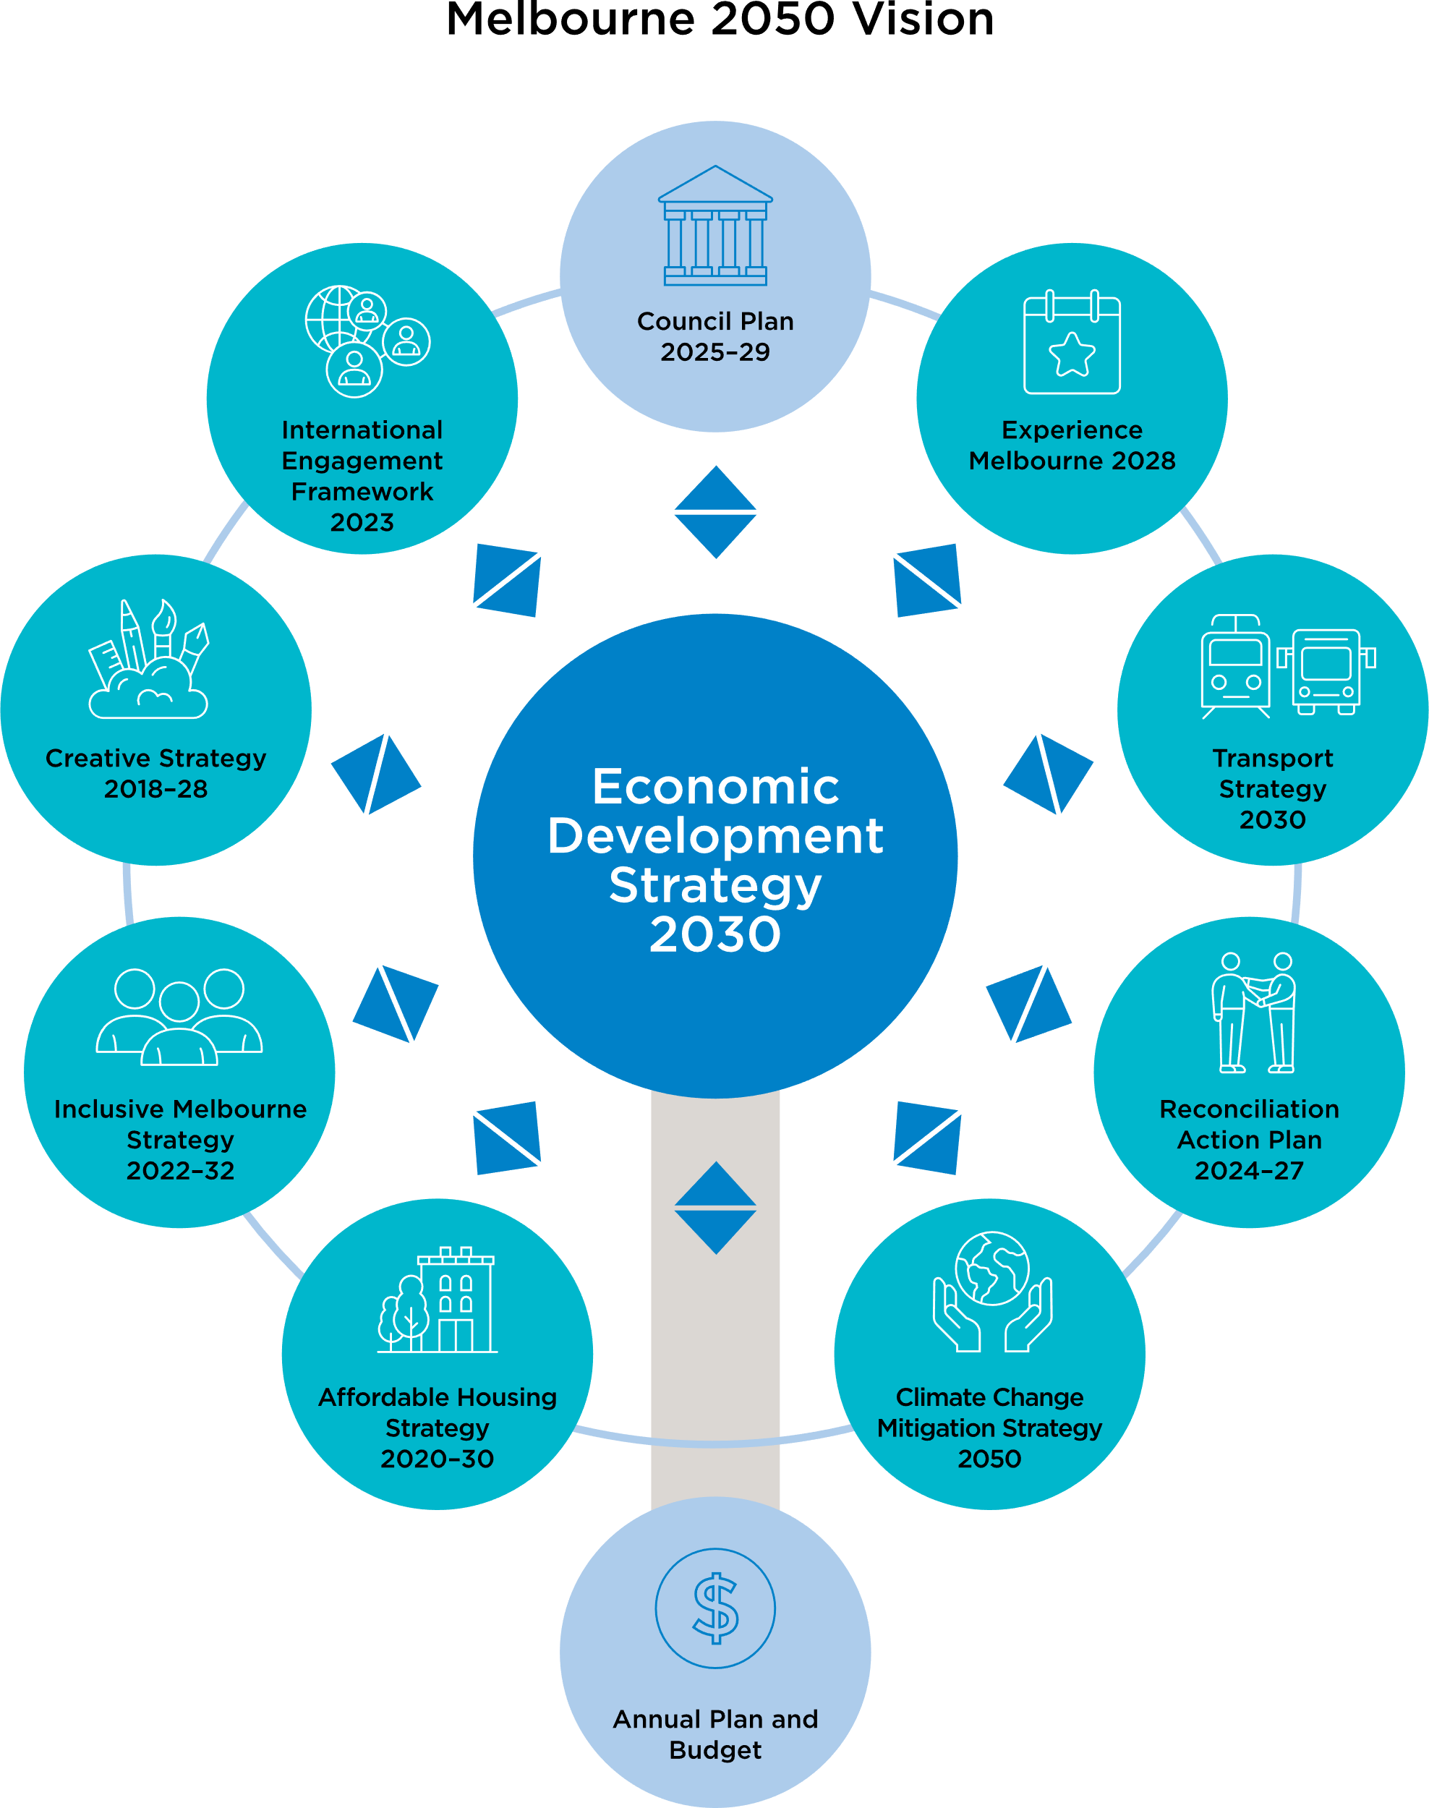

Conclusion
The Melbourne Advantage outlines a bold and decisive strategy to strengthen Melbourne’s economy, while ensuring that growth creates opportunities for all – residents, workers, students and visitors alike. By building on the city’s strengths and tackling its challenges, our economy will develop so it is both dynamic and inclusive, enshrining our competitiveness, generating prosperity and sharing it widely.
At its core, this strategy is driven by innovation, inclusion and liveability. These themes are the key drivers of economic success through population growth, workforce participation and productivity. Complementing these, Melbourne’s competitiveness and energy provide the bedrock for the city’s future prosperity.
The strategic ambitions outlined here reinforce these priorities, ensuring Melbourne continues to be a global leader in economic opportunity and quality of life.
Melbourne’s continued growth and evolution are inevitable. This strategy ensures that growth is both strong and purposeful, leading to outcomes that deliver the greatest benefits for the greatest number of people.

Appendix: facts and figures
Table 3: Comparative cost of doing business in Victoria and other states
 | Victoria | New South Wales | Queensland
Payroll tax 1 | 4.85% | 5.45% | 4.75% for <$6.5 million in wages  4.95% for >$6.5 million in wages
Prime industrial lease costs  ($/sqm, NF 2) | $140 | $245 | $158
Prime office costs  ($/sqm, NF 3) | $717 | $1,320 | $769
Gas price 4  (DWGM) | $12.25 | $13.66 | $14.71
NF = Net face rent
DWGM = Declared wholesale gas market

Sources:
Victorian State Revenue Office, Revenue NSW, Queensland Revenue Office
Knight Frank Research, Market Report, 2024
Knight Frank Research, Market Report, 2024
Australian Energy Market Operator, Quarterly Energy Dynamics, Q4, 2024

Figure 10: Jobs in the City of Melbourne by sector
(FTE, as at 30 June 2024, source: economy.id)
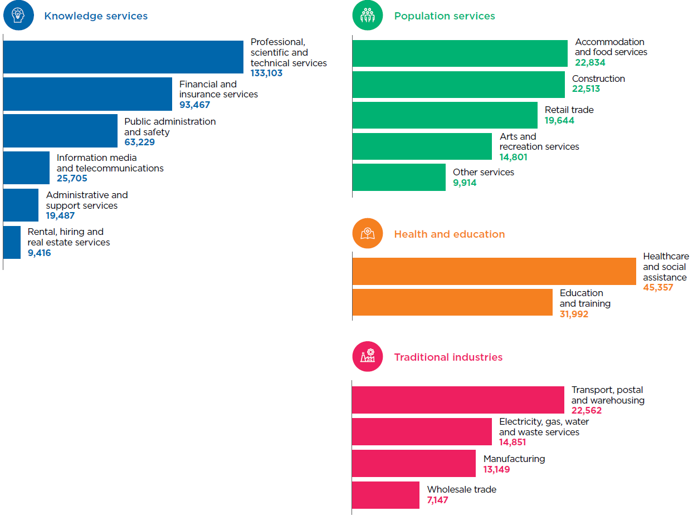

Figure 11: Value-add by sector in City of Melbourne
($ million, as at 30 June 2024)
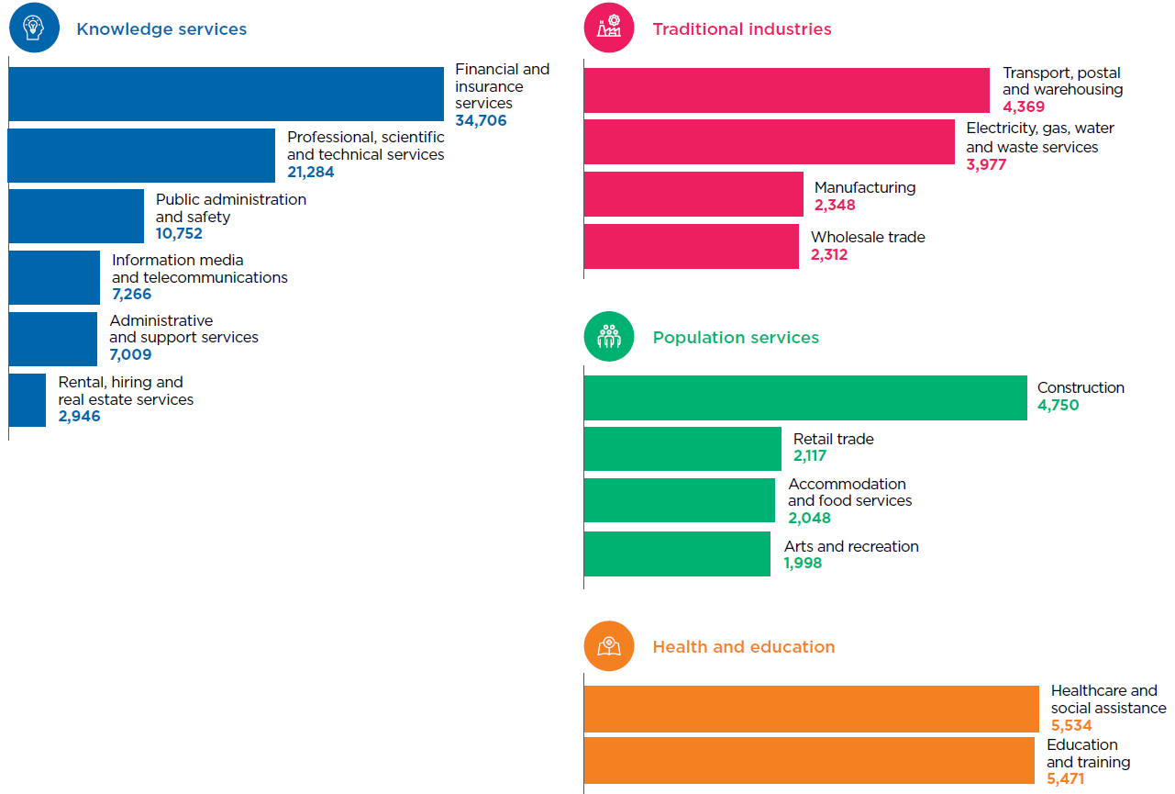

Table 4: Industries that have contributed most to the City of Melbourne’s economic growth over the decade to 2023–24
 | Industry | Increase in value-add 2014–15 to 2022–23 ($m) | Contribution to growth  (% rounded)
1 | Professional, scientific and technical services (except computer system design and related services) | 5,853 | 18
2 | Finance | 5,158 | 16
3 | Computer system design and related services | 2,880 | 9
4 | Administrative services | 2,708 | 8
5 | Auxiliary finance and insurance services | 2,701 | 8
6 | Public administration | 2,631 | 8
7 | Insurance and superannuation funds | 1,636 | 5
8 | Telecommunications services | 1,306 | 4
9 | Hospitals | 1,136 | 4
10 | Heavy and civil engineering construction | 1,034 | 3

End notes

https://participate.melbourne.vic.gov.au/united-nations-sustainable-development-goals/project-overview
https://hdp-au-prod-app-com-participate-files.s3.ap-southeast-2.amazonaws.com/4816/5595/7875/SDGs-FINAL_21_06_2022_4195_Voluntary_Local_Review_ONLINE-compressed.pdf
Comprising of 77.2% of Victoria’s exports in City of Melbourne economy.id
Combined spend on accommodation, food and retail trade in the City of Melbourne increased by 18% between 2018–19 and 2022–24 (inflation adjusted) economy.id
CBRE August 2024
City of Melbourne is 24.1% of Victoria’s value-add, and 34.4% of exports economy.id
CBRE October 2024
economy.id 2024
Australian Bureau of Statistics, Census of Population and Housing 2021 compiled and presented in economy.id
In the five years ending June 2024, median unit rents increased by an average of 3.4% in City of Melbourne compared to an average increase of 6.3% in greater Melbourne Housing Monitor
CBRE Research November 2023
City of Melbourne Transport Strategy 2030 p.16
London and Partners explores these themes: Destination cities and the new expectations of the experience economy
City of Melbourne Annual Report 2023–24 p. 55
Economist Intelligence Unit

