
Un/Real
SIGNAL Curators Collective
March 2025 Exhibition at Blender Studio

Contents
Exhibiting artists 3
Abigail Anderson 4
Alissa Putri 5
Amira Akhtar 6
Annabelle Ryan 7
Baricho Yalew 8
Bastian Nicholls 9
Chloe Ford 10
Emily Raskin 11
Imogen Davis 12
Indiana Pepperell 13
Jade Schmutter 14
Liwen Lian 15
Lois Bowerman 16
Margarita Sierralta 17
Mia Herreen 18
Michael Hall 19
Nina Fitzsimmons 20
Olivia Sutherland 21
Ruby Guerin 22
Sharleen Cu 23
Stephanie Siu 24
Suze Anthony 25

Exhibiting artists
- Abigail Anderson
- Alissa Putri
- Amira Akhtar
- Annabelle Ryan
- Baricho Yalew
- Bastian Nicholls
- Chloe Ford
- Emily Raskin
- Imogen Davis
- Indiana Pepperell
- Jade Schmutter
- Liwen Lian
- Lois Bowerman
- Margarita Sierralta
- Mia Herreen
- Michael Hall
- Nina Fitzsimmons
- Olivia Sutherland
- Ruby Guerin
- Sharleen Cu
- Stephanie Siu
- Suze Anthony
Presented by The SIGNAL Curators collective, the show Un/Real is concerned primarily with the relationship between perception and reality. Within this overarching concept lies a particular focus on the politics of perception; systems of knowledge and their particular biases explored... the question "who benefits from this message of the truth?” presented for the viewer to interrogate. The diversity of artistic mediums within this exhibition targets a broad sensory base in an effort to infiltrate and re-imagine the perceived reality of the viewer; challenging their pre-conceived notion of perception and encouraging viewers to become more critical in their own experience of reality. Viewers of this exhibition will therefore be invited to examine what lies within, between, and behind the “real”, engaging with mythologies, dualities, and mirrors.

Abigail Anderson

The Skin That Lies Beneath

Performance Sculpture
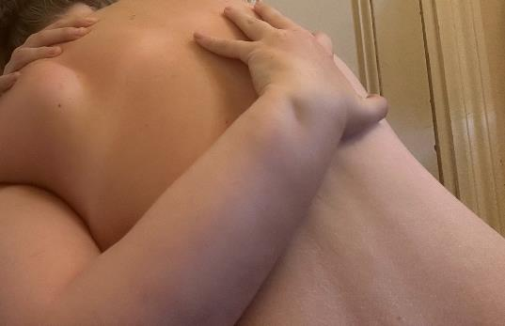
The piece The Skin That Lies Beneath is a performance sculptural piece exploring the interaction between The Self and The Skin. For this piece I really wanted to explore the idea of being the creator, the muse and the subject: roles in which women have been traditionally limited to either the muse or the subject. Ultimately, women have rarely been in control of their own image, thus “unreal”, and in this piece, I wanted to confront and overcome that, projecting an ultimately “real” image of the feminine to the viewer.
The viewer observes The Self first exploring The Skin (in which the clay covering the subject embodies) and then the experience of becoming overly aware and claustrophobic within The Skin. The piece ultimately explores the feeling of being trapped in the body of something foreign or “unreal,” (which could be interpreted as the “idealised” female body) and ultimately the desperation associated with the dire need to escape it. In this particular context, The Skin is both a physical and metaphorical symbolisation of feeling trapped within both concepts such as societal ideologies, with specific reference to The Male Gaze, and also feeling trapped within your own body. The last segment of this piece observes the subject removing The Skin in aggressive, desperate motions, and shaping it into organic sculptural forms… thus becoming The Creator (In which the removal of The Skin is necessary to become). Remnants of The Skin still remain at the conclusion of this piece, posing the question… will we ever escape The Unreal?

Alissa Putri

The Echoes of a Screen

Painting Series
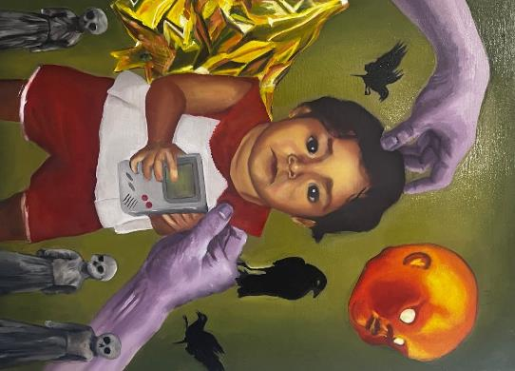
In this series, I invite you into a world where innocence meets the complexities of identity. Through these three portraits, I explore the surreal intersection of my childhood experiences, seen through the lens of migration and cultural dissonance. I became both a reflection and a fragment, pulled between the world I came from and the one I was expected to navigate.
The hands that reach into each painting are more than mere symbols of support or guidance; they represent the suffocating grip of societal norms, control, and perfectionism. They are a constant reminder of how I was shaped—by expectations placed upon me, and by the desire to carve out my own sense of self amidst external pressures. The touch of these hands is both nurturing and limiting, a dual force that speaks to the internal conflict I faced in reconciling who I was with how I was seen.
This work is not just a reflection of my past, but a conversation about identity, culture, and the struggle for self-understanding in a world that often simplifies who we are. It’s a personal reckoning that comes with trying to fit into a world that asks you to be both a part of it and separate from it.
Alissa Putri is a Melbourne-based artist originally from Malaysia, who migrated to Australia at the age of three. A current Visual Arts student at RMIT, Alissa began her artistic journey in early 2024, working primarily with oils and mixed media. Specializing in portraiture, her work explores themes of Asian dysphoria, identity, and childhood, often reflecting on the complexities of growing up in a predominantly white society. Instagram: @alissaaa_putri

Amira Akhtar

I WILL MOURN YOU UNTIL THE EARTH RECLAIMS MY TEETH

Video
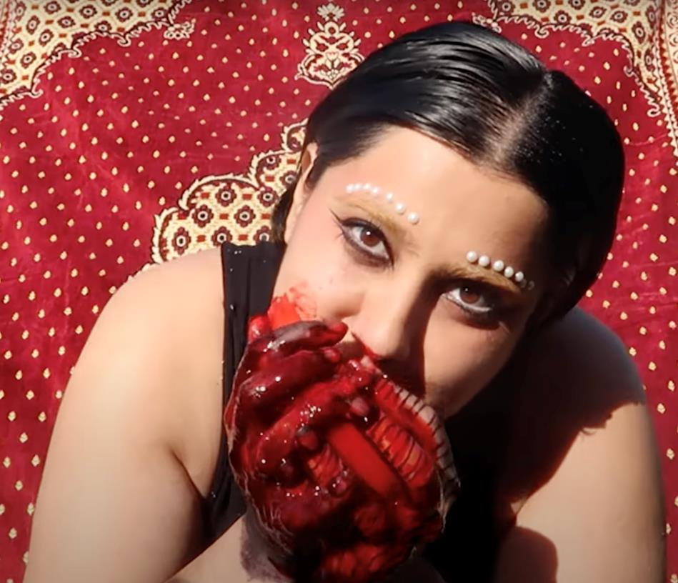
I wanted to explore a video that captured a cryptic south asian creature that attacked a human who was wearing a camera. The video captures the creature consuming a heart that I'd made from jelly and apple.
I was exploring a fantasy world where an astronaut crash lands into a world that is an alien, south-asian, futuristic landscape and this is the first piece of mine that explores that world. This piece in its core is about the grief that follows loss of life and loss of culture/knowledge through the violence of colonisation.
The experiences of my people during the british occupation of South Asia, the consequent partition and the stories that live in my genes are all confronted and consumed by this south-asian entity as they consume (the viewer's) heart.
Amira (they/them) creates on unceded Wurundjeri Country. They enjoy making videos and zines, with a particular focus on documenting their lived experience as a queer south-asian muslim. They're also a big fan of the analog. If you'd like to connect/chat, their instagram is @amiramakesthings

Annabelle Ryan

Daydreams

Painting
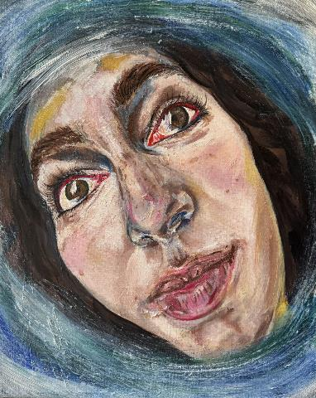
Who’s to say that daydreams are not reality? Although not completely tangible, they are powerful sources of creativity and inspiration, with a side of delusion.
If we can extend beyond our definition of what is real, daydreaming can be a very real form of encouragement and hope. Our imagination has the ability to challenge those limitations and fears we often place on ourselves, perhaps revealing those as the things that are in fact un-real.
The art of daydreaming might be more significant than we give it credit for.
“Dreaming with these open eyes” - Song lyrics from ‘Spirit 2.0’ by Sampha

Baricho Yalew

Perseus with the head of Perseus (Immorality and punishment)

Painting
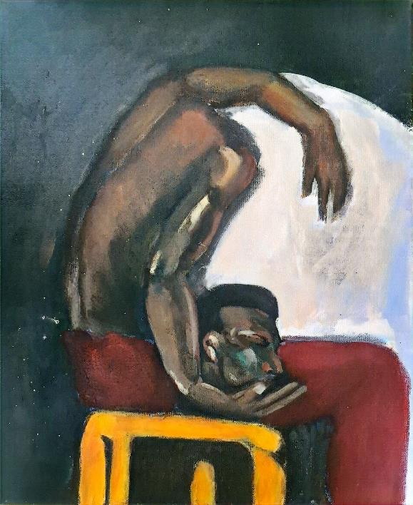
"The man who has a conscience suffers whilst acknowledging his sin. That is his punishment." Fyodor Dostoevsky
I aim to recontextualise the depiction of the mythological figure Perseus holding Medusa’s head, reframing the scene to highlight the imbalance of power. As a privileged demigod, Perseus was endowed with superpowers by the gods to aid in Medusa’s defeat. Medusa, on the other hand, is often labeled a monster, but in reality, she was a victim of the gods. She was assaulted, then cursed to have snakes for hair and turn anyone who looked at her into stone. This reinterpretation will emphasize the power asymmetry between Perseus and Medusa. I aim to question the fairness of his actions. After beheading Medusa in her sleep, does he truly feel prideful and victorious, as sculptures and paintings often depict him? Or is he left with struggle and moral burden?
I imagine Perseus in a state of contemplation and internal struggle. Rather than standing in a prideful and victorious posture, he should appear burdened by the weight of his actions against Medusa, holding his own head instead of hers, symbolizing his cruelty toward her is a cruelty towards himself.

Bastian Nicholls

Smog

Ink Illustration
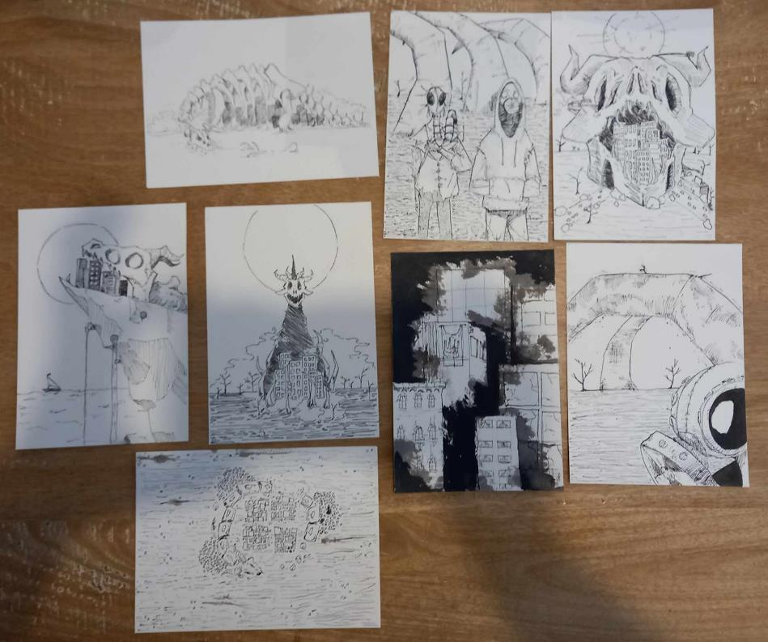
In this series of ink illustrations I’m trying to portray how in the pursuit for power and advancement we’re slowly destroying everything that’s beautiful and worthwhile about our world.

Chloe Ford

The distance that connects

Painting
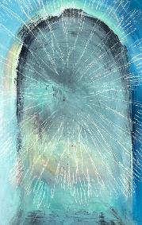
I invite you into the liminal spaces where ancestral wisdom reaches through the veil of modern certainty. The painting, "the distance that connects" emerges from that sacred intersection where the linear gives way to the cyclical, where consciousness dissolves into mystery – expands into an awareness of the multilogue the dead speak from.
In times of planetary upheaval and intimate loss, when our familiar narratives of progress and development show their inadequacy, these hands offer neither salvation nor damnation. Instead, they invite a different kind of movement: a falling together, a composting of certainties, a profound disruption of our presumed trajectories. Let this painting serve not as a window to be looked through, but as a threshold to be crossed and re-crossed, each crossing making us less certain of where we stand, and more open to the questions that make us human. Holding the space for grief to be a powerful decolonial practice.
Chloe Ford is a Narrm based Artist and Poet. Their work engages Decolonial and Queer theory and practice in alinement with their Takatāpui identity and a politics of Neurodiversity.Drawing guidance from posthumanist thought and legacies of carnival practices, they are committed to creating as a devotional act to a vibrant reality.

Emily Raskin
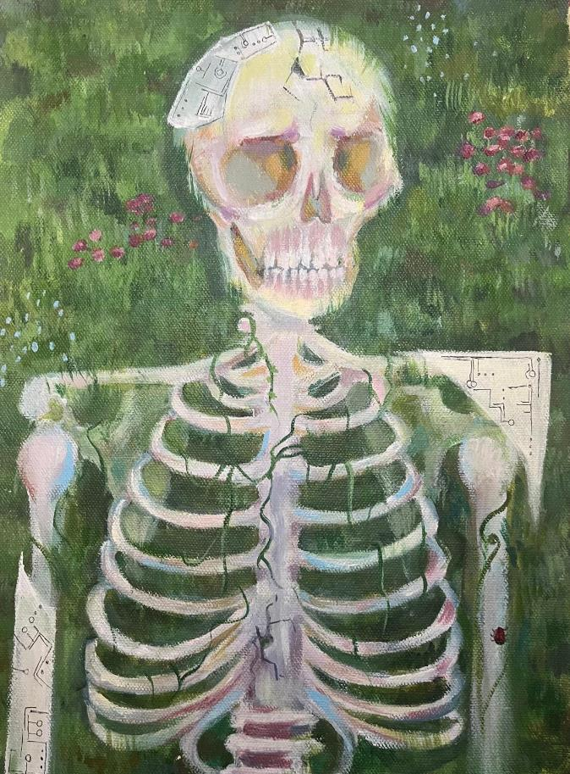
This piece intends to explore the relationship between nature, both human and floral, and mechanics. With the discussion of AI and the future of technology's role in our human lives on the front of everyone's minds, I wanted to share my hope for a future where humans and technology coincide in a balance. Where technology supports us, where it becomes our tool. I believe it is possible for a balance to be achieved. My peice's subject is a decaying skeleton overgrown with vines and flora, however it also contains pieces of mechanical bones and plates, showing a human life that is/was both one with nature and technology.

Imogen Davis

Single use plastic garment (blouse) & (pants)
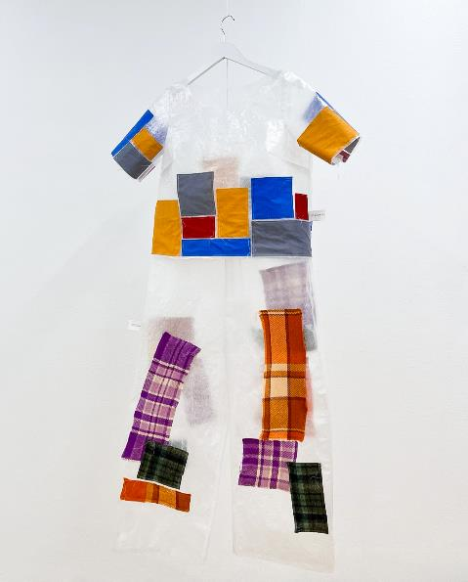
In this artwork common items of clothing are assembled from the deconstructed materials that make up fabric compositions commonly found in fast fashion stores. Discarded retail packaging fused together to fabricate clear sheets of plastic represent similarly petroleum-derived polyester fabric, with only as much wool or cotton affixed to each piece as would be proportionally found in the garments.
With enough clothing already on the planet for the next six generations and still limited knowledge of the full effects of the saturation of plastic and its associated chemicals within our lives, we need to interrogate what materials we accept in our purchases as well as how much we consume. Is plastic fabric real fabric or is it just another symptom of our obsession with the cheap and convenient resources standing between us and a healthy future?
It’s easy to ignore when synthetic fibres are sandwiched between sales and greenwashing but for just a handful of wears, these garments are heavy with costs to our environment and our health, both known and yet to be discovered.
Imogen Davis is an artist and maker from Naarm with a focus on the relationship between materials and process. Through a variety of mediums including textiles, painting, and woodworking, she explores ways to apply specialised processes to materials outside of their usual scope, often bringing craft construction methods into environments they haven’t always been welcome in. Blurring the lines between definitions of art and craft, she experiments with the ways that multidisciplinary thinking around artwork fabrication can complement the development of artwork as well as spark technological exploration to create alternative solutions for the future. Instagram @imy_davis_

Indiana Pepperell

Welcome to Mars

Interactive Installation
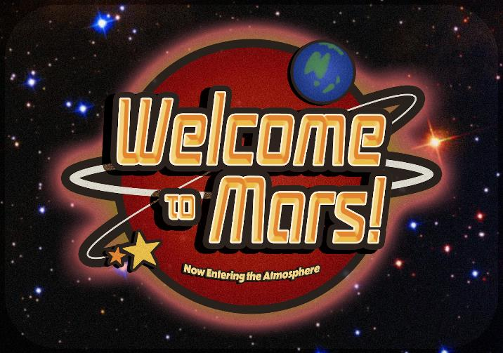
Does curiosity drive conspiracy? And can anybody really prove you didn’t go to Mars?
In an experiential installation, 'Welcome to Mars' pulls earthlings into orbit and launches them straight into a Martian conspiracy. From a cryptic ticket booth to the eerie echoes of extraterrestrial life, ‘Welcome to Mars’ puts the fun in non-refundable galactic travel (no exemptions or debunkings apply).
Collect your boarding pass, step inside and peek behind the crimson curtain to explore a subliminally liminal reality beyond the greater beyond!
Indiana Pepperell is a Melbourne-based designer taking a whimsical approach to speculative design through immersive activations and graphic works. Instagram @pepryll

Jade Schmutter

Lucid

Film
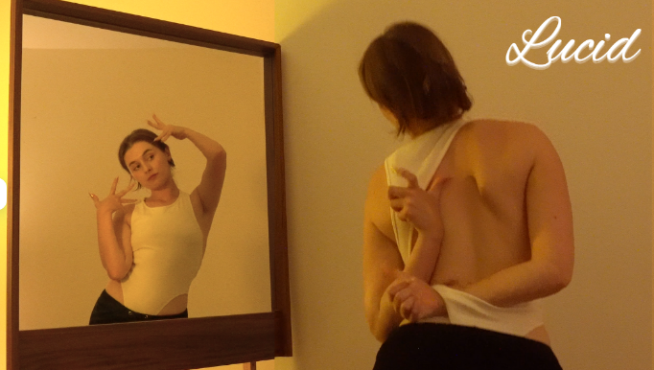
The subject reflects on themselves through a mirror, exploring dreamy, feminine, almost ‘perfect’ movement. As the piece develops, a contrary perspective is unveiled; one that is more desperate and jarring. Like lucid dreaming, the audience is asking what is real?
I‘ve used the dance style Whacking/Waacking, for several of the posing elements in this piece, as well as some of the lines, circles, and sharp arm movements. I’d like to acknowledge that I am a guest in this dance style and that it originated in Los Angeles, in the 1970s, from a primarily black and Latinx queer community.

Liwen Lian

Unrealised Visions

Digital Print on Fabric
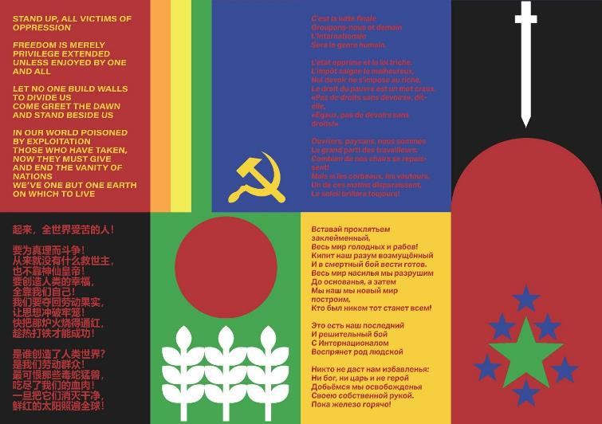
How can revolutionary ideals embrace difference, complexity, and individual dignity? "L'Internationale" is a famous anthem written by French revolutionary poet and worker Eugène Pottier. It’s written in June 1871 during the final days of the Paris Communethe and has since been adapted by socialist, communist and other political groups in many countries and translated to different languages. Reflecting on our past, there have been great socialist and communist experiments in history, yet we haven't come close to reaching this ideal.
This work excavates the unresolved promises of collective liberation, offering an invitation to reflect on the ongoing dialectic between systemic constraint and transformative potential.
Liwen Lian is a Hui-Chinese artist and designer who holds a Bachelor of Interior Design (Honours) from RMIT University. Their practice interrogates how material culture—objects, technologies, and environments—shape, distort, and reimagine identities and narratives. Through a hybrid design-led approach, they navigate the interplay between selfhood and systemic structures, weaving narratives from fragments of personal and collective memories. Instagram @liwen_lian

Lois Bowerman

Spring

Painting
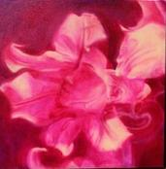
In “Spring” I explore the intricate and transformative nature of personal growth.
Through the use of fluid, almost dreamlike imagery, this painting represents the subtle yet powerful influences that shape our identities.
Featuring my sister as the model, symbolises the genetic and psychological bond that has shaped and reshaped our beliefs, development, and overall sense of self.
This interconnected growth speaks to how we see ourselves in others.
Lois Bowerman is an artist based in Naarm / Melbourne, who mainly concerns herself with providing insight into experiences commonly tied to female identity; including issues of mental health, sexism and connection. As an autistic person art has served Lois as a communicative tool to express her thoughts and emotions. Her work often reflects her lived experiences which sparked a strong sense of justice, particularly regarding feminist issues, aiming to inspire dialogue and create community around an issue. Visit @lo.is.art on Instagram to connect.

Margarita Sierralta

Quiet

Painting
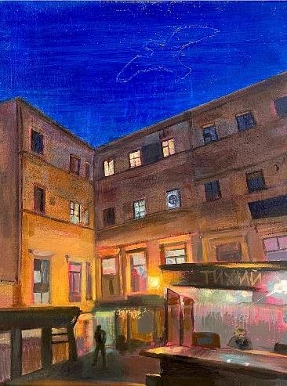
“Quiet" explores the surreality of a place once called home. Based on a photograph of an old building in my hometown of St. Petersburg, Russia, the painting captures a familiar yet distant scene from my childhood. An etched seagull in the sky symbolizes freedom—an uneasy contrast to Russia’s current reality as a repressive state, where LGBTQ identities are banned, and feminist movements are restricted. Positioned within Un/Real, this work reflects on dual identity and the layered meanings of place in a globalized world, speaking to all people with connections to more than one sense of ‘home’.
Margarita Sierralta is a Naarm based, Russian-Peruvian artist whose work is a personal exploration of identity and belonging. Through her abstract oil paintings, she transforms memories of Place into vivid and nostalgic spaces using geometric forms, bold colour and architectural references. Instagram @msierr.art

Mia Herreen

Being

Painting
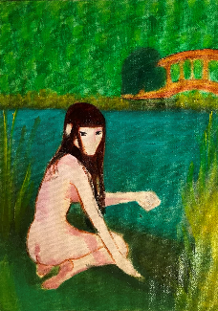
“Being” is about the rediscovery of identity, specifically for me, finding comfort in femininity. The blurred lines of being lost and discovering who you are. This is an ever evolving spiritual process that develops in pain and shines in rebirth. This piece aims to capture the alluring experience of feeling like you're back on the right path of self discovery. The girl depicted can represent this as she too could be finding her path back herself, or perhaps she is a reflection of the inner voice. What is she calling for? What are you calling for?

Michael Hall

I go and feed her

Video
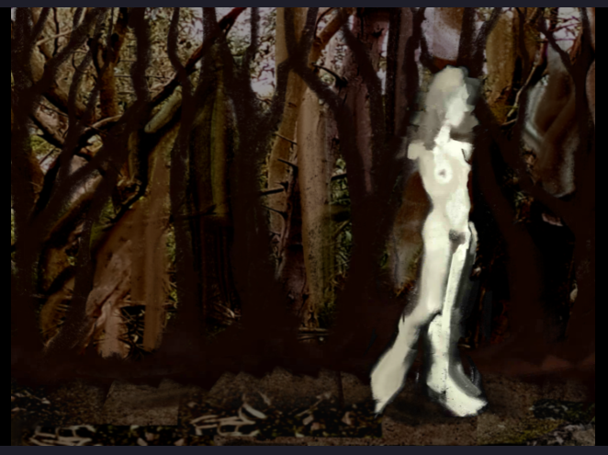
This video was made using 2D animation, 3D renderings, nature footage, and writing from my journal.

Nina Fitzsimmons

Vases

Painting
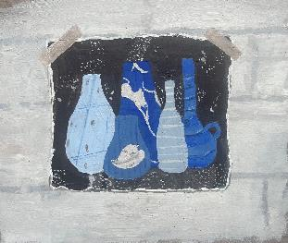
This painting is a trompe-l'œil of a collage stuck to a brick wall. Trompe-l'œil is a French term meaning to ‘deceive the eye’.

Olivia Sutherland

Series of Embroidery on Thrifted Handkerchief
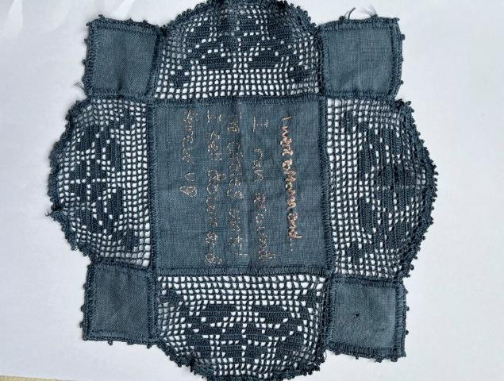
This collection questions what productions we consider to be valuable, real artworks and which are discarded or deemed unreal. Online posts, designed to be flippantly consumed and forgotten, merge with embroidered handiwork which, although slow and meticulous, is often dismissed as commonplace and undervalued for its connection to domesticity and femininity. Both the handkerchief’s crochet edging and the meme’s digital source material are created by others, provoking questions about cocreation in artmaking and the difference between medium and artwork.
Olivia Sutherland, @lilvvitch, MoMA child, @raphoffline, handkerchief artists

Ruby Guerin

Intervals

Digital Photographs
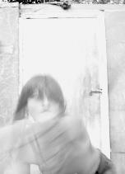
My work “Intervals” is informed by feminist lens-based art histories, is an exploration of how the body is depicted in sculptural and performative ways. Using photography as both a mode of documentation and means to experience performance through, I turn the installation of documentation images into a still performance. My work considers how the self may not be singular and integrated, but can be translated through multiple lenses, layered to create one full but not complete or final image. How does this change the viewers’ experience of the work - can the work be seen as an act? I ask, can the work be considered a feminist performance when a feminine body becomes its object? How is feminist practice possible in relation to historically over-objectified feminine bodies? Through this enquiry, I am also interested in how, historically and contemporaneously, women have reclaimed power as subjects and how this has influenced public conversation surrounding feminine bodies across these contexts.

Sharleen Cu

Face of the Moon

Sculpture
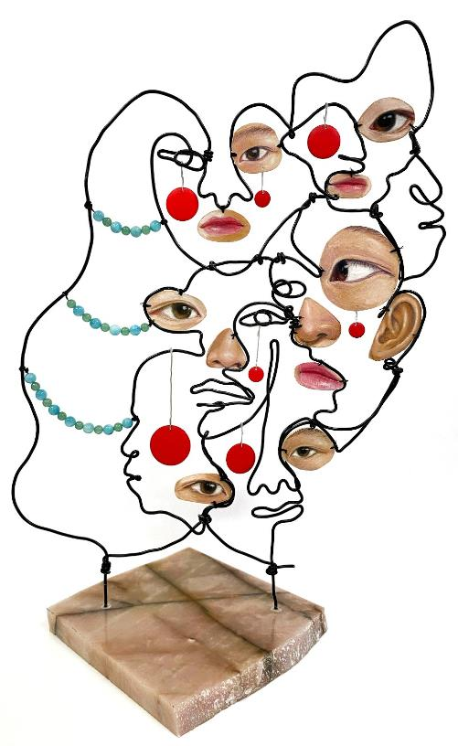
“Face of the Moon” is a self-portrait sculpture that shows the complexity of identity, illustrating how one person can wear multiple faces depending on their interactions. Each layer and texture symbolizes the different roles we assume in various contexts—friend, artist, confidant—revealing the dynamic nature of who we are. Through this work, I invite viewers to reflect on their own multifaceted identities and consider how relationships shape our perceptions of self.
As you engage with this piece, I ask: In what ways do you adapt your identity to connect with those around you?
Sharleen Cu is a multidisciplinary artist with a background of fine arts and digital illustration. Her works play with the art of self-portraiture through mixed media in order to explore the complicated mess that makes up her identity as a Chinese-Filipino living in Australia. Instagram @sharleencu_art

Stephanie Siu

Dreamscape

Painting
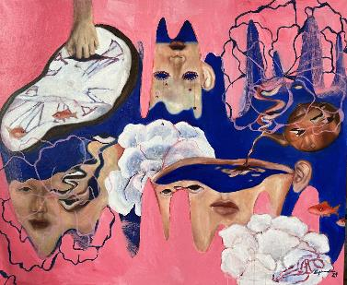
My work is often inspired by themes of memory, nostalgia, grief, and identity. Through surreal, dream-like portraitures, often featuring distorted self-portraits that represent the fragmented nature of emotional growth, my oil paintings capture the strange and disorienting emotions of life. My recent works are heavily inspired by the transformative years of my early to mid-twenties, a stage of life marked by uncertainty and discovery, where belonging and personal identity are continuously being reshaped. The distorted, uncanny portraitures reflect this ongoing dialogue between the real and the imagined. I left my family and moved to Australia from Hong Kong when I was a teenager. The series of changes that came forced me to become skilled at adapting to new environments. When I impose portraits of the self on collections of objects, I think about my ability to assimilate like a chameleon, leaving parts of myself behind and simultaneously taking on new forms. I am drawn to surrealist imagery as much as I am fascinated with my own dreams and nightmares, and I often try to incorporate the haziness of that into my work. Through bizarre reiterations of the self, I aim to investigate the dynamic relationships between my physical and emotional self.

Suze Anthony

Motherboard

Short film on 4k digital
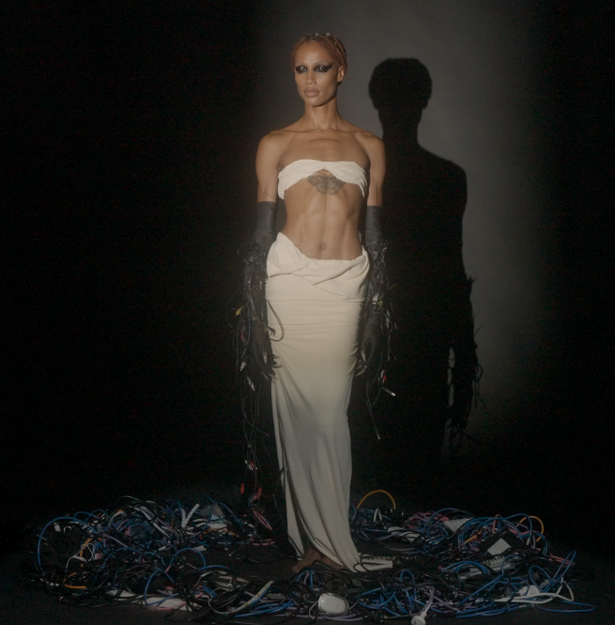
The ‘Motherboard’ explores the idea that technology is inherently feminine, a concept first popularised by philosopher Sadie Plant.
We are introduced to a figure, standing statuesque among a techno-junk graveyard. The modern day Venus De Milo. We witness this goddess resist, struggle and ultimately accept her role as the heart of the machine.
Through a surreal, fever dream sequence, a commentary on AI and its consequence on the human metaphysical (our thoughts and desires) erupts, as do subjects of consent, consumerism, divine technology and ethical usage.
Suze Anthony is an emerging director and video artist living and practicing in Naarm. Looking into the viewfinder, Suze observes a kaleidoscope of thought and emotion, particularly moved by ideas of heritage, technology, connectedness and perfectionism. She commands her lens to capture what is implicit, largely in surreal, romantic or sombre contexts, building a unique visual identity. Instagram @suzeanthonyy

We would like to extend our gratitude to SIGNAL, the City of Melbourne, Blender Studio, and Dark Horse Entertainment for their kind support in the Un/Real exhibition.
- Creative Producer: Jeany Lee
- Facilitators: Matisse Laida, Zeth Cameron
- Poster Design: Suze Anthony
- Catalogue Design: Liwen Lian.

