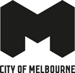
City Marketing Industry Toolkit
Only in the City
2025
Contents
Acknowledgement of Country 2
Campaign summary 3
Creative examples 3
Audience segments 5
Core segments 5
Growth segments 5
How to get involved 5
Create a What’s On Melbourne Listing 6
Photos 6
Copywriting 6
Share the campaign 7
Want to know more? 7

Acknowledgement of Country
The City of Melbourne respectfully acknowledges the Traditional Owners of the land we govern, the Wurundjeri Woi-wurrung and Bunurong / Boon Wurrung peoples of the Kulin Nation and pays respect to their Elders past and present.
We acknowledge and honour the unbroken spiritual, cultural and political connection they have maintained to this unique place for more than 2000 generations.
We accept the invitation in the Uluru Statement from the Heart and are committed to walking together to build a better future.

Campaign summary
‘Only in the City’ is the City of Melbourne’s destination marketing platform, aimed at increasing preference for the municipality as the number one leisure place of choice for all Melburnians. Campaign activity drives leisure visitation, economic uplift and positive sentiment for all local businesses to leverage, by highlighting our points of difference to other destinations.
The city is a melting pot of diverse and inclusive cultures, creative energy and multi-layered experiences. It was identified that what makes Melbourne, Melbourne, is how the city embraces different personal perspectives, which is reflected in the experiences locals have when they visit our city. This strategic underpinning is brought to life through communications that showcase the breadth of the unique event, hospitality, retail, arts and cultural offerings of our city, which cannot be experienced collectively elsewhere.
The campaign aims to ignite civic pride, engaging audiences by showcasing meaningful Melbourne moments and the unique, indescribable vibe that's found only in this city of ours.

Creative examples
Melbourne moments, captured with genuine city character. We use the city as a literal canvas, bringing the distinctly urban textures, colours, and intricate details of the city to life through our assets. Connecting Melburnians visually to that special something they'll find, only in this city of ours.
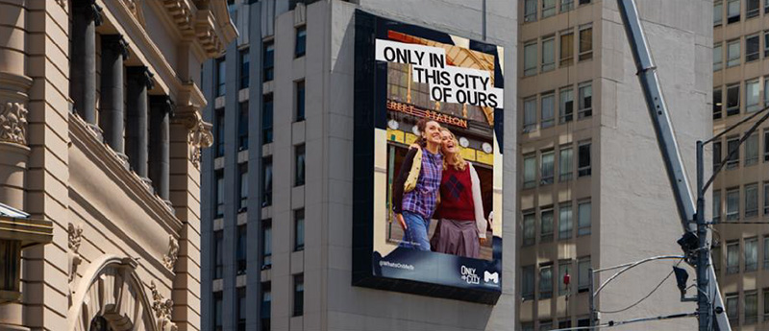
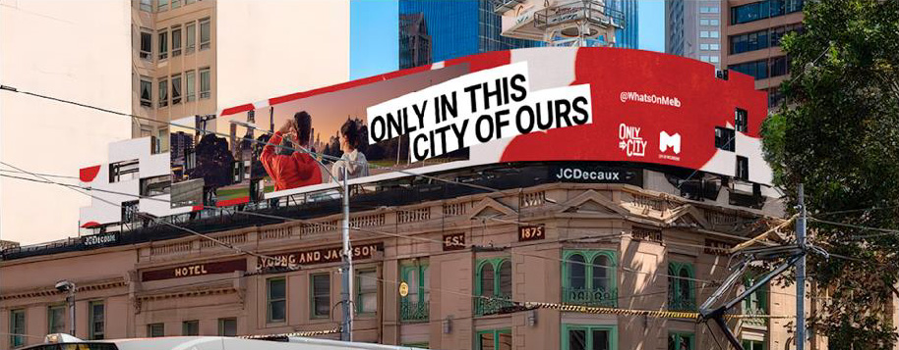
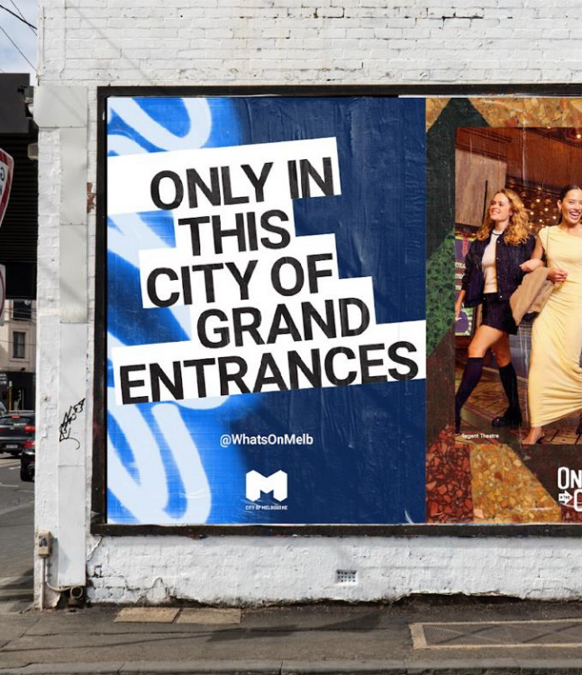
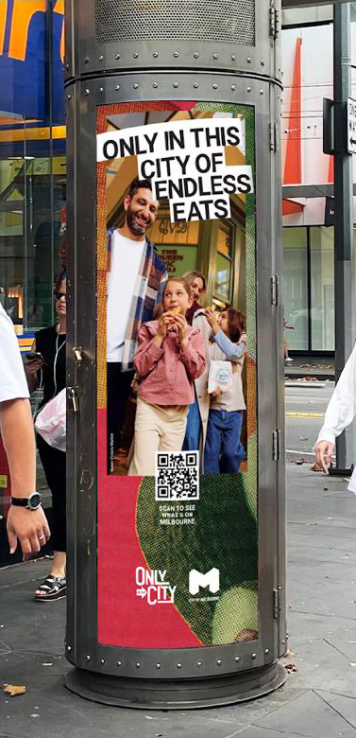

Audience segments
Following a detailed refresh of our leisure audience segmentation in 2024, we have identified three 'core' and three 'growth' segments as priority audiences that have the most potential to visit the city as a destination for leisure. Our marketing efforts focus on people based within 30km of central Melbourne, but also extend our activity to reach audiences with the highest propensity to visit the city from state-wide areas.

Core segments
- Cultured Advocates: They love everything the city has to offer and know the city better than any other segment. They feel Melbourne aligns with their personal values.
- Eager Explorers: Young and passionate, they embrace the city’s vibe and atmosphere. They love exploring the city - coming in without a plan and seeing where they end up.
- Family Focused: They have children living at home, so their choice to visit the city often revolves around catering to their children’s needs and interests.

Growth segments
- Casual Convenience: The ‘tagalongs’ are rarely the social instigators but will happily accompany those who are. The city is a convenient place to spend leisure time.
- Special Occasioners: They live much further away from the city but do enjoy coming in for a special treat and spend big. Usually staying in a hotel with a jam-packed itinerary.
- Locally Bound: They have a strong preference for spending time in their neighbourhood or places other than the city. While they can feel overwhelmed by the hustle and bustle of the city, they will visit for specific events or activities that align with their interests.

How to get involved
There are plenty of ways to get involved in the campaign.
- Check out the marketing support page: Find out how we can promote your business and events via our marketing support page.
- List your business: To be featured in campaign activity, businesses and events must first be listed on the What’s On Melbourne website, which receives over 8 million unique visitors annually. Listed businesses are eligible for promotion through What’s On Melbourne’s feature articles, Facebook and Instagram.
- Share your updates: Launching a new event? Upgraded your venue? An exciting offer or unique activity in the works? To be considered for promotion, please email information, assets or news you want to share to marketing@melbourne.vic.gov.au.
- Use campaign assets: Show your support for the campaign by sharing the campaign assets on your channels and leveraging the campaign messaging in your communications (see page 9). You can also contact us at marketing@melbourne.vic.gov.au to request bespoke campaign assets and an ‘Only in the City’ window decal.
- Be included in our Visitor Services briefing sessions:
To promote your business or event to visitors through our network of more than 240 city volunteers, join a seasonal event forum or the familiarisation program by emailing tourism.volunteer@melbourne.vic.gov.au.
- Apply for a free brochure display: At the Visitor Hub and Booth, more information here: Promotion at Visitor Hubs.

Create a What’s On Melbourne Listing
To be featured in campaign activity, businesses and events must first be listed on the What’s On Melbourne website2. What’s On Melbourne promotes more than 3,000 businesses and events each year, with over 8 million unique visitors visiting the website annually. Sign up for a free What’s On Melbourne account and get your business or event listed by following these four easy steps:
- Sign up for a free What’s On Melbourne account.
- Read our eligibility criteria. Restaurants, cafes, bars and most shops are eligible.
- Create a new listing. You will need a brief description, image, contact details and event details, like location, time and cost.
- Submit your listing. Your listing will be reviewed within two business days. If you need help creating a listing please reach out using the contact us form. Please read the listing criteria prior to submission to avoid disappointment.

Photos
- Photos should be high resolution (1 MB or more) with no text, logos or graphics.
- Pick photos that are bright, colourful and in focus.
- Make sure you own the rights to the image before you share.
- Avoid empty venues, single-use plastic and extreme close-ups.
- Shoot with the light behind you or to the side.
- Include a combination of landscape and portrait photos to fit different formats.

Copywriting
- Keep it brief and get to your key message in the first sentence.
- Include the most newsworthy aspect of your business or event.
- Don’t use promotional or sales-focused language.

Share the campaign
We have developed some assets for businesses to share their support of the campaign and help us showcase experiences that make the city unique. You can do this by referencing the phrase “Only in the City” or "Only in this city of ours "when promoting your unique experience in your communications.
Is your business or event in an iconic location? Maybe you sell products that are directly inspired by the city itself. Or perhaps you provide an experience that speaks directly to the unique and distinctive nature of Melbourne.
Visit the Only in the City page to explore what others are sharing, get inspired, and stay up to date with what’s happening around the city - including things to do, eat and drink, shopping and more.
Access campaign assets here
These materials are provided for use in the following conditions:
- Accompanying text material may be adapted to suit your specific purposes so long as the substantive intent of the message is not affected.
- Assets must be used 'as is’ and must not be altered or modified.
- Assets must link to What’s On Melbourne
If you would like to discuss bespoke marketing assets, pitch a special offer or require assistance, please contact the team: marketing@melbourne.vic.gov.au.

Want to know more?
Visit Only in the City8 or contact the Destination Marketing team marketing@melbourne.vic.gov.au.

https://www.melbourne.vic.gov.au/marketing-support
https://whatson.melbourne.vic.gov.au
https://www.facebook.com/WhatsOnMelb
https://www.instagram.com/WhatsOnMelb
https://www.melbourne.vic.gov.au/promotion-visitor-hubs
https://whatson.melbourne.vic.gov.au/listings/listing/create
https://whatson.melbourne.vic.gov.au/listings/pages/help
https://whatson.melbourne.vic.gov.au/only-in-the-city
https://whatson.melbourne.vic.gov.au/things-to-do
https://whatson.melbourne.vic.gov.au/eat-and-drink
https://whatson.melbourne.vic.gov.au/shop
https://cityofmelbourne-my.sharepoint.com/:f:/g/personal/tessa_browne_melbourne_vic_gov_au/Eg8r3FjW_bRCkEz78wM8DIMBhyNSOmiJb63CXfJjeNeRDg?e=lGFYct

