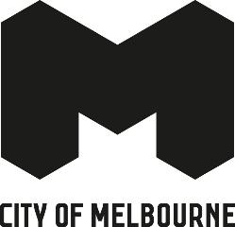

Quick Response Arts Grants program
2025 grant recipients – 40 applicants receiving $5,000
Recipient | Artform
Ada Tzinis | Film
Alchemy Consort | Music
Antuong Nguyen | Creative development - Film
Badra Aji | Creative development - Visual art
Celline Marge Mercado | Visual art
Cyndi Makabory | Creative development - Film
David Mendelsohn | Visual art
Elena Betros López | Visual art
Elmira (Cheung) Ng | Visual art
Fayen d'Evie | Visual art
Helen Kwok | Creative development - Visual art
India Stewart-Williams | Dance
Jason Maling | Theatre, live art
Jump Left | Art.Co.Lab | Visual art
Katharine (Kat) Nelligan | Film
Katherine Dolheguy | Writing
Kathryne Honey | Multimedia
Leisa Shelton-Campbell | Theatre, live art
Lilibeth Hall | Creative development - Music
Lilikoi Kaos | Circus, physical theatre
Liquid Architecture Sound Inc | Music
Madeleine Thornton-Smith | Visual art
Maggie Church-Kopp | Circus, physical theatre
Mickey Stosser | Music
Ming Liew | Visual art
Nathan Bird | Music
Olivia Floate | Theatre, live art
Paul Gorrie | Music
PWP Collective | Visual art
Rachel Ang | Creative development - Writing
Rawcus Theatre Company Inc. | Theatre, live art
Sara Retallick | Music
Sarah-Jane Woulahan | Multimedia
Speak Percussion | Music
Tahlia Palmer | Creative development - Music
Tay Pitts | Theatre, live art
The Dax Centre | Visual art
The Johnston Collection | Visual art
Tilde - Melbourne’s Trans and Gender Diverse Film Festival | Film
Writers Victoria | Writing

