Area 2, Block – Palmerston Street, Rathdowne Street, Elgin Street, Lygon Street, Drummond Street
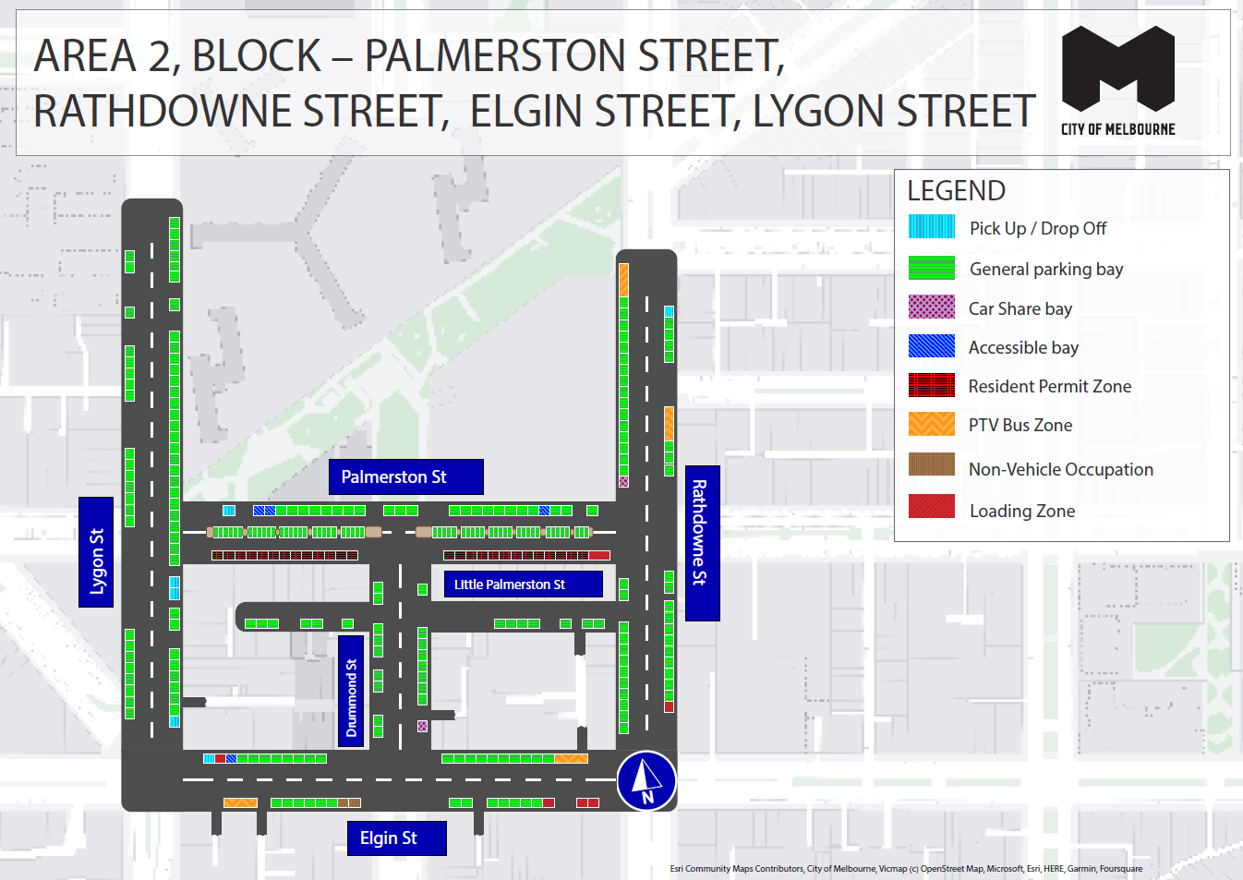
This map presents the parking conditions to be applied within this block as part of the parking improvement works in this neighbourhood.

Lygon Street
General parking bays and Pick up/Drop Off bay.

Rathdowne Street
General parking bays, Pick up/Drop Off bay, Loading Zone bay, Car Share bay and PTV Bus Zones.

Palmerston Street
General parking bays, Loading Zones, Pick up/Drop Off bay and Accessible bay.

Little Palmerston Street
General parking bays.

Drummond Street
General parking bays and Car Share bay.

Elgin Street
General parking bays, Accessible Bays, Loading Zones, Pick up/Drop Off bay and PTV Bus Zones.

Parking controls to be applied in this area
Within this area, we will apply consistent parking controls to make parking more available and reliable.
Pick up/drop off bays will typically be signed ‘No Parking’. We will add signage to explain that the space is for passenger pick up / drop off for up to 2 minutes.
General parking bays will be signed ‘7am – 10pm, Mon – Sun’ depending on location. Meters will not be added to streets which are unmetered currently. The exception is on streets where meters are already in place and there is a mix of paid and unpaid parking. Any existing 11pm restrictions will be kept the same.
Exceptions from time limits for Resident Parking Permit holders will typically not change throughout Carlton. There may be small adjustments to the position of resident permit excepted parking spaces (marked with specific ‘Area # Resident’ signs) within a street or area based on the needs of the kerbside. The total number of spaces provided to serve a resident permit area will remain the same.
Resident Permit Zone means parking for Resident Parking Permit holders only.
Metered bays will typically be signed ‘1/2P-4P Meter, 7am – 10pm, Mon – Sun’ to support residential areas. Peak and off-peak fees (outside central city rates) will apply at $4 per hour from 7am to 7pm and a reduced rate of $2 per hour after 7pm weekdays and all weekend. The offer of $0 payment for short stops of up to 15 minutes in any metered parking space via the EasyPark app will be available in this location. This allows short stops in any green-sign space rather than limiting short stops to a small number of specific bays (for example, ‘1/4P’).
Car Share bays will typically be signed as ‘Permit Zone, Car Share Vehicles’ for the permitted car share vehicle operator.
Accessible (disability) parking bays will typically be signed ‘2P, Disability Only, 7am – 10pm, Mon – Sun’ or ‘P, Disability Only, 7am – 10pm, Mon – Sun’. We will apply blue line-marking to these spaces.
Loading Zones will typically be signed as ‘Loading Zone, 30-minute, 7am – 7pm, Mon – Sun’ in the commercial area and ‘Loading Zone, 30-minute, 7am – 4pm, Mon – Fri’ in other areas. Where possible spaces will typically become general parking spaces after Loading Zone hours. People making deliveries can also use green-sign spaces for short stays of up to 15 minutes for $0 via the EasyPark app.
Motorcycle parking will be signed as ‘P, Motor Cycles Only’ with no time limits.
Postal Vehicle bays will be signed as ‘No Parking, Postal Vehicles Excepted’. They can be used by Australia Post vehicles, and by any other vehicle needing to access an adjacent postbox for up to 2 minutes.
Taxi Zones will be in areas with high demand for taxis.
Coach bays will typically be signed as ‘No Stopping, Buses Excepted’ with a time limit applied where there is demand for bus turnover.
Non-vehicle occupation includes temporary infrastructure in a parking space (for example, an outdoor dining parklet).
Construction Zones will be signed as ‘Permit Zone, Construction Vehicles’ to allow construction vehicles with a permit to stop and park.

