Southbank Parking Adjustments – City Road and Coventry zones
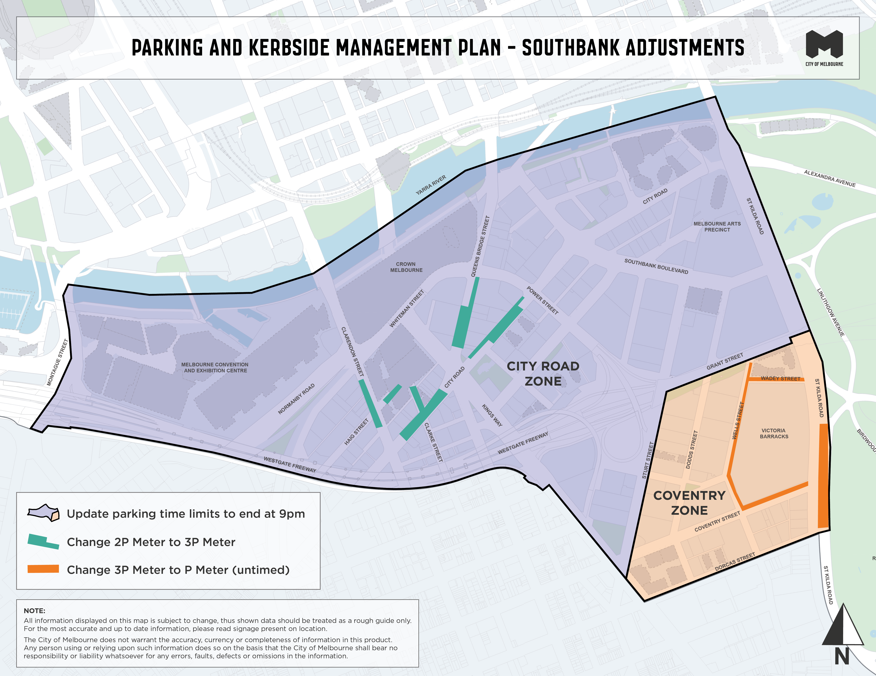
This map presents the parking conditions to be adjusted within these zones as part of the parking improvement works in this neighbourhood.

City Road zone
Update parking time limits to end at 9pm throughout zone.
Change from 2P Meter parking to 3P Meter parking in select areas.

Coventry zone
Update parking time limits to end at 9pm throughout zone.
Change from 3P Meter parking to P Meter (untimed) parking in select areas.

