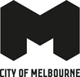
Green Economy



Melbourne aims to be a city powered by 100 per cent renewable energy by 2030
and reach zero net emissions by 2040. Industry capability and investment opportunity
exists in circular economy solutions, urban sustainability, clean energy and
infrastructure projects.
- 250 Melbourne climate tech innovators
- $450m Invested in climate tech deals over five years
- 7th Globally for clean energy research
- 1st Australian local council to facilitate power purchase agreement

Melbourne’s dynamic clean energy industry
Our green economy sector is one of the fastest growing segments of the economy, with Victoria responsible for 30 per cent of the nation’s renewable energy workforce. The need to take action to reduce emissions and manage climate change are recognised as a joint priority between industry and all levels of government and is driving demand for environmental solutions. Global companies ACCIONA, BayWa r.e, Mainstream Renewable Power, Tilt Renewables and Trust Power have selected Melbourne for their Australian headquarters.

Strong graduate pipeline of talent
Victoria has Australia’s largest pipeline of job-ready sustainability graduates.
The University of Melbourne offers globally recognised courses in environmental science, ranking second in Australia and 23rd globally.
Number of Agriculture and Environmental Studies and Natural and Physical Sciences Graduates per State in Australia (‘000, 2021)
State | Natural and Physical Sciences graduates | Agricultural Environmental and Related Studies | Total
Victoria | 10 | 1 | 11
New South Wales | 7 | 1 | 8
Queensland | 4 | 1 | 5
Western Australia | 4 | 0 | 4
South Australia | 1 | 0 | 1
Australian Capital Territory | 1 | 0 | 1
Tasmania | 1 | 1 | 2
Northern Territory | 0 | 0 | 0

Committed to achieving net zero
City of Melbourne has aggressive renewable energy targets and is working with all levels of government to achieve net zero by 2040.

Melbourne’s planned transition to net zero
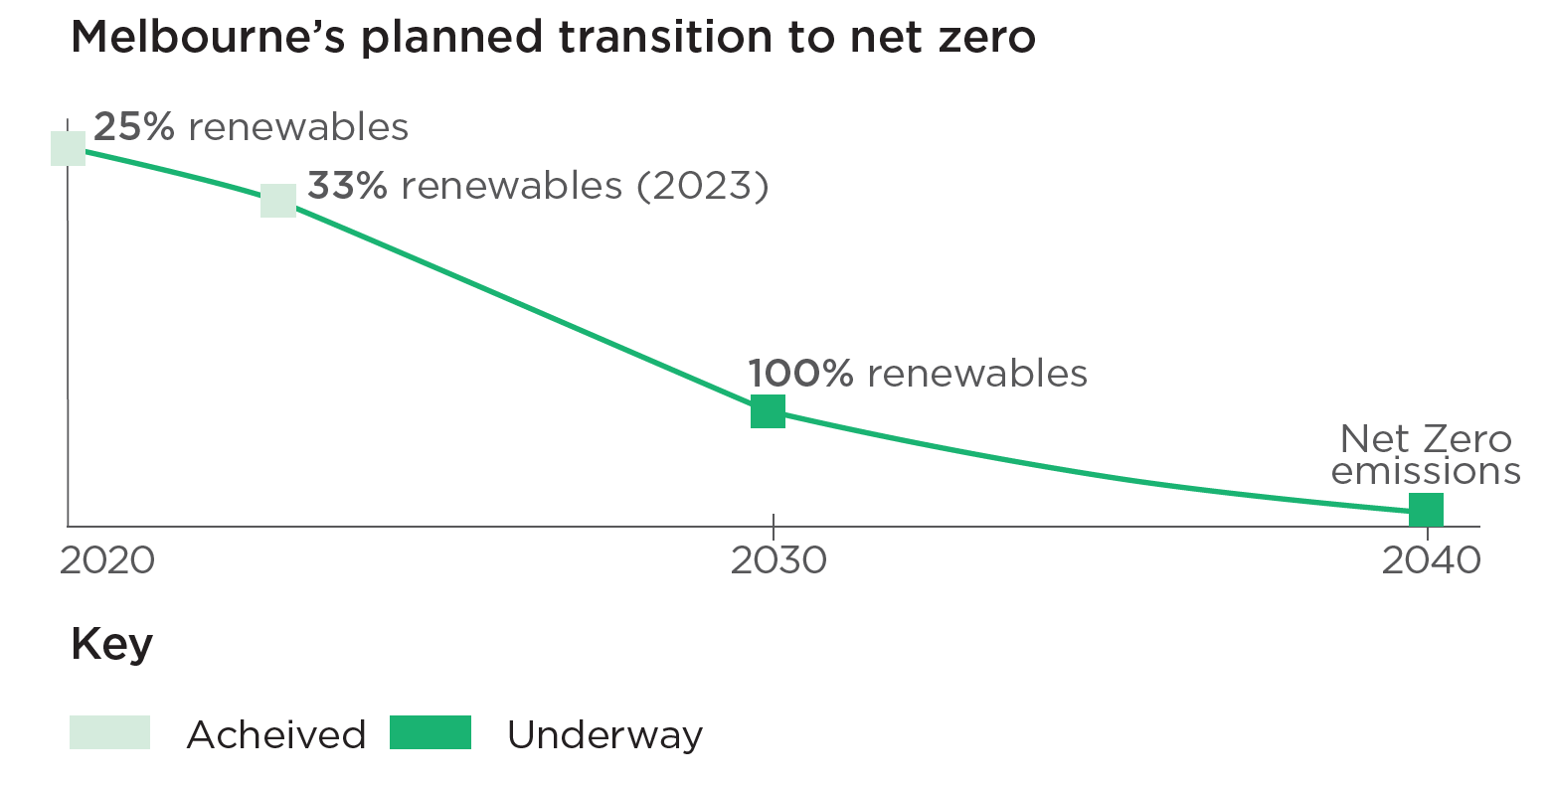

City of Melbourne initiatives
United Nations Sustainable Development Goals, partnering through C40, Resilient Cities Network and United Nations Economic and Social Commission for Asia and the Pacific to identify sustainable solutions.
Melbourne Climate Network aims to identify priorities that support sector growth and increase employment opportunities.
Zero Carbon Buildings seeks and promotes initiatives to transition buildings in the central business district to net zero emissions.
Power Melbourne will install a network of batteries across the city to help residents and businesses access affordable renewable energy.
Melbourne Renewable Energy Project facilitates a 10-year renewable energy power purchase agreement for local businesses.
Go Full Circle assists small businesses to adopt a circular business model that contributes to economic, environmental and social objectives.
CitySwitch helps commercial office tenants reduce their environmental footprint through access to funding, walk-through audits and workshops.

Industry strengths and investment opportunities

Renewable Energy
Over one-third of Victoria’s energy generation comes from a renewable source. Favourable policy settings have played a critical role in stimulating private sector investment. Australia’s most advanced offshore windfarm project, Star of the South, is proposed to be located off Victoria’s coastline and could supply up to 20 per cent of Victoria’s energy needs on completion. The State Electricity Commission will invest $1 billion to deliver 4.5 GW of renewable energy assets.
1st Australian state to set a renewable energy target.

Water Solutions
Melbourne leads the nation in water innovation, with Melbourne Water, the city’s water management authority, investing in research and development projects. The Fishermans Bend Innovation Precinct will be the largest water sensitive urban design project in Australia, creating a climate-resilient and ecologically thriving neighbourhood. Melbourne companies solving global water management issues include GHD, which has introduced water sensitive urban design to 17 cities in China, and Aither which delivers projects in 15 countries across water economics, performance, policy, resilience, strategy and utilisation.
60 Research and development projects in 2020 valued at $6 million

Urban Sustainability
Melbourne has a thriving urban sustainability industry resulting in a landmark portfolio of green buildings. Local company, Exergenics, develops high-spec cooling technologies that improve the energy efficiency of buildings. The Docklands Precinct is a leader in 6 Star Green Star building performance. Opened in 2014, NAB’s global headquarters was the first Australian building to be awarded a Green Star rating and ANZ’s 80,000 m2 office space is the largest single-tenanted 6 Star Green Star rated building in Australia. Docklands Library is the first public building to become 6 Star certified. Melbourne is the chosen global headquarters of design, engineering and advisory company Aurecon, which manages sustainability and building performance projects in New Zealand and Asia.
1st Green Star building in Australia.

Circular Economy
Victoria has an ambitious circular economy agenda to transform the recycling sector, avoid waste and create new commercial opportunities for businesses. City of Melbourne supports local businesses through its Go Full Circle program, helping develop circular business models to improve environmental outcomes, reduce costs and improve innovation. Melbourne is home to two of the nation’s largest recycling companies, Visy and Cleanaway as well as local business, Who Gives a Crap, which manufactures sustainable toilet paper, exporting to over 36 countries.
80% Waste diverted from landfill 2030 target.

Transport
Victoria is pursuing low-energy and zero-emission transport solutions. Melbourne’s world-famous trams are 100 per cent solar powered. Trials are underway for electric and hydrogen powered buses across Melbourne. Incentives are widely available to fast track the transition to zero emission vehicles and charging facilities are being constructed across the state. Melbourne headquartered drone delivery startup, Swoop Aero, provides an aviation platform that moves essential healthcare products to remote locations, currently servicing 4.5 million people over six continents.
#1 Largest tram network in the world.

Battery technology + infrastructure
Australia is the largest producer of lithium in the world and the country’s battery manufacturing industry is globally recognised. Leading companies include Chargefox, Envirostream, GreenSync, Redback Technologies, Reposit, SupraG Energy and Volgren. The industry is well supported by the Future Battery Industries Cooperative Research Centre, a conglomerate of 60 industry partners, universities, the Commonwealth Scientific and Industrial Research Organisation (CSIRO) and the Battery Research and Innovation Hub.
#1 Australia’s largest lithium-ion battery is in Victoria.

Melbourne climate tech startups
Melbourne is home to some of Australia’s leading climate tech investors with more than $450 million invested in climate tech companies over the past five years. It is home to the third-largest climate tech startup ecosystem in Oceania and ranks third in the Global Smart Cities rankings for the application of emerging technologies.
Local company Great Wrap is a hallmark EnviroTech startup success story, which manufactures compostable stretch wrap and has grown rapidly since its inception in 2019 with a valuation of $66 million.
The City of Melbourne’s innovation competitions assist in accelerating zero-carbon solutions and the Nexus Pitch competition, START in Melbourne and SCALE to Southeast Asia programs have successfully leveraged business expansion into Asia.

A collaborative innovation ecosystem
Part of the University of Melbourne’s premier research capabilities, the Melbourne Energy Institute undertakes world-leading research on the transition to a clean energy system, including energy materials, energy systems, hydrogen and clean fuels, and power generation and transport.
The Net Zero Australia project is a collaborative partnership that investigates how Australia can achieve a net zero economy by 2050.
Led by RMIT University, Supporting the Electrification of Victoria’s Future Fleet is a major project addressing the infrastructure needed to support widespread adoption of electric vehicles in Victoria.
Based at Monash University, the Climateworks Centre bridges the gap between research and climate action and Water Sensitive Cities Australia supports the adoption of urban water management solutions.
Australia ranks seventh in the world for its clean energy research according to the Nature Index 2022.

Melbourne is delivering sustainability outcomes around the world
Gaia Project Australia specialises in advanced crop cultivation techniques that improve crop productivity and resilience in the face of climate change and is working on a controlled environment agriculture prototype for NASA.
Allume Energy developed the world’s first hardware solution that enables apartment owners in Australia, Europe and North America to access solar power.
ClimaSens is a climate intelligence startup specialising in real-time decision support tools for urban heat adaption and climate resilience for governments, businesses and communities.
Relectrify’s battery energy storage technology is utilised by American Electric Power in the United States, Chubu Electric Power in Japan and Counties Energy in New Zealand.

JET Charge – World leading energy management
JET Charge is a leader in the electric vehicle and infrastructure sector and has deployed more charging stations than any other company in Australia and has a growing presence in New Zealand. JET Charge is leading the way in developing tools to help integrate electric vehicle charging into the electricity grid, from energy management, smart charging and electricity grid transformation.
The company now employs over 170 people and has committed to expanding its Melbourne headquarters to Fishermans Bend, Melbourne’s hub for advanced manufacturing innovation. The Australian market is poised for significant growth in the coming years with 50 per cent of new vehicles sold in 2030 expected to be electric.

Melbourne has plenty to offer foreign businesses

Favourable visa settings
Australia proactively attracts top-tier talent through dedicated visa programs such as the Global Talent Visa and Global Talent Employer Sponsored program. These programs draw highly skilled migrants to Melbourne and enrich local industry labour markets.

Government support
The Australian Government and Victorian Government are investing heavily to reduce greenhouse gas emissions and improve sustainability. They offer a range of incentives, grants and support, including funding projects that unlock opportunities for investors.
Eligible foreign investors benefit from strong research and development tax incentives in Australia, receiving up to 43.5 per cent as a refundable tax credit.

Gateway to the Asia-Pacific
Victoria is positioned to export clean products and services to help Asia-Pacific countries meet their net zero targets. The Singapore-Australia Green Economy Agreement supports Australia’s economic, trade, investment and climate policy objectives.

Lower business costs
Melbourne’s industrial leases and office space rentals are around 35 per cent cheaper than Sydney. Victoria has the second lowest metropolitan payroll rate in the country (4.85 per cent) and the lowest regional tax rate (1.21 per cent). Melbourne’s energy costs are 45 per cent lower than in Sydney.

Intellectual property protection
Australia ranks 11th globally in the International Property Rights index, ensuring protection for companies with respect to patents, trademarks, and protection against corruption. Per size of population, Australia has one of the highest ratios of renewable energy patents in the world – on par with the United States and Germany.

Advantageous time zone
Shared time zones with Asia enables businesses to operate an Asia-Pacific headquarters from Melbourne. The city is an ideal location for a ‘follow the sun’ business model with Melbourne’s business hours bridging European and US business days.

Multicultural workforce
Melbourne’s diverse workforce speaks around 260 languages, enabling clean energy companies to cater to international markets and employers to deliver in-language services.

Exceptional liveability
Melbourne is currently ranked as the fourth most liveable city in the world, having held the title of the World’s Most Liveable City for a record-breaking seven years from 2011 to 2017.

Earth Systems – specialist advice for international environmental issues
Earth Systems is a Melbourne-based environmental consulting firm specialising in carbon reduction, ecology, energy efficiency, social impact assessment and water management and treatment, which have broad application in energy, infrastructure development, mining, oil and gas and urban and rural development.
Earth Systems employs 50 people across eight global offices and has helped clients address critical environmental and social challenges across more than 500 major projects in Africa, the Asia-Pacific, North America and South America.
The company’s clients include Aitken Spence in Sri Lanka, Central Asia Metals in Kazakhstan, City of Zhongshan in China, Fiji Department of Environment, Government of Lao PDR, and The World Bank.

Thinking about starting a business in Melbourne?
Visit Investing in Melbourne or email us at investmelbourne@melbourne.vic.gov.au
Want help identifying products and services produced in Melbourne?
Visit International collaboration or email us at global@melbourne.vic.gov.au
Disclaimer: This document is provided for information and it does not purport to be complete. While care has been taken to ensure the content in the report is accurate, we cannot guarantee it is without flaw of any kind. There may be errors and omissions or it may not be wholly appropriate for your particular purposes. In addition, the publication is a snapshot in time based on historic information which is liable to change. The City of Melbourne accepts no responsibility and disclaims all liability for any error, loss or other consequence which may arise from you relying on any information contained in this report.
© Copyright City of Melbourne 2024. To receive this publication in an accessible format, email: global@melbourne.vic.gov.au

melbourne.vic.gov.au/invest
melbourne.vic.gov.au/international

