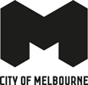
Melbourne:
Globally Connected

Acknowledgement of Traditional Owners
The City of Melbourne respectfully acknowledges the Traditional Owners of the land we govern, the Wurundjeri Woi-wurrung and Bunurong / Boon Wurrung peoples of the Kulin Nation and pays respect to their Elders past and present.
We acknowledge and honour the unbroken spiritual, cultural and political connection they have maintained to this unique place for more than 2000 generations.
We accept the invitation in the Uluru Statement from the Heart and are committed to walking together to build a better future.

Contents
Acknowledgement of Traditional Owners 2
Disclaimer 4
Melbourne - Globally Connected 5
We welcome you 5
A great place to live 5
A strong, high-performing economy 5
Partnering to address global challenges 6
Purpose of this document 6
Take a closer look 7
The place to do business 8
A dynamic, supportive business environment 8
A diverse, highly educated population 8
One of the most liveable cities in the world 9
Australia’s fastest-growing capital city 9
World-class research 9
Low business costs 9
Modern, reliable infrastructure 9
A gateway to the Asia Pacific 10
Melbourne: a Business Hub to Asia 11
Meeting Times 11
A knowledge economy– industry capability overview 12
A premier tourist destination 13
Event extravaganza 13
Leading business events destination 13
Dynamic municipality – innovative precincts 14
Innovative Precincts: City of Melbourne 15
Exciting startup and innovation culture 16
Fostering international startup ecosystem connections 16
Diversity and purpose-driven startups 16
A smart, forward-thinking city 17
Making Melbourne the world’s best city for students 17
How City of Melbourne undertakes international engagement 18
Strengthening city-to-city relationships 18
Facilitating inbound and outbound missions and visits 18
Attracting foreign direct investment and top talent 18
Supporting innovation 19
Knowledge acquisition and sharing 19
Promoting connection 19
Working together on joint city challenges 20
United Nations Sustainable Development Goals 20
The 17 Sustainable Development Goals 20
What we’re doing to respond to climate change 20
Reducing homelessness 21
How City of Melbourne can help 21
We can help you by: 21

Disclaimer
We’ve taken every care to ensure this information is correct at the time of publication. The City of Melbourne assumes no responsibility or liability for any errors, omissions or changes to information over time. The City of Melbourne does not accept any liability whatsoever for any direct or indirect loss, damage or injury suffered as a result of reliance on this information.

Melbourne - Globally Connected
Melbourne is Australia’s largest and fastest growing city. It has a dynamic business environment and is one of the world’s most multicultural and globally connected cities. City of Melbourne is the local government authority for central Melbourne and its surrounding suburbs. We partner with international cities to connect with people, drive mutual economic development, encourage innovation and address global challenges such as climate change.We build Melbourne’s global competitiveness and provide opportunities for local and international businesses.
Greater Melbourne is the cultural, sporting, recreational and business capital of Victoria. It has a population of about five million, with a diverse, young and highly educated workforce.
We are welcoming and inclusive and celebrate our differences. We’re a proudly multicultural society with people from all over the world. Fifty-five per cent of residents in our municipality were born overseas and more than 70 per cent have at least one parent who was born overseas.
For the Traditional Owners of the land, the Wurundjeri Woi-wurrung, Bunurong Boon Wurrung, Taungurung, Dja Dja Wurrung and Wadawurrung peoples of the Eastern Kulin, the place now known as Melbourne has always been an important meeting place and location for events of political, cultural, social and educational significance.
To them, this place is Narrm.

We welcome you
Melbourne is one of the best places in the world to visit, study, work and do business. We invite you to come and explore Melbourne and all it has to offer.

A great place to live
We’re one of the world’s most liveable cities. We have a cohesive, stable society and government and a reliable legal system.
As a developed economy, our city is safe and cosmopolitan, with quality, affordable healthcare, a leading education system, reliable infrastructure, great business opportunities and a healthy environment.
Renowned for our arts, culture, shopping and high-quality food and wine, Melbourne knows how to mix business with pleasure. Boasting state-of-the-art sporting facilities, the city stages some of the world’s top sporting events, including the Australian Open tennis tournament, Formula One Australian Grand Prix and Melbourne Cup Carnival. We host a diverse range of cultural and creative events such as the Melbourne International Comedy Festival, Moomba, Melbourne Fashion Week and Rising Festival, attracting millions of visitors yearly. Melbourne has hundreds of playgrounds, parks and sporting facilities for families and visitors to enjoy.

A strong, high-performing economy
Melbourne is a global centre of excellence for many growing and emerging industries. We have capabilities in biotechnology, life sciences, higher education, medical and scientific research, information and communications technology (ICT), financial services and sustainable urban and industrial design.
We enable knowledge-sharing and collaboration among businesses, universities, research institutes and government stakeholders. We also facilitate strategic business investment and infrastructure projects. We work to reduce regulatory barriers to growth and innovation.

Partnering to address global challenges
In the face of increasing global challenges such as inequality and climate change, City of Melbourne is working with other international cities to share solutions for sustainable urban development.
We are proud to be the first city in Australia to conduct a Voluntary Local Review of our progress towards the United Nations Sustainable Development Goals. We lead on global issues to create a brighter future for Melbourne and contribute to a better planet for all.

Purpose of this document
This document explains the value of Melbourne as an international business destination. It provides an overview of our industry capability for international businesses looking to buy from Melbourne. It details why Melbourne is a great place to establish a business or partner with a local company. It shows why our city is one of the best places in the world to visit, study, work and live. Finally, it explains our role in partnering with global peer cities to address shared challenges.
Find out more about our international engagement in Melbourne as a global city.

Take a closer look
Melbourne is Australia’s fastest growing and most dynamic business city. City of Melbourne is the municipal centre and capital city government of Greater Melbourne. It covers nearly 40 square kilometres and includes eight universities and over 25 technology, engineering and medical facilities.

Melbourne municipality in 2022
- 159,813 residents
- A$114 billion gross local product
- 480,576 jobs
- 1251 startups
- 150+ languages spoken
- Over a million international visitors per year

Industries in Melbourne municipality in 2022
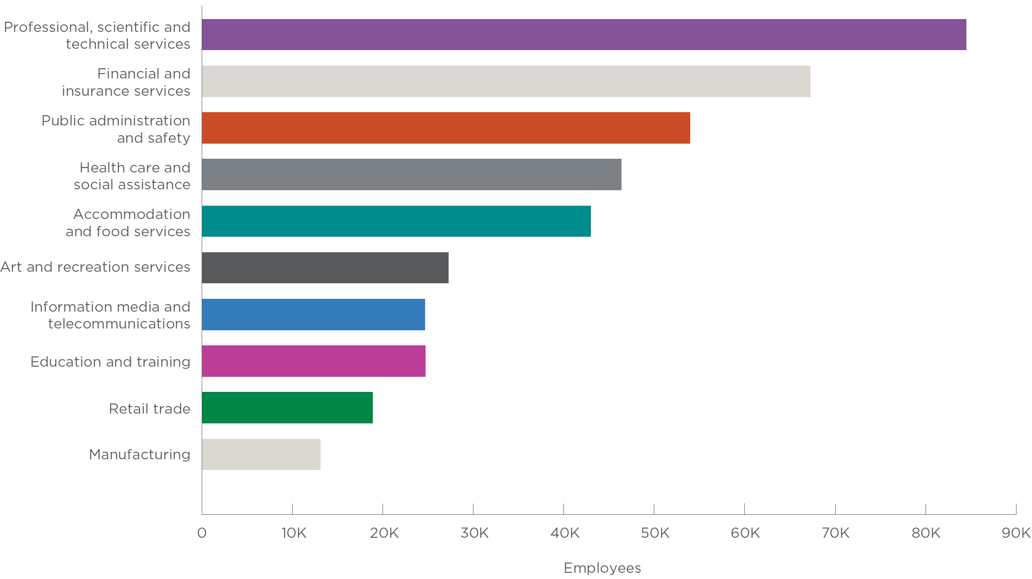
Source: Clue 2023

Population in 2022
- Australia population 26 million
- Victoria population 6.6 million
- Greater Melbourne population 5 million
- City of Melbourne population 160,000

The place to do business
Melbourne contributes significantly to the Victorian and Australian economies. The municipality accounted for 23 per cent of Victoria’s gross state product and 5.3 per cent of Australia’s gross domestic product in 2023.
Victoria comprises only 3 per cent of Australia’s land mass yet delivers 23 per cent of the country’s gross domestic product. It has achieved 2.71 per cent average annual growth in gross state product over the last ten years. Victoria is Australia’s best-performing economy, having experienced higher growth than New South Wales during seven of the past ten years. Victoria is rated AA by Standard & Poor’s and Aa2 with a stable outlook by Moody’s Investors Service.

A dynamic, supportive business environment
Melbourne provides a positive, highly supportive business environment for startups, small-to-medium enterprises and global organisations.
In 2023, Australia was rated as the sixth best country in the world to invest in by Conway Data. Melbourne was rated as the top investment location in the country and the seventh- best metro investment location in the world.
Seven of the top 15 Australian companies are headquartered in Melbourne – including Australia’s largest telecommunication provider, Telstra, and two of Australia’s big four banks, NAB and ANZ. Australia’s national postal service, Australia Post, is headquartered in Melbourne, along with the NBN Co, an Australian Government-owned company established to design, build and operate Australia’s broadband network.
Many top global companies have selected Melbourne for their Australian headquarters, including Alston Transport, AIA, Alibaba, Asahi, BASF, Block, Bombardier, Bosch, BUPA, CITIC Resources, Dassault Systèmes, Disney, Electronic Arts (EA), ExxonMobil, GSK, Hanwha, IBM, Infosys, JBS, Moderna, Mondelez, Revolut, RUAG, Siemens, Toyota, TotalEnergies, Qenos, Village Roadshow, Worldline and Zendesk.
The Global Innovation Index rates Melbourne as having one of the best regulatory environments in the world. The World Bank Doing Business Report describes it as one of the easiest places to set up and run a business. Australia’s currency is fully internationalised and there are few restrictions on access to credit, loan facilities or capital.
Australia has the lowest risk of social unrest in the world, with sound legal and governance frameworks, a stable system of government and strong protection of intellectual property rights.

A diverse, highly educated population
Melbourne is the ideal business hub location for the Asia Pacific. Most residents within the City of Melbourne municipality were born overseas and more than 70 per cent have at least one parent who was born overseas. Over 260 languages are spoken in Victoria, with more than a million Asian and European language speakers.
Melbourne has a highly diverse, educated population, with residents originating from nearly every country in the world. More than half the population holds a bachelor’s degree. It is Australia’s most educated city and the 10th most educated city worldwide.
There are over 1100 public and private education and training providers in Victoria, along with eight world- class universities with expertise in biotechnology, medical research, advanced manufacturing, information communications technology, water management, environmental and energy technologies and food.
Melbourne is one of the most popular education destinations in the world. Each year more than 160,000 international students from over 170 countries choose to come to Victoria to study.
Melbourne is the most student friendly city in Australia and second in the world according to Quacquarelli Symonds (QS) 2024. We lead the nation in yearly graduates of technology, business, engineering, education and health qualifications (undergraduate and postgraduate studies).
University of Melbourne is Australia’s highest-ranked university, placed 34th globally in the Times Higher Education World University Rankings 2023. Monash University is Australia’s largest university by student enrolment.

One of the most liveable cities in the world
Melbourne is the sporting, arts, culture and culinary capital of Australia – a place of endless creativity and world-class events.
The city’s enviable lifestyle makes it easy for employers to recruit and retain talented staff. Our clean and safe environment, world-class infrastructure, excellent healthcare and education, diverse cultural scene and harmonious blend of modernity and history make it an exceptional place to live and work.
Melbourne is celebrated as a leader in civic, creative, economic and business arenas. It was named the world’s most liveable city for eight consecutive years, from 2011 to 2017. In 2024, it ranked fourth in the Economist Intelligence Unit’s Global Liveability Index.
Melbourne was also named the friendliest city in the world in 2022 by UK insurance company William Russell. It has been rated as Australia’s most LGBTIQA+ friendly city and fourth worldwide by Big7 travel.

Australia’s fastest-growing capital city
Melbourne provides a strong and growing pool of talented workers for business. The population of Victoria is projected to increase from 6.8 million in 2023 to almost 9 million by 2041. It is Australia’s fastest-growing capital city – adding more than 710,000 residents from 2010 to 2020, which is a 17 per cent increase in population.

World-class research
It is home to world-class research institutes, such as the Australian Synchrotron, Australian Centre for Disease Preparedness, AgriBio and Carbon Nexus, as well as Australia’s largest biomedical precinct in Parkville. Victoria attracts more than 40 per cent of Australia’s biomedical research funding.

Low business costs
Victoria has some of the lowest business costs along the Australian east coast. Prime industrial land is approximately 36 per cent cheaper in Melbourne compared to Sydney, while prime office space costs 35 per cent less. Salaries are typically between five to 10 per cent lower in Melbourne compared to Sydney. Victoria’s energy costs are competitive and the State offers the second lowest metropolitan payroll tax rate in the country at 4.85 per cent.

Modern, reliable infrastructure
Melbourne is Australia’s freight and logistics hub and has several multimodal logistics centres, including West Swanson Dock (DP World), Victoria Dock (Qube), Dynon (Qube), and ACFS Logistics. We have a fast, high-capacity communications network and a safe and efficient road and public transport system. We have Australia’s most advanced road and rail infrastructure, largest public transport system, largest curfew-free freight and passenger airport and largest container and general cargo port.
Victoria is investing more in infrastructure than any other state in Australia. The Victorian Government’s $100 billion Big Build program will deliver over 165 major road and rail projects to support the State’s growing freight task and keep Victorians on the move.

A gateway to the Asia Pacific
Melbourne is an ideal base for Asia-Pacific (APAC) operations. APAC is home to 60 per cent of the world’s population – some 4.4 billion people in 2023. Three-quarters of Australia’s two-way trade in 2021-22 was with Asia, with 80 per cent of the country’s exports going there. Twelve of Australia’s 15 largest trading partners are in Asia. Asia accounts for about 70 per cent of global growth, with China and India responsible for about half.
Global megatrends – including the technology revolution, population ageing, the impact of climate change and humanitarian crises, urbanisation and migration – present challenges that require collaboration, while also creating opportunities for business. Australia has free trade agreements with leading economies in the region, which deliver improved access and opportunities for global businesses who choose to set up in Melbourne.
Melbourne’s time zone overlaps normal business hours in most APAC nations and trading partners while bridging the gap between the time zones of Europe and the United States. We are located in the Australian south-east triangle, with access to two-thirds of Australia’s population and 61 per cent of economic activity.

Melbourne: a Business Hub to Asia
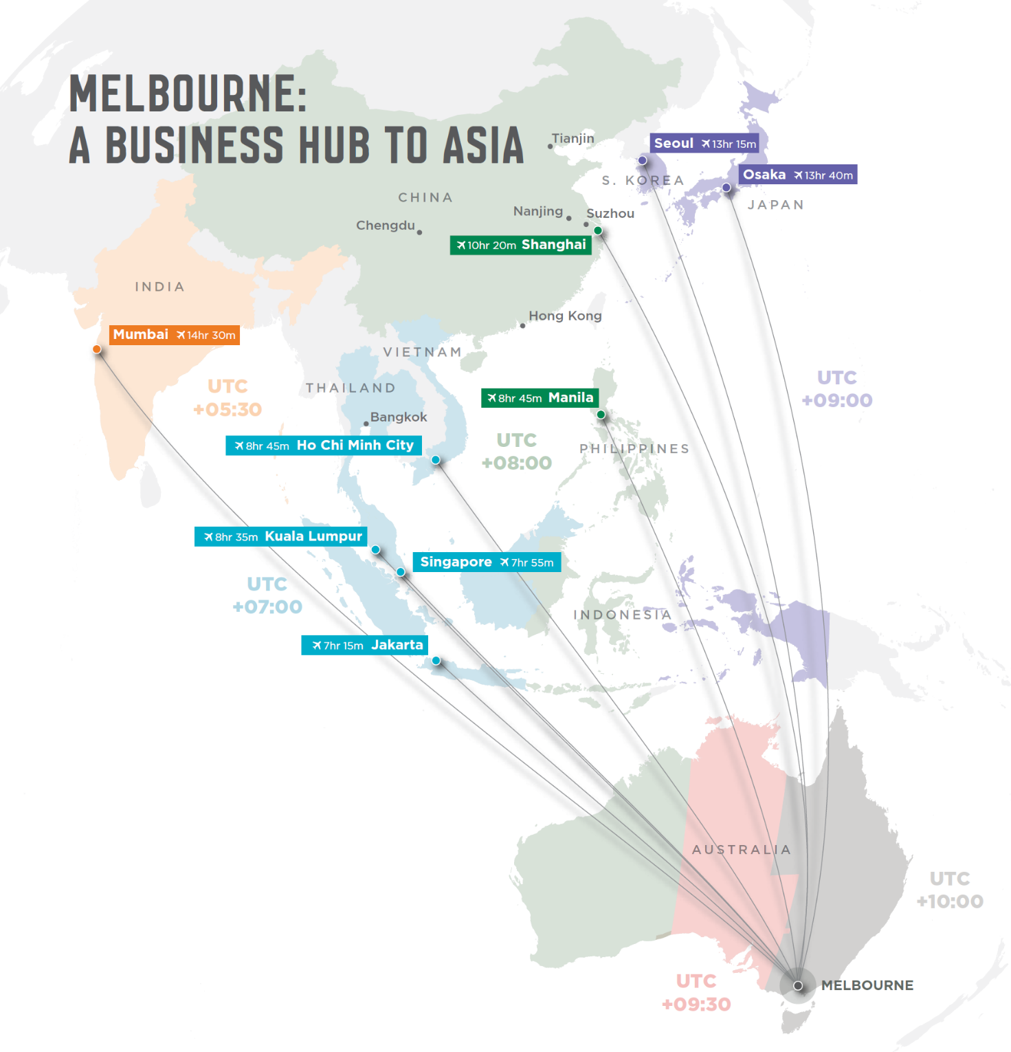

Meeting Times
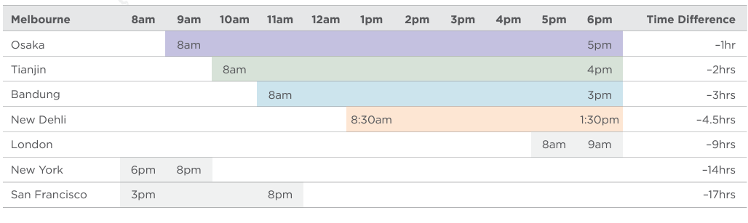

A knowledge economy – industry capability overview
Melbourne is a knowledge city, a city that creates and exchanges new ideas and developments that drive innovation, economic growth and sustainability.
Life sciences and health technology – Melbourne is the life science and health-tech capital of Australia. The industry includes pharmaceutical, biotechnology, medical equipment, food science and healthcare organisations. Over 40 per cent of Australia’s ASX-listed life sciences companies are headquartered in Melbourne. Victoria accounts for over 60 per cent of the nation’s pharmaceuticals exports and is the ideal location for clinical trials.
Technology and innovation – Savills has ranked Melbourne as the top-ranked tech city in Australia and the 14th worldwide. Melbourne has a deep technology ecosystem, access to capital, and a strong startup ecosystem. Industry strengths exist in fintech, edtech, digital games, sports tech, health tech, cyber security, artificial intelligence (AI), software as a service (SaaS), and Agtech.
Financial and professional services – The professional services sector is the largest segment of Victoria and Melbourne’s economies, with broad based capability in accounting, advertising, architecture, computer system design, engineering design and consulting, legal, management consulting, market research, professional photography and scientific research and testing, and surveying and mapping services. The financial services industry is world leading, driven by a high performing banking industry, significant asset management sector, and thriving startup community.
Education – Offering a world-class education and excellent job opportunities in a welcoming environment. International education is Victoria’s largest service export with students from across the globe. We have Australia’s highest performing university and campuses around the world.
Green economy – Melbourne aims to be a city powered by 100 per cent renewable energy by 2030 and reach zero net emissions by 2040. Industry capability and investment opportunity exists in circular economy solutions, urban sustainability, clean energy and infrastructure projects.
Tourism and events – One of Australia’s most popular tourist destinations, attracting business, leisure, and event-based travellers. Hailed as the nation’s cultural, culinary and events capital, the city boasts unique experiences, world-class dining, and premium infrastructure to host business events.
Creative economy – A premier destination for the creation and presentation of arts and entertainment. With historical and modern venues, iconic institutions and a busy calendar of events, opportunities exist in film production, games development, live music and cultural experiences.
Advanced manufacturing – Australia’s leader in advanced manufacturing and engineering with key innovation precincts in Fishermans Bend and Parkville. Victoria has the nation’s largest manufacturing workforce and the deepest and most diverse supply chains. Sectors of strength include defence and aerospace, composite and advanced materials, additive manufacturing, 3D printing, medical devices and pharmaceuticals.

A premier tourist destination
Melbourne is the cultural, sports and events capital of Australia and one of the country’s most sophisticated and popular tourist destinations. Locals and visitors love the city’s lifestyle – its vibrant energy, trendy cafes, bars and restaurants, buzzing markets and fashion boutiques, stimulating galleries and museums, spacious parks and distinct urban neighbourhoods.
The city’s essence is in its art-filled laneways and opulent arcades, which provide an unforgettable journey of discovery and delight. Melbourne’s street art includes the work of acclaimed artists such as Rone and ABOVE to name a few. Designated as a UNESCO City of Literature, Melbourne’s literary heritage and culture is also internationally recognised and celebrated.
Visitors can discover more about Aboriginal culture at the Koorie Heritage Trust, Birrarung Marr park along the Yarra River, the award winning Bunjilaka Aboriginal Cultural Centre at Melbourne Museum, and the Aboriginal Melbourne walk from Fitzroy Gardens to the harbour at Docklands. The Ian Potter Centre showcases an impressive collection of works by Aboriginal and Torres Strait Islander artists, with Big Esso by Mabu Mabu and Pawa Café and Bar celebrating native flavours. The Mapping Aboriginal Melbourne interactive map helps visitors understand the city’s rich First Nations culture and histories.
Home to some of the world’s best baristas, Melbourne is famous for its culinary culture. It is a gastronomist’s delight, with a food scene mirroring the city’s vibrant multicultural population. Many chefs incorporate indigenous ingredients in their meals, giving traditional recipes a distinctly Australian twist.
Melbourne is surrounded by nature. A short drive from the city will take you to pristine beaches, award-winning wineries, hot springs, dramatic mountains and forests teeming with wildlife. Victoria’s high country is popular for hiking and mountain biking in the summer months and skiing in winter. The Twelve Apostles and Wilsons Promontory are renowned for their coastal beauty.

Event extravaganza
Melbourne boasts a year-round calendar of quality international events, arts festivals, live music and exhibitions, blockbuster theatre shows, renowned exhibitions and cultural and sporting celebrations.
The city’s annual major events include:
- Australian Open at Melbourne Park, the first Grand Slam tennis tournament held each year
- Formula 1 Australian Grand Prix, the first race on the Formula One Calendar
- Moomba Festival, Australia’s largest community festival
- Rising Festival, a festival of new art, performance and music
- Melbourne Fashion Week and Melbourne Fashion Festival
- Always Live, a celebration of contemporary music - the largest of its kind in the Southern Hemisphere.
- Melbourne Cup horse race, known as ‘the race that stops a nation’
- Melbourne Food and Wine Festival
- Now or Never, showcasing art, ideas, sound, technology and future thinking
- Melbourne International Comedy Festival, the largest stand-alone comedy festival in the world.

Leading business events destination
Melbourne boasts a superb range of flexible event spaces and venues in the heart of the city including the Melbourne Convention and Exhibition Centre, Melbourne and Olympic Parks, Marvel Stadium and Showtime Events Group venues.
The Melbourne Convention Bureau has an outstanding track record for securing and hosting some of the world’s largest and most prestigious international conferences. The city hosts hundreds of national and international association events each year as well as corporate meeting and incentive travel programs predominantly from the Asia Pacific region. Whether it’s a small or large conference, convention, corporate meeting or incentive reward program, the bureau provides free support including: business development, bidding, event servicing, corporate meeting and itinerary planning and in some cases, financial assistance to support event acquisition. It is a member of the Global Destination Sustainability Index (GDS Index), an initiative that drives the adoption and recognition of sustainable practices in the business tourism and events industry. Melbourne is ranked first in Australia, fourth in APAC and 27th overall.

Dynamic municipality – innovative precincts
Melbourne has an emerging network of innovation precincts, each with unique specialisations.
Melbourne Central Business District (CBD) is the financial and business hub of Victoria, offering globally competitive office and co-working spaces. As Australia’s largest CBD office market, Melbourne office space costs less than Singapore, Sydney and San Francisco. The CBD has a thriving retail and hospitality sector and world-famous entertainment facilities.
Docklands is adjacent to the CBD, connecting the city to the waterfront. One of Australia’s largest urban renewal projects, it is a premier financial and professional services hub. Docklands is a contemporary waterfront dining, retail and entertainment precinct. It hosts one of the largest concentrations of green buildings in Australia, as well as Marvel Stadium, Docklands Studios Melbourne and 11 hectares of parks and open space.
Parkville is a world-leading biomedical and research precinct within walking distance of the CBD. Parkville is home to major hospitals and research facilities and plays a critical role in Australia’s innovation capability, specialising in biotech and neuroscience. The precinct consistently secures one-quarter of Australia’s annual competitive biomedical research funding and yields a publication citation rate of twice the global average.
Arden is a major urban renewal precinct in North Melbourne, less than 2 kilometres from the central city. It will be home to 15,000 residents and 34,000 jobs, focused on supporting health and life science industries. Serviced by Arden Station, opening in 2025, it will host new campuses of Royal Melbourne Hospital and Royal Women’s Hospital from 2031.
Fishermans Bend is Australia’s largest urban renewal project, almost three times the size of Melbourne’s CBD. Connecting the CBD to the bay, it will be home to approximately 80,000 residents and provide employment for up to 80,000 people by 2050. The project will put Victoria at the forefront of global innovation in advanced manufacturing, engineering and design.

Innovative Precincts: City of Melbourne
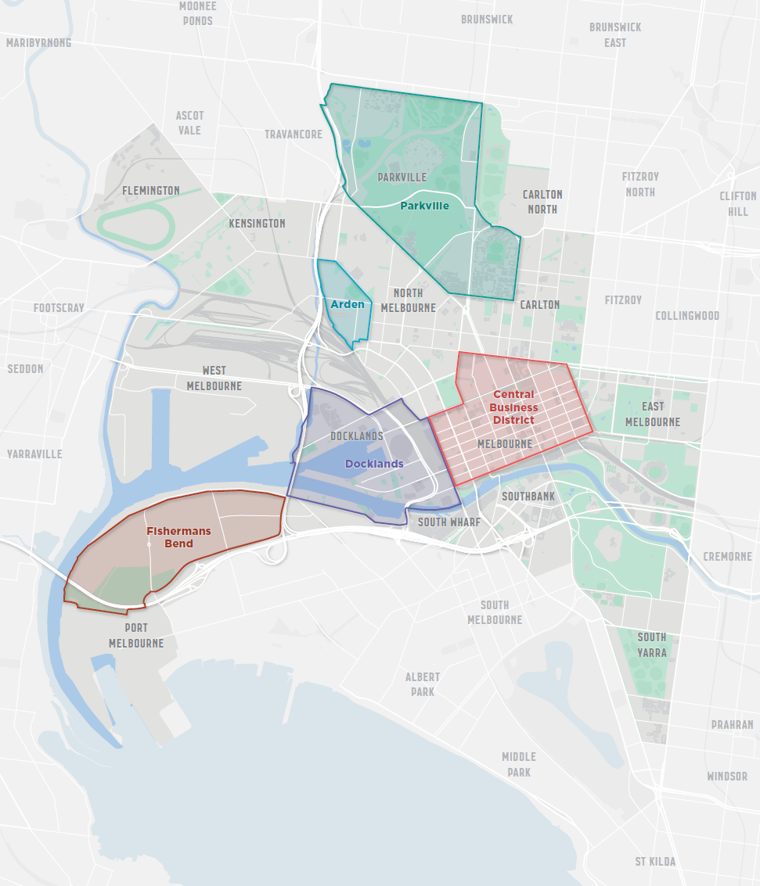

Exciting startup and innovation culture
Melbourne is a great place to start and grow a business. Our startup ecosystem jumped six places to 33rd in the 2023 Startup Genome Global Startup Ecosystem Report global ranking, surpassing peer ecosystems in Hong Kong, Dublin, Barcelona and Kuala Lumpur. Our growing scene includes almost 3000 startups, nearly 500 investors and close to 50 accelerators.
Our startups are performing particularly well in industries that build on our city’s long-standing areas of strength: biotech and medtech, climate technology, digital gaming, edtech and sportstech.

Fostering international startup ecosystem connections
Making the right contacts at the right time is critical to the success of any startup. That’s why City of Melbourne supports a range of entrepreneurial programs.
Through our START in Melbourne, SCALE to Southeast Asia program, we’ve helped founders of Melbourne startups connect with investors, accelerators and founders in Singapore, Indonesia and Vietnam. In partnership with Melbourne edtech company HEX, we have delivered workshops, mentoring and networking sessions at local innovation hubs, with virtual connections into Southeast Asian startup hubs, universities and government.
In 2021, we delivered the Melbourne-Bandung Innovation Series and pitch competition with SPARK Deakin, The Greater Hub at the Institute of Technology Bandung and the Bandung City Government. The virtual sessions brought together nearly 1000 experts, innovators, entrepreneurs and students to explore solutions to shared city challenges, focusing on four themes: inclusive entrepreneurship, sustainability, tourism and public health.
With our international partner city, Nanjing, we deliver Nexus pitch competitions, supporting Melbourne tech businesses to launch in China, and an Asia Market Sprint capability-building program, helping startups expand into Asia. Delivered in partnership with ACASE, our NexStar program pairs businesses with students to explore new opportunities in the Asia Pacific region, including China, Japan, Indonesia and Singapore.

Diversity and purpose-driven startups
Melbourne’s startup identity is also deeply connected to our social enterprise sector. We’re home to Australia’s largest collection of social enterprises, with more than 5000 organisations employing around 75,000 staff. Local startups include STREAT, KeepCup, Thankyou Group, Movember and Pozible.
The diversity of Melbourne’s startup community reflects the diversity of our city. Melbourne hosts the Australian round of She Loves Tech, the world’s largest startup competition for women and tech. City of Melbourne is the competition’s local government partner in Australia. We support entrepreneurs from diverse backgrounds, including female founders, migrants and international students.

A smart, forward-thinking city
City of Melbourne works with businesses, students and residents to develop and test new ideas and technologies such as 5G, video analytics, AI and the Internet of Things that have the potential to reshape everyday life for current and future generations.
We run annual innovation challenges that encourage participants to use data and technology to address urban problems. Recent competitions have focused on making Melbourne more inclusive for international students and alumni, minimising waste and creating a circular economy, and making Melbourne more accessible for people with disabilities.
We use sensors in parks and open spaces to better understand user behaviour and inform how we design and manage public space, sharing insights with the community, via live data dashboards on the Participate Melbourne website. For instance, dashboards show speeds and peak usage of active transport modes on shared paths.
Repurposing local waste for good – we’re investigating how to use recycled materials in raingardens in a pilot at Fishermans Bend –a low-lying area prone to flooding. Raingardens filter and manage the flow of local rainwater to avoid flooding, while growing healthy plants and habitats. We are using sensors to understand the impact of raingardens on water management, micro-climates and soil and plant health.
Micro-Labs was created to provide local communities and small businesses with a digitally enabled, free, accessible and inclusive meeting place. At this pilot venue in the heart of the CBD, people collaborate, co-work, and host or join an event. With technology – including sensors in the space – and feedback via a live data dashboard, we can respond to users’ needs.

Making Melbourne the world’s best city for students
Greater Melbourne is home to more than 160,000 international students from over 170 countries. They’re a major part of what makes our city great. Many also chose to stay in Melbourne after their studies. International students and alumni bring diverse experiences, cultural insights and a wealth of global connections.
Melbourne is Australia’s best student city and the fourth best student city in the world according to the QS World University Rankings. It was also named the second best city in the world for student experience, based on factors such as diversity and inclusion, friendliness, ease of getting around, nightlife, arts and culture and employment opportunities.
City of Melbourne hosts activities to help make students feel welcome. We advocate for post-study work rights and provide programs to connect, support and empower students and improve their employability. Each year, our student programs engage over 12,000 students.
Lord Mayor’s Student Welcome is a free, annual event that welcomes new students to the city, celebrating international students’ contributions to Melbourne’s cultural life and diversity. Past events have included traditional Aboriginal and Islander performances, Latin, K-Pop and Bollywood music and Chinese lion dances.
The Couch is our international student centre, which provides a safe place to make friends, learn new skills and eat free cooked meals. Students can volunteer and connect with the local community. The Couch is attended by 800 to 1000 students per month, from over 40 education institutions and 48 different countries.
My Melbourne Program is a series of outings to attractions, events, behind-the-scenes tours and ticket giveaways. City of Melbourne staff accompany students to events such as the Melbourne Cup, the Fringe Festival, Australian Football League games, the Indian Film Festival, food and wine shows and major art exhibitions.

How City of Melbourne undertakes international engagement

Strengthening city-to-city relationships
We partner with cities worldwide and participate in global networks. We share knowledge, encourage innovation and business connections and foster community and cultural links. In the past, City of Melbourne established sister-city relationships; we now prefer to partner via flexible relationships to achieve mutually beneficial outcomes.
Melbourne is the only city in Australia with an overseas office. The Melbourne Office Tianjin facilitates trade and investment between Melbourne companies and organisations and their counterparts in select regions of China.
Sister cities | - Osaka, Japan (1978)  - Tianjin, China (1980) – Melbourne Office Tianjin (1998)  - Thessaloniki, Greece (1984)  - Boston, Massachusetts, United States (1985)  - Milan, Italy (2004)
Partner cities | - Nanjing, Suzhou and Chengdu, China  - Bandung, Indonesia
Global networks | - Business Partner City Network: Osaka, Hong Kong, Singapore, Bangkok, Kuala Lumpur, Manila, Jakarta, Seoul, Shanghai, Ho Chi Minh City, Mumbai, Melbourne, Tianjin, Auckland and Hamburg  - C40 Cities  - Carbon Neutral Cities Alliance  - Global Covenant of Mayors  - City Champions for Heat Action (Adrienne Arsht-Rockefeller Foundation)  - Resilient Cities Network Asia Pacific  - United Nations Economic and Social Commission for Asia and the Pacific  - World Cities Culture Forum

Facilitating inbound and outbound missions and visits
City of Melbourne conducts targeted international visit programs to facilitate new connections and foster long-term relationships. We also enable inbound civic and business visits by mayors, councillors and delegations from international partner cities.

Attracting foreign direct investment and top talent
Invest Melbourne is our team of experienced advisors who help investors achieve business success in Melbourne. We assist with market entry business case validation, provide introductions to industry stakeholders and potential supply chain partners, expedite business approvals and help you access all levels of government, including government support. Our TradeStart advisors connect Melbourne exporters with overseas buyers.

Supporting innovation
We facilitate collaboration between Melbourne and international startup communities. We bring together experts, investment partners, innovators, entrepreneurs and students to explore shared city challenges and make business connections.

Knowledge acquisition and sharing
We share international best practice on liveability and sustainability, smart cities and innovation, retail and creative economy, economic strategies and initiatives. We want to work together to make progress against United Nations Sustainable Development Goals.

Promoting connection
We promote cross-cultural exchanges and build relationships with people from partner cities, including student arts exchanges, residencies, innovation and design showcases, and storytelling. We also engage with our multicultural communities and international students to fosters community cohesion and create empowerment.

Melbourne City Chinese Flavour – stories of Chinese people living in Melbourne
To celebrate the 200th anniversary of the arrival of Chinese people in Australia in 2018, City of Melbourne worked with media group Ergeng to produce an award-winning documentary, Melbourne City Chinese Flavour. The documentary features three stories demonstrating the cultural, education and sporting bonds between Melbourne and China.

International Urban Regional Cooperation program, European Union
In 2023, we welcomed officials visiting from the European Union, City of Madrid, City of Florence and Brisbane to exchange information and ideas in urban planning, sustainable mobility and innovation precincts. Led by the European Union, the program promotes city-to-city partnerships and bilateral exchanges on urban issues.

Creative play connects kids in Australia and Korea
City of Melbourne’s ArtPlay brings together children, families and artists. We partnered with the Factory of Contemporary Arts in Jeonju, South Korea, to develop digital works with children and artists in Australia and Korea. Children can explore three self-led journeys online in English and Korean: Gallery of Strange, Peculiar Parent Picture and Party of Ghosts.

Working together on joint city challenges
We collaborate with other leading cities to identify solutions to shared challenges, such as tackling climate change, biodiversity action, pandemic recovery, urban resilience, affordable housing, gender equality, water security, city safety and waste management.

United Nations Sustainable Development Goals
We know global change requires local action, and we are proud to be the first city in Australia to conduct a Voluntary Local Review of our progress towards the United Nations Sustainable Development Goals. We believe that by tracking Melbourne’s progress against this global framework, we can compare and contrast with other cities, share our strengths and learn how to address our challenges.

The 17 Sustainable Development Goals
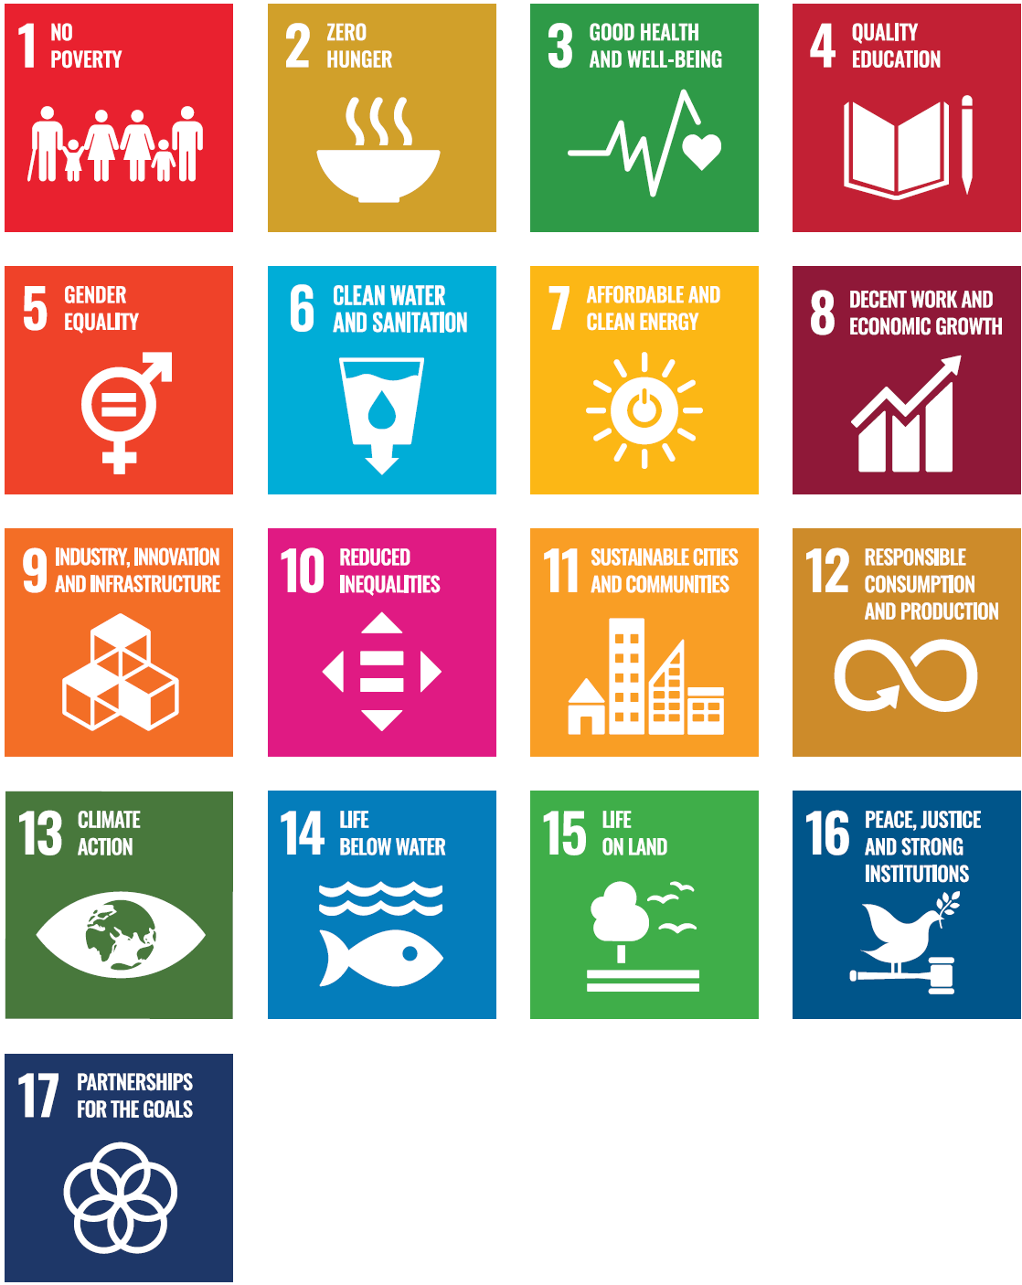
Source: The United Nations Sustainable Development Goals.

What we’re doing to respond to climate change
We aim to be a city powered by 100 per cent renewable energy by 2030 and reach zero net emissions by 2040.
City of Melbourne’s operations have been certified carbon neutral for over ten years, and we switched our major events to carbon neutral too. We purchase 100 per cent renewable energy through the Melbourne Renewable Energy Project. In the last decade, we planted 3000 trees yearly to grow our urban forest. We have increased our understory vegetation by more than one-quarter since 2017, providing habitat for wildlife.
We have invested in six stormwater harvesting systems, providing 23 per cent of our water use. By expanding parks and changing streetscapes, we greened the city and increased permeability by over 3500 square metres. Since the launch of our food and organics service in 2021, we’ve converted more than 1900 tonnes of organic waste into compost.
Power Melbourne will establish a network of mid-scale batteries and a renewable electricity offer for the community, to accelerate our transition to a renewable- powered city. We aim to create a model that can be replicated across greater Melbourne and beyond.
Under our plan to Retrofit Melbourne, we set a target for all existing buildings to be ‘zero carbon ready’ by 2040. We reviewed policies from cities such as New York, Tokyo, Vancouver, Seattle, Boston, Washington, Copenhagen and Hong Kong to identify the world’s best practice initiatives addressing barriers to zero carbon building retrofits.

Reducing homelessness
Greater Melbourne lacks tailored housing to support vulnerable people. Through the Make Room project, we are converting a Council-owned building into secure, safe, supported accommodation for people experiencing homelessness and sleeping rough.

How City of Melbourne can help

We can help you by:
- identifying products and services produced in Melbourne
- providing advice on doing business in Melbourne, along with insights on industry capability and business opportunities
- providing introductions to other levels of government and industry contacts
- sharing knowledge and collaborating on joint city challenges
- partnering with you to deliver projects of mutual interest
- introducing you to international education support services.
Contact the international team: global@melbourne.vic.gov.au
Contact the investment team: investmelbourne@melbourne.vic.gov.au

https://www.melbourne.vic.gov.au/melbourne-global-city

