Section two, block – Pelham Street, Lygon Street, Queensberry Street and Swanston Street

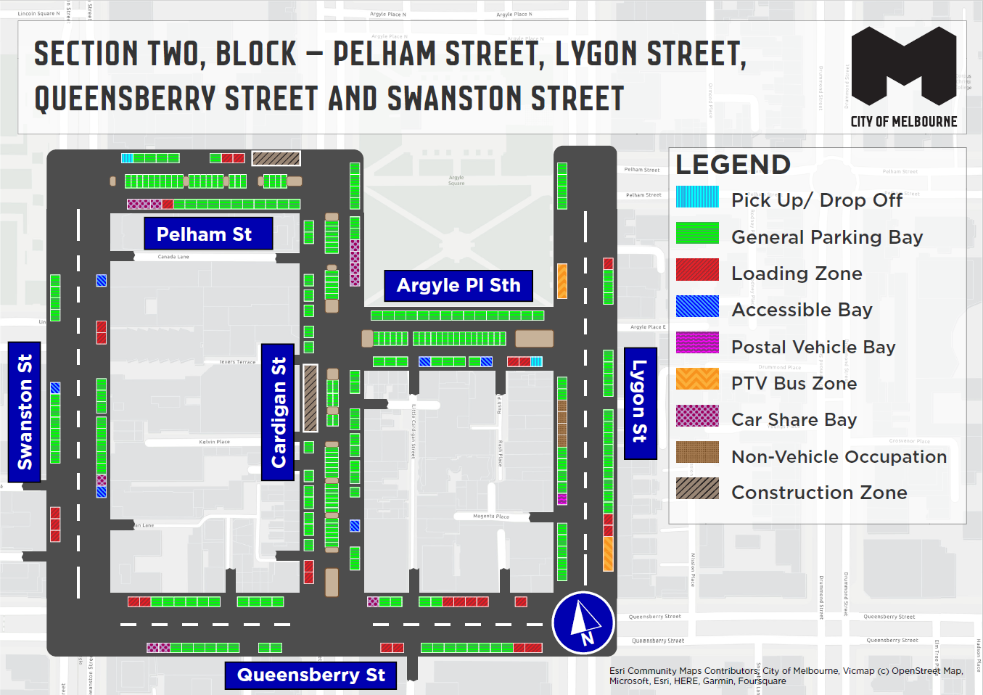
This map presents the parking conditions to be applied within this block as part of the parking improvement works in this neighbourhood.

Swanston Street

Car Share Bay, Accessible Bays, Loading Zones and General parking bays

Pelham Street

Loading Zones, Car Share Bays, Pick up/Drop off and General Parking Bays

Argyle Place South

Accessible Bays, Loading Zones, Pick up/Drop off and General Parking Bays

Cardigan St Street

Accessible Bay, Car Share Bays, Loading Zones and General Parking Bays.

Lygon Street

PTV Bus Zones, Postal Vehicle Bay, Loading Zones and General Parking Bays.

Queensberry Street

Loading Zones, Car Share Bays and General Parking Bays

Parking controls to be applied in this area
Within this area, we will apply consistent parking controls to make parking fairer and more reliable.
Pick up/drop off spaces will typically be signed ‘No Parking’. We will add signage to explain that the space is for passenger pick up / drop off for up to 2 minutes.
Paid spaces will typically be signed ‘2P Meter, 7am – 7pm, Mon – Sun’ within the commercial area or ‘1/2P-4P Meter, 7am – 10pm, Mon – Sun’ to support the residential areas. Peak and off-peak fees (outside central city rates) will apply at $4 per hour from 7am to 7pm and a reduced rate of $2 per hour after 7pm weekdays and all weekend. The offer of $0 payment for short stops of up to 15 minutes in any metered parking space via the EasyPark app will begin in this location from Monday 5 August 2024. This allows short stops in any green-sign space rather than limiting short stops to a small number of specific bays (for example, ‘1/4P’).
Unpaid spaces will be signed ‘7am – 7pm’ or ‘7am – 10pm, Mon – Sun’ depending on location. Meters will not be added to streets which are unmetered currently. The exception is on streets where meters are already in place and there is a mix of paid and unpaid parking. Any existing 11pm restrictions will be kept the same.
Loading Zones will typically be signed as ‘Loading Zone, 30-minute, 7am – 7pm, Mon – Sun’ in the commercial area and ‘Loading Zone, 30-minute, 7am – 4pm, Mon – Fri’ in other areas. Where possible spaces will typically become general parking spaces after Loading Zone hours. People making deliveries can also use green-sign spaces for short stays of up to 15 minutes for $0 via the EasyPark app.
Resident permit excepted parking spaces will typically not change throughout Carlton. There may be small adjustments to the position of resident permit excepted parking spaces within a street or area based on the needs of the kerbside. The total number of spaces provided to serve a resident permit area will remain the same.
Accessible (disability) parking spaces will typically be signed ‘2P, Disability Only, 7am – 10pm, Mon – Sun’ or ‘P, Disability Only, 7am – 10pm, Mon – Sun’. We will apply blue line-marking to these spaces.
Motorcycle parking will be signed as ‘P, Motor Cycles Only’ with no time limits.
Car Share spaces will typically be signed as ‘Permit Zone, Car Share Vehicles’ for the permitted car share vehicle operator.
Postal Vehicle spaces will be signed as ‘No Parking, Postal Vehicles Excepted’. They can be used by Australia Post vehicles, and by any other vehicle needing to access an adjacent postbox for up to 2 minutes.
Taxi Zones will be in areas with high demand for taxis.
Coach spaces will typically be signed as ‘No Stopping, Buses Excepted’ with a time limit applied where there is demand for bus turnover.
Authorised vehicle parking means access for permitted uses only (for example, police vehicle parking).
Non-vehicle occupation includes temporary infrastructure in a parking space (for example, an outdoor dining parklet).
Construction Zones will be signed as ‘Permit Zone, Construction Vehicles’ to allow construction vehicles with a permit to stop and park.

