
City of Melbourne
Open Space Strategy 2012
Light Touch Review
Prepared by

In association with

Adopted June 2024

The City of Melbourne respectfully acknowledges the Traditional Owners of the land we govern, the Wurundjeri Woi-wurrung and Bunurong / Boon Wurrung peoples of the Kulin and pays respect to their Elders past and present. We acknowledge and honour the unbroken spiritual, cultural and political connection they have maintained to this unique place for more than 2000 generations.
We accept the invitation in the Uluru Statement from the Heart and are committed to walking together to build a better future.

Contents
Glossary 7
1 Introduction 8
1.1 Project scope and purpose 8
1.1.1 Project purpose 8
1.1.2 Project scope 8
1.2 Summary of the review of the 2012 Strategy and Technical Report 8
2 Research into open space policy and provision 10
2.1 International and National open space policy research 10
2.1.1 Health and wellbeing 10
2.1.2 Open space strategies 11
2.1.3 Conclusions from the review of the international/national research 12
2.2 Victorian Government policy changes 13
2.2.1 Summary of key new policies 13
2.2.2 Conclusions from the review of the Victorian government policy changes 14
3 Local influences on open space planning in the City of Melbourne 15
3.1 Overview 15
3.1.1 Summary of key new policies and changes since 2012 Strategy 15
3.2 Updated strategic framework plans for the City of Melbourne 16
3.2.1 Updated strategic growth framework plan 16
3.2.2 Updated strategic transport framework plan 16
3.2.3 Updated strategic open space framework plan 18
3.3 Population change and forecasts 19
3.3.1 Residential population change 2011 to 2021 19
3.3.2 Forecast residential population change 2021 to 2031 23
3.3.3 Employment population 25
3.3.4 Implications of the forecasts on the updated precinct actions in the 2012 Strategy 27
3.4 Increased importance of nature conservation values and Caring for Country 29
3.4.1 Nature in the City Strategy 29
3.4.2 Caring for Country 29
4 Changes to the open space network since 2012 30
4.1 Overview 30
4.2 Quantity and provision of open space 34
4.3 Issues associated with acquiring new open space 40
4.3.1 Overview 40
4.3.2 Proposed sub-precinct assessments to identify suitable locations for new open space 40
4.3.3 Structure plans and the provision of new open space, which is not limited by the 7.06 per cent contribution rate 41
4.3.4 Additional Municipal open space 41
4.3.5 Diversity of open space to better meet open space needs in high density settings 42
5 Overall recommendations 43
5.1 Summary of recommendations 43
5.2 Update to the open space hierarchy 45
5.2.1 Overview 45
5.2.2 Established areas including the Hoddle Grid 45
5.2.3 Urban renewal and areas in the process of change 48
5.3 Update to the criteria for new open space 54
5.4 Vision and Goals 58
5.4.1 Summary of the Vision and Goals in the 2012 Strategy Technical Report 58
5.4.2 Update to the Vision and Goals in this Light Touch Review 58
5.5 New Municipal open space 60
5.5.1 Summary of the provision of new Municipal open space in the 2012 Strategy 60
5.5.2 Update to the provision of new Municipal open space in this Light Touch Review 61
5.5.3 Update to acquiring new Municipal open space 61
5.6 Quality of existing and new open space 63
5.6.1 Existing recommendations regarding the quality of open space in the 2012 Strategy 63
5.6.2 Proposed updates to the recommendations regarding the quality of open space in this Light Touch Review 63
6 Updated precinct actions 65
6.1 Overview 65
6.2 Carlton | Carlton North 67
6.2.1 Changes to the existing open space network since the 2012 Strategy 67
6.2.2 Summary of the population change between 2011 and 2021 70
6.2.3 Summary of the forecast population change from 2021 to 2031 71
6.2.4 Implications for the population forecast changes on the updated Actions in this Section 71
6.2.5 Updated Precinct Actions for Carlton | Carlton North 71
6.3 Docklands 74
6.3.1 Changes to the existing open space network since the 2012 Strategy 74
6.3.2 Summary of the population change between 2011 and 2021 76
6.3.3 Summary of the forecast population change from 2021 to 2031 76
6.3.4 Implications for the population forecast changes on the updated Actions in this Section 77
6.3.5 Updated Precinct Actions for Docklands 77
6.4 East Melbourne 82
6.4.1 Changes to the existing open space network since the 2012 Strategy 82
6.4.2 Summary of the population change between 2011 and 2021 84
6.4.3 Summary of the forecast population change from 2021 to 2031 84
6.4.4 Implications for the population forecast changes on the updated Actions in this Section 85
6.4.5 Updated Precinct Actions for East Melbourne 85
6.5 Flemington | Ascot Vale 88
6.5.1 Changes to the existing open space network since the 2012 Strategy 88
6.5.2 Summary of the population change between 2011 and 2021 89
6.5.3 Summary of the forecast population change from 2021 to 2031 89
6.5.4 Updated Precinct Actions for Flemington | Ascot Vale 90
6.6 Kensington 92
6.6.1 Changes to the existing open space network since the 2012 Strategy 92
6.6.2 Summary of the population change between 2011 and 2021 94
6.6.3 Summary of the forecast population change from 2021 to 2031 94
6.6.4 Implications for the population forecast changes on the updated Actions in this Section 95
6.6.5 Updated Precinct Actions for Kensington 97
6.7 Melbourne 3000 101
6.7.1 Changes to the existing open space network since the 2012 Strategy 101
6.7.2 Summary of the population change between 2011 and 2021 103
6.7.3 Summary of the forecast population change from 2021 to 2031 104
6.7.4 Implications for the forecast population changes on the updated Actions for this Section 104
6.7.5 Updated Precinct Actions for Melbourne 3000 104
6.8 Melbourne 3004 | South Yarra 109
6.8.1 Changes to the existing open space network since the 2012 Strategy 109
6.8.2 Summary of the population change between 2011 and 2021 113
6.8.3 Summary of the forecast population change from 2021 to 2031 113
6.8.4 Implications for the forecast population changes on the updated Actions for this Section 113
6.8.5 Updated Precinct Actions for Melbourne 3004 | South Yarra 113
6.9 North Melbourne 117
6.9.1 Changes to the existing open space network since the 2012 Strategy 117
6.9.2 Summary of the population change between 2011 and 2021 120
6.9.3 Summary of the forecast population change from 2021 to 2031 120
6.9.4 Implications for the population forecast changes on the updated Actions for this Section 120
6.9.5 Updated Precinct Actions for North Melbourne 121
6.10 Parkville 126
6.10.1 Changes to the existing open space network since the 2012 Strategy 126
6.10.2 Summary of the population change between 2011 and 2021 128
6.10.3 Summary of the forecast population change from 2021 to 2031 128
6.10.4 Implications for the forecast population changes on the updated Actions for this Section 129
6.10.5 Updated Precinct Actions for Parkville 129
6.11 Port Melbourne 132
6.11.1 Changes to the existing open space network since the 2012 Strategy 132
6.11.2 Summary of the population change between 2011 and 2021 134
6.11.3 Summary of the forecast population change from 2021 to 2031 134
6.11.4 Implications for the forecast population changes on the updated Actions for this Section 135
6.11.5 Updated Precinct Actions for Port Melbourne 136
6.12 Southbank | South Wharf 139
6.12.1 Changes to the existing open space network since the 2012 Strategy 139
6.12.2 Summary of the population change between 2011 and 2021 142
6.12.3 Summary of the forecast population change from 2021 to 2031 142
6.12.4 Implications for the forecast population changes on the updated Actions for this Section 142
6.12.5 Updated Precinct Actions for Southbank | South Wharf 143
6.13 West Melbourne 148
6.13.1 Changes to the existing open space network since the 2012 Strategy 148
6.13.2 Summary of the population change between 2011 and 2021 151
6.13.3 Summary of the forecast population change from 2021 to 2031 151
6.13.4 Implications for the forecast population changes on the updated Actions for this Section 151
6.13.5 Updated Precinct Actions for West Melbourne 154
7 References 159

Glossary
A-b-s Australian Bureau of Statistics
C-o-m City of Melbourne
D-o-h Department of Housing
Dtp Department of Transport and Planning
Dev Vic Development Victoria
Fwgp Friends of Westgate Park
M-o-p-t Melbourne and Olympic Parks Trust
Mcc Melbourne Cricket Club
Mwc Melbourne Water Corporation
N-e-i-c National Employment and Innovation Cluster
Nsw New South Wales
O-s-s Open Space Strategy
Pcrz Public Conservation and Resource Zone
Pprz Public Park and Recreation Zone
Pv Parks Victoria
Rbgv Royal Botanic Gardens Victoria
Srt Shrine of Remembrance Trustees
T-o Traditional Owners
Vic Govt Victorian Government
Vrc Victoria Racing Club

1 Introduction

1.1 Project scope and purpose

1.1.1 Project purpose
The project brief for the Light Touch Review prepared by the City of Melbourne requested a technical review of the City of Melbourne Open Space Strategy adopted by Council in 2012. The Strategy included both a summary document of Strategy outcomes and a Technical Report that contained the background research, principles and actions to be delivered. The two documents are:
- City of Melbourne Open Space Strategy Technical Report, 2012
- City of Melbourne Open Space Strategy (2012)
The brief described the purpose of the Light Touch Review:
Provide a ‘light touch’ review of the Open Space Strategy’s works and acquisition prioritisation to
reflect actions completed, population growth and identified community needs after 10 years of strategy implementation. The review shall include recommendations regarding the need for additional open space to inform future acquisition and park expansion opportunities.
This Light Touch Review has identified continued support for the principles and actions contained in the 2012 Strategy as well as the need to update some actions to respond to policy changes by the Victorian Government and the City of Melbourne, and the actual population change that has occurred since 2012 compared to the forecasts used in the 2012 Strategy.

1.1.2 Project scope
The following key tasks summarise the accepted scope and methodology for undertaking the Light Touch Review of the 2012 Strategy and the Technical Report, including:
- Research into the changes in open space policy and provision since the 2012 Strategy was prepared.
- Consultation with internal Council Stakeholders.
- Source and prepare a breakdown of the updated resident and employment forecasts.
- Update the mapping of the existing open space network to show the changes since 2012.
- Update the open space database.
- Prepare a Background Paper documenting the updated population forecasts and policy changes for review.
- Following confirmation of the research, undertake a review of all the actions for each precinct and update them based on the new forecasts and implications from the policy changes.
- Prepare the Open Space Strategy ‘Light Touch’ Review report.

1.2 Summary of the review of the 2012 Strategy and Technical Report
The research undertaken for the Light Touch Review confirmed that the open space needs based assessment methodology used to prepare the 2012 Strategy continues to be the current best practice method to prepare open space strategies.
Reviewing the two 2012 Strategy documents, the majority of the content in the two reports is still current and relevant. This includes a robust and relevant definition of open space, the summary of the existing open space network and the open space hierarchy that was customised for Melbourne as a capital city. The 2012 Strategy identified and highlighted the need to consider the forecast substantial change and growth in both residential and employment populations and the proposed urban expansion into the western parts of the City. As the City develops and changes, the 2012 Strategy identified the need to provide a new diverse open space network in the western areas of the City to match the existing unique system of open space in the north east and south east areas of the City. The new open space network to the west needs to includes Capital City, Regional and Municipal open space as well as the Neighbourhood, Local and Small Local open spaces. The City of Melbourne is internationally and nationally recognised for its iconic existing network of open space and the vision from the 2012 Strategy is to ensure that as the City grows and expands to the west, a diverse, connected and robust open space network supports this growth and change.
Based on the assessment of what new open space has been delivered during the implementation of the 2012 Strategy to date, the Light Touch Review has identified there is a need for more ambitious goals in relation to the diversity and size of the new open spaces being provided in the future.
Other key directions from the 2012 Strategy that remain current and relevant include:
- Recognise the critical role of open space in mitigating the impacts of climate change by providing regularly spaced areas of green open space that contribute to urban cooling and greening. This includes integrating sustainable water reuse into the future design and management of the open space network so they are effective in this role and sustainable.
- Plan for the existing and forecast community in the locations where they will live and work.
- Aim for everyone to live and work within a 300 metre or 10 minute walk of public open space.
- Improve the quality and character of the open space network to improve community health and wellbeing.
The key changes that have arisen since the 2012 Strategy was prepared that need to be addressed in this Light Touch Review include:
- Changes to the overall strategic framework plan and directions for future growth and change in Melbourne. This includes identifying where new open space will be required based on past and future growth.
- The need for more purposeful and meaningful involvement of Traditional Owners in the future management, planning and development of open space.
- An increased focus by the City of Melbourne on acquiring new public open space, including the larger parcels of land for new Municipal open space.
This Light Touch Review includes recommendations for parts of the 2012 Strategy Technical Report that needed revision in addition to the updated Precinct Actions. This involved extracting and updating specific tables and maps from the 2012 Strategy and incorporating them into this Light Touch Review. The updated maps for selected precincts spatially illustrate the new 10 year actions for the precincts where changes are proposed.
The Light Touch Review was prepared showing proposed changes to the 2012 Strategy Technical Report in red coloured text so it could be considered by Council for adoption. Following Council adoption in June 2024, the red coloured text and strike throughs showing the changes have been removed and other updates have been made in accordance with the Council resolution. This Light Touch Review now forms an addendum to the 2012 Strategy and the 2012 Strategy Technical Report.

2 Research into open space policy and provision

2.1 International and National open space policy research

2.1.1 Health and wellbeing
The following research into the connection between green and blue open space and health and wellbeing by the World Health Organization have been published since the 2012 Strategy was prepared. This additional research and evidence strengthens the importance of the connection and provides additional detail into the size and walking catchments to open space. The main research reviewed include:
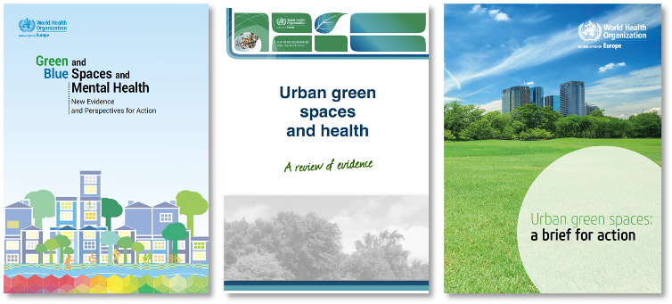
These reports highlight the importance of green open space in supporting community mental health and wellbeing in an urban setting. This includes the importance of everyone being able to easily access green space irrespective of age, gender, income and mobility and ensure green spaces are distributed equitably across urban areas. The research highlights the importance of being to provide enough spaces for the community to retreat to and use and rely on locally in the context of the lessons learned during the Covid-19 pandemic, when there were restrictions on people’s movement and travel.
Key health and wellbeing principles from this research that are consistent with the 2012 Strategy
- Increased urban densities and population growth places additional pressure on and demands on open space, which results in the need to both provide additional open space to meet the health and wellbeing needs of a growing population, and improve the quality of open space to better cater to increased levels of use.
- Support the preparation of site specific open space needs based assessments that are fit for purpose in urban centres.
- Provide a diversity of well-connected, attractive green spaces that offer safe and equitable opportunities for urban residents to actively recreate. This includes a broad range of opportunities from participating in active sports to quiet contemplative spaces and spaces for social contact.
- The importance of green open space in relation to urban cooling.
New principles from the research that are addressed in the Light Touch Review
- The need for communities to be able to access public green spaces of at least 0.5 to 1.0 hectare in size within a 300 metre radial (linear) distance of home. While these broad principles were available in 2012, the more recent research has led to the more specific recommendations regarding the preferred size and distances.
- Specifically in response to the Covid-19 pandemic, the importance of a diversity of open space that can be easily accessed within the local neighbourhood without the need to travel further.

2.1.2 Open space strategies
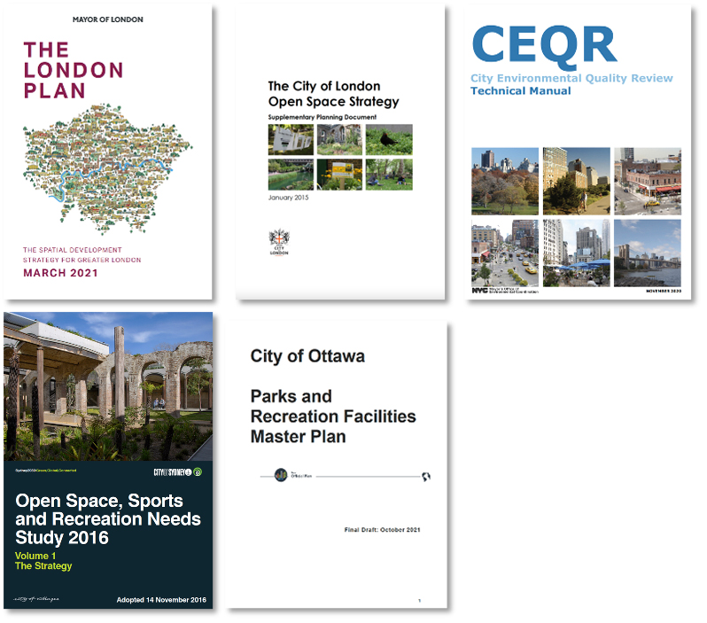
London and New York were selected as comparative international examples of how the provision of new open space is being addressed in cities experiencing population growth with high density development and substantial visitor and worker populations as well. The City of Ottawa and City of Sydney were included at the request of the Project Working Group.
Key principles that support the 2012 Strategy
- The open space hierarchy and walking catchments included in the 2021 London Plan remain unchanged from those that were referenced during the preparation of the 2012 Strategy.
- Support for a needs-based open space assessment to identify where and what type of new open space is needed and what upgrades or changes are required.
- Confirm that increased urban densities results in an increased reliance on and need for public open space due to a lack of private open space. Measuring the quantity of open space relative to population density is one of the measures of the adequacy of the open space network. Other measures include the spatial location of open space relative to the population, the diversity of the open space network and the proportion of open space relative to the total land area.
- The 2012 Strategy included a measure of open space relative to the total land area and was benchmarked against other capital cities including London and Sydney, along with adjoining municipalities in Melbourne. As a proportion of total land area, Melbourne and Sydney had the same amount, whereas London had significantly less. Compared with adjoining municipalities, the City of Melbourne has the second highest, with City of Port Phillip having the highest at 21.6 per cent, followed by the City of Melbourne at 14.4 per cent of the total land area of the municipality.

Key changes arising from the research to include in this Light Touch Review
- Since the 2012 Strategy was prepared, New York City has increased the indicator that a precinct has an adequate provision of open space from 7 square metres per ‘New Yorker’ to 10.1 square metres of open space per resident. This level of adequacy is combined with no spatial gaps in the network with the application of a 400 metre walking catchment to all open space. At the time the 2012 Strategy was prepared a figure of 7 square metres per ‘New Yorker’ was used, but there is no clarification if that included non-residents as well as residents. The updated document for New York City nominates a separate amount for non-residents of 0.6 square metre per person, which is the same as the metric used by the City of London for the total population which includes workers and residents. When compared to the average provision in the City of Melbourne, these figures nominated by New York City and the City of London are well below the averages for Melbourne.
- In the City of Melbourne in 2012, there was 56 square metres of open space per resident, and 7.4 square metres per person when the resident and worker population was added together. The Light Touch Review continues to recommend that the measure of open space relative to population density is used as one factor, but not the only factor, as part of the open space needs assessment.
- The City of Sydney released a combined open space and sport and recreation strategy in 2016. The Strategy is based on the 2010 Nsw State Government Recreation and Open Space Planning Guidelines for Local Government. The standards include 9 per cent of the total land area as local-district open space for non-industrialised land, increasing to 15 per cent when including regional open space. For urban renewal areas, the standards are between 9 and 15 per cent for local-district open space depending on the proposed site density. Where the highest densities are proposed, 15 per cent of the land area is required. The City of Sydney Strategy does not rely solely on a percentage of land area, it also includes a 400 metre walking catchment for local-district open space and a 250 metre catchment for open space linkages. The source for all these standards is the 2010 Nsw Government Recreation and Open Space Planning Guidelines for Local Government. These guidelines are no longer available on the Nsw Department of Planning’s website, therefore, the basis for the percentages is not clearly explained.

2.1.3 Conclusions from the review of the international/national research
- The research supports the needs based assessment methodology for open space planning, consistent with that used in the 2012 Strategy.
- The City of London, New York, Sydney and Ottawa Strategies all acknowledge that increased urban densities result in higher levels of use of open space which creates the need for both upgrades to existing open space to cater to the increased levels of use, and the provision of new open space. This is consistent with the needs based analysis already used in the 2012 Strategy. Updated 2021-2036 resident population forecasts and the proposed changes to the strategic growth framework plan in the Melbourne Planning Scheme have been used to inform the updates to the Precinct Actions in this Light Touch Review.
- The nominated per square metre rates of open space per person vary between the different strategies. Similarly, the percentage of land area rates vary significantly. As noted above, while these differences can be referenced, there is no standard comparable percentage or per square metre rate that is consistently adopted as best practice, therefore the needs based assessment remains as the preferred best practice approach for open space strategies.

2.2 Victorian Government policy changes

2.2.1 Summary of key new policies
New open space policies since the 2012 Strategy:
- Plan Melbourne 2017 - 2050 Metropolitan Planning Strategy
- Open Space for Everyone – Open Space Strategy for Metropolitan Melbourne
- Open Space Strategies Planning Practice Note | 70
- Victorian Aboriginal and Local Government Strategy 2021 – 2026 Pathways to Stronger Partnerships
- Fishermans Bend Framework – The next chapter in Melbourne’s growth story
- Yarra Strategic Plan – Burndap Birrarung burndap umarkoo
- Waterways of the West Action Plan
The review of the above new Victorian Government policies and strategies reinforce the directions already outlined in the 2012 Strategy, while others inform changes proposed as part of the Light Touch Review, as described below.
Key principles that support the 2012 Strategy
- Plan Melbourne provides an over-arching framework for the growth and change in Metropolitan Melbourne. The definition of open space in Plan Melbourne is broadly consistent with the definition in the 2012 Strategy. It supports many of the issues that were identified and included in the 2012 Strategy, including the role of open space in supporting community health and wellbeing, mitigating urban heat island effect and the importance of large canopy trees and urban greening to mitigating urban heat. In summary, Plan Melbourne supports the key directions that were outlined in the 2012 Strategy and remain relevant for this Light Touch Review.
- Open space for everyone describes the Victorian Government’s direction for overall management and governance of open space. The definition of open space is consistent with Plan Melbourne 2017–2050 and the 2012 Strategy. The key change from Plan Melbourne is the revised focus on the Yarra River (Birrarung) and the Maribyrnong River (Mirrangbamurn), consistent with the Waterways of the West Action Plan and the Yarra River Strategic Plan – Burndap Birrarung burndap umarkoo. This is reflected in the Light Touch Review.
- The guidance provided by the Open Space Strategies Planning Practice Note | 70 is consistent with the open space needs assessment method used to prepare the 2012 Strategy.
Key changes to include in this Light Touch Review:
- Recognition and need for meaningful and purposeful involvement by Traditional Owners in the future management, planning and development of public open space in the City of Melbourne. Open space provides an opportunity for truth telling, connection to country and involvement in future management of country. This Light Touch Review updates the principles from the 2012 Strategy to reflect Council’s commitment to working with these groups.
- The precinct actions in this Light Touch Review are updated to be consistent with the Yarra Strategic Plan and Waterways of the West Action Plan.
- The precinct actions for Port Melbourne are updated in this Light Touch Review to reference the Lorimer and the Fishermans Bend National Employment Innovation Cluster (N-e-i-c). This is generally consistent with the adopted Fishermans Bend Framework while also introducing and reinforcing the City of Melbourne’s preferred criteria for new open space and diverse open space network, particularly in the western areas of the City to the meet the vision for this in the 2012 Strategy.
- The precinct actions for North Melbourne and Kensington are updated to reference the endorsed Arden Structure Plan 2022 and Macaulay Structure Plan 2022. Given the amount of public open space set out in the 2022 endorsed Structure Plans is less than was shown in the 2012 Open Space Strategy, the Light Touch Review also includes recommendations to refer to the open space hierarchy and advocate to expand the open space network over and above what is in the Structure Plans to be consistent with the 2012 Strategy.
- The inclusion of the Victorian Government’s Big Build Projects which have commenced since 2012 including the new Metro Tunnel Project and the Westgate Tunnel Link Project, which influences where future urban densities will increase and availability or otherwise of conversion of suitable Victorian Government owned land to Municipal open space.

2.2.2 Conclusions from the review of the Victorian government policy changes
- The 2012 Strategy is consistent with the Victorian Government’s policy for preparing open space strategies, including the use of a needs based assessment.
- The Light Touch Review will update how the open space framework is applied to differentiate between the established areas and urban renewal areas.
- The precinct actions are updated to include the changes in the Victorian Governments growth framework influenced by the new major transport infrastructure projects and current renewal area planning. This includes the Fishermans Bend Framework, the Metro Tunnel Project including the change of urban densities and focus associated with the new stations, and the Westgate Tunnel Link project that influences the future Dynon Road corridor and E-Gate.

3 Local influences on open space planning in the City of Melbourne

3.1 Overview

3.1.1 Summary of key new policies and changes since 2012 Strategy
Key new and updated policies relevant to open space planning have been adopted by the City of Melbourne since 2012. These include:
- Council Plan 2021-2025 City of Melbourne City of Possibility, including the Health and Wellbeing Plan
- Municipal Planning Strategy to be included in the Melbourne Planning Scheme with updated policy to guide future growth and change for the City of Melbourne
- Arden Structure Plan 2022
- Macaulay Structure Plan 2022
- Nature in the City Strategy 2017
- Reconciliation Action Plan 2021-2023
- Greenline Project 2021
The proposed strategic growth framework plan for the City of Melbourne has changed from that shown in the 2012 Strategy. The Melbourne Planning Scheme has been reformatted in accordance with the current Victoria Planning Provisions and new strategic framework plans have been prepared for inclusion in the Municipal Planning Strategy at Clause 02.04 of the Melbourne Planning Scheme (Amendment C432). Key changes to the framework since the 2012 Strategy include:
- Fishermans Bend is a new urban renewal precinct that was identified after the 2012 Strategy was prepared.
- The Metro Tunnel and West Gate Tunnel Projects have influenced the planning for growth and change in the City of Melbourne, including the timing of urban development in the west of the city, and future opportunities for new Municipal open space.
- The Arden and the Macaulay Structure Plans have both been prepared since the 2012 Strategy replacing the previously adopted Arden Macaulay Structure Plan. Notably, both Kensington and North Melbourne have received lower levels of growth and change than was forecast at the time the 2012 Strategy was prepared.
- Melbourne 3000, Parkville, Docklands and Melbourne 3004 precincts have all received substantially higher rates of residential growth and change than was forecast in the 2012 Strategy.
Other key changes from reviewing the new policies and strategies include:
- Recognition and need for meaningful and purposeful involvement of Aboriginal people in the City of Melbourne. Open space provides an opportunity for truth telling, connection to country and involvement in future management of country.
- Increased emphasis on environmental issues and on improving biodiversity in the city.
- The Greenline Project 2021 is focused on revitalising the north bank of the Yarra River (Birrarung). Greenline covers the four kilometres between Birrarung Marr and the Bolte Bridge and Actions previously allocated to the north bank of the Yarra River (Birrarung) in the 2012 Strategy have been amended to refer to the Greenline Project.

3.2 Updated strategic framework plans for the City of Melbourne

3.2.1 Updated strategic growth framework plan
The City of Melbourne has endorsed an updated strategic growth framework plan that forms part of an Amendment to update the Municipal Planning Statement in the Melbourne Planning Scheme. The plan is proposed to be included in Clause 02.04.
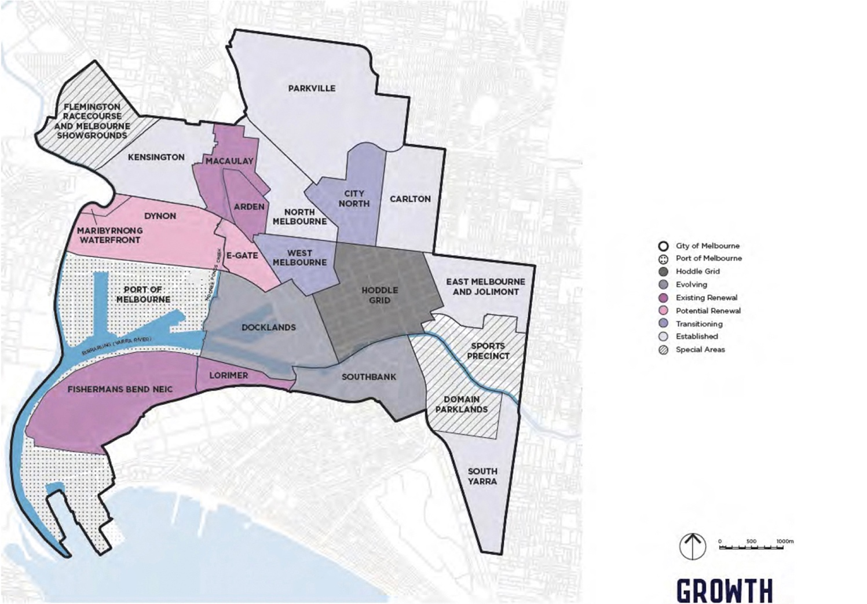

3.2.2 Updated strategic transport framework plan
The strategic transport framework plan illustrates the updated major transport projects currently under construction by the Victorian Government. The Metro rail project and its stations facilitate increased urban densities and business growth and opportunities, as shown in Figure 3B. Additionally, the alignment of the elevated road projects impact on land area that was identified as opportunity sites for new Municipal open space in E-Gate, which now may not be feasible due to the elevated road.
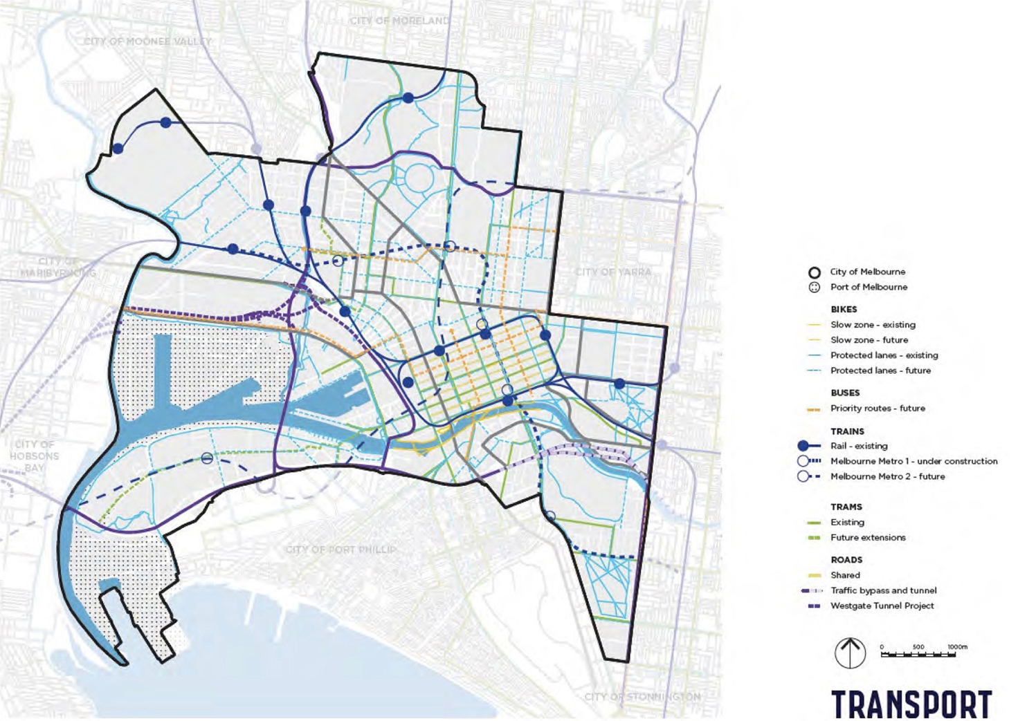
The Light Touch Review has taken into consideration the proposed changes in the strategic growth and transport framework plans and has updated the recommendations and actions.

3.2.3 Updated strategic open space framework plan
The strategic open space framework plan illustrates the overall direction for the provision of open space in the City of Melbourne. This includes reference to the 2012 Strategy along with more recent initiatives including the Greenline Project, Fishermans Bend Framework and Arden and Macaulay Structure Plans. Please refer to Figure 3C.
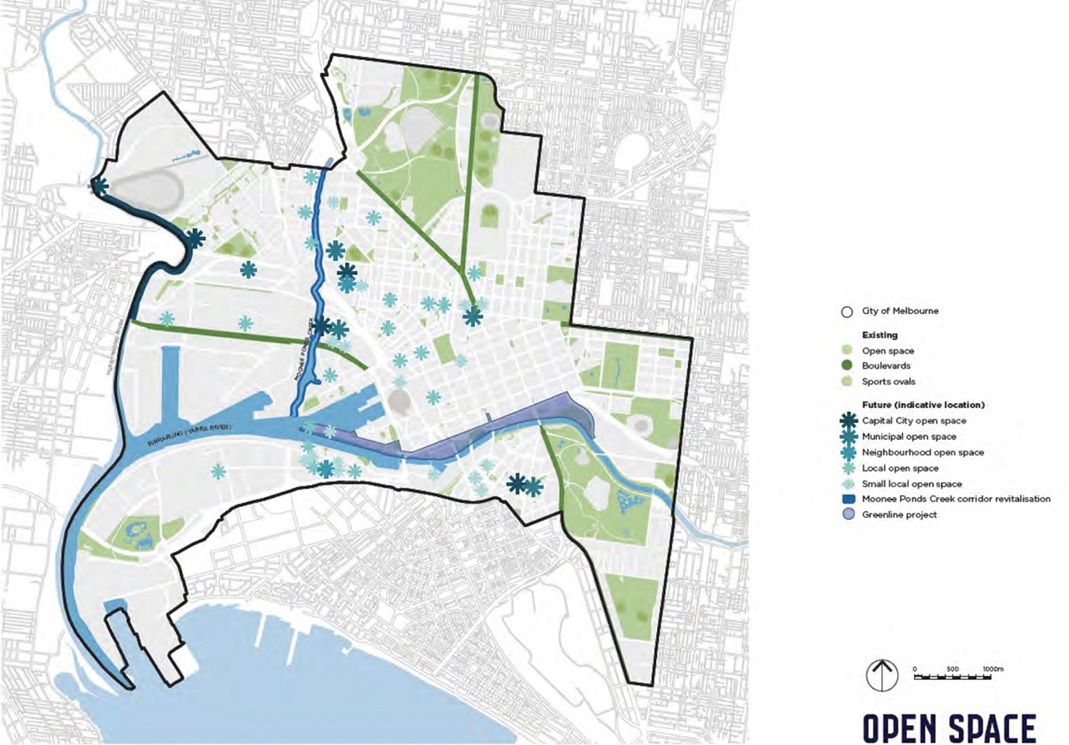
The Light Touch Review makes recommendations for changes to this plan to reflect the updated Actions included in Section 6. The updated open space plan is included in Section 5 of this Light Touch Review.

3.3 Population change and forecasts

3.3.1 Residential population change 2011 to 2021
The 2012 Strategy relied on and published population figures and residential forecasts that were supplied to the project by the City of Melbourne at that time. The forecasts were for a period of 15 years from 2011 to 2026 and shown below in Table 3-1.
The most significant residential population change in terms of the total number of people forecast for the precincts included Melbourne 3000, followed by North Melbourne, Southbank and Carlton. In terms of the change relative to the existing population, the greatest percentage change was forecast in West Melbourne, Docklands, North Melbourne, Southbank and Melbourne 3000.
Table 3-1. Residential population change forecast between 2011 and 2026 in the 2012 Open Space Strategy
Precinct name | Total residential population 2011 (2012 O-s-s) | Total forecast residential population 2026 (2012 O-s-s) | Difference in forecast residential population between 2011 and 2026 (2012 O-s-s) | % change in forecast residential population between 2011 and 2026 (2012 O-s-s)
Carlton | 14,644 residential population in 2011 | 23,773 forecast population in 2026 | 9,129 difference in population between 2011 and 2026 | 62% change
Docklands | 6,134 residential population in 2011 | 14,205 forecast population in 2026 | 8,071 difference in population between 2011 and 2026 | 132% change
East Melbourne | 5,162 residential population in 2011 | 5,770 forecast population in 2026 | 608 difference in population between 2011 and 2026 | 12% change
Kensington | 10,460 residential population in 2011 | 13,229 forecast population in 2026 | 2,769 difference in population between 2011 and 2026 | 26% change
Melbourne 3000 | 21,080 residential population in 2011 | 35,264 forecast population in 2026 | 14,184 difference in population between 2011 and 2026 | 67% change
Melbourne 3004 | 1,630 residential population in 2011 | 2,064 forecast population in 2026 | 434 difference in population between 2011 and 2026 | 27% change
North Melbourne | 11,650 residential population in 2011 | 22,346 forecast population in 2026 | 10,696 difference in population between 2011 and 2026 | 92% change
Parkville | 5,773 residential population in 2011 | 5,826 forecast population in 2026 | 53 difference in population between 2011 and 2026 | 1% change
Port Melbourne | 0 residential population in 2011 | 0 residential population in 2011 | 0 difference in population between 2011 and 2026 | 0% change
Southbank | 13,107 residential population in 2011 | 23,282 forecast population in 2026 | 10,175 difference in population between 2011 and 2026 | 78% change
South Yarra | 4,702 residential population in 2011 | 4,724 forecast population in 2026 | 22 difference in population between 2011 and 2026 | 0% change
West Melbourne | 3,821 residential population in 2011 | 9,400 forecast population in 2026 | 5,579 difference in population between 2011 and 2026 | 146% change
Totals | 98,163 residential population in 2011 | 159,883 forecast population in 2026 | 61,720 difference in population between 2011 and 2026 | 63% change
Given the 2021 A-b-s Census figures are now available, the population forecasts have been updated to reflect the change. The 2012 Strategy did not have a complete set of forecasts for the interim 2021 year, so it is not possible to do a direct comparison with what was forecast to have occurred by 2021 and what has happened. However, it is useful instead to look at the emerging trends based on the actual change that has occurred between 2011 and 2021 and how this compares with the 2012 Strategy forecast. This is shown in Table 3-2.
Overall Table 3-2 indicates that total residential population in 2021 is just 6,217 short of the 2026 forecast in the 2012 Strategy. It also shows that the location of where the population change has occurred is different from what was forecast in the 2012 Strategy.
The main changes include:
- Growth has been much slower than forecast in Carlton, East Melbourne, Kensington and North Melbourne. The reasons for slower growth in Kensington and North Melbourne was due to the key planning changes made by the Victorian Government, which is described in the Arden Structure Plan as being due to revised flood mitigation methods in response to extreme rainfall events, resulting in the decision to prepare two new separate structure plans for the Arden and Macaulay areas. No specific reasons for the slower growth in Carlton and East Melbourne have been provided to the project.
- Growth has already exceeded the 2026 forecasts in Docklands, Melbourne 3000, Melbourne 3004, Parkville and Port Melbourne.
- Growth in Southbank and West Melbourne is generally on track with the forecasts in the 2012 Strategy.

Table 3-2. Actual residential population change between 2011 and 2021
Precinct name | Total residential population 2011 (2012 O-s-s) | Difference in forecast residential population between 2011 and 2026 (2012 O-s-s) | % change in forecast residential population between 2011 and 2026 (2012 O-s-s) | Total actual residential population 2021 (Census 2021/Sgs Forecasts  C-o-m 2022) | Difference in actual residential population 2011 and 2021 | % change in actual population between 2011 and 2021 (Census)
Carlton | 14,644 residential population in 2011 | 9,129 difference in forecast population between 2011 and 2026 | 62% change in the forecast population | 17,185 actual population in 2021 | 2,541 difference in actual population between 2011 and 2021 | 17% change in the actual population
Docklands | 6,134 residential population in 2011 | 8,071 difference in forecast population between 2011 and 2026 | 132% change in the forecast population | 15,926 actual population in 2021 | 9,792 difference in actual population between 2011 and 2021 | 160% change in the actual population
East Melbourne | 5,162 residential population in 2011 | 608 difference in forecast population between 2011 and 2026 | 12% change in the forecast population | 4,965 actual population in 2021 | -197 difference in actual population between 2011 and 2021 | -4% change in the actual population
Kensington | 10,460 residential population in 2011 | 2,769 difference in forecast population between 2011 and 2026 | 26% change in the forecast population | 10,932 actual population in 2021 | 472 difference in actual population between 2011 and 2021 | 5% change in the actual population
Melbourne 3000 | 21,080 residential population in 2011 | 14,184 difference in forecast population between 2011 and 2026 | 67% change in the forecast population | 43,825 actual population in 2021 | 22,745 difference in actual population between 2011 and 2021 | 108% change in the actual population
Melbourne 3004 | 1,630 residential population in 2011 | 434 difference in forecast population between 2011 and 2026 | 27% change in the forecast population | 3,121 actual population in 2021 | 1,491 difference in actual population between 2011 and 2021 | 91% change in the actual population

North Melbourne | 11,650 residential population in 2011 | 10,696 difference in forecast population between 2011 and 2026 | 92% change in the forecast population | 15,653 actual population in 2021 | 4,003 difference in actual population between 2011 and 2021 | 34% change in the actual population
Parkville | 5,773 residential population in 2011 | 53 difference in forecast population between 2011 and 2026 | 1% change in the forecast population | 7,813 actual population in 2021 | 2,040 difference in actual population between 2011 and 2021 | 35% change in the actual population
Port Melbourne | 0 residential population in 2011 | 0 difference in forecast population between 2011 and 2026 | 0% change in the forecast population | 7 actual population in 2021 | 7 difference in actual population between 2011 and 2021 | 69900% change in the actual population
Southbank | 13,107 residential population in 2011 | 10,175 difference in forecast population between 2011 and 2026 | 78% change in the forecast population | 22,588 actual population in 2021 | 9,481 difference in actual population between 2011 and 2021 | 72% change in the actual population
South Yarra | 4,702 residential population in 2011 | 22 difference in forecast population between 2011 and 2026 | 0% change in the forecast population | 3,717 actual population in 2021 | -985 difference in actual population between 2011 and 2021 | -21% change in the actual population
West Melbourne | 3,821 residential population in 2011 | 5,579 difference in forecast population between 2011 and 2026 | 146% change in the forecast population | 7,934 actual population in 2021 | 4,113 difference in actual population between 2011 and 2021 | 108% change in the actual population
Totals | 98,163 residential population in 2011 | 61,720 difference in forecast population between 2011 and 2026 | 63% change in the forecast population | 153,666 actual population in 2021 | 55,503 difference in actual population between 2011 and 2021 | 57% change in the actual population
The updated Strategy Actions in this Light Touch Review have taken into account both the changes in the actual residential growth between 2011 and 2021 shown in Table 3-2 and the forecast residential change to 2031 shown in Table 3-3. All three tables inform the updated Actions included in Section 6 of this Light Touch Review.

3.3.2 Forecast residential population change 2021 to 2031
Residential population growth is forecast across all precincts, including those that have experienced a population decline in the previous period up to 2021. The largest number of new residents is forecast for Melbourne 3000 with nearly 27,000 new residents forecast over the next 10 years. This is followed by Southbank with nearly 13,000 new residents, then North Melbourne, Carlton and Docklands with over 9,000 forecast for each of these three precincts.
Overall, nearly 88,000 new residents are forecast to be living in the City of Melbourne by 2031 compared to the 2021 population.
Table 3-3. Forecast residential population change between 2021, 2026 and 2031
Precinct name | Total actual residential population 2021 (Census 2021/Sgs Forecasts  C-o-m 2022) | Total forecast residential population 2026 (Sgs Forecasts  C-o-m 2022) | Total forecast residential population 2031 (Sgs Forecasts  C-o-m 2022) | Difference between 2021 and 2031 (Sgs Forecasts  C-o-m 2022) | % change between 2021 and 2031 (Sgs Forecasts  C-o-m 2022)
Carlton | 17,185 actual population in 2021 | 20,745 forecast population in 2026 | 26,374 forecast population in 2031 | 9,189 difference in forecast population between 2021 and 2031 | 53% change in forecast population between 2021 and 2031
Docklands | 15,926 actual population in 2021 | 19,998 forecast population in 2026 | 25,292 forecast population in 2031 | 9,366 difference in forecast population between 2021 and 2031 | 59% change in forecast population between 2021 and 2031
East Melbourne | 4,965 actual population in 2021 | 6,204 forecast population in 2026 | 7,445 forecast population in 2031 | 2,480 difference in forecast population between 2021 and 2031 | 50% change in forecast population between 2021 and 2031
Kensington | 10,932 actual population in 2021 | 12,940 forecast population in 2026 | 15,846 forecast population in 2031 | 4,914 difference in forecast population between 2021 and 2031 | 45% change in forecast population between 2021 and 2031
Melbourne 3000 | 43,825 actual population in 2021 | 55,423 forecast population in 2026 | 70,551 forecast population in 2031 | 26,726 difference in forecast population between 2021 and 2031 | 61% change in forecast population between 2021 and 2031
Melbourne 3004 | 3,121 actual population in 2021 | 3,756 forecast population in 2026 | 4,430 forecast population in 2031 | 1,309 difference in forecast population between 2021 and 2031 | 42% change in forecast population between 2021 and 2031
North Melbourne | 15,653 actual population in 2021 | 19,378 forecast population in 2026 | 25,301 forecast population in 2031 | 9,648 difference in forecast population between 2021 and 2031 | 62% change in forecast population between 2021 and 2031
Parkville | 7,813 actual population in 2021 | 9,339 forecast population in 2026 | 11,223 forecast population in 2031 | 3,410 difference in forecast population between 2021 and 2031 | 44% change in forecast population between 2021 and 2031
Port Melbourne | 7 actual population in 2021 | 414 forecast population in 2026 | 1,187 forecast population in 2031 | 1,180 difference in forecast population between 2021 and 2031 | 16857% change in forecast population between 2021 and 2031
Southbank | 22,588 actual population in 2021 | 28,429 forecast population in 2026 | 35,552 forecast population in 2031 | 12,964 difference in forecast population between 2021 and 2031 | 57% change in forecast population between 2021 and 2031
South Yarra | 3,717 actual population in 2021 | 4,615 forecast population in 2026 | 5,466 forecast population in 2031 | 1,749 difference in forecast population between 2021 and 2031 | 47% change in forecast population between 2021 and 2031
West Melbourne | 7,934 actual population in 2021 | 9,746 forecast population in 2026 | 12,715 forecast population in 2031 | 4,781 difference in forecast population between 2021 and 2031 | 60% change in forecast population between 2021 and 2031
Totals | 153,666 actual population in 2021 | 190,987 forecast population in 2026 | 241,382 forecast population in 2031 | 87,716 difference in forecast population between 2021 and 2031 | 57% change in forecast population between 2021 and 2031

The total residential forecasts for each of the precincts exceeds the forecasts for 2026 in the 2012 Strategy. The magnitude of change varies across the precincts with the greatest magnitude of additional residents above the 2026 forecasts in the 2012 Strategy are:
- Melbourne 3000, more than double the number of residents forecast by 2026 in the 2012 Strategy with over 35,000 additional residents forecast by 2031
- Southbank, with approximately 12,000 additional residents
- Docklands, with approximately 11,000 additional residents
- Parkville, with approximately 5,000 additional residents.
This magnitude of change has informed the update to the Strategy Actions in Section 6 of this Light Touch Review.

3.3.3 Employment population
The employment population has an influence on the open space provision in the City of Melbourne. Workers add significantly to the total population in the municipality, particularly in Melbourne 3000, Docklands and Southbank where they substantially exceed the residential population.
While the activities and times that workers use open space may be different from residents, the survey work we completed as part of the 2012 Strategy identified that workers use open space near their workplace for a range of reasons including to relax and unwind, play sport, socialise with work colleagues and family and to take a break during work. The more recent open space surveys of workers use of open space undertaken for the 2020 Yarra Open Space Strategy confirmed this trend.
Table 3-4 shows the employment population forecasts included in the 2012 Strategy on the following page. There was a 40 per cent overall increase in the employment population forecast between 2011 and 2026. This included more than 100,000 additional workers in Melbourne Central Business District, along with a substantial increase of more than 200 per cent in Kensington and over 100 per cent increase in North Melbourne. The least amount of change in the worker population forecasts was in Parkville, with only a slight increase of 8 per cent.

Table 3-4. Employment population change forecast between 2011 and 2026 in the 2012 Open Space Strategy
Precinct name (Clue) | Total estimated employment population 2011 (2012 O-s-s) | Total forecast employment population 2026 (2012 O-s-s) | Difference in forecast employment population 2011 to 2026 (2012 O-s-s) | % change between 2011 and 2026 (2012 O-s-s)
Carlton | 17,823 estimated employment population in 2011 | 24,147 forecast employment population in 2026 | 6,324 difference between 2011 and 2026 | 35% change in the employment population between 2011 and 2026
Docklands | 33,503 estimated employment population in 2011 | 44,000 forecast employment population in 2026 | 10,497 difference between 2011 and 2026 | 31% change in the employment population between 2011 and 2026
East Melbourne | 21,080 estimated employment population in 2011 | 25,000 forecast employment population in 2026 | 3,920 difference between 2011 and 2026 | 19% change in the employment population between 2011 and 2026
Kensington | 5,634 estimated employment population in 2011 | 20,500 forecast employment population in 2026 | 14,866 difference between 2011 and 2026 | 264% change in the employment population between 2011 and 2026
Melbourne 3000 | 223,326 estimated employment population in 2011 | 323,855 forecast employment population in 2026 | 100,529 difference between 2011 and 2026 | 45% change in the employment population between 2011 and 2026
Melbourne 3004 (Remainder) | 24,899 estimated employment population in 2011 | 30,700 forecast employment population in 2026 | 5,801 difference between 2011 and 2026 | 23% change in the employment population between 2011 and 2026
North Melbourne | 9,379 estimated employment population in 2011 | 23,000 forecast employment population in 2026 | 13,621 difference between 2011 and 2026 | 145% change in the employment population between 2011 and 2026
Parkville | 27,109 estimated employment population in 2011 | 29,221 forecast employment population in 2026 | 2,112 difference between 2011 and 2026 | 8% change in the employment population between 2011 and 2026
Port Melbourne | 15,366 estimated employment population in 2011 | 17,000 forecast employment population in 2026 | 1,634 difference between 2011 and 2026 | 11% change in the employment population between 2011 and 2026
South Yarra | Estimated employment population in 2011: included in  Melbourne 3004 | Forecast employment population in 2026: included in  Melbourne 3004 | Difference between 2011 and 2026:  not applicable | Change in the employment population between 2011 and 2026:  not applicable
Southbank | 37,796 estimated employment population in 2011 | 46,000 forecast employment population in 2026 | 8,204 difference between 2011 and 2026 | 22% change in the employment population between 2011 and 2026
West Melbourne (Industrial) | 15,587 estimated employment population in 2011 | 19,742 forecast employment population in 2026 | 4,155 difference between 2011 and 2026 | 27% change in the employment population between 2011 and 2026
West Melbourne (Residential) | Estimated employment population in 2011: included in Industrial | Forecast employment population in 2026: included in Industrial | Difference between 2011 and 2026:  not applicable | Change in the employment population between 2011 and 2026:  not applicable
Totals | 431,502 estimated employment population in 2011 | 603,165 forecast employment population in 2026 | 171,663 difference between 2011 and 2026 | 40% change in the employment population between 2011 and 2026
The employment population was resurveyed in 2021, however the survey was held during the Covid-19 pandemic when work from home orders were in place and retail and hospitality establishments were closed. Given the uncertainty around the ongoing impacts of the change in work patterns and retail and hospitality business activity, the 2021 employment figures and forecasts will not be used for this Light Touch Review, as they are lower than the original forecasts from 2012. Instead, we will continue to rely on the 2012 employment forecasts as shown in Table 3-4.

3.3.4 Implications of the forecasts on the updated precinct actions in the 2012 Strategy
Overall quantum of change
In order to determine what changes are required to the actions for each precinct, it is necessary to understand firstly the differences between what was forecast for the residential population in the 2012 Strategy and what has actually occurred. Secondly, assessment of the quantum of change to the residential forecasts for the next 10 year is undertaken for the overall precinct including the change from what was originally forecast in the 2012 Strategy. For example, the total quantum of change that is forecast for the precinct by 2031, compared to what was forecast by 2026 in 2012. In relation to the employment population forecasts, the analysis for this Light Touch Review assumes no change to the original forecasts in the 2012 Strategy. Therefore, the employment population is accounted for in the original precinct actions - the fluctuation and change are dependent on the change in the residential population forecast only.
For the residential population, there are differences between what was forecast in the 2012 Strategy and what has occurred. The residential growth is higher in all precincts than was forecast in the 2012 Strategy. Overall the resident population forecasts exceed the 2012 Strategy 2026 forecasts with just over 31,000 additional residents forecast to be living in the City of Melbourne by 2026. Going forward from 2026 for the next 5 year period, the residential forecasts from Sgs (dated November 2022) assume ongoing growth in all precincts through to 2031, with just over 50,000 additional residents forecast to be moving into the municipality by 2031.
Location of change
The rate and extent of forecast residential and worker population change varies across the different precincts. The growth has the greatest implications in areas with deficiencies in open space. For example, while there has been a substantial increase in the residential population in Parkville, the majority of the new population is located in the high density development in the western area of Parkville between the Tullamarine Freeway and Royal Park. Given the close proximity of this development to Royal Park there is capacity for their additional open space needs to be accommodated in the existing open space network. This contrasts with the additional 35,000 residents in Melbourne 3000 where there are existing gaps in the spatial distribution of open space. The additional residents in this location create the need for additional open space to be provided.
In order to understand where the residential change has occurred between 2011 and 2021, Dr Serryn Eagleson assembled Mesh Block Difference spatial maps that show changes between the 2011 and 2021 census data for dwellings and these are attached to this Light Touch Review as Appendix A. We have relied on the spatial mapping of the actual change in the residential population in Appendix A to directly inform the update to the precinct actions in Section 6. This has been combined with consideration of change to the employment forecasts in each precinct based on the forecasts included in the 2012 Strategy.
Tbld has reviewed this data in the context of what has changed compared to what was anticipated to change. We have combined this assessment with the updated Sgs residential forecasts for the 2021 to 2031 period in updating the precinct actions. The implications of the forecast change have informed the updated 10 year priority program of works for each precinct, which are described in Section 6 of this Light Touch Review.

3.4 Increased importance of nature conservation values and Caring for Country

3.4.1 Nature in the City Strategy
In 2017, the City of Melbourne prepared the Nature in the City Strategy which focussed on supporting a diverse, resilient and healthy ecosystem to support a liveable city. In a recent mid-point review of the Strategy, it has been identified that community interest in biodiversity values has increased further due to the global Climate and Biodiversity Emergency, the extensive bushfires in 2019, the Covid-19 pandemic and the adoption of the Kunming-Montreal Global Biodiversity Framework.
The key actions arising from the review of the Nature in the City Strategy are to improve and create additional habitat and connect more people to nature through applying 'Caring for Country' principles.
The 2012 Open Space Strategy recognised the importance of the nature conservation values, including recognising and identifying opportunities to improve biodiversity values. This included proposed revegetation and habitat improvement along the waterway corridors, treatment of urban runoff to improve the quality of receiving waters while increasing the presence of water in open space from sustainable sources to strengthen its role to mitigate urban heat island effect. The Light Touch Review will cross reference to the Nature in the City Strategy where appropriate.

3.4.2 Caring for Country
In the Council Plan 2021 - 2025, one of the top five priorities is:
- First Peoples experts are consulted and lead sustainable land management practices and implement ‘Caring for Country’ principles in the management, planning and development of city land.
The Reconciliation Action Plan 2021-2023 identified some key actions for open space including Action 12, to protect, recognise and promote Aboriginal culture, heritage and place including research and consultation with local Traditional Owner groups into Caring for Country knowledge and practices and how they may be applied to the work of the Council in areas such as urban design, sustainability, parks and gardens and public art.

4 Changes to the open space network since 2012

4.1 Overview
There have been numerous changes to the open space network since the 2012 Strategy. Overall, an additional 23.07 hectares of new open space has been added to the network through a combination of conversion of existing public land to open space, land contributions as part of the development application and approvals process, and purchase of land using open space contributions.
New open space added to the network:
- 573.16 hectares of open space (excluding restricted open space)
- An additional 23.07 hectares of open space has been added across the municipality since the 2012 Strategy.
- Open space comprises 15 per cent of the total land area of the municipality, up from 14.4 per cent in 2012.
- Open space relative to the residential population density has reduced from 56 square metres per resident in 2012 to 37 square metres per resident based on the 2021 resident population density.
- Key changes include:
  - Carlton – 1.07 hectares of new open space has been added to Carlton as a combination of new open spaces on the former Department of Housing land and the expansion of University and Lincoln Squares into the adjoining road reserves
  - Docklands – 3.93 hectares of new open space in Docklands, with the Ron Barassi Senior Park comprising 2.4 hectares of the new land area
  - Flemington – 1.92 hectares of new open space along the Maribyrnong River adjacent to Flemington Racecourse
  - Kensington – 4.97 hectares of new open space in Kensington, with 3.2 hectares of this is the rezoning of Moonee Ponds Creek as Pprz, 0.77 hectares along the Maribyrnong River and 0.36 hectares as the future new Local open space in Chelmsford Street
  - Melbourne 3000 – 1.28 hectares of new open space, Victoria Market Reserve as a new Capital City open space and rezoned as Pprz
  - North Melbourne – 0.76 hectares of open space has been added to North Melbourne comprising mainly the expansion to Gardiner and Errol Street Reserves
  - Parkville – an additional 0.65 hectares of open space has been added to Royal Park following completion of the Royal Children's Hospital.
  - Port Melbourne – 6.83 hectares of new open space has been added to Westgate Park in Port Melbourne
  - Southbank – 1.06 hectares of new open space has been added to Southbank, which includes the new Southbank Boulevard Reserve and Boyd Park
  - West Melbourne – 0.62 hectares of new Small Local open space with the new Wominjeka Park and expansions to Howard & William Street Reserve, Hawke & Adderley Street Park and Railway & Miller Street Reserve.
- There are a series of smaller distributed new Local and Small Local open spaces across the precincts with new and expanded open spaces and this includes:
  - Six new Local and Small Local open spaces in Docklands
  - Four new Small Local open spaces in Carlton | Carlton North
  - Three new open spaces in Southbank
  - Four new Small Local open spaces in the Melbourne Cbd in addition to a new Regional open space at the Queen Victoria Market.
The existing open space network has been spatially mapped, showing the expanded network described above. The changes are highlighted with red circles in Figure 4B.
Figure 4A on the following page includes the Existing open space network from the 2012 Strategy Technical Report, and Figure 4B shows the updated Existing open space network up to November 2022.
Recommendation Ltr1.
Refer to Figure 4B – Existing open space in this Light Touch Review as an update and to replace Figure 1(a) in the 2012 Technical Report.
Note, Figure 1(a) from the 2012 Strategy Technical Report is included in this Light Touch Review as Figure 4A for ease of reference.

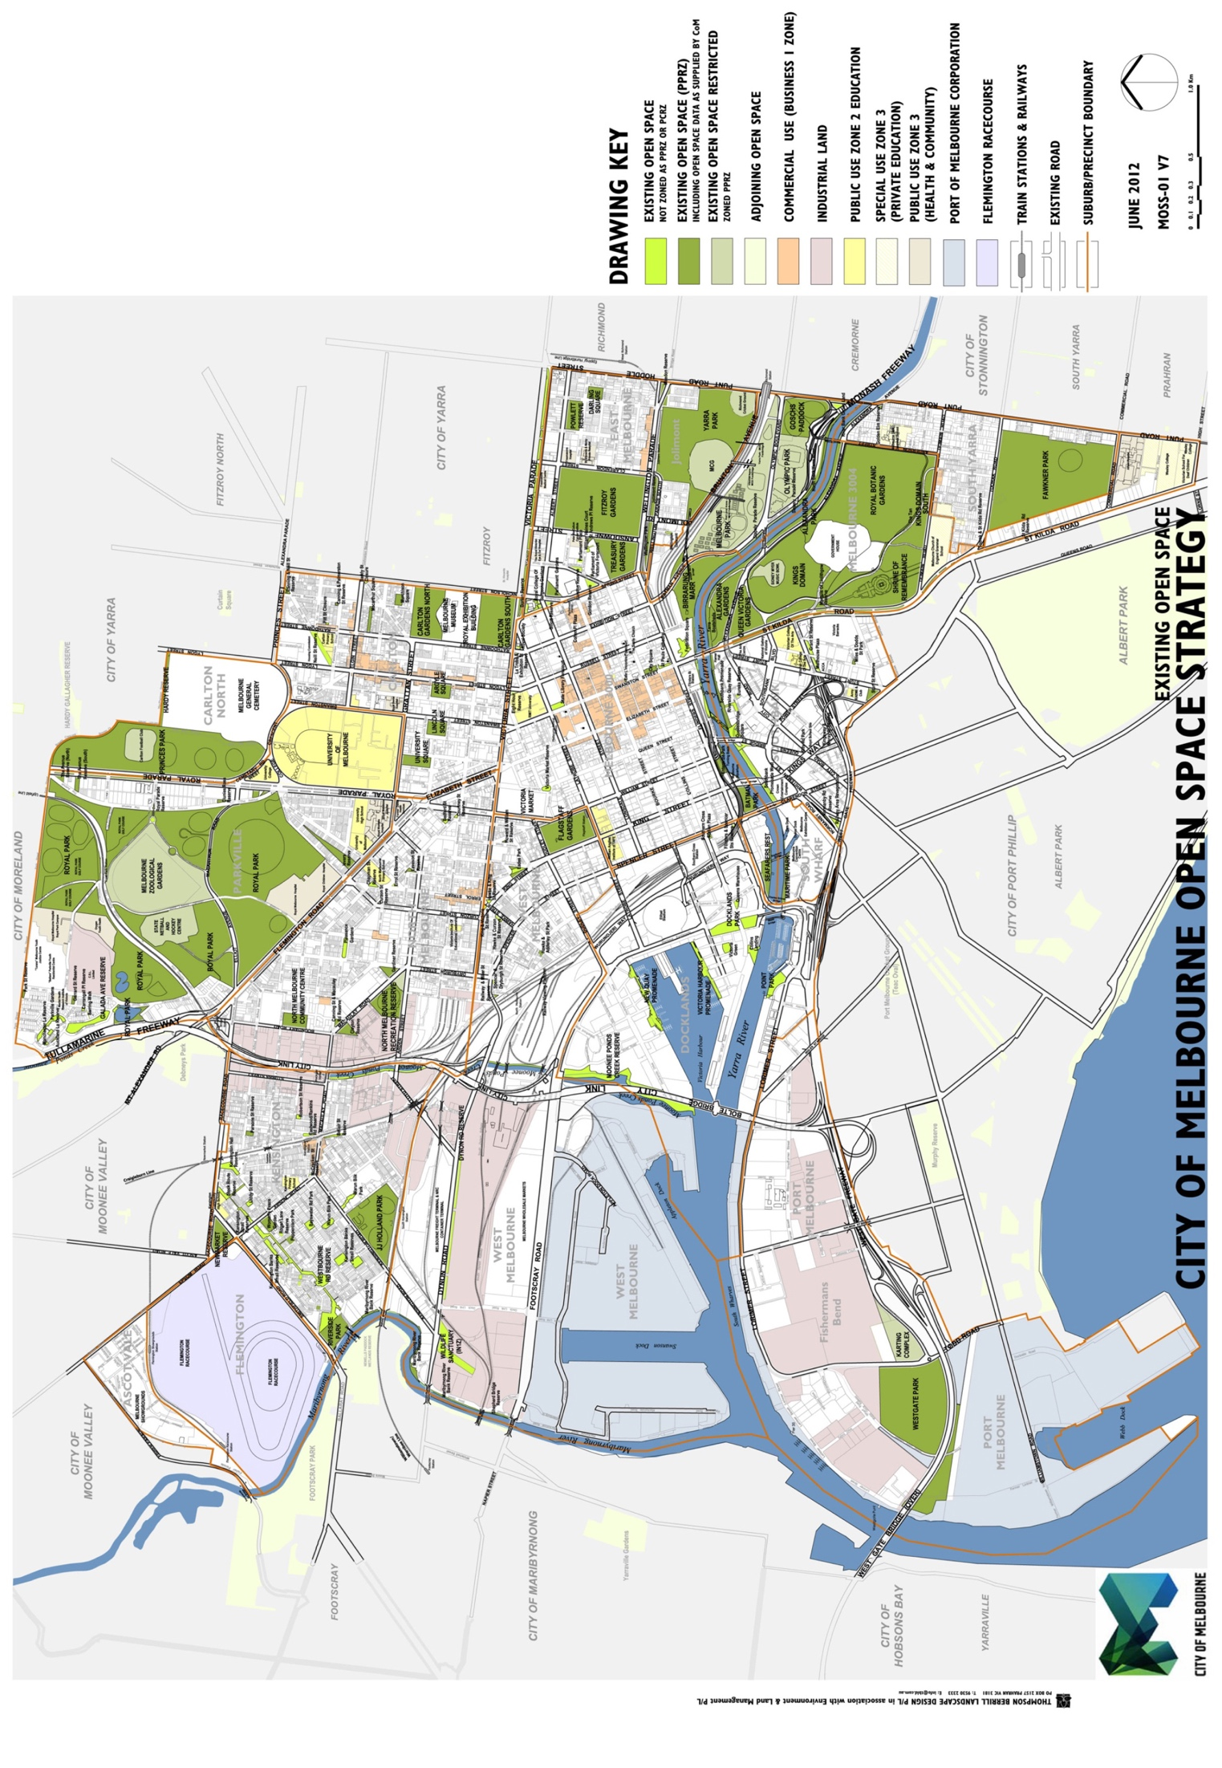
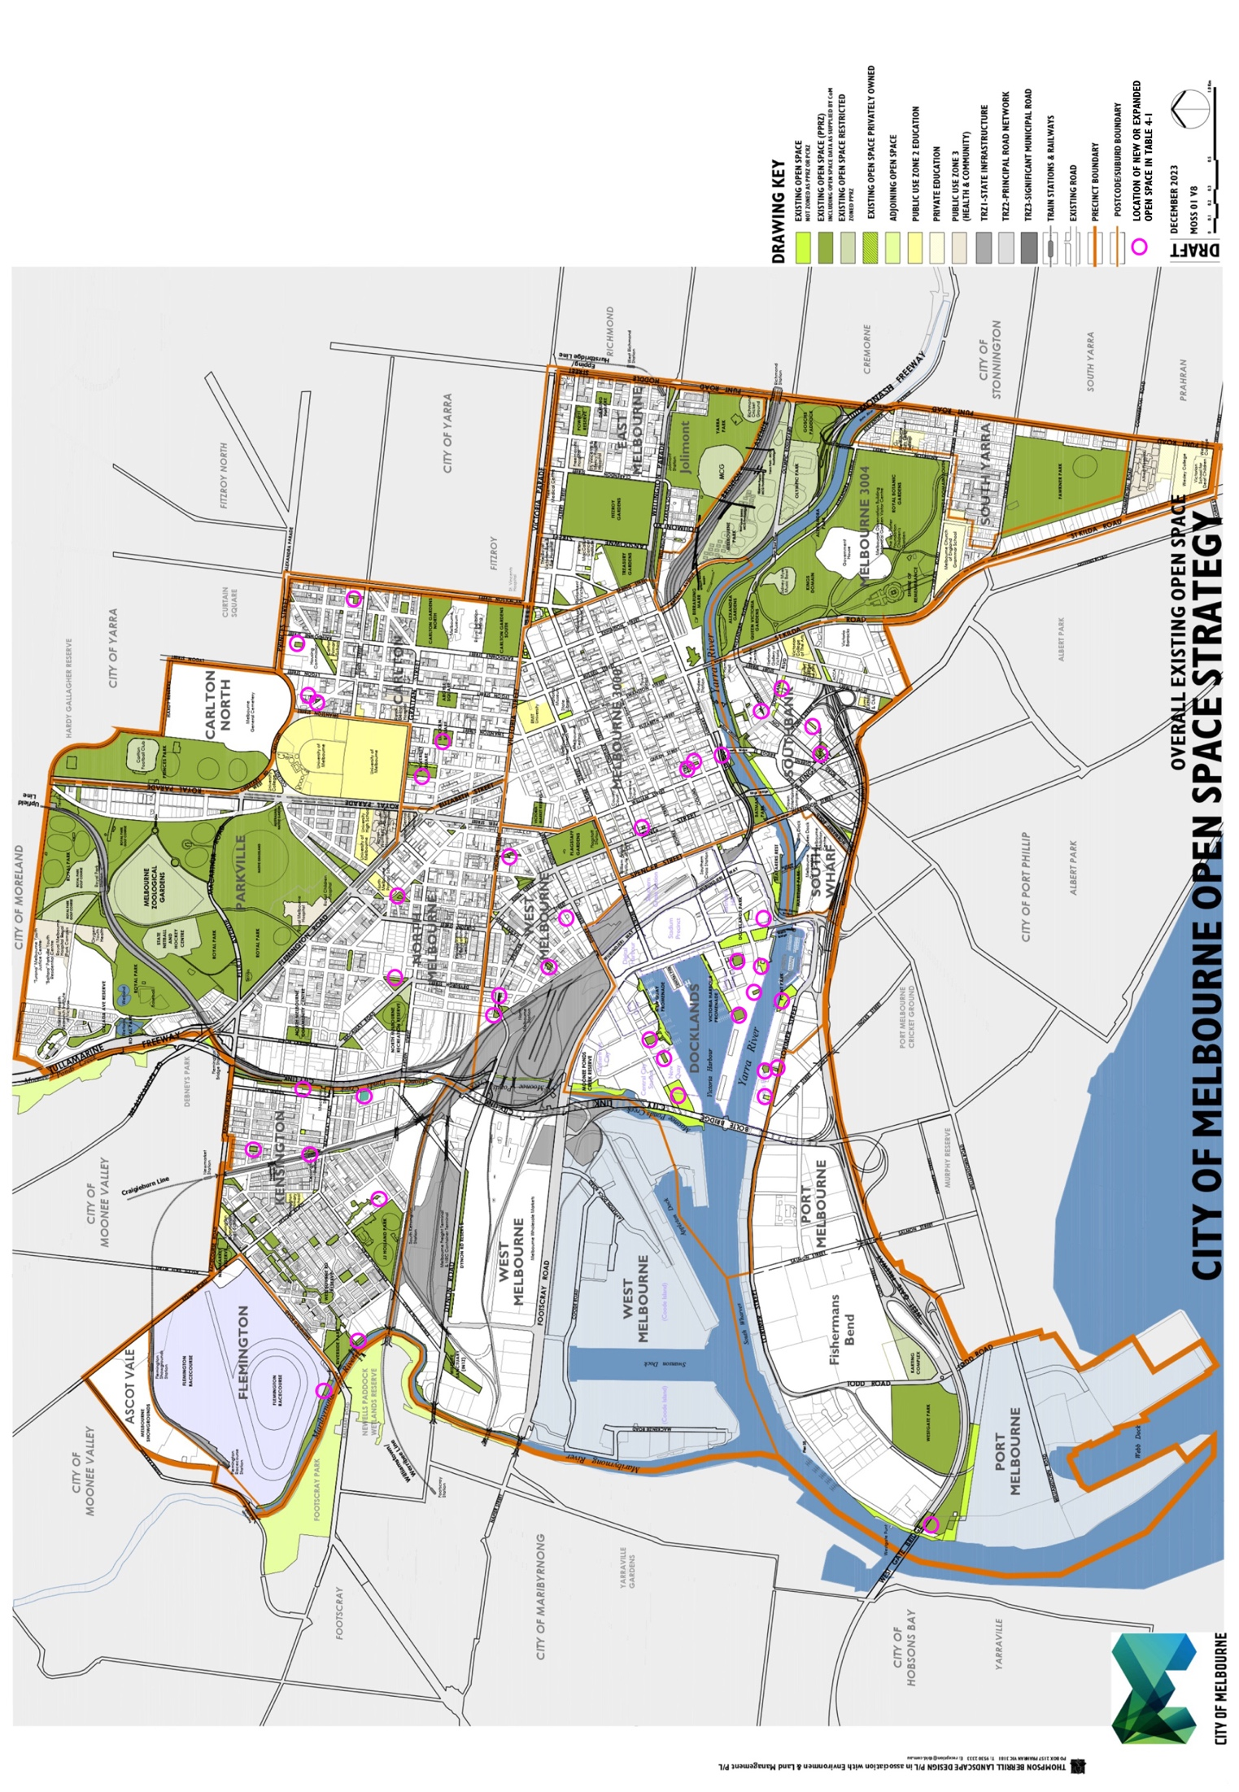

4.2 Quantity and provision of open space
There have been changes to the existing open space network since the 2012 Strategy was prepared. As noted in Section 4.1 of this review, the changes include provision of new open space, changes to the size and extent of existing open spaces and the purchase of land for future open space. The following table provides a list of the changes documented to December 2023.
Table 4-1. List of changes to the public open space network since the 2012 Strategy
Carlton | Carlton North
Public open space | Type of contribution/ comments | Hierarchy | Difference in open space area | Difference in open space area
Cardigan Street Park | New open space, conversion of D-o-h Land | Small Local open space | 527 square metres | 0.05 hectare
Keppel Street Park | New open space, conversion of D-o-h Land | Small Local open space | 383 square metres | 0.04 hectare
Lincoln Square | Expanded the size of the reserve to the north and south into the adjoining road reserves | Neighbourhood open space | 3,007 square metres | 0.30 hectare
Reeves Street Park | New open space, conversion of D-o-h Land | Small Local open space | 1,625 square metres | 0.16 hectare
Station Street Park | New open space - conversion of D-o-h Land | Small Local open space | 2,561 square metres | 0.26 hectare
University Square | Expanded into the road reserve | Neighbourhood open space | 2,686 square metres | 0.27 hectare
Subtotal difference in open space for Carlton | Carlton North | Not applicable | Not applicable | Additional 10,789 square metres in total | Additional 1.08 hectares in total
Docklands
Public open space | Type of contribution/ comments | Hierarchy | Difference in open space area | Difference in open space area
Adela Lane Reserve | New open space | Small Local open space | 1,071 square metres | 0.11 hectare
Buluk Park | New open space | Local open space | 4,211 square metres | 0.42 hectare
Collins Landing / Australian Wharf | Expanded existing open space | Local open space | 1,175 square metres | 0.12 hectare
Docklands Community Hub Reserve | New open space | Neighbourhood open space | 1,438 square metres | 0.14 hectare
Moonee Ponds Creek Reserve | Reduced open space by 3,200 square metres adjacent to Dockland Studio Development | Regional open space | -3,200 square metres | -0.320 hectare
New Quay Central Park | New open space | Local open space | 4,426 square metres | 0.44 hectare
Quay Park | New open space | Small Local open space | 1,652 square metres | 0.17 hectare
Ron Barassi Senior Park | New open space - Maintained by C-o-m via agreement with Places Victoria | Municipal open space | 24,503 square metres | 2.45 hectares
Unnamed Reserve 1 | New open space | Small Local open space | 736 square metres | 0.07 hectare
Unnamed Reserve 2 | New open space | Small Local open space | 1,183 square metres | 0.12 hectare
Victoria Green | Expanded the existing open space (excluding Buckley Walk) | Local open space | 924 square metres | 0.09 hectare
Wharfs Landing | New open space | Small Local open space | 1,174 square metres | 0.12 hectare
Subtotal difference in open space for Docklands | Not applicable | Not applicable | Additional 39,293 square metres in total | Additional 3.93 hectares in total
East Melbourne
Public open space | Type of contribution/ comments | Hierarchy | Difference in open space area | Difference in open space area
Burston Reserve | Reduced open space, Tram shelter area excised from open space area | Small Local open space | -14 square metres | -0.001 hectare
Subtotal difference in open space for East Melbourne | Not applicable | Not applicable | -14 square metres in total | -0.001 hectare in total
Flemington
Public open space | Type of contribution/ comments | Hierarchy | Difference in open space area | Difference in open space area
Maribyrnong River Bank Reserve (Flemington) | New open space (formerly part of the Flemington Racecourse Reserve), rezoned as Pprz | Regional open space | 19,001 square metres | 1.90 hectares
Subtotal difference in open space for Flemington | Not applicable | Not applicable | Additional 19,001 square metres in total | Additional 1.90 hectares in total

Kensington
Public open space | Type of contribution/ comments | Hierarchy | Difference in open space area | Difference in open space area
Chelmsford Street (70-90) Future Local open space | Future open space - C-o-m purchased in advance of redevelopment | Local open space | 3,648 square metres | 0.36 hectare
Eastwood and Rankins Road Reserve | Expanded existing open space into the road reserve | Small Local open space | 1,042 square metres | 0.10 hectare
Maribyrnong River Bank Reserve (Expanded) | New open space, expanded reserve as an open space land contribution | Regional open space | 7,653 square metres | 0.77 hectare
Moonee Ponds Creek Linear Reserve - Racecourse to Macaulay Roads | New open space reserve, rezoned as Pprz in the planning scheme | Regional open space | 32,601 square metres | 3.26 hectares
Parsons Street Reserve | Expanded in size with part Davis Street closed and added to the reserve | Small Local open space | 260 square metres | 0.03 hectare
Warun Bilik Park | Expanded and added as an open space land contribution | Local open space | 4,495 square metres | 0.45 hectare
Subtotal difference in open space for Kensington | Not applicable | Not applicable | Additional 49,699 square metres in total | Additional 4.97 hectares in total
The above subtotal difference in open space for Kensington includes 3,648 square metres (0.36 hectare) of future open space.

Melbourne 3000
Public open space | Type of contribution/ comments | Hierarchy | Difference in open space area | Difference in open space area
Collins Street Park | New open space | Small Local open space | 474 square metres | 0.05 hectare
Customs Square | New open space, convert Crown Land | Small Local open space | 1,258 square metres | 0.13 hectare
Market Street Park (Part) | New open space provided as an open space land contribution | Small Local open space | 1,381 square metres | 0.14 hectare
Merritts Place Reserve | Existing open space not identified in the 2012 Strategy | Small Local open space | 322 square metres | 0.03 hectare
Scots Church | Fountain, removed | Small Local open space | -44 square metres | -0.004 hectare
St Pauls Cathedral | Removed from the list as the land owned by the church and is not public open space | Capital City open space | -1,331 square metres | -0.13 hectare
Victoria Market Reserve | The land has been rezoned as Pprz and currently still operating as a car park for Queen Victoria Market | Capital City open space | 12,705 square metres | 1.27 hectares
Victoria Market Reserve (Roundabout on Queen and Franklin Streets) | This has been reallocated as road reserve | Small Local open space | -1,916 square metres | -0.19 hectare
Subtotal difference in open space for Melbourne 3000 | Not applicable | Not applicable | Additional 12,849 square metres in total | Additional 1.28 hectares in total
The above subtotal difference in open space for Melbourne 3000 assumes that the City Square will be returned as public open space following completion of the Metro Rail Project
North Melbourne
Public open space | Type of contribution/ comments | Hierarchy | Difference in open space area | Difference in open space area
Errol Street Reserve | Expanded in size into the adjoining road reserve | Local open space | 4,378 square metres | 0.44 hectare
Gardiner Street Reserve | Expanded in size into the adjoining road reserve | Local open space | 3,183 square metres | 0.32 hectare
Subtotal difference in open space for North Melbourne | Not applicable | Not applicable | Additional 7,561 square metres in total | Additional 0.76 hectare in total

Parkville
Public open space | Type of contribution/ comments | Hierarchy | Difference in open space area | Difference in open space area
Royal Park | Expanded with an additional area returned to Royal Park following the completion of the Royal Children's Hospital. | State open space | 6,458 square metres | 0.65 hectare
Subtotal difference in open space for Parkville | Not applicable | Not applicable | Additional 6,458 square metres in total | Additional 0.65 hectare in total
Port Melbourne
Public open space | Type of contribution/ comments | Hierarchy | Difference in open space area | Difference in open space area
Westgate Park | Expanded existing Reserve to include additional land parcels which are not yet rezoned as Pprz south of Westgate Bridge and adjacent to the Yarra River | Regional open space | 68,255 square metres | 6.83 hectares
Subtotal difference in open space for Port Melbourne | Not applicable | Not applicable | Additional 68,255 square metres in total | Additional 6.83 hectares in total
Southbank | South Wharf
Public open space | Type of contribution/ comments | Hierarchy | Difference in open space area | Difference in open space area
Boyd Park | New open space | Local open space | 4,869 square metres | 0.49 hectare
Cook Street Reserve | New open space - conversion of former road reserve | Small Local open space | 476 square metres | 0.05 hectare
Kennedy Park (Kavanagh St) | New open space | Small Local open space | 858 square metres | 0.09 hectare
Southbank Boulevard Reserve | New open space - conversion of road reserve to open space. | Local open space | 4,402 square metres | 0.44 hectare
Subtotal difference in open space for Southbank | South Wharf | Not applicable | Not applicable | Additional 10,605 square metres in total | Additional 1.06 hectares in total

West Melbourne
Public open space | Type of contribution/ comments | Hierarchy | Difference in open space area | Difference in open space area
Hawke & Adderley Street Park | Expanded - conversion of road reserve and purchase of adjoining land | Small Local open space | 1,073 square metres | 0.11 hectare
Howard & William Street Reserve | Expanded - conversion of road reserve | Small Local open space | 1,606 square metres | 0.16 hectare
Railway & Miller Street Reserve | Expanded - conversion of road reserve | Local open space | 2,180 square metres | 0.22 hectare
Stawell St Park (formerly Railway Place & Miller Street Park) | Expanded as part of the West Gate Tunnel Project | Local open space | 888 square metres | 0.09 hectare
Wominjeka Park | New open space, Roslyn Street | Small Local open space | 460 square metres | 0.05 hectare
Subtotal difference in open space for West Melbourne | Not applicable | Not applicable | Additional 6,207 square metres in total | Additional 0.62 hectare in total
Total additional open space for the city of Melbourne since the 2012 Strategy | Not applicable | Not applicable | Additional 230,703 square metres in total for the city of Melbourne | Additional 23.07 hectares in total for the city of Melbourne
As noted at the start of Table 4-1, the 12 new open space reserves from open space land contributions are shown in blue coloured text, while the remainder are the provision of new open space or expansions to existing open space funded and secured by a range of mechanisms. Not all the new open space has been re-zoned as either Pprz or Pcrz. This is intended to occur in the future, as per the continued implementation of the 2012 Strategy.

4.3 Issues associated with acquiring new open space

4.3.1 Overview
The program of establishing new open space as recommended in the 2012 Strategy has been difficult to achieve, particularly in the high density precincts including Melbourne 3000 and Southbank. Generally, where new open space has been provided it is at the lowest end of the size range for the hierarchy of open space. Based on the research undertaken in this Light Touch Review, the key issues associated with the acquisition and provision of new open space are:
- The high land values making land purchase expensive and difficult.
- Acquisition processes are set out in the Local Government Act 2020. Once land is identified, acting on acquisition opportunities is slow, whereas a more timely and agile process may be needed to achieve the desired acquisition.
- Difficulty negotiating open space land contributions that are of a suitable size and quality to meet the criteria for new open space. This can be a challenge when dealing with individual planning applicants to secure sufficient land and in a location on the site that meets the relevant open space criteria. For some developments, the Minister may have approval authority instead of the Council. The Minister for Planning is responsible for approving projects for the sites and development types as set out in Clause 72.01 of the Melbourne Planning Scheme. The City of Melbourne is consulted as the Referral Authority under Clause 66.04 for large developments over 25,000 square metres in size where the Minister will approve the project.
- Difficulty setting aside suitable land for new open space on large developments sites through the planning permit process. Development plans are submitted for approval in advance of subdivision of the new development, and Council needs to be proactive to ascertain if the large development site is suitable for a land contribution. The different timing of the two processes and reliance on different legislation complicates Council’s position when a land contribution is sought. As part of the introduction of Amendment C209 in the Melbourne Planning Scheme (including the public open space contribution rates), the Council had a local planning policy that highlighted the need for developers to consult early with Council about open space contribution requirements. This policy statement has not been able to be retained due to statutory limitations, making it more critical for Council to identify likely sites for land contributions well in advance of development proposals. There is a precedent in Victorian Civil and Administrative Tribunal cases that will support the requirement for an open space land contribution and the location of that land on the site (with reference to key criteria for new open space).
- Lack of support for the City of Melbourne's position regarding provision of new public open space through the structure planning processes by various authorities.
- In some locations, difficulty converting road space to open space including the costs, loss of car parking, impact on vehicle traffic flow and movement and change in land use.
- Lack of adequate resources for the sub-precinct assessments as recommended in Section 6.3 of the 2012 Strategy Technical Report.
Section 6 of the 2012 Strategy Technical Report contains the Municipal-wide recommendations, with recommendations for providing new open space.

4.3.2 Proposed sub-precinct assessments to identify suitable locations for new open space
The 2012 Strategy recommended as a high priority that sub-precinct assessments are undertaken for locations where new open space is required. This process is to allow Council to investigate the range of options available to provide the type of new open space identified in the 2012 Strategy. This includes assessment of potential options on both public and private land and developing a short list of locations that may be suitable.
By undertaking the sub-precinct assessment process, it narrows down the potential opportunity sites for new open space that can then be investigated further either as part of development applications, or proactively by Council. Council can develop a proactive program for acquiring new open space using the Council's GIS System, which is recommended in Section 5 of this Light Touch Review.

4.3.3 Structure plans and the provision of new open space, which is not limited by the 7.06 per cent contribution rate
In addition to Council undertaking the new open space sub-precinct assessment work, there is an important ongoing role for Council to advocate for new open space in urban renewal areas, consistent with the criteria and outcomes identified in the 2012 Strategy and this Light Touch Review. Rezonings and Structure Plans or Development Plans provide opportunities to identify land for new open space, and this is not limited to 7.06 per cent of the total private land within the planning area. The 7.06 percentage rate is included in the schedule to Clause 53.01 of the Melbourne Planning Scheme and applies to eligible subdivisions. The 7.06 percentage rate is the minimum open space contribution rate for the area being planned, noting that larger land areas for new open space are likely to be required where extensive urban growth is being planned, e.g. Dynon Rail Corridor and E-Gate. In all cases, land identified for new open space is to meet the updated criteria for new open space included in Section 5, including a diversity of sizes and types of open space.

4.3.4 Additional Municipal open space
The 2012 Strategy identified that additional Municipal open space is required. The locations of where it is required was based on where the main growth and change was forecast at the time the 2012 Strategy was prepared. This included near Southbank, in Docklands and in proximity to the Arden and Macaulay growth areas.
Over the past 10 years of implementation, one new Municipal open space has been provided in Docklands, which is Ron Barassi Senior Park adjacent to and partially encumbered by the Bolte Bridge. While this is a reasonable outcome, the land was already compromised due to overshadowing and noise from the Bolte Bridge.
The City of Melbourne has identified the need for additional multi-use sports facilities including outdoor sports fields to meet the needs of the growing population. While a more detailed needs assessment of this is yet to be completed, key issues include the need to increase the capacity of existing outdoor sports fields with a range of improvements and changes to them including installation of irrigation, improving drainage, upgrading the soil profile and improving lighting, along with conversion of some sports fields to synthetic surfaces.
Some of the options being investigated by Council regarding the need for new multi-use sports facilities and outdoor sports fields include:
- Fishermans Bend Lorimer and Employment Precincts with a preferred site of a minimum of 10 to 15 hectares in size to include three multi-sport fields and associated pavilion, sports lighting and supporting infrastructure.
- Dynon Rail Corridor planning precinct with a preferred site of minimum 10 to 15 hectares in size to incorporate 2 ovals, 3 multi-use rectangular fields and associated pavilions, sports lighting, multi-use courts and supporting infrastructure.
- E-Gate multi use sports facilities to incorporate two multi-sports fields and associated pavilions, lighting and supporting infrastructure along with a minimum of four new lit outdoor multi-use courts.
- Arden Structure Plan to support the planning and delivery of a new sports field with pavilion and sports field lighting.
- Royal Park Masterplan review - identify opportunities to create additional community sport facilities.
The 2012 Strategy included an action for the City of Melbourne to advocate to the Victorian Government to provide new land area for Municipal open space, however the change in the Victorian Government focus and major transport infrastructure planning has reduced the opportunities for this to occur.
An alternative method to provide the additional Municipal open space is to acquire privately owned land for public open space, however the existing open space contribution rate did not include the cost of land purchase for the proposed new Municipal open spaces as it relied on the Victorian Government to provide the new Municipal open space identified in the Strategy, given that the land was already in public ownership.
During the preparation of the endorsed Arden Structure Plan 2022 and Macaulay Structure Plan 2022, one new Municipal open space has been identified to be set aside partially for this purpose. The land set aside in the Arden Structure Plan 2022 is a drainage reserve rather than an open space reserve. It is noted that this reserve is also to be used for recreation, informal use, heritage, nature conservation and water feature. It is not clear how these functions are all to be successfully accommodated on the land. In addition, despite the need to acquire additional land primarily for structured sporting use in the Arden and Macaulay areas, the Plans do not clearly demonstrate they have allowed for this.
As structured sporting needs will still need to be satisfied for the new populations in Arden and Macaulay, there is potential for the City of Melbourne to enter into early negotiations to secure new Municipal open space in the E-Gate and Dynon urban renewal areas for this purpose, given no detailed plans have yet been prepared for these areas. Locating new open space on railway land in the E-Gate and Dynon urban renewal areas was recommended in the 2012 Strategy, including to serve Arden and Macaulay, and is confirmed to still be required in this Light Touch Review. Future Municipal open space is to be assessed and meet the criteria in the revised Table 3a(ii-b) and Criteria in Table 6(ii) in this Light Touch Review.
Refer to Section 5.5 of this Light Touch Review for recommendations for new Municipal open space.

4.3.5 Diversity of open space to better meet open space needs in high density settings
Part of the scope of this Light Touch Review was to undertake research into best practice approaches to open space planning in high density settings. This has been undertaken and a summary of the documents reviewed are in Section 2 of this Review. The key points from this research include:
- There is a need for small local green spaces to be very close to where people live in addition to the larger green spaces.
- The COVD-19 pandemic reinforced the need for large and small green spaces to be located near to where people live so they have access to open space without having to travel beyond their local area to use it.
- Green open space has numerous mental and physical health and wellbeing benefits and is the reason we need both large and small spaces. In addition to the health and wellbeing benefits of visiting the open space, it also has other inherent values such as urban cooling and biodiversity habitat.
- Updated advice was received from Professor Emeritus Nigel Tapper, School of Earth, Atmosphere and Environment at Monash University and contributor to the 2012 Strategy. Professor Nigel Tapper confirmed the need to continue to provide well distributed green open space to assist with mitigating the impacts of urban heat island effect, as per his recommendations in the 2012 Strategy. This supports the approach adopted in the 2012 Strategy and the City of Melbourne Urban Forest Strategy and does not require change as part of this Light Touch Review.
The research reinforced the need to provide more green open space as the population continues to grow. The updated 10 Year Action Plan in Section 6 of this Light Touch Review reflects the intention to continue to increase the provision of a diversity of green open spaces in the City of Melbourne.

5 Overall recommendations

5.1 Summary of recommendations
Summary of the overall recommendations included in this Light Touch Review include:
- Recommendation Ltr1
Refer to the plan shown in Figure 4B Existing Open Space 2023 that documents the updated network as at December 2023. This replaces the reference to Figure 1(a) in the 2012 Strategy Technical Report.
- Recommendation Ltr2
Update the open space hierarchy in the 2012 Strategy Technical Report to differentiate between the established areas within the City of Melbourne and those that are subject to urban renewal and ongoing change. This is to address the need to provide larger open spaces in the western areas of the city given this has not been achieved over the first 10 years of implementation of the Strategy. Additionally it is to reinforce the need to provide a diversity of new open space across all the different hierarchy types to ensure a dynamic and sustainable open space network is provided for the increased forecast population in the City. The two updated criteria tables in this Light Touch Review referred to as Table 3(ii-a) and Table 3(ii-b) will update and replace the use of the Hierarchy Table 3(ii) Hierarchy of open space in the City of Melbourne in the 2012 Strategy Technical Report.
- Recommendation Ltr3
Updated the criteria for new open space to address policy changes and updates to the hierarchy. Table 6(ii) Assessment criteria for suitability of land area for public open space in this Light Touch Review will update and replace the Table 6(ii) in the 2012 Strategy Technical Report.
- Recommendation Ltr4
Update the locations for proposed new Municipal open space to reflect the changes to the strategic framework plans. This will include the clarification that all new Municipal open space will need to be large enough and designed to provide structured sporting facilities without being encumbered by other primary uses, for example being a drainage reserve. Please refer to Figure 5A in this Light Touch Review which replaces Figure 5(e) in the 2012 Strategy Technical Report. The updated criteria will apply to the Municipal open space as per Recommendation Ltr3.
- Recommendation Ltr5
Update the 2012 Strategy Recommendations to include recommendations for undertaking a more detailed investigation into identifying land that is potentially suitable as new Municipal open space in the vicinity of locations shown indicatively in Figure 5A in this Light Touch Review. This is to target expansion to the open space network in the western areas of city, particularly in the current and proposed urban renewal areas. This will replace Recommendation 6.1.3-B in the 2012 Strategy Technical Report with the updated text shown in Recommendation 6.1.3-B in Section 5.5 of this Light Touch Review Report 2024.
- Recommendation Ltr6
Update the Vision and Goals as described in Section 5.4 of this Light Touch Review to replace the Vision and Goals in Section 1.4 in the 2012 Strategy Technical Report. These have been updated to reflect the current City of Melbourne Council Plan 2021-2025.
- Recommendation Ltr7
Update the 2012 Strategy Recommendations where appropriate to improve and strengthen biodiversity and nature conservation values. Please refer to Section 5.6 of this Light Touch Review with proposed amendments to replace Overall Recommendations 6.2.4a(i), 6.2.5b(ii), 6.2.5b(iii) in the 2012 Strategy Technical Report.

- Recommendation Ltr8
Add a new recommendation to develop an agreed framework to ensure Traditional Owners meaningful and purposeful involvement in the management, planning and development of open space. Please refer to Section 5.6 of this Light Touch Review with proposed amendments to replace Overall Recommendation 6.2.5a(i) from the 2012 Strategy Technical Report.
- Recommendation Ltr9
Update the Precinct Actions in response to the research, policy and population changes described in this Light Touch Review. Please refer to Section 6 of this Light Touch Review, which replaces the Precinct Action Tables in Sections 7 and 8 of the 2012 Strategy Technical Report. Additionally, Section 6 of this Light Touch Review replaces the Existing Open Space Tables and Figures in Sections 7 and 8 for all Precincts in the 2012 Strategy Technical Report.
- Recommendation Ltr10
Update selected Precinct Recommendations Plans for the precincts where there has been substantial change since the 2012 Strategy was prepared. This includes Flemington/Ascot Vale, Port Melbourne, Southbank/South Wharf and West Melbourne. The updated Precinct Recommendations Plans are included in Section 6 of this Light Touch Review.

5.2 Update to the open space hierarchy

5.2.1 Overview
The open space hierarchy in the 2012 Strategy Technical Report is fit for purpose in the established areas including the Hoddle Grid, however it requires a new version that is applicable to the urban renewal areas including those that are in the process of change. The urban renewal areas being referred to in this Light Touch Review include:
- Arden and Macaulay
- E-Gate
- Dynon
- Flemington/Ascot Vale
- Port Melbourne – Fishermans Bend and Lorimer.
The areas in the process of change include:
- Docklands
- Southbank/South Wharf
- City North
- West Melbourne.
The Light Touch Review acknowledges that it may be difficult for Council to achieve the larger land sizes in the areas in the process of change, however the intention is to continue to seek the larger land sizes as the objective.
The hierarchy applies to the entire public open space network in the City of Melbourne including areas of encumbered open space. In urban renewal areas there has been a tendency for the planning process to focus on provision of small sized areas of open space only, rather than securing a diverse range of sizes that are closer to the mid-point size of each open space hierarchy type required. Where larger areas of open space have been achieved, they are typically encumbered.
The proposed new hierarchy table for the urban renewal and areas in the process of change includes larger minimum open space sizes including minimum dimensions compared to that which is applied to the established areas including the Hoddle Grid. It is noted that due to the lack of larger land parcels being available to purchase or set aside as new public open space, that the smaller open space sizes in the 2012 Strategy are deemed to still be acceptable in the established areas including the Hoddle Grid.

5.2.2 Established areas including the Hoddle Grid
Established areas outside of the urban renewal and areas in the process of change will continue to provide new open space consistent with the open space hierarchy shown in the 2012 Strategy, Table 3(ii-a), included below.
For established areas including the Hoddle Grid, it is important to maintain, and where lacking, achieve a diverse and high quality open space network. Where possible, at least the mid-point size of the nominated new open space is to be provided to increase the resilience of the network. This includes:
- In the established areas there is a need for a range of different types and configurations of open space. Where the 2012 Strategy recommends a new Local open space is provided and it is not feasible to provide one single area that meets the mid-point size, then sites should be selected that have the potential to be expanded on in future, or provided as a series of spaces that together make up the Local open space mid-point size.
- Where the 2012 Strategy recommends a new Small Local open space, a series of smaller spaces that together make up the Small Local open space mid-point size may be provided.
For established areas, this Light Touch Review has reviewed the Precinct Actions and updated these where appropriate based on the changes to forecast growth and change identified in this Light Touch Review. Refer to Section 6 of this Light Touch Review for the updated Action Tables for each Precinct including the new types of open space proposed and the sub-precincts in which they are recommended to be provided.
Table 3(ii-a) Hierarchy of open space in the City of Melbourne - established areas including the Hoddle Grid
Open Space hierarchy | Size | Distance from the population | Purpose of open space
Capital City open space | Size is unlimited | No specific distance from the population, as this open space is defined by its purpose | Purpose of open space: Iconic open space that is primarily established and managed to stage activities and events of international, national, state and metropolitan importance, catering to a broader public need. These spaces are synonymous with the character of the City of Melbourne and provide facilities that are known by and primarily for international and interstate visitors to Victoria and the City of Melbourne. Examples include Birrarung Marr, Domain Parklands, Federation Square, Royal Botanic Gardens, Fitzroy Gardens and the Yarra River Banks. Some have restricted access and include Melbourne Park, Olympic Park and the MCG.
State open space | Size is unlimited | No specific distance from the population, as this open space is provided for a broad catchment of users | Purpose of open space: Open space that is primarily set aside and managed for the whole of the State of Victoria and are not integrally linked to the image of Melbourne as is the case with Capital City open space. These areas include Royal Park, Yarra Park and Gosch's Paddock.
Regional open space | Size is unlimited | No specific distance from the population, as this open space is provided for a broad regional catchment | Purpose of open space: Primary purpose caters to a broader Melbourne-wide catchment of visitors, as well the local community. Generally these are easily accessible to people from adjoining municipalities and may be of regional recreational importance and use and/or regional environmental value. For example, linear open space along the waterways (other than those located through the central city adjacent to the Yarra River (Birrarung), which are designated as Capital City open space) with habitat connectivity in the riparian zone, and/or regional trails that extend beyond the City of Melbourne boundaries, or major features that attract people from a broader catchment than Melbourne. Examples include Princes Park, Maribyrnong River, Moonee Ponds Creek, Fawkner Park, Carlton Gardens North and Westgate Park.
Municipal open space | Size is minimum 3 hectares* | Distance from the population: located within 2 kilometres of all dwellings | Purpose of open space: Open space that is valued and visited primarily by the City of Melbourne population, providing facilities that of a broader scale than those of a local or neighbourhood focus. For example this may include sporting facilities, or historical gardens. Examples include JJ Holland Park, North Melbourne Recreation Reserve and Powlett Reserve.  * There can be some Municipal open space smaller than the minimum 3 hectares where the reserve is a specialised facility on a smaller area of land, and fulfills a Municipal function. Example: Powlett Reserve.
Neighbourhood open space | Size is minimum 1 hectare | Distance from the population: located within 500 metres safe walking distance from all dwellings | Purpose of open space: Provides for Neighbourhood open space use within walking distance of home with a diversity of character and facilities that appeal to the local community at a neighbourhood level. This means a family or groups of people can visit the park for an extended time, with a suitable range of facilities to meet their different needs. Examples include Argyle Square and Docklands Park.
Local open space | Size is less than 1 hectare (0.99 to 0.26 hectare). | Distance from the population: located within 300 metres safe walking distance from all dwellings | Purpose of open space: Located within easy safe walking distance of home and large enough to provide for at least two activities in the one open space reserve - e.g. a playground and open grassed area with seats. These are generally more intimate spaces that are not intended for large groups. Examples include Clayton Reserve, Jolimont Reserve, MacArthur Square and Sturt Street Reserve
Small Local open space | Size is from 0.25 to 0.03 hectare (ie. 50 by 50 metres) | Distance from the population: located within 300 metres safe walking distance from all dwellings | Purpose of open space: Located within easy safe walking distance of home and generally able to accommodate a single use including rest and relaxation, play, socialising, urban heat mitigation, contact with nature and memorial. Examples include Bellair Street Reserve, Chapman Street Reserve, Peppercorn Park and Golden Elm Reserve.
Small Local Link | Size is usually less than 0.03 hectare | Distance from the population: not applicable | Purpose of open space: These areas of open space provide improved connectivity between streets and open space reserves. They are less than 0.03 hectares in size and only provide for the single use of a path connection between streets or open space reserves. Examples include Barring Walk and parts of the Stockyard route in Kensington.

5.2.3 Urban renewal and areas in the process of change
As noted in the 2012 Strategy in Section 5.2.3, there is a need for a diverse range of new open space types in the urban renewal areas. This Light Touch Review has confirmed that a diverse open space network with different size and types of open space continues to be best practice in open space planning. Diversity maximises the potential for the open spaces to meet the different open space needs of our community. The Covid-19 pandemic highlighted that we need to build in resilience to the open space network to address unexpected issues as they arise in a changing world.
The recent Covid-19 pandemic experience highlighted that providing the absolute minimum amount of public open space in newer urban renewal areas is not sustainable or resilient. These are the locations within the City of Melbourne where historically there has been limited residential population and the provision of open space is already minimal. A high density urban form will become common in the urban renewal areas as indicated by population forecasts, Council’s strategic growth framework and structure planning. In high density areas, the need for public open space close to where people live and work became very important and highly valued as safe places that communities could meet and socialise, exercise, be in contact nature and relax and unwind. Of particular value were the larger open spaces due to restrictions on the distance people were able to travel from their place of residence.
To assist with building resilience and sustainability into the future open space networks in the urban renewal and areas in the process of change, an additional hierarchy has been developed to increase the minimum sizes of new open space to be provided in the urban renewal areas in the future. Refer to Table 3(ii-b). The review also acknowledges it is difficult to provide additional larger sized areas of open space within the established areas of the City of Melbourne. Therefore, it is recommended that in the established areas and the Hoddle Grid that the original open space hierarchy in the 2012 Strategy will continue to apply. Refer to Table 3(ii-a). In the areas in the process of change, it is acknowledged that it may be difficult to achieve the increased minimum sizes, however there are still areas that are yet to be developed and it is important to aim for these larger open spaces where feasible, particularly in the context of the increased population forecasts that exceed those in the 2012 Strategy.
The open space network must be sufficient to meet development and population growth in terms of sizes of open space, as well as diversity. There are still opportunities to respond to the lack of open space for incoming populations by providing sufficient open space for the future. Accordingly, this Light Touch Review recommends including a second hierarchy of open space with Table 3(ii-b) Hierarchy of open space - urban renewal and areas in the process of change.

Table 3(ii-b) Hierarchy of open space in the City of Melbourne - urban renewal and areas in the process of change
Open Space | Size | Travel / walking catchments | Purpose of the open space
Capital City open space | Size is unlimited, no less than 0.1 hectare | No specific travel catchment, as this open space is defined by its purpose and is primarily for a broad catchment of visitors from outside of the City of Melbourne.  Where facilities are provided for the City of Melbourne community, a walking catchment of 400m is applied. | Purpose of the open space: Iconic open space that is primarily established and managed to stage activities and events of international, national, state and metropolitan importance, catering to a broader public need. These spaces are synonymous with the character of the City of Melbourne and provide facilities that are known by and primarily for international and interstate visitors to Victoria and the City of Melbourne. Examples include Birrarung Marr, Domain Parklands, Federation Square, Royal Botanic Gardens, Fitzroy Gardens and the Yarra River Banks. Some have restricted access and include Melbourne Park, Olympic Park and the MCG. For the size of new Capital City open space please refer to Table 6(ii), Assessment criteria for suitable land area for public open space.
State open space | Size is unlimited, no less than 0.1 hectare | No specific travel catchment, as this open space is provided for a broad catchment of visitors from outside of the City of Melbourne.  Where facilities are provided for the City of Melbourne community, a 400m walking catchment of all dwellings and workplaces is applied. | Purpose of the open space: Open space that is primarily set aside and managed for the whole of the State of Victoria and is not integrally linked to the image of Melbourne as is the case with Capital City open space. These areas include Royal Park, Yarra Park and Gosch's Paddock. For the size of new State open space please refer to Table 6(ii), Assessment criteria for suitable land area for public open space.

Regional open space | Size is unlimited, no less than 0.1 hectare | No specific travel catchment, as this open space is provided for a broad Melbourne-wide catchment of visitors.  Where facilities are provided for the City of Melbourne community, a 400m walking catchment of dwellings and workplaces is applied. | Primary purpose of the open space: caters to a broader Melbourne-wide catchment of visitors, as well the local community. Generally these are easily accessible to people from adjoining municipalities and may be of regional recreational importance and use and/or regional environmental value. For example, open space along the waterways (other than those located through the central city adjacent to the Yarra River (Birrarung), which are designated as Capital City open space) with habitat connectivity in the riparian zone, and/or regional trails that extend beyond the City of Melbourne boundaries, or major features that attract people from a broader catchment than Melbourne. Examples include Princes Park, Maribyrnong River, Moonee Ponds Creek, Fawkner Park, Carlton Gardens North and Westgate Park. For the size of new Regional open space please refer to Table 6(ii), Assessment criteria for suitable land area for public open space.
Municipal open space | Size: preference for 10 hectares with a minimum of 8 hectares | Travel/walking catchment: located within 1 kilometre of up to 95% of dwellings and workplaces.  Where neighbourhood facilities are provided, a 400m safe walking catchment of dwellings and workplaces is applied. | Purpose of the open space: Open space that is valued and visited primarily by the City of Melbourne community, providing facilities of a broader scale than those with a local or neighbourhood focus. For example this may include sporting facilities, or historical gardens. Examples include JJ Holland Park, North Melbourne Recreation Reserve and Powlett Reserve.  * There can be some Municipal open space smaller than the preferred 10 hectares where the reserve is a specialised facility on a smaller area of land and fulfills a Municipal function. Example: Powlett Reserve. For the size of new Municipal open space please refer to Table 6(ii), Assessment criteria for suitable land area for public open space.
Neighbour-hood open space | Size: Preference for 3 hectares with a minimum of 1 hectare, minimum dimension of 75 metres in both length and width | Travel/walking catchment: located within a 400 metre safe walking catchment of dwellings and workplaces. | Purpose of the open space: Provides for Neighbourhood use within walking distance of all dwellings and workplaces, with an overall size that allows for a diversity of facilities and character which appeal to the local community at a neighbourhood level. This means a family or groups of people can visit the park for an extended time, with a suitable range of facilities to meet their different needs. Examples include Argyle Square and Docklands Park. For the size of new Neighbourhood open space please refer to Table 6(ii), Assessment criteria for suitable land area for public open space.

Local open space | Size: Range from 0.90 to an absolute minimum of 0.26 hectare, minimum dimension of 50 metres in both length and width | Travel/walking catchment: located within a 300 metre easy safe walking catchment of dwellings and workplaces | Purpose of the open space: Located within easy safe walking distance of all dwellings and workplaces and large enough to provide for at least two activities in the one open space reserve, for example a playground and open grassed area with seats. These are generally more intimate spaces that are not intended for large groups. Examples include Clayton Reserve, Jolimont Reserve, MacArthur Square and Sturt Street Reserve. For the size of new Local open space please refer to Table 6(ii), Assessment criteria for suitable land area for public open space.
Small Local open space | Size: Range from 0.25 to an absolute minimum of 0.05 hectare, minimum dimension of 20 metres in both length and width | Travel/walking catchment: located within a 200 metre easy safe walking catchment of dwellings and workplaces | Purpose of the open space: Located within easy safe walking distance of all dwellings and workplaces and generally able to accommodate a single use including rest and relaxation, play, socialising, urban heat mitigation, contact with nature and memorial. Examples include Bellair Street Reserve, Chapman Street Reserve, Peppercorn Park and Golden Elm Reserve. For the size of new Small Local open space please refer to Table 6(ii), Assessment criteria for suitable land area for public open space.
Small Local Link | Size is usually less than 0.05 hectare, minimum dimension of 10 metres in both length and width | Travel/walking catchment: Not applicable | Purpose of the open space: These areas of open space provide improved connectivity between streets and open space reserves. Typically they are less than 0.05 hectares in size and only provide for the single use of a path connection between streets or open space reserves. For the size of new Small Local Links please refer to Table 6(ii), Assessment criteria for suitable land area for public open space.
Explanation of the proposed changes to the hierarchy for urban renewal and areas in the process of change
Travel and walking catchments
Travel and walking catchments have been updated to reflect best practice for high density precincts, calibrating the walking catchment to suit the size and role of the open space in the network. The Small Local open spaces are designed for shorter stays and their catchment has been reduced to 200 metres to reflect this. In high density settings, Small Local open spaces need to be very easy to get to so they are not overcrowded, provide some urban greening and cooling and contribute to the identity, character and amenity of their neighbourhoods. The catchments for Local and Small Local open space consider barriers to access including major roads and railways. This is to ensure that everyone can easily reach some open space near their workplace and home.

New Capital City open space
As noted in Section 5.3 of the 2012 Strategy, the key purpose of Capital City open space is to contribute to the identity, character and liveability of Melbourne. The 2012 Strategy identifies the existing Capital City open space and emphasises the importance of extending its provision to the urban renewal areas to ensure that the iconic character of Melbourne continues to be strengthened in the future. Figure 5(d) from the 2012 Strategy will be updated to illustrate new Capital City open space in Fishermans Bend and future open space links, which has been incorporated into Figure 5A. Refer to Recommendation Ltr4.
New Municipal and Neighbourhood open space
The main opportunities for adding new Municipal and Neighbourhood open space to the network is in the urban renewal areas or as part of major infrastructure projects. The Light Touch Review criteria has updated the minimum land parcel sizes for these open spaces with a minimum of 1 hectare of open space for Neighbourhood open space and a preference for 10 hectares for Municipal open space in the urban renewal and areas in the process of change. While the 2022 Structure Plan for Arden has been completed and the Macaulay Structure Plan is awaiting final approval, this does not preclude Council continuing to advocate for the larger land parcels of open space it needs through the implementation process and in the planning for the Fishermans Bend N-e-i-c Precinct. As is shown in the Figure 5(f) of the 2012 Strategy, new Neighbourhood open space was shown in the Arden and Macaulay urban renewal areas, however this has not been included in the two new Structure Plans. Advocating, requesting and potentially purchasing new land for Municipal and Neighbourhood open space in the future urban renewal areas including Fishermans Bend, Dynon, E-Gate and West Melbourne will continue to be a key priority for the City of Melbourne. For further detail regarding the provision of new Municipal open space, refer to Section 5 of the 2012 Strategy regarding the rationale for the provision of new Municipal open space. Figure 5(e) in the 2012 Strategy has been updated, please refer to Figure 5A in this Light Touch Review which illustrates the indicative locations of new Municipal open space.
New Local and Small Local open space
The minimum size and catchment for new Local and Small Local open space has been increased. It will assist Council to negotiate larger areas of new Local and Small Local open space in urban renewal areas.
Overall new open space network in the urban renewal and areas in the process of change
This Light Touch Review has identified the importance of ensuring the future open space network in the urban renewal and areas in the process of change has a diverse range of open space sizes, characters and types. This is to strengthen the recommendations in the existing 2012 Strategy that a diverse open space network is critical and to avoid providing only the minimum size of new open spaces in these areas where there is an opportunity for larger land parcels to be set aside for this purpose. To assist with this, Recommendation Ltr2.2 is added in this Light Touch Review and would be read in conjunction with the text in Section 6.1.1 of the 2012 Strategy Technical Report after Table 6 (i).
No. | Recommendation | Responsibility | Priority
6.1.1a | Recommendation: New open space in urban renewal and areas in the process of change  All open space networks in urban renewal and areas in the process of change must provide a diverse range of open space hierarchy types applicable to the size and extent of the area. As a minimum they must demonstrate they provide Neighbourhood, Local and Small Local open spaces that meet at least the mid-point size of the hierarchy in Table 3(ii-b) and the majority of the criteria for new open space in Table 6(ii) in this Light Touch Review. The open space network must demonstrate it is a linked system via the local access street network or other suitable method - for example linear connectivity along waterway corridors. | Responsibility:  C-o-m  Developers  Victorian Government Agencies | Priority:  Very High and Ongoing

Recommendation Ltr2.
Ltr2.1 – Replace Table 3(ii) Hierarchy of open space in the City of Melbourne in the 2012 Strategy Technical Report with the following two tables included in the Light Touch Review 2024:
- Table 3(ii-a) Hierarchy of open space in the City of Melbourne - established areas including the Hoddle Grid
- Table 3(ii-b) Hierarchy of open space in the City of Melbourne - urban renewal and areas in the process of change.
Ltr2.2 – Add Recommendation 6.1.1 following Table 6(i) in the 2012 Strategy Technical Report with the new recommendation included in the Light Touch Review 2024.

5.3 Update to the criteria for new open space
As part of this Light Touch Review, the Assessment criteria for suitability of land area for public open space, which is Table 6(ii), Assessment Criteria for suitability of land area for public open space of the 2012 Strategy Technical Report was reviewed in the context of the changes since 2012.
Specifically key changes that have informed the updates to the criteria include:
- The increased importance of the biodiversity and nature conservation values to the City of Melbourne as part of the Nature in the City Strategy
- Caring for Country and meaningful involvement of Traditional Owners in places which are of cultural importance.
- The need for a diverse network of open space that builds in some resilience beyond the absolute minimum to allow for unplanned changes in the future as learned during the Covid-19 pandemic.
- The increased encumbrance of land from Climate Change, particularly in relation to flooding and inundation.
The table below incorporates the adopted changes to the existing assessment criteria in the 2012 Strategy Technical Report. The intention is to strengthen the criteria to describe more clearly what the City of Melbourne requires. All new public open space is to be assessed against these criteria to determine its suitability. It is acknowledged that not all criteria will necessarily be fully met in every case, however this process will allow Council to make an informed decision regarding the appropriateness of proposed new land area as public open space.
Table 6(ii) Assessment criteria for suitability of land area for public open space
Criteria | Description
Criteria: Accessibility | Description: Provides excellent physical access into the open space including the inherent topography, is located on natural ground (i.e. not an elevated part of a building), has no overhead structures or balconies protruding into it, and has universal access that makes it safe and accessible for everyone. (Note - refer also to Transport, Visibility, Condition and Location in this list of Criteria for other access related issues).
Criteria: Adjoining land use | Description: The adjoining land use complements and supports the recreational, ecological, aesthetic values, winter sunlight access, social and cultural value of the open space. This includes consideration of existing and future planned land use and associated urban densities, built form and height.
Criteria: Amenity | Description: The visual and passive amenity values of the open space will contribute to the character and liveability of the neighbourhood, providing visual relief from built form, noise levels associated with traffic and other urban land use activities, adequate levels of winter sunlight access and aesthetic values. Refer to Sunlight in this table.
Criteria: Climate change mitigation | Description:  - Ability for the open space to have long-lived broad spreading canopy trees planted with adequate space and soil volume to become fully established without encroachment into their tree protection zone and canopy with infrastructure such as paths, play facilities etc.  - Ability for the open space to incorporate sustainable water supply and reuse to irrigate the open space and maximise moisture retention to allow passive cooling of the local microclimate including open areas that allow for long-wave radiant cooling at night.  - Ability for the open space to remain useable, accessible and functional recreational open space in the context of sea level rise and larger storm events which are forecast to increase in the future.
Criteria: City of Melbourne policies | Description: For new open space, the planning processes and policies for the subject site and its surrounding precinct/adjoining land use are consistent with all or part of the site being public open space.
Criteria: Condition | Description: The existing physical condition of the land is to be suitable for use as public open space including that there are no inherent issues such as contamination and significant financial or safety implications for the City of Melbourne if the land becomes public open space.
Criteria: Cultural heritage | Description: Traditional Owners values of the site are considered and acknowledged and are consistent with the site being open space.  All other cultural and heritage values including contemporary values are considered and consistent with the site becoming open space.  In locations and precincts with heritage value, that open space contributes to the protection, enhancement and interpretation of the heritage and historical values.
Criteria: Ecological | Description: The existing biodiversity values and/or the potential for the open space to contribute to the protection and enhancement of the City of Melbourne's biodiversity values along with a site's contribution to existing or future ecological diversity.
Criteria: Equity | Description: All the City of Melbourne community including residents and workers should have universal access to a diversity of public open spaces, including to be living and/or working within safe and easy walking distance of it.
Criteria: Financial | Description: The costs to the City of Melbourne in obtaining and improving the land as open space, along with the costs associated with the ongoing maintenance and management of it need to be fair and reasonable.
Criteria: Landscape character | Description: The open space contributes to the character, sense of place, nature conservation values and attractiveness of the neighbourhood.
Criteria: Location/linkages | Description: The contribution the new open space has to the wider open space network including addressing areas without open space (gap areas) and forming connections between open space reserves. This includes consideration of other strategic planning projects in the municipality including linear open space corridors, links and connections to improve accessibility into existing or proposed future open space.
Criteria: Ongoing maintenance and management | Description: The ability for the City of Melbourne to re-zone the land for open space purposes, and to effectively maintain and manage the land as open space.
Criteria: Ownership | Description: Where the land is already in public ownership, the potential to convert it to open space where it can successfully be rezoned for this purpose. This may include City of Melbourne assets or land owned by other authorities. Conversion of public land is preferred where it eliminates the need to purchase land for public open space and this method will likely be used in a range of areas across the municipality as redevelopment occurs.  Where land is privately owned, land can be acquired through open space contributions, generally at the time a site is redeveloped. Private land acquisition can also be preferred. The land must be capable of being transferred to public ownership and rezoned as public open space.
Criteria: Recreation | Description: The potential for the site to accommodate a range of organised, unstructured and informal recreational uses. These can include field sports, outdoor hardcourt sports, play, walking, jogging, cycling, exercising, informal ball games, socialising, picnicking, sitting, relaxing and dog walking.
Criteria: Services/easements | Description: The extent of other services and easements do not impact, restrict or affect the primary use and development of the land for recreational purposes. This includes roadways, overhead structures, water supply, power supply, flood mitigation and drainage.
Criteria: Size | Description: The size, shape and dimension of the open space for urban renewal and areas in the process of change is to meet its intended purpose, on its own or in combination with adjoining land. Refer to the size and minimum dimensions for each type of open space in the applicable location as described in Table 3(ii-a) and Table 3(ii-b) as follows:  - Capital City of open space, unlimited (no smaller than 0.10 hectares for urban renewal and areas in the process of change, with no minimum in established areas and the Hoddle Grid) and demonstrates it is fit for purpose with a minimum dimension of 20 metres and a minimum depth that demonstrates best practice to protect and support healthy large canopy trees.  - State open space, unlimited (no smaller than 0.10 hectares) and demonstrates it is fit for purpose with a minimum dimension of 20 metres and a minimum depth that demonstrates best practice to protect and support healthy large canopy trees.  - Regional open space, unlimited (no smaller than 0.10 hectares) and demonstrates it is fit for purpose, with a minimum dimension of 20 metres and a minimum depth that demonstrates best practice to protect and support healthy large canopy trees.  - Municipal open space, preferably at least 10 hectares with a minimum of 8 hectares for each parcel of land, demonstrating that the proposed municipal recreation facilities can be accommodated within it and is fit for purpose, and a minimum depth that demonstrates best practice to protect and support healthy large canopy trees for the urban renewal and areas in the process of change. Note, a minimum of 3 hectares in established areas.  - Neighbourhood open space, ranging from 3 hectares to 1 hectare, with a minimum of 1 hectare for each land parcel with a minimum dimension of 75 metres and a minimum depth that demonstrates best practice to protect and support healthy large canopy trees in the urban renewal and areas in the process of change, and 1 hectare minimum in established areas.  - Local open space, between 0.90 and 0.26 hectares, with a preference of 0.6 hectares as the mid-point size for each land parcel, with a minimum dimension of 50 metres for urban renewal and areas in the process of change and a minimum depth that demonstrates best practice to protect and support healthy large canopy trees.  - Small Local open space, between 0.25 and 0.05 hectares with a minimum of 0.10 hectares for urban renewal and areas in the process of change, with a dimension of 20 metres and a minimum depth that demonstrates best practice to protect and support healthy large canopy trees. In established areas the minimum is 0.03 hectares.  - Small Local Link, with a minimum length and width of 10 metres in urban renewal areas, and 5 metres minimum width with no minumum length for established areas.
Criteria: Sunlight | Description: Adequate levels of sunlight access to public open space to ensure it is attractive and comfortable to use, supports community health and wellbeing (particularly exposure to direct sunlight during winter), and supports healthy vegetation including trees, garden beds and grass. The following sunlight access requirements are to be met:  - Sunlight protection to public open space between the hours of 10am to 3pm in winter on 21 June for new open space.  - Ensure no additional overshadowing to existing open space between the hours of 10am to 3pm in winter on 21 June.  - There are other existing controls in place for the Central City (the Hoddle Grid, Southbank and Docklands), however this Strategy reinforces the importance of Winter sunlight access to open space and supports the objective to maximise Winter sunlight access to public open space wherever possible.
Criteria: Transport | Description: The range of transport options for the community to easily access the site including proximity to public transport, linear shared trails, major roads and the street network, relevant to the size and anticipated catchment for the proposed open space. Open space directly adjoining arterial and major roads is not preferred as the traffic noise and speed impacts the amenity, safety and use of the open space.
Criteria: Visibility | Description: The open space to be at ground level, as defined by Clause 73.01 General Terms of the Melbourne Planning Scheme, and have public access preferably to all sides, without being enclosed by property boundaries and fences and as a minimum has local roads to at least two sides. This increases its visual prominence to maximise its use, contribution to the sense of place and landscape character, and to address personal safety issues associated with a lack of passive surveillance.

Recommendation Ltr3.
Replace 'Table 6(ii) Assessment criteria for suitability of land area for public open space' in the 2012 Strategy Technical Report with the revised version of Table 6(ii) included in the Light Touch Review 2024.

5.4 Vision and Goals

5.4.1 Summary of the Vision and Goals in the 2012 Strategy Technical Report
The Community Vision and Goals for open space in the 2012 Strategy Technical Report were drawn from the Municipal Strategic Statement in the 2012 Melbourne Planning Scheme. The goals and principles developed for open space were directly aligned with the broader Community Vision at that time.

5.4.2 Update to the Vision and Goals in this Light Touch Review
The new Vision in the Council Plan 2021-2025 is: a
‘The City of Melbourne is to be a city of possibility’
To achieve the Vision, the Council Plan 2021-2025 includes six high level goals. These goals have been extracted from the Council Plan and are shown below in italics. This Light Touch Review has included a dot point list under each goal as to how the open space Strategy can assist Council deliver these goals in the future. The dot points are taken from the adopted 2012 Strategy and were updated to match the current Vision in the Council Plan. This replaces the Vision and Goals section in the 2012 Strategy.
‘Economy of the future: Focus on driving economic recovery and creating the conditions for a strong, adaptive, sustainable and thriving future city economy supported by a diverse mix of industries and jobs that provide dignity and opportunity.’
- Continue to advocate for and provide elite sport and event venues that facilitate Melbourne and the State of Victoria attracting major international sporting and cultural events like the Australian Open.
- Continue to provide high-quality open spaces with no net-reduction in open space so that Melbourne continues to be one of the world's most liveable cities, attracting businesses and residents to locate in the municipality.
- Open space continues to support the vibrancy and role of Melbourne as the capital city of the State of Victoria.
- Open space that is green, flexible and adaptable allowing the City of Melbourne to adapt to changing needs in the future.
- Open space that caters well to the large student population that lives in the knowledge precinct, supporting this long-established tradition.
- Open space that serves the workers in the knowledge precinct and across the city.
‘Melbourne's unique identity and place: Celebrate and protect the places, people and cultures that make Melbourne a unique, vibrant and creative city with world-leading liveability.’
- Traditional Owners and Aboriginal people's involvement in Caring for Country and connection to the land to underpin the future management, planning and development of the open space network.
- Creative, innovative and inspirational open spaces in both their design and management that fosters the creative spirit of the City of Melbourne.
- Innovative solutions to the provision, design and use of open space with the City of Melbourne continuing to have a lead advocacy role with innovative ideas for open space design, management and maintenance.
- Staging events in open space encouraging the community who live and work nearby to socialise and visit these spaces as an integral part of their local neighbourhood, and support and promote creativity.
- Local open spaces that reflect the creativity of the community who live and work around it.
‘Aboriginal Melbourne: The place now known as Melbourne has always been an important meeting place and location for events of political, cultural, social and educational significance. Ensure that First Peoples’ culture, lore, knowledge, and heritage enrich the city’s growth and development.’
- Traditional Owners and Aboriginal people's meaningful and purposeful involvement in Caring for Country and connection to the land to underpin the future management, planning and development of the open space network.
‘Climate and biodiversity emergency: Prioritise our environment and take urgent action to reduce emissions and waste in order to protect public health, strengthen the economy and create a city that mitigates and adapts to climate change.’
- Open space that improves the ecological and biodiversity values of open space and Caring for Country underpinning future management of open space.
- A linked open space system that strengthens native habitat connectivity and biodiversity.
- Open space that is green with natural features and the permeable surfaces that have a positive role in urban cooling and mitigate urban heat build-up.
- Open space that provides space for large broad spreading canopy trees to assist with carbon sequestration and urban cooling in the summer.
- Open space that supports and encourages sustainable water use.
- Open space that encourages sustainable forms of transport including walking and cycling with the aim of reducing car parking areas in open space.
‘Access and affordability: Reduce economic and social inequality by ensuring universal access to housing, core services and information.’
- A linked and accessible open space network that connects to key facilities in the population centres, encouraging people to meet and socialise.
‘Safety and wellbeing: Plan and design for the safety and wellbeing of those who live, visit, work and do business in Melbourne, regardless of their background.’
- Open space that is easily accessible (within a 10 minute walk) to the resident, worker and visitor community of all ages, abilities, health, gender and culture.
- Open space designed to encourage the community to exercise, socialise, relax, rest, play, and be outdoors in green and natural settings which contributes to their health and wellbeing.
Recommendation Ltr6.
Replace Section 1.4 Community Vision and Goals in the 2012 Strategy Technical Report with the revised version of Vision and Goals included in the Light Touch Review 2024.

5.5 New Municipal open space

5.5.1 Summary of the provision of new Municipal open space in the 2012 Strategy
Sections 5 and 6 of the 2012 Strategy describe the vision and rationale for the provision of new Capital City, Regional and Municipal open space in the western area of the City of Melbourne to address the future change and growth shown in the 2012 Strategy. The rationale in the 2012 Strategy describing why the new open space is required is still current and relevant and does not require update or review. The only part that requires update is the location of where new open space is required based on the updated strategic framework plans for the City of Melbourne and the forecast increased population growth. The existing locations are shown in Figure 5(e) in the 2012 Strategy Technical Report, and that Figure has been updated with Figure 5A and will replace Figure 5(e).
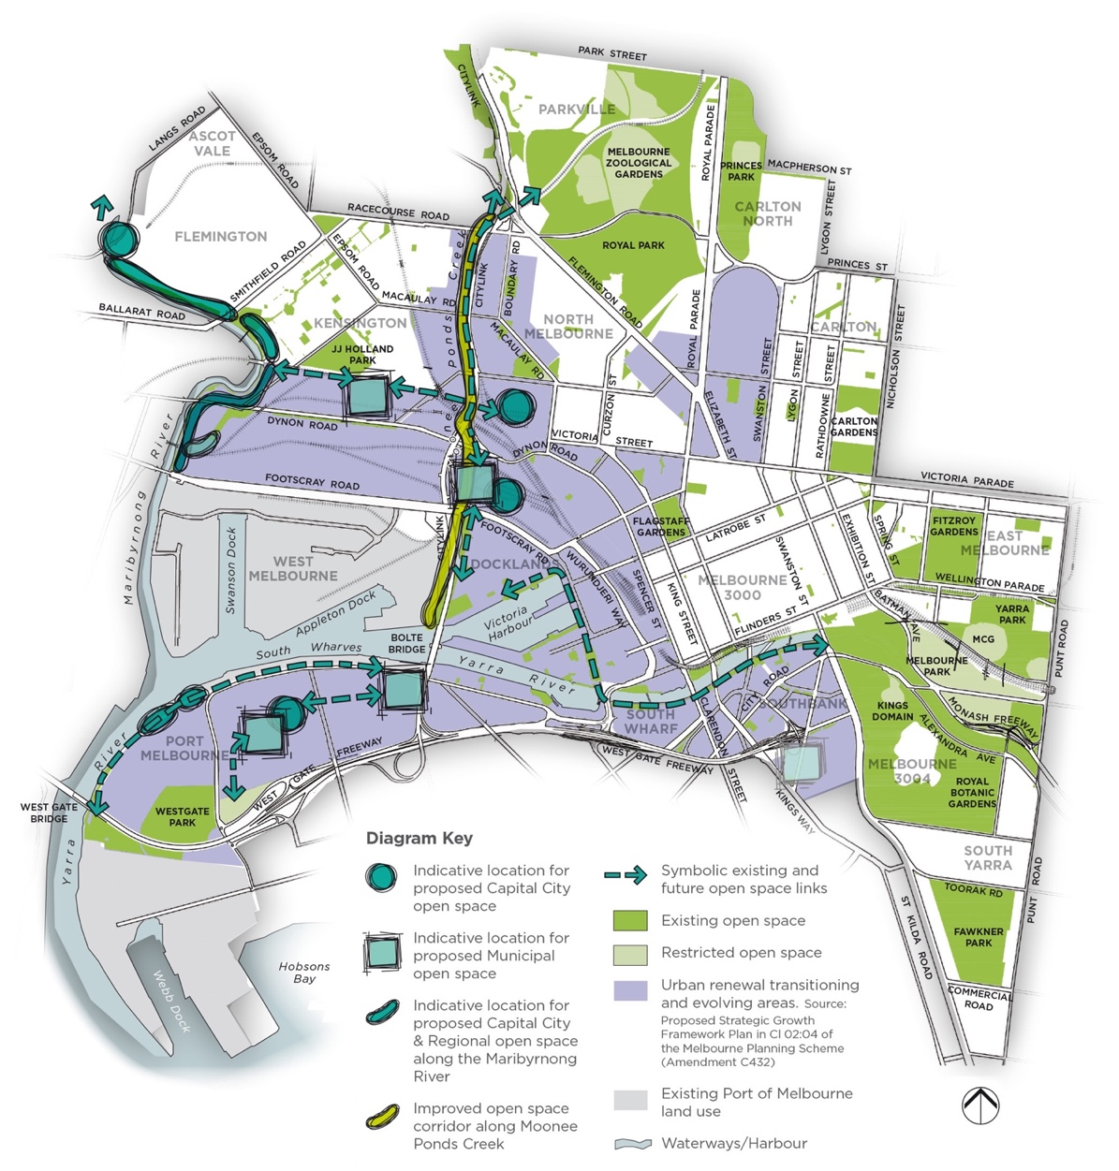

5.5.2 Update to the provision of new Municipal open space in this Light Touch Review
The locations for new Municipal open space in the 2012 Strategy were based on the forecast growth framework at the time it was prepared. With the changes to the growth framework described in Section 3.2 of this Light Touch Review, two new Municipal open spaces are proposed in Port Melbourne in the Lorimer and the Fishermans Bend N-e-i-c precincts.
In addition to the two new Municipal open spaces in Lorimer and the Fishermans Bend N-e-i-c, new Municipal open space is also required in the Dynon and E-Gate urban renewal areas. Given the nature of the high density development in Southbank, the Strategy recommends retaining a long term option for the provision of new Municipal open space there if a future opportunity arises.
This Light Touch Review recommends that Figure 5(e) is updated to illustrate the changes as indicatively shown in Figure 5A in this Light Touch Review.
Recommendation Ltr4.
Replace Figure 5(e) Indicative locations of the future Municipal open space in the City of Melbourne in the 2012 Strategy Technical Report with the revised plan shown in Figure 5A Indicative locations of the future Capital City, Regional and Municipal open space in the City of Melbourne, updated as to show additional areas based on this Light Touch Review 2024.

5.5.3 Update to acquiring new Municipal open space
While the 2012 Strategy relied on new Municipal open space being provided on Victorian Government owned land, this Light Touch Review recommends including a second option to purchase the land area required for this if it cannot be provided at no cost by the Victorian Government. It is important that these areas of Municipal open space are secured either ahead of, or as part of, the future urban renewal area planning.
On the following page is the updated Recommendation 6.1.3-B from the 2012 Strategy Technical Report regarding the provision of new Municipal open space:
No. | Recommendation | Responsibility | Priority
6.1.3-B | Recommendation: New Municipal open space  To secure new Municipal open space, the options available include:  Option one - the City of Melbourne is to advocate to the Victorian Government to set aside land area for future Municipal open space prior to the state owned land being planned for redevelopment. The purpose of the Municipal open space is to primarily provide community sport and recreation facilities that support the future population on both the Victorian Government redevelopment sites and in the broader catchment as shown indicatively in Figure 5A in this Light Touch Review. The preferred size and purpose for each of the new Municipal open spaces will be defined by the City of Melbourne and refined in consultation with the Victorian Government.  Option 2 - the City of Melbourne is to investigate undertaking a detailed assessment of suitable privately owned and other land in the vicinity of each of the indicative locations for proposed new Municipal open space shown in Figure 5A of this Light Touch Review. The assessment for this is to be guided by the criteria for the new open space in the updated Table 6 (ii) in the Light Touch Review. If Option 2 is pursued, the investigation is to include the indicative cost of land acquisition for identified land parcels and likely timing of conversion to open space. Additional funding may need to be sought from future development for this purpose, as the cost of land acquisition for Municipal open space in these locations has not been included in the current Schedule 2, Clause 53.01 Public open space contribution in the Melbourne Planning Scheme or in a Development Contributions Plan.  Refer to Section 6.3.1 regarding assessment criteria for suitability of land as public open space. | Responsibility: C-o-m | Priority: Very High

Recommendation Ltr5.
Replace Recommendation 6.1.3-B in the 2012 Strategy Technical Report with the revised Recommendation 6.1.3-B included in this Light Touch Review, which describes the second option to identify suitable land parcels for purchase as Municipal open space in the indicative locations shown in Figure 5A in the Light Touch Review 2024.

5.6 Quality of existing and new open space

5.6.1 Existing recommendations regarding the quality of open space in the 2012 Strategy
Section 6.2 of the 2012 Strategy provides overall direction and guidance for the improvement to the quality of the existing and new open space. These guidelines have been reviewed and overall they are still current and relevant, however the recommendations in Section 6.2.4, Biodiversity and Section 6.2.5, Cultural heritage are recommended to be updated to better respond to policy changes since the 2012 Strategy was prepared. This includes the Nature in the City Strategy, the updated plans regarding the waterway corridors and the Reconciliation Strategy.

5.6.2 Proposed updates to the recommendations regarding the quality of open space in this Light Touch Review
These updated recommendations replace the same numbered recommendations in the 2012 Strategy Technical Report.
Waterway corridors
No. | Recommendation | Responsibility | Priority
6.2.4a(i) | Recommendation: Moonee Ponds Creek  Continue to work to transform this creek corridor to improve the ecological, cultural and recreational values of the waterway corridor and the adjoining open space reserves. This includes providing trails along the corridor and east-west bridge access across it to improve connectivity between the new urban renewal areas in Arden and Macaulay. Advocate for a state level implementation plan to coordinate governance, funding and resolution of the fragmented land ownership along the waterway corridor. Implement or facilitate actions consistent with the state level documents including the Waterways of the West Strategy and C-o-m endorsed strategic documents including the Moonee Ponds Creek Strategic Opportunities Plan and the Draft Macaulay Structure Plan. Future open space adjoining Moonee Ponds Creek needs to clearly identify areas that are encumbered as described in Recommendation 6.3.2d(i) and other considerations including within the minimum 30 metre riparian zone, noise levels and overshadowing. Any future open space provided as an open space contribution as part of Clause 53.01 is to be in addition to encumbered land. | Responsibility: C-o-m  Mwc  T-o  VicTrack,  Dev Vic  CityLink  Dtp | Priority: Ongoing
6.2.5b(ii) | Recommendation: Maribyrnong River  Existing and proposed expansion to the open space corridor and ongoing improvements are to be designed to improve biodiversity values along the river corridor where appropriate, consistent with the Waterways of the West Strategy and engagement with the Traditional Owners, Melbourne Water and other relevant agencies including Flemington Racecourse, Parks Victoria and adjoining municipalities as required regarding future proposals for the open space adjoining the river. Future proposals for the additional open space adjoining the river need to clearly identify areas that are encumbered as described in Recommendation 6.3.2d(i)k, including within the 30 metre riparian zone. Any future open space provided as an open space contribution as part of Clause 53.01 is to be in addition to encumbered land. | Responsibility: C-o-m  Mwc  T-o  Government Agencies | Priority: Ongoing
6.2.5b(iii) | Recommendation: Yarra River (Birrarung)  In future open space upgrades along the Yarra River (Birrarung), ensure they are consistent with the Yarra Plan, the Yarra Strategic Plan the Greenline Project and engagement with the Traditional Owners, Melbourne Water and other relevant agencies including Parks Victoria and adjoining Municipalities. Investigate opportunities to improve the biodiversity values where and appropriate to the existing and historical character of the waterway. | Responsibility: C-o-m  Mwc  T-o  Government Agencies | Priority: Ongoing
Indigenous cultural heritage values
No. | Recommendation | Responsibility | Priority
6.2.5a(i) | Recommendation: Involvement of Traditional Owners in the management, planning and development of open space  Future management, planning and development of open space will include meaningful and respectful involvement of the Traditional Owners. | Responsibility: C-o-m  T-o  Developer  Government Agencies | Priority: Ongoing

Recommendation Ltr7.
Replace the Recommendations in the 2012 Strategy Technical Report with the following revised recommendations included in the Light Touch Review 2024 to strengthen the biodiversity and nature conservation values:
- ‘Recommendation 6.2.4a(i) Moonee Ponds Creek’
- ‘Recommendation 6.2.5b(ii) Maribyrnong River’
- ‘Recommendation 6.2.5b(iii) Yarra River’

Recommendation Ltr8.
Update the Recommendation to develop an agreed framework to ensure Traditional Owners have meaningful and purposeful involvement in the management, planning and development of open space including:
- Update Recommendation 6.2.5a(i) Involvement of Traditional Owners in the management, planning and development of open space.

6 Updated precinct actions

6.1 Overview
The scope for this Light Touch Review identified the need for an updated action plan to reflect the changes in forecast growth and change that has occurred over the past 10 years. The actions are prepared by precinct in the 2012 Strategy Technical Report, and the same precinct extents and naming has been used in the Light Touch Review for consistency.
The updated action plan is based on the following:
- Assessment of the residential growth and change between 2011 and 2021 including the spatial analysis using the Mesh Block mapping included in Appendix A.
- Research and review of the implications of the changes to the strategic growth framework and other key policy changes and updates as described in Sections 1 to 5 of this Light Touch Review.
- Assessment of the residential forecasts supplied to the project by the City of Melbourne and summarised in Section 3.3 of this Light Touch Review.
- The assumption that the employment growth included in the 2012 Strategy will continue as forecast.
Below is a brief comparison for each precinct of the actual residential population change between 2011 and 2021 compared to what was forecast to occur by 2026 in the 2012 Strategy:
- Carlton | Carlton North – on a precinct wide level the change has been slower than forecast at 17 per cent compared to the 62 per cent change that was forecast.
- Docklands – the change has occurred at a faster rate than was forecast at 160 per cent compared to the 132 per cent change that was forecast.
- East Melbourne – there has been a loss of residential population in this precinct rather than an increase with -4 per cent decrease compared to the 12 per cent increase that was forecast.
- Flemington | Ascot Vale – there has been no growth in this precinct compared to the 4,950 residents that were forecast.
- Kensington – change has occurred more slowly at 5 per cent compared to the 26 per cent change that was forecast.
- Melbourne 3000 – the residential growth was higher than forecast at 108 per cent compared to the 67 per cent that was forecast.
- Melbourne 3004 | South Yarra - the residential growth in Melbourne 3004 was higher than forecast with 91 per cent change compared to the 27 per cent that was forecast. In South Yarra there has been a loss of residential population with a -21 per cent loss compared to 0 per cent change that was forecast.
- North Melbourne – the residential growth was much slower than forecast at 34 per cent change compared to the 92 per cent change that was forecast.
- Parkville – the residential growth was substantially more than forecast with a 35 per cent increase compared to the 1 per cent that was forecast.
- Port Melbourne – there was no residential population in 2021 and this is consistent with the 0 per cent change that was forecast.
- Southbank | South Wharf – residential growth has been similar to what was forecast with a 72 per cent increase compared to the 78 per cent change that was forecast.
- West Melbourne – residential growth has been slower than was forecast with a 108 per cent increase compared to the 146 per cent that was forecast.
The precinct action tables from the 2012 Strategy Technical Report have been extracted and included in this Light Touch Review. Each action has been assessed and all changes to the actions and the new actions are included in this Report. These Action Tables now replace the Action Tables in the 2012 Strategy Technical Report. Each precinct chapter also includes:
- Updated table of number, size and type open space
- Updated table listing the existing open space in alphabetical order
- Updated spatial plan showing the updated existing open space network, with symbols to highlight the new open spaces and those that have changed in size.
- A summary of the changes to the population forecasts from 2011 to 2021
- A summary of the population forecasts for the next 10 year period to 2031
- Updated precinct action tables with all changes to the actions since the 2012 Strategy included in this Light Touch Review.
Recommendation Ltr9.
Ltr9.1 – Replace the Precinct Action Tables in Sections 7 and 8 of the 2012 Strategy Technical Report with the Precinct Action Tables included in the Light Touch Review 2024.
Ltr9.2 – Replace the Existing Open Space Tables and Figures in 7 and 8 of the 2012 Strategy Technical Report with the updated Existing Open Space Tables and Figures in the Section 6 of the Light Touch Review 2024.

Recommendation Ltr10.
Replace the following Precinct Recommendations Plans in the 2012 Strategy Technical Report with those in this Light Touch Review, including:
- Flemington/Ascot Vale (Figure7.4~4 in the 2012 Strategy Technical Report to be replaced with Figure 6E in the Light Touch Review 2024)
- Port Melbourne (Figure 8.5~4 in the 2012 Strategy Technical Report to be replaced with Figure 6M in the Light Touch Review 2024)
- Southbank/South Wharf (Figure 7.8~5 in the 2012 Strategy Technical Report to be replaced with Figure 6O in the Light Touch Review 2024)
- West Melbourne (7.9~5 in the 2012 Strategy Technical Report to be replaced with Figure 6R in the Light Touch Review 2024).

6.2 Carlton | Carlton North
Please refer to Section 7.2 in the 2012 Strategy Technical Report
The following Figures, Tables and Sections have been updated from the 2012 Strategy Technical Report and included in this Light Touch Review. The remaining information in Section 7.2 of the 2012 Strategy Technical Report remains unchanged:
- Figure 7.2~1
- Table 7.2 (i)
- Table 7.2 (iia)
- Table 7.2 (iib)
- Table 7.1 (iic)
- Section 7.2.5b, Precinct Actions for Carlton | Carlton North

6.2.1 Changes to the existing open space network since the 2012 Strategy
Figure 6A illustrates the changes to the open space network since the 2012 Strategy was prepared. As noted in Section 4.2 of this Light Touch Review, new open space has been added to the network. In Carlton, the new open spaces are mainly associated with the redevelopment of the public housing in Carlton. Additionally, there has been an expansion to the size of Lincoln and University Squares.
The quantity of open space has increased in Carlton | Carlton North from 56.31 hectares in the 2012 Strategy to 57.39 hectares in 2023, resulting in an additional 1.08 hectares of open space.
Table 7.2(i) Updated number, size and type of open space in Carlton | Carlton North
No. | Hierarchy of open space | Area | %
1 | Capital city open space | 8.81 hectares | 15%
2 | Regional open space | 39.98 hectares | 70%
5 | Neighbourhood open space | 6.87 hectares | 12%
2 | Local open space | 0.74 hectare | 1%
6 | Small Local open space | 0.74 hectare | 1%
3 | Small Local Link | 0.26 hectare | 0%
19 | Totals | 57.39 hectares | 100%
1 | Restricted open space | 4.38 hectares | Percentage not applicable
Table 7.2(iia) Updated existing open space in Carlton in 2023
Open space | Hierarchy | Total area in square metres | Total area in hectares
Argyle Square | Neighbourhood open space | 13,298 square metres | 1.33 hectares
Barkly St Closure | Small Local Link | 433 square metres | 0.04 hectare
Burton Reserve | Small Local Link | 1,881 square metres | 0.19 hectare
Canning & Neill Street Reserve | Small Local open space | 1,897 square metres | 0.19 hectare
Canning & Palmerston Street Reserve | Small Local open space | 403 square metres | 0.04 hectare
Cardigan Street Park | Small Local open space | 527 square metres | 0.05 hectare
Carlton Gardens North | Regional open space | 71,160 square metres | 7.12 hectares
Carlton Gardens South | Capital City open space | 88,121 square metres | 8.81 hectares
Keppel Street Park | Small Local open space | 383 square metres | 0.04 hectare
Lincoln Square | Neighbourhood open space | 16,270 square metres | 1.63 hectares
Macarthur Square | Local open space | 3,590 square metres | 0.36 hectare
Murchison Square | Local open space | 3,767 square metres | 0.38 hectare
Neill Street Reserve | Neighbourhood open space | 10,300 square metres | 1.03 hectares
Reeves Street Park | Small Local open space | 1,625 square metres | 0.16 hectare
Station Street Park | Small Local open space | 2,561 square metres | 0.26 hectare
Pitt St Closure | Small Local Link | 243 square metres | 0.02 hectare
University Square | Neighbourhood open space | 18,496 square metres | 1.85 hectares
Total area | Not applicable | 234,955 square metres in total | 23.50 hectares in total
Table 7.2(iib) Updated existing open space in Carlton North in 2023
Open space | Hierarchy | Total area in square metres | Total area in hectares
Hardy Reserve | Neighbourhood open space | 10,290 square metres | 1.03 hectares
Princes Park (excluding Visy Oval) | Regional open space | 328,644 square metres | 32.86 hectares
Total area | Not applicable | 338,934 square metres in total | 33.89 hectares in total

Table 7.2(iic) Updated existing restricted open space in Carlton North in 2023
Open space | Hierarchy | Total area in square metres | Total area in hectares
Princes Park - Visy Oval / Restricted open space | Regional open space | 43,756 square metres | 4.38 hectares
Total area | Not applicable | 43,756 square metres in total | 4.38 hectares in total
The changes to the open space network since the 2012 Strategy are shown in Figure 6A.
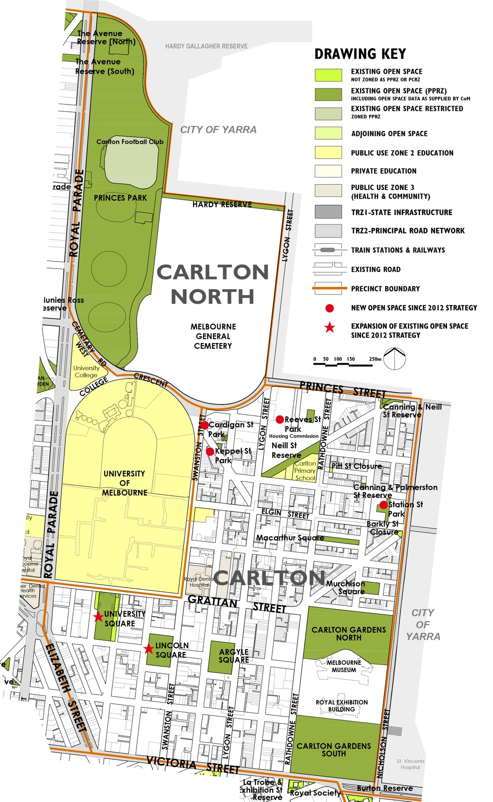

6.2.2 Summary of the population change between 2011 and 2021
As noted in Section 3.3.1 in this Light Touch Review, the residential population has grown by 17 per cent between 2011 and 2021. This is lower than the 62 per cent growth forecast over the 15 year timeframe in the 2012 Strategy. An additional 2,541 residents were living in Carlton in 2021. As noted in Section 3.3.3 in this Light Touch Review, the employment population figures for 2021 were impacted by Covid-19 and are not reported here.

6.2.3 Summary of the forecast population change from 2021 to 2031
The resident population is forecast to continue to grow over the next 10 years with an additional 9,189 residents forecast to live in Carlton by 2031, which represents a 53 per cent increase from 2021. While there was no spatial breakdown of the forecasts provided we assume the majority of the change will occur in the City North area shown in Figure 3A in this Light Touch Review.
As noted in Section 3.3.2, the employment population forecasts from the 2012 Strategy will continue to be relied on, which is in Section 7.2.4a of the 2012 Strategy Technical Report. In summary, the worker population is forecast to continue to grow through to 2026.

6.2.4 Implications for the population forecast changes on the updated Actions in this Section
By 2031, 9,189 additional residents are forecast to be living in Carlton which is 2,600 more than the total residential population forecast by 2026 in 2012 Strategy, while the worker population we are planning for has already been accounted for in the actions from 2012 Strategy. Given this, we have assumed a slightly higher overall population than was planned for in the 2012 Strategy. Please refer to Section 7.2 of the 2012 Strategy Technical Report for the rationale for the actions in addition to the updated information in this Light Touch Review.
Table 7.2 (iv) in the 2012 Strategy Technical Report requires two corrections - Sub-precinct CN3 needs to be renumbered to CN4, and sub-precinct CN4 needs to be renumbered to CN5.

6.2.5 Updated Precinct Actions for Carlton | Carlton North
Please note the Actions retain the numbering from the 2012 Strategy Technical Report.
A Additional open space
No. | Action | Responsibility | Priority
Action 7.2A-1 | Provide additional Small Local open space in the south-west area of sub-precinct CN4 to cater to the existing and future population. This will contribute to urban greening and cooling and provide a small space close to residents in this high density precinct, and complement the nearby Lincoln and University Squares. | Responsibility: C-o-m  Developer | Priority: Very High
Action 7.2A-2 | Provide an additional Small Local open space in sub-precinct CN5 the vicinity of the CUB site primarily for the forecast substantial additional population. This will contribute to urban greening and cooling and provide an accessible open space for residents without crossing major roads. | Responsibility: C-o-m  Developer | Priority: Very High
Action 7.2A-3 | Action completed with the provision of two new open spaces being Cardigan Street Park and Keppel Street Park. Refer to Actions 7.2H-3 and 7.2H-4. | Responsibility: C-o-m  Developer | Priority: Complete
Action 7.2A-4 | Action completed with the provision of the new Station Street Park. Refer to Action 7.2H-5. | Responsibility: C-o-m  Developer | Priority: Complete
Action 7.2A-5 | Provide a Local open space in sub-precinct C4 for both the existing and forecast future population. This sub-precinct currently has no open space. | Responsibility: C-o-m  Developer | Priority: High
B Additional open space links
Not applicable

C Capital City open space
No. | Action | Responsibility | Priority
Action | Carlton Gardens South  Continue to implement the updated Carlton Gardens Masterplan (adopted 2022) with a focus on meeting the broader regional needs within the context of the World Heritage values of the gardens. Note the updated 2022 Masterplan combines Carlton Gardens North and South in the one Masterplan. | Responsibility: C-o-m | Priority: Ongoing
D Regional open space
No. | Action | Responsibility | Priority
Action 7.2D-1 | Carlton Gardens North  Continue to implement the updated Carlton Gardens Master Plan (adopted 2022) providing facilities for the local population as well as the broader regional needs within the context of the World Heritage values of the gardens. Note the updated 2022 Masterplan combines Carlton Gardens North and South in the one Masterplan. | Responsibility: C-o-m | Priority: Ongoing
Action 7.2D-3 | Princes Park  Continue to implement the Princes Park Master Plan and accommodate and manage existing and future structured sporting needs of the existing and forecast additional population in the future. | Responsibility: C-o-m | Priority: Ongoing
E Municipal open space
Not applicable
F Neighbourhood open space
No. | Action | Responsibility | Priority
Action 7.2F-1 | Argyle Square  Continue to maintain with minor upgrades as required to accommodate the increased use from the forecast local population in the City North urban renewal precincts CN4 and CN5 which are located within walking distance to the west of Argyle Square. | Responsibility: C-o-m | Priority: Low
Action 7.2F-2 | Lincoln Square  Continue to implement the upgrade works included in the Landscape Concept Plan. | Responsibility: C-o-m | Priority: Ongoing
Action 7.2F-3 | University Square  Finalise and implement Part Two of the 2016 Masterplan incorporating the Metro Station entry to the north-west side of the Square. Part One of the Masterplan has been completed. | Responsibility: C-o-m | Priority: Very High
Action 7.2F-4 | Neill Street Reserve  Action completed. Continue to maintain. | Responsibility: C-o-m | Priority: Ongoing

Action 7.2F-5 | Hardy Reserve  Prepare a Landscape Concept Plan to investigate options to improve the use of this reserve for the local community living to the north. Future plans to prioritise protecting the existing mature canopy trees. | Responsibility: C-o-m | Priority: Low
G Local open space
No. | Action | Responsibility | Priority
Action 7.2G-1 | Macarthur Square  Continue to maintain and manage the heritage values balanced with contemporary recreational needs and values. | Responsibility: C-o-m | Priority: Ongoing
Action 7.2G-2 | Murchison Square  Continue to maintain and manage the heritage values balanced with contemporary recreational needs and values. | Responsibility: C-o-m | Priority: Ongoing
H Small Local open space
No. | Action | Responsibility | Priority
Action 7.2H-1 | Canning & Palmerston Street Reserve  Investigate future minor upgrade including playground within the context of other facilities provided in new open space in sub-precinct C3. | Responsibility: C-o-m | Priority: Low
Action 7.2H-2 | Canning & Neill Street Reserve  Minor upgrade to improve function and use within the context of other facilities provided in new open space in sub-precinct C3. | Responsibility: C-o-m | Priority: Medium
Action 7.2H-3 | Cardigan Street Park  Continue to maintain | Responsibility: C-o-m | Priority: Ongoing
Action 7.2H-4 | Keppel Street Park  Continue to maintain. | Responsibility: C-o-m | Priority: Ongoing
Action 7.2H-5 | Station Street Park  Continue to maintain. | Responsibility: C-o-m | Priority: Ongoing
J Small Local Link
No. | Action | Responsibility | Priority
Action 7.2J-1 | Burton Reserve  Continue to maintain. | Responsibility: C-o-m | Priority: Ongoing
Action 7.2J-2 | Pitt Street Closure  Continue to maintain. | Responsibility: C-o-m | Priority: Ongoing
Action 7.2J-3 | Barkly Street Closure  Continue to maintain. | Responsibility: C-o-m | Priority: Ongoing

6.3 Docklands
Please refer to Section 7.3 in the 2012 Strategy Technical Report
The following Figures, Tables and Sections have been updated from the 2012 Strategy Technical Report and included in this Light Touch Review. The remaining information in Section 7.3 of the 2012 Strategy Technical Report remains unchanged:
- Figure 7.3~1
- Table 7.3(i)
- Table 7.3(ii)
- Section 7.3.5b, Precinct Actions for Docklands

6.3.1 Changes to the existing open space network since the 2012 Strategy
Figure 6B illustrates the changes to the open space network since the 2012 Strategy was prepared. As noted in Section 4.2 of this Light Touch Review, new open space has been added to the network. In Docklands, the eight new open spaces have been provided across the precinct as part of the major urban renewal project managed by the Victorian Government in partnership with the developers.
The quantity of open space has increased in Docklands from 12.12 hectares in the 2012 Strategy to 16.36 hectares in 2023, resulting in an additional 4.25 hectares of open space.
Table 7.3(i) Updated number, size and type of open space in Docklands
No. | Hierarchy of open space | Area | %
1 | Capital City open space | 0.09 hectare | 1%
7 | Regional open space | 11.30 hectares | 70%
1 | Municipal open space | 2.45 hectares | 15%
3 | Local open space | 1.29 hectares | 8%
8 | Small Local open space | 0.92 hectare | 6%
19 | Totals | 16.04 hectares | 100%
Table 7.3(ii) Updated existing open space in Docklands in 2023
Open space | Hierarchy | Total area in square metres | Total area in hectares
Adela Lane Reserve | Small Local open space | 1,071 square metres | 0.11 hectare
Buluk Park | Local open space | 4,211 square metres | 0.42 hectare
Collins Landing/Australian Wharf | Regional open space | 6,363 square metres | 0.64 hectare
Docklands Community Hub Reserve | Small Local open space | 1,438 square metres | 0.14 hectare
Docklands Park | Regional open space | 22,292 square metres | 2.23 hectares
Flinders & Spencer Street Reserve | Small Local open space | 462 square metres | 0.05 hectare
Moonee Ponds Creek Reserve | Regional open space | 39,079 square metres | 3.91 hectares
New Quay Central Park | Local open space | 4,426 square metres | 0.44 hectare
New Quay Promenade | Regional open space | 17,612 square metres | 1.76 hectares
Point Park | Regional open space | 10,689 square metres | 1.07 hectares
Quay Park | Small Local open space | 1,652 square metres | 0.17 hectare
Queens Warehouse | Small Local open space | 1,454 square metres | 0.15 hectare
Ron Barassi Senior Park | Municipal open space | 24,503 square metres | 2.45 hectares
Seafarers Rest | Regional open space | 5,256 square metres | 0.53 hectare
Spencer Street Plaza (Southern Cross Station Plaza) | Capital City open space | 884 square metres | 0.09 hectare
Unnamed Reserve | Small Local open space | 736 square metres | 0.07 hectare
Unnamed Reserve | Small Local open space | 1,183 square metres | 0.12 hectare
Victoria Harbour Promenade | Regional open space | 11,655 square metres | 1.17 hectares
Victoria Green | Local open space | 4,281 square metres | 0.43 hectare
Wharfs Landing | Small Local open space | 1,174 square metres | 0.12 hectare
Total area | Not applicable | 160,421 square metres in total | 16.04 hectares in total
The changes to the open space network since the 2012 Strategy are shown in Figure 6B.
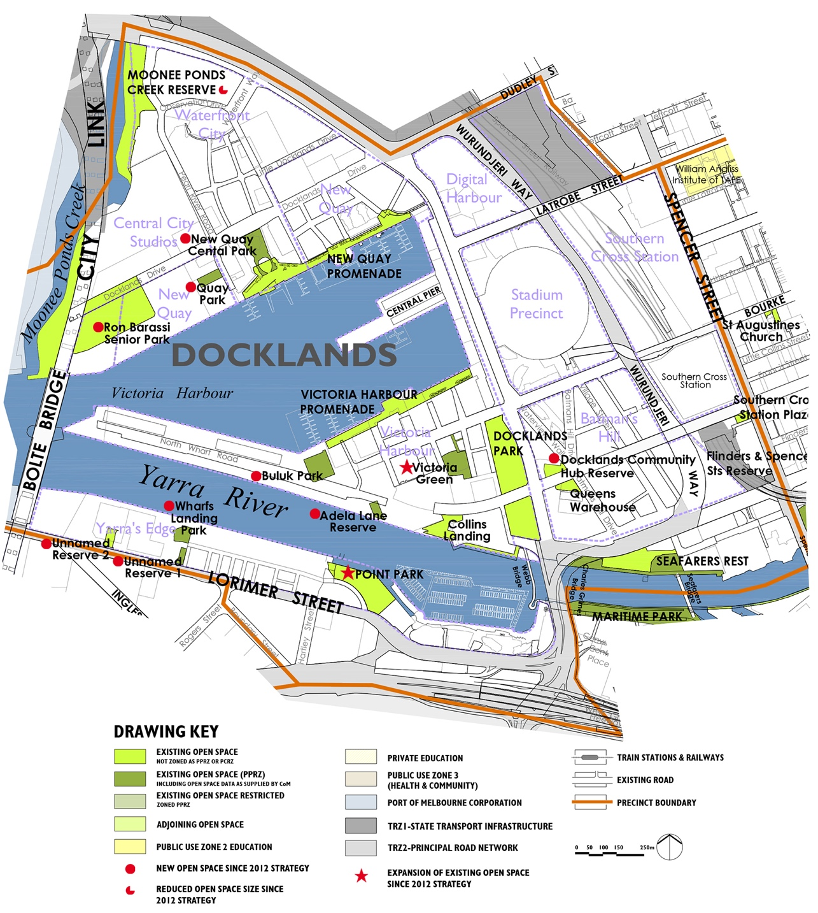

6.3.2 Summary of the population change between 2011 and 2021
As noted in Section 3.3.1 of this Light Touch Review, there has been 160 per cent resident population growth in Docklands between 2011 and 2021. This is higher than the 130 per cent change that was forecast to occur by 2026 over the 15 year timeframe of the 2012 Strategy. An additional 9,792 residents were living in Docklands in 2021.
As noted in Section 3.3.3 of this Light Touch Review, the employment figures for 2021 were impacted by Covid-19 and are not reported here.

6.3.3 Summary of the forecast population change from 2021 to 2031
The resident population is forecast to continue to increase over the next 10 years with an additional 9,366 residents forecast to live in Docklands by 2031, which represents a 59 per cent increase from the 2021 population. While there was no spatial breakdown of the forecasts provided we assume the majority of the change will be distributed across the precinct.
As noted in Section 3.3.2, the employment population forecasts from the 2012 Strategy will continue to be relied on, which is in Section 7.3.4a of the 2012 Strategy Technical Report.

6.3.4 Implications for the population forecast changes on the updated Actions in this Section
Overall, there will be more than 9,000 additional residents living in Docklands by 2031, which is approximately 5,500 more residents than the total residential population change forecast in 2012 Strategy over the 15 year period to 2026. We are also assuming the same number of the additional workers to be in the precinct as was forecast in 2012 Strategy. We have therefore assumed a higher population overall, and hence the reason for recommending that the actions from the 2012 Strategy continue to be implemented including the additional open space. Please refer to Section 7.3 Docklands in the 2012 Strategy Technical Report for the rationale and break down that explains the conclusions and recommendations for the actions in the 2012 Strategy. It is important to note that since the 2012 Strategy was adopted by Council, the Minister for Planning excluded the leased area of Docklands from the open space contribution rate and decreased the areas outside the lease areas to 5 per cent.
For this Light Touch Review, a number of new open spaces have been delivered since the 2012 Strategy based on the development agreements. The approach taken for the update to the Precinct Actions for Docklands is to reference the original analysis and recommendations as this was not constrained by the subsequent removal of the precinct from the open space contribution rate by the Minister for Planning, and instead represents recommendations based on a consistent open space needs assessment applied across the whole municipality at that time.

6.3.5 Updated Precinct Actions for Docklands
Please note the Actions retain the numbering from the 2012 Strategy Technical Report.
A Additional open space
No. | Action | Responsibility | Priority
Action 7.3A-1 | Action completed with the provision of the new Local open space - New Quay Central Park. Refer to Action 7.3G-2. | Responsibility: Dev Vic  C-o-m  Developer | Priority: Complete
Action 7.3A-2 | Continue to advocate to Development Victoria to expand the size of Ron Barassi Senior Park to improve the diversity and quality of the structured sporting use at this park. Refer to Action 7.3E-1. | Responsibility: Dev Vic  C-o-m  Developer | Priority: Ongoing
Action 7.3A-3 | Provide an additional Local open space already agreed to by Development Victoria in sub-precinct D1 with access to the Yarra River (Birrarung). This is primarily to cater to the future population and will be required when development occurs. | Responsibility: Dev Vic  C-o-m  Developer | Priority: Medium
Action 7.3A-4 | Action completed with the provision of the new Small Local open space - Quay Park. Refer to Action 7.3H-4. | Responsibility: Dev Vic  C-o-m  Developer | Priority: Complete
Action 7.3A-5 | Action completed with the provision of the new Local open space - Buluk Park. Refer to Action 7.3G-3. | Responsibility: Dev Vic  C-o-m  Developer | Priority: Complete
Action 7.3A-6 | Provide an additional two Small Local open spaces on the waterfront adjacent to Harbour Esplanade as already agreed to by the Victorian government. This is to cater to existing and future population. One is located north of Central Pier and the other is south of Central Pier and will only be required when redevelopment of Central Pier occurs. | Responsibility: Dev Vic  C-o-m  Developer | Priority: Low
Action 7.3A-7 | Provide an additional Local open space on the western end of sub-precinct D2 near Bolte Bridge as already agreed to by the Victorian government and will only be required when this area redevelops. | Responsibility: Dev Vic  C-o-m  Developer | Priority: Medium
Action 7.3A-8 | Action completed with the provision of the new Small open space - Adela Lane Reserve. Refer to Action 7.3H-1. | Responsibility: Dev Vic  C-o-m  Developer | Priority: Complete
Action 7.3A-9 | Provide an additional Small Local open space central sub-precinct D3 to cater for the existing and future population when the forecast development occurs in this sub-precinct. | Responsibility: Dev Vic  C-o-m  Developer | Priority: Low
Action 7.3A-10 | Provide additional Small Local open space in the south-east area of open space sub-precinct D6. This is for the future population. | Responsibility: Dev Vic  C-o-m  Developer | Priority: High
Action 7.3A-11 | Action partially complete with the provision of 3 new Small Local open spaces, including Wharf's Landing Park and Unnamed Reserve 1 and 2. Council to continue to advocate to Development Victoria to expand the size of the existing reserves to create a larger space that is unencumbered and provides excellent sunlight and water access. | Responsibility: Dev Vic  C-o-m  Developer | Priority: Very High
Action 7.3A-12 | Continue to liaise with Development Victoria to provide a new Small Local open space in sub-precinct D1 to address the change from commercial to more residential development in this sub-precinct. | Responsibility: Dev Vic  C-o-m  Developer | Priority: Very High
B Additional open space links
Not applicable
No. | Action | Responsibility | Priority
Action 7.3B-1 | Southern Cross Station  Action completed. | Responsibility: C-o-m | Priority: Complete
Action 7.3B-2 | Achieve a public promenade along Victoria Harbour to connect New Quay Promenade to the Moonee Ponds Creek and proposed Municipal open space, sub-precinct D1. Capital City open space not costed in this Strategy. | Responsibility: Dev Vic  C-o-m | Priority: Ongoing
Action 7.3B-3 | Achieve a public promenade along Victoria Harbour connecting the future proposed new Local open space near Bolte Bridge to Victoria Harbour Promenade. Public realm, not costed in this Strategy | Responsibility: Dev Vic  C-o-m | Priority: Ongoing
Action 7.3B-4 | Achieve a public promenade along Victoria Harbour connecting the two proposed Small Local open spaces adjacent to Harbour Esplanade in sub-precinct D2. Capital City open space not costed in this Strategy | Responsibility: Dev Vic  C-o-m | Priority: Ongoing
Action 7.3B-5 | Achieve a public promenade along Victoria Harbour and Yarra River (Birrarung) connecting the Victoria Harbour Promenade around to Collins Landing in sub-precinct D2. Capital City open space not costed in this Strategy | Responsibility: Dev Vic  C-o-m | Priority: Ongoing
Action 7.3B-6 | Achieve a public promenade along the south side of the Yarra River (Birrarung) connecting Point Park to the proposed the Bolte Bridge sub-precinct D8. Capital City open space not costed in this Strategy | Responsibility: Dev Vic  C-o-m | Priority: Ongoing
Action 7.3B-7 | Northbank Promenade Greenline Project  Complete the Northbank Promenade Redevelopment project between Seafarers Rest and Collins Landing under Wurundjeri Way as part of the Greenline Project. | Responsibility: Vic Govt  C-o-m | Priority: Very High
C Capital City open space
No. | Action | Responsibility | Priority
Action 7.3C-1 | Southern Cross Station Plaza  Continue to maintain. | Responsibility: | Priority: Ongoing
D Regional open space
No. | Action | Responsibility | Priority
Action 7.3D-1 | Collins Landing  Connect Collins Landing to future public open space along the Yarra River (Birrarung) as part of the Greenline Project. | Responsibility: C-o-m | Priority: Ongoing
Action 7.3D-2 | Docklands Park  Prepare a new Landscape Master Plan for Docklands Park in consultation with the community to update add facilities that meet the recreational needs of the local community in the open space. This is particularly important for the population in open space sub-precincts D4 and D5 who have no other open space located nearby. | Responsibility: C-o-m  Dev Vic | Priority: High
Action 7.3D-3 | Moonee Ponds Creek  Continue to maintain and strengthen riparian and biodiversity values of the creek corridor. Post completion of the West Gate Tunnel Project, ensure public access north along the creek via shared paths is maintained or created, and that the riparian zone revegetation is implemented. Note, Regional works are not costed in this Strategy. | Responsibility: C-o-m  T-o  Mwc  Dev Vic  Dtp | Priority: Ongoing
Action 7.3D-5 | New Quay Promenade  Continue to advocate to Development Victoria to achieve a future extension to the west to connect to the Ron Barassi Senior Park. | Responsibility: C-o-m  Dev Vic  Developer | Priority: Very High
Action 7.3D-6 | Point Park  Council to advocate to the Victorian Government to expand this open space if the proposed new tram route to the Fishermans Bend reduces its size. | Responsibility: C-o-m  Vic Govt | Priority: Very High
Action 7.3D-7 | Seafarers Rest  Complete upgrade and undertake minor expansion as part of the Greenline Project as noted in 7.3B-7. | Responsibility: C-o-m | Priority: High
Action 7.3D-8 | Victoria Harbour Promenade  Continue to maintain. | Responsibility: C-o-m | Priority: Ongoing
E Municipal open space
No. | Action | Responsibility | Priority
Action 7.3E-1 | Ron Barassi Senior Park  Council to continue to advocate to the Victorian Government to expand the size of this reserve to improve the standard and diversity of structured sporting use for the existing and forecast community and undertake upgrades as required to improve its quality and use. | Responsibility: C-o-m  Dev Vic  Vic Govt | Priority: Very High
F Neighbourhood open space
Not applicable
G Local open space
No. | Action | Responsibility | Priority
Action 7.3G-1 | Victoria Green  Continue to maintain. | Responsibility: C-o-m | Priority: Ongoing
Action 7.3G-2 | New Quay Central Park  Continue to maintain this new open space established since the 2012 Strategy was prepared. | Responsibility: C-o-m | Priority: Ongoing
Action 7.3G-3 | Buluk Park  Continue to maintain this new open space established since the 2012 Strategy was prepared. | Responsibility: C-o-m | Priority: Ongoing
H Small Local open space
No. | Action | Responsibility | Priority
Action 7.3H-1 | Adela Lane Reserve  Continue to maintain this new open space established since the 2012 Strategy was prepared. | Responsibility: C-o-m | Priority: Ongoing
Action 7.3H-2 | Docklands Community Hub Reserve  Continue to maintain this new open space established since the 2012 Strategy was prepared. | Responsibility: C-o-m | Priority: Ongoing
Action 7.3H-3 | Flinders & Spencer Street Reserve  Continue to maintain. | Responsibility: C-o-m | Priority: Ongoing
Action 7.3H-4 | Quay Park  Continue to maintain this new open space established since the 2012 Strategy was prepared. | Responsibility: C-o-m | Priority: Ongoing
Action 7.3H-5 | Queens Warehouse  Council to continue to advocate to the Victorian Government to transfer this over to the City of Melbourne as public open space in the future. | Responsibility: C-o-m  Vic Govt | Priority: Ongoing
Action 7.3H-6 | Unnamed Reserve 1  Continue to advocate to the Victorian Government to expand the size of this reserve to increase its recreational function and use. | Responsibility: C-o-m  Vic Govt | Priority: Very High
Action 7.3H-7 | Unnamed Reserve 2  Continue to advocate to the Victorian Government to the expand the size of this reserve to increase its recreational function and use. | Responsibility: C-o-m  Responsibility: Vic Govt | Priority: Very High
Action 7.3H-8 | Wharfs Landing Park  Investigate opportunities to expand this open space given the high density precinct in which it is located and the need for it to provide a diversity of recreational opportunities. | Responsibility: C-o-m  Dev Vic  Developer | Priority: Very High

6.4 East Melbourne
Please refer to Section 8.2 in the 2012 Strategy Technical Report
The following Figures, Tables and Sections have been updated from the 2012 Strategy Technical Report and included in this Light Touch Review. The remaining information in Section 8.2 of the 2012 Strategy Technical Report remains unchanged:
- Figure 8.2~1
- Table 8.2(i)
- Tables 8.2(iia) and 8.2(iib)
- Section 8.2.5b, Precinct Actions for East Melbourne

6.4.1 Changes to the existing open space network since the 2012 Strategy
Figure 6C illustrates the changes to the open space network since the 2012 Strategy was prepared. As noted in Section 4.2 of this Light Touch Review, no new open space has been added to the network, however, there has been some minor updates to zoning of open space and transport corridors within the precinct.
The quantity of open space is slightly reduced by 14 square metres in East Melbourne, but has largely not changed from the 2012 Strategy with 65.27 hectares of open space and 11.13 hectares of restricted open space.
Table 8.2(i) Updated number, size and type of open space in East Melbourne
No. | Hierarchy of open space | Area | %
2 | Capital City open space | 31.94 hectares | 49%
1 | State open space | 25.86 hectares | 40%
1 | Municipal open space | 2.05 hectares | 3%
6 | Local open space | 4.08 hectares | 6%
8 | Small Local open space | 1.34 hectares | 2%
18 | Totals | 65.27 hectares | 100%
2 | Restricted open space | 11.13 hectares | Percentage not applicable
Table 8.2(iia) Updated existing open space in East Melbourne in 2023
Open space | Hierarchy | Total area in square metres | Total area in hectares
Burston Reserve | Small Local open space | 2,026 square metres | 0.20 hectare
Darling Square | Local open space | 8,194 square metres | 0.82 hectare
Fitzroy Gardens | Capital City open space | 261,000 square metres | 26.10 hectares
Gillott Reserve/Tianjin Gardens | Small Local open space | 1,360 square metres | 0.14 hectare
Gordon Reserve | Local open space | 3,785 square metres | 0.38 hectare
Jolimont Reserve | Local open space | 8,790 square metres | 0.88 hectare
Parliament Gardens | Small Local open space | 7,351 square metres | 0.74 hectare
Parliament of Victoria Forecourt | Small Local open space | 341 square metres | 0.03 hectare
Parliament Place | Local open space | 659 square metres | 0.07 hectare
Powlett Reserve | Municipal open space | 20,478 square metres | 2.05 hectares
Royal College Of Surgeons Gardens | Local open space | 4,533 square metres | 0.45 hectare
St Andrews Place Reserve | Small Local open space | 945 square metres | 0.09 hectare
Treasury Gardens | Capital City open space | 58,380 square metres | 5.84 hectares
Weedon Reserve | Local open space | 6,035 square metres | 0.60 hectare
Wellington Crescent | Small Local open space | 533 square metres | 0.05 hectare
Wellington Park | Local open space | 8,799 square metres | 0.88 hectare
William Haines Court | Small Local open space | 882 square metres | 0.09 hectare
Yarra Park | State open space | 258,600 | 25.86 hectares
Total area | Not applicable | 652,691 square metres in total | 65.27 hectares in total
The changes to the open space network since the 2012 Strategy are shown in Figure 6C.
Table 8.2(iib) Updated existing restricted open space in East Melbourne in 2023
Open space | Hierarchy | Total area in square metres | Total area in hectares
Melbourne Cricket Ground | Capital City open space | 83,950 square metres | 8.40 hectares
Richmond Cricket Ground | Capital City open space | 27,300 square metres | 2.73 hectares
Total Restricted open space | Not applicable | 111,250 square metres in total | 11.13 hectares in total
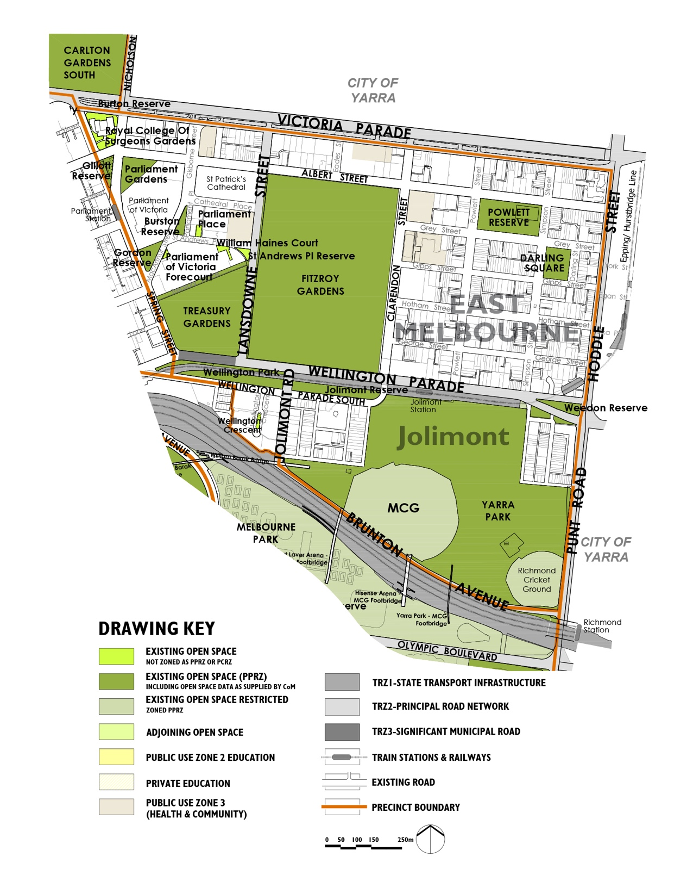

6.4.2 Summary of the population change between 2011 and 2021
As noted in Section 3.3.1 of this Light Touch Review, the residential population has reduced by 4 per cent between 2011 and 2021. This is lower than the 12 per cent growth forecast over the 15 year timeframe in the 2012 Strategy. There are 197 less residents in East Melbourne in 2021 with a total of 4,965 residents compared to 5,162 in 2011 in the 2012 Strategy.
As noted in Section 3.3.3 of this Light Touch Review, the employment figures for 2021 were impacted by Covid-19 and are not reported here.

6.4.3 Summary of the forecast population change from 2021 to 2031
The resident population is forecast to grow over the next 10 years an additional 2,480 residents forecast to live in East Melbourne by 2031, which represents a 50 per cent increase from 2021. This is a significant increase compared to reduction in the resident population between 2011 and 2021 and the forecasts prepared for the 2012 Strategy which was planning for an additional 608 people. There is no spatial breakdown of the forecasts provided, so we assume the majority of the change will be outside the heritage overlay areas.
As noted in Section 3.3.2, the employment population forecasts from the 2012 Strategy will continue to be relied on, which is in Section 8.2.4a of the 2012 Strategy Technical Report. In summary, the worker population was nearly four times the size of the resident population and it is forecast to continue to grow through to 2026.

6.4.4 Implications for the population forecast changes on the updated Actions in this Section
With the forecast increase in the resident population beyond what was forecast in the 2012 Strategy, there will be a need to improve the quality of the existing open space network to accommodate the additional population. The worker population we are planning for has already been accounted for the actions from the 2012 Strategy. Please refer to the remainder of Section 8.2 in the 2012 Strategy Technical Report for the rationale for the Actions in addition to the updated information in this Light Touch Review.

6.4.5 Updated Precinct Actions for East Melbourne
Please note the Actions retain the numbering from the 2012 Strategy Technical Report.
A Additional open space
No. | Action | Responsibility | Priority
Action 8.2A-1 | Additional Local open space  While not identified in the updated strategic growth framework plan, if any further development occurs on land associated with the Jolimont railway corridor in the future, then additional Local open space may be required subject to the scale and type of development proposed. | Responsibility: C-o-m  Developer | Priority: Long Term
B Additional open space links
No. | Action | Responsibility | Priority
Action 8.2B-1 | Links over the Brunton Avenue and the Railway  Action completed. | Responsibility: C-o-m | Priority: Complete
C Capital City open space
No. | Action | Responsibility | Priority
Action 8.2C-1 | Fitzroy Gardens  Continue to implement the updated 2010 Fitzroy Gardens Masterplan, particularly in the context of the forecast increased resident population in this precinct. | Responsibility: C-o-m | Priority: Medium
Action 8.2C-2 | Treasury Gardens  Continue to maintain and monitor the forecast increased levels of use that the Gardens will receive particularly during lunchtime for office workers, and upgrade where required to accommodate this use, particularly in the context of the forecast increased resident population in this precinct and also in Melbourne 3000. | Responsibility: C-o-m | Priority: Ongoing
D Regional open space
Not applicable
E Municipal open space
No. | Action | Responsibility | Priority
Action 8.2E-1 | Powlett Reserve  Continue to maintain this reserve. | Responsibility: C-o-m | Priority: Ongoing
F Neighbourhood open space
Not applicable
G Local open space
No. | Action | Responsibility | Priority
Action 8.2G-1 | Darling Square  Continue to implement minor upgrades, including stormwater reuse. | Responsibility: C-o-m | Priority: Medium
Action 8.2G-2 | Gordon Reserve  Continue to implement the Conservation Management Plan for this reserve. | Responsibility: C-o-m | Priority: Ongoing
Action 8.2G-3 | Parliament Gardens  Continue to maintain. | Responsibility: C-o-m | Priority: Ongoing
Action 8.2G-4 | Weedon Reserve  Prepare a design plan to guide future upgrade of Weedon Reserve including investigating the potential to improve accessibility and use of Weedon Reserve for people north of Wellington Parade, for the existing and forecast population in its catchment. | Responsibility: C-o-m | Priority: High
Action 8.2G-5 | Jolimont Reserve  Prepare a design plan to guide future major upgrades to this open space to improve access and use, for the existing and forecast population. | Responsibility: C-o-m | Priority: Medium
Action 8.2G-6 | Wellington Park  Continue to implement the design plan to guide future minor upgrades to this open space to improve access and use for the local community. | Responsibility: C-o-m | Priority: Medium
H Small Local open space
No. | Action | Responsibility | Priority
Action 8.2H-1 | Burston Reserve  Review existing design and undertake minor upgrades and tree placement works. | Responsibility: C-o-m | Priority: Complete
Action 8.2H-2 | Gillott Reserve  Continue to maintain. | Responsibility: C-o-m | Priority: Ongoing
Action 8.2H-3 | Parliament Place  Minor upgrade to improve access and function for public seating when not in use as outdoor seating for the adjoining café. | Responsibility: Vic Govt | Priority: Medium

Action 8.2H-4 | Royal College of Surgeons Gardens  Minor upgrade to provide additional seating for future population. | Responsibility: Royal College of Surgeons  C-o-m | Priority: Low
Action 8.2H-5 | St Andrews Place Reserve  Continue to maintain. | Responsibility: C-o-m | Priority: Ongoing
Action 8.2H-6 | Wellington Crescent  Continue to maintain. | Responsibility: C-o-m | Priority: Ongoing
J Small Local Link
No. | Action | Responsibility | Priority
Action 8.2J-1 | Parliament of Victoria Forecourt  Continue to maintain. | Responsibility: Vic Govt | Priority: Ongoing
Action 8.2J-2 | William Haines Court  Continue to maintain. | Responsibility: Vic Govt | Priority: Ongoing
K State open space
No. | Action | Responsibility | Priority
Action 8.2K-1 | Yarra Park  City of Melbourne to continue to advocate on behalf of the local community to maintain public access and use of Yarra Park while recognising its role in supporting the Melbourne Cricket Ground. | Responsibility: Mcc  C-o-m | Priority: Ongoing

6.5 Flemington | Ascot Vale
Please refer to Section 7.4 in the 2012 Strategy Technical Report
The following Figures, Tables and Sections have been updated from the 2012 Strategy Technical Report and included in this Light Touch Review. The remaining information in Section 7.4 of the 2012 Strategy Technical Report remains unchanged:
- Figure 7.4~1
- Table 7.4(i)
- Table 7.4(ii)
- Section 7.4.5b, Precinct Actions for Flemington | Ascot Vale

6.5.1 Changes to the existing open space network since the 2012 Strategy
Figure 6D illustrates the changes to the existing open space network since the 2012 Strategy was prepared. As noted in Section 4.2 of this Light Touch Review, new open space has been added to the network along the Maribyrnong River.
The quantity of open space has increased in Flemington | Ascot Vale from none in the 2012 Strategy to 1.9 hectares of new open space in 2023.
Table 7.4(i) Existing number, size and type of open space in Flemington | Ascot Vale
No. | Hierarchy of open space | Area | %
1 | Regional open space | 1.90 hectares | 100%
1 | Totals | 1.90 hectares | 100%
Table 7.4(ii) Existing open space in Flemington | Ascot Vale in 2023
Open space | Hierarchy | Total area in square metres | Total area in hectares
Maribyrnong River Bank Reserve (Flemington) | Regional open space | 19,001 square metres | 1.90 hectares
Total area | Not applicable | 19,001 square metres in total | 1.90 hectares in total
The changes to the open space network since the 2012 Strategy are shown in Figure 6D.
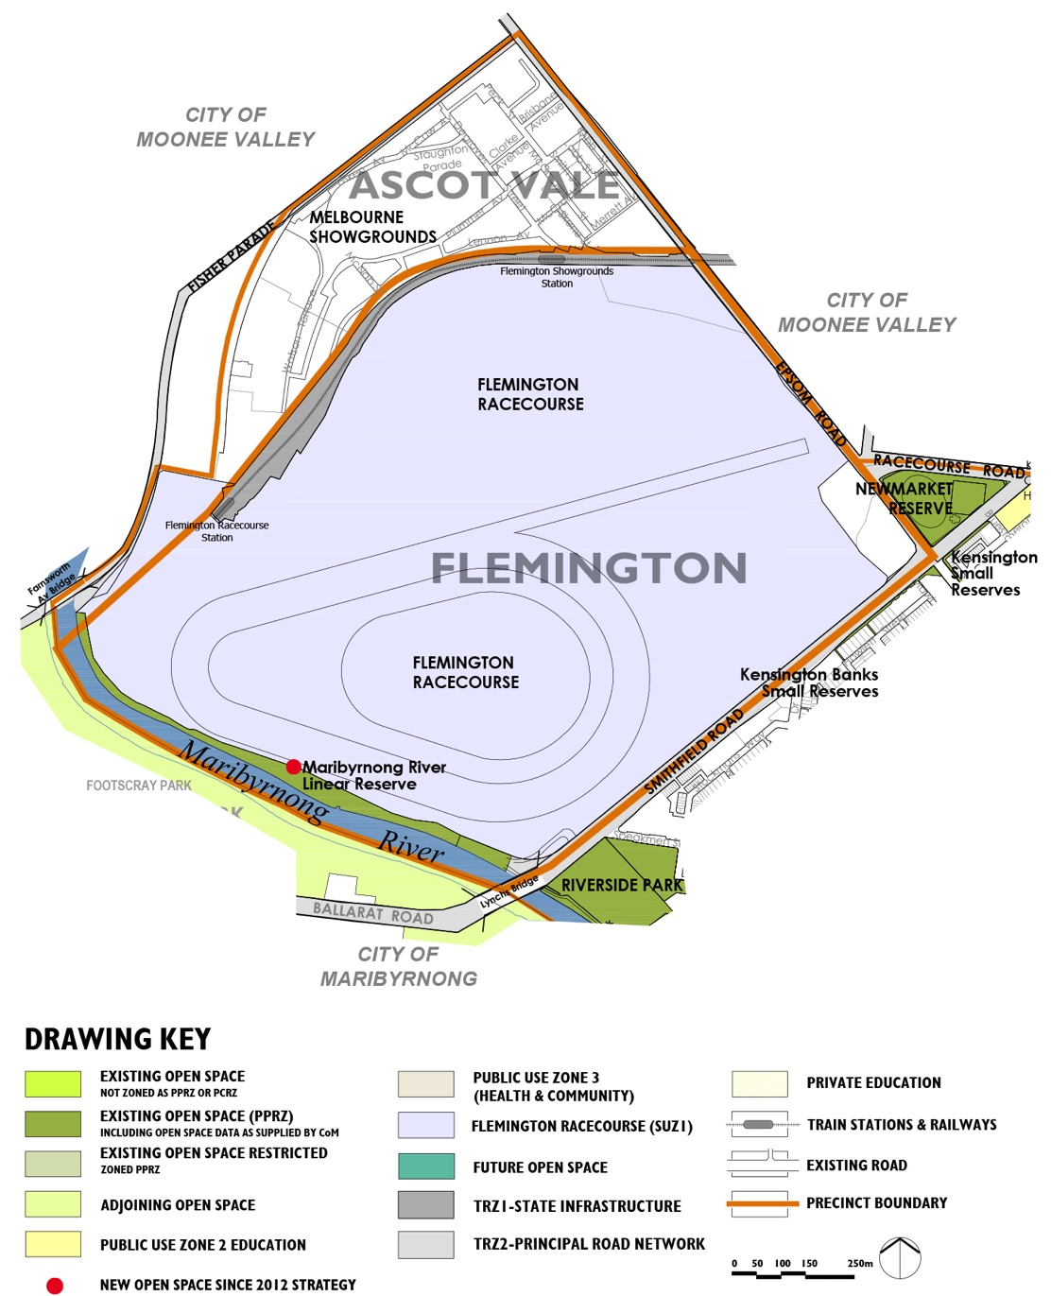

6.5.2 Summary of the population change between 2011 and 2021
As noted in Section 3.3.1 of this Light Touch Review, there was no residential population change in Flemington | Ascot Vale between 2011 and 2021. While the growth area planning for the Racecourse rail corridor in the Ascot Vale is identified as long term and beyond the next 10 year forecast, it is useful to retain the actions in case the change occurs earlier than forecast.

6.5.3 Summary of the forecast population change from 2021 to 2031
There is no resident population forecast for the period between 2021 and 2031. As noted above, the actions below would only be required if the long term forecast change associated with the Racecourse rail corridor urban renewal area was to proceed. It is also assumed there will be no employment population change for the period between 2021 and 2031, however the long term forecast remains unchanged from the 2012 Strategy if change was to occur earlier than forecast.
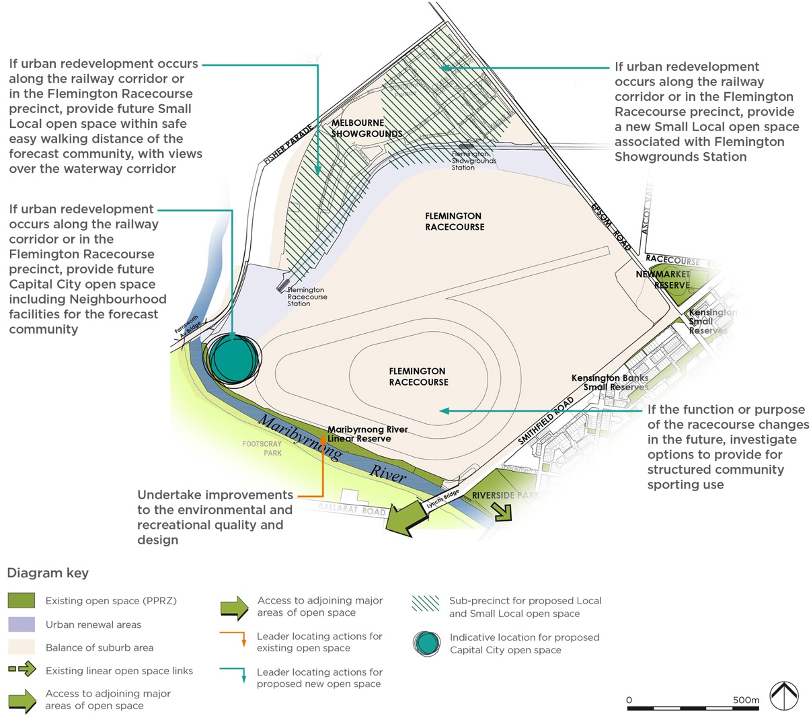

6.5.4 Updated Precinct Actions for Flemington | Ascot Vale
Please note the Actions retain the numbering from the 2012 Strategy Technical Report.
A Additional open space
No. | Action | Responsibility | Priority
Action 7.4A-1 | If urban development occurs in the future in the railway corridor or Flemington Racecourse precinct, provide a Capital City and Neighbourhood open space for the forecast community adjacent to the Maribyrnong River, downstream of Fisher Parade. The proposed site is in the vicinity of the existing car park area adjacent to the River. | Responsibility: C-o-m  Vic Govt  Vrc  Developer | Priority: Ongoing
Action 7.4A-2 | Action partially complete on the land between the Maribyrnong River and fenced area of Flemington Racecourse has been rezoned as Pprz. Undertake improvements to the environmental and recreational quality and design of this linear open space. | Responsibility: C-o-m  Vic Govt  Mwc  T-o  Victorian Racing Club | Priority: High
Action 7.4A-3 | If urban development occurs in the future in the railway corridor or Flemington Racecourse precinct, provide new Small Local open space within easy walking distance of the forecast population. | Responsibility: C-o-m  Developer | Priority: Ongoing
Action 7.4A-4 | If urban development occurs in the future along the railway corridor or in Flemington Racecourse precinct, provide new Small Local open space within easy walking distance of the forecast population in the area around Flemington Showgrounds Station. | Responsibility: C-o-m  Developer | Priority: Ongoing
Action 7.4A-5 | If the function or purpose of the racecourse changes in the future, investigate options to provide for structured community sporting use. | Responsibility: C-o-m  Vic Govt | Priority: Ongoing
B Open space links
No. | Action | Responsibility | Priority
Action 7.4B-1 | If urban development occurs in the future along the railway corridor or in the Flemington Racecourse Precinct, provide a shared trail link generally along the railway line from Epsom Road to the Maribyrnong River, connecting to the shared trail along the railway east of Epsom Road, linking to Royal Park. | Responsibility: C-o-m  VicTrack | Priority: Ongoing

6.6 Kensington
Please refer to Section 7.5 in the 2012 Strategy Technical Report
The following Figures, Tables and Sections have been updated from the 2012 Strategy Technical Report and included in this Light Touch Review. The remaining information in Section 7.5 of the 2012 Strategy Technical Report remains unchanged:
- Figure 7.5~1
- Table 7.5(i)
- Table 7.5(ii)
- Section 7.5.5b, Precinct Actions for Kensington

6.6.1 Changes to the existing open space network since the 2012 Strategy
Figure 6F illustrates the changes to the existing open space network since the 2012 Strategy was prepared. As noted in Section 4.2 of this Light Touch Review, new open space has been added to the network along Moonee Ponds Creek including the acquisition of land for a new Local open space in Chelmsford Street. Other changes include the expansion of some existing open space reserves.
The quantity of open space has increased in Kensington from 24.26 in the 2012 Strategy to 29.23 hectares of open space in 2023, resulting in an additional 4.97 hectares of open space. Note, this list includes the future Chelmsford Street Reserve, which is 0.36 hectares of open space, where the land has been acquired using the public open space contributions reserve however the new open space reserve has not yet been established.
Table 7.5(i) Existing number, size and type of open space in Kensington
No. | Hierarchy of open space | Area | %
2 | Regional open space | 4.36 hectares | 15%
2 | Municipal open space | 12.01 hectares | 41%
1 | Neighbourhood open space | 2.91 hectares | 10%
8 | Local open space | 8.87 hectares | 30%
8 | Small Local open space | 1.08 hectares | 4%
21 | Totals | 29.23 hectares | 100%
Table 7.5(ii) Existing open space in Kensington in 2023
Open space | Hierarchy | Total area in square metres | Total area in hectares
Bayswater Road Park | Local open space | 2,695 square metres | 0.27 hectare
Bellair Street Reserve | Small Local open space | 1,523 square metres | 0.15 hectare
Chelmsford Street (70-90) future Local open space | Local open space | 3,648 square metres | 0.36 hectare
Eastwood & Rankins Road Reserve | Small Local open space | 2,010 square metres | 0.20 hectare
J J Holland Park/Altona Street Reserve | Municipal open space | 102,682 square metres | 10.27 hectares
Kensington Banks Small Reserves | Local open space | 37,080 square metres | 3.71 hectares
Kensington Hall Reserve | Local open space | 4,926 square metres | 0.49 hectare
Kensington Small Reserves (7) | Local open space | 1,855 square metres | 0.19 hectare
Liddy Street Reserve | Small Local open space | 1,228 square metres | 0.12 hectare
Maribyrnong River Bank Reserve | Regional open space | 11,019 square metres | 1.10 hectares
McCracken Street Reserve | Small Local open space | 375 square metres | 0.04 hectare
Moonee Ponds Creek Linear Reserve - Racecourse to Macaulay Roads | Regional open space | 32,601 square metres | 3.26 hectares
Newmarket Reserve | Municipal open space | 17,420 square metres | 1.74 hectares
Parsons Street Reserve | Small Local open space | 1,811 square metres | 0.18 hectare
Peppercorn Park | Small Local open space | 2,245 square metres | 0.22 hectare
Riverside Park | Neighbourhood open space | 29,073 square metres | 2.91 hectares
Robertson Street Reserve | Small Local open space | 900 square metres | 0.09 hectare
Rogan Lane Reserve | Small Local open space | 696 square metres | 0.07 hectare
Stock Route Reserve | Local open space | 6,944 square metres | 0.69 hectare
Warun Biik Park | Local open space | 7,447 square metres | 0.74 hectare
Westbourne Road Reserve | Local open space | 17,480 square metres | 1.75 hectares
Womens Peace Garden | Local open space | 6,599 square metres | 0.66 hectare
Total area | Not applicable | 292,257 square metres in total | 29.23 hectares in total
The changes to the open space network since the 2012 Strategy are shown in Figure 6F.
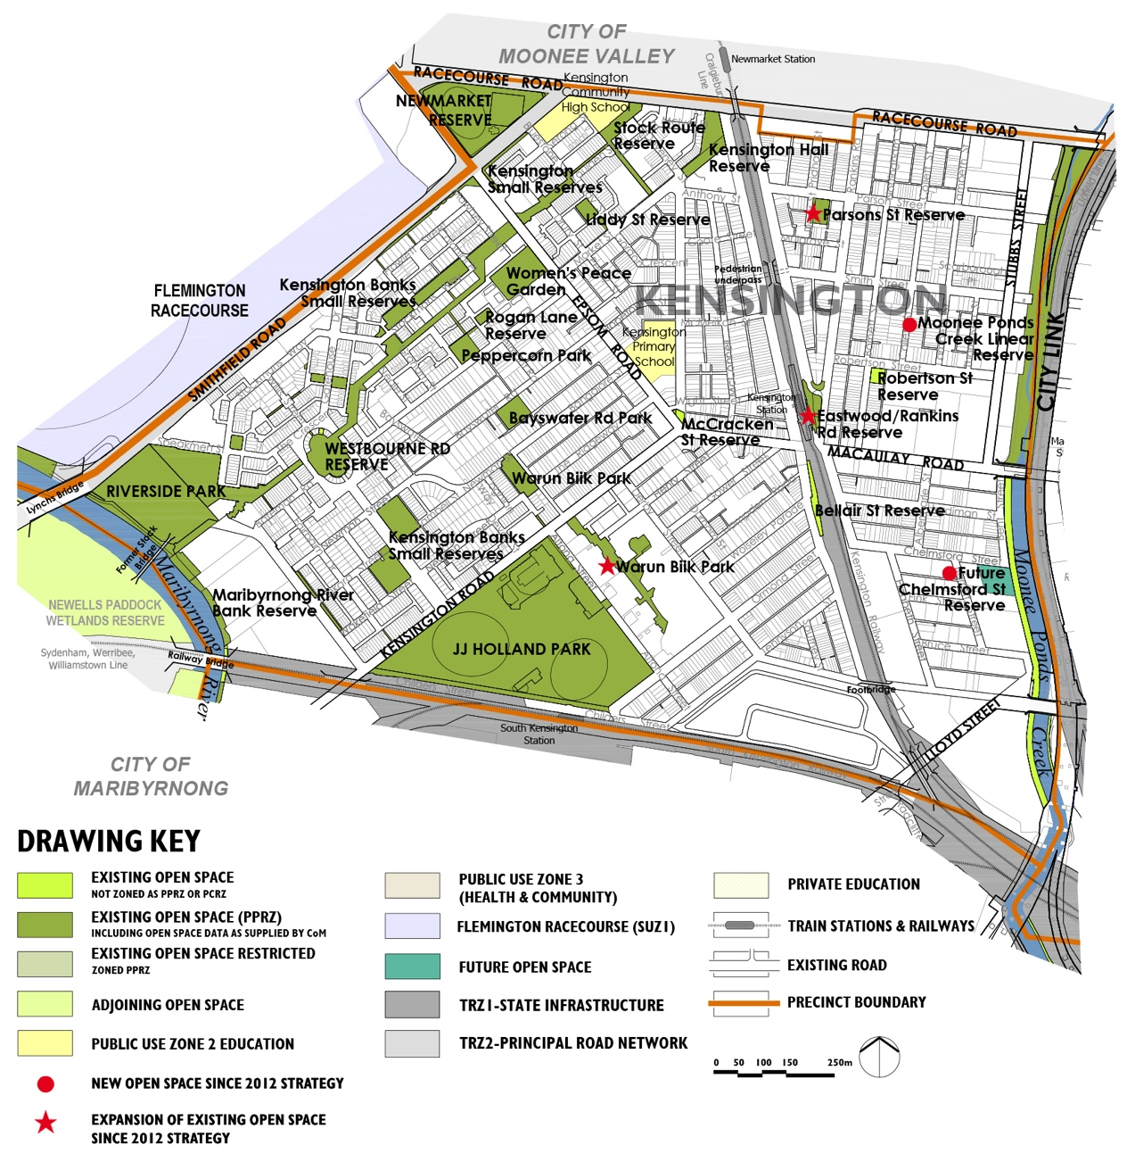

6.6.2 Summary of the population change between 2011 and 2021
As noted in Section 3.3.1 of this Light Touch Review, the residential population has grown by 5 per cent between 2011 and 2021. This is well below the 26 per cent growth forecast over the 15 year timeframe in the 2012 Strategy. An additional 472 residents were living in Kensington in 2021.
Analysis of the Mesh Block census data (refer to Appendix A) for residential dwelling change between 2011 and 2021 has identified the main areas of change are in the northern part of Kensington in open space sub-precinct K4 (south of Racecourse Road) and east of the railway and in sub-precinct K1 adjacent to the Maribyrnong River.
As noted in Section 3.3.3 of this Light Touch Review, the employment figures for 2021 were impacted by Covid-19 and are not reported here.

6.6.3 Summary of the forecast population change from 2021 to 2031
The resident population is forecast to continue to increase over the next 10 years with an additional 4,914 residents forecast to live in Kensington by 2031, which represents a 45 per cent increase from 2021. While there was no spatial breakdown of the forecasts provided we assume the majority of the change will occur in the Macaulay urban renewal area.
As noted in Section 3.3.2, the employment population forecasts from the 2012 Strategy will continue to be relied on, which is in Section 7.5.4a of the 2012 Strategy Technical Report. In summary the worker population is forecast to continue to grow through to 2026.

6.6.4 Implications for the population forecast changes on the updated Actions in this Section
By 2031, nearly 5,000 additional residents are forecast to be living in Kensington which is just over 2,600 more residents than the total residential population change forecast in 2012 Strategy, while the worker population we are planning for has already been accounted for in the actions from the 2012 Strategy. Given this, we have assumed a higher population overall than was planned for in the actions originally. Please refer to Section 7.5 Kensington in the 2012 Strategy Technical Report for the rationale for the Actions in addition to the updated information in this Light Touch Review.
The Macaulay Structure Plan 2021 has been prepared to guide the forecast growth and change. While the forecast growth is similar to that forecast when the 2012 Strategy was prepared it is noted that the Macaulay Structure Plan 2021 does not include a similar quantity of new open space as recommended in the 2012 Strategy. This Light Touch Review recommends that Council continues to be guided by the recommendations for new open space from the 2012 Strategy which is additional to that identified in the Macaulay Structure Plan.
Table 7.5 (vi) in the 2012 Strategy Technical Report requires corrections to the numbering of three of the open space sub-precincts, with the following changes:
- Sub-precinct AM6 needs to be renumbered to AM7
- Sub-precinct AM7 needs to be renumbered to AM8
- Sub-precinct AM8 needs to be renumbered to AM9.
Figure 7.5~5 has been updated and included below to show the correct sub-precincts for Kensington.
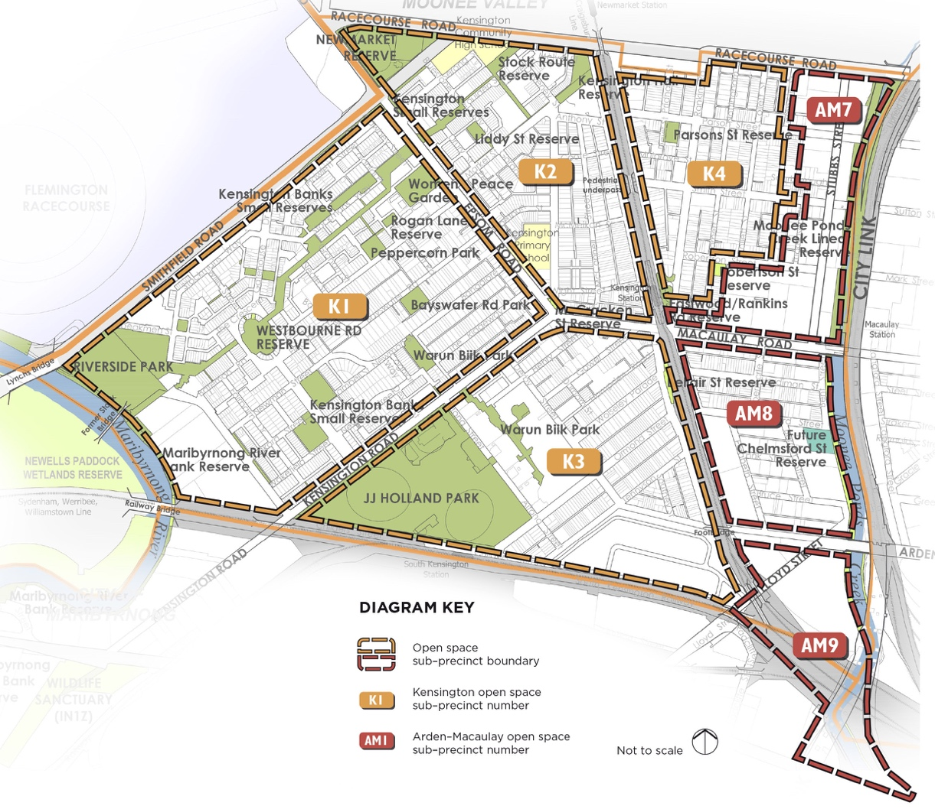

6.6.5 Updated Precinct Actions for Kensington
Please note the Actions retain the numbering from the 2012 Strategy Technical Report.
A Additional open space
No. | Action | Responsibility | Priority
Action 7.5A-1 | New Local open space in the northern part of sub-precinct AM7  Provide an additional Local open space in the northern area of sub-precinct AM7 away from the City Link overhead freeway so it is not encumbered by traffic noise and flooding. This is primarily for the forecast future population. | Responsibility: C-o-m  Developer | Priority: High
Action 7.5A-2 | New Neighbourhood open space in the southern part of sub-precinct AM7  Provide a new Neighbourhood open space in the southern area of sub-precinct AM7 away from the City Link overhead freeway so it is not encumbered by traffic noise, for the existing population in sub-precinct K4 for the forecast future population. | Responsibility: C-o-m  Developer | Priority: High
Action 7.5A-3 | New Neighbourhood open space in sub-precinct AM8  This action is partially complete, however Council to continue to acquire additional land to achieve a minimum size of 1 hectare to achieve a new Neighbourhood open space in sub-precinct AM8 primarily for the forecast future population and the existing population south of Chelmsford Street. | Responsibility: C-o-m  Developer | Priority: High
Action 7.5A-4 | New Small Local open space in sub-precinct AM9 if land use changes  An additional Small Local open space in sub-precinct AM9 located west of Lloyd Street and south of Arden Street may be required, if Arden Street is upgraded to a major road through this sub-precinct. If this does not occur, then the additional open space will not be required. | Responsibility: C-o-m  Developer | Priority: Low
Action 7.5A-5 | Additional Regional open space along the Maribyrnong River  Negotiate to achieve Regional open space along the Maribyrnong River providing connectivity to and along the river for the substantial forecast future population in the Arden and Macaulay urban renewal areas. Future proposals for the additional open space adjoining the river need to clearly identify areas that are encumbered as described in Recommendation 6.2.3d(i), in the 2012 Strategy Technical Report and take account of the setback of development from the waterway beyond the 30 metre riparian zone as required by Clause 12.03 of the Melbourne Planning Scheme. Any future open space provided as an open space contribution as part of Clause 53.01 is to be in addition to encumbered land and the riparian zone setback. | Responsibility: C-o-m  Developer  T-o  Mwc  Pv | Priority: High

B Additional open space links
No. | Action | Responsibility | Priority
Action 7.5B-1 | Linear open space along Moonee Ponds Creek  The City of Melbourne is to facilitate the process to liaise with Melbourne Water, Traditional Owners and other relevant agencies to provide increased linear open space along Moonee Ponds Creek to improve the regional trail connection through this section, along with biodiversity values in an area that has been neglected by government agencies due to historical land use decisions adjoining the creek. This includes investigating east-west shared path bridges at Robertson and Chelmsford Streets. This open space is encumbered given the overshadowing and noise from CityLink.  Future proposals for the additional open space adjoining the river need to clearly identify areas that are encumbered as described in Recommendation 6.2.3d(i), in the 2012 Strategy Technical Report and take account of the setback of development from the waterway beyond the 30 metre riparian zone as required by Clause 12.03 of the Melbourne Planning Scheme. Any future open space provided as an open space contribution as part of Clause 53.01 is to be in addition to encumbered land and the riparian zone setback. | Responsibility: Vic Govt  T-o  C-o-m  Mwc | Priority: Ongoing
Action 7.5B-2 | Linear open space link between Moonee Ponds Creek and the Maribyrnong River via JJ Holland Park  Investigate the potential to establish a linear open space link to future Regional open space along the Maribyrnong River connecting the future population to the River. Refer to Section 5.3 of this Strategy. | Responsibility: C-o-m  Vic Govt | Priority: Medium
C Capital City open space
Not currently applicable. Refer to Actions 7.5A-6 regarding new Capital City open space
D Regional open space
No. | Action | Responsibility | Priority
Action 7.5D-1 | Maribyrnong River Bank Reserve  Proactively liaise with Mwc, the Victorian Government and Traditional Owners to seek expansion to this open space reserve as redevelopment of adjoining sites occur, noting that the provision of adequate open space setback from the Maribyrnong River corridor where it provides a regional link does not form part of the open space contribution. Refer to Action 7.5A-5. | Responsibility: C-o-m  Vic Govt  Mwc  T-o  Pv | Priority: Ongoing
Action 7.5D-2 | Moonee Ponds Creek linear open space  Continue to maintain and improve the quality of the existing open space reserve including improvement to the natural environmental qualities where appropriate. Refer to Action 7.5B-1 regarding expansion to this open space reserve. | Responsibility: C-o-m  Vic Govt  Mwc  T-o | Priority: Ongoing

E Municipal open space
No. | Action | Responsibility | Priority
Action 7.5E-1 | JJ Holland Park  Continue to maintain the recent upgrades including the synthetic sports surfaces. In the longer term upgrade the facilities for informal use as demand for use increases as redevelopment occurs in the Macaulay urban renewal area. | Responsibility: C-o-m | Priority: Ongoing
Action 7.5E-2 | Newmarket Reserve  Action complete, continue to maintain. | Responsibility: C-o-m | Priority: Ongoing
F Neighbourhood open space
No. | Action | Responsibility | Priority
Action 7.5F-1 | Riverside Park  Action complete. Continue to maintain. | Responsibility: C-o-m | Priority: Ongoing
G Local open space
No. | Action | Responsibility | Priority
Action 7.5G-1 | Bayswater Road Park  Prepare a design plan to guide the future design and upgrade of this open space to cater to both the existing and future population. | Responsibility: C-o-m | Priority: Medium
Action 7.5G-2 | Kensington Banks Reserves  Continue to maintain. | Responsibility: C-o-m | Priority: Ongoing
Action 7.5G-3 | Kensington Hall Reserve  Prepare a design plan to guide future minor upgrade works including tree planting and playground. | Responsibility: C-o-m | Priority: Low
Action 7.5G-4 | Kensington Small Reserves  Continue to maintain. | Responsibility: C-o-m | Priority: Ongoing
Action 7.5G-5 | Stock Route Reserve  Continue to maintain. | Responsibility: C-o-m | Priority: Ongoing
Action 7.5G-6 | Warun Biik Park  Continue to maintain. | Responsibility: C-o-m | Priority: Ongoing
Action 7.5G-7 | Westbourne Road Reserve  Continue to maintain. | Responsibility: C-o-m | Priority: Ongoing
Action 7.5G-8 | Womens Peace Garden  Continue to maintain. | Responsibility: C-o-m | Priority: Ongoing
H Small Local open space
No. | Action | Responsibility | Priority
Action 7.5H-1 | Bellair Street Reserve  Action complete. Continue to maintain. | Responsibility: C-o-m  VicTrack | Priority: Ongoing
Action 7.5H-2 | Eastwood Street & Rankins Road Reserve  Action complete. Continue to maintain. | Responsibility: C-o-m | Priority: Ongoing
Action 7.5H-3 | Liddy Street Reserve  Continue to maintain. | Responsibility: C-o-m | Priority: Ongoing
Action 7.5H-4 | McCracken Street Reserve  Continue to maintain. | Responsibility: C-o-m | Priority: Ongoing
Action 7.5H-5 | Parsons Street Reserve  Action complete. Continue to maintain. | Responsibility: C-o-m | Priority: Ongoing
Action 7.5H-6 | Peppercorn Park  Continue to maintain in the short-term, review design layout in the longer term with appropriate protection of heritage values. | Responsibility: C-o-m | Priority: Low
Action 7.5H-7 | Robertson Reserve  Investigate options to expand this open space and incorporate into the future Neighbourhood open space - Refer to Action 7.5A-2. Once confirmation of expansion to open space is complete, prepare a design plan to guide the future upgrade of this open space to cater to the increased population in the sub-precinct AM7. | Responsibility: C-o-m | Priority: High
Action 7.5H-8 | Rogan Lane Reserve  Minor upgrade including improved seating area. | Responsibility: C-o-m | Priority: Low

6.7 Melbourne 3000
Please refer to Section 7.6 in the 2012 Strategy Technical Report
The following Figures, Tables and Sections have been updated from the 2012 Strategy Technical Report and included in this Light Touch Review. The remaining information in Section 7.6 of the 2012 Strategy Technical Report remains unchanged:
- Figure 7.6~1
- Table 7.6(i)
- Table 7.6(ii)
- Section 7.6.5b, Precinct Actions for Melbourne 3000

6.7.1 Changes to the existing open space network since the 2012 Strategy
Figure 6H illustrates the changes to the existing open space network since the 2012 Strategy was prepared. As noted in Section 4.2 of this Light Touch Review, new open space has been added to the network in the western areas of Melbourne 3000, including Collins Street/Market Street Park, Customs Square, St Augustine Parish and the future Market Square at the Queen Victoria Market. Merritts Place Reserve has been added to the plan and database as this was inadvertently omitted from the 2012 Strategy.
The quantity of open space has increased in Melbourne 3000 from 12.74 hectares in the 2012 Strategy to 14.02 hectares in 2023, resulting in an additional 1.28 hectares of open space.
Table 7.6(i) Existing number, size and type of open space in Melbourne 3000
No. | Hierarchy of open space | Area | %
8 | Capital City open space | 11.82 hectares | 84%
1 | State open space | 0.33 hectare | 2%
2 | Regional open space | 1.41 hectares | 10%
5 | Small Local open space | 0.46 hectare | 3%
16 | Totals | 14.02 hectares | 100%
Table 7.6(ii) Existing open space in Melbourne 3000 in 2023
Open space | Hierarchy | Total area in square metres | Total area in hectares
Batman Park | Capital City open space | 14,260 square metres | 1.43 hectares
Birrarung Marr | Capital City open space | 82,900 square metres | 8.29 hectares
City Square | Capital City open space | 2,888 square metres | 0.29 hectare
Cohen Pl Plaza | Capital City open space | 229 square metres | 0.02 hectare
Collins Street Park | Small Local open space | 474 square metres | 0.05 hectare
Customs Square | Small Local open space | 1,258 square metres | 0.13 hectare
Eight Hour Reserve | Capital City open space | 900 square metres | 0.09 hectare
Enterprize Park | Capital City open space | 7,129 square metres | 0.71 hectare
Federation Square | Capital City open space | 6,600 square metres | 0.66 hectare
Flinders Walk (North Bank Yarra - Banana Alley to Birrarung Marr) | Capital City open space | 3,340 square metres | 0.33 hectare
Market Street Park | Small Local open space | 1,381 square metres | 0.14 hectare
Merritts Place Reserve | Small Local open space | 322 square metres | 0.03 hectare
Latrobe & Exhibition Street Reserve | Small Local open space | 270 square metres | 0.03 hectare
Royal Society of Victoria | Small Local open space | 2,247 square metres | 0.22 hectare
Scots Church (Removed) | Hierarchy not applicable | Total area not applicable | Total area not applicable
St Pauls Cathedral (Removed as not public open space) | Hierarchy not applicable | Total area not applicable | Total area not applicable
State Library Forecourt | State open space | 3,340 square metres | 0.33 hectare
Victoria Market Reserve | Regional open space | 12,705 square metres | 1.27 hectares
Victoria Market Reserve (Roundabout Queen & Franklin Streets, reverted to road reserve) | Hierarchy not applicable | Total area not applicable | Total area not applicable
Total area | Not applicable | 140,243 square metres in total | 14.02 hectares in total
The changes to the open space network since the 2012 Strategy are shown in Figure 6H.
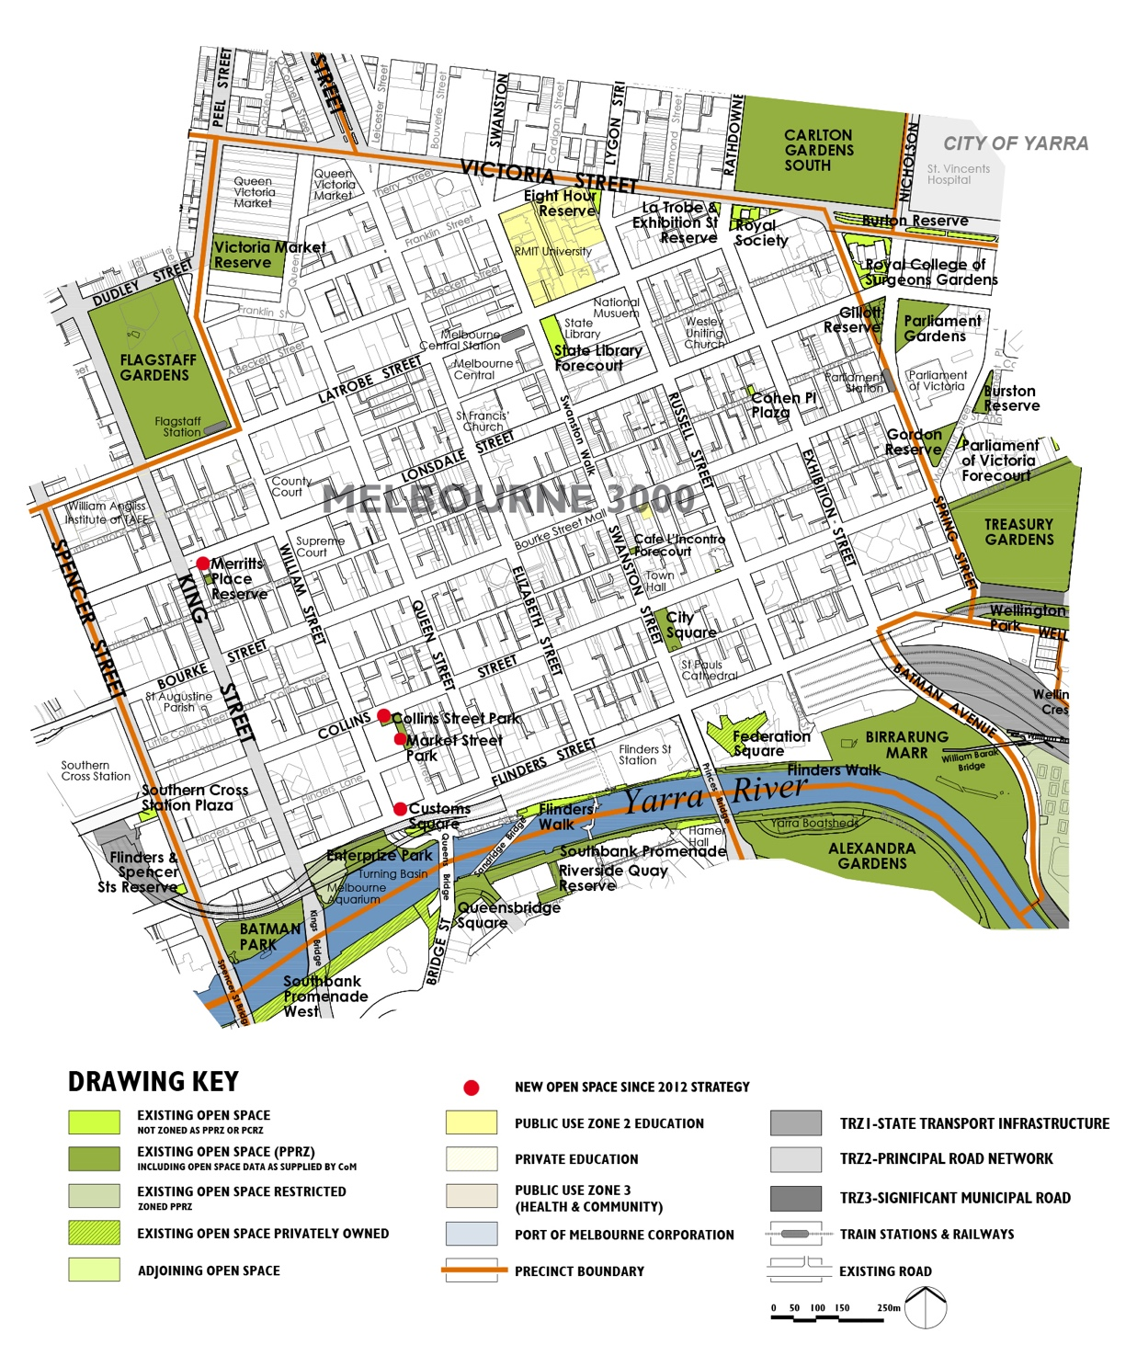

6.7.2 Summary of the population change between 2011 and 2021
As noted in Section 3.3.1 of this Light Touch Review, the residential population has grown by 108 per cent between 2011 and 2021. This is higher than the 67 per cent growth forecast over the 15 year timeframe in the 2012 Strategy. An additional 22,745 residents were living in Melbourne 3000 in 2021.
Analysis of the Mesh Block data (refer to Appendix A) for residential dwelling change between 2011 and 2021 has identified there was significant change in open space sub-precincts M2, M3, M4 and M9, with reasonable levels change in sub-precincts M5, M8 and M12 and limited change in sub-precincts M6, M7, M10 and M11. This assessment of where change has occurred has informed the updated precinct actions.
As noted in Section 3.3.3 of this Light Touch Review, the employment figures for 2021 were impacted by Covid-19 and are not reported here.

6.7.3 Summary of the forecast population change from 2021 to 2031
The resident population is forecast to grow over the next 10 years with an additional 26,726 residents forecast to be living in Melbourne 3000 by 2031, which represents a 61 per cent increase from 2021. Combined, the total population forecast by 2031 will be nearly double the forecast resident population that was planned for in the 2012 Strategy.
As noted in Section 3.3.2, the employment population forecasts from the 2012 Strategy will continue to be relied on, which is in Section 7.6.4a of the 2012 Strategy Technical Report. In summary, the worker population was nearly 10 times the size of the resident population and it was forecast to continue to grow through to 2026.

6.7.4 Implications for the forecast population changes on the updated Actions for this Section
By 2031, 26,726 additional residents are forecast to be living in Melbourne Cbd which is just over 35,000 more than the total residential population forecast by 2026 in the 2012 Strategy. The worker population we are planning for has already been accounted for in the actions from the 2012 Strategy. Given this, we have assumed a slightly higher overall population than was planned for in the actions originally. Please refer to the Section 7.6 of the 2012 Strategy Technical Report for the rationale for the Actions in addition to the updated information in this Light Touch Review.

6.7.5 Updated Precinct Actions for Melbourne 3000
Please note the Actions retain the numbering from the 2012 Strategy Technical Report.
A Additional open space
No. | Action | Responsibility | Priority
Action 7.6A-1 | New Small Local open space in sub-precinct M2 or M3 near the Victoria and Elizabeth Street intersection  Provide an additional Small Local open space to integrate into the future redevelopment sites in the north-east extent of sub-precinct M2 or west extent of sub-precinct M3. This will provide some green open space within safe walking distance and assist with urban greening and cooling. | Responsibility: C-o-m  Developer | Priority: Very High
Action 7.6A-2 | New Small Local open space in sub-precinct M3  Provide an additional Small Local open space in sub-precinct M3 given the substantial increase in people living in this precinct between 2011 and 2021. | Responsibility: C-o-m  Developer | Priority: Very High
Action 7.6A-3 | New Regional open space Victoria Market Reserve in sub-precinct M2  Provide a new Regional open space at Victoria Market Reserve (Market Square). Refer to Action 7.6D-1. | Responsibility: C-o-m  Developer | Priority: Very High
Action 7.6A-4 | New Small Local open space in sub-precinct M4  Provide a new Small Local open space in sub-precinct M4, which has experienced substantial residential dwelling change between 2011 and 2021. This will primarily be for the recently arrived population and for the forecast population. This is to be a green open space with integrated sustainable water re-use principles to assist with urban greening and cooling. The first step in this action is to undertake a detailed assessment of opportunity sites for future open space within this sub-precinct. | Responsibility: C-o-m  Developer | Priority: Very High

Action 7.6A-5 | New Small Local open space in sub-precinct M5  Provide new Small Local open space in open space sub-precinct M5 to establish a green space that encourages people to spend time outside. This is a high priority given the substantial increase in dwellings between 2011 and 2021. | Responsibility: C-o-m  Developer | Priority: High
Action 7.6A-6 | New Small Local open space in sub-precinct M6  Provide new Small Local open space in open space sub-precinct M6 to establish a green space that encourages people to spend time outside. | Responsibility: C-o-m  Developer | Priority: Medium
Action 7.6A-7 | New Small Local open space in sub-precinct M9  This Action is complete with the new Market Street Park and Collins Street Park. Refer to Action 7.6H-6. | Responsibility: C-o-m  Developer | Priority: Complete
Action 7.6A-8 | New Small Local open space in sub-precinct M10  Provide new Small Local open space in sub-precinct M10 to establish a green space that encourages people to spend time outside. The priority for this action is lower given there have been lower levels of change in this sub-precinct than forecast in the 2012 Strategy. | Responsibility: C-o-m  Developer | Priority: Medium
Action 7.6A-9 | Long term opportunities to acquire part of St Francis Church grounds as public open space in sub-precinct M10  Continue to investigate long term opportunities to acquire/secure at least part of the St Francis Church grounds on the corner of Elizabeth and Lonsdale Streets as public open space in the longer term acknowledging this is not feasible in the short term given previous approaches by the C-o-m have been unsuccessful. | Responsibility: C-o-m  St Francis Church | Priority: Ongoing
Action 7.6A-10 | Secure part of Welsh Church grounds as public open space in sub-precinct M10  C-o-m to continue to investigate the potential to acquire/secure at least part of the Welsh Church grounds on La Trobe Street between Queen and Elizabeth Streets as public open space to form part of the network of future green open spaces within the central city. | Responsibility: C-o-m, Welsh Church | Priority: Ongoing
Action 7.6A-11 | Secure part of the St Augustine Parish grounds as public open space in sub-precinct M8  C-o-m to continue to investigate opportunities to acquire/secure at least part of the St Augustine Parish grounds on Bourke Street between Spencer and King Streets as public open space. | Responsibility: C-o-m  St Augustine Parish | Priority: Ongoing
Action 7.6A-12 | Secure part of the St Paul's Cathedral grounds as public open space in sub-precinct M11  Continue to investigate options to acquire/secure the public seating and grassed areas of St Paul's Cathedral facing Swanston Street as public open space. | Responsibility: C-o-m  St Pauls Cathedral | Priority: Ongoing

B Additional open space links
No. | Action | Responsibility | Priority
Action 7.6B-1 | - In future redevelopment sites south of Flinders Street, investigate opportunities to improve pedestrian access and connectivity from the Hoddle Grid to the Yarra River (Birrarung). This includes Flinders Street Station and any future redevelopment of any railway land including Jolimont Railway.  - Any future redevelopment is to not cause any further overshadowing of the existing public open space along the Yarra River (Birrarung). | Responsibility: C-o-m & Developer | Priority: Ongoing
Action 7.6B-2 | Action complete. | Responsibility: C-o-m | Priority: Complete
C Capital City open space
No. | Action | Responsibility | Priority
Action 7.6C-1 | Batman Park  As part of the implementation of the Greenline Project, prepare a design plan to guide future upgrade to this space, considering the existing and future population needs and keeping elements of informality to this space as a contrast to the more formal spaces. This space will need to function for neighbourhood use as well as Capital City space. Costs included in this Strategy are only for the neighbourhood use component of the works. | Responsibility: C-o-m  T-o  Mwc  Pv | Priority: High
Action 7.6C-2 | Birrarung Marr  Prepare a Masterplan to both recognise the important role of:  - Continuing to maintain, schedule and hold events along as the key priority, along with catering to informal use by residents and workers in Melbourne 3000 where this complements the Capital City role.  - Implement the proposed upgrades to the interface with Yarra River (Birrarung) edge including seating and viewing areas as part of the Greenline Project Masterplan. | Responsibility: C-o-m  T-o  Pv  Mwc | Priority: High
Action 7.6C-3 | City Square  Continue to advocate for maximising useable public open space in the design of the new Metro Station entry located in the Square. In the redesign of the City Square, provide informal facilities for visitors and the local worker and resident community along with urban greening and cooling opportunities following removal of the Metro station construction activity and sheds. | Responsibility: C-o-m  Metro Tunnel Project | Priority: Ongoing
Action 7.6C-4 | Cohen Place Plaza  Continue to maintain in the short term. In the longer term, investigate opportunities to increase urban greening in this Small Local open space to improve urban cooling in the sub-precinct. | Responsibility: C-o-m | Priority: Medium
Action 7.6C-5 | Eight Hour Reserve  Continue to maintain. | Responsibility: C-o-m | Priority: Ongoing
Action 7.6C-6 | Enterprize Park  As part of the Greenline Project, investigate opportunity to provide informal recreation opportunities for the worker, resident and visitor Community including incorporating open grassed areas for recreational use along with improving its interface to the Yarra River (Birrarung). | Responsibility: C-o-m  T-o  Pv  Mwc | Priority: Ongoing
Action 7.6C-7 | Federation Square  Continue to advocate for Federation Square to form part of the new arts precinct and cultural spine. This space will continue to contribute to the identity and character of Melbourne. | Responsibility: Fed Square  C-o-m | Priority: Ongoing
Action 7.6C-8 | Flinders Walk (Banana Alley to Birrarung Marr, north bank)  - Continue to maintain and improve connectivity to this if feasible in future redevelopment, refer to Action 7.6B-1.  - Implement the actions identified in the Greenline Project to improve the interface treatment to the Yarra River (Birrarung) edge including pedestrian and cycle connectivity. | Responsibility: C-o-m | Priority: Ongoing  Priority: Medium
D Regional open space
No. | Action | Responsibility | Priority
Action 7.6D-1 | Victoria Market Reserve  Continue design development and delivery of Market Square consistent with the Market Square Charter. The space should provide for a range of passive, event and informal open space uses catering to the broader regional visitor community at Queen Victoria Market and local community use. This recognises the particular operational arrangements for the Market and the need to cater for the significant increase in residential population in this precinct. | Responsibility: C-o-m | Priority: Very High
E Municipal open space
Not applicable
F Neighbourhood open space
Not applicable
G Local open space
Not applicable
H Small Local open space
No. | Action | Responsibility | Priority
Action 7.6H-1 | Latrobe & Exhibition Street Reserve  Continue to maintain. | Responsibility: C-o-m | Priority: Ongoing
Action 7.6H-2 | Royal Society of Victoria  Continue to maintain as it makes a valuable contribution to canopy cover and urban greening. | Responsibility: C-o-m | Priority: Ongoing
Action 7.6H-3 | Scots Church  Action complete, as the fountain has been removed. | Responsibility: C-o-m  Church | Priority: Complete
Action 7.6H-4 | Victoria Market Reserve (roundabout)  This roundabout will revert to road reserve. | Responsibility: C-o-m | Priority: Ongoing
Action 7.6H-5 | Merritts Place Reserve  Undertake an upgrade including investigating options to improve urban greening and cooling characteristics of the existing reserve in the context of high levels of dwelling growth between 2011 and 2021. | Responsibility: C-o-m | Priority: Very High
Action 7.6H-6 | Market Street Park / Collins Street Park  Continue to maintain this new open space as a single open space reserve to meet the needs of the nearby worker and residential community. This Action is the result of the implementation of Action 7.6A-5. | Responsibility: C-o-m | Priority: Ongoing
Action 7.6H-7 | Customs Square  Continue to maintain this recently established open space as part of the Greenline Project. | Responsibility: C-o-m | Priority: Ongoing
J Small Local Link
Not applicable
K State open space
No. | Action | Responsibility | Priority
Action 7.6K-1 | State Library Forecourt  The City of Melbourne is to continue to advocate retaining this important forecourt space as a public open space in any future proposals for change. | Responsibility: State Library  C-o-m | Priority: Ongoing

6.8 Melbourne 3004 | South Yarra
Please refer to Section 8.3 in the 2012 Strategy Technical Report
The following Figures, Tables and Sections have been updated from the 2012 Strategy Technical Report and included in this Light Touch Review. The remaining information in Section 8.3 of the 2012 Strategy Technical Report remains unchanged:
- Figure 8.3~1
- Table 8.3(i)
- Table 8.3(ii)
- Section 8.3.5b, Precinct Actions for Melbourne 3004 | South Yarra

6.8.1 Changes to the existing open space network since the 2012 Strategy
Figure 6I illustrates the existing open space network since the 2012 Strategy. As noted in Section 4.2 of this Light Touch Review, there has been no new open space added to the network.
The quantity of open space has remained the same as the open space areas in Melbourne 3004 | South Yarra in the 2012 Strategy.
Table 8.3(i) Existing number, size and type of open space
Melbourne 3004
No. | Hierarchy of open space | Area | %
13 | Capital City open space | 107.88 hectares | 94%
1 | State open space | 7.18 hectares | 6%
1 | Small Local open space | 0.09 hectare | 0%
15 | Totals | 115.15 hectares | 100%
3 | Restricted open space | 36.53 hectares | Percentage not applicable
South Yarra
No. | Hierarchy of open space | Area | %
2 | Regional open space | 41.69 hectares | 100%
1 | Small Local open space | 0.08 hectare | 0%
3 | Totals | 41.77 hectares | 100%
Table 8.3(iia) Existing open space in Melbourne 3004 in 2023
Open space | Hierarchy | Total area in square metres | Total area in hectares
Alexandra Gardens | Capital City open space | 52,190 square metres | 5.22 hectares
Alexandra Park | Capital City open space | 49,250 square metres | 4.93 hectares
Goschs Paddock | State open space | 71,800 square metres | 7.18 hectares
Kings Domain | Capital City open space | 214,865 square metres | 21.49 hectares
Kings Domain South | Capital City open space | 144,800 square metres | 14.48 hectares
Marquis of Linlithgow Memorial Reserve | Capital City open space | 2,356 square metres | 0.24 hectare
North Bank Yarra River | Capital City open space | 30,150 square metres | 3.02 hectares
Queen Victoria Gardens | Capital City open space | 48,550 square metres | 4.86 hectares
Rockery Fountain (East) | Capital City open space | 1,163 square metres | 0.12 hectare
Rockery Fountain (West) | Capital City open space | 472 square metres | 0.05 hectare
Royal Botanic Gardens | Capital City open space | 384,700 square metres | 38.47 hectares
Shrine of Remembrance Reserve | Capital City open space | 129,900 square metres | 12.99 hectares
Stapely Parade Reserve | Capital City open space | 11,222 square metres | 1.12 hectares
Toorak & St Kilda Road Reserve | Small Local open space | 921 square metres | 0.09 hectare
Yarra Boathouses | Capital City open space | 9,166 square metres | 0.92 hectare
Total area | Not applicable | 1,151,505 square metres in total | 115.15 hectares in total
Restricted open space in Melbourne 3004
Open space | Hierarchy | Total area in square metres | Total area in hectares
Melbourne Park | Capital City open space | 230,600 square metres | 23.06 hectares
Olympic Park | Capital City open space | 107,599 square metres | 10.76 hectares
Sidney Myer Music Bowl | Capital City open space | 27,090 square metres | 2.71 hectares
Total area (Restricted) | Not applicable | 365,289 square metres in total | 36.53 hectares in total
Table 8.3(iib) Existing open space in South Yarra in 2023
Open space | Hierarchy | Total area in square metres | Total area in hectares
Fawkner Park | Regional open space | 412,089 square metres | 41.21 hectares
River Bank Reserve | Regional open space | 4,806 square metres | 0.48 hectare
Golden Elm Reserve | Small Local open space | 756 square metres | 0.08 hectare
Total area | Not applicable | 417,651 square metres in total | 41.77 hectares in total
The open space network is shown in Figure 6I.

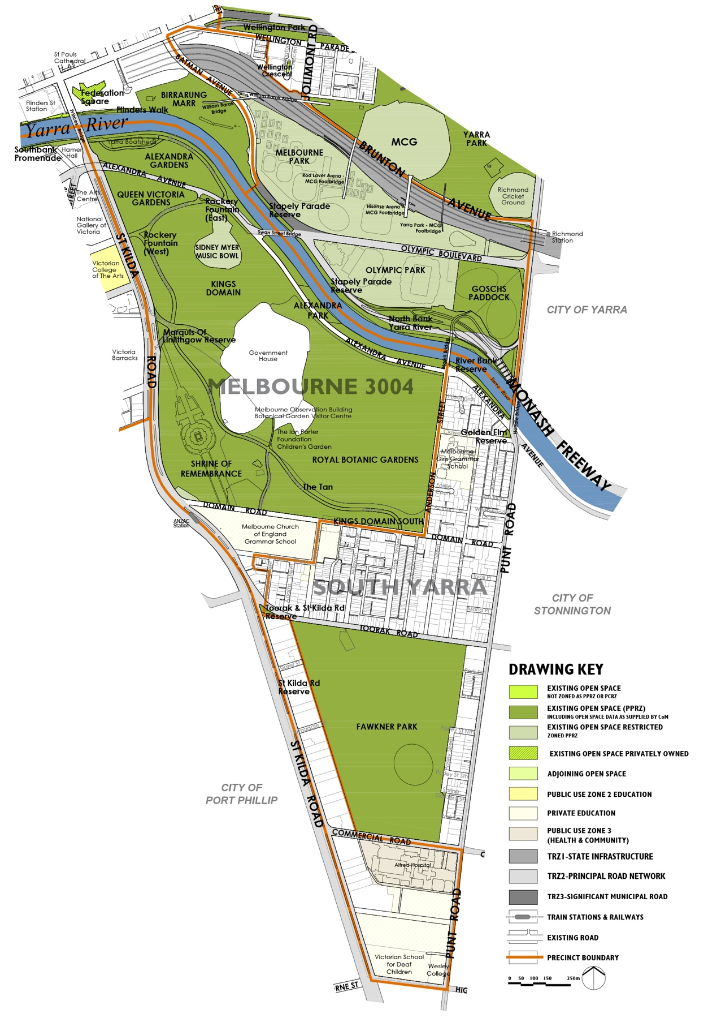

6.8.2 Summary of the population change between 2011 and 2021
As noted in Section 3.3.1 of this Light Touch Review, the residential population change in Melbourne 3004 between 2011 and 2021 was higher than 2026 forecasts in the 2012 Strategy, with a 91 per cent increase, while in South Yarra the residential population reduced by 21 per cent. In Melbourne 3004 there was an overall increase of 1,491 residents in 2021 from 2011 Compared to 434 that were forecast in the 2012 Strategy. In South Yarra there was an overall decrease of 985 compared to an increase of 22 forecast in the 2012 Strategy.
Analysis of the Mesh Block data (refer to Appendix A) for residential dwelling change between 2011 and 2021 has identified there was significant change in open space sub-precincts SKR2 and SKR3, with minimal change in the other sub-precincts. This assessment of where change has occurred has informed the updated precinct actions.
As noted in Section 3.3.3 of this Light Touch Review, the employment figures for 2021 were impacted by Covid-19 and are not reported here.

6.8.3 Summary of the forecast population change from 2021 to 2031
The resident population in both Melbourne 3004 and South Yarra is forecast to continue to grow over the next 10 years with an additional 1,309 residents forecast to be living in Melbourne 3004 by 2031, and an additional 1,749 residents in South Yarra. This is more than the resident population increase between 2011 and 2021 and will result in more than double the forecast resident population that was planned for in the 2012 Strategy for Melbourne 3004 and around 15 per cent more in South Yarra.
As noted in Section 3.3.2, the employment population forecasts from the 2012 Strategy will continue to be relied on, which is in Section 8.3.4a of the 2012 Strategy Technical Report. In summary, the worker population was nearly 10 times the size of the resident population and it was forecast to continue to grow through to 2026.

6.8.4 Implications for the forecast population changes on the updated Actions for this Section
By 2031, 3,058 additional residents are forecast to be living in Melbourne 3004 | South Yarra which is approximately 2,600 more than the total residential population forecast by 2026 in 2012 Strategy. The worker population we are planning for has already been accounted for in the actions from the 2012 Strategy. Given this, we have assumed a slightly higher overall population than was planned for originally. Please refer to Section 8.3 of the 2012 Strategy Technical Report for the rationale for the actions in addition to the updated information in this Light Touch Review.

6.8.5 Updated Precinct Actions for Melbourne 3004 | South Yarra
Please note the Actions retain the numbering from the 2012 Strategy Technical Report.
A Additional open space
Not applicable
B Additional open space links
Not applicable

C Capital City open space
Srt = Shrine of Remembrance Trustees
No. | Action | Responsibility | Priority
Action 8.3C-1 | Alexandra Gardens  Implement the 2019 - 2039 Domain Parklands Masterplan for Alexandra Gardens. This includes upgrades to cater to the broader regional uses and improve access and use by the local community. The upgrades include improving the riverbank with paths, seats and planting, redesign the skate facility, improve pedestrian access to the boathouse precinct and rowing access. | Responsibility: C-o-m  T-o  Pv | Priority: High
Action 8.3C-2 | Alexandra Park  Implement the proposed works identified in the 2019-2039 Domain Parklands Master Plan including upgrades to the picnic and barbecue areas and improvements to path links, connections and the interface to the river banks. Alexandra Park has an important role in provision of the shared trail and social gatherings for large picnics and barbecues. Continue to maintain Alexandra Park for Capital City use. | Responsibility: C-o-m  Mwc  Pv | Priority: High
Action 8.3C-3 | Kings Domain  Implement the 2019 - 2039 Domain Parklands Master Plan, including facilities and works that are primarily for the local community needs within the context of this Capital City open space. This includes the proposed improvements to paths, seating and access into the Domain from St Kilda Road. | Responsibility: C-o-m | Priority: High
Action 8.3C-4 | Kings Domain South  Implement the 2019-2039 Domain Parklands Master Plan, including consideration of local residential needs within the context of this Capital City open space. Works include reinstatement of Edmund Herring Oval and picnic tables and facilities between Domaine Road and Birdwood Avenue. | Responsibility: C-o-m | Priority: Medium
Action 8.3C-5 | Marquis of Linlithgow Reserve  Continue to maintain. | Responsibility: C-o-m | Priority: Ongoing
Action 8.3C-6 | North Bank Yarra River (Birrarung) (Swan Street Bridge to Hoddle Bridge)  - Continue to implement the Greenline Project City of Melbourne is to prepare a holistic Master Plan for the open spaces along the Yarra River (Birrarung) corridor, including the North Bank to guide future improvement to local accessibility and use, offering a different experience to the south bank, particularly as the population in the Cbd increases over time. Refer also to 8.3D-3.  - Undertake improvement works to the North Bank, with a priority focus between Morell Bridge and Swan Street Bridge consistent with the directions in the Yarra Strategic Plan (Burndap Birrarung burndap umarkoo) 2022-2032, the Yarra River Birrarung Strategy. This includes collaboration with Traditional Owners, integration of more diverse fitness/exercise opportunities to increase recreational use, social spaces and improving ecological outcomes. Refer also to 8.3C-10 and Birrarung Marr Masterplan in Melbourne 3000, Action 7.6C-2. | Responsibility: C-o-m  T-o  Mwc  Pv | Priority: Complete  Priority: High
Action 8.3C-7 | Queen Victoria Gardens  Undertake improvements identified in the 2019-2039 Domain Parklands Masterplan including buffer planting to Alexandra Avenue and investigate improvement to pedestrian access across it to Alexandra Gardens. Continue to support access and use of the Gardens by the local community. | Responsibility: C-o-m | Priority: High and Ongoing
Action 8.3C-8 | Royal Botanic Gardens  City of Melbourne to continue to advocate on behalf of the local community with Royal Botanic Gardens Victoria regarding ongoing access to and management of the Royal Botanic Gardens. Implement the relevant actions in the 2019-2039 Domain Parklands Masterplan which includes improving pedestrian links within the gardens and enhancing the interface. | Responsibility: C-o-m,  Rbgv | Priority: Ongoing
Action 8.3C-9 | Shrine of Remembrance  City of Melbourne to continue to maintain the Reserve in conjunction with the Shrine of Remembrance Trustees to maintain general public access to the Reserve and implement relevant actions in the Domain Parklands Masterplan. | Responsibility: C-o-m  Srt | Priority: Ongoing
Action 8.3C-10 | Stapely Parade Reserve (Birrarung Marr to Swan Street Bridge, north bank)  Undertake improvement works as part of the works to North Bank Yarra River (Birrarung) (Action 8.3C-6). This includes collaboration with Traditional Owners, integration of more diverse fitness/exercise opportunities to increase recreational use, social spaces and improving ecological outcomes. | Responsibility: C-o-m  T-o  Mwc  Pv | Priority: High
Action 8.3C-11 | Yarra Boatsheds  In partnership with the Victorian Government and Parks Victoria design and provide new rowing landing and provide a new shared zone behind the boathouses with the aim to reduce vehicle movement in accordance with the recommendations in the 2019-2039 Domain Parklands Masterplan. | Responsibility: C-o-m  Pv  Vic Govt | Priority: High
D Regional open space
No. | Action | Responsibility | Priority
Action 8.3D-2 | Fawkner Park  Continue to implement the existing Fawkner Park Master Plan in the short term. In the longer term review and prepare an updated Fawkner Park Master Plan to guide future works, with consideration of facilities and use by both the local community and the regional visitors. | Responsibility: C-o-m | Priority: Medium
Action 8.3D-3 | River Bank Reserve (Morrell Bridge to Hoddle Bridge,  south bank of the River)  Continue to maintain. Refer also to 8.3C-6. | Responsibility: Pv  Vic Govt  C-o-m | Priority: Ongoing
E Municipal open space
Not applicable
F Neighbourhood open space
Not applicable
G Local open space
Not applicable
H Small Local open space
No. | Action | Responsibility | Priority
Action 8.3H-1 | Toorak & St Kilda Road Reserve  City of Melbourne to continue to maintain. | Responsibility: C-o-m | Priority: Ongoing
Action 8.3H-2 | Golden Elm Reserve  Continue to maintain. Review and confirm the site is zoned as public open space in order to protect it in the long term. | Responsibility: C-o-m | Priority: Ongoing
J Small Local Link
Not applicable
K State open space
No. | Action | Responsibility | Priority
Action 8.3K-1 | Gosch's Paddock  City of Melbourne to continue to advocate to the Melbourne and Olympic Parks Trust to retain public access to Gosch's Paddock when not in formal use for training purposes. | Responsibility: C-o-m  M-o-p-t | Priority: Ongoing

6.9 North Melbourne
Please refer to Section 7.7 in the 2012 Strategy Technical Report
The following Figures, Tables and Sections have been updated from the 2012 Strategy Technical Report and included in this Light Touch Review. The remaining information in Section 7.7 of the 2012 Strategy Technical Report remains unchanged:
- Figure 7.7~1
- Table 7.7(i)
- Table 7.7(ii)
- Section 7.7.5b, Precinct Actions for North Melbourne

6.9.1 Changes to the existing open space network since the 2012 Strategy
Figure 6J illustrates the changes to the open space network since the 2012 Strategy was prepared. As noted in Section 4.2 of this Light Touch Review, new open space has been added to the network. In North Melbourne this has included expansion of Gardiner Reserve and Errol Street Reserve. While not complete, currently the City of Melbourne is undertaking an expansion of the Bedford and Courtney Street Reserves.
The quantity of open space has increased in North Melbourne from 8.16 hectares in the 2012 Strategy to 8.92 hectares of open space in 2023, resulting in an additional 0.76 hectares of open space.
Table 7.7(i) Existing number, size and type of open space in North Melbourne
No. | Hierarchy of open space | Area | %
1 | Municipal open space | 4.52 hectares | 51%
1 | Neighbourhood open space | 1.43 hectares | 16%
4 | Local open space | 2.36 hectares | 26%
4 | Small Local open space | 0.53 hectare | 6%
2 | Small Local Link | 0.07 hectare | 1%
10 | Totals | 8.92 hectares | 99%
Table 7.7(ii) Existing open space in North Melbourne in 2023
Open space | Hierarchy | Total area in square metres | Total area in hectares
Bedford Street Reserve | Small Local open space | 1,013 square metres | 0.10 hectare
Canning Street & Macaulay Road Reserve | Small Local open space | 1,762 square metres | 0.18 hectare
Chapman Street Reserve | Small Local open space | 1,480 square metres | 0.15 hectare
Clayton Reserve | Local open space | 6,531 square metres | 0.65 hectare
Courtney Street Reserve | Small Local Link | 456 square metres | 0.05 hectare
Curzon Street Reserve | Small Local Link | 265 square metres | 0.03 hectare
Errol Street Reserve | Local open space | 4,907 square metres | 0.49 hectare
Gardiner Reserve | Local open space | 8,468 square metres | 0.85 hectare
Leveson Street Reserve | Small Local open space | 1,079 square metres | 0.11 hectare
North Melbourne Community Centre | Neighbourhood open space | 14,311 square metres | 1.43 hectares
North Melbourne Recreation Reserve | Municipal open space | 45,221 square metres | 4.52 hectares
Pleasance Gardens | Local open space | 3,712 square metres | 0.37 hectare
Total area | Not applicable | 89,205 square metres in total | 8.92 hectares in total
The changes to the open space network since the 2012 Strategy are shown in Figure 6J.
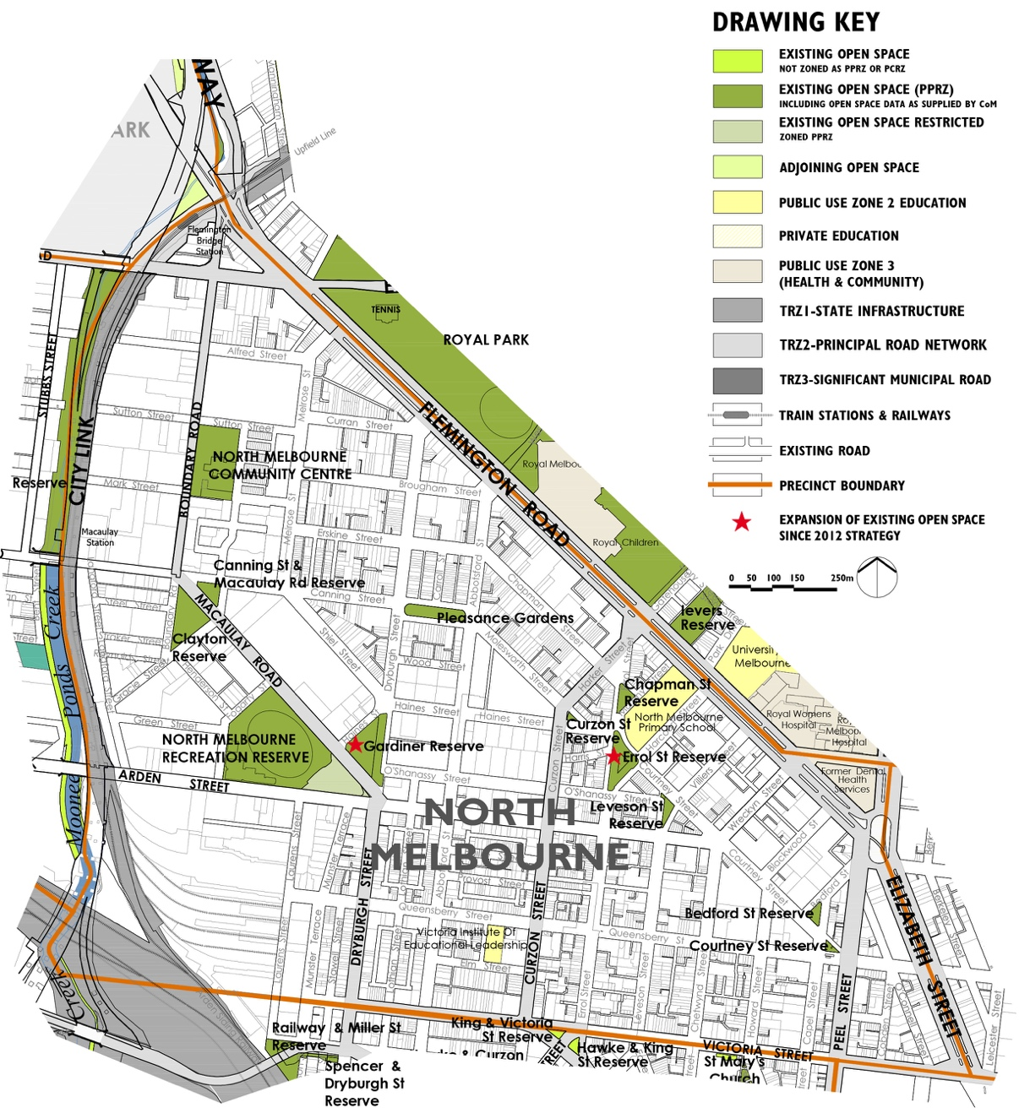

6.9.2 Summary of the population change between 2011 and 2021
As noted in Section 3.3.1 of this Light Touch Review, the residential population has grown by in North Melbourne by 34 per cent between 2011 and 2021. This is lower than the 92 per cent growth forecast over the 15 year timeframe in the 2012 Strategy. An additional 4,003 residents were living in in North Melbourne in 2021.
A review of the mesh block data indicates that some areas of North Melbourne have experienced very little change while other areas have experienced significant change including:
- NM3 and CN1, located in the south-east part of North Melbourne, have both experienced a significant increase in dwellings, with 738 new dwellings in NM3 and just over 1,000 new dwellings in CN1, with in the order of 2,800 additional residents.
- AM4, between Macaulay Road and Sheil Street, has experienced a more than 500 per cent increase in the resident population, representing more than 550 additional dwellings.
As noted in Section 3.3.3 of this Light Touch Review, the employment figures for 2021 were impacted by Covid-19 and are not reported here.

6.9.3 Summary of the forecast population change from 2021 to 2031
The resident population is forecast to continue to grow over the next 10 years with 9,648 residents forecast to be living in North Melbourne by 2031, which represents a 62 per cent increase from 2021. It is anticipated they will be distributed across the precinct including the Arden renewal area in the west and the City North area in the east.
As noted in Section 3.3.2, the employment population forecasts from the 2012 Strategy will continue to be relied on, which is in Section 7.6.4a of the 2012 Strategy Technical Report. In summary, the worker population was forecast to continue to grow through to 2026.

6.9.4 Implications for the population forecast changes on the updated Actions for this Section
By 2031, 9,648 additional residents are forecast to be living in North Melbourne which is approximately 14,300 more than total residential population forecast by 2026 in 2012 Strategy, while the worker population we are planning for has already been accounted for in the actions from 2012 Strategy. Given this, we have assumed a higher overall population, and hence the reason for recommending the actions from the 2012 Strategy continue to be implemented including the additional open space. Please refer to Section 7.7 North Melbourne in the 2012 Strategy Technical Report for the rationale for the actions in addition to the updated information in this Light Touch Review.
The Arden Structure Plan has been prepared to guide the forecast growth and change in the urban renewal area of North Melbourne. While the forecast growth is higher than was forecast when the 2012 Strategy was prepared it is noted that the Arden Structure Plan 2022 does not include a similar quantity of new open space as recommended in the 2012 Strategy. This Light Touch Review recommends that Council continues to be guided by the recommendations for new open space from the 2012 Strategy which is additional to that identified in the Arden Structure Plan.
There are some minor corrections required to the description of two sub-precincts in Tables 7.7 (vi) and 1.4-3 in the 2012 Strategy. These are:
Please note there is a minor correction to Table 7.7(vi) in the 2012 Strategy Technical Report in sub-precinct AM5, where the first sentence of the Description should read:
'This sub-precinct extends south of Arden Street to Dynon Road, just south of the North Melbourne
suburb boundary.'

There is also a minor correction to Table 1.4-3 in the 2012 Strategy Technical Report in sub-precinct NM3, where the first sentence of the Description should read:
'Bounded to the north by Courtney Street, the west by Curzon Street, the east by Capel Street and
south by Victoria Street'.

6.9.5 Updated Precinct Actions for North Melbourne
Please note the Actions retain the numbering from the 2012 Strategy Technical Report.
A Additional open space
No. | Action | Responsibility | Priority
Action 7.7A-1 | New Small Local open space in sub-precinct AM1, northern area west of Boundary Rd  Provide an additional Small Local open space in the northern area of sub-precinct AM1 with excellent north south connectivity to a new Local open space in the south of this sub-precinct AM1. Ensure the future design of these spaces provides a respite from traffic noise and includes the principles of UHI mitigation. This open space is primarily for the new population and will complement the recently approved new Small Local open space as a land contribution in Alfred Street. This is the reason this new open space has been reduced from Local to Small Local. | Responsibility: C-o-m  Developer | Priority: Very High
Action 7.7A-2 | New Local open space in sub-precinct AM1 - southern area west of Boundary Rd  Provide an additional Local open space in the southern area of sub-precinct AM1 with excellent north south connectivity to the new Small Local open spaces in the north of this sub precinct AM1. Ensure the future design of these spaces provides a respite from traffic noise and includes the principles of UHI mitigation. This open space is primarily for the new population. | Responsibility: C-o-m  Developer | Priority: Very High
Action 7.7A-3 | New Municipal open space in sub-precinct AM3 between Macaulay Rd, Arden St and Moonee Ponds Creek  Provide a new Integrated Stormwater Management open space as shown in the Arden Structure Plan in the south-west area of sub-precinct AM3. The design of the new Municipal open space is to include facilities that are accessible and useable by the local community to replace the need for the previously proposed Local open space in this sub-precinct. | Responsibility: C-o-m  Developer | Priority: Very High
Action 7.7A-4 | New Capital City open space in sub-precinct AM5 near the new Arden Metro Station  This Action is partially complete, with the new Capital City open space provided. Council to advocate for the design to meet the needs of the new community and the visitor community, along with contributing to the liveability and character of the new Arden precinct. | Responsibility: Vic Govt  C-o-m | Priority: Very High
Action 7.7A-5 | New Neighbourhood open space in sub-precinct AM5 south of the Metro Station  Provide a new Neighbourhood open space as shown in the Arden Structure Plan in sub-precinct AM5 located south of the Metro Station. | Responsibility: C-o-m  Developer | Priority: Very High
Action 7.7A-6 | New Small Local open space in sub-precinct AM6 east of Laurens Street  Provide a new Small Local open space east of Laurens Street and north of Queensberry Street, sub-precinct AM6. This will cater to both the existing and future population between Laurens and Dryburgh Streets in the proposed high density mixed use precinct. | Responsibility: C-o-m  Developer | Priority: Very High
Action 7.7A-7 | New Local open space in the central south-east part of sub-precinct CN1  Investigate options to provide a new Local open space in sub-precinct CN1 in the area near Flemington Road and Peel Street. This includes proactively seeking land contributions to add to conversion of road reserves to establish a larger open space that provides for open space and recreational needs of the forecast future community. | Responsibility: C-o-m  Developer | Priority: Very High
Action 7.7A-8 | New Small Local open space in sub-precinct CN2 between Peel and Elizabeth Streets  Provide an additional Small Local open space in the heart of this triangular sub-precinct CN2 between Peel and Elizabeth Streets. This is likely to utilise part of a road reserve to establish the open space, and given there has been limited change between 2011 and 2021, there is still an opportunity to establish this in conjunction with a future land contribution. | Responsibility: C-o-m  Developer | Priority: Low
Action 7.7A-9 | New Small Local open space in sub-precinct NM1, west of Curzon St  Provide an additional Small Local open space in the north-west area of this sub-precinct NM1 to address an existing gap area and primarily for the existing population. | Responsibility: C-o-m  Developer | Priority: High
Action 7.7A-10 | New Local open space in sub-precinct NM2, between Dryburgh and Curzon Streets  Provide an additional Local open space in sub-precinct NM2 to address an existing gap area for the existing population. This is likely to be conversion of part of a road reserve due to the presence of heritage overlays limiting the likely redevelopment of sites within this sub-precinct. | Responsibility: C-o-m  Developer | Priority: High
Action 7.7A-11 | New Local open space in sub-precinct NM3, between Curzon and Capel Streets  This Action is partially complete with one new Small Local open space already achieved via the expansion to Errol Street Reserve. Provide one new additional Local open space in sub-precinct NM3 to address both the existing and future population needs in this area. It is anticipated there will be substantial growth in this sub-precinct. | Responsibility: C-o-m  Developer | Priority: Very High
B Additional open space links
No. | Action | Responsibility | Priority
Action 7.7B-1 | On-street link Molesworth St  Improve on-street links along Molesworth Street between Pleasance Gardens and Curzon Reserve. | Responsibility: C-o-m | Priority: High
Action 7.7B-2 | On-street link Courtney St  Improve on-street links along Courtney Street between Errol Street Reserve and Bedford Street Reserve. | Responsibility: C-o-m | Priority: Very High
Action 7.7B-3 | On-street connectivity to new Capital City open space at Arden Metro  Improve east-west connectivity between the proposed Capital City open space near the proposed Arden Metro on Queensberry Street, including crossing over Dryburgh Street. | Responsibility: C-o-m | Priority: Medium
Action 7.7B-4 | Linear open space along Moonee Ponds Creek  The City of Melbourne is to facilitate the process to liaise with Mwc, the Victorian Government and Traditional Owners to provide increased linear open space along Moonee Ponds Creek to improve the regional trail connection through this section, along with biodiversity values in an area that has been neglected by government agencies due to historical land use decisions adjoining the creek. This open space is encumbered by the overshadowing and noise from Citylink  Future proposals for the additional open space adjoining the river need to clearly identify areas that are encumbered as described in Recommendation 6.2.3d(i), in the 2012 Strategy Technical Report and take account of the setback of development from the waterway beyond the 30 metre riparian zone as required by Clause 12.03 of the Melbourne Planning Scheme. Any future open space provided as an open space contribution as part of Clause 53.01 is to be in addition to encumbered land and the riparian zone setback. | Responsibility: Vic Govt  C-o-m  Mwc  T-o | Priority: Ongoing
Action 7.7B-5 | Links between future open space in Arden and Macaulay Structure Plan areas and the Capital City Trail  In future urban design provide clear and safe pedestrian cycle connections via the future street network from the existing and proposed open space in North Melbourne and the Capital City Trail along Moonee Ponds Creek. This Action has been included in the Arden and Macaulay Structure Plans. | Responsibility: C-o-m  Developer | Priority: Ongoing
Action 7.7B-6 | North-south link west of Boundary Rd  Sub-precinct AM1 ensure that internal north-south pedestrian links area designed into future developments to provide an alternative north-south pedestrian access route to Boundary Road. This Action has been shown in the Macaulay Structure Plan. | Responsibility: C-o-m  Developer | Priority: Ongoing
Action 7.7B-7 | North-south link east of the railway  Investigate the potential to provide safe cycle/pedestrian north-south link along railway reserve through Arden Macaulay precinct, north to Royal Park and south to future Capital City open space in West Melbourne. | Responsibility: C-o-m  Developer | Priority: Very High
Action 7.7B-8 | Improve open space links between Clayton Reserve and new Small Local open space to be provided in sub-precinct AM3. This Action is now included in the Arden Structure Plan. | Responsibility: C-o-m  Developer | Priority: Very High

Action 7.7B-9 | Action complete. | Responsibility: C-o-m  Developer | Priority: Complete
Action 7.7B-10 | This Action is no longer feasible given the updated levee bank and flood mitigation measures. | Responsibility: C-o-m  Developer | Priority: Complete
Action 7.7B-11 | Investigate improving pedestrian access across Flemington Road to Royal Park to improve open space accessibility for the North Melbourne population. This is to be included in the new Royal Park Masterplan and investigate at grade outstands as pedestrian bridges are not recommended by VicRoads. | Responsibility: C-o-m  VicRoads | Priority: High
C Capital City open space
None provided in North Melbourne
D Regional open space
No. | Action | Responsibility | Priority
Action 7.7D-1 | Moonee Ponds Creek Linear open space  Continue to maintain and improve the quality of the existing open space reserve including improvement to the natural environmental qualities where appropriate. Refer to Action 6.2.4a(i) regarding expansion to this open space reserve. | Responsibility: C-o-m  Vic Govt  Mwc  T-o | Priority: Ongoing
E Municipal open space
No. | Action | Responsibility | Priority
Action 7.7E-1 | North Melbourne Recreation Reserve  Continue to maintain this open space primarily for structured sporting use. | Responsibility: C-o-m | Priority: Ongoing
F Neighbourhood open space
No. | Action | Responsibility | Priority
Action 7.7F-1 | North Melbourne Community Centre (also referred to as Buncle Street Reserve in the Macaulay Structure Plan)  Prepare a design plan to guide the future design and upgrade of this open space to cater to structured sporting needs of both the existing and new population needs in the sub-precinct AM1, located immediately west of this open space, and the unstructured recreation and local open space needs of the existing and new population in sub-precinct AM2. Pending final size and facilities, potentially upgrade this to a Municipal open space. | Responsibility: C-o-m  Developer  Vic Govt | Priority: Very High
G Local open space
No. | Action | Responsibility | Priority
Action 7.7G-1 | Clayton Reserve  Prepare and implement a Master Plan for this Local Open Space to better provide for the existing and future population in sub-precinct AM3. | Responsibility: C-o-m  Developer | Priority: Medium
Action 7.7G-2 | Gardiner Reserve  Action complete. Continue to maintain. | Responsibility: C-o-m  Developer | Priority: Ongoing
Action 7.7G-3 | Pleasance Gardens  Investigate the potential to increase the size of Pleasance Gardens to improve its viability and use as open space. Prepare and implement a Concept Plan for this Local open space, protecting heritage values, improving its character, complementing the nearby Gardiner Reserve, and investigation options to increase its size. | Responsibility: C-o-m  Developer | Priority: Low
H Small Local open space
No. | Action | Responsibility | Priority
Action 7.7H-1 | Bedford Street Reserve  This Action is in progress with the reserve currently in construction. Once completed, continue to maintain. | Responsibility: C-o-m | Priority: Ongoing
Action 7.7H-2 | Canning St and Macaulay Rd Reserve  Prepare a design plan to guide major upgrade to this open space to address the redevelopment of the recent Arden Gardens and improve the retail precinct interface to this Reserve. This includes activating the interface and improving pedestrian priority and entry points to the park and potentially expand the reserve into the road reserve to improve its character and useability. | Responsibility: C-o-m  Developer | Priority: Medium
Action 7.7H-3 | Chapman Street Reserve  Prepare a design plan to guide the future upgrade of this open space to improve its use for the existing population in sub-precinct NM3. Consider its proximity to the school as part of the design process. | Responsibility: C-o-m | Priority: High
Action 7.7H-4 | Errol Street Reserve  Action completed. Continue to maintain. | Responsibility: C-o-m | Priority: Ongoing
Action 7.7H-5 | Leveson Street Reserve  Action completed. Continue to maintain. | Responsibility: C-o-m | Priority: Ongoing
J Small Local Link
No. | Action | Responsibility | Priority
Action 7.7J-1 | Courtney Street Reserve  This Action is in progress with the reserve currently under construction and now expanded to link to Bedford Street Reserve. Once works are completed, continue to maintain. | Responsibility: C-o-m | Priority: Ongoing
Action 7.7J-2 | Curzon Street Reserve  Continue to maintain the mature canopy trees in the open space. | Responsibility: C-o-m | Priority: Ongoing

6.10 Parkville
Please refer to Section 8.4 in the 2012 Strategy Technical Report
The following Figures, Tables and Sections have been updated from the 2012 Strategy Technical Report and included in this Light Touch Review. The remaining information in Section 8.4 of the 2012 Strategy Technical Report remains unchanged:
- Figure 8.4~1
- Table 8.4(i)
- Table 8.4(iia) and Table 8.4(iib)
- Section 8.4.5b, Precinct Actions for Parkville

6.10.1 Changes to the existing open space network since the 2012 Strategy
Figure 6K illustrates the changes to the open space network since the 2012 Strategy was prepared. As noted in Section 4.2 of this Light Touch Review, additional open space has been added back into Royal Park following the completion of the Royal Children's Hospital since the 2012 Strategy was prepared.
The quantity of open space has increased in Parkville from the 2012 Strategy, with an additional 0.65 hectares of additional open space in Royal Park.
Table 8.4(i) Existing number, size and type of open space in Parkville
No. | Hierarchy of open space | Area | %
1 | State open space | 161.53 hectares | 97%
1 | Regional open space | 0.30 hectare | 0%
2 | Neighbourhood open space | 2.70 hectares | 2%
1 | Local open space | 0.68 hectare | 0%
5 | Small Local open space | 0.54 hectare | 0%
3 | Small Local Link | 0.10 hectare | 0%
13 | Totals | 165.85 hectares | 100%
3 | Restricted open space | 40.46 hectares | Percentage not applicable
Table 8.4(iia) Existing open space in Parkville in 2023
Open space | Hierarchy | Total area in square metres | Total area in hectares
Auckland Lane Reserve | Small Local Link | 323 square metres | 0.03 hectare
Barring Walk | Small Local Link | 304 square metres | 0.03 hectare
Carrangall Place Reserve | Small Local open space | 404 square metres | 0.04 hectare
Clunies Ross Reserve | Small Local open space | 1,163 square metres | 0.12 hectare
Galada Avenue Reserve | Neighbourhood open space | 13,330 square metres | 1.33 hectares
Garrard Street Reserve | Small Local open space | 1,158 square metres | 0.12 hectare
Ievers Reserve | Neighbourhood open space | 13,660 square metres | 1.37 hectares
Manchester Lane Reserve | Small Local Link | 395 square metres | 0.04 hectare
Park Street Reserve | Small Local open space | 789 square metres | 0.08 hectare
Parkville Gardens/Cade Square | Local open space | 6,796 square metres | 0.68 hectare
Royal Park | State open space | 1,615,258 square metres | 161.53 hectares
The Avenue Reserve (North) | Small Local open space | 1,897 square metres | 0.19 hectare
The Avenue Reserve (South) | Regional open space | 3,020 square metres | 0.30 hectare
Total area | Not applicable | 1,658,497 square metres in total | 165.85 hectares in total
Table 8.4(iib) Existing restricted open space in Parkville in 2023
Open space | Hierarchy | Total area in square metres | Total area in hectares
State Netball Hockey Centre | State open space | Total area not applicable | Total area not applicable
Melbourne Zoological Gardens | State open space | Total area not applicable | Total area not applicable
Royal Park Golf Course | State open space | Total area not applicable | Total area not applicable
Total restricted open space | Not applicable | 404,619 square metres in total | 40.46 hectares in total
The existing open space network is shown in Figure 6K.

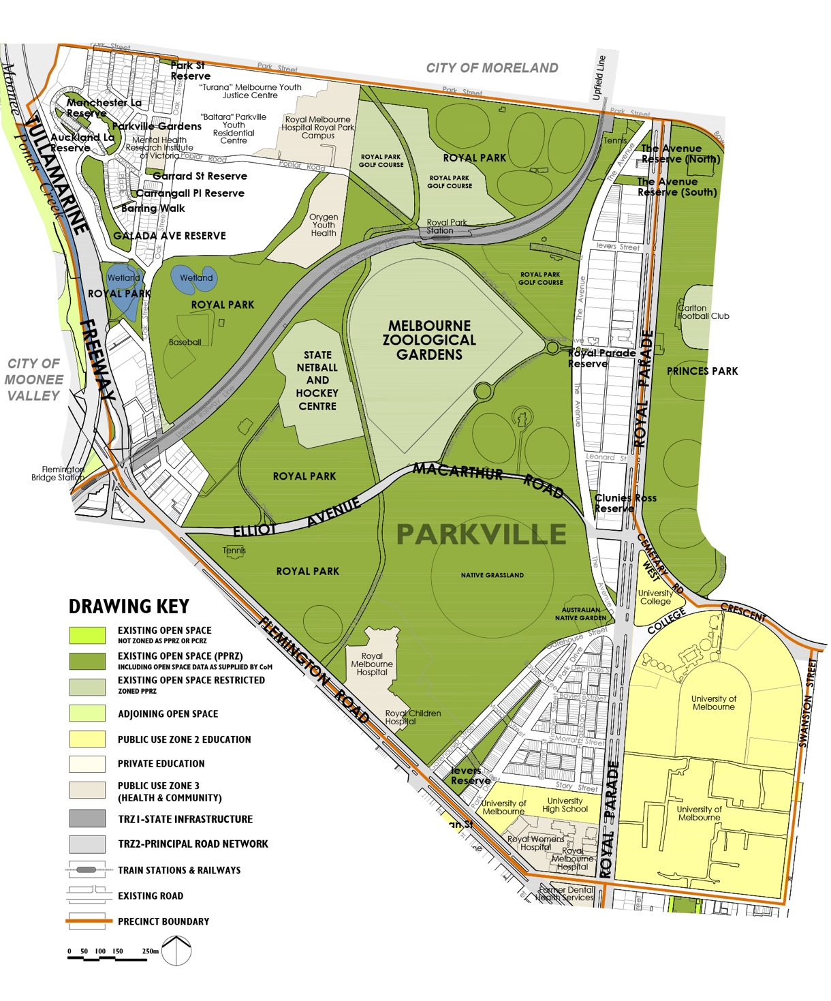

6.10.2 Summary of the population change between 2011 and 2021
As noted in Section 3.3.1 of this Light Touch Review, the residential population has grown by 35 percent between 2011 and 2021. This was much higher than the 1 per cent growth forecast over the 15 year timeframe in the 2012 Strategy. An additional 2,040 residents were living Parkville in 2021.
Analysis of the Mesh Block data for residential dwelling change between 2011 and 2021 has identified the majority of the change is in open space sub-precinct PA1, which is in the north-western part of Parkville associated with high density development adjacent to the Tullamarine Freeway.
As noted in Section 3.3.3 of this Light Touch Review, the employment figures for 2021 were impacted by Covid-19 and are not reported here.

6.10.3 Summary of the forecast population change from 2021 to 2031
The resident population is forecast to continue to grow over the next 10 years with an additional 3,410 residents forecast to live in Parkville by 2031, which represents a 44 per cent increase from 2021. While there was no spatial breakdown of the forecasts provided we assume the majority of the change will continue to occur in the area between Royal Park and the Tullamarine Freeway.
As noted in Section 3.3.2, the employment population forecasts from the 2012 Strategy will continue to be relied on, which is in Section 8.4.4a of the 2012 Strategy Technical Report. In summary, the worker population was forecast to continue to grow through to 2026 and is approximately five times the size of the resident population.

6.10.4 Implications for the forecast population changes on the updated Actions for this Section
By 2031, 3,411 additional residents are forecast to be living in Parkville which is approximately 1,900 more than the total residential population forecast by 2026 in the 2012 Strategy, while the worker population we are planning for has already been accounted for in the actions from the 2012 Strategy. Given this we have assumed a slightly higher overall population than was planned for in the actions originally. Please refer to Section 8.4 Parkville in the 2012 Strategy Technical Report for the rationale for the actions in addition to the updated information in this Light Touch Review.

6.10.5 Updated Precinct Actions for Parkville
Please note the Actions retain the numbering from the 2012 Strategy Technical Report.
A Additional open space
Not applicable
B Additional open space links
No. | Action | Responsibility | Priority
Action 8.4B-1 | Capital City Trail link through Royal Park, Princes Park and east to Merri Creek  Undertake improvements as required including consideration of improved lighting to the Capital City trail link to Princes Park, Hardy Gallagher Reserve through to Merri Creek. | Responsibility: C-o-m | Priority: Ongoing
C Capital City open space
Not applicable
D Regional open space
No. | Action | Responsibility | Priority
Action 8.4D-1 | The Avenue Reserve (South)  Continue to maintain Capital City trail link to Princes Park, Hardy Gallagher Reserve through to Merri Creek. Refer to Action 8.4B-1. | Responsibility: C-o-m | Priority: Ongoing
E Municipal open space
Not applicable

F Neighbourhood open space
No. | Action | Responsibility | Priority
Action 8.4F-1 | Galada Avenue Reserve  Continue to maintain this recently upgraded reserve. | Responsibility: C-o-m | Priority: Ongoing
Action 8.4F-2 | Ievers Reserve  Action completed. Continue to maintain.  Investigate potential to integrate water harvesting and re-use in this reserve, and if feasible, continue to implement to improve ongoing sustainability. | Responsibility: C-o-m | Priority: Ongoing
G Local open space
No. | Action | Responsibility | Priority
Action 8.4G-1 | Parkville Gardens  Undertake a major upgrade of this open space to increase the diversity of unstructured recreation and informal facilities to improve its accessibility, function and use, particularly given the recent population growth in the catchment of this open space. | Responsibility: C-o-m | Priority: Very High
H Small Local open space
No. | Action | Responsibility | Priority
Action 8.4H-1 | Carrangall Place Reserve  Continue to maintain. | Responsibility: C-o-m | Priority: Ongoing
Action 8.4H-2 | Clunies Ross Reserve  Undertake minor upgrade of this open space to improve accessibility, function and use. | Responsibility: C-o-m | Priority: Medium
Action 8.4H-3 | Garrard Street Reserve  Action completed. Continue to maintain. | Responsibility: C-o-m | Priority: Ongoing
Action 8.4H-4 | Park Street Reserve  Continue to maintain. | Responsibility: C-o-m | Priority: Ongoing
Action 8.4H-5 | The Avenue Reserve (North)  Undertake minor upgrade of this open space to improve accessibility, function and use. | Responsibility: C-o-m | Priority: Low
J Small Local Link
No. | Action | Responsibility | Priority
Action 8.4J-1 | Auckland Lane Reserve  Continue to maintain. | Responsibility: C-o-m | Priority: Ongoing
Action 8.4J-2 | Barring Walk  Continue to maintain as a pedestrian link. | Responsibility: C-o-m | Priority: Ongoing
Action 8.4J-3 | Manchester Lane Reserve  Continue to maintain. | Responsibility: C-o-m | Priority: Ongoing

K State open space
No. | Action | Responsibility | Priority
Action 8.4K-1 | Royal Park  Continue to implement the updated Royal Park Masterplan once complete in 2025, including works to improve facilities for the local neighbourhood living to the west of Royal Park in high density dwellings, and those that benefit the broader regional and state-wide visitors. Refer also to Action 7.7B-11 regarding access over Flemington Road to Royal Park. Provision of neighbourhood level facilities has a higher priority now given the recent and future high density development between Royal Park and CityLink. | Responsibility: C-o-m | Priority: Ongoing

6.11 Port Melbourne
Please refer to Section 8.5 in the 2012 Strategy Technical Report
The following Figures, Tables and Sections have been updated from the 2012 Strategy Technical Report and included in this Light Touch Review. The remaining information in Section 8.5 of the 2012 Strategy Technical Report remains unchanged:
- Figures 8.5~1a and 8.5~1b
- Table 8.45(i)
- Table 8.5(iia) and Table 8.5(iib)
- Section 8.5.5b, Precinct Actions for Port Melbourne

6.11.1 Changes to the existing open space network since the 2012 Strategy
Figures 6La and 6Lb illustrate the changes to the open space network since the 2012 Strategy was prepared. As noted in Section 4.2 of this Light Touch Review, new open space has been added to expand the size of Westgate Park.
The quantity of open space as increased in Port Melbourne from the 2012 Strategy, with 6.83 hectares of additional open space.
Table 8.5(i) Existing number, size and type of open space in Port Melbourne
No. | Hierarchy of open space | Area | %
1 | Regional open space | 35.31 hectares | 100%
1 | Totals | 35.31 hectares | 100%
1 | Restricted open space | 5.24 hectares | Percentage not applicable
Table 8.5(iia) Existing open space in Port Melbourne in 2023
Open space | Hierarchy | Total area in square metres | Total area in hectares
Westgate Park | Regional open space | 353,055 square metres | 35.31 hectares
Total area | Not applicable | 353,055 square metres in total | 35.31 hectares in total
Table 8.5(iib) Existing restricted open space in Port Melbourne in 2023
Open space | Hierarchy | Total area in square metres | Total area in hectares
Melbourne International Karting Complex | Regional open space | 52,350 square metres | 5.24 hectares
Total area | Not applicable | 52,350 square metres in total | 5.24 hectares in total
The changes to the open space network since the 2012 Strategy are shown in Figures 6La and 6Lb.
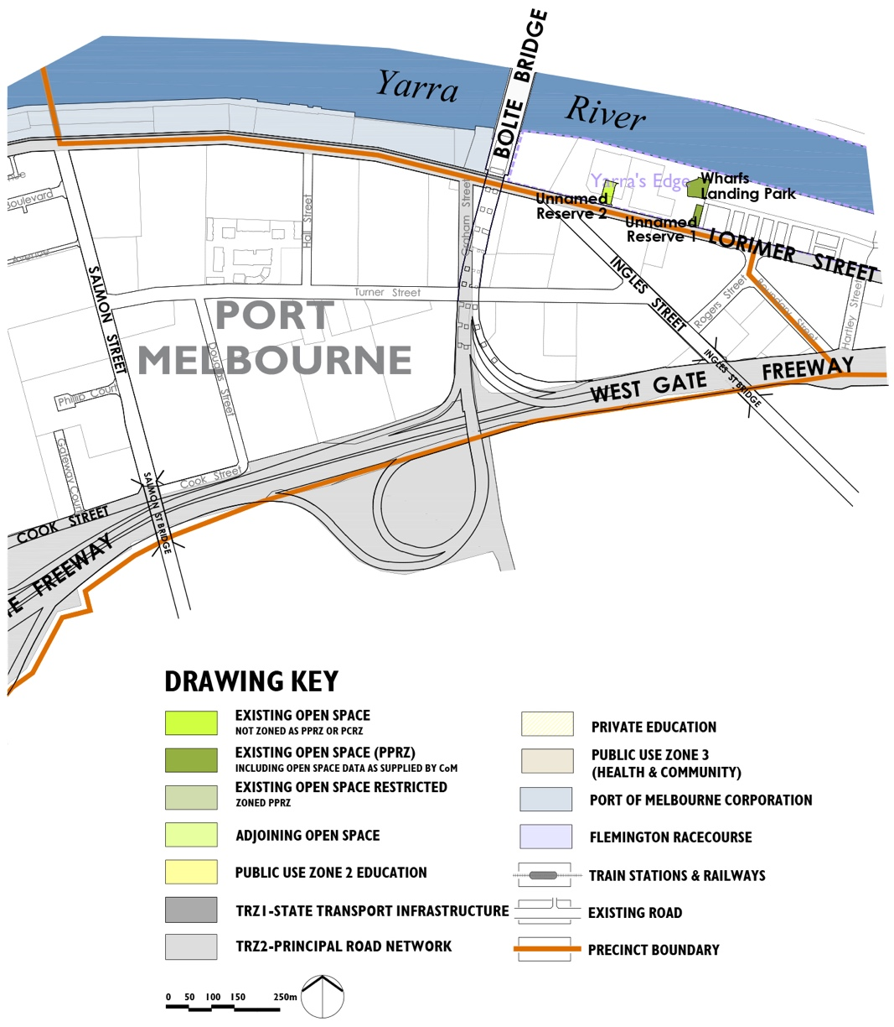
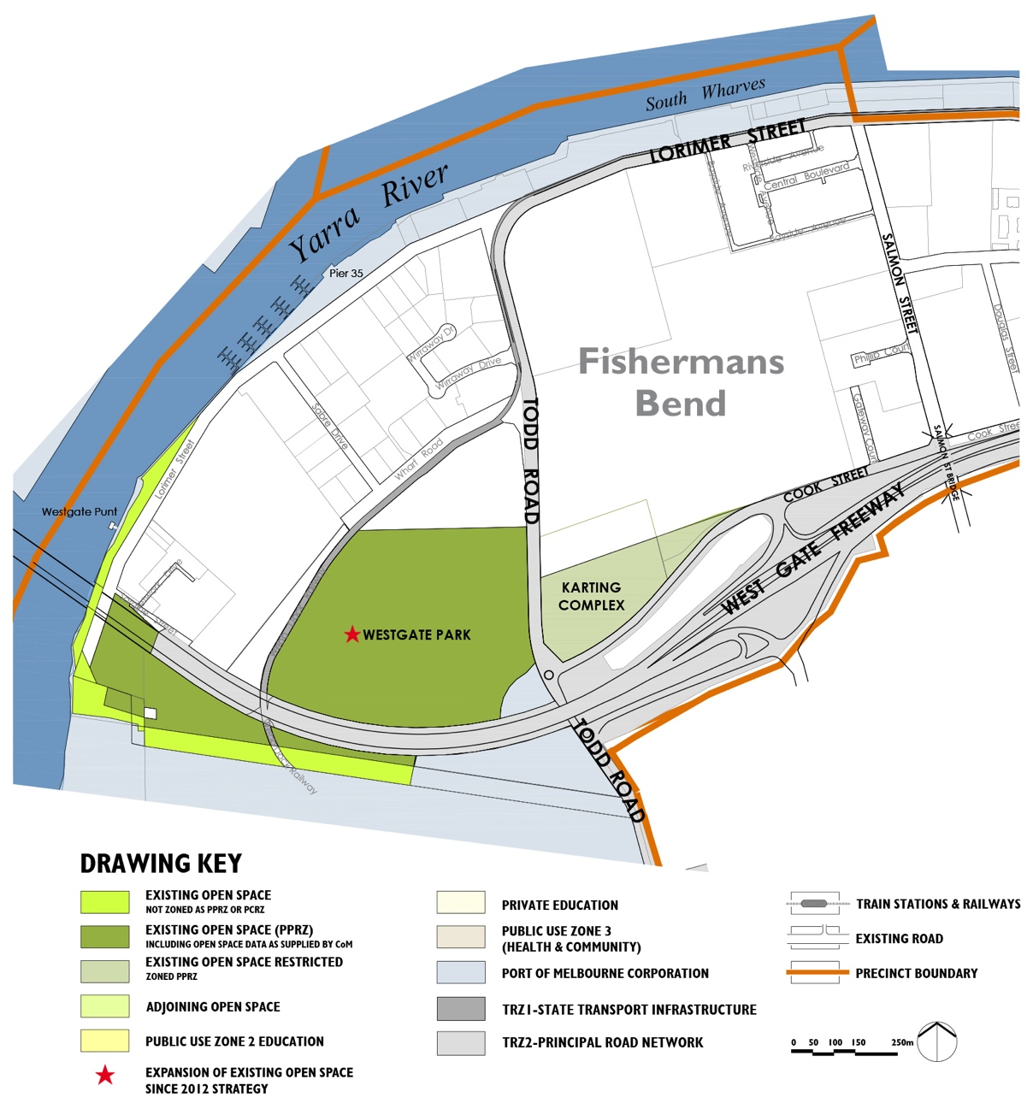

6.11.2 Summary of the population change between 2011 and 2021
As noted in Section 3.3.1 of this Light Touch Review, the residential population has not grown between 2011 and 2021.
As noted in Section 3.3.3 of this Light Touch Review, the employment figures for 2021 were impacted by Covid-19 and are not reported here.

6.11.3 Summary of the forecast population change from 2021 to 2031
The resident population is forecast to grow over the next 10 years with an additional 1,180 residents forecast to live in Port Melbourne by 2031, which is a substantial increase given there was almost no resident population in 2021.
As noted in Section 3.3.2, the employment population forecasts from the 2012 Strategy will continue to be relied on, which is in Section 8.5.4a of the 2012 Strategy Technical Report. In summary, the worker population was forecast to continue to grow through to 2026 and is substantially more than the resident population.

6.11.4 Implications for the forecast population changes on the updated Actions for this Section
By 2031, 1,180 additional residents are forecast to be living in Port Melbourne, which is 1,180 more than the total residential population change forecast by 2026 in the 2012 Strategy. We are also assuming the same number of the additional workers to be in the precinct as was forecast in 2012 Strategy, which is approximately 2,000 more workers.
The Fishermans Bend Strategic Framework Plan has been prepared to guide the forecast growth and change in the Lorimer Precinct of Port Melbourne. This Light Touch Review recommends that Council continues to be guided by the recommendations for new open space in the Fishermans Bend Strategic Framework Plan, however where feasible advocate for the new open spaces to meet the updated sizes and intent as shown in the updated Table 3(ii-b) in this Light Touch Review Report. The remaining area of Port Melbourne is referred to as the Fishermans Bend National Employment Innovation Cluster (N-e-i-c) as identified in Plan Melbourne and referenced in Section 3.2.1 of this Light Touch Review.

6.11.5 Updated Precinct Actions for Port Melbourne
Given the substantial change that has occurred to Port Melbourne since the 2012 Strategy was prepared, the diagram illustrating a summary of the recommendations has been updated and included in this Light Touch Review.
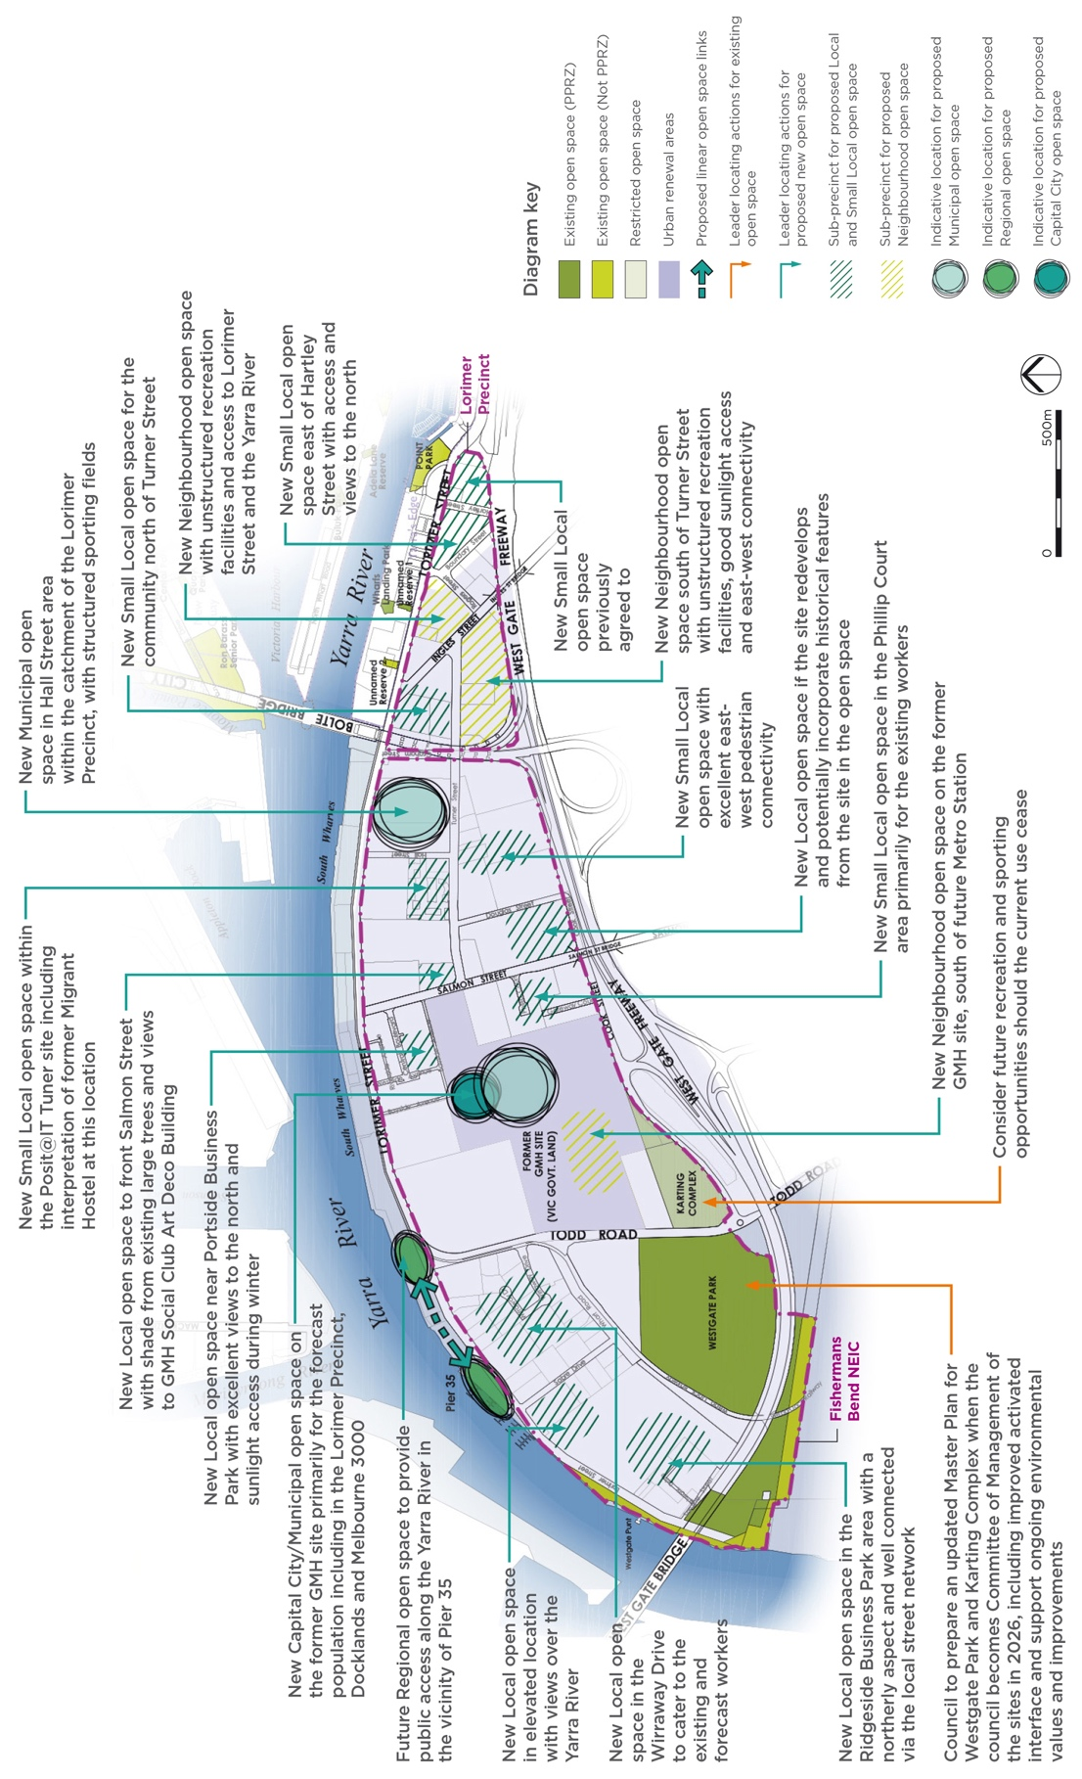

Please note the Actions retain the numbering from the 2012 Strategy Technical Report.
A Additional open space
No. | Action | Responsibility | Priority
Action 8.5A-1 | Lorimer Precinct  Continue to implement the Fishermans Bend Framework Plan, including investigating the potential to improve the open space outcomes for this Precinct with reference to the preferred open space hierarchy, ensuring a diversity of open space sizes and types that provide a diverse range of unstructured recreation facilities and opportunities are included, in addition to the active transport routes and links that are set out in the Fishermans Bend Framework Plan. | Responsibility: C-o-m  Vic Govt  Developer | Priority: Ongoing
Action 8.5A-2 | Fishermans Bend N-e-i-c  City of Melbourne to continue to participate in the precinct planning for the Fishermans Bend N-e-i-c. This is to reference the open space needs assessments already prepared for the City of Melbourne by Tbld to ensure the delivery of a diverse open space network that meets the needs of the forecast population, including delivery of new Municipal open space for the population outside of the employment precinct including in Southbank, Docklands, Melbourne 3000 and the Lorimer Precinct. | Responsibility: C-o-m  Developer | Priority: Very  High
B Additional open space links
No. | Action | Responsibility | Priority
Action 8.5B-1 | Investigate the potential to secure the foreshore of the Yarra River (Birrarung) as public open space and improve its condition and character between Westgate Freeway and Pier 35, including Pier 35 as part of the future open space planning for the Fishermans Bend N-e-i-c.  Additionally, if the opportunity arises in the future with changes to the Port of Melbourne function, investigate additional provision of open space along the Yarra River (Birrarung) to Bolte Bridge. | Responsibility: C-o-m  Vic Govt  T-o  Pv  Mwc | Priority: Very  High
Action 8.5B-2 | Investigate future open space link along the Yarra River (Birrarung) from the Bolte Bridge downstream to Pier 35 in the long term if the area changed from a working Port to an alternative use in the future. | Responsibility: C-o-m  Port of Melbourne  T-o | Priority: Ongoing
Action 8.5B-3 | Include future open space links or active transport links between Westgate Park and the proposed new open space network in the Fishermans Bend N-e-i-c to provide excellent access to Westgate Park and biodiversity links and connections. | Responsibility: C-o-m  Vic Govt | Priority: Ongoing
Action 8.5B-4 | Achieve improved pedestrian link along Turner Street to provide improved access between the proposed future open space network in the Fishermans Bend N-e-i-c. | Responsibility:  Vic Govt | Priority: Ongoing
C Capital City open space
Not applicable

D Regional open space
No. | Action | Responsibility | Priority
Action 8.5D-1 | Westgate Park  City of Melbourne has agreed to become Committee of Management for Westgate Park from 2026 and will prepare an updated master plan following transfer of responsibilities. The Master Plan should address the improved urban context for Westgate Park as part of the future planning for Fishermans Bend N-e-i-c. This includes advocating for activated interfaces that increase passive surveillance, entry points and personal safety and security in the Park. The Master Plan will also continue to support the ongoing conservation and biodiversity improvements to Westgate Park and future biodiversity links into the future diverse open space network in Fishermans Bend N-e-i-c. | Responsibility: C-o-m  Pv  Fwgp | Priority: Very High
Action 8.5D-2 | Karting Complex  City of Melbourne has agreed to become Committee of Management for Westgate Park from 2026 and will consider future active recreation and sporting opportunities should this current use cease. | Responsibility: C-o-m  Pv | Priority: Very High

6.12 Southbank | South Wharf
Please refer to Section 7.8 in the 2012 Strategy Technical Report
The following Figures, Tables and Sections have been updated from the 2012 Strategy Technical Report and included in this Light Touch Review. The remaining information in Section 7.8 of the 2012 Strategy Technical Report remains unchanged:
- Figure 7.8~1
- Table 7.8(i)
- Table 7.8(ii)
- Section 7.8.5b, Precinct Actions for Southbank | South Wharf

6.12.1 Changes to the existing open space network since the 2012 Strategy
Figure 6N illustrates the changes to the open space network since the 2012 Strategy was prepared. As noted in Section 4.2 of this Light Touch Review, new open space has been added to the network. In Southbank this includes Southbank Boulevard Reserve, Boyd Park and Kennedy Park.
The quantity of open space has increased in Southbank from 5.89 hectares in the 2012 Strategy to 6.95 hectares of open space in 2023, resulting in an additional 1.06 hectares of open space.
Table 7.8(i) Existing number, size and type of open space in Southbank | South Wharf
No. | Hierarchy of open space | Area | %
5 | Capital City open space | 2.35 hectares | 34%
1 | Regional open space | 1.17 hectares | 17%
1 | Neighbourhood open space | 1.25 hectares | 18%
4 | Local open space | 1.66 hectares | 24%
5 | Small Local open space | 0.47 hectare | 7%
2 | Small Local Link | 0.04 hectare | 1%
18 | Totals | 6.95 hectares | 100%
Table 7.8(ii) Existing open space in Southbank | South Wharf in 2023
Open space | Hierarchy | Total area in square metres | Total area in hectares
Boyd Park | Local open space | 4,869 square metres | 0.49 hectare
City Road Park | Small Local Link | 275 square metres | 0.03 hectare
Cook Street Reserve | Small Local open space | 476 square metres | 0.05 hectare
Eureka Reserve | Small Local open space | 455 square metres | 0.05 hectare
Grant Street Reserve | Local open space | 2,540 square metres | 0.25 hectare
Kennedy Park | Small Local open space | 858 square metres | 0.09 hectare
Kings Way & Moray Street Reserve | Small Local Link | 110 square metres | 0.01 hectare
Malthouse Plaza | Capital City open space | 2,514 square metres | 0.25 hectare
Maritime Park | Regional open space | 11,670 square metres | 1.17 hectares
Miles & Dodds Street Reserve | Small Local open space | 588 square metres | 0.06 hectare
Normanby Road Reserve | Neighbourhood open space | 12,513 square metres | 1.25 hectares
Queensbridge Square | Capital City open space | 9,113 square metres | 0.91 hectare
Railway Revegetation Area | Small Local open space | 2,354 square metres | 0.24 hectare
Riverside Quay Reserve | Capital City open space | 2,990 square metres | 0.30 hectare
Southbank Boulevard Reserve | Local open space | 4,402 square metres | 0.44 hectare
Southbank Promenade | Capital City open space | 7,630 square metres | 0.76 hectare
Southbank Promenade West | Capital City open space | 1,290 square metres | 0.13 hectare
Sturt Street Reserve | Local open space | 4,808 square metres | 0.48 hectare
TOTAL AREA | Not applicable | 69,455 square metres in total | 6.95 hectares in total
The changes to the open space network since the 2012 Strategy are shown in Figure 6N.
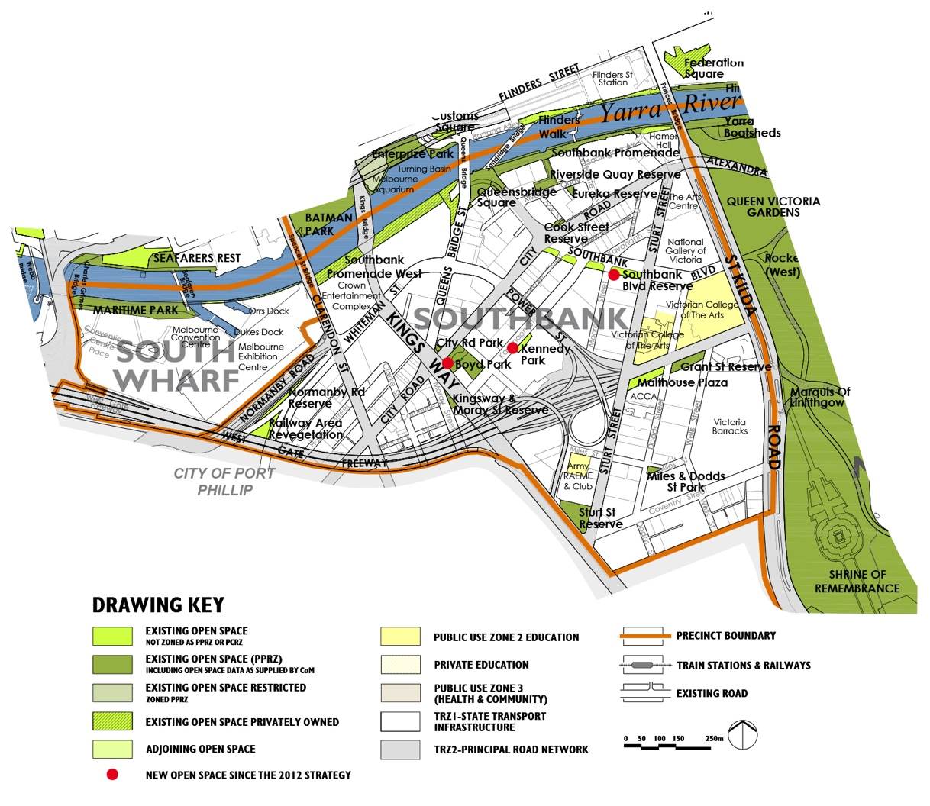

6.12.2 Summary of the population change between 2011 and 2021
As noted in Section 3.3.1 of this Light Touch Review, the residential population has grown by 72 per cent between 2011 and 2021. This is generally consistent the with 79 per cent growth forecast over the 15 year timeframe in the 2012 Strategy. An additional 9,481residents were living in Southbank in 2021.
Analysis of the Mesh Block data (refer to Appendix A) for residential dwelling change between 2011 and 2021 has identified there was significant change in open space sub-precincts SB5, SB7, SB9, SB10 and SB11, with reasonable levels change in sub-precincts SB1, SB2 and SB6 and limited change in sub-precincts SB8 and SB12.
As noted in Section 3.3.3 of this Light Touch Review, the employment figures for 2021 were impacted by Covid-19 and are not reported here.

6.12.3 Summary of the forecast population change from 2021 to 2031
The resident population is forecast to continue to grow over the next 10 years with an additional 12,964 residents forecast to live in Southbank by 2031, which represents a 57 per cent increase from 2021.
As noted in Section 3.3.2, the employment population forecasts from the 2012 Strategy will continue to be relied on, which is in Section 7.8.4a of the 2012 Strategy Technical Report. In summary, the worker population was forecast to continue to grow through to 2026.

6.12.4 Implications for the forecast population changes on the updated Actions for this Section
By 2031, 12,964 additional residents are forecast to be living in Southbank which is approximately 25,300 more than the total residential population forecast by 2026 in the 2012 Strategy. The worker population we are planning for has already been accounted for in the actions from 2012 Strategy. Given this we have assumed a substantially higher overall population than was planned for in the actions originally. Please refer to Section 7.8 Southbank | South Wharf in the 2012 Strategy Technical Report for the rationale for the actions in addition to the updated information in this Light Touch Review.

6.12.5 Updated Precinct Actions for Southbank | South Wharf
Given the substantial change that has occurred in Southbank | South Wharf since the 2012 Strategy was prepared, the diagram illustrating a summary of the recommendations has been updated and included in this Light Touch Review.
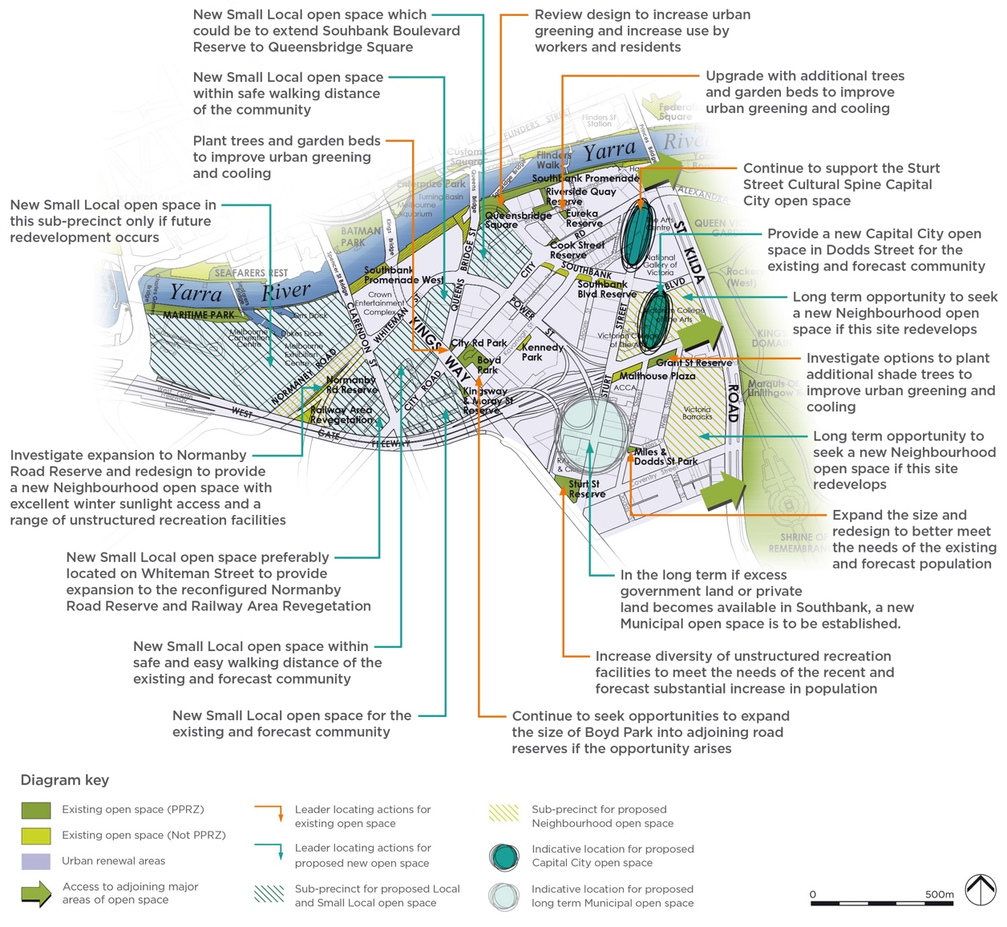

Please note the Actions retain the numbering from the 2012 Strategy Technical Report.
A Additional open space
No. | Action | Responsibility | Priority
Action 7.8A-1 | New Small Local open space in sub-precinct SB1  - Continue to negotiate with developer to provide an additional Small Local Open space in the western end of sub-precinct SB1 primarily for the existing and also for the future population.  - Complete Southbank Boulevard open space project between City Road and Queensbridge Square. | Responsibility: C-o-m  Developer | Priority: Very High
Action 7.8A-2 | Sturt Street cultural spine open space  Continue to support the development of the Sturt Street Cultural Spine open space which is currently in progress and as recommended in the Southbank Structure Plan 2010. | Responsibility: Vic Govt  C-o-m | Priority: High
Action 7.8A-3 | New Small Local open space in sub-precinct SB4  Provide an additional Small Local open space in sub-precinct SB4 for both the existing and future population and while no significant change has occurred between 2011 and 2021, this action is still required given the growth forecasts to 2031. | Responsibility: C-o-m  Developer | Priority: Very High
Action 7.8A-4 | New Local open space in sub-precinct SB5  This Action is in progress with the provision of the new Southbank Boulevard Reserve. Refer to Action 7.8G-3. | Responsibility: C-o-m  Developer | Priority: Ongoing
Action 7.8A-5 | New Local open space in sub-precinct SB6  This Action is complete with the provision of the new Southbank Boulevard Reserve. Refer to Action 7.8G-3. | Responsibility: C-o-m  Developer | Priority: Complete
Action 7.8A-6 | Miles and Dodds Street Park expansion in sub-precinct SB7  Complete the investigation into the proposal to expand the size of Miles and Dodds Street Park to increase it to a Local open space size and undertake a major upgrade to better cater to the recreational needs of sub-precinct SB7. | Responsibility: C-o-m  Developer | Priority: Very High
Action 7.8A-7 | New Neighbourhood open space at the VCA or Victoria Barracks  Long-term opportunity to seek a Neighbourhood open space in either the VCA or Victoria Barracks sites if these redevelop within the Strategy timeframe. Note: the costs for this project have not been included in this strategy, as it is not forecast to occur within the current timeframe. | Responsibility: Common-wealth Government  C-o-m | Priority: Ongoing
Action 7.8A-8 | New Small Local open space in sub-precinct SB8  Provide additional Small Local open space in sub-precinct SB8, preferably east of Queens Bridge Street for the existing and future population. | Responsibility: C-o-m  Developer | Priority: Very High
Action 7.8A-9 | New Neighbourhood open space on the Boyd School site in sub-precinct SB9  Boyd Park is now set aside as public open space, however it is a Local rather than Neighbourhood open space size. Continue to seek opportunities to expand this site into the adjoining road reserves when opportunities arise. Refer to Action 7.8G-4. | Responsibility: C-o-m  Developer | Priority: Ongoing
Action 7.8A-10 | New Small Local open space in sub-precinct SB10  Provide an additional Small Local open space in sub-precinct SB10 for both the existing and future population. | Responsibility: C-o-m  Developer | Priority: Very High
Action 7.8A-11 | New Small Local open space in sub-precinct SB11  Provide an additional Small Local open space in sub-precinct SB11 for both the existing and future population. | Responsibility: C-o-m  Developer | Priority: Very High
Action 7.8A-12 | New Small Local open space in sub-precinct SB12  Provide an additional Small Local open space in sub-precinct SB12 for both the existing and future population. Ideally, this will be located adjoining Whiteman Street with north/west aspect to encourage good winter sunlight access and longer vistas/sense of space from the future open space. | Responsibility: C-o-m  Developer | Priority: Very High
Action 7.8A-13 | Long term options for new open space in sub-precincts SB13 and SB14  In the long-term if excess land associated with the CityLink tunnel becomes available, review the need for new open space in sub-precincts SB13 and SB14. | Responsibility: C-o-m | Priority: Long-term
Action 7.8A-14 | New Capital City open space in Dodds Street  Provide a new Capital City open space in Dodds Street for the existing and forecast community. | Responsibility: C-o-m  Developer | Priority: Very High
Action 7.8A-15 | Long term new Municipal open space  In the long-term, if excess government land or private land becomes available, provide new Municipal open space. This is to provide organised sport and informal recreation facilities for the existing and future population of Southbank. | Responsibility: C-o-m  Vic Govt  Developer | Priority: Long-term
C Capital City open space
No. | Action | Responsibility | Priority
Action 7.8C-1 | Malthouse Plaza  Continue to maintain this open space as the forecourt to the Australian Centre for Contemporary Art. | Responsibility: Vic Govt | Priority: Ongoing
Action 7.8C-2 | Queensbridge Square  Renew the Square to cater for events, local worker and resident community use and urban greening for Capital City purposes. | Responsibility: C-o-m | Priority: High
Action 7.8C-3 | Riverside Quay Reserve  Action completed, continue to maintain. | Responsibility: C-o-m | Priority: Ongoing
Action 7.8C-4 | Southbank Promenade  Continue to maintain for Capital City purposes, with minor upgrade of facilities for local community use where appropriate. | Responsibility: C-o-m | Priority: High
Action 7.8C-5 | Southbank Promenade West  Continue to maintain for Capital City purposes. | Responsibility: C-o-m | Priority: Ongoing

D Regional open space
No. | Action | Responsibility | Priority
Action 7.8D-1 | Maritime Park  Continue to retain access along the Yarra River (Birrarung) through this open space. | Responsibility: C-o-m | Priority: Ongoing
E Municipal open space
Not applicable
F Neighbourhood open space
No. | Action | Responsibility | Priority
Action 7.8F-1 | Normanby Road Reserve  Investigate opportunities to expand and redesign Normanby Road Reserve, surrounding open space and Whiteman Street to provide an improved configuration of useable open space, diverse unstructured recreational facilities and urban heat island effect mitigation. Establishing a new Neighbourhood open space with excellent winter sunlight access is a very high priority given the current demand for open space and substantial increase in forecast population growth in Southbank. This includes the Railway Revegetation Area open space. | Responsibility: C-o-m | Priority: Very High
G Local open space
No. | Action | Responsibility | Priority
Action 7.8G-1 | Grant Street Reserve  Review the design to introduce additional shade and diversity of facilities to meet the changing demographics. This includes investigation into options to plant additional trees within the constraints of Citylink Tunnel being located beneath this reserve. | Responsibility: C-o-m | Priority: Very High
Action 7.8G-2 | Sturt Street Reserve  Undertake a Master Plan to increase the diversity of recreational facilities in this reserve and undertake upgrade as required, to meet the needs of the recent substantial increase in the resident population along with the forecast population. The presence of major roads to the boundaries of this Reserve impacts on its quality and therefore it is not identified for expansion. | Responsibility: C-o-m | Priority: High
Action 7.8G-3 | Southbank Boulevard Reserve  Continue to maintain this series of Local open space reserves. | Responsibility: C-o-m | Priority: Ongoing
Action 7.8G-4 | Boyd Park  Continue to maintain and continue seek opportunities to expand its size where feasible given the forecast growth. Refer to Action 7.8A-9. | Responsibility: C-o-m | Priority: Ongoing

H Small Local open space
No. | Action | Responsibility | Priority
Action 7.8H-1 | Eureka Reserve  Review design to include facilities for local community use and urban heat island effect mitigation. Investigate options to increase greening, provide seating and signage to confirm this is a public open space and is not private space. As part of this, investigate options to identify if it is feasible to remove or modify the overhead canopy. | Responsibility: C-o-m | Priority: High
Action 7.8H-2 | Miles and Dodds Street Reserve  Refer to Action 7.8A-6 regarding expansion of this existing open space to make it more useable. | Responsibility: Refer  7.8A-6 | Priority: Refer  7.8A-6
Action 7.8H-3 | Railway Revegetation Area  Refer to Action 7.8F-1 regarding reconfiguration of open space in the vicinity of Whiteman Street and Normanby Road. | Responsibility: Refer  7.8F-1 | Priority: Refer  7.8F-1
Action 7.8H-4 | Kennedy Park  Continue to maintain and in the longer term investigate options to repurpose to better meet community needs. | Responsibility: C-o-m | Priority: Ongoing
J Small Local Link
No. | Action | Responsibility | Priority
Action 7.8J-1 | City Road Park  Continue to maintain and upgrade to improve the contribution to urban greening with trees, garden beds and seating. | Responsibility: C-o-m | Priority: High
Action 7.8J-2 | Kingsway & Moray Street Reserve  Continue to maintain as a dog off-lead park. | Responsibility: C-o-m | Priority: Ongoing

6.13 West Melbourne
Please refer to Section 7.9 in the 2012 Strategy Technical Report
The following Figures, Tables and Sections have been updated from the 2012 Strategy Technical Report and included in this Light Touch Review. The remaining information in Section 7.9 of the 2012 Strategy Technical Report remains unchanged:
- Figures 7.9~1a and 7.9~1b
- Table 7.9(i)
- Table 7.9(ii)
- Section 7.9.5b, Precinct Actions for West Melbourne

6.13.1 Changes to the existing open space network since the 2012 Strategy
Figures 6Pa and 6Pb illustrate the changes to the open space network since the 2012 Strategy was prepared. As noted in Section 4.2 of this Light Touch Review, new open space has been added to the network. In West Melbourne a new open space being Wominjeka Park and expansions to a number of existing reserves including Howard & William Street Reserve, Railway & Miller Street Reserve, Stawell Street Park and Hawke & Adderley Street Park.
The quantity of open space has increased in West Melbourne from 14.56 hectares in the 2012 Strategy to 15.18 hectares of open space in 2023, resulting in an additional 0.62 hectares of open space.
Table 7.9(i) Existing number, size and type of open space in West Melbourne
No. | Hierarchy of open space | Area | %
5 | Regional open space | 11.27 hectares | 74%
1 | Municipal open space | 2.28 hectares | 15%
2 | Local open space | 0.84 hectare | 6%
5 | Small Local open space | 0.68 hectare | 4%
3 | Small Local Link | 0.12 hectare | 1%
16 | Totals | 15.18 hectares | 100%
Table 7.9(ii) Existing open space in West Melbourne in 2023
Open space | Hierarchy | Total area in square metres | Total area in hectares
Dynon Road Reserve | Regional open space | 20,817 square metres | 2.08 hectares
Eades Park | Local open space | 5,127 square metres | 0.51 hectare
Flagstaff Gardens | Regional open space | 73,350 square metres | 7.34 hectares
Hawke & Adderley Street Park | Small Local open space | 1,885 square metres | 0.19 hectare
Hawke & Curzon Street Reserve | Small Local open space | 1,408 square metres | 0.14 hectare
Hawke & King Street Reserve | Small Local Link | 596 square metres | 0.06 hectare
Howard & William Street Reserve | Small Local open space | 1,859 square metres | 0.19 hectare
King & Victoria Street Reserve | Small Local Link | 507 square metres | 0.05 hectare
Maribynong River Bank Reserve (West Melbourne) | Regional open space | 10,993 square metres | 1.10 hectares
Moonee Ponds Ceek Reserve | Regional open space | 4,789 square metres | 0.48 hectare
Railway & Miller Street Reserve | Local open space | 3,290 square metres | 0.33 hectare
Railway Viewing Platform | Small Local Link | 110 square metres | 0.01 hectare
Shepherd Bridge Reserve | Regional open space | 2,705 square metres | 0.27 hectare
Stawell Street Park (Formerly Spencer & Dryburgh St Reserve in 2012 Strategy) | Small Local open space | 1,161 square metres | 0.12 hectare
Wildlife Sanctuary | Municipal open space | 22,790 square metres | 2.28 hectares
Wominjeka Park | Small Local open space | 460 square metres | 0.05 hectare
Total area | Not applicable | 151,847 square metres in total | 15.18 hectares in total
The changes to the open space network since the 2012 Strategy are shown in Figures 6Pa and 6Pb.
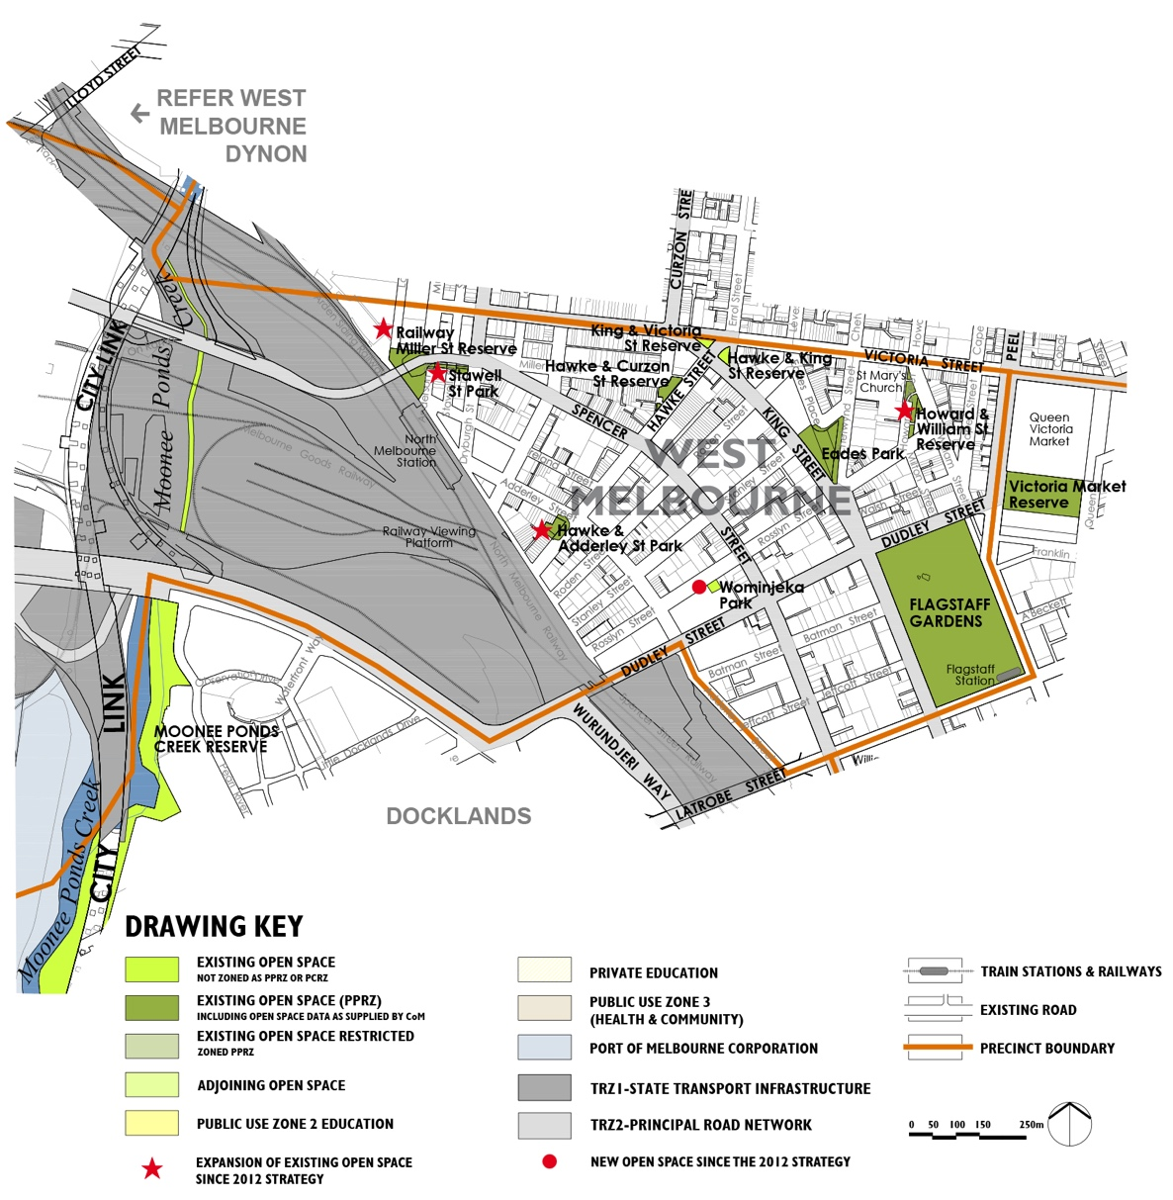
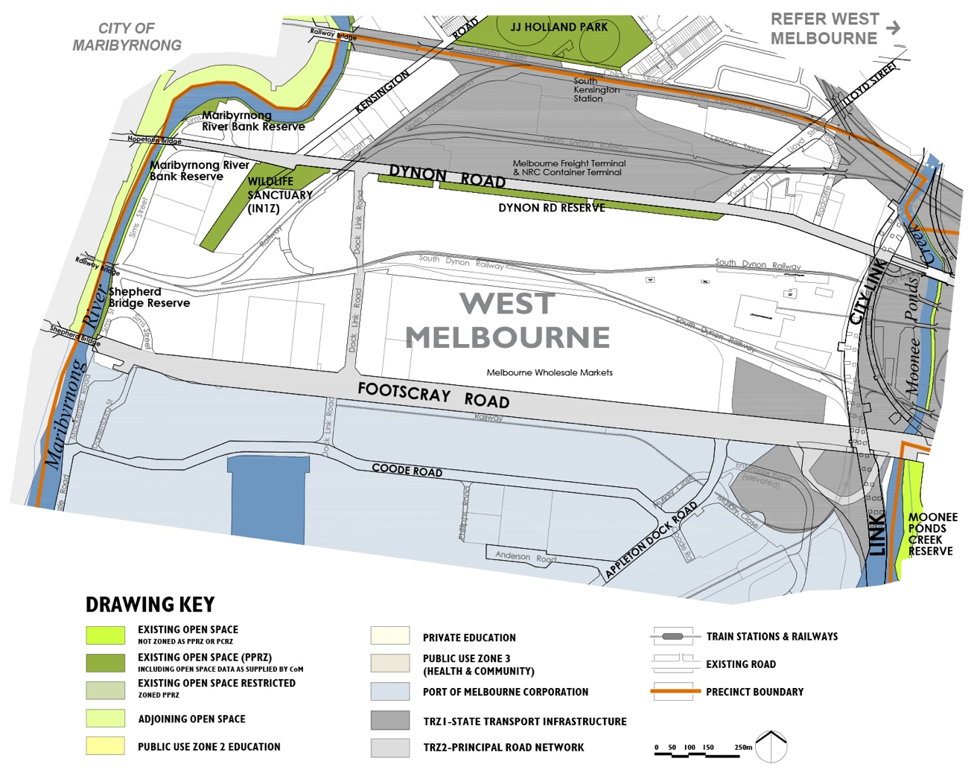

6.13.2 Summary of the population change between 2011 and 2021
As noted in Section 3.3.1 of this Light Touch Review, the residential population has grown by 108 per cent between 2011 and 2021. This is lower than the 146 per cent growth forecast over the 15 year timeframe in the 2012 Strategy. An additional 4,113 residents were living in West Melbourne in 2021.
Analysis of the Mesh Block data (refer to Appendix A) for residential dwelling change between 2011 and 2021 has identified there was significant change in open space sub-precincts WM1, WM3,WM5 and WM6. There was no residential population forecast for the West Melbourne - Dynon Precinct or the E-Gate precincts which were both anticipated to redevelop at the time the 2012 Strategy was prepared.
As noted in Section 3.3.3 of this Light Touch Review, the employment figures for 2021 were impacted by Covid-19 and are not reported here.

6.13.3 Summary of the forecast population change from 2021 to 2031
The resident population is forecast to continue to grow over the next 10 years 2021 with an additional 4,781 residents forecast to live in West Melbourne by 2031, which represents a 60 per cent increase from 2021. The change is anticipated to mainly occur in the sub-precincts WM1 to WM6.
As noted in Section 3.3.2, the employment population forecasts from the 2012 Strategy will continue to be relied on, which is in Section 7.9.4a of the 2012 Strategy Technical Report. In summary, the worker population was forecast to continue to grow through to 2026.

6.13.4 Implications for the forecast population changes on the updated Actions for this Section
By 2031, 4,781 additional residents are forecast to be living in West Melbourne which is approximately 3,300 more than the total residential population forecast by 2026 in the 2012 Strategy. The worker population we are planning for has already been accounted for the actions from the 2012 Strategy. Given this, we have assumed a higher overall population than was planned for in the actions originally. Please refer to Section 7.9 of the 2012 Strategy Technical Report for the rationale for the actions in addition to the updated information in this Light Touch Review.
Please note there is a minor correction to Table 7.9(iv) in the 2012 Strategy Technical Report in sub-precinct EG1, where the first sentence of the Description should read:
'This sub-precinct is known as the E-Gate site and extends from Moonee Ponds Creek in the west, to
Dynon Road in the north, Footscray Road in the south and North Melbourne railway in the east.'
There is also a minor correction to Table 7.9(v) in the 2012 Strategy Technical Report in sub-precinct WD1, where the first sentence of the Description should read:
'Directly adjoining the Maribyrnong River, this sub-precinct extends east to Moonee Ponds Creek and
south of Dynon Road'
Please note, Figure 7.9~4 has been updated and included on the next page to show the correct sub-precincts for West Melbourne.
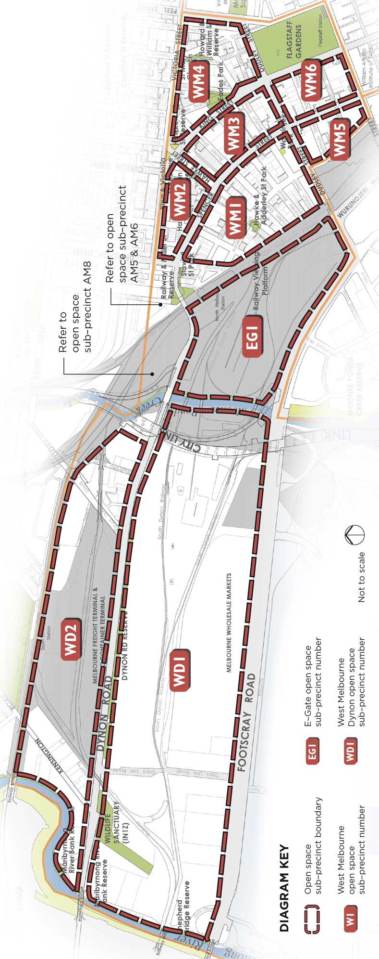

6.13.5 Updated Precinct Actions for West Melbourne
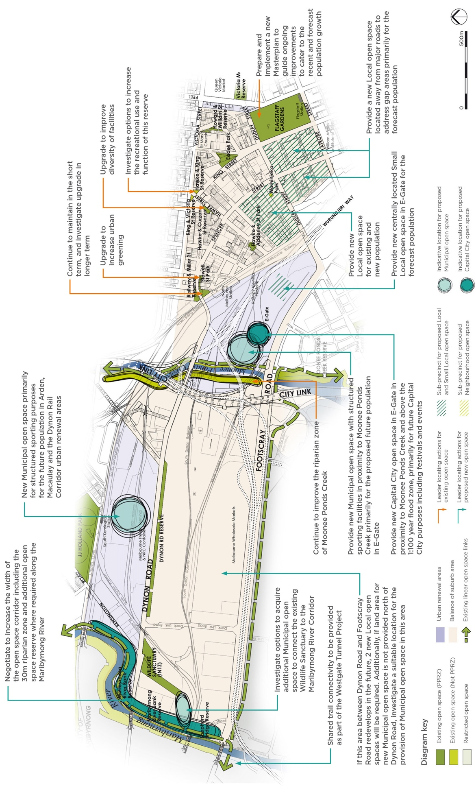

Please note the Actions retain the numbering from the 2012 Strategy Technical Report.
A Additional open space
No. | Action | Responsibility | Priority
Action 7.9A-1 | New Capital City open space in E-Gate  Establish a Capital City open space adjacent to Moonee Ponds Creek in the E-Gate site capable of holding major events and designed to contribute to the core character and values of the urban renewal areas in the north-west Melbourne. Refer to conclusions in sub-precinct EG1. | Responsibility: C-o-m  Vic Govt | Priority: Ongoing
Action 7.9A-2 | New Municipal open space in E-Gate  Establish a new Municipal open space adjacent to Moonee Ponds Creek in the E-Gate site capable of providing organised sports facilities including sports fields to cater to E-Gate, Docklands and Arden-Macaulay. | Responsibility: C-o-m  Vic Govt | Priority: Very High
Action 7.9A-3 | New Municipal open space in Dynon area  Establish a new Municipal open space in the Dynon urban renewal area capable of providing organised sports facilities including sports fields to cater primarily to the new population in Arden-Macaulay, and any future population in the Dynon Rail corridor. | Responsibility: C-o-m  Vic Govt | Priority: Very High
Action 7.9A-4 | New Small Local open space in E-Gate  Establish an additional Small Local open space located centrally and towards the south of the E-Gate site away from traffic noise and activity. This is to be accessible via the residential street network to provide for the forecast future local population in addition to the Capital City and Municipal open space in EG1. | Responsibility: C-o-m  Vic Govt | Priority: Ongoing
Action 7.9A-5 | New Local open space in sub-precinct WM1  Provide an additional Local open space in the south of sub-precinct WM1 to provide for the existing and future population. This will need to be located away from major roads to provide sense of protection and refuge from traffic flow and noise. | Responsibility: C-o-m  Developer | Priority: Very High
Action 7.9A-6 | Expand size of Howard & William Street Reserve  This Action is complete. | Responsibility: C-o-m  Developer | Priority: Complete
Action 7.9A-7 | Expand width of open space corridor along the Maribyrnong River in sub-precinct WD2  Negotiate in future redevelopment of the sites adjacent to the Maribyrnong River in sub-precinct WD2 to achieve additional width of open space.  Future proposals for the additional open space adjoining the river need to clearly identify areas that are encumbered as described in Recommendation 6.2.3d(i), in the 2012 Strategy Technical Report and take account of the setback of development from the waterway beyond the 30 metre riparian zone as required by Clause 12.03 of the Melbourne Planning Scheme. Any future open space provided as an open space contribution as part of Clause 53.01 is to be in addition to encumbered land and the riparian zone setback. | Responsibility: C-o-m  Developer  Vic Govt  T-o | Priority: Ongoing

Action 7.9A-9 | New open space in the Footscray Road area  If the area between Footscray Road and the railway in sub-precinct WD1 redevelops with an increase in the worker/resident population, then new open space will be required. This may be a future location for new Municipal open space if the other location shown for this north of Dynon Road in WD2 is not provided. Alternatively, a minimum of 2 No. new Local open spaces in sub-precinct WD1 will be required for the future worker population if it redevelops as part of the Dynon urban renewal area. | Responsibility: C-o-m  Developer | Priority: Ongoing
Action 7.9A-10 | Expand width of open space corridor along the Maribyrnong River in sub-precinct WD1  Negotiate in future redevelopment of the sites adjacent to the Maribyrnong River in sub-precinct WD1 to achieve additional width.  Future proposals for the additional open space adjoining the river need to clearly identify areas that are encumbered as described in Recommendation 6.2.3d(i), in the 2012 Strategy Technical Report and take account of the setback of development from the waterway beyond the 30 metre riparian zone as required by Clause 12.03 of the Melbourne Planning Scheme. Any future open space provided as an open space contribution as part of Clause 53.01 is to be in addition to encumbered land and the riparian zone setback. | Responsibility: C-o-m  Developer  Vic Govt  Mwc  T-o | Priority: Ongoing
Action 7.9A-11 | New Local open space in sub-precinct WM6  Establish a new Local open space utilising part of Batman Street or similar as a refuge away from busy traffic to provide for the existing and future population and to assist with mitigating urban heat island effect in sub-precinct WM6. | Responsibility: C-o-m  Developer | Priority: Very High
Action 7.9A-12 | New Local open space in sub-precinct WM5  Establish a new Local open space utilising part of Batman Street or similar as a refuge away from busy traffic to provide for the existing and future population and to assist with urban heat island effect mitigation in sub-precinct WM5. | Responsibility: C-o-m  Developer | Priority: Very High
B Additional open space links
No. | Action | Responsibility | Priority
Action 7.9B-1 | Continue to improve the Dynon Road linear open space corridor link including future safe connections into redeveloped industrial sites to encourage cycling access for workers to the Dynon urban renewal area. | Responsibility: C-o-m  Vic Govt | Priority: Ongoing
C Capital City open space
Not applicable

D Regional open space
No. | Action | Responsibility | Priority
Action 7.9D-1 | Dynon Road Reserve  Continue to maintain as a regional linear trail connection through West Melbourne to the Maribyrnong River shared trail. | Responsibility: C-o-m | Priority: Ongoing
Action 7.9D-2 | Flagstaff Gardens  Prepare a new Master Plan to guide ongoing improvements, particularly in the context of substantial recent change and forecast growth in the catchment of these gardens between 2011 and 2021. | Responsibility: -C-o-m | Priority: Medium
Action 7.9D-3 | Maribyrnong River Bank Reserve  Investigate increasing the width of this open space corridor as per Action 7.9A-7. | Responsibility: C-o-m | Priority: Ongoing
Action 7.9D-4 | Moonee Ponds Creek  Continue to improve the riparian zone where appropriate, and maintain the shared trail. Refer to Action 7.9A-1 regarding additional Capital City open space adjoining Moonee Ponds Creek in West Melbourne. | Responsibility: C-o-m  Mwc | Priority: Ongoing
Action 7.9D-5 | Shepherd Bridge Reserve  Continue to maintain the trail and improve the landscape character consistent with the Maribyrnong River Design Guidelines 2010 or any similar guidelines that replace these. | Responsibility: C-o-m  T-o  Mwc | Priority: Ongoing
E Municipal open space
No. | Action | Responsibility | Priority
Action 7.9E-1 | Wildlife Sanctuary (Depot)  Continue to maintain and manage for nature conservation and environmental improvement values.  Investigate options to secure/acquire additional land adjoining this site to achieve two outcomes:  - Establish a new Municipal open space in the Dynon urban renewal area referred to in Action 7.9A-3.  - Connect the Wildlife Sanctuary to the Maribyrnong River corridor incorporating the existing tributary that flows through VicTrack land, with adequate space to both achieve a habitat corridor and informal recreational use of the corridor for future residents and works in the Dynon urban renewal area. | Responsibility: C-o-m  Responsibility: C-o-m, Vic Govt | Priority: Ongoing  Priority: Very High
F Neighbourhood open space
Not applicable
G Local open space
No. | Action | Responsibility | Priority
Action 7.9G-1 | Eades Park  This Action is complete, continue to maintain. | Responsibility: C-o-m | Priority: Ongoing

H Small Local open space
No. | Action | Responsibility | Priority
Action 7.9H-1 | Hawke & Adderley Street Park  This Action is complete, continue to maintain. | Responsibility: C-o-m | Priority: Ongoing
Action 7.9H-2 | Hawke & Curzon Street Reserve  Investigate options to increase the useability and function of this open space while retaining the urban character of the adjoining area. | Responsibility: C-o-m | Priority: Very High
Action 7.9H-3 | Howard & Williams Street Reserve  This Action is complete, continue to maintain. | Responsibility: C-o-m | Priority: Ongoing
Action 7.9H-4 | Railway & Miller Street Reserve  Continue to maintain in the short term and in the longer term review options to increase the diversity of unstructured recreation facilities in this reserve as the population grows in this precinct as forecast. | Responsibility: C-o-m | Priority: Medium
Action 7.9H-5 | Stawell Street Park  Upgrade to increase urban greening in this reserve, recognising it continues to be encumbered by the traffic volumes and noise. | Responsibility: C-o-m | Priority: Medium
J Small Local Link
No. | Action | Responsibility | Priority
Action 7.9J-1 | Hawke & King Street Reserve  Investigate options to improve the function and useability of this open space reserve. | Responsibility: C-o-m | Priority: Medium
Action 7.9J-2 | King & Victoria Street Reserve  Continue to maintain. | Responsibility: C-o-m | Priority: Ongoing
Action 7.9J-3 | Railway Viewing Platform  Continue to maintain in the short term. Review function and design within the context of the future E-Gate redevelopment in sub-precinct WM1. | Responsibility: C-o-m | Priority: Medium

7 References
Aspect & T.C.L (2023) The Greenline Project Draft Master Plan, Prepared for the City of Melbourne, August 2023
City of London (2015) City of London Open Space Strategy
City of London (2022) Open Spaces and Recreation Audit Report
City of Melbourne (2012) Urban Forest Strategy
City of Melbourne (2017) Nature in the City - thriving biodiversity and healthy ecosystems
City of Melbourne (2019) Domain Parklands Master Plan 2019 - 2039
City of Melbourne (2019) Moonee Ponds Creek Strategic Opportunities Plan
City of Melbourne (2021) Reconciliation Action Plan June 2021 – June 2023
City of Melbourne (2021) Council Plan 2021-2025
City of Melbourne (2022) City of Melbourne Population and Jobs Forecasts 2021 - 2041 Summary Report
City of Melbourne (2022) Macaulay Structure Plan, May 2022
City of Melbourne (undated) City of Melbourne Parks Policy
City of Ottawa (2021) Ottawa Parks and Recreation Facilities Master Plan 2021
City of Sydney (2016) Open Space, Sports and Recreation Needs Study 2016, Vols 1, 2 and 3
Environment & Land Management Pty Ltd (2023) City of Melbourne Open Space Contributions Framework Review, Prepared for the City of Melbourne, March 2023
Mayor of London (2021) The London Plan - The Spatial Development Strategy for Greater London, March 2021
Melbourne Planning Scheme, Planning Schemes Online
Melbourne Water Corporation (2022) Burndap Birrarung Burndap Umarkoo Yarra Strategic Plan – A 10-year plan for the Yarra River corridor 2022 to 2032
New York City Mayors Office of Environmental Coordination (2020) City Environmental Quality Review Technical Manual
Otium Planning Group (2022) Recreation Facilities Master Plan Work – Visit – Play Prepared for the City of Melbourne June 2022
Parks Victoria (2016) Westgate Park Master Plan Community Update #1 Draft Concept Plan – July 2016
Parliament of Victoria (2022) Inquiry into environmental infrastructure for growing populations, Parliament of Victoria Legislative Assembly Environment and Planning Committee, February 2022
Reconciliation Victoria (undated) It's Time for Treaty - A Guide for Local Government
Thompson Berrill Landscape Design Pty Ltd (2012) City of Melbourne Open Space Strategy Planning for Future Growth, Prepared for the City of Melbourne by Thompson Berrill Landscape Design Pty Ltd in collaboration with Environment & Land Management Pty Ltd and Professor Nigel Tapper
Thompson Berrill Landscape Design Pty Ltd et al (2012) City of Melbourne Open Space Strategy Technical Report, Prepared for the City of Melbourne
Townsend M and Weerasuriya R (2010) Beyond Blue to Green: The benefits of contact with nature for mental health and well-being, Beyond Blue Limited
Veal, A.J. (2013) Open Space Planning Standards in Australia: in Search of Origins, Published in Australian Planner 50(3), 224-32
Victoria State Government (2015) Open Space Strategies Planning Practice Note 70
Victoria State Government (2017) Plan Melbourne 23017-2050 Metropolitan Planning Strategy
Victoria State Government (2017) West Gate Tunnel Project Environment Effects Statement Development and Urban Design Plans, December 2017 prepared by the Western Distributor Authority
Victoria State Government (2018) Fishermans Bend Framework – The next chapter in Melbourne's growth story, October 2018
Victoria State Government (2021) Victorian Aboriginal and Local Government Strategy 2021 – 2026 Pathways to Stronger Partnerships
Victoria State Government (2021) Waterways of the West Action Plan
Victoria State Government (2021) Open Space for Everyone – Open Space Strategy for Metropolitan Melbourne 2021
Victoria State Government (2022) Melbourne Planning Scheme - Clause 02 and Maps
Victoria State Government (undated) Yarra River Action Plan Wilip-gin birrarung murron
Victorian Aboriginal Heritage Council (2020) Taking Care of Culture State of Victoria's Aboriginal Cultural Heritage Report Discussion Paper
Victorian Planning Authority (2022) Arden Structure Plan Wurundjeri Woi Wurrung Country Prepared July 2022
White, M.P, Alcock, I., Grellier, J, et al (2019) Spending at least 120 minutes a week in nature is associated with good health and wellbeing, Published in Scientific Reports Nature (2019) 9:7730
World Health Organization (2021) Urban blue and green spaces and health – A review of evidence
World Health Organization (2021) Manifesto for a Healthy Recovery from Covid-19
World Health Organization Regional Office for Europe (2017) Urban Green Spaces: a brief for action
World Health Organization Regional Office for Europe (2021) Green and Blue Spaces and Mental Health – New Evidence and Perspectives for Action

