
Victorian Government
Draft Housing Targets
City of Melbourne Submission
September 2024
Contents
Introduction 3
Theme 1: Feasibility of draft housing targets 6
Theme 2: City of Melbourne’s role in housing supply 8
Theme 3: Accommodating growth within the City of Melbourne 10
Theme 4: Homes in liveable, high amenity neighbourhoods 13
Theme 5: Safeguarding our role as a capital city 14
Theme 6: Affordable housing, diversity and quality 15
Theme 7: Victorian Government leadership 17
Theme 8: Urban modelling 18
References 20
Appendix A: Factors influencing housing 21
Appendix B: City of Melbourne amendments awaiting decisions from the Minister for Planning in recent years 22

Introduction
Melbourne is Australia’s fastest growing city and the City of Melbourne is experiencing some of the highest growth across all municipalities in Victoria. To accommodate more people living in our city we need more housing that meets a range of household needs. This housing must be accessible to more Victorians, including key workers, low income households, older adults, first-home buyers, young families and vulnerable communities.
The City of Melbourne welcomes the establishment of housing targets, and notes that this complements the existing work of councils, who actively plan for, encourage, and accommodate housing growth.
In the context of the targets, it is important to note that the housing challenges in Victoria are complex, growing, and decades in the making. They require a sophisticated and far-reaching response, from all tiers of government. There is no single solution, and some solutions will not be popular. Plan for Victoria and the statewide housing targets, as well as the concurrent review of the Planning and Environment Act 1987, and the Federal Government’s National Urban Policy and forthcoming National Housing and Homelessness Plan, present a unique opportunity to address these challenges. We welcome the Victorian and Federal Government’s concerted efforts to respond to the housing crisis.
In releasing Victoria’s Housing Statement – the decade ahead 2024-2034 the Victorian Government set an ambitious target of delivering 2.24 million new homes by 2051. The recent Victorian Government announcement of statewide draft housing targets provides each of Victoria’s 79 Council’s with an indicative target for where these homes are to be built over the next 26 years to 2051. City of Melbourne’s draft housing target is for an additional 134,000 homes, a 122 percent increase on existing homes.
As a capital city, our municipality serves as a major economic driver for the state, providing significant access to transport, jobs and activities and much of the state’s premier cultural, community and sports infrastructure. The City of Melbourne is well positioned to play a central role in accommodating significant population growth. We have the highest rate of housing growth of developed suburbs in metropolitan Melbourne and we are home to three significant urban renewal precincts, enabling considerable housing supply.
This submission provides feedback on the Victorian Government’s statewide draft housing targets. Our feedback is focused on eight themes with a set of recommendations to further strengthen and refine the development and delivery of a housing target as detailed in Table 1.
While this submission focuses specifically on the draft statewide housing target, it should be received in the context of our recent submissions and recommendations, including our submission:
- to the Australian Government’s draft National Urban Policy (DOCX 42 KB)
- to the Australian Government’s National Housing and Homelessness Plan (DOCX 129KB)
- to the Victorian Government’s development of a new Plan for Victoria (DOCX 416 KB)

We welcome the opportunity to work alongside the Victorian Government in responding to one of the clearest challenges facing us today – providing quality and diverse housing for everybody, now and into the future.

Table 1 City of Melbourne submission recommendations
Theme | Recommendations
- Feasibility of draft housing targets | - Victorian Government provides further information on how the draft housing targets were developed to better understand how they relate to our future population and housing forecasts and share this publicly.  - Victorian Government provides councils with a breakdown of the target by year and by each local area and precinct, if available.
- Council’s role in housing supply | - That statewide draft housing targets are a measure of capacity not a threshold of planning approvals or housing delivered, noting that local government cannot compel delivery of housing  - The Victorian Government, in partnership with other levels of Government, investigate opportunities to review and reform tax and regulatory structures to address housing inequity and stimulate new development.
- Accommodating growth within the City of Melbourne | - Victorian Government works with the City of Melbourne to refine the capacity target based on strategic planning and capacity across the change types and local areas identified by the City of Melbourne.  - Victorian Government confirms whether the potential urban renewal areas of Maribyrnong Waterfront, E-Gate and Dynon are included in the draft housing target, noting this may affect the suitability of the target.  - Victorian Government considers how the retrofit of existing buildings can be incorporated into the housing targets, noting City of Melbourne’s unique land use mix and housing constraints.
- Homes in liveable, high amenity neighbourhoods | - Victorian Government incorporates land set aside for open space, community and transport infrastructure in determining statewide housing targets.  - Victorian Government works with local government to reform funding and financing mechanisms to ensure infrastructure can support the significant rate of development within our municipality and maintain our high-quality and high-amenity neighbourhoods and central city.  - Victorian Government supports local government in the timely consideration and progression of development contributions planning and controls to ensure new development contributes to the renewal and delivery of infrastructure that is required to support increased population growth.
- Safeguarding our role as a capital city | - Victorian Government provides further information on how non-residential capacity within the central city, Parkville NEIC and urban renewal areas has been factored into the housing targets, noting that an increase in residential uses must be balanced by an increase in non-residential uses.  - Victorian Government incorporates capacity set aside for non-residential floor space that maintains the economic and cultural function of the central city in determining housing targets.
- Affordable housing, diversity and quality | - Victorian Government introduces an affordable housing target as part of the statewide housing targets, in consultation with local government.  - Victorian Government introduces mandatory affordable housing contributions as part of the Victoria Planning Provisions and as an interim, support Councils that seek to apply mandatory controls for affordable housing contributions.  - Victorian Government shares assumptions that have informed statewide housing targets, including household size, dwelling size and typology.  - Statewide housing targets are supported with robust policy recognising the importance and need for housing diversity and quality, and affordable housing.
- Victorian Government leadership | - Identify and establish funding and delivery pathways for all infrastructure required to support the development of our urban renewal areas, including drainage, public transport and other enabling infrastructure to unlock housing capacity.  - Prepare a metropolitan-scale strategic plan alongside Plan for Victoria that responds to the interconnected complexities of housing, transport, the environment and land use within the metropolitan region.  - Provide timely advice and processing of planning scheme amendments to support strategic planning.  - Victorian Government implements and manages statewide monitoring and review of targets.
- Urban modelling | - Provide further detail on the proposed methodology and data, including how the capacity discount is applied, to support a more detailed review by City of Melbourne.  - Engage closely with the City of Melbourne in refining the capacity modelling approach.  - City of Melbourne’s draft City Spatial Plan change areas are incorporated into modelling for more accurate calculations that reflect the City of Melbourne’s unique development context.

Theme 1: Feasibility of draft housing targets
In 2023, there were 110,100 homes in the City of Melbourne. The Victorian Government housing target of an additional 134,000 new homes in our municipality by 2051 is an increase of 122 percent on top of our current housing stock.
Historic trends show that over the past two decades (2002-2022) an average of 4000 homes were built in our municipality, per year. Our population forecast to 2043 anticipates an increase in household size to accommodate a growing share of family and couple households in the municipality. This means that there are likely to be fewer dwellings accommodating the same number of people, with a forecast average of 2100 homes built per year from 2021 to 2041.
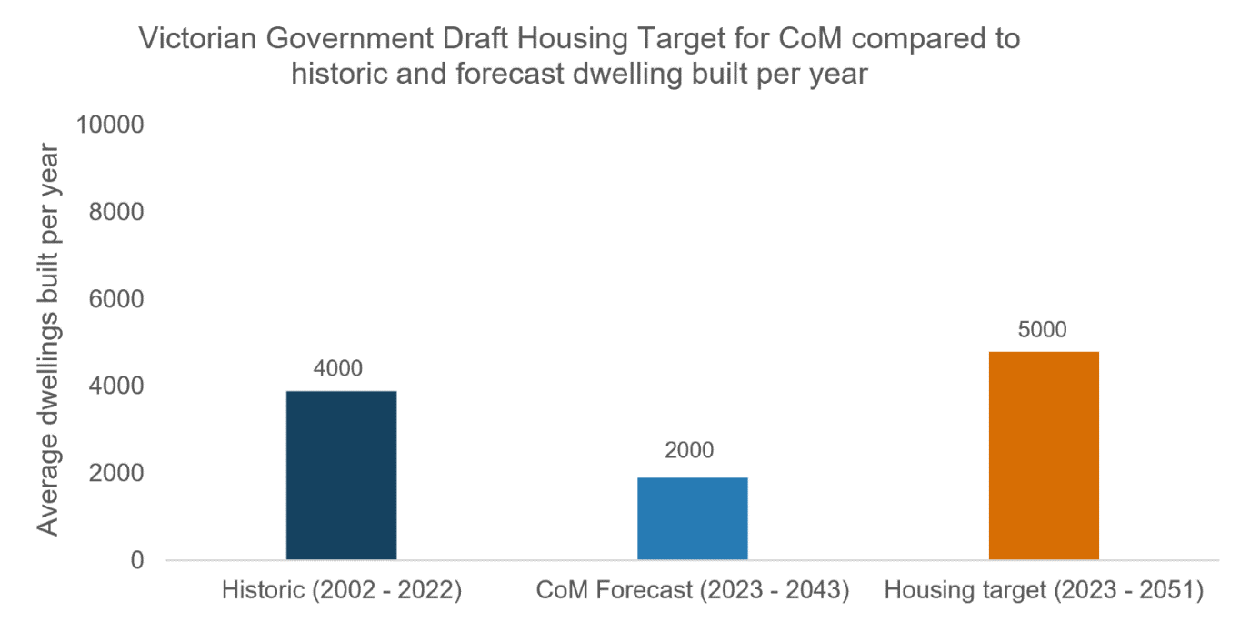
Figure 1 Victorian Government annualised draft housing target for City of Melbourne (5000 dwellings built per year) compared to historic and forecast trends. Historic trends (2002 – 2022) of an average 4000 dwellings per year and CoM forecast (2023 – 2043) of 2000 average dwellings built per year. (City of Melbourne Census of Land Use and Employment (CLUE) 2022, City of Melbourne Forecasts 2024, Victorian Government Draft Housing Targets 2024)
The target set by the Victorian Government would require an unprecedented 5000 additional houses to be built per year for the next 26 years. To put this in perspective, Kensington has 5500 homes. Delivery of the housing targets would require a scale of development akin to a new suburb every year for the next 26 years.
Extrapolating City of Melbourne housing forecast data, we are likely to need an additional 52,900 homes by 2051 to accommodate future population growth. The target set by the Victorian Government requires an additional 81,000 homes beyond the expected demand. While we understand that the targets have been set above forecast growth to realise greater capacity within our municipality, to date there has been insufficient information on how the measure of additional capacity was calculated in establishing the target and where the capacity is expected to be delivered.
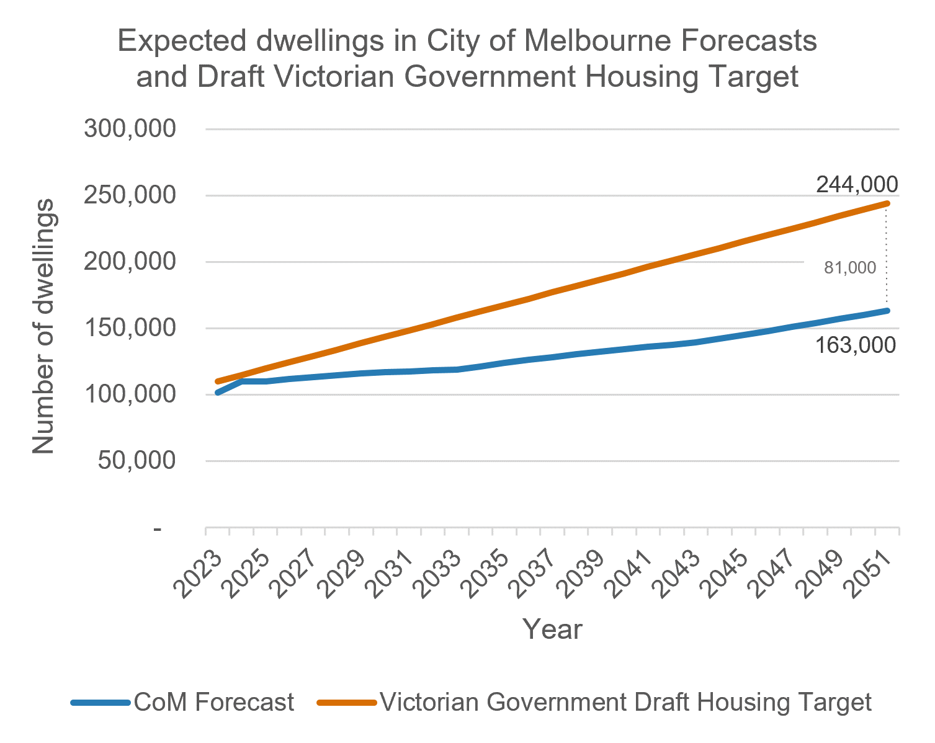
Figure 2 Expected dwellings in the City of Melbourne forecasts (163,000 by 2051) and Victorian Government draft housing target for City of Melbourne (244,000 by 2051), identifying an 81,000 additional homes required under the draft housing target. (City of Melbourne analysis of City of Melbourne Forecasts 2024 and Victorian Government Draft Housing Targets 2024)

Recommendations
- Victorian Government provides further information on how the statewide draft housing targets were developed to better understand how they relate to our future population and housing forecasts and share this publicly.
- Victorian Government provides councils with a breakdown of the target by year and by each local area and precinct, if available.

Theme 2: City of Melbourne’s role in housing supply
There is a lack of clarity on whether the statewide draft housing targets relate to approvals, housing capacity of existing or future zones and development controls, or a target for housing to be delivered by 2051. Setting a target as a statutory delivery mechanism presents multiple issues, including that local government cannot control the number of applications lodged nor can it compel the industry to act on existing approvals.
The establishment of a housing target (or the subsequent granting of a permit) does not equate to dwelling supply. Other factors must also support the delivery of development at a particular point in time, most notably, market conditions. Other factors influencing the supply of housing include supply chains, construction costs, labour supply, levies and charges, and financial settings (refer Appendix A). The statewide housing targets must acknowledge these broader influences and be supported by other actions, coordinated across government, to respond appropriately to the housing crisis. The following recommendations from our recent submission on the Housing and Homelessness Plan (refer Section 1.4 of the submission) and our recent submission on the National Urban Policy (refer Theme 4 of the submission) present opportunities to review and reform tax and regulatory structures to address housing inequity and stimulate new development:
- Review and reform tax and regulatory structures to address housing inequity. The holistic review and reforms should seek to:
  - Reduce land and housing speculation and redistribute tax incentives to improve the supply of quality housing for owner-occupiers.
  - Increase diversity in the housing market by encouraging a range of public, not-for-profit and other alternative delivery models.
  - Consider and evaluate options to encourage institutional investment (e.g. superannuation) in affordable housing.
- Establish a definition of Build to Rent housing or encourage the establishment of such a definition by state governments to link the land use and this housing delivery model with appropriate public policy and regulation.
- Address the impact of the Short Term Rental Accommodation sector, including by enabling local governments to introduce regulations that respond to unique STRA operating environments in their local communities.
In addition, the Victorian Government has introduced the vacant residential land tax (VRLT) and has recently made changes that strengthen reporting obligations and penalties for those that do not declare their vacant dwellings. These changes could be further strengthened through proactive enforcement activities to ensure that dwellings are being used.
Since 2015, the City’s Development Activity Monitor (DAM) has tracked the completion of over 41,000 dwellings (more than 4000 dwellings built per year). Currently, there are more than 16,000 residential dwellings granted a permit that have not yet commenced construction. Table 2 shows the year in which these permitted dwellings were applied and approved. While most of these approved dwellings entered the system from 2019, some permitted dwellings were originally submitted a decade ago. This illustrates that delivery constraints exist outside of local government control.
Table 2 Residential dwellings with a permit, construction not started by year applied and approved. (City of Melbourne Development Activity Monitor June 2024)
Year | Applied | Approved
2014 | 722 | 0
2015 | 1612 | 1292
2016 | 1164 | 84
2017 | 25 | 175
2018 | 735 | 787
2019 | 3380 | 1870
2020 | 3282 | 3568
2021 | 1720 | 3268
2022 | 5648 | 5169
2023 | 1788 | 1960
2024 | 450 | 2353

This reinforces that housing targets should be expressed as a measure of housing ‘capacity’ and not housing delivery. The terminology and description of the statewide housing targets needs to be updated to provide clarity and certainty for our community and organisations as we plan for significant growth. We have assumed hereafter that the Victorian Government’s draft housing target of 134,000 additional homes in the City of Melbourne by 2051 refers to capacity not delivery.
Recommendations
- That statewide draft housing targets are a measure of capacity not a threshold of planning approvals or housing delivered, noting that local government cannot compel delivery of housing.
- The Victorian Government, in partnership with other levels of Government, investigate opportunities to review and reform tax and regulatory structures to address housing inequity and stimulate new development.

Theme 3: Accommodating growth within the City of Melbourne
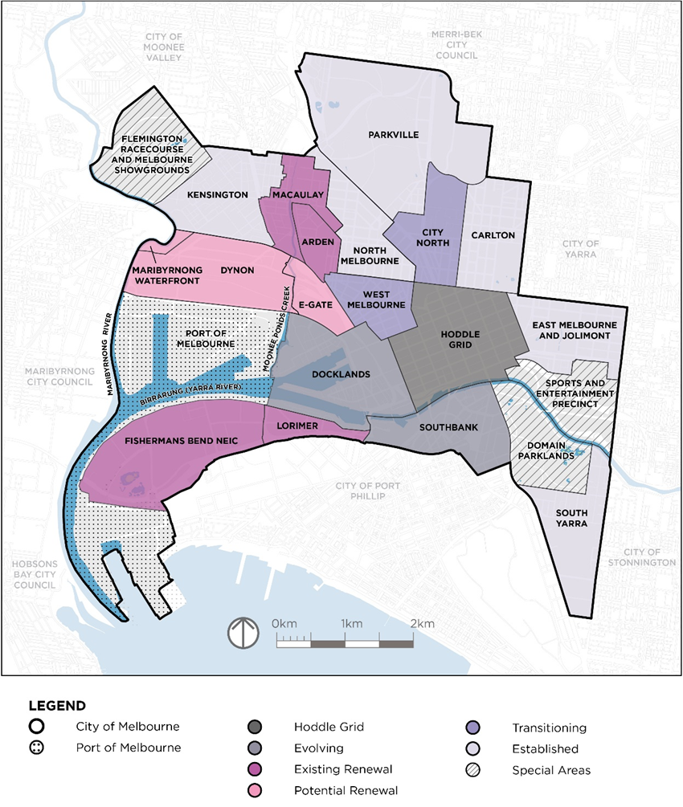
Figure 4 Change areas defined in the City of Melbourne’s draft City Spatial Plan
Housing is essential infrastructure and a human right. We embrace the central role our municipality will play in enabling more housing choice. The City of Melbourne’s draft City Spatial Plan and Municipal Planning Strategy (Amendment C432), currently on exhibition, recognise that while the rate and scale of transformation will be different, all areas within our municipality will have a part to play in accommodating more homes. The challenge is enabling the city to grow in a way that maintains and reinforces our liveability, character, resilience and prosperity, while facilitating ambitious energy and waste reduction as well as housing diversity and affordability and quality. The change areas (Figure 4) establish an understanding of how each of our local areas will experience growth and change to accommodate new homes, now and into the future.
The change types defined in the draft City Spatial Plan signal where the most intervention in planning and land use controls is required to support and guide growth in our neighbourhoods:
- The existing renewal precincts of Arden, Macaulay and Fishermans Bend will experience the greatest level of transformation in the municipality, reflected in their ongoing strategic planning:
  - The Arden Structure Plan was approved in July 2022. New planning controls were gazetted into the Melbourne Planning Scheme via Amendment C407. These controls enable the transformation of the precinct, with the precinct planned to be home to 34,000 jobs and 14,000 residents. The Victorian Government’s release of the Housing Statement in September 2023 updated the population targets for Arden, which now seeks to be home to 20,000 people.
  - The Macaulay Precinct will continue its transformation from a historically industrial area to a vibrant mixed-use, mid-rise precinct for people to work, live and play. The vision for Macaulay is established in the Macaulay Structure Plan 2021. The primary implementation pathway for the land use and built form controls is Amendment C417. The City of Melbourne recently received conditional authorisation to prepare the amendment, with public exhibition of the proposed controls occurring in August 2024.
  - The City of Melbourne continues to work with the state to develop a pathway for the transformation of Fishermans Bend, including the mixed-use Lorimer Precinct as well as the National Employment and Innovation Cluster (NEIC). City of Melbourne is also a submitter to Amendment GC224 Fishermans Bend Urban Renewal Area Development Contributions Plan (Lorimer Precinct), which seeks to support the renewal of the precinct.
- The Maribyrnong Waterfront, E-Gate and Dynon represent vast growth potential including employment and industry and important community and environmental infrastructure needs. However, the type and intensity of uses that can be accommodated is not yet known and may be constrained by flooding and contamination issues. Understanding the potential of these renewal precincts to accommodate housing requires significant technical assessment and strategic planning to be undertaken.
- The central city, comprising Hoddle Grid, Docklands and Southbank, will continue to accommodate a significant portion of housing in the municipality through infill development, intensification of uses and redevelopment of sites. Capacity in these areas will slow over time as the number of undeveloped sites diminishes. The 2016 Central City Built Form Review introduced changes to planning controls that guide built form and development in the central city. The updated controls introduced through Amendment C270 support continued growth and adaptation in the central city while delivering greater public benefit such as public open space, laneways, community space and affordable housing.
- For the transitioning neighbourhoods of City North and West Melbourne, ongoing strategic planning is supporting the incremental infill and change of the areas towards a greater diversity of uses and activity, including denser built form that respects and retains existing character. Amendment C385 introduced new planning controls to the Melbourne Planning Scheme in May 2022 to guide West Melbourne’s transition. As part of the Parkville NEIC, strategic planning for City North is focused on enabling the area to support the knowledge economy including research centres, bio-medical institutions and a large startup ecosystem. In this precinct there is a need to balance housing delivery with protecting the opportunity for employment and research land uses which are critical to enable growth of the internationally significant education and research functions.
- For the near future, a much smaller level of change and transformation is anticipated in our established neighbourhoods, however they will accommodate some development as the city changes. For most sites, properties and streetscapes, the identified heritage values, small lots and established neighbourhood character limit development potential. Any work to increase development capacity of these areas needs to address existing conditions, as well as community sentiment in ensuring some growth is facilitated to maintain accessibility and affordability of these areas, while the unique character that makes these areas valuable for businesses and residents is maintained. As such it is anticipated that established neighbourhoods are unlikely to deliver the bulk of the municipality’s housing growth and will make a marginal contribution in comparison with urban renewal precincts. Unlocking further capacity in these areas, if required, may be contemplated through a review of policies, application of land use zones and development within activity centres, though this will need to follow a transparent and strategic planning process. Further information will be required from the Victorian Government to understand the underlying assumptions and breakdown of anticipated housing capacity by each local area and precinct.
Overall, the number of undeveloped sites in the municipality is dwindling, with only 700,000 m² of developable land still undeveloped across our municipality, including land not zoned for residential use. Building new homes cannot be the only response to the housing crisis. The City of Melbourne with a significant existing building stock must support housing capacity through retrofitting and adaptation while also reducing carbon through material reuse and renewal of existing built form. There are approximately 255 buildings within the central city identified as predominantly unoccupied or unused (CLUE 2022). Through building retrofits in the City of Melbourne alone, there is the potential to provide an additional 10,000 new homes through retrofits in the central city as well as adding over $2.7 billion to the Victorian economy by 2040, with 12,000 jobs and a yearly reduction in energy costs of over $184 million (Point Advisory 2022).
Recommendations
- Victorian Government works with the City of Melbourne to refine the capacity target based on strategic planning and capacity across the change types and local areas identified by the City of Melbourne.
- Victorian Government confirms whether the potential urban renewal areas of Maribyrnong Waterfront, E-Gate and Dynon are included in the draft housing target, noting this may affect the suitability of the target.
- Victorian Government considers how retrofit of existing buildings can be incorporated into the housing targets, noting City of Melbourne’s unique land use mix and housing constraints.

Theme 4: Homes in liveable, high amenity neighbourhoods
The amount of housing supply is a single measure. In isolation it will not adequately address the crisis in front of us. Increased housing supply, particularly in higher density environments, must be accompanied by allocating space for new and expanded public open space, active, sustainable and accessible transport, and integrated water management. Social infrastructure that supports community wellbeing, sustainability and resilience, must be provided early to ensure the places where people choose to live, work and play meet their daily needs and remain highly liveable.
Housing capacity in the municipality must be considered alongside the need to deliver a diverse open space network across the City of Melbourne’s open space hierarchy, with a need to address a shortfall in municipal and neighbourhood open spaces. Between 2012 and 2022, the amount of open space per resident in the City of Melbourne declined by 30 per cent, from 61 m² per person in 2012 to 42 m² per person in 2022 (ABS 2022, CLUE 2022).
Meeting housing targets will place significant demand on already overburdened infrastructure and the environment. Funding and financing the scale of committed and future required infrastructure needs to keep pace with our municipality’s population and visitation growth, reinforcing the need to partner with other levels of government and the private and community sectors.
Calculating the housing capacity of our neighbourhoods must include provision for land set aside as open space, for improved and expanded transport networks and for community and social facilities.
Recommendations
- Victorian Government incorporates land set aside for open space, community and transport infrastructure in determining statewide housing targets.
- Victorian Government works with local government to reform funding and financing mechanisms to ensure infrastructure can support the significant rate of development within our municipality and maintain our high-quality and high-amenity neighbourhoods and central city.
- 1Victorian Government supports local government in the timely consideration and progression of development contributions planning and controls to ensure new development contributes to the renewal and delivery of infrastructure that is required to support increased population growth.

Theme 5: Safeguarding our role as a capital city
The City of Melbourne is the heart of the metropolis and the engine room of the state economy. The central city performs a pivotal role in job creation and is perfectly positioned to continue to grow as a global hub of innovation, knowledge and creativity. It is also home to the State’s premier arts, cultural and sports infrastructure and events, offering a diversity of experiences that attract investment, talent and drive tourism. Balancing a true mix of uses in the City of Melbourne is crucial to the state’s continuing economic, cultural and civic growth and sustainability.
Over the last two decades the City of Melbourne has undergone a significant and unprecedented transformation from primarily a place where people worked and did business to one where people live. Between 2002 and 2022 residential floor space tripled from around 3 million m² to 9 million m² (CLUE 2022). Over the same period, employment floor space grew by just 26 per cent, from 15 million m² to 19 million m².
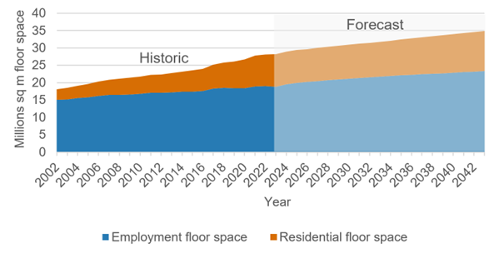
Figure 5 Historic and forecast residential and employment floor space in the City of Melbourne (CLUE 2022 and City of Melbourne Forecasts 2024)
Housing capacity within the central city, the Parkville NEIC and urban renewal areas must be balanced with non-residential development to ensure we can continue our vital role as the state’s heart for jobs, education and opportunity.
Recommendations
- Victorian Government provides further information on how non-residential capacity within the central city, Parkville NEIC and urban renewal areas has been factored into the housing targets, noting that an increase in residential uses must be balanced by an increase in non-residential uses.
- Victorian Government incorporates capacity set aside for non-residential floor space that maintains the economic and cultural function of the central city in determining housing targets.

Theme 6: Affordable housing, diversity and quality
A capacity target for new homes must be supported by a recognition of the importance of housing diversity and quality. A range of housing types and tenures are needed to support our diverse community and give people the choice to move through their life stages in place. The recognition of affordable housing as essential infrastructure and a review of planning controls and regulatory structures that address housing inequity are vital for an inclusive, diverse and prosperous city.
Housing must respond to the different ways that people live. Housing forecasts for the City of Melbourne anticipate average household sizes increasing into the future, reflecting the increasing share of family and couple households in the municipality. This means that there will need to be a greater proportion of larger (two to three bedroom) dwellings than has been previously delivered in the municipality. Fewer larger dwellings rather than a larger number of smaller dwellings will accommodate the same number of people in different housing configurations. It is unclear currently how demographics like household size have factored into the statewide housing targets and how they might influence appropriate targets.
Table 3 Forecast household structure in the City of Melbourne (City of Melbourne Forecasts 2024)
Year | Couple family with children | Couple family without children | Group household | Lone person | One-parent family | Other family | Total
2023 | 8815 | 29683 | 18628 | 34969 | 2834 | 2834 | 97763
2028 | 10340 | 34608 | 21113 | 38332 | 2988 | 2820 | 110202
2033 | 11346 | 36403 | 21836 | 38604 | 3067 | 2635 | 113891
2038 | 13335 | 39871 | 23859 | 41992 | 3529 | 2745 | 125331
2043 | 15400 | 41949 | 24991 | 45146 | 4094 | 3292 | 134871

Increasing housing capacity (and supply) is important, but Plan for Victoria and the statewide housing targets must ensure that the supply of targeted, subsidised, affordable housing is increased, in addition to general housing supply. In this submission, we use the term “affordable housing” as per the definition in Victorian legislation, which includes social housing.
The Victorian Government has stated that the draft statewide housing targets account for ‘additional housing over and above projected levels, with the aim to change the balance of affordability through extra supply’. The rationale being that if more housing is built, supply will exceed demand, and result in increased housing affordability. Housing policy responses must be much more nuanced.
The housing crisis is not entirely caused by a limited housing supply, but a lack of affordable housing for households on very low to moderate incomes. This is evidenced by the continued increase in the demand for affordable housing, despite recent construction booms and the dramatic increase in the number of dwellings in Melbourne. Planning policy is not the primary barrier preventing the delivery of housing.
Capacity targets must include a mechanism to secure the delivery of affordable housing. Government subsidies, affordable housing contribution requirements, and uplift or value sharing mechanisms are essential in delivering affordable housing. The minimum cost of land, construction and profit means that appropriate housing for very low to moderate income earners cannot be delivered by the market alone. Resolving the housing crisis requires addressing the shortfall of affordable housing, not marginal improvements in housing affordability.
The rate of development needed to meet capacity targets cannot come at the expense of quality housing and apartments. In 2022, apartments comprised 90 percent of all dwellings in the City of Melbourne. It is important that people living in all types of homes, including apartments, have a quality lifestyle with the services and spaces they require to meet their daily needs.
The City of Melbourne anticipates that the Plan for Victoria and any metropolitan strategic plan will provide the underpinning policy and strategy to ensure the housing target centres on the need for diverse and quality housing and affordable housing. More detail regarding our position on housing diversity and quality and affordable housing can be found in the City of Melbourne’s comprehensive submission to the National Housing and Homelessness Plan.
Recommendations
- Victorian Government introduces an affordable housing target as part of the statewide housing targets, in consultation with local government.
- Victorian Government introduces mandatory affordable housing contributions as part of the Victorian Planning Provisions and as an interim, support Councils that seek to apply mandatory controls for affordable housing contributions.
- Victorian Government shares assumptions that have informed statewide housing targets, including household size, dwelling size and typology.
- Statewide housing targets are supported with robust policy recognising the importance and need for housing diversity and quality, and affordable housing.

Theme 7: Victorian Government leadership
We welcome the leadership by the Victorian Government in developing Plan for Victoria and the draft statewide housing targets, which provide an opportunity for coordinated and long-term planning across the state to address the housing crisis.
Our submission on the draft National Urban Policy recognised the role that Plan Melbourne plays in addressing the demands of urban development in metropolitan regions, where the complexities and unique spatial characteristics require an integrated approach. This is particularly relevant for addressing the housing crisis, where the statewide housing targets must be supported by consistent and aligned policy and coordination at a metropolitan scale to deliver enabling and catalytic infrastructure and respond to the increasingly complex challenges of housing inequality, infrastructure funding and responding to the climate crisis.
The City of Melbourne encompasses two of the seven Victorian Government-identified National Employment and Innovation Clusters, the central city and three significant urban renewal areas. These sites will form the backbone of delivering housing and jobs over the coming decades. However, their ability to do so is reliant on consistent and integrated policy and coordination across levels of government to identify and deliver the major infrastructure that will catalyse their development. In Fishermans Bend, this includes commitment to delivery of high-capacity public transport. Across our municipality and particularly our renewal precincts we must realise funding and governance to mitigate risk and ensure consistency in approaches to integrated water management.
Reviewing and amending local planning policy and controls is critical to ensuring the planning framework is guiding decision-making, land use and development activity in line with strategic objectives. Local government is reliant on the Victorian Government to provide clear, timely and consistent advice and processing of amendments. The timelier processing of amendments at all stages the planning scheme amendment process is critical for unlocking capacity within the City of Melbourne and ensuring that new development within our municipality is in accordance with the positions of our Council. A list of Planning Scheme Amendments is included at Appendix B.
Monitoring state-led actions, including the housing targets is critical to measure the success of initiatives in achieving the desired outcomes, including delivery of affordable housing, housing diversity and supply. This must be led by the Victorian Government and supported by consistent collection, analysis and sharing of data. Monitoring will support local governments to undertake strategic work as well as enable evaluation of progress and review of targets.
Recommendations
- Identify and establish funding and delivery pathways for all infrastructure required to support the development of our urban renewal areas, including drainage and flood mitigation, public transport and other enabling infrastructure to unlock housing capacity.
- Prepare a metropolitan-scale strategic plan alongside Plan for Victoria that responds to the interconnected complexities of housing, transport, the environment and land use within the metropolitan region.
- Provide timely advice and processing of planning scheme amendments to support strategic planning.
- Victorian Government implements and manages statewide monitoring and review of targets.

Theme 8: Urban modelling
We understand that the Victorian Government will be refining the capacity targets for each local government area through urban modelling to determine the capacity of existing controls. Based on the limited information provided, this section lists preliminary feedback on the proposed approach:
- The approach of using land use zones to determine capacity does not reflect the impact of diverse planning controls and outcomes within different areas of the municipality. City of Melbourne:
  - Recommends that the modelling use ‘change area’ categories designated in the City of Melbourne’s draft City Spatial Plan (July 2022). The draft City Spatial Plan integrates spatial data and demographic projections to assess the potential for residential development and recommends ‘change area’ categories (refer Figure 4 on page 10).
  - Recommends that the modelling excludes areas categorised in the draft City Spatial Plan as ‘Special Areas’, ‘Urban Renewal Areas – Potential’ (excluding land already zoned Mixed-use within Maribyrnong Waterfront) and the Fishermans Bend NEIC as they have no residential development potential, or there is insufficient information available to confirm the development potential of these areas for housing capacity.
- City of Melbourne generally does not support using the top five percent of largest projects within a planning zone to determine appropriate densities. The top five percent of largest projects within a planning zone may be delivering density that is not appropriate across the entirety of that land use zone, particularly where several schedules to the Design and Development Overlay (DDO) apply within one land use zone. We note that:
  - Several approvals within Melbourne are superseded by recently established DDOs, for example, Arden (2022), West Melbourne (2022), the Central City (2016) and Macaulay (2024 authorisation). Therefore, the top five percent of largest projects within these areas may no longer represent possible or desirable outcomes.
  - Existing and proposed built form controls, in particular DDOs, should be included in calculating capacity. Where DDO controls based on mandatory heights, mandatory or discretionary floor area ratios, or discretionary heights and built form controls apply, calculations should account for the effective impact to development potential.
- City of Melbourne generally supports removing land from the pool of developable lots where a constraint is likely to prohibit development. However:
  - The current designation of small lots as ‘not developable’ is not accurate for all areas within the City of Melbourne. Smaller lots (100-300m²) in the Hoddle Grid, Evolving Central City and Transitioning Neighbourhoods have achieved significant development enabled through building envelope controls.
  - The current designation of lots and properties listed on the Victorian Heritage Register (VHR) or the Victorian Heritage Inventory (VHI) as ‘not developable’ is not accurate for all areas within the City of Melbourne. In the Hoddle Grid, Evolving Central City, Transitioning Neighbourhoods and Existing Urban Renewable Areas, VHR and VHI properties are sometimes subject to development. This is influenced by the larger amount of heritage properties within this area which are sometimes amalgamated into larger development sites or exist on an otherwise unconstrained development site. It is recommended that a specifically tailored capacity discount is applied.
- City of Melbourne generally supports applying capacity discounts where land is affected by certain overlays, however Victorian Government must clarify how the capacity discount is applied as this will have significant implications for both the appropriate methodology and the outcomes of the modelling. In addition:
  - The current approach sets a capacity discount of 50 percent for properties subject to an Environmental Audit Overlay (EAO). Depending on how the capacity discount is applied, this does not reflect Council findings, where an EAO does not generally reduce development capacity on a site. This is subject to the level of potential contamination, which often does not impact development capacity so much as feasibility.
  - The current approach sets a capacity discount of 50 percent for properties subject to a Heritage Overlay (HO). Land subject to a HO in Established areas is unlikely to be developed due to a combination of factors in addition to the HO such as land use zone, fragmented ownership, lot size and built form controls. Development capacity on land in other areas is not necessarily constrained by the application of a HO. In these areas, local policy facilitates development while limiting impacts on the prominence, character, and three-dimensionality of heritage properties.
  - The current approach sets a capacity discount of 50 percent for properties subject to a Land Subject to Inundation Overlay (LSIO). Historically, within the City of Melbourne, properties within an LSIO are likely to be developed. This overlay applies specifically to Southbank and Arden areas which have experienced, and anticipate, significant ongoing growth. In addition, we note that Amendment C384 proposes to apply the LSIO to large parts of our Existing Urban Renewal Precincts. Capacity in these areas needs to address the assumption that the identified drainage and flood mitigation infrastructure is delivered and incorporates flood mitigation design techniques.
Recommendations
- Provide further detail on the proposed methodology and data, including how the capacity discount is applied, to support a more detailed review by City of Melbourne.
- Engage closely with the City of Melbourne in refining the capacity modelling approach.
- City of Melbourne’s draft City Spatial Plan change areas are incorporated into modelling for more accurate calculations that reflect the City of Melbourne’s unique development context.

References
Australian Bureau of Statistics 2022-base---2071, Population Projections, Australia, ABS, viewed 12 September 2024, <https://www.abs.gov.au/statistics/people/population/population-projections-australia/2022-base-2071>.
Planning and Environment Act 1987 (Vic)
Point Advisory, 2022, Commissioned model for the City of Melbourne on retrofit rate, investment, jobs and economic contribution, unpublished.
SGS Economics and Planning, April 2023, National Housing Assistance Policy: Trends and Prospects, SGS Economics and Planning Pty Ltd, viewed 12 September 2024, <https://sgsep.com.au/assets/main/SGS-Economics-and-Planning_Commonwealth-housing-policy_occasional-paper.pdf>

Appendix A: Factors influencing housing
This appendix includes a table describing the wider housing system split into two primary categories, Supply and Demand, and the factors within each influencing housing. (SGS Economics and Planning 2023).
Within the Supply stream, three categories:
- Developments Costs – land & infrastructure, Materials, Labour, Soft costs, landing environment
- Land use Controls – Regulatory environment and Zoning (Lot size, density, Etc)
- Community Features – Community-wide infrastructure, Quality of the built environment
and Amenities

Planning links
State and Federal Fiscal Policy
Economic Development Links

Within the Demand stream:
- Quality of life Preferences – Housing features
  - Proximity to: Parks open space, Shopping, Dining, Employment, Entertainment,
Transportation
- Household formation – Natural population growth, in-migration, Employment opportunity
- Financial influences – Availability of deposit, Household income, Lending environment, Taxes and changes (e.g. stamp duty)

Appendix B: City of Melbourne amendments awaiting decisions from the Minister for Planning in recent years
Table 4 List of amendments awaiting decisions from the Minister for Planning
Amendment | Purpose | Status | Date submitted
Gaming Policy – Amendment C366 (formerly C307) | To introduce a revised policy to ensure that electronic gaming machines are located and operated to minimise gaming-related harm. | Referred to the Minister for Planning for Approval | August 2019
Sunlight to Public Open Space – Amendment C415 (formerly C278) | To protect winter sunlight access to all parks across the municipality excluding the Central City and Southbank. | Referred to the Minister for Planning for Approval | September 2021
Carlton Heritage Review and Punt Road Oval – Amendment C405 | To implement the recommendations of the Carlton Heritage Review November 2021 (Lovell Chen). | Referred to the Minister for Planning for Approval | June 2023
Miami Hotel Site West Melbourne Planning Scheme – Amendment C435 | To apply the Specific Control Overlay (SCO) to facilitate the redevelopment of the site generally in accordance with development plans prepared by Hachem Architects, December 2021. | Referred to the Minister for Planning for Authorisation | July 2023
North Melbourne Heritage Review – Amendment C403 | To implement the recommendations of the North Melbourne Heritage Review July 2022 (Lovell Chen). | Referred to the Minister for Planning for Approval | October 2023
Parkville Heritage Review – Amendment C444 (permanents) | To implement the recommendations of the Parkville Heritage Review March 2023 (GML Heritage) | Referred to the Minister for Planning for Authorisation | November 2023
South Yarra Heritage Review – Amendment C426 | To implement the recommendations of the South Yarra Heritage Review August 2022 (GML Heritage). | Referred to the Minister for Planning for Approval | July 2024

Table 5 List of amendments recently approved by the Minister for Planning
Amendment | Purpose | Date gazetted
Heritage Policies Review – Amendment C258 | To implement the findings of the Heritage Review 2016 and the West Melbourne Heritage Review | July 2020 (submitted March 2020)
Southbank Heritage Review – Amendment C305 | To implement the recommendations of Southbank Heritage Review 2017, updated November 2020 | April 2021 (submitted December 2020)
Central City and Southbank Urban Design – Amendment C308 | To introduce new urban design-built form controls | September 2021 (submitted December 2019)
Melbourne Arts Precinct – Amendment C323 | To encourage arts uses at lower storeys | December 2021 (submitted June 2020)
West Melbourne Structure Plan – Amendment C385 (formerly C309) | To implement the West Melbourne Structure Plan 2018 | May 2022 (submitted 5 May 2020)
Public Park and Recreation Zone Anomalies – Amendment C380 | To rezone Council owned public open space and land reserved for public open space purposes under the Crown Land (Reserves) Act 1978 to the Public Park and Recreation Zone | July 2022 (submitted December 2021)
Finalisation of the Heritage Places Inventory – Amendment C396 | To convert the heritage gradings for properties not converted through Amendment C258 | July 2022 (submitted 30 March 2022)
Hoddle Grid Heritage Review – Amendment C387 | To implement the recommendations of the Hoddle Grid Heritage Review (GML and GJM, July 2020) (Updated March 2022) | September 2022 (submitted May 2022)
Fishermans Bend Heritage Review – Amendment C394 | To implement the recommendations of the Fishermans Bend In-Depth Heritage Review and Stakeholder Engagement Summary Report (HLCD, 2022) | October 2022 (submitted June 2022)
Exceptional Tree Register – Amendment C379 | To protect additional exceptional trees as listed in Council’s Exceptional Tree Register. | February 2024 (submitted March 2023)

Table 6 List of amendments recently authorised by the Minister for Planning
Amendment | Purpose | Date authorised
200 Arden Street North Melbourne – Amendment C447 | To rezone the site to a Mixed-Use Zone and apply a new DDO schedule to allow a range of building height | May 2024 (submitted April 2024)
Macaulay Urban Renewal – Amendment C417 | To implement the land use and development objectives of the Macaulay Structure Plan 2021 | May 2024 (submitted August 2022)
West Gate Service Stations Heritage Review – Amendment C463 | To apply heritage protection to the service station canopies | June 2024 (submitted June 2024)
Municipal Planning Strategy – Amendment C432 | To introduce a new Municipal Planning Strategy, and provide new policies for all local areas | July 2024 (submitted April 2023)

https://mvga-prod-files.s3.ap-southeast-4.amazonaws.com/public/2024-09/draft-national-urban-policy.docx
https://mvga-prod-files.s3.ap-southeast-4.amazonaws.com/public/2024-08/national-housing-homelessness-plan-submission-october-2023.docx
https://mvga-prod-files.s3.ap-southeast-4.amazonaws.com/public/2024-09/new-plan-victoria.docx

