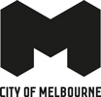
City of Melbourne
Stretch Reconciliation Action Plan
August 2024 – July 2027
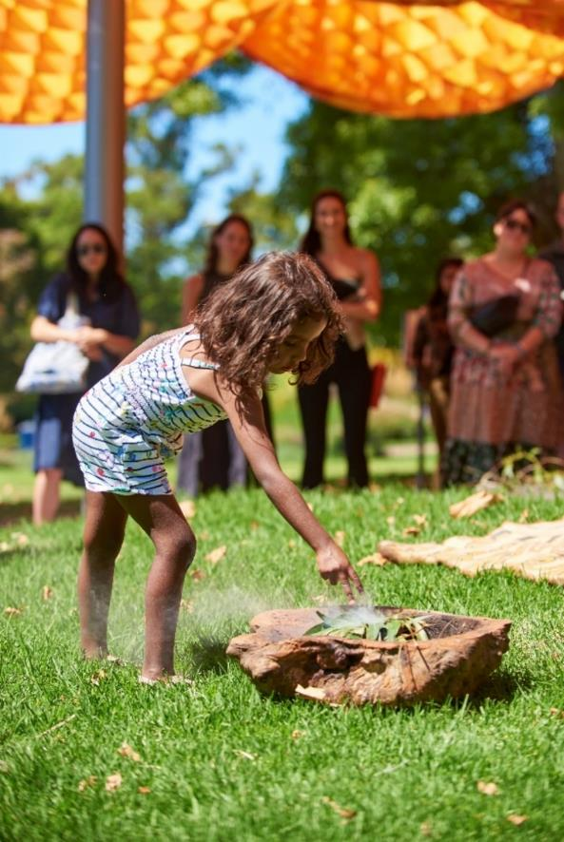
Smoking Ceremony at truth-telling event in Queen Victoria Gardens.
Photo credit: Rodney Dekker.

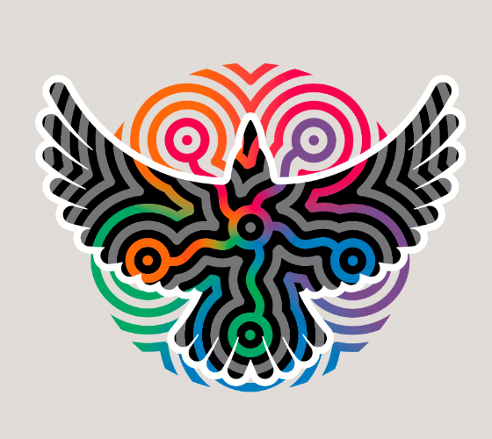
Aboriginal Melbourne
The Aboriginal Melbourne word mark acknowledges Waa the Crow, the spiritual protector of the Birrarung, “Yarra River”.
Five circular forms symbolise the Tanderrum Ceremony, where Traditional Owners allow safe and temporary access to their land, and the bringing together of the five language groups of the Eastern Kulin: the Wurundjeri, Bunurong, Taungurung, Dja Dja Wurrung and the Wadawurrung.
These in turn form interconnecting pathways that lead to the centre of Waa, symbolising Aboriginal Melbourne as the gathering place. These pathways visually express the pulse of Aboriginal Melbourne as a dynamic and progressive gathering place where everyone in the community has a voice.
Acknowledgement of Traditional Owners
The City of Melbourne respectfully acknowledges the Traditional Owners of the land we govern, the Wurundjeri Woi-wurrung and Bunurong / Boon Wurrung peoples of the Kulin and pays respect to their Elders past and present. We acknowledge and honour the unbroken spiritual, cultural and political connection they have maintained to this unique place for more than 2000 generations.
We accept the invitation in the Uluru Statement from the Heart and are committed to walking together to build a better future.
Throughout this document, we refer to Aboriginal peoples because, in Victoria, Aboriginal peoples are the Traditional Owners. Our use of the term Aboriginal within Victoria reflects cultural protocols that the Victorian Government has also adopted. We recognise the diversity of Aboriginal people living throughout Victoria. The term Aboriginal Victorians is used to encompass Victorian Traditional Owners, clans, family groups and all other people of Aboriginal and Torres Strait Islander descent living in Victoria.
City of Melbourne
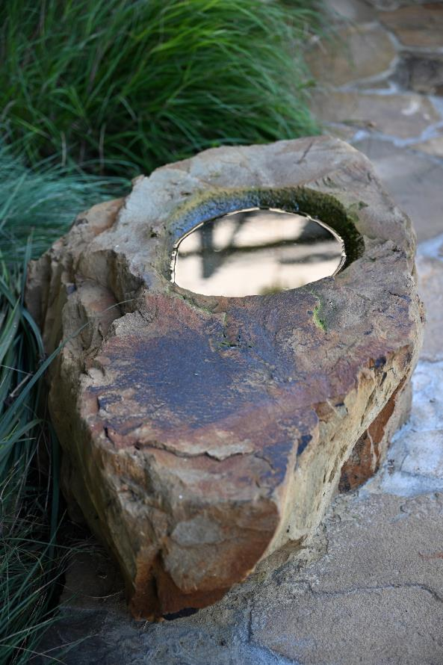
Rooftop terrace landscape at narrm ngarrgu library represents the different local landscapes of narrm / Melbourne.
Photo credit: Wayne Quilliam.

Contents
Message from the Lord Mayor 6
Message from the CEO 8
Message from the CEO of Reconciliation Australia 9
Our vision for reconciliation 10
Why is a RAP important for the City of Melbourne? 10
Our organisation 12
Timeline 14
Our journey 16
Achievements since our last plan 16
Case studies 18
Learnings and challenges 20
Our Reconciliation Action Plan 22
Community engagement and feedback 23
Governance 23
Our actions, deliverables and targets 25
Pillar 1. Truth-Telling 27
Pillar 2. Relationships 29
Pillar 3. Respect 33
Pillar 4. Opportunities 39
Pillar 5. Governance 43

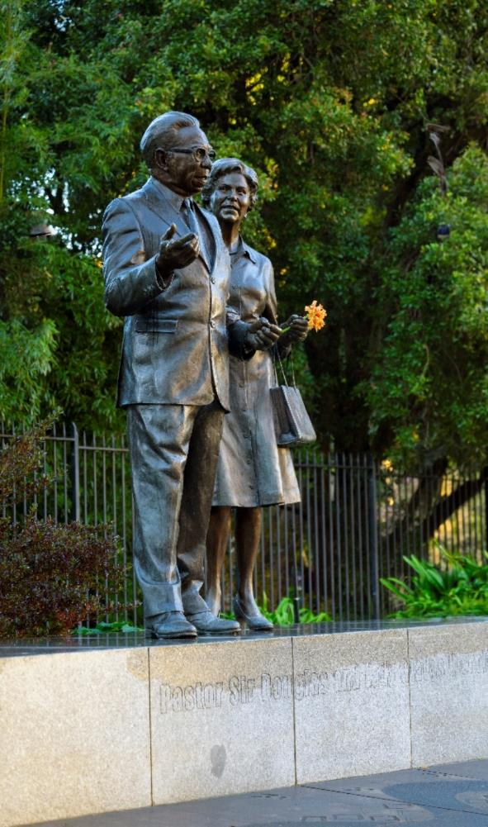
Pastor Sir Douglas and Lady Gladys Nicholls Memorial in Parliament Gardens.
Photo credit: Wayne Quilliam.

Message from the Lord Mayor
Our vision for reconciliation is to work alongside Sovereign First Nations to make true self-determination possible, so that Aboriginal and Torres Strait Islander people have the freedom to live well according to their own values and beliefs.
The City of Melbourne Stretch Reconciliation Action Plan August 2024 – July 2027 significantly strengthens our reconciliation commitments, so we can deliver positive outcomes for Traditional Owners and the broader Aboriginal community, enriching the whole city. It stretches us to make high-impact commitments and back them up with measurable goals that are critical to our vision for a truly inclusive city.
An essential part of our work towards genuine reconciliation is truth-telling.
Truth-telling allows Aboriginal peoples to share their history, heritage and culture with us all, imparting knowledge of thousands of years of rich histories, languages and stories.
Truth-telling helps us develop a shared understanding of the impact of colonisation, and the diversity, strength and resilience of First Peoples' cultures. It is a form of restorative justice that creates space for Aboriginal people to voice and record evidence of past actions. It is a way to acknowledge Aboriginal people’s experiences of dispossession and inequality.
If we are to learn, heal and change within Melbourne and beyond, we must show our support for reconciliation and truth-telling in a tangible way.
We support the Yoorrook Justice Commission – the first formal truth-telling process into injustices experienced by First Peoples in Victoria. We will address relevant recommendations from the commission into our work, in concert with this Stretch Reconciliation Action Plan.
It is vital to our identity as a city that Aboriginal people can participate equally in our city's economy and activities. That’s why we will embed Aboriginal perspectives into Council processes, governance and decision-making. An important step is our First Nations Committee, designed to advise on First Nations policy and programs, and elevate diverse voices from the Aboriginal community to ensure they have a say in decisions and priorities.
We will embed Aboriginal culture in the design of events, public places and facilities. Our urban and design landscape will also grow with us.
We have more to learn together, so we can all share the enormous benefits and richness of the oldest continuous culture on Earth.
Reconciliation is an opportunity for Aboriginal and non-Aboriginal people to work together to create a just and equitable society. A place where all people are free to shape their own lives.
I am proud to share this plan with you. It leads the way to a brighter, shared future.
Nicholas Reece
Lord Mayor
City of Melbourne

Message from the CEO
I am proud to present the City of Melbourne’s Stretch Reconciliation Action Plan August 2024–July 2027. This is our sixth Reconciliation Action Plan, and it will guide our continued work towards reconciliation and a more inclusive future. As we mark this milestone, I extend my heartfelt thanks to the many staff and community members who have helped shape this plan and define our next steps on this important shared journey.
As a local government representing diverse people, we are proud of the work we've done over time to promote reconciliation, engage communities and deliver outcomes for Traditional Owners. However, there is always more we can do. This plan is designed to increase and sustain our momentum – turning good intentions into clear actions.
Truth-telling is the foundation of reconciliation. Since our last plan, we've focused on creating opportunities for truth-telling to facilitate learning, healing, and change. Central to our approach has been sharing knowledge by partnering with Traditional Owners and acknowledging the impacts of past government policies, including the role that Council played in colonisation. We are committed to addressing these injustices, which are not only contained to our deep past but, in some instances, continue today.
Since our last plan, we've also worked to elevate the voices of Traditional Owners in city decision-making, including deepening our relationship with the Bunurong Land Council Aboriginal Corporation and Wurundjeri Woi-wurrung Cultural Heritage Aboriginal Corporation. We are committed to continuing to deepen these relationships and partnerships with Traditional Owners.
First Nations-led community organisations have also played an important role, collaborating with us to inform and enhance our responses to housing, homelessness, cultural awareness, economic development and the arts. We are grateful for our strong relationships with the Koorie Heritage Trust, the Ngwala Willumbong Aboriginal Corporation, Kinaway and The Torch – a remarkable arts organisation that supports First Nations people impacted by incarceration.
As we reflect on our reconciliation journey and turn our eyes to the future, there is an important word at the forefront of our minds: treaty. A treaty will deliver long-term sustainable solutions because it enables self-determination – putting Aboriginal people in the driver’s seat to make decisions about what impacts their lives. We will support First Nations communities on the pathway towards this goal.
Read on to explore our Stretch Reconciliation Action Plan August 2024–July 2027. The content of this plan has been developed with great care – with our community through meaningful, long-term engagement with Aboriginal and non-Aboriginal people in our city. We will report on our progress every year.
Alison Leighton
Chief Executive Officer
City of Melbourne

Message from the CEO of Reconciliation Australia
On behalf of Reconciliation Australia, I congratulate City of Melbourne on its formal commitment to reconciliation, as it implements its first Stretch Reconciliation Action Plan (RAP), its sixth RAP overall.
Formed around the pillars of relationships, respect, and opportunities, the RAP program helps organisations realise the critical role they can play in driving reconciliation across their work and area of expertise. Through the creation of this Stretch RAP, City of Melbourne continues to contribute to the every-growing community of RAP organisations that have taken this consideration and goodwill, and transformed it into action. As the local government body responsible for Australia’s second largest city, the scope of City of Melbourne’s sphere of influence is considerable.
With this RAP, its focus on working alongside Sovereign First Nations to support the true self-determination. This is the bedrock of reconciliation, listening, learning, working hand in hand. This approach builds on City of Melbourne’s experiences working with Traditional Owners in its previous RAPs, involving them as key decision makers on the direction of several projects including the Mapping Aboriginal Melbourne project, an interactive map pf places of Aboriginal importance and the design of narrm ngarrgu, the new library and family services building in the Queen Victoria Market precinct. These experiences created meaningful opportunities for Aboriginal-led place based truth-telling across Melbourne, and this approach continues in this Stretch RAP.
Recognising the impacts of past government policies on Aboriginal and Torres Strait Islander peoples, City of Melbourne is supporting self-determination principles through targeted funding and the creation of its First Nations policy and programs. By embracing Aboriginal knowledge and lived experience as a core element of Melbourne’s past, present and future identity. City of Melbourne honours their essential contributions to the city’s growth and wellbeing.
Through its inclusion of First Nations knowledge and experiences in policy and program development, City of Melbourne has the potential to drive considerable reconciliation outcomes across its vast sphere of influence. On behalf of Reconciliation Australia, I commend City of Melbourne on this Stretch RAP and look forward to following its ongoing reconciliation journey.
Karen Mundine
Chief Executive Officer
Reconciliation Australia

Our vision for reconciliation
The City of Melbourne’s vision for reconciliation is to work alongside Sovereign First Nations, enabling true self-determination and ensuring Aboriginal peoples have the freedom to live well according to their own values and beliefs.
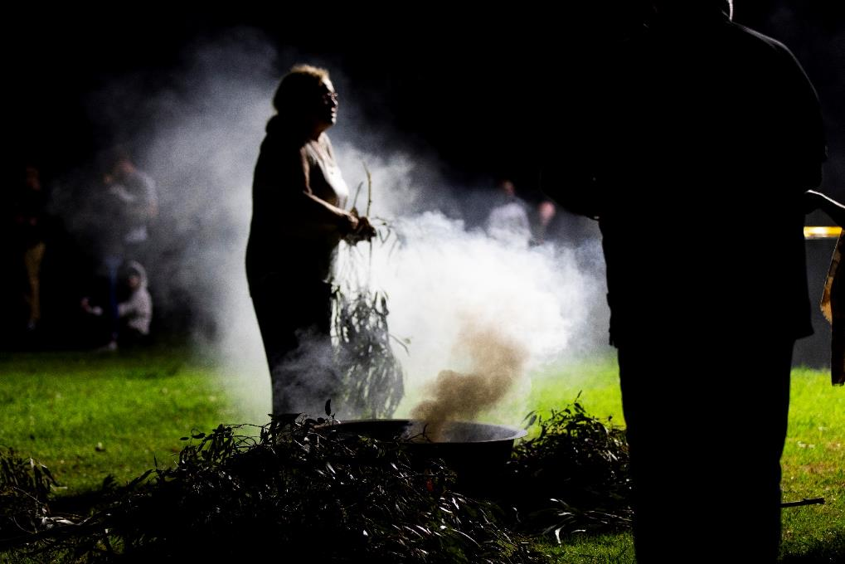
Day of Mourning.
Photo credit: Blue Tree Studios.

Why is a RAP important for the City of Melbourne?
The City of Melbourne is proud to support reconciliation within our organisation and across the city. We were the first local government in Australia to develop a Reconciliation Action Plan (RAP) in 2006. Since then, we’ve adopted five plans, ensuring we learn and improve each time.
Reconciliation is essential to our country. It is about promoting an understanding of the history between Aboriginal and non-Aboriginal Australians and developing better relations for the future. Reconciliation benefits everyone and allows us to move forward together.
This Stretch Reconciliation Action Plan – August 2024–July 2027 is our sixth plan. It builds on our journey in the reconciliation space over time, working with First Nations people to deliver outcomes for Traditional Owners and the broader Aboriginal community and provide opportunities for our organisation and municipal community to engage.
The RAP is critical to achieving our vision for reconciliation of a truly inclusive city where Aboriginal peoples have the right to self-determine their future and the freedom to live well according to their values and beliefs.
The Stretch RAP: Reconciliation Leadership significantly advances our reconciliation journey, moving from an Innovate level to a Stretch level – a higher level of accountability, reporting and transparency within the Reconciliation Australia RAP framework.
Our Stretch RAP demonstrates our robust and meaningful commitment to reconciliation and our continued work towards becoming a culturally safe and aware organisation. By embedding reconciliation into every aspect of the City of Melbourne’s work, it has become business as usual.
Our RAP is based on five pillars of respect, relationships, good governance, and opportunities, with truth-telling at the heart of our work.
The City of Melbourne recognises the importance of truth-telling to facilitate learning, healing, and change within Melbourne and beyond. Truth-telling allows Aboriginal peoples to share their history, heritage, and culture with the broader community and to voice and record evidence about past actions. It’s an opportunity to impart knowledge of thousands of years of rich histories, languages, and stories and provide a form of restorative justice by acknowledging Aboriginal people’s experiences of dispossession and inequity.
We support the Yoorrook Justice Commission – the first formal truth-telling process into injustices experienced by First Peoples in Victoria. It is integral to the Victorian Government’s journey towards a treaty with First Nations people. In Victoria, there will be one overarching treaty and multiple local Treaties with individual Traditional Owner groups.
Our community overwhelmingly supports reconciliation and views it as a high priority for the city – over 77 per cent of people in the Melbourne electorate voted ‘Yes’ in the 2023 referendum on the Voice to Parliament, the highest percentage of ‘Yes’ votes nationally. The community sees Melbourne as a city with an Aboriginal focus, where Aboriginal culture, knowledge and heritage will enrich the city’s growth and development (Future Melbourne 2026), and 94.4 per cent of people believe the relationship with Aboriginal people is important (Council Plan 2021–25). Our city is based on 11 neighbourhoods. When establishing their priorities, all neighbourhoods identified one or more priorities relating to First Nations people and culture.
We recognise the value of demonstrating our support of reconciliation and truth-telling and see that this is an essential step in working towards genuine reconciliation. The City of Melbourne formalised this support in September 2021 by endorsing the Declaration of Recognition and Commitment. The Declaration recognises Aboriginal peoples as the first inhabitants of this land and sets out our commitment to fully support reconciliation at an organisational, local, national, and international level.
We also understand the pivotal role we can play in advocating for positive outcomes for Aboriginal peoples at a community, state and national level. In March 2023, the City of Melbourne proudly endorsed a motion supporting the 2017 Uluru Statement from the Heart and the ‘Yes’ campaign for the Constitutional Recognition of an Aboriginal and Torres Strait Islander Voice to Parliament. Council recognised the importance of delivering an education campaign to ensure everyone understood what the referendum was about. This was an essential step in our commitment towards treaty, justice and reconciliation with our First Peoples.
Our RAP is one way we seek to implement our commitments under the United Nations Declaration on the Rights of Indigenous Peoples and our Council Plan 2021–25 Aboriginal Melbourne objective.

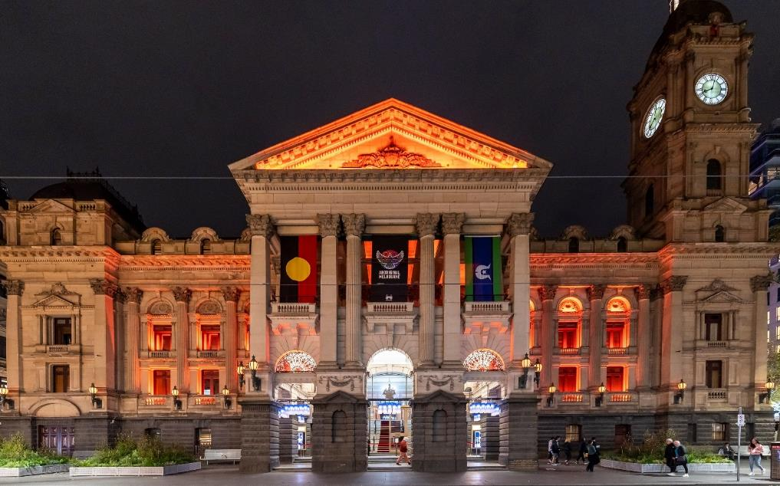
Melbourne Town Hall during NAIDOC Week.
Photo credit: Tiffany Garvie

Our organisation
The City of Melbourne is a dynamic municipality covering 37 square kilometres with a broad set of 11 neighbourhoods, each with its unique characteristics and needs – from densely populated urban environments, such as the central business district, to more residential areas, such as Kensington, Carlton and South Yarra.
Our population includes 177,396 residents, including 769 Aboriginal peoples (2021 ABS Census data). We also welcome almost a million visitors daily, including tourists and workers. Our city is incredibly culturally diverse. More than half of our residents were born in other countries — the top five countries of birth are India, China, England, Vietnam and New Zealand, and almost half of our residents speak a language other than English at home.
Resident population:
- 177,396 residents
- 50 per cent females
- 50 per cent males
- 55 per cent born overseas
- 46 per cent speak a language other than English
- 234,609 International students studying in Victoria
- 3114 same-sex couple households
- 769 Aboriginal and Torres Strait Islander peoples
- 2.3 per cent with disability
- 130 people sleeping rough
Source: Annual Plan 2024–25
Local councils govern and deliver municipal services that support the community. These include planning and building services, waste management, local laws and emergency management, and recreation and community services.
In governance terms, local councils are elected by and accountable to the people who live and do business within the municipality. Being responsive to the community's voices is critical to success.
As the local government authority, the City of Melbourne is focused on access and inclusion in delivering a wide range of services to residents, businesses, and visitors, including economic development, early years care, waste and resource management and wellbeing and recreation services. We also play an essential role as Victoria’s capital city. City of Melbourne owns and operates four Council office buildings within the Melbourne CBD as well as multiple sporting, library, community and recreation facilities throughout the municipality.
As of June 2023, the City of Melbourne employed 1770 people, with a full-time equivalent of 1530. While we do not currently collect data on the number of staff who identify as Aboriginal, we acknowledge our past shortcomings in recruiting and retaining Aboriginal staff. We are committed to learning from our past and have made cultural safety a top priority across the workplace. We are actively seeking to create employment pathways, demonstrating our dedication to a more inclusive and diverse workforce. We are aware of the need for improvement and are determined to do better.
Our reconciliation journey

Timeline
1985
- City of Melbourne provides a safe location for the internment of repatriated Aboriginal skeletal remains belonging to 38 language groups across Victoria at King’s Domain.
1990s to 2000s
- Aboriginal consultative committees guide the work of the City of Melbourne.
1999
- Council adopts the Statement of Commitment to Aboriginal and Torres Strait Islander People.
- Indigenous Arts Advisory Panel formed.
2003
- Council establishes a dedicated Indigenous unit.
2006
- Council becomes the first local government to introduce a Reconciliation Action Plan.
- First-ever gathering of Victorian Traditional Owner group at Melbourne Town Hall. Victorian Traditional Owner group gifts Lord Mayor John So with a possum skin cloak.
- Unveiling of Birrarung Wilam art installation at Birrarung Marr in time for the 2006 Commonwealth Games.
2007
- Indigenous Framework 2007–10.
- Launched second Reconciliation Action Plan 2007–10.
2008
- Indigenous Heritage Study 2008–10.
2009
- Indigenous Arts Advisory Panel celebrated 10 years.
2011–2014
- Reconciliation Action Plan 2011–14.
- In 2011, we began ensuring Traditional Owners were acknowledged at the commencement of all major City of Melbourne events, and at events where Councillors speak as representatives of the City of Melbourne.
- Since 2012, we have permanently raised the Aboriginal flag above Melbourne Town Hall and included a Welcome to Country at the first meeting of each newly elected Council.
- Indigenous Arts Festival 2012 and 2014.
- Indigenous Heritage Study Action Plan 2011–14.

2015–2016
- Aboriginal Heritage Action Plan.
- Reconciliation Action Plan 2015–18.
- In 2016, we unveiled a memorial marker at the corner of Victoria and Franklin streets to recognise Tunnerminnerwait and Maulboyheenner, two Aboriginal Tasmanian men who were publicly hanged in Melbourne in 1842.
2016
- City of Melbourne hosts an Aboriginal Enterprise Expo with over 40 Aboriginal-owned businesses and launches our Aboriginal Procurement Strategy with a target of (0.9 per cent).
2017
- Since 2016, all new staff members have participated in an Aboriginal Cultural Awareness Program, including an Indigenous Cultural Awareness Walk, as part of their induction to the City of Melbourne.
- In 2017 we launched the YIRRAMBOI Festival – Australia’s premier First Nations arts and cultural event-– and created a dedicated agency for Aboriginal authors in the Lord Mayor’s Creative Writing Awards.
2019
- City of Melbourne launched a new Aboriginal Melbourne branch to help build organisational capability around all issues affecting Aboriginal communities in Melbourne.
2021
- Council Plan 2021–25, includes Aboriginal Melbourne as a strategic objective.
- Launched Innovate Reconciliation Action Plan 2021–23 and added the truth-telling pillar.
- Council endorses the Declaration of Recognition and Commitment to Aboriginal Peoples.
2022
- Launch of the Mapping Aboriginal Melbourne interactive digital map of places of significance within the City of Melbourne.
2023
- City of Melbourne endorsed a Motion supporting the Uluru Statement from the Heart and the ‘Yes’ campaign for the Constitutional Recognition of an Aboriginal and Torres Strait Islander Voice to Parliament.
2024
- First Nations Committee created to advise the City of Melbourne on First Nations policy and programs.

Our journey
The City of Melbourne was the first local government to develop a Reconciliation Action Plan (RAP) in 2006. Since then, we’ve adopted five RAPs, each building on the work of the previous, ensuring that we learn and continue to do better.
We are proud of our work in the reconciliation space over time to deliver outcomes for Traditional Owners and the broader Aboriginal community and provide opportunities for our organisation and municipal community to engage.
In reflecting on our reconciliation journey, we are also looking to the future, where we collaborate with Sovereign First Nations to enable self-determination and support the community’s pathway to a treaty. A treaty will deliver long-term, sustainable solutions because Aboriginal peoples will be in the driver’s seat, making decisions about the matters that impact their lives.
We acknowledge that before our previous RAP, we needed more momentum on action within our organisation and in influencing reconciliation and the move towards a treaty with First Nations people. Our Innovate Reconciliation Action Plan 2021–23 was a reset for the organisation. It was an ambitious plan with 84 deliverables across five pillars. It was the first RAP to introduce truth-telling as a pillar and to focus on Caring for Country in a city.
Creating a separate Aboriginal Melbourne branch in 2019 set the tone for our recent commitment to be a more empowering and culturally connected organisation. As a branch of the City of Melbourne, Aboriginal Melbourne was created to guide the Council towards this goal. Aboriginal Melbourne seeks to lead by example in meaningfully engaging with Aboriginal communities to build respect for Aboriginal heritage, culture, and knowledge, embed Aboriginal voices and aspirations in the core business of the Council and decision-making at every level.

Achievements since our last plan
Pillar one – Truth-telling: We introduced truth-telling as a core pillar of our Reconciliation Action Plan. The objective was to elevate truth-telling in order to raise awareness across our municipality of past injustices as a means to educate and provide opportunities for healing. Victoria is on a pathway to treaty and the actions under this pillar provide opportunities for the broader community to understand the impact of colonisation and why a treaty is required to achieve true reconciliation.
We have focused on creating opportunities for truth-telling to facilitate learning, healing, and change within Melbourne and beyond. Sharing knowledge by partnering with the Traditional Owners together with acknowledging the impacts of past government policies has been central to our approach. We have used many mechanisms to do this including public talks, online resources, partnering with community organisations to develop interactive mobile app and influencing projects in the public realm.
Examples include an annual series of public design yarns that sought to engage the public about incorporating truth-telling in the design of the public realm, supporting the development and launch of Yalinguth an interactive app that provides the opportunity for the public to learn about the history of locations within the municipality, and public art that seeks to acknowledge past injustices and provide spaces for healing.
Pillar two – Relationships: Since our last plan, we have increased Traditional Owner involvement in city decision-making. Traditional Owners were engaged on a broad range of matters beyond the statutory obligations. We have sought to deepen our relationship with the Bunurong Land Council Aboriginal Corporation and Wurundjeri Woi-wurrung Cultural Heritage Aboriginal Corporation by increasing their voice in decisions that impact them and a commitment to develop formal partnerships.
From 1 July 2022 to 30 June 2023 we engaged with Traditional Owners 155 times which is a 138 per cent increase from the previous year (increasing from 65 sessions in 2021–22). This has included engaging on major projects and strategies, not in one-off instances but throughout the duration of a project to ensure it reflects the needs of Traditional Owners. On some projects, like Mapping Aboriginal Melbourne, it has also seen Traditional Owners as the key decision makers on the direction of projects.
Collaborating with the Aboriginal Community Controlled sector has informed and enhanced our responses to community needs in housing / homelessness, cultural awareness, economic development and the arts.
We have strong relationships with Koorie Heritage Trust, the Ngwala Willumbong Aboriginal Corporation, Kinaway, and The Torch.
We have worked with the Koorie Heritage Trust by providing grants to contribute to their operational costs, sponsorship of an annual award in their Koorie Art Show and have partnered to deliver cultural walks to educate our staff on the Aboriginal history of our city.
Our work in addressing homelessness within the city has been enhanced by developing a relationship with Ngwala Willumbong Aboriginal Corporation to ensure that culturally responsive services are provided to community. We anticipate this will be further enhanced during the period of this RAP, with an aim to support Ngwala Willumbong to have a permanent presence within the CBD.
We work closely with Kinaway to enhance opportunities for Aboriginal businesses within the municipality. This has included funding the Deadly in Melbourne expo in which 52 businesses were provided with the opportunity to promote their offerings to more than 500 attendees.
The Torch is an arts organisation that’s supports First Nations People currently in, or recently released, from Victorian prisons. We have funded the delivery of two large scale murals within the municipality.
Pillar three – Respect: Under the third pillar, we have increased respect for Aboriginal peoples, cultures, histories, knowledge, and rights within our organisation by delivering cultural competency training to Councillors, Executive team members, and all staff. The training is currently developed and delivered by the Wurundjeri Woi-wurrung Cultural Heritage Aboriginal Corporation and has been the foundation of increasing cultural safety across the organisation. We also provide cultural walking tours through the Koorie Heritage Trust and Melbourne Museum.
We have also worked to increase the presence of Aboriginal culture throughout our community places, facilities and events to increase understanding and respect within our broader community. A community of practice has been established within the organisation to share knowledge and ideas about how to embed First Nations perspectives into the design of our public spaces.
The entry of our Town Hall now features a permanent exhibition of contemporary Aboriginal artwork. Our children’s, early learning, and family centres are bringing Aboriginal perspectives into their everyday programs through Acknowledgements, books, songs, resources and classroom decorations.
In 2022, Melbourne Fashion Week debuted the Ganbu Marra runway that spotlights Indigenous designers, and the Moomba Festival is now opened by Wurundjeri Woi-wurrung Elders.
Pillar four – Opportunities: A focus since our fifth RAP has been increasing Aboriginal supplier diversity to improve economic outcomes and stimulate Aboriginal business development and growth. We developed the Aboriginal Procurement Strategy 2021–24, aiming to increase the City of Melbourne’s spending with Aboriginal suppliers by 0.5 per cent in Year 1, 0.75 per cent in Year 2, and 1 per cent in Year 3. We have exceeded our targets.
In 2023, we created the Sustainable Procurement Framework, which provides our staff with information on engaging with Aboriginal businesses.
Also in 2023, we hosted the successful Deadly in Melbourne business expo in partnership with the Kinaway Chamber of Commerce. More than 800 registered attendees and 52 First Nations businesses were showcased. We are members of Supply Nation and Kinaway.
Pillar five – Governance: Strengthening governance will be achieved by creating the First Nations Committee in 2024 to advise on First Nations policy and programs. Its purpose is to elevate diverse voices from across the Aboriginal community to ensure they have a say in decisions and priorities. The First Nations Committee will include nine external representatives.
Highlights
- Launching our Mapping Aboriginal Melbourne project, an interactive map that reveals places of importance to Traditional Owners as told by Traditional Owners.
- Delivering events across the City of Melbourne to celebrate Aboriginal culture including the annual Reconciliation Oration and Mabo Day in May/June and NAIDOC Week in July.
- Increasing the visibility of Aboriginal arts and culture throughout our festivals and events including the delivery of the nationally unique YIRRAMBOI Festival.
- Influencing the design of our public spaces and buildings including the new narrm ngarrgu Library and Family Services building in the Queen Victoria Market precinct.
Embedding appropriate design references to Aboriginal cultures across urban and landscape design, for example in the Greenline Project.

A public report containing more detailed information on our achievements can be accessed at the City of Melbourne website.

Case studies

Stolen Generations Marker
Acknowledging and paying tribute to the Stolen Generations is vital to the truth-telling process that underpins reconciliation. Between 1910 and the 1970s, up to one in three Aboriginal and Torres Strait Islander children were forcibly removed from their families, culture and Country through race-based laws and policies of state and national governments. These children became known as the Stolen Generations.
The Bringing Them Home Report stated that memorials (markers) are significant in acknowledging and ‘commemorating individuals, families, and communities’ affected by Stolen Generations policies ‘at the local and regional level’. They provide an opportunity for the voice of the Stolen Generations to be heard and educate the public about past injustices.
Guided by a working group that includes Stolen Generations survivors, their descendants, Traditional Owners, and other relevant community representatives, we are creating a marker to acknowledge and pay tribute to the Stolen Generations. The marker will be a permanent place with significant artwork that reflects the resilience of the Stolen Generations and their families, acknowledges the past injustices, and provides future opportunities to move along the path to reconciliation together.
Peppercorn Lawn in Alexandra Gardens on Wurundjeri Country has been selected as the site for the marker, following consultation with Stolen Generations, their families and Victoria’s Aboriginal community. Chosen for the cultural significance of the river and the central location in the city, Alexandra Gardens was once an oasis of billabongs and offers a peaceful space for reflection.
An Aboriginal artist will design the marker. In 2023, we invited Aboriginal and Torres Strait Islander artists to submit an expression of interest for the design of the permanent Stolen Generations Marker. Shortlisted artists are developing their final proposals in close consultation with the Stolen Generations Marker Working Group.
The marker will be open in 2026.

Mapping Aboriginal Melbourne
The City of Melbourne has partnered with Traditional Owners to develop a new online truth-telling tool, making it easier for Melburnians and visitors to explore the city’s rich First Nations culture and history.
The Mapping Aboriginal Melbourne tool features around 70 places of interest across the city – exploring the Kulin and broader Aboriginal connection to Country, culture and significant events and experiences since colonisation. The content and presentation of the map were determined by Traditional Owners.
The interactive digital map is a significant part of our reconciliation journey. It seeks to engage the community in a meaningful dialogue around the gathering, interpreting, and storing of Aboriginal knowledge. By improving how people access local First Nations histories, the map invites visitors to explore geographically, chronologically, or by theme and be a part of this important journey.
Our tool challenges people’s perception of modern-day Melbourne and its history. It shares the stories and rich history of Traditional Owners so that those who live in, work in and visit the municipality can appreciate Melbourne’s unique Aboriginal heritage and culture.
A significant place of interest on the map is Melbourne Cricket Ground (MCG) – Wurundjeri Woi-wurrung gathering place. A gathering place and living area for the Wurundjeri Woi-wurrung, the scarred trees around the MCG are part of Wurundjeri’s tangible, continuing connection to the area, as is football. Wurundjeri Woi-wurrung youth were seen by early colonists playing football (marngrook) here, with parts of Australian Rules football believed to originate from marngrook.
As of April 2024, more than 30,000 people had accessed the Mapping Aboriginal Melbourne tool.

narrm ngarrgu
Ensuring that Aboriginal culture is reflected and embedded in the design of our community spaces and buildings is integral to increasing understanding of and respect for Aboriginal identity.
In November 2023, we opened narrm ngarrgu, a new library and family services centre in the Queen Victoria Market precinct. narrm ngarrgu is located on Wurundjeri Woi-wurrung Country, and the City of Melbourne worked closely with Elders, artists and community members to bring this warm, welcoming space to life by drawing on deep knowledge systems.
The library is the first to open in the City of Melbourne in almost a decade. It offers a range of family health and wellbeing services and a collection of more than 30,000 new books.
The name, the materials, the artwork – even the design of the carpet – honour and celebrate the First Nations community. narrm ngarrgu means ‘Melbourne Knowledge’ in Wurundjeri Woi-wurrung language.
Maree Clarke, a Mutti Mutti / Yorta Yorta and Wemba Wemba / Boon Wurrung artist from north-western Victoria collaborated with other creatives and designers to shape immersive spaces that tell the stories of the site and its context. Designed to invite reflection, learning, ceremony and play – the artworks at narrm ngarrgu celebrate the rich contribution First Nations people make to the city's life, share stories of Country and speak to the impact of colonisation. Wurundjeri Elders guided the project and provided language names for inside the building.
Maree described the expansive library space as a super-giant blank canvas. “In the children’s library, I’ve designed the carpet to represent the seven seasons of the Kulin Nation through plants and animals,” Maree said. “Through the main library carpet – with the beautiful watercolour and the maps over the top – people will get to learn about the five clans of the Kulin Nation. And what better place to learn than in a library.”
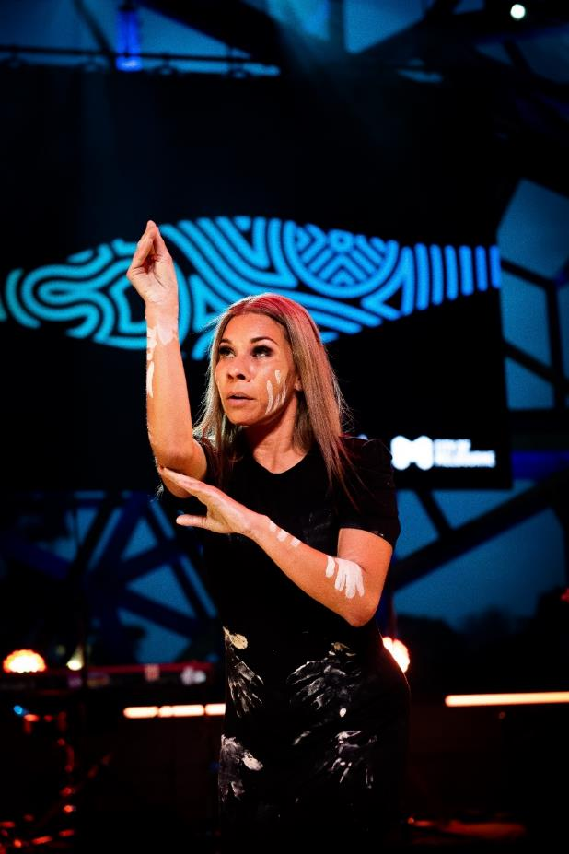
Mabo Day Concert at Federation Square.
Photo credit: Alister McKeich

Learnings and challenges
A key realisation during the implementation of our previous RAP was that we needed to revise our governance structures. From 2021 to 2022, our RAP working group included an external community representative. Mixed representation with the community and staff in the working group was challenging and didn’t enable leaders in the organisation to share challenges openly. We learned that we needed to be clearer about ownership of deliverables and outcomes. To be more accountable and elevate the voices of the community, we are establishing a First Nations Committee in 2024.
Challenges from our previous plan
- Without a First Nations Strategy, the RAP became the default for all things First Nations.
- The RAP was too descriptive rather than being outcomes focused.
- There were no key performance indicators or targets set for RAP commitments.
- Ownership of deliverables was not clear.
- Governance would work better with a separate external advisory group and a RAP internal working group.
- There was no ‘fit for purpose’ reporting and monitoring system.
10 key learnings
- Develop clear objectives and actions in the RAP.
- Develop meaningful, transparent targets and ensure that we publicly report on our progress.
- Establish well-defined lines of responsibility and ownership of deliverables.
- Elevate self-determination – Aboriginal voices and aspirations must be embedded in our core business and decision-making at every level as we strive for reconciliation, recognition, respect and truth-telling. Govern with Sovereign First Nations to enable true self-determination, where deliberative engagement is proactive, responsive and consistent.
- Ensure that Aboriginal people have access to the full range of services provided by City of Melbourne.
- Develop a First Nations Strategy rather than putting all our work under the reconciliation umbrella.
- Embed self-determination and provide a mechanism for the community to have a say on decisions that directly impact them.
- Ensure there are opportunities year-round to celebrate Aboriginal culture, not just during Reconciliation Week and NAIDOC Week.
- Create more impactful actions and events – quality versus quantity. For example, running 10 activities during NAIDOC Week waters down the impact that delivering one or two much larger scale events can have.
- Seek better ways to support Traditional Owners and enable greater engagement in city governance.
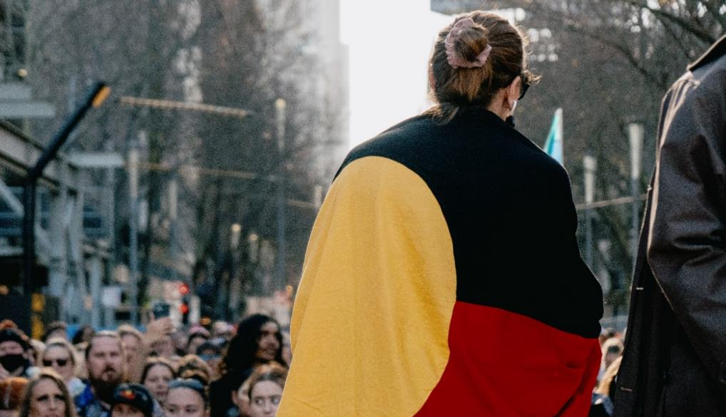
NAIDOC Rally.
Photo credit: Jacinta Keefe.

Our Reconciliation Action Plan
We are pleased to deliver our Stretch Reconciliation Action Plan (RAP) August 2024–July 2027. Creating a Stretch RAP significantly strengthens our reconciliation commitments. It builds on our deep commitment to deliver outcomes for Traditional Owners and the broader Aboriginal community.
Our RAP strives to educate the community about First Peoples' culture, lore, knowledge, and heritage. We are immensely proud of Melbourne’s unique Aboriginal cultural heritage and are committed to appropriately recognising, protecting, and celebrating it. It is vital to our identity and promotes Aboriginal peoples’ equal participation in our city's economy and activities. Embedding Aboriginal culture in the design of our community places, facilities and events allows us to share the enormous benefits and richness of the oldest continuous culture on earth. It is also essential that we embed Aboriginal perspectives into Council processes, governances, and decision-making.
Reconciliation is about Aboriginal and Torres Strait Islander peoples and non-Aboriginal Australians working together to create a just and equitable society where Aboriginal peoples have the ability to shape their own lives and the freedom to live well.
Our approach is based on the five dimensions of reconciliation: historical acceptance, race relations, equality and equity, institutional integrity, and unity. These dimensions informed our vision for reconciliation of genuine self-determination, where Aboriginal peoples have equal education, employment, and health opportunities.
Within our five pillars, we outline 16 actions and 67 deliverables for the City of Melbourne, our community, our partners and the Aboriginal community. We have focused on outcomes with clear timeframes and measurable performance indicators. By embedding reconciliation into every aspect of the City of Melbourne’s work, it is factored into our processes and has become business as usual.
Our Stretch RAP demonstrates our robust and meaningful commitment to reconciliation and our continued work towards becoming a culturally safe and aware organisation.
Importantly, responsibility for delivering actions is shared throughout the organisation, with everyone at the City of Melbourne contributing to our reconciliation journey. We have created this plan with our community through meaningful, long-term engagement with Aboriginal and non-Aboriginal people in our city, and we will report back to our community on our progress every year.
Our RAP is structured around truth-telling, and Reconciliation Australia’s four pillars: respect, relationships, opportunities and governance.
Our five pillars
- Truth-telling: Giving Aboriginal voices opportunities for deliberate sharing of history and experience, inclusive of injustice and wrongdoing.
- Relationships: Ensuring inclusivity of Aboriginal people is centric to the work of Council, to strengthen relationships and elevate their voices.
- Respect: Understanding of and respect for Aboriginal culture and identity is integral to meaningful and lasting relationships with the community.
- Opportunities: Providing and maintaining Aboriginal cultural and social and economic development opportunities enables outcomes to be embedded within the community.
- Governance: Aboriginal voices and interests are protected within the organisation and always maintained as priority.

Community engagement and feedback
This Stretch RAP was developed through in-depth community engagement. We used two methods: targeted engagement with Aboriginal stakeholders, and broad community engagement using the Participate Melbourne platform and an online survey.
Targeted engagement with Aboriginal stakeholders, including in-person meetings with Traditional Owners and key stakeholders, was critical to informing the RAP.
We ran a four-week consultation on the Participate Melbourne platform in March and April 2024, inviting residents, visitors, businesses and community groups to provide feedback on our RAP Discussion Paper and help shape our reconciliation journey over the next three years. We also ran a survey asking people what they want City of Melbourne to achieve towards reconciliation. A total of 118 people completed the survey over the four-week consultation from 13 March to 10 April 2024, providing valuable input on our approach and the outcomes they want to see.
City of Melbourne staff were also involved in shaping our Stretch RAP. The Aboriginal Melbourne branch led internal discussions and challenged the broader organisation to propose ways it can contribute to the community's prioritised outcomes.

Governance
Creating our sixth RAP allowed us to learn from our previous plan and reimagine how the City of Melbourne prioritises First Nations outcomes.
As outlined above, we are reshaping and strengthening the governance structure, systems and processes to implement, monitor and report progress on our Reconciliation Action Plan. We’ve also embedded reconciliation into every aspect of our work so that it is factored into our processes and has become business as usual.
In 2024 we will establish a new First Nations Committee which will be the external governance mechanism by which we will be accountable for our performance against the RAP and will elevate diverse voices from the Aboriginal community to ensure they have a say in decisions and priorities.
Internally, we will establish a new steering committee, a leadership group with an executive champion that will have oversight and sponsorship of the RAP. This underscores our leadership’s commitment to the RAP and its successful implementation. The steering committee provides high level oversight of the RAP and is the key decision-making committee for the RAP. The committee will meet quarterly.
Additionally, we are establishing a RAP working group that is responsible for the day-to-day implementation. The working group will be a diverse team, comprising staff from the Aboriginal Melbourne branch, Aboriginal staff and staff from all areas of the organisation. This inclusivity ensures that all perspectives are considered in our RAP initiatives. The group will meet every six weeks, providing a regular platform for collaboration and progress updates.
This new structure provides us with external accountability and internal ownership.
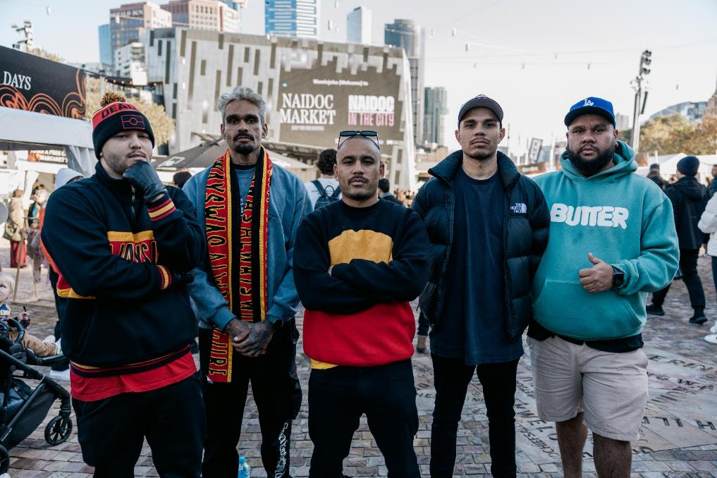
NAIDOC in the City, Federation Square.
Photo credit: Jacinta Keefe.

Our actions, deliverables and targets
Our vision
The City of Melbourne’s vision for reconciliation is to work alongside Sovereign First Nations, enabling true self-determination and ensuring Aboriginal peoples have the freedom to live well according to their own values and beliefs.
Our commitment
Our reconciliation commitments are presented by five pillars, these are:
- Pillar 1 – Truth-telling
- Pillar 2 – Relationships
- Pillar 3 – Respect
- Pillar 4 – Opportunities
- Pillar 5 – Governance
Under each pillar are the actions and deliverables we will implement over the next three years and targets that measure our progress towards delivering this plan. This information is presented in the next section of this plan, starting from page 20.
Our progress
Our progress will be monitored and reported annually to the community.
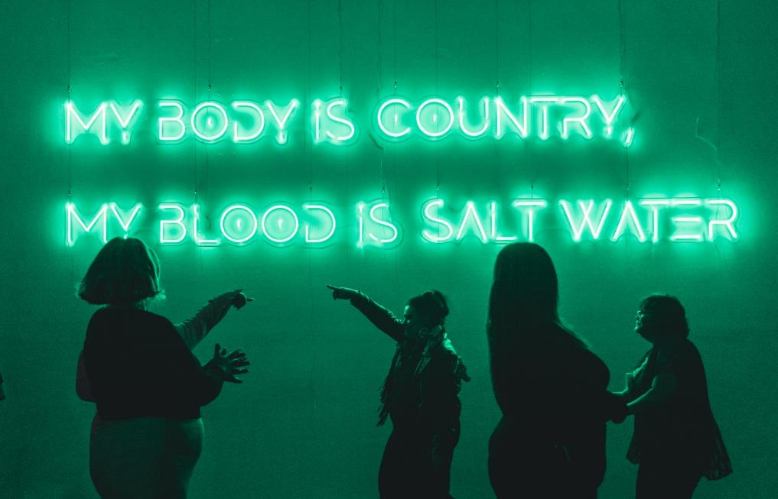
My Body is Country, My Blood is Salt Water by Caleb Nichols-Mansell (Palawa).
Commissioned by YIRRAMBOI 2023.
Photographer: Jacinta Keefe.
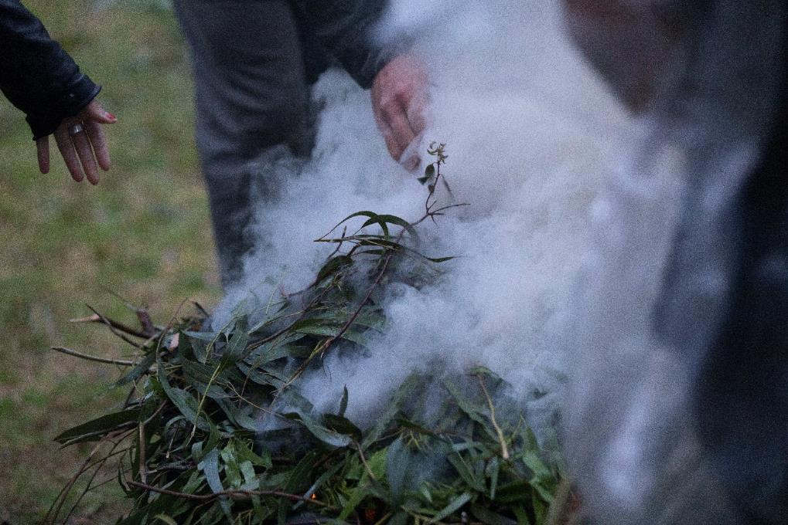
Day of Mourning.
Photo credit: Blue Tree Studios.

Pillar 1. Truth-Telling
Giving Aboriginal voices opportunities for deliberate sharing of history and experience, inclusive of injustice and wrongdoing.
The City of Melbourne recognises the importance of truth-telling in facilitating learning, healing, and change within our organisation and the municipality of Melbourne. It’s an opportunity to impart knowledge of thousands of years of rich histories, languages, stories and living cultures. Truth-telling builds empathy and understanding and is integral to reconciliation and the Victorian Government’s journey towards a treaty with First Nations people.
We support the Yoorrook Justice Commission – the first formal truth-telling process into injustices experienced by First Peoples in Victoria. Yoorrook is looking into past and ongoing injustices experienced by First Peoples in Victoria in all areas of life since colonisation. Truth-telling provides a form of restorative justice by acknowledging Aboriginal people’s experiences of dispossession and inequity. It helps develop a shared understanding among all Victorians of the impact of colonisation and the diversity, strength, and resilience of First Peoples' cultures.

Action 1.1 Explore and deliver opportunities for truth-telling to facilitate learning, healing, and change within the City of Melbourne and externally.
Ref | Deliverables | Responsibility | Timeline | Targets
1.1.1 | Deliver a program of public activities including talks that provide an opportunity for Aboriginal people to share information about past injustices, culture and history with the broader community. | Director Aboriginal Melbourne | June 2025, June 2026, June 2027 | Three public activities per year.
1.1.2 | Create a permanent Stolen Generations Marker, for Stolen Generations survivors and as a place of truth-telling. | Director Aboriginal Melbourne  Director Creative City | May 2026 | Marker delivered May 2026.
1.1.3 | In partnership with Traditional Owners, continue to develop the Mapping Aboriginal Melbourne website. | Director Aboriginal Melbourne | December 2024, June 2025, June 2026, June 2027 | N/A
1.1.4 | Deliver an activity or activities that acknowledge and honour National Sorry Day. | Director Aboriginal Melbourne | May 2025, May 2026, May 2027 | At least one activity per year.

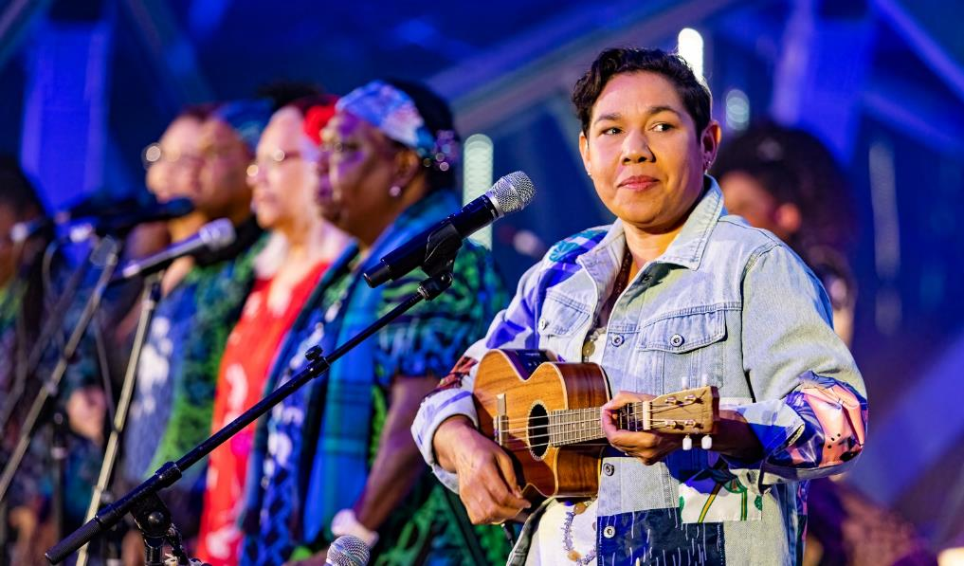
Mabo Day Concert at Federation Square.
Photo credit: Paul Gosney.

Pillar 2. Relationships
Ensuring inclusivity of Aboriginal people is centric to the work of Council, to strengthen relationships and elevate their voices to enable self-determination.
Working with First Nations people is critical for the City of Melbourne to become a genuinely inclusive city where Aboriginal peoples have the right to self-determine their future and the freedom to live well according to their values and beliefs. We are focused on deepening our relationships with the Wurundjeri Woi-wurrung Cultural Heritage Aboriginal Corporation and the Bunurong Land Council Aboriginal Corporation by increasing their voice in decisions that impact them. Building strong relationships with Traditional Owners, the broader Aboriginal community and the Aboriginal Community Controlled sector has informed and enhanced our responses to community needs regarding housing and homelessness, cultural awareness, economic development, and the arts.

Action 2.1 Establish and maintain mutually beneficial relationships with Aboriginal stakeholders and organisations.
Ref | Deliverables | Responsibility | Timeline | Targets
2.1.1 | Develop formal partnerships that enable self-determination with the Wurundjeri Woi-wurrung Cultural Heritage Aboriginal Corporation and Bunurong Land Council Aboriginal Corporation. | Director Aboriginal Melbourne | June 2025, March 2026 | Wurundjeri Woi-wurrung Cultural Heritage Aboriginal Corporation partnership in place.  Bunurong Land Council Aboriginal Corporation partnership in place.
2.1.2 | Develop a Traditional Owner and Aboriginal Community Engagement Framework that is based on enabling self-determination and upholds the principles of the United Nations Declaration on the Rights of Indigenous Peoples. | Director Aboriginal Melbourne | December 2025 | Framework developed December 2025.
2.1.3 | Develop and maintain seven two-way partnerships with key Aboriginal community controlled organisations that are either based within the municipality or deliver services within the municipality. | Director Aboriginal Melbourne  Director Creative City  Director Economic Development and International  Director Homes Melbourne | June 2025, June 2026, June 2027 | Aboriginal Housing Victoria (new)  Djirra (new)  Killara Foundation (new)  Kinaway (existing)  Ngwala Willumbong Aboriginal Corporation (existing)  The Torch (existing)  Blak and Bright (existing)
2.1.4 | Ensure our Council-endorsed committees have formal Aboriginal representation. | Director Aboriginal Melbourne  Director Governance | June 2025, June 2026, June 2027 | At least one Aboriginal member.

Action 2.2 Build relationships through celebrating National Reconciliation Week (NRW).
Ref | Deliverables | Responsibility | Timeline | Target
2.2.1 | Establish an internal working group to deliver a series of NRW events. This includes staff are supported to participate in at least two external NRW events. | Director Aboriginal Melbourne  All Directors | May-June 2025, May-June 2026, May-June 2027 | Deliver at least two internal NRW events.  One NRW Oration per year.  One Mabo Day event per year.
2.2.2 | Develop and adopt a communications plan that:  - Promotes reconciliation resources (i.e. Reconciliation Australia NRW materials) to all staff and the general public.  - Encourages all staff and the general public to participate in events that recognise and celebrate reconciliation (i.e. National Reconciliation Week). | Director Strategic Communications  Director Aboriginal Melbourne | April 2025, April 2026, April 2027 | Communications plan adopted annually by May.
2.2.3 | Register all City of Melbourne NRW events on Reconciliation Australia’s NRW website. | Director Aboriginal Melbourne | April 2025, April 2026, April 2027 | N/A
2.2.4 | Deliver a community grants program for community organisations and groups that includes opportunities to increase community understanding of reconciliation as part of NRW. | Director Aboriginal Melbourne | June 2025, June 2026, June 2027 | Community grants program is delivered annually.

Action 2.3 Promote reconciliation through our sphere of influence.
Ref | Deliverables | Responsibility | Timeline | Target
2.3.1 | Publicly communicate our commitment to reconciliation through Council’s key communication channels. | Director Strategic Communications | May-June 2025, May-June 2026, May-June 2027 | Social media.  Corporate channels i.e. website, Melbourne Magazine.  Media releases.  Internal channels.
2.3.2 | Implement strategies to positively influence our external stakeholders to drive reconciliation outcomes. | Director Aboriginal Melbourne | December 2025, December 2026, December 2027 | N/A
2.3.3 | Collaborate with at least three like-minded organisations to implement ways to advance reconciliation. | Director Aboriginal Melbourne | June 2025, June 2026, June 2027 | Three local government organisations.

Action 2.4 Promote positive race relations through anti-discrimination strategies.
Ref | Deliverables | Responsibility | Timeline | Target
2.4.1 | Review all policies and procedures that address discrimination, racism, and harassment in the workplace. | Chief People Officer | Every two years, 2025, 2026, 2027 | Policies and procedures reviewed every two years or when there are legislative changes.
2.4.2 | Maintain and communicate an anti-discrimination policy for our organisation that is informed by staff experiences and engagement with Aboriginal staff and advisors. This includes:  - Consulting with staff to refresh the policy by June 2025.  - New training designed by December 2025 and delivered to all staff.  - All directors ensure all staff complete mandatory training requirements. | Chief People Officer  All Directors | June 2025, June 2026, June 2027 | 100 per cent compliance with mandatory training (all staff).
2.4.3 | Provide ongoing education opportunities for the general public on the effects of racism. | Director Strategic Communications | June 2025, June 2026, June 2027 | N/A
2.4.4 | Senior leaders to publicly support anti-discrimination campaigns and initiatives against racism. | Chief Executive Officer  All General Managers  All Directors | June 2025, June 2026, June 2027 | 100 per cent support by our senior leaders.

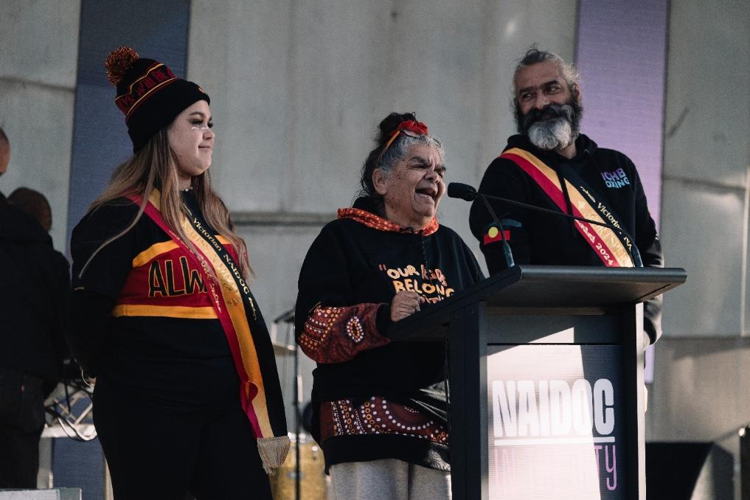
NAIDOC in the City Concert.
Photo credit: Jacinta Keefe.

Pillar 3. Respect
Understanding of and respect for Aboriginal culture and identity is integral to meaningful and lasting relationships with the community.
We are immensely proud of Melbourne’s unique Aboriginal cultural heritage and are committed to appropriately protecting and celebrating it. It is vital to our identity and ensures Aboriginal peoples’ equal participation in our city's economy and activities. We strive to educate our organisation and the Melbourne community about First Peoples' culture, lore, knowledge, and heritage. By embedding Aboriginal culture in the design of our urban landscape, buildings, and community spaces, we are recognising and reflecting the Aboriginal culture in the very fabric of our city.
To ensure self-determination and elevate Traditional Owner voices, we are increasing our organisation's understanding of and respect for Aboriginal peoples, cultures, histories, knowledge, and rights. Staff undertake cultural competency training and cultural walking tours and need to understand what self-determination is from the perspective of Traditional Owners to understand how they should be thinking about our work and providing opportunities for self-determination to come to life. The training, developed and delivered by Traditional Owners, has been the foundation of increasing cultural safety across the organisation.

Action 3.1 Increase understanding, value and recognition of Aboriginal cultures, histories, knowledge and rights through cultural learning.
Ref | Deliverables | Responsibility | Timeline | Target
3.1.1 | Develop and communicate an Aboriginal Cultural Learning Strategy. This includes:  - Consult Aboriginal employees and Traditional Owners to develop the strategy.  - Develop a capability framework for cultural learning.  - Maintain a learning and development program for all people leaders to ensure Aboriginal staff are culturally safe and supported.  - Provide a diverse range of learning opportunities and courses for a range of learning needs at all organisational levels. | Chief People Officer  Director Aboriginal Melbourne | June 2025, June 2026, June 2027 | By December 2025 develop an Aboriginal Cultural Learning Strategy.  Maintain and improve the existing learning and development cultural learning program to ensure offerings are relevant and accessible.
3.1.2 | Ensure executives, managers and staff have opportunities to undertake a variety of cultural learning activities. | All Directors | June 2025, June 2026, June 2027 | 90 percent of staff undertake e-learning module.  40 per cent of staff undertake face-to- face cultural learning activities.
3.1.3 | Ensure councillors have opportunities to undertake a variety of cultural learning activities. | Chief of Staff  Office of the CEO | June 2025, June 2026, June 2027 | N/A

Action 3.2 Demonstrate respect to Aboriginal and Torres Strait Islander peoples by observing cultural protocols.
Ref | Deliverables | Responsibility | Timeline | Target
3.2.1 | Review the City of Melbourne style guide to ensure that it reflects accurate and current guidance and advice on cultural language protocols. | Director Strategic Communications | June 2025, June 2026, June 2027 | Annual review of the style guide.
3.2.2 | Invite a Traditional Owner to provide a Welcome to Country or other appropriate cultural protocol at premier events each year. | Director Experience Melbourne | June 2025, June 2026, June 2027 | Christmas Festival  Firelight Festival  Melbourne Awards  Melbourne Fashion Week  Moomba Festival  New Year’s Eve  Now or Never Festival
3.2.3 | Establish measures that increase staff understanding of the purpose and significance behind cultural protocols, including Welcome to Country and Acknowledgement of Country protocols. | Director Strategic Communications | June 2025, June 2026, June 2027 | N/A
3.2.4 | Include an Acknowledgement of Country or other appropriate protocols at the commencement of internal and external important meetings and all public events. | All Directors | June 2025, June 2026, June 2027 | N/A
3.2.5 | Display Acknowledgment of Traditional Owners plaques and signage on the main Council-owned or managed offices and buildings in which Council services are primarily delivered from including:  - Melbourne Town Hall  - Administration buildings – Town Hall, Council House 1 and 2 and City Village  - Family services – North Melbourne Children’s Centre, Hotham Hub, Lady Huntingfield, Carlton Family Resource Centre, Carlton Learning Precinct, Powlett Reserve Childcare Centre, Fawkner Park Children’s Centre, the Harbour Family and Children’s Centre, Cardigan Street Chapel  - Libraries – Library at the Dock, East Melbourne Library, Kathleen Syme Library, North Melbourne Library  - Community Centres – Fawkner Park Senior Citizens Centre, ArtPlay, Jean McKendry Neighbourhood House, Arnion House, Signal, Boyd Community Hub, Kensington Neighbourhood Centre  - Major signage at entry points to the municipality and  - Sport and recreational facilities | Director City Property | Quarterly, 2025, 2026, 2027 | Four to five signs per quarter.

Action 3.3 Engage with Aboriginal cultures and histories by celebrating NAIDOC Week.
Ref | Deliverables | Responsibility | Timeline | Target
3.3.1 | Ensure that HR policies and procedures enable staff participation in NAIDOC Week events. | Chief People Officer | June 2025, June 2026, June 2027 | Policies and procedures reflect enterprise agreement for cultural and ceremonial leave.
3.3.2 | Support all staff to participate in at least one NAIDOC Week event in our local area. | All Directors | July 2024, July 2025, July 2026 | Staff participate in at least one NAIDOC Week event.
3.3.3 | Establish an internal working group to deliver a series of NAIDOC Week events and activities that is supported by a communications plan. | Director Aboriginal Melbourne  Director Strategic Communications | July 2024, July 2025, July 2026, July 2027 | Deliver at least:  - One NAIDOC in the City Concert.  - One program of activities for children.  - One internal event for staff.

Action 3.4 Promote and celebrate Aboriginal heritage and cultures internally within the organisation.
Ref | Deliverables | Responsibility | Timeline | Target
3.4.1 | Include Aboriginal performers or content at significant events e.g. end of year celebrations. | All Directors | June 2025, June 2026, June 2027 | N/A
3.4.2 | Acquire and display artworks by Aboriginal artists within Council-owned and managed buildings to celebrate Aboriginal cultures. | Director Creative City | June 2025, June 2026, June 2027 | At least 50 per cent of the acquisitions budget is spent on acquiring works by Aboriginal artists.
3.4.3 | Continue to explore and implement culturally appropriate Aboriginal names for our buildings, offices, and meeting rooms. | Director City Property | June 2025, June 2026, June 2027 | N/A
3.4.4 | Fly Aboriginal and Torres Strait Islander flags at Council buildings (Melbourne, Kensington, and North Melbourne town halls). | Director Governance | June 2025, June 2026, June 2027 | N/A

Action 3.5 Promote Aboriginal experiences for the public to celebrate Melbourne as an Aboriginal City.
Ref | Deliverables | Responsibility | Timeline | Target
3.5.1 | Our Visitor Hub at Town Hall offers information and opportunities for visitors to learn about and experience Aboriginal heritage and cultures. | Director Experience Melbourne | June 2025, June 2026, June 2027 | Showcase a minimum of eight experiences.
3.5.2 | Experience Melbourne to promote Aboriginal experiences through owned communications channels including ‘What’s On’. | Director Experience Melbourne | June 2025, June 2026, June 2027 | Minimum 12 posts per annum featuring Aboriginal experiences.

Action 3.6 Educate the broader community about Aboriginal heritage and culture.
Ref | Deliverables | Responsibility | Timeline | Target
3.6.1 | Develop an Aboriginal City Framework that aligns with self-determination principles and embraces Aboriginal peoples, culture, knowledge and heritage as a core element of Melbourne’s past, present and future identity. | Director Aboriginal Melbourne | December 2027 | Framework developed by December 2027
3.6.2 | Develop annual work plans to support the development and delivery of the Aboriginal City Framework. | Director Aboriginal Melbourne  Director Creative City  Director City Design  Director Climate Change and City Resilience  Director City Strategy  Director Parks and City Greening  Director City Projects  Director Experience Melbourne  Director Recreation and Waterways | September 2025, September  2026, September  2027 | Annual work plans developed by end of September each year.

Action 3.7 Protect, recognise and promote Aboriginal culture, heritage and place.
Ref | Deliverables | Responsibility | Timeline | Target
3.7.1 | Identify and implement opportunities for the naming of places and roads to prioritise the use of Aboriginal language names. | Director Aboriginal Melbourne  Director City Strategy  Director Planning and Building | June 2025, June 2026, June 2027 | N/A
3.7.2 | In collaboration with Traditional Owners, develop a Caring for Country Framework that explores how Caring for Country knowledge and practices can be applied across our work. | Director Aboriginal Melbourne | December 2026 | Caring for Country Framework developed by December 2026.
3.7.3 | Develop annual work plans to show how – in collaboration with Traditional Owners – Caring for Country knowledge and practices will be integrated in our work. | Director Aboriginal Melbourne  Director Creative City  Director City Design  Director Climate Change and City Resilience  Director City Strategy  Director Parks and City Greening  Director City Projects  Director Experience Melbourne  Director Recreation and Waterways | September 2025, September  2026, September  2027 | Annual work plans developed by end of September each year.
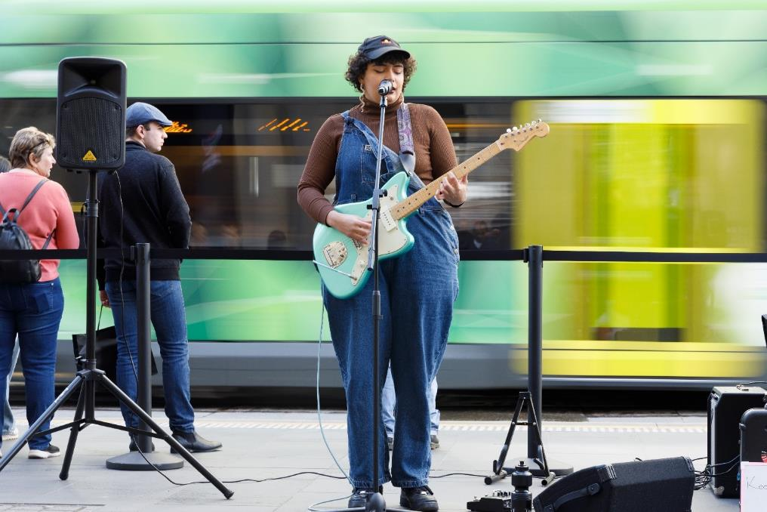
Sounds of Country, NAIDOC Week.
Photo credit: James Henry.

Pillar 4. Opportunities
Providing and maintaining Aboriginal cultural and social and economic development opportunities enables outcomes to be embedded within the community.
We acknowledge that Aboriginal self-determination is a human right enshrined in the United Nations Declaration on the Rights of Indigenous Peoples, and we are committed to working towards cultural, social and economic equity for Aboriginal Victorians.
Providing and maintaining opportunities for Aboriginal businesses, peoples and communities that results in increased cultural, social and economic equity, is a step towards achieving our vision for reconciliation and a truly inclusive city.
The City of Melbourne is increasing Aboriginal supplier diversity across our wide range of service delivery, including economic development, visitor services, care, recreation and resource management. We do this by embedding engagement with Aboriginal businesses in our procurement framework and our Aboriginal Procurement Strategy 2021–24. These changes have resulted in positive outcomes – we have already exceeded our spending targets with Aboriginal suppliers. We acknowledge our past shortcomings in recruiting Aboriginal staff and are working to improve employment outcomes by increasing the recruitment, retention and professional development of Aboriginal staff members.
We are also focused on increasing culturally appropriate housing options for Aboriginal people in our municipality. Aboriginal people are vastly over-represented in Melbourne's overall population of people experiencing homelessness and rough sleeping. Despite comprising just 0.5 per cent of the City of Melbourne's population, Aboriginal people equate to 17 per cent of all people sleeping rough. Although Aboriginal people represent a high percentage of people experiencing homelessness, there is no Aboriginal-specific access point within Melbourne's CBD. We are exploring options to support Aboriginal community controlled organisations to control the design, delivery and evaluation of their community’s housing, health and social services.

Action 4.1 Improve employment outcomes by increasing Aboriginal and Torres Strait Islander recruitment, retention and professional development.
Ref | Deliverables | Responsibility | Timeline | Target
4.1.1 | Build understanding of Aboriginal staffing to inform future employment and professional development opportunities. This includes:  - Creating culturally safe space environments where staff feel supported to identify and share all aspects of diversity.  - Increased systems capability.  - Target campaigns to encourage staff to share diversity data. | Chief People Officer  All Directors | December 2024, December 2025, December 2026, December 2027 | Increased participation in Australia Workplace Equality Index (AWEI) Survey or equivalent.
4.1.2 | Review and deliver an Aboriginal Employment and Retention Strategy. | Chief People Officer | June 2025, June 2026, June 2027 | One per cent for first year.  One and a half per cent for second year.  Two per cent for third year.
4.1.3 | Advertise job vacancies in ways that effectively reach Aboriginal peoples. | Chief People Officer | June 2025, June 2026, June 2027 | 100 per cent of job vacancies are appropriately advertised.
4.1.4 | Review and improve our recruitment procedures and policies to remove barriers to Aboriginal people’s participation in our workplace and procedures. This includes:  - Enhance procedures and policies as appropriate based on review. | Chief People Officer | December 2025 | Policies and procedures reviewed in 2025.
4.1.5 | Support Aboriginal employees to take on management and senior level positions. This includes:  - All directors to create and support opportunities for Aboriginal employees. | Chief People Officer  All Directors | June 2025, June 2026, June 2027 | Track opportunities provided to Aboriginal employees.

Action 4.2 Provide opportunities to support improved economic development outcomes for Aboriginal Victorians.
Ref | Deliverables | Responsibility | Timeline | Target
4.2.1 | Maintain an Aboriginal Procurement Strategy and engage at least 30 commercial relationships with Aboriginal businesses. | Director Procurement and Contract Management  Director Aboriginal Melbourne | June 2025, June 2026, June 2027 | Spend $2 million annually with Aboriginal businesses.
4.2.2 | Maintain Supply Nation and Kinaway memberships. | Director Procurement and Contract Management | June 2025, June 2026, June 2027 | N/A
4.2.3 | Develop and communicate opportunities for the procurement of goods and services from Aboriginal businesses to staff. | Director Procurement and Contract Management | June 2025, June 2026, June 2027 | N/A
4.2.4 | Review and improve procurement practices to remove barriers to procuring goods and services from Aboriginal businesses. | Director Procurement and Contract Management | June 2025, June 2026, June 2027 | N/A
4.2.5 | Explore opportunities for pop-ups in vacant City of Melbourne properties for Aboriginal businesses and will be guided by a new leasing policy. | Director City Property | June 2025, June 2026, June 2027 | Leasing policy implemented 2024-25.
4.2.6 | Ensure that Aboriginal businesses in the municipality are highly visible, initially through the exploration of a central location that serves as a consumer-facing hub for Aboriginal businesses. | Director Economic Development and International | December 2027 | N/A

Action 4.3 Provide opportunities to support improved cultural and social outcomes for Aboriginal Victorians.
Ref | Deliverables | Responsibility | Timeline | Target
4.3.1 | In consultation with Traditional Owners, explore a permanent outdoor ceremonial site. | Director Aboriginal Melbourne | December 2027 | One outdoor permanent ceremonial site.
4.3.2 | Deliver an annual program of Aboriginal public art works that celebrate locations of significance to community. These will be designed and co-delivered with Aboriginal artists in accordance with Indigenous Cultural and Intellectual Property rights. | Director Creative City | June 2025, June 2026, June 2027 | Moreton Bay Fig Tree Commission  Warrior Woman Lane  University Square Commission
4.3.3 | Support the delivery of Yirramboi Festival and support the transition to an annual event. | Director Creative City | May 2025, annually from 2027 | From 2027 the festival is delivered annually.
4.3.4 | Provide in-kind access to our bookable spaces in libraries and community hubs for Aboriginal community organisations. | Director Creative City | June 2025, June 2026, June 2027 | Increase bookings by five per cent.
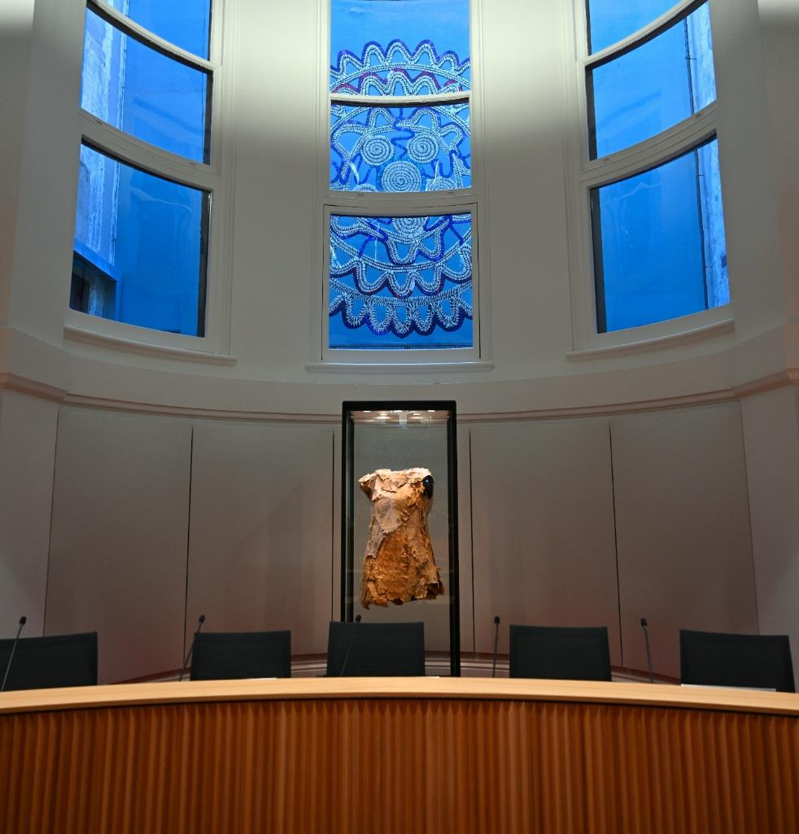
The Commons at Melbourne Town Hall.
Photo credit: Wayne Quilliam.

Pillar 5. Governance
Aboriginal voices and interests are protected within the organisation and always maintained as priority.
To ensure Aboriginal voices are critical to the City of Melbourne’s operations, we have reworked and strengthened our governance structure, systems and processes to support the implementation, monitoring and reporting of the Reconciliation Action Plan.
In 2024, we will establish a First Nations Committee to advise on First Nations policy and programs, elevating diverse voices from the Aboriginal community to ensure they have a say in decisions and priorities. We’ve also embedded reconciliation into every aspect of our work so that it is factored into our processes and has become business as usual.
Within our organisation, we will establish a new steering committee, a leadership group that will have oversight and sponsorship of the RAP. This underscores our leadership's commitment to the RAP and its successful implementation. A new RAP Working Group includes Aboriginal Melbourne team members, Aboriginal staff and staff from all areas of the organisation. This new structure provides us with external accountability and internal ownership.

Action 5.1 Maintain an effective governance structure, systems and processes to support the implementation, monitoring and reporting of the RAP.
Ref | Deliverables | Responsibility | Timeline | Target
5.1.1 | Maintain a First Nations Committee to elevate diverse voices from the Aboriginal community and ensure they have a say in decisions and priorities.  Maintain a terms of reference. | Director Aboriginal Melbourne | Quarterly, 2024, 2025, 2026, 2027 | Four meetings per year.
5.1.2 | Establish a steering committee with an executive champion to have oversight of the RAP. It should meet at least four times a year and establish and maintain a terms of reference. | Director Aboriginal Melbourne | Quarterly, 2024, 2025, 2026, 2027 | Four meetings per year.
5.1.3 | Maintain an internal RAP working group that meets every six weeks and maintain a terms of reference. | Director Aboriginal Melbourne | Every six weeks, 2024, 2025, 2026, 2027 | Eight meetings per year.
5.1.4 | Align resources with Council’s annual budget and planning processes to support the implementation of the RAP. | Director Aboriginal Melbourne | June 2025, June 2026, June 2027 | N/A
5.1.5 | Embed key RAP actions in performance expectations of senior management. | Chief Executive Officer  All General Managers | June 2025, June 2026, June 2027 | N/A
5.1.6 | Include the RAP as a standing agenda item at senior management meetings. | Chief Executive Officer  Director Aboriginal Melbourne | June 2025, June 2026, June 2027 | N/A
5.1.7 | Report RAP progress to all staff and senior leaders and Councillors quarterly. | Director Aboriginal Melbourne | Quarterly, 2024, 2025, 2026, 2027 | Four quarterly progress reports.
5.1.8 | Publicly report against our RAP commitments in June, outlining achievements, challenges, and learnings. | Director Aboriginal Melbourne | June 2025, June 2026, June 2027 | One annual report.
5.1.9 | Complete the annual RAP impact survey for Reconciliation Australia. | Director Aboriginal Melbourne | September 2024, September 2025, September 2026 | Annual survey completed.
5.1.10 | Participate in Reconciliation Australia’s biennial workplace RAP barometer survey.  Confirm participation in 2026 survey in May 2026 | Chief People Officer  Director Aboriginal Melbourne | September 2024, September 2026 | Submit survey response in September 2024 and 2026.
5.1.11 | Register via Reconciliation Australia’s website to begin developing the next RAP. | Director Aboriginal Melbourne | January 2027 | N/A
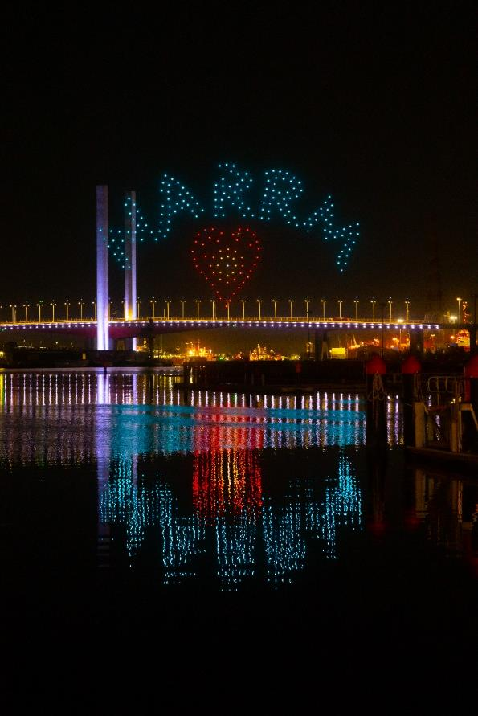
Summer Nights Drone Show in Docklands.
Photo credit: Ray Reyes.
How to contact us
Aboriginal Melbourne –
Reconciliation Action Plan
Telephone:
03 9658 9658
Business hours, Monday to Friday
(Public holidays excluded)
Online:
City of Melbourne website
In person:
Melbourne Town Hall - Administration Building
120 Swanston Street, Melbourne
Business hours, Monday to Friday
(Public holidays excluded)
Fax:
03 9654 4854
In writing:
City of Melbourne
GPO Box 1603
Melbourne VIC 3001
Australia
Interpreter services
We cater for people of all backgrounds.
Please call 03 9280 0726
03 9280 0717 Cantonese
03 9280 0719 Indonesia
03 9280 0720 Italian
03 9280 0721 Mandarin
03 9280 0722 Somali
03 9280 0723 Spanish
03 9280 0725 Vietnamese
03 9280 0726 Arabic
03 9280 0726 Korean
03 9280 0726 Hindi
03 9280 0726 All other languages
National Relay Service:
If you are deaf, hearing impaired or speech-impaired, call us via the National Relay Service: Teletypewriter (TTY) users phone 1300 555 727 then ask for 03 9658 9658
9am to 5pm, Monday to Friday (Public holidays excluded)

https://www.melbourne.vic.gov.au/
https://www.melbourne.vic.gov.au/
https://www.melbourne.vic.gov.au/

