Prior to a permit expiring an email notification will be sent to the applicant alerting them the permit is due to expire and to extend/renew.

If you do not want to extend/renew the permit, please contact the Street Trading Team via https://services.melbourne.vic.gov.au/ask/question, including ‘Street trading’ in the subject and provide your permit reference number.

If you are not extending/renewing an Outdoor dining parklet permit, you will be responsible for having the relevant infrastructure removed.

- How to extend/renew your permit
- How to pay your Tax Invoice
- Frequently asked questions

How to extend/renew your permit

- To extend/renew the permit, click View Permit.
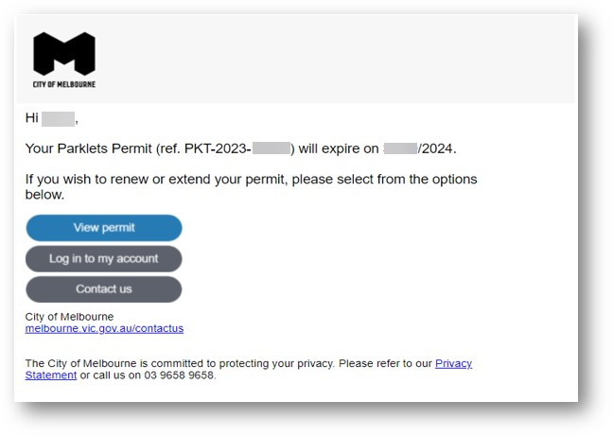

This will navigate you to the City of Melbourne Services page.
- Enter your username, this will be an email.
- Enter your password
- Click Log in
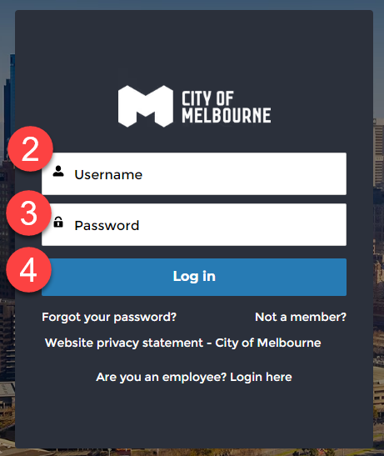
This will direct you to the City of Melbourne Services log-in page and you will be asked to enter a one-time verification code.
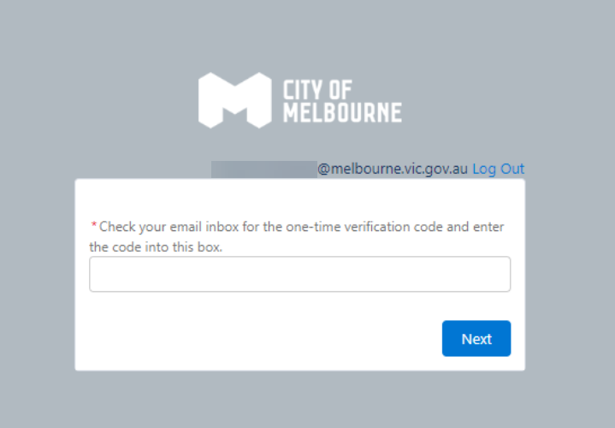

- Go to your email and find the one-time verification code.
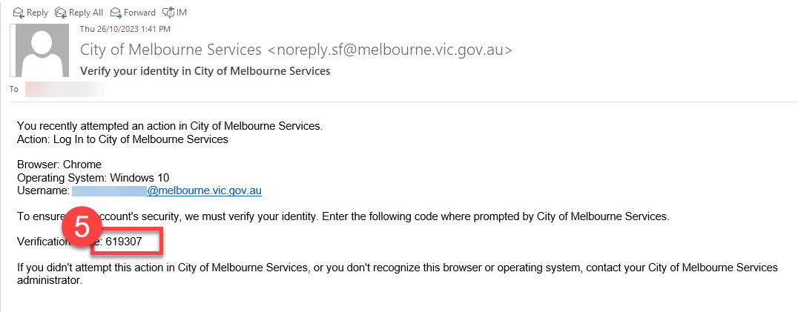
- Return back to the City of Melbourne Services page and enter the code into the box and click Next.
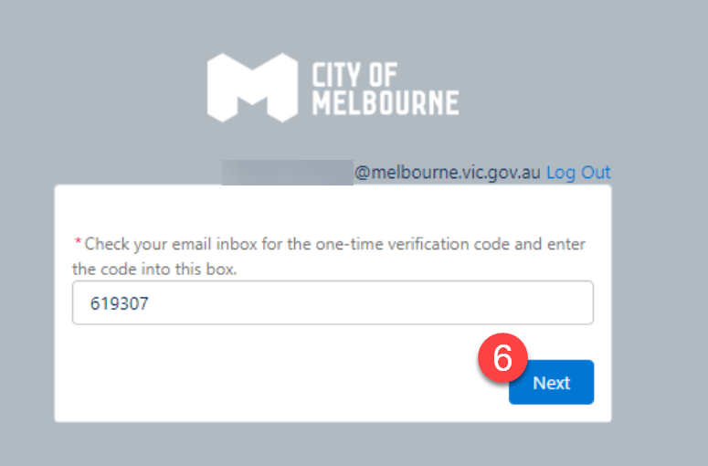

- The existing permit that requires renewal will be shown. To extend/renew the permit, click on , and select Extend/renew permit.
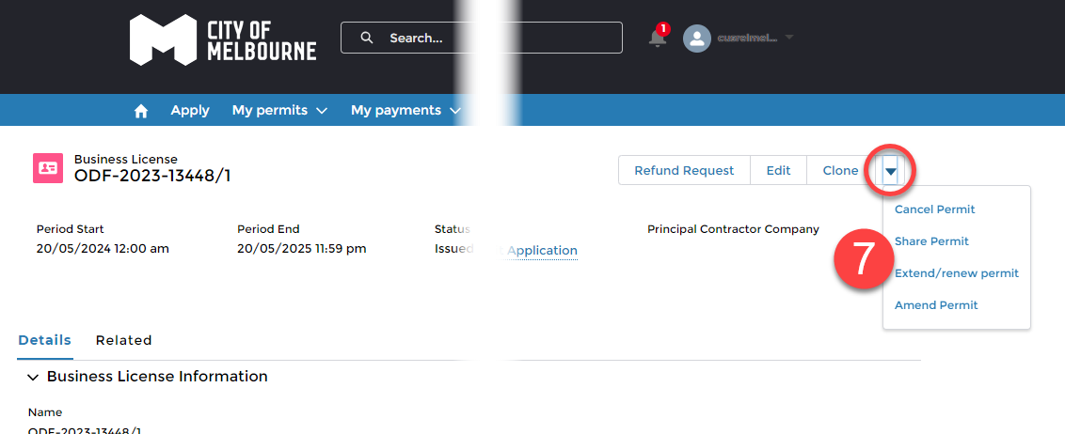
A new tab will open, with a new reference number for the extension/renewal.
- Click here to continue with the process.
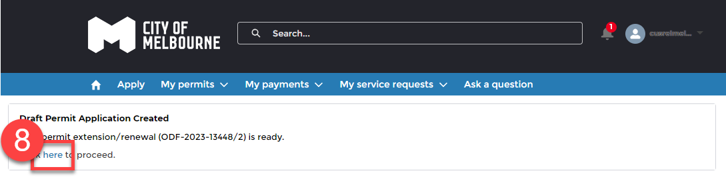
A new tab will open, which will display the new start and end dates of the permit.
- Outdoor dining footpath permits will automatically extend/renew for 12 months.
- Outdoor dining parklet permits will automatically extend/renew for 3 months.

**These dates cannot be modified.

- Click Next.
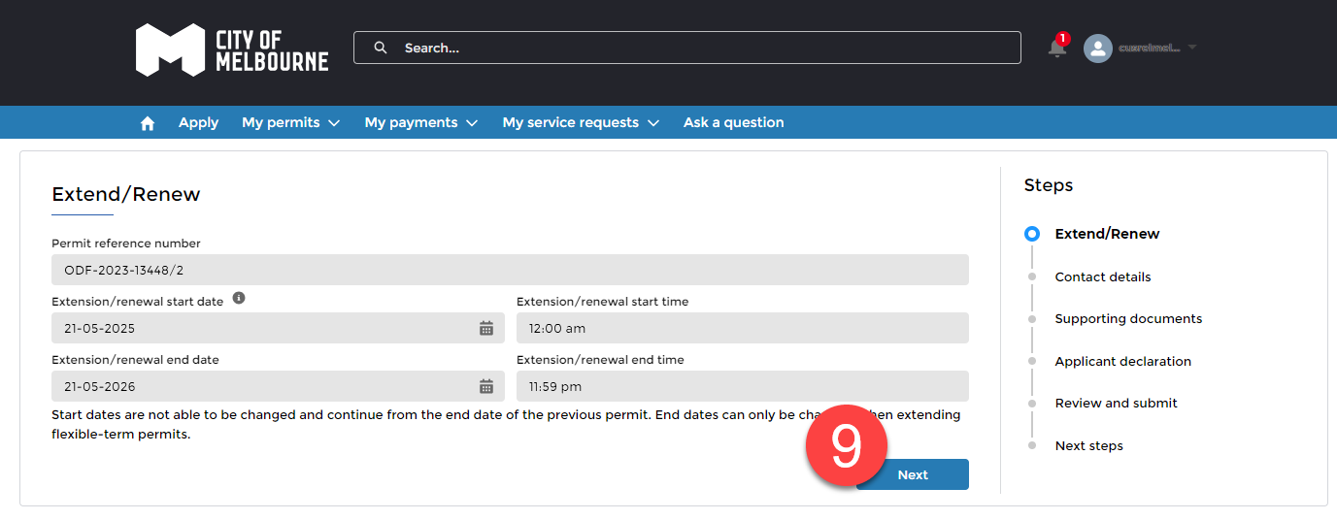
The contact details will be displayed.
- The mobile number can be edited, if required and click Next.
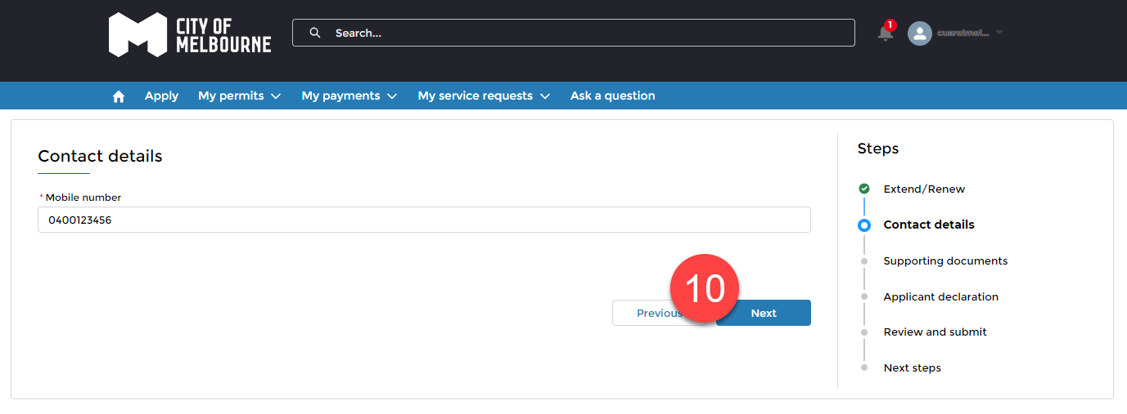
You will be required to confirm and agree to the application declaration.
- Tick the box and click Next.
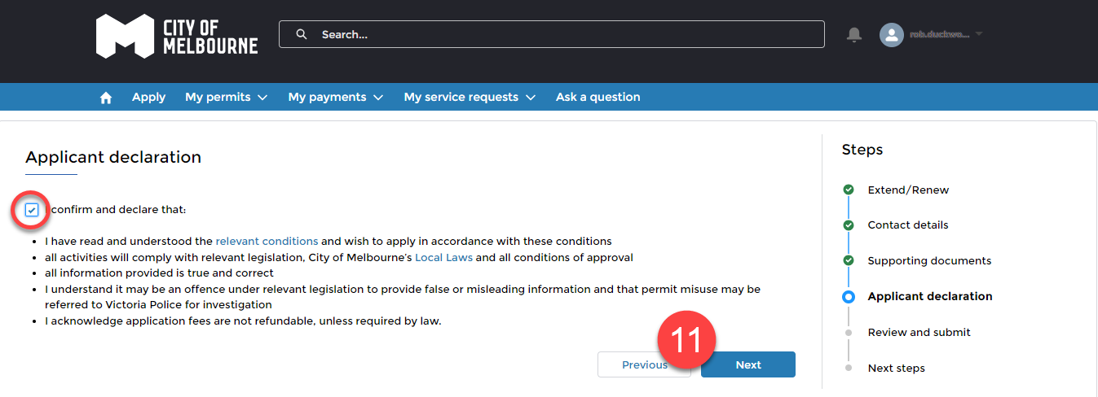

A summary of the fees will be displayed.

The fee summary will vary depending on what the permit is for and the area you are trading in.
For example, if you are extending/renewing an Outdoor dining parklet permit you may be required to pay for footpath rental.

- Click Next.
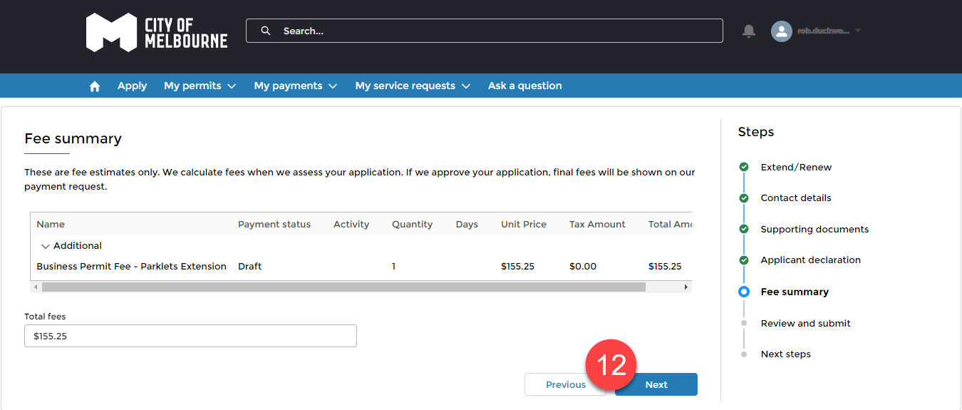
- Review the application and click Submit to lodge the application.
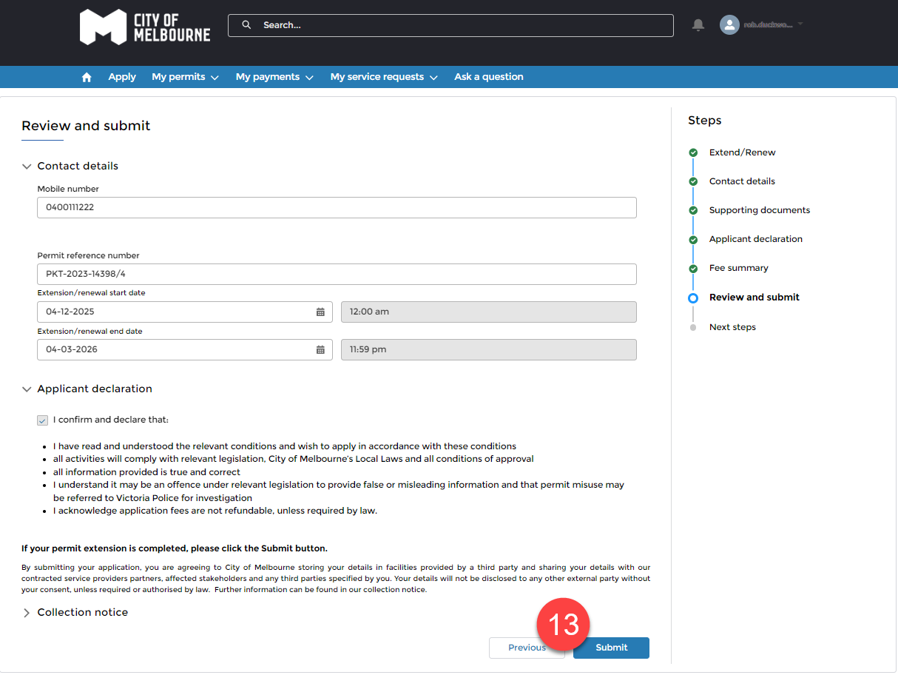
- Your application will be submitted and be sent to the City of Melbourne’s Street Trading Officer to assess the application.
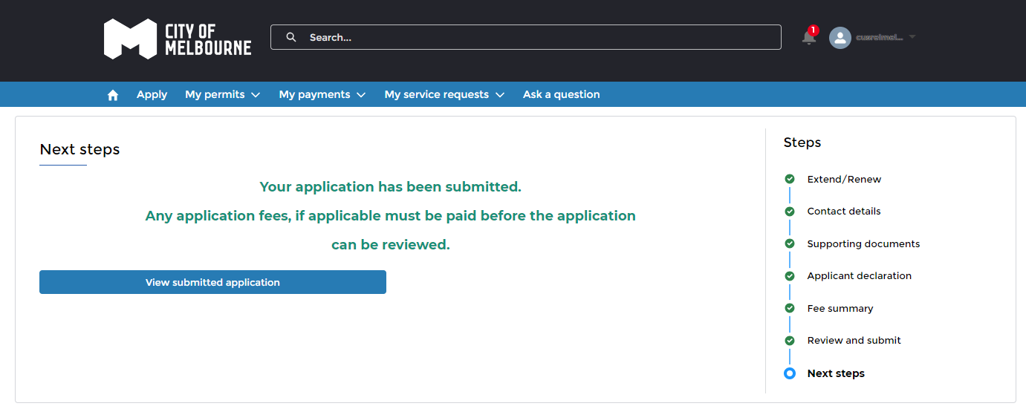
Once the application has been assessed and approved, you will receive a Tax Invoice via email with outstanding payment amounts and options on how to pay.

How to pay your Tax Invoice
A tax invoice will be sent via email to person that is associated to the permit.
- Click Pay Now to pay the invoice.
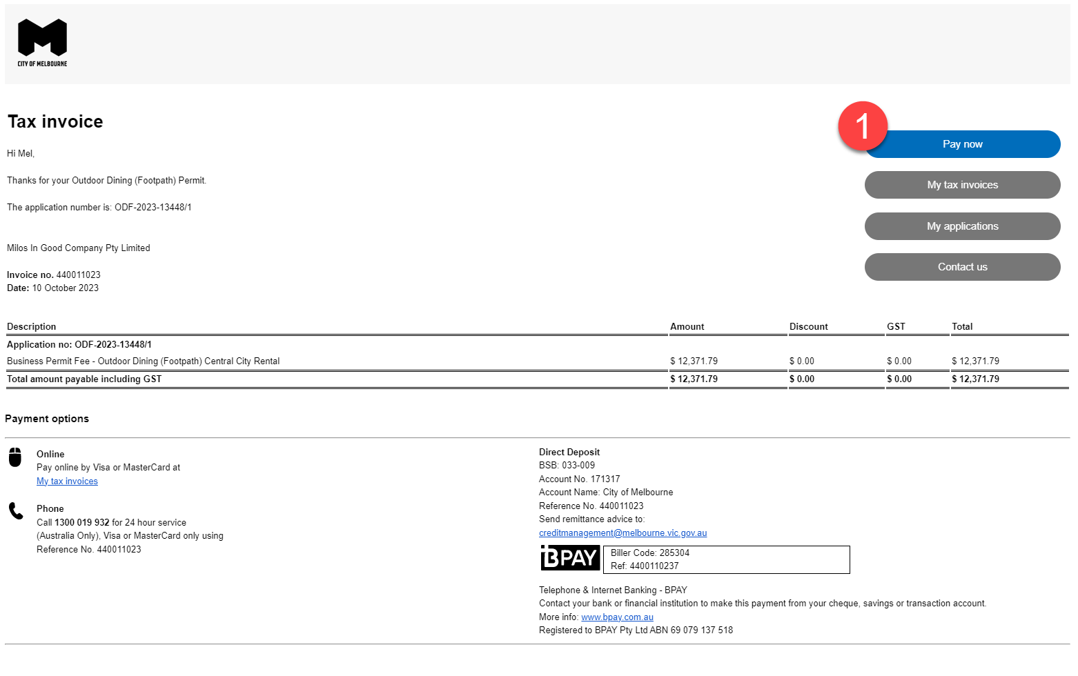
The email can be forwarded to another person/area to make payment. No City of Melbourne Services accounts are required to make payment.
Once the payment has been made, a tax invoice receipt will be sent via email to person that is associated to the permit.
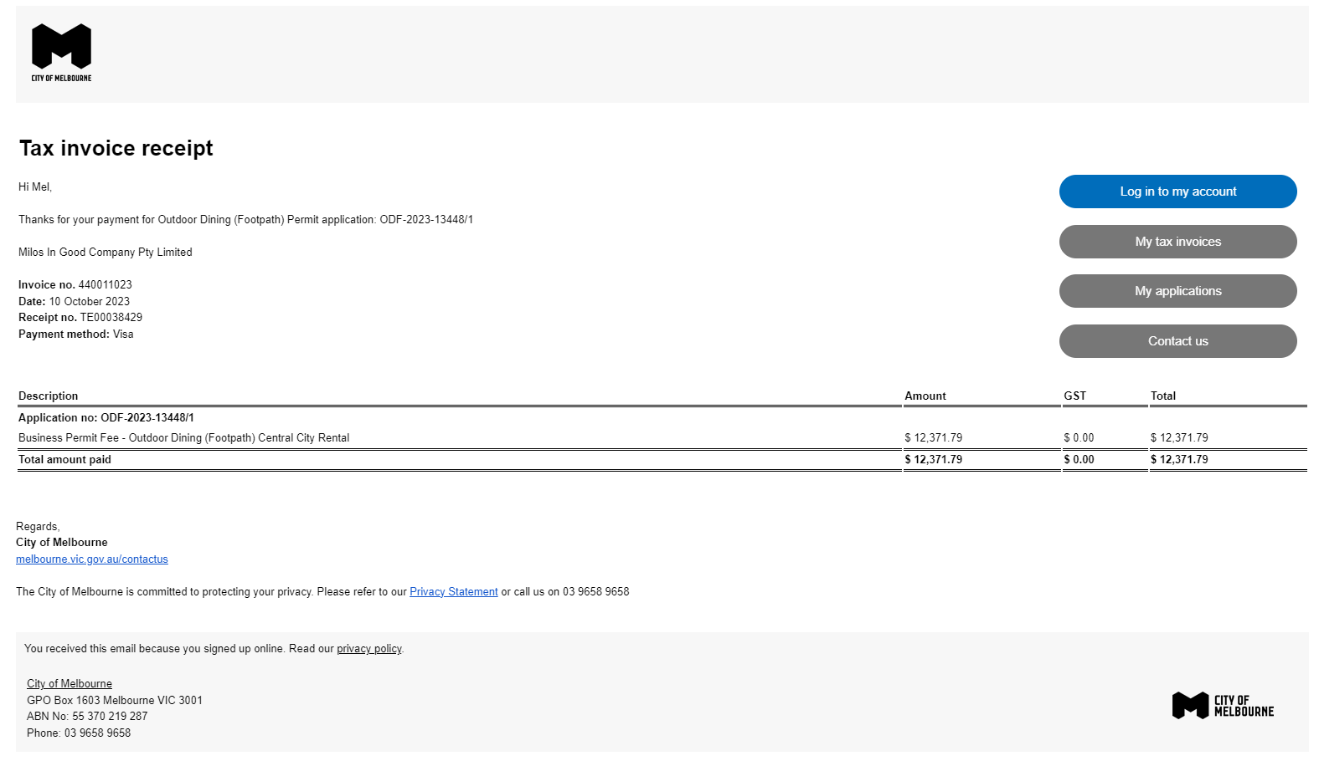

The permit will also automatically be issued and sent to the applicant via email.
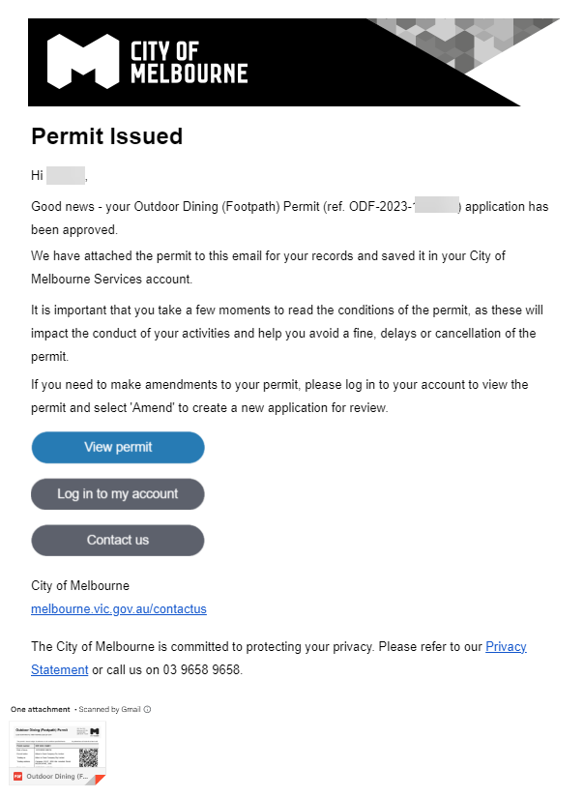

You can also view the permits via your portal.
- Click My permits and My permits.
- Click on the relevant permit number.
- Click on the Related tab, and the permit will be located in Notes & Attachments.
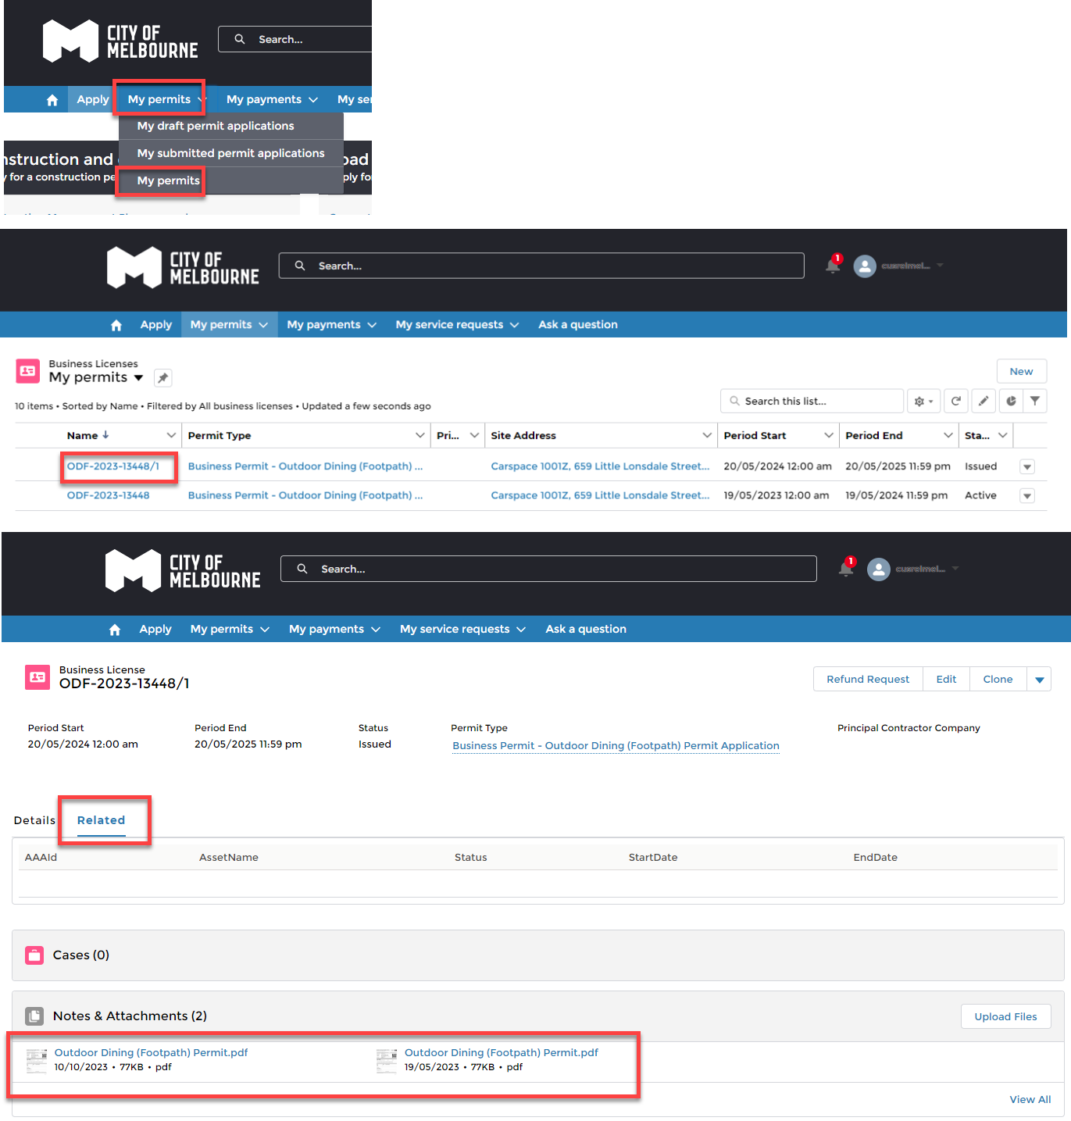

Frequently asked questions
I no longer want/need a permit.
Please contact the Street Trading Team via https://services.melbourne.vic.gov.au/ask/question, including ‘Street trading’ in the subject and provide your permit reference number.

If you are not extending/renewing an Outdoor dining parklet permit, you will be responsible for having the relevant infrastructure removed.

I need to change the contact person listed on the permit.
Please contact the street trading team via https://services.melbourne.vic.gov.au/ask/question, including ‘Street trading’ in the subject and provide your permit reference number, and contact details.

For any updates to the contact person, you will need to provide the following:
- first and last name
- email address

I have recently purchased the business, and I need access to the permit.
If you are taking over a premises with an outdoor dining permit, complete and submit the change of permit holder registration form via https://www.melbourne.vic.gov.au/outdoor-dining-permits .

Before you start, please ensure you have the following information and documents:
- Trading address and existing permit number (if known)
- Your business details, including organisation name, ABN/ACN and any business names your business is known by.
- A copy of your Public Liability Insurance for $20 million, in the same name as the company/organisation applying
- Evidence you have taken over the premises (lease agreement, contract of purchase, etc)

Once we receive the request, we will review the information. If you are eligible, the permit will be amended on your behalf and an application fee payment request will be issued.

Can I transfer a City of Melbourne Services account to another person?
No, accounts are allocated to specific person and cannot be transferred.
If a person is the applicant of the permit, but is no longer at the business, please create a new City of Melbourne Services account. Then contact the Street Trading Team to have the permits transfer to the new person’s name.

Can I give access someone to manage the renewal on my behalf?
Yes you can, however we do not recommend sharing usernames and passwords.
You can provide access to the person by sharing the permit. This allows them to extend/renew the permit.
The person you want to share with must have a City of Melbourne Services account. Accounts can be created via the website https://service.melbourne.vic.gov.au/s/login/
Please note, only people with access to the permit can share it.

To share a permit, please follow the below steps:
- From the City of Melbourne Services portal, click My permits, and then My permits.
- Select the permit number to want to share.
- Click on and select Share permit.
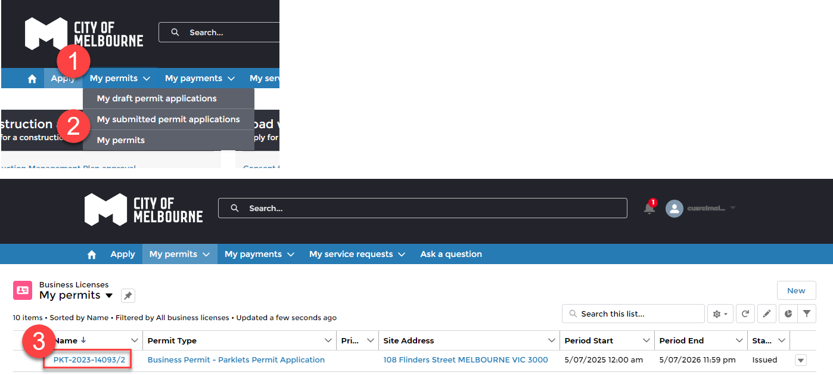
- Enter the first name.  - Enter the last name.  - Enter the email.  - Click on Share. | 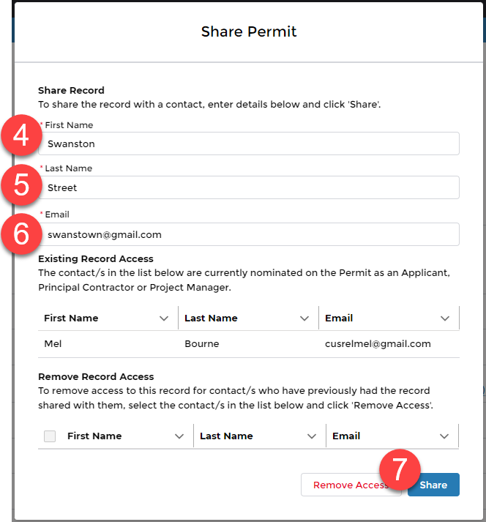
- The person name will appear in the Existing Record Access.  - The person can also be removed via Remove Record Access. | 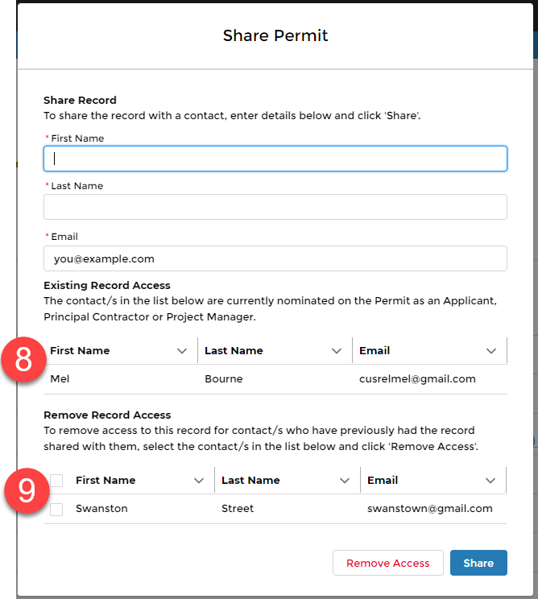

I’ve submitted my extension/renewal, when will I receive my tax invoice for payment?
We aim to process these within 1-2 business days.

Can I pay for the full 12 months for my parklet permit?
If you require a Parklet permit for the full 12 months (sometimes required for a liquor licence), you can request this from the Street Trading Team.
Please contact the street trading team via https://services.melbourne.vic.gov.au/ask/question, including ‘Street trading’ in the subject and provide your permit reference number. Confirm you will pay for the full 12 months.

Can I pay with a direct deposit?
Our preferred payment is via credit card.

If you do not have a credit card, you can submit payment via direct deposit. Please note direct deposits can take up to 1-2 days to transfer.

To pay via direct deposit, please follow the below steps:

- Submit your extension/renewal as per the guide above.
- Once the permit has been approved, you will receive a tax invoice for payment via email with the outstanding amount.
- Transfer the fund using the following bank details.
Account name: | City of Melbourne
Bank: | Westpac Bank - 227 Collins St, Melbourne VIC 3000
BSB: | 033-009
Account number: | 171317
Reference | Include the invoice number (beginning with 4400xxxxxx)
- Email confirmation of payment to creditmanagement@melbourne.vic.gov.au and street.trading@melbourne.vic.gov.au including the invoice number, (beginning with 4400xxxxxx) as a payment reference.

