Acknowledgement of Traditional Owners
The City of Melbourne respectfully acknowledges the Traditional Owners of the land we govern, the Wurundjeri Woi-wurrung
and Bunurong / Boon Wurrung peoples of the Kulin Nation
and pays respect to their Elders past and present. We acknowledge and honour the unbroken spiritual, cultural
and political connection they have maintained to this place for more than 2000 generations.
We accept the invitation in the Uluru Statement from the Heart and are committed to walking together to build a better future.

Council Plan 2021-25

The Council Plan 2021-25 sets out our strategic direction and commitment to the community for the next four years. Based on six strategic objectives for our city, this is our detailed plan for our city’s revitalisation and considers the needs of all people who access and experience the City of Melbourne municipality. For more information visit melbourne.vic.gov.au/councilplan

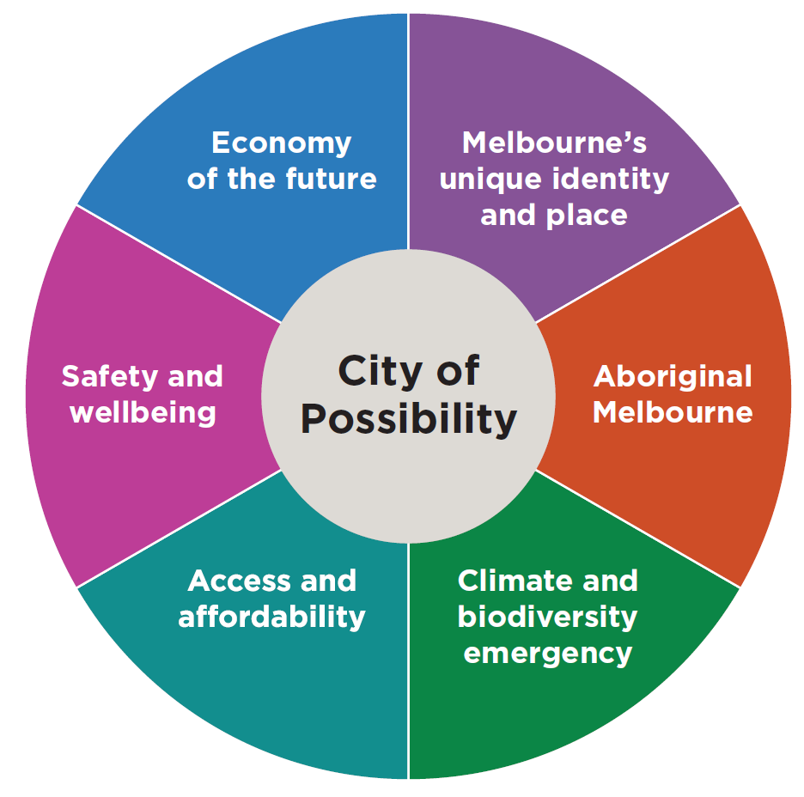

Melbourne’s unique identity and place

Melbourne is a city defined by its places, people and cultures, assets we want to celebrate and protect. Driven by our creative, entertainment and education sectors we will ensure Melbourne remains a unique, vibrant, and creative city with world-leading liveability.

Climate and biodiversity emergency

Melbourne is a city setting the standard on climate action. Prioritising our environment and taking urgent action to reduce emissions and waste is key to protecting public health, strengthening the economy, and creating a city that mitigates and adapts to climate change.

Recognition

We would like to recognise the foundational work of our predecessors in the early 1990s as part of the Postcode 3000 initiative which included the Building Recycling Guidelines for Residential and Mixed Uses (1993). That earlier work has set the platform to shape the refreshed contemporary guidelines and we would like to thank everyone who has been involved.

We would like to acknowledge and thank Tract and Gardner Group for their expert planning and building input, research, and guidance. This has been instrumental in helping shape the new and updated guidelines.

Contents

1. Executive summary 5

2. Introduction 6

3. A path to success 7

3.1 A path to a successful project 7

3.2 Pre-application process 9

4. Important considerations 10

4.1 Building selection 10

4.2 Land use and regulatory controls 11

4.3 Building position and performance 11

4.4 Apartment amenity and design 11

4.5 Environmental Sustainability 12

4.6 Fire safety and construction 12

4.7 Design considerations 12

4.8 Structural considerations 12

5. Planning and design considerations 13

5.1 Planning 13

5.2 Zones and overlays 14

5.3 Proposals to increase the gross floor area of the building 15

5.4 Apartment amenity and design 15

5.5 Sites affected by the Heritage Overlay 21

5.6 Subdivision of a building 22

6. Building and construction considerations 23

6.1 Building principles 23

6.2 Legislative requirements 23

6.3 Change of use 24

6.4 Fire safety – key principles 24

6.5 Fire resisting construction 26

6.6 Provision for escape 27

6.7 Building openings (light and ventilation) 28

6.8 Other building considerations 28

6.9 Consultation with authorities 30

6.10 Construction 31

6.11 Maintenance 31

Appendix A: Building classes 32

Executive summary
City of Melbourne is home to an array of unique buildings that offer a window into the historical heart and soul of Melbourne. However, many of these buildings need new life breathed into them to accommodate the needs of Melbourne today and tomorrow. Adaptive reuse of underutilised or obsolete office buildings into new, functional uses is key to addressing urban and environmental challenges such as climate change, a rise in vacant office spaces in central business districts, and a growing housing shortage.
City of Melbourne's Commitment
We recognise the complexities associated with assessing feasibility, design challenges, and regulatory approvals for adaptive reuse. Our aim is to support and guide you through these processes to ensure successful outcomes. The Guidelines for the Adaptive Reuse of Office Buildings (The Guidelines) are designed to assist building owners in the initial phases of assessing building feasibility against current planning and building regulatory requirements, and encourage engaging with the right professionals early in the project including with the City of Melbourne. Our goal is to streamline the planning approvals process and offer guidance on innovative and sustainable design features.
The Guidelines encourage best practice adaptive reuse projects, complementing the Retrofit Melbourne Plan published in 2023 that encourages the retrofit of commercial buildings in the central city and thereby reducing their environmental impact.
How to Use This Document

The Guidelines are broken down into four sections. Section 3 outlines the steps to consider towards a successful adaptive reuse project from project inception to completion. Section 4 summarises the key design, planning and building considerations when assessing the feasibility of your building for adaptive reuse. Further details and links to resources can be found in Sections 4 (Design & Planning) and 5 (Building).
- Building Owners: Use this document to assess your property’s potential for adaptive reuse, understand the planning and regulatory landscape, and explore how to engage with our design and planning teams.
- Architects, Developers, Planners and Building Surveyors: Refer to this guide for detailed considerations on building selection, design, and regulatory compliance. It will help in aligning your project with current standards and identifying areas for flexibility.
Importantly, the Guidelines are not intended to dictate outcomes or diminish design approaches. The Guidelines instead establish a framework within which adaptive reuse projects can innovate. By embracing adaptive reuse, we can collectively address urban challenges, enhance sustainability, and improve quality of life in our cities. We look forward to collaborating with you on this transformative journey.

Introduction
In the 1990s, the City of Melbourne experienced a dramatic increase in its residential population within the central city from approximately 1,000 to more than 50,000. To accommodate this growth, the city embraced adaptive reuse as part of the housing solution that saw the conversion of multiple old or low-grade office, commercial and industrial buildings into residential buildings.
Much has changed since the 1990s. Melbourne now hosts close to 180,000 residents supported by a residential development boom. The forecasts show by 2041 the number of people living in the City of Melbourne is expected to reach over 308,000. Like other parts of Australia and around the world, Melbourne is also facing a housing shortage, requiring all tiers of government to respond to the challenge.
Melbourne’s office market has remained very strong with millions of square metres of new office towers being added. However, the way we work has shifted in recent times with an increase in office vacancies and a demand for new premium and A-grade sustainable office spaces.
Furthermore, over 60% of the buildings in the central city are now more than thirty years old and in need of renewal strategies that minimise environmental impact, respond to market demand and the housing shortage. Many of these existing buildings are inefficient and 60% of emissions in the city are generated by commercial office buildings. As a result commercial buildings, particularly mid-tier scale and grades are no longer deemed market attractive or fit-for-purpose.
Adaptive reuse of old or low-grade office, commercial and industrial buildings into residential buildings is one lever among many that can address housing shortages, office vacancies and environmental sustainability. Adaptive reuse also offers owners the opportunity to revitalise older buildings to current standards, employ innovative and sustainable design principles that save on operating costs and increase marketability. Cities around the world such as New York and London are embracing this concept with much success.
The City of Melbourne is a strong supporter of adaptive reuse projects encouraging building owners to transform and retrofit buildings in the CBD to reduce their carbon emissions and propel the municipality towards the ambitious goal of net zero emissions by 2040. It is estimated that 80 buildings will need to be retrofitted each year to meet the highest national standards for environmental performance and energy efficiency and achieve net zero emissions by 2040.
In the words of the former president of the American Institute of Architects, Carl Elefante, “The greenest building is the one that already exists.” Adaptive reuse of older building stock offers up one of many solutions towards the City of Melbourne achieving its objective towards increasing housing stock in a environmentally sustainable manner.
Recognising that each building project is unique and will require a tailored approach, we have developed the Guidelines alongside a comprehensive planning and building pre-application service to help proactively facilitate adaptive reuse developments. The Guidlines are designed to align and complement the Retrofit Melbourne Plan and assist owners of commercial office spaces in navigating some of the key planning and building considerations that would form part of your adaptive reuse project.

3. A path to success

3.1 A path to a successful project
Embarking on a successful adaptive reuse project starts with undertanding what might be possible.

Initially, gathering key information and conducting a detailed feasibility study to evaluate the building's condition and architectural integrity, energy performance, zoning requirements, and potential market demands is crucial.

Engaging the right consultant team early, which could be made up of architects, planners, building surveyors, engineers and other specilaists will fast track feasability and design, while engaging with Council and other service authorities will facilitate alignment of project goals and ensure regulatory compliance.

A tailored pre-application service is available to ensure you receive the right information and guidance (refer section 3.2 for more information). This includes acess to council planners, building surveyors, urban designers and environmentally sustainable design officers.

This may also be an opportune time for the project to be refered to the Melbourne Design Review Panel (MDRP) who provide expert design review advice for significant projects. This collaborative review process is an opportunity to seek feedback on adaptive reuse designs and hear from experts and design professionals including architecture, landscape architecture, urban and sustainable design.

Figure 1 outlines the various steps we encourage owners and developers to navigate as part of the approval process.

Once approvals are obtained and construction has commenced, regular inspections and quality assurance measures help maintain standards and mitigate risks.

Upon completion of the project, post-completion activities, such as monitoring energy performance and gathering feedback from occupants, contribute to the project's long-term success and its positive impact on the community.

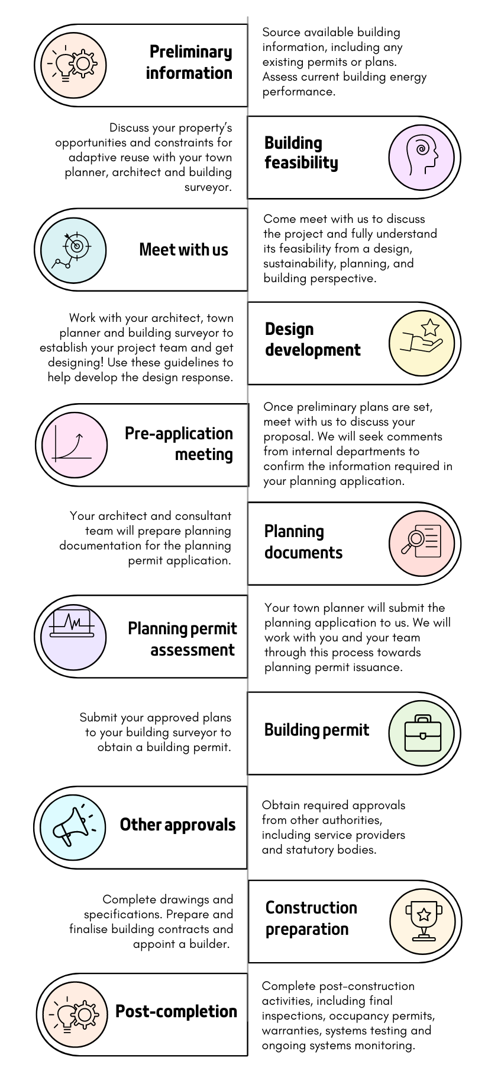

Figure 1. Steps to consider as part of your adaptive reuse project.

3.2 Pre-application process

It is important to determine early on whether your adaptive reuse project is worth pursuing.
We’ve created a specialised pre-application process that gives you priority access to our senior planning and building officers for guidance on your project.
Early conversations with us will help you understand the rules and important considerations, which are vital for determining if your project can move forward. Having clear guidance upfront will provide a faster experience and will help define the project scope.
While we will do our best to address as much as we can, please keep in mind that pre-application meetings may not cover every detail included in the formal assessment stage once you submit your application.
To help us provide you the best guidance, please provide as much information as you can before the meeting and bring along any relevant information.

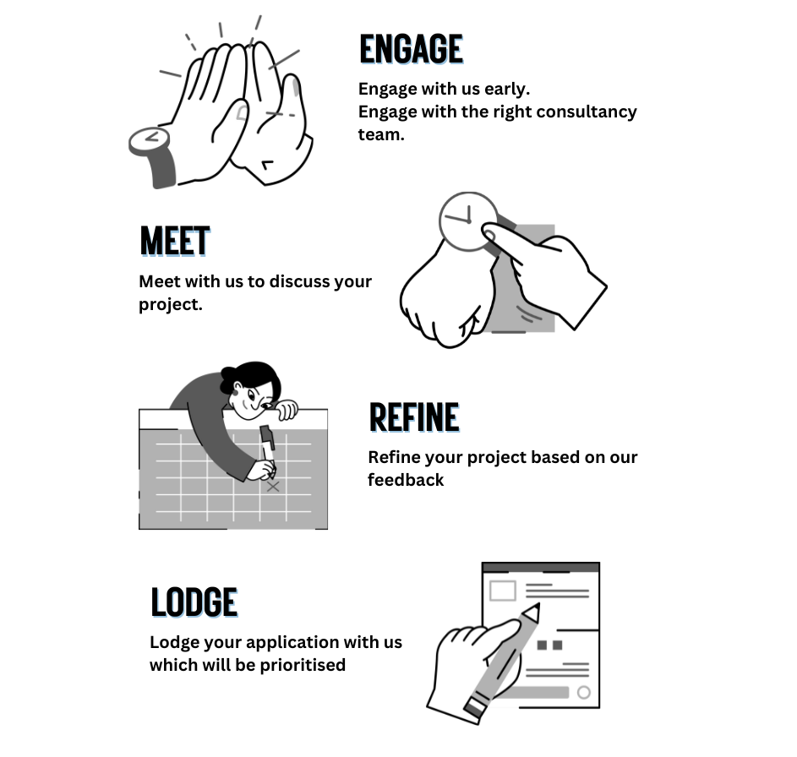

4. Important considerations

There are many important benefits, opportunities and considerations when converting unused or low use commercial buildings into accommodation.

Responding to housing challenges and market demands, maximising the economic potential of the building, enhancing community dynamics and reducing environmental impacts are just a few. However, it also requires careful planning and navigation of planning and building regulatory requirements to ensure a successful project.

When considering whether your building is suitable for adaptive reuse, there are several factors that need to be considered, such as apartment amenity, environmental sustainability and land use and regulatory control (Figure 2). In sections 5 and 6, you can find further detailed infomation on important considerations.

4.1 Building selection
Choosing the right office building for adaptive reuse is an exciting proposition that takes an existing structure and transforms it to meet new needs.
Unlike new construction, adaptive reuse repurposes existing buildings, optimising their use, enhancing sustainability, and preserving architectural heritage. When considering the suitability of your building, factors like location, structural integrity, historical significance, and zoning regulations play pivotal roles in decision-making. The goal is to creatively reimagine spaces, turning old offices into vibrant hubs for residential and mixed-use purposes, enhancing city life.
Buildings with good structural integrity and flexible layouts often offer easier adaptability. Buildings in strategic urban areas such as the central city can capitalise on existing transport infrastructure and reduce environmental impact.
We recommend engaging with a team of consultants with specialised expertise in all design disciplines at the project’s inception to test and guide the suitability of your building and its viability for an adaptive reuse. This will also help to navigate the planning and building processes in an efficient and effective way.

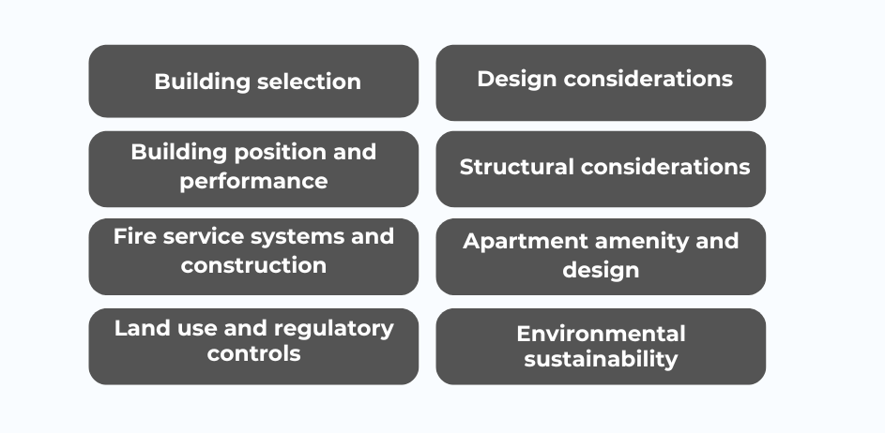
Figure 2. Factors under planning and building regulations to consider as part of your adaptive reuse project.

4.2 Land use and regulatory controls
Zoning rules and overlays guide how your land can be used and developed. They also specify if you need a permit for your development, what information you need to provide with your application, and what factors that will be considered when reviewing your proposal. More information on the planning process, zones and overlays can be found in sections 5.1, 5.2 and 5.3.
Overlays add extra requirements for standards relating to the environment, landscape, heritage, flooding and building design. More detailed information is available in sections 5.2 and 5.5.
Subdividing the building to create apartments for sale introduces further requirements that need to be considered early, as design choices can affect amenities like common property and easements for services. More information on this process is available in section 5.6.
Buildings must also be safe to live in. Projects will be considered against the Victorian building regulatory framework and National Construction Code (NCC). Understanding how the framework and Code relate to adaptive reuse projects is important and is detailed in section 6.

4.3 Building position and performance
The position of the building, also known as siting, and the size of the floor plate is largely fixed. While this can be restrictive, it can present an opportunity for clever design. The design should consider whether the building can accommodate appropriate ground level street interfaces, building entrances, the location of car parking areas and vehicular access (if applicable), and building orientation.
While building positioning can also affect environmental sustainability objectives, adopting innovative design can maximise energy efficiency, performance and reduce ongoing operating costs. Innovative design can also support contemporary waste management and recycling and facilitate integrated water and stormwater management.
High performance building facades are a key characteristic of successful adaptive reuse projects both here in Australia and globally, as they offer optimised internal environmental quality and occupant comfort and lower ongoing operational and maintenance costs. For further information, please see the Central Melbourne Design Guide (DD01).
Introducing appropriate building openings, communal spaces, winter gardens, roof top gardens, planter boxes, shared daylight and other measures can assist with meeting planning requirements and maximising the use of space. Our Green Factor Tool, a free online green infrastructure assessment program, can help you implement the new standard for green infrastructure.

4.4 Apartment amenity and design
Apartment design and liveability of adaptive reuse projects is considered through the Better Apartment Design Standards (BADS) and Liveable Housing Design requirements. When planning your project, important aspects of apartment design to focus on include making sure apartments are easy to access, have private outdoor areas, spacious living and bedroom areas, well-placed windows for natural light and ventilation, and access to daylight.
It is also important to consider your adaptive reuse project against the Central Melbourne Design Guide. The guide serves as a comprehensive tool with design dos and don’ts relating to urban structure, site layout, building mass, building program, public interface and design quality.
Section 5.4 outlines the BADS considerations and where flexibility can be applied to help facilitate your project while section 6.8.5 outlines the relevant Liveable Housing Design requirements.

4.5 Environmental Sustainability
The City of Melbourne is committed to reaching net zero emissions by 2040. Existing commercial building stock accounts for 60% of the city’s carbon emissions, and adaptive reuse proposals are uniquely positioned to contribute to zero emissions targets.
Environmentally Sustainable Design (ESD) forms part of key considerations across both the planning and building processes with more detail available in sections 5.4.2 and 6.8.8. We can assist by providing guidance to help you understand what improvements can be made to the building’s environmental performance as part of the project and help you to meet the required ESD standards. This includes improvements to thermal comfort, air quality and the reduction of operating costs for future occupants.

4.6 Fire safety and construction
Fire service systems ensure the safety and compliance of buildings to meet fire safety regulations. These systems are designed to detect fires early, alert occupants, and facilitate safe evacuation in the event of an emergency.

Changing the use of a building through adaptive reuse will require changes in the fire service systems. Apartment buildings require more advanced smoke detection and occupant warning systems than office buildings.

It’s important to consider this early to ensure they are carefully integrated to align with the building's new use and layout (more detail is available in section 6.4).

It’s also important to design the internal layout to prevent or delay the spread of fire, and to provide appropriate exits and travel distances to ensure the building occupants are safe. Further information can be found in sections 6.5 and 6.6.

4.7 Design considerations
City of Melbourne hold aspirations towards maintaining Melbourne's global reputation as a design city. The Design Excellence Program promotes the value of excellent design across Melbourne’s built environment. Every new building and public space has the potential to improve our quality of life, attract investment and elevate the city’s reputation as a design city.

The Design Excellence Advisory Committee provides Council with strategic advice. The Melbourne Design Review Panel (MDRP) provides free and independent expert advice on proposed developments.

4.8 Structural considerations
Assessing the building's structural capacity to support new uses will be important and may require strengthening or retrofitting to meet safety and durability standards.

Medium and high-rise buildings will require consideration of wind and earthquake impacts as historically many older buildings have not been designed to meet current standards. Early engagement with appropriately qualified structural engineers is critical to determining the viability of any reuse project. Further information can be found in section 6.8.1.

The change in use will also require acoustic separation between apartments and common or public spaces to maintain amenity. This should be incorporated into the design early (see section 6.8.7 for further information).

Finally, and where relevant, you will need to check the external cladding of the building to ensure it is not combustible and meets current requirements.

5. Planning and design considerations

This section provides an outline of the key planning frameworks and statutory considerations regarding adaptive reuse projects. This includes amenity and design, relevant heritage considerations, and the building subdivision process.

We will work with you to determine the planning opportunities and constraints to your site. Apartment layout, amenity and design considerations will guide the suitability of your building and assist you in delivering a quality apartment product.

Planning
Approvals will be required to convert existing office buildings to residential use, and this section briefly describes the town planning process as it applies to office-to-residential conversions.

5.1.1 The role of the Adaptive Reuse Guidelines in planning applications
The Melbourne Planning Scheme sets out the planning controls and policies that apply across the City of Melbourne. It sets out policies for the use and development of land including the protection and conservation of heritage buildings and the city’s environmentally sustainable design aspirations.
These guidelines provide building owners and developers with practical guidance to support the conversion of existing commercial buildings to residential use, but they do not override the provisions of the Melbourne Planning Scheme or the Planning and Environment Act 1987.
Key principles that underpin the planning assessment of adaptive reuse proposals include:

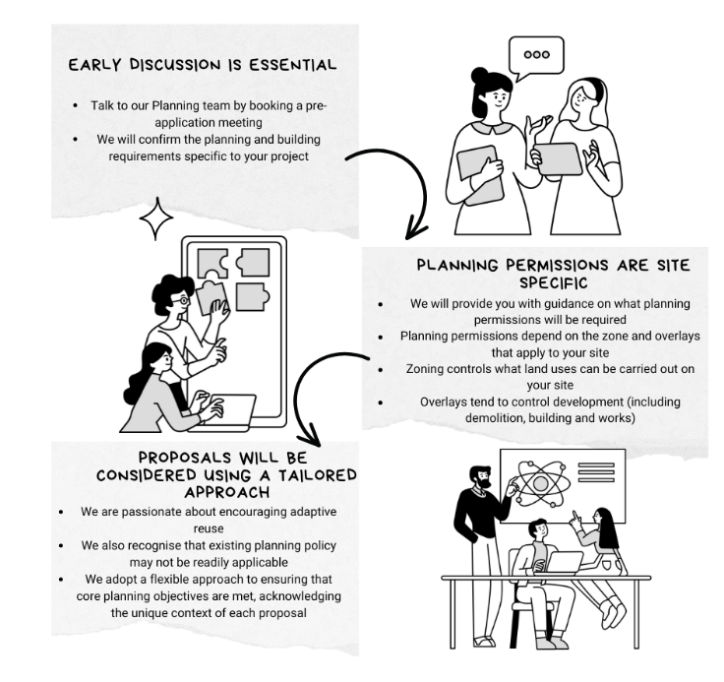

5.2 Zones and overlays
The planning permit requirements are determined by the zones and overlays that apply to the site.
Zones apply to all land across Victoria and nominate the uses which are permissible on the land. They also specify requirements relating to development and subdivision of land or buildings. Zones outline particular application requirements and detail the matters which the decision maker must consider in assessing an application.
Overlays typically identify requirements relating to the development of land including the construction of a building. Unlike zones, not all land is affected by overlays. Overlays can specify environmental, landscape, heritage, built form, land management or other requirements in addition to those set out by the zone.
The section below includes an outline of the zones that apply throughout the City of Melbourne.
We have not included detail on the various overlays (with the exception of the Heritage Overlay), noting that there are dozens of overlays with specific requirements that can vary considerably from site to site. The specific requirements of overlays applying to your site can be discussed with our staff or your planning consultant.

5.2.1 Zoning within the City of Melbourne
Land within the City of Melbourne can most readily be categorised by its zoning:
- Land within the Capital City Zone (CCZ) or Docklands Zone (DZ) - This includes Docklands, the Central Business District, City North, Southbank, the Fishermans Bend Urban Renewal Area, and the Melbourne Arts Precinct.
- Other land – This includes all other land which may be in a commercial, residential, mixed use or industrial zone.
You can search your property on the Department of Transport and Planning’s website to identify the zoning and overlays affecting the land. This also includes links to the relevant Planning Scheme provisions.

5.2.2 Land in the Capital City Zone or Docklands Zone
There are seven schedules each to the CCZ and the DZ which work to break these large areas up into smaller precincts where specific land use and development outcomes can be facilitated through tailored planning controls.
This means that each schedule will have a different approach to land use. In some of these precincts no planning permission will be required to use the land for dwellings, and in others a planning permit will be required. Importantly, there are no areas within the CCZ and DZ where it is prohibited to use land for a dwelling.
Within the CCZ (other than in CCZ6) a planning permit will also be required to demolish or remove a building or works.
On all CCZ and DZ land, approval will be required for buildings and works (including internal works and rearrangement) associated with use of the land for a dwelling.

5.2.3 Land in other zones
Other land throughout the municipality is subject to a broad range of zones, with each of these having their own purpose, land use controls, and application requirements.
Planning permissions will vary throughout these different areas, so we encourage a conversation with our team early to clarify applicable considerations. In some instances, it is prohibited to use land for dwellings such as in the Commercial 2 Zone, Industrial 1 Zone, and Industrial 3 Zone.
In all cases, planning approval will be required for buildings and works (including internal works) associated with use of the land for a dwelling.

5.3 Proposals to increase the gross floor area of the building
In some instances, there may be an opportunity to increase the gross floor area of the building by increasing the building height or decreasing building setbacks. This will largely be dependent on the zone and overlays that apply to the site, with some planning controls imposing mandatory maximum building heights, setbacks, and floor area ratio requirements.
Where there is flexibility provided by the planning controls, we understand that increasing the building height may assist in the feasibility of the project and encourage you to consider how building additions can also improve the amenity of the dwellings (such as through the provision of outdoor communal spaces, balconies and the like).
Our Planning and Building Department or your planning consultant can confirm whether changes to the building envelope are possible, and your building surveyor can advise on building permit implications.

5.4 Apartment amenity and design
It's crucial to make sure that the homes created from adaptive reuse projects are functional and attractive to future occupants. The Better Apartment Design Standards (BADS) are rules that apply across the state for designing apartments. When planning your project, important aspects of apartment design to focus on include making sure they are easy to access, having private outdoor areas, spacious living and bedroom areas, well-placed windows for natural light and ventilation, and access to daylight.

5.4.1 How the Better Apartment Design Standards apply to adaptive reuse proposals.
Converting an existing building to residential use requires consideration of the BADS. BADS applies to apartment developments and provides guidance for the design of homes which are appealing, comfortable, sustainable and fit-for-purpose.
These design standards are implemented through provisions in Victorian Planning Schemes depending on the development context (Table 1). The sections below set out the key elements of the BADS that will need to be considered when assessing the amenity and design of proposed apartments in line with planning policy, while recognising the unique conditions of office-to-residential conversions. Each section is intended to align with those key apartment design standards for consideration in adaptive reuse projects.

Dwelling diversity
Apartment developments should provide a range of dwelling sizes and types to cater to a diversity of household types. This should include dwellings with a different number of bedrooms and apartments which are capable of being adapted over time to meet the changing needs of families.

Private open space
The provision of adequate private open space for the recreational and service needs of residents is important in apartment developments. Retrofitting an existing building to provide balconies, however, can be difficult and result in poor urban design outcomes. With this in mind, we welcome alternative responses to the requirements of the BADS as they relate to private open space.
In place of bolt-on balconies or alternatives which project from the existing building envelope, consider opportunities for wintergardens which make the most of the deep floorplates of existing buildings while providing light-filled, open, and weather protected private open spaces.
Relevant Clause | Applies to
Clause 55.07 | - Apartment developments up to 4 storeys in height within the Neighbourhood Residential Zone (NRZ), General Residential Zone (GRZ), Residential Growth Zone (RGZ) and Mixed-Use Zone (MUZ)  - Generally, these zones apply to land outside of the Central City
Clause 58 | - Apartment developments of any height within the Capital City Zone (CCZ), Commercial 1 Zone (C1Z), Special Use Zone (SUZ) and Docklands Zone (DZ), and to developments of five or more storeys within the RGZ

Table 1. Relevant apartment development provisions of Victorian Planning Schemes

Communal open space
Apartment developments should provide integrated communal open space which meets the recreation and amenity needs of residents. For developments of 10 or more dwellings, a minimum of 30 square metres of outdoor communal open space should be provided. Additional internal communal open space should also be provided in accordance with the standard.
As the site layout is largely predetermined by the existing building orientation, we understand that it may be challenging to meet the BADS Standard for solar access to communal open space. In these cases, we will consider variations to the solar access requirements provided it can be demonstrated that the communal outdoor open space area achieves appropriate usability and amenity.
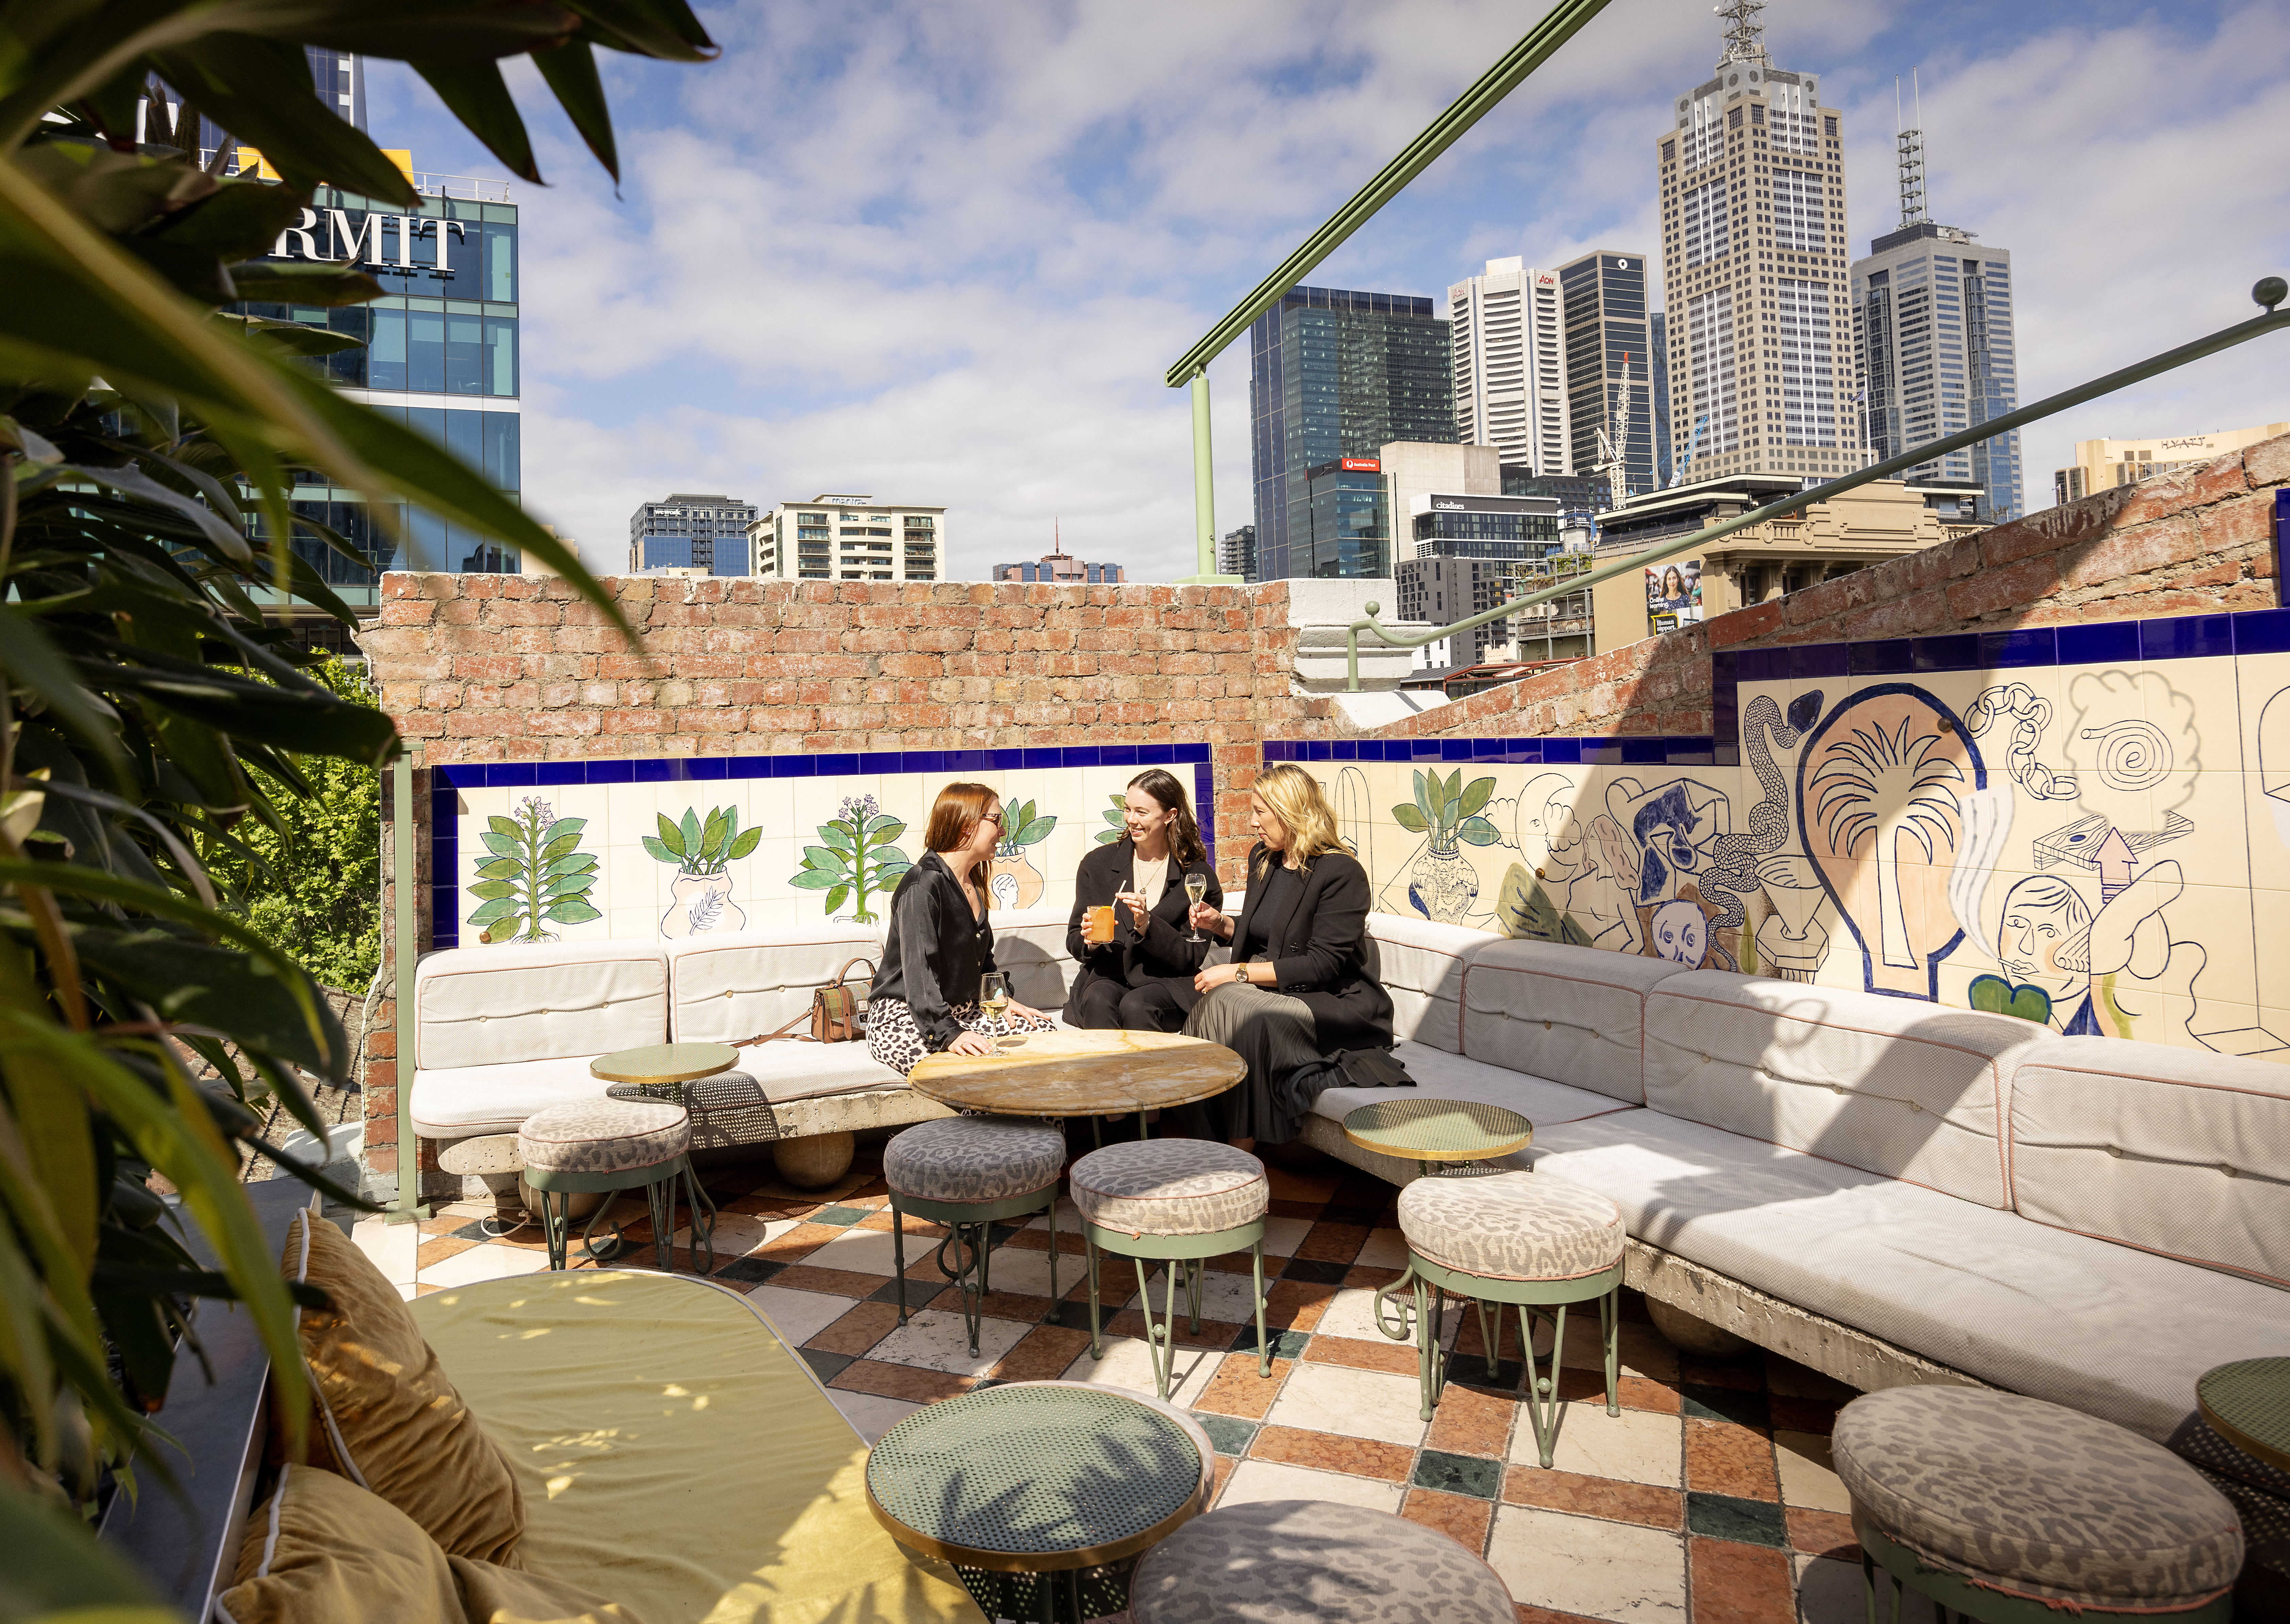

Landscaping
BADS seeks to support the provision of new canopy cover through climate responsive landscaping that supports biodiversity, wellbeing, and amenity, and reduces urban heat. Landscaping can also play an important role in softening the visual impact of buildings on the streetscape.
Achieving the deep soil requirements specified by BADS can be challenging in adaptive reuse projects, particularly where the existing building footprint covers all or most of the site area. However, there are many opportunities to incorporate landscaping through alternative means such as planter boxes, green walls, and rooftop gardens.
The City of Melbourne’s Green Factor Tool can assist proponents in the delivery of green infrastructure to improve the vegetation cover of their development. Also, you can apply for a grant through the City of Melbourne’s Urban Forest Fund matched-funding grant and the Green Your Laneway program for your greening efforts as part of your adaptive reuse project.

Integration with the street
Good urban design is of great importance to the City of Melbourne. Improving a building’s integration with the street is important in achieving a vibrant, attractive public realm, which in turn promotes walking, cycling and public transport use. In converting an office building to a residential use, active frontages at the ground floor level should be protected and enhanced. Of course, this needs to be contextually responsive having regard to the building’s location and existing streetscape character, as well as any other built form controls which apply to the site. Early discussions with us will assist with determining expectations responding to the building’s integration with the street.

Energy efficiency
Planning seeks to promote apartments which provide thermal comfort, offer amenity through good daylight access, and help reduce energy consumption and cost through considered design.
While building orientation is set, opportunities exist to retrofit buildings to achieve and enhance energy and thermal efficiency. When considering apartment design for energy efficiency in an adaptive reuse project, proponents should maximise opportunities for solar access to living areas and private open space.
Straightforward and cost-effective opportunities for improving a building’s energy performance could include:
- replacing windows with double-glazed, operable windows
- implementing appropriate ventilation
- reducing / increasing the extent of glazing where needed and implementing shading devices
- ensuring airtightness and insulation.
Apartment building common areas can benchmark their operational energy performance using the National Australian Built Environment Rating System (NABERS) for Apartment Buildings rating tool.
Maximum cooling load requirements should also be considered to ensure dwellings achieve adequate thermal efficiency using the Nationwide House Energy Rating Scheme (NatHERS).

Waste and recycling
Effective waste management in apartment developments is integral to ensuring that recycling is promoted, the environment is protected, and health and safety is supported.
In addition to ensuring an adaptive reuse project addresses the requirements of the waste and recycling standards, we provide clear guidance on anticipated waste generation rates, and collection frequencies. In developments of more than 250 apartments, a compactor is required – this should be factored into proponents’ review of candidate buildings.
Refer to the City of Melbourne’s Guidelines for Waste Management Plans for further guidance.
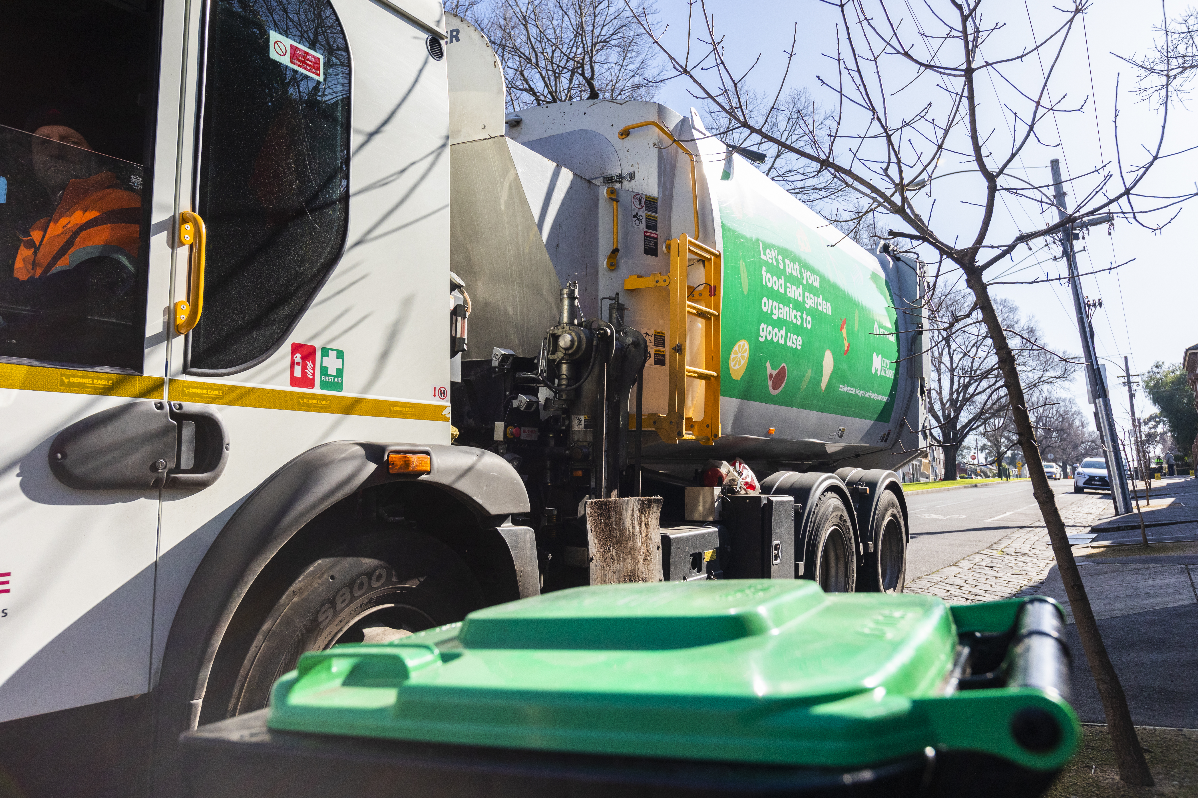

Integrated water and stormwater management
In converting an office building, an integrated water management system will be essential. Overlapping with the overarching Environmentally Sustainable Design (ESD) initiatives across the municipality, adaptive reuse projects should demonstrate compliance with current best practice performance objectives for stormwater quality. This includes rainwater collection and recycling, to be used for non-drinking purposes, and reducing stormwater runoff.

Functional layout
The BADS provide clear guidance on minimum room sizes, to ensure that the apartment building provides functional and adaptable dwellings. A benefit of the large floor plates of office buildings is that the minimum room dimension requirements as set out by BADS should be readily achievable in adapting these buildings for apartments.

Room depth
BADS specifies room depth requirements with a view to protect internal amenity for future residents by providing adequate daylight. Typically, single-aspect habitable rooms should not exceed a room depth of 2.5 times the ceiling height. Habitable rooms with a ceiling height of at least 2.7 metres above finished floor level can have a room depth up to 9 metres, measured from the external surface of the habitable room window.
Depending on the candidate building, ceiling heights may be higher than what would typically be expected for an apartment building. Equally, in installing new infrastructure to service apartments as part of the building conversion, ceiling heights of 2.7 metres above finished floor level may be difficult to maintain. In these cases, we will work with you to explore opportunities to vary the standard while ensuring that adequate daylight to these rooms is still achievable.

Windows
Windows need to be provided to habitable rooms of apartments to support access to natural daylight, direct sunlight, and airflow. The deep floor plates of office buildings can make it difficult to provide direct access to windows for every habitable room.
Borrowed light and snorkel arrangements which vary the minimum width or maximum depth requirements specified by BADS will be considered by us on a case-by-case basis, provided this is not for a main bedroom or living / dining area.
You are also encouraged to explore the feasibility of adding lightwells through buildings in response to deep floor plates, to improve daylight access and ventilation opportunities to apartments.

Building setback
Acknowledging that building setbacks will be established, when identifying a candidate building consideration should be given to access to daylight, location of habitable room windows and private open space of adjoining properties, and opportunities for outlook, to protect the amenity of existing and future dwellings. Where these cannot be overcome and will impact on the amenity of future occupants, consider exploring alternative uses for these spaces.

Natural ventilation
Maximising opportunities for natural ventilation in apartment developments supports improved indoor air-quality and passive cooling. Dwellings should be designed to maximise openable windows and doors on external walls. BADS seeks to achieve developments where a minimum of 40% of dwellings achieve effective cross ventilation. In adaptive reuse projects where the scale of the existing building precludes the development from reasonably achieving the requisite BADS outcomes, mechanical ventilation systems will be considered by us.

Building entry and circulation
Apartment entries should be designed to create a sense of identity, encouraging social interaction, and supporting safe and convenient access for residents and visitors. Design of building entries should be contextually appropriate – both in respect to the existing design of the building and size of the development. If both residential and non-residential uses are envisaged, it’s important to note that these entrances should be clearly separated and distinguishable.
Common areas and corridors within the development must have at least one natural light / ventilation source. This is particularly important in adaptive reuse projects where opportunities for natural ventilation need to be maximised.
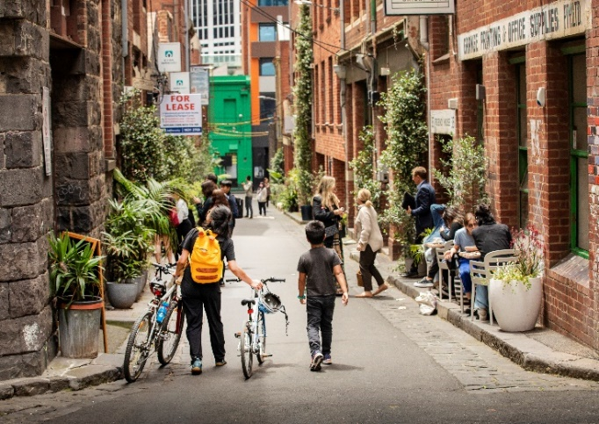

Accessibility
Existing office buildings tend to have large, expansive floor plates. Therefore, it is expected that the accessibility standard can be met.

Site services
Residential buildings have different service needs to office or commercial buildings. It is important when fitting the building with the required services, consideration is given to ensure they are installed in accessible locations and visually integrated into the building design. Mailbox areas and site facilities should be adequate in size, durable, water-protected, located for convenient access and integrated into the overall design of the development.
Reticulated gas connections are prohibited in new apartment developments under the planning scheme (Clause 53.03), so you will need to plan and design for this in your project. Additional ventilation requirements may apply depending on the replacement services which may have spatial implications on how areas are used such as rooftops or service areas.

NOTE: Design and Development Overlay, Schedule 1 (DDO1) applies to most land in the CCZ (within the Central City and Southbank areas) and requires that ground floor building services, including waste, loading, and parking access, occupy less than 40% of the site area.
This means you will not be able to convert a building to residential use where more than 40% of the site area is used for ground floor services unless you can reduce the ground floor services area to comply with this requirement.

Noise impacts
Locating building infrastructure such as mechanical plants and services away from existing and proposed dwellings is essential to protect residential amenity. Acoustic attenuation measures and compliance with the Noise Impacts Standards is expected.

External walls and materials
If you are considering making changes to the finish or material of external walls, it is important that these respond to the existing context and are of a good quality and demonstrate durability. The Central Melbourne Design Guide is a useful reference document and provides guidance on the use of external walls and materials.

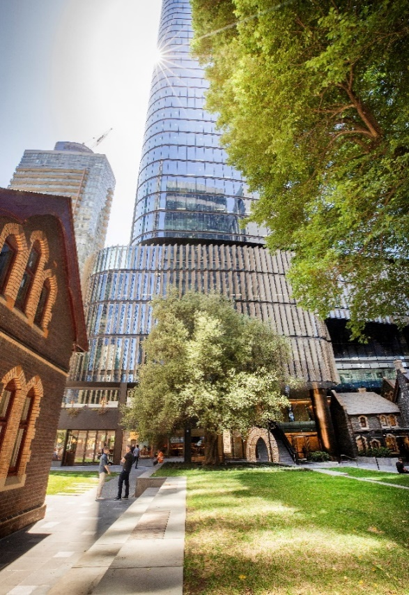

Parking and access
The City of Melbourne benefits from excellent access to public transport and walking and cycling infrastructure.
Existing buildings are likely to have established access and car parking arrangements. Proponents should explore opportunities in these areas to convert existing above-ground parking areas to habitable space – whether in the form of dwellings or communal areas.
In the Capital City Zone (CCZ) or Docklands Zone (DZ), there is no requirement to provide car parking for dwellings. In many cases, maximum car parking rates are set, and a planning permit is required to provide excess parking.
In other zones, car parking is likely to be required but a permit can be granted to reduce or waive the number of car parking spaces required.
We take a proactive approach to encouraging active transport and are generally supportive of applications to reduce or waive car parking requirements where this is supported by a Green Travel Plan, ample bike parking and supporting facilities such as a bike workshop.

NOTE: Design and Development Overlay, Schedule 1 (DDO1) applies to most land in the CCZ (within the Central City and Southbank areas), and prohibits:
- any above ground car parking in the Central City
- above ground parking in Southbank unless any parking interfaces to the street are sleeved by active uses
This means that you will not be able to convert a building with above ground parking to residential use unless you can remove or convert the car parking (or sleeve it with active uses in Southbank).

5.4.2 Environmentally sustainable design (ESD) considerations
We appreciate that some requirements may be challenging to meet due to existing building constraints and are committed to working with proponents to find alternative solutions which also recognise the environmental value of the proposed building retention. We are ready to assist you in overcoming the limitations of the site and existing structure, with a more flexible approach to the requirements, provided design excellence is demonstrated.
There are important considerations outlined within section 5.4.1 relating to landscaping, open space, energy efficiency, waste and recycling, windows and natural ventilation that will all contribute to the sustainability of the building.
Speaking with a sustainability consultant or Council’s ESD officer early can assist with determining the opportunities and constraints with improving the sustainability of the building and how to achieve a strong sustainable outcome.

5.5 Sites affected by the Heritage Overlay
Sites which are of heritage significance are identified by the Heritage Overlay, indicating that the site is of local, state, or national significance. Where heritage controls apply and depending on the significance of the heritage place, additional considerations may apply.
Heritage controls should not be seen as a barrier to building conversion, with many examples across Melbourne of successful redevelopment, refurbishment, and reuse of buildings.
The following section provides a brief overview of the levels of heritage protection within the City of Melbourne.

5.5.1 Local heritage places
Planning approval will be required to demolish parts of a building, make external alterations or for additions. This includes changing windows, recladding, rendering, and sandblasting. In many instances painting will also require approval.
Internal changes to a building do not typically require planning approval. However, it is always best to check with our team.
When planning approval is required, there are local heritage policy and guideline considerations that you will need to consider. Broadly speaking, the intent is to protect, conserve, enhance and celebrate places of local heritage significance.
This does not mean you can’t modify a building. In fact, the City of Melbourne’s planning policy encourages adaptive reuse of heritage places as an alternative to demolition.
Where possible, significant, and visible elements of contributory buildings should be preserved. In the case of non-contributory buildings, any external alterations should ensure they respect the significance of the heritage precinct.
Council’s heritage policy also provides guidance on additions to heritage places, encouraging the addition to be concealed where possible in significant streetscapes outside the Central City. Where they are visible, additions should be clearly distinct from the existing building design, maintaining the prominence of the existing building.

5.5.2 State heritage places
When a place is of state significance, it is also listed on the Victorian Heritage Register. In this case you will need to seek permission from Heritage Victoria. In these instances, Council will not consider heritage matters as part of your project, these will be considered by Heritage Victoria.
The Victorian Heritage Register (VHR) lists and provides legal protection to places or objects of state significance. A Heritage Permit will typically need to be obtained from Heritage Victoria to undertake work on a state listed heritage place. Work on a VHR listed heritage place requiring a Heritage Permit includes:
- extensions, interior works, demolition or relocation of buildings and structures
- changes to colour schemes and signage
- construction of new buildings and garden structures like fences, decks, pathways, driveways
- works to registered trees and gardens which are not regular maintenance works
- excavation including damage or alteration to an archaeological artefact
- relocation or repair of objects.
The City of Melbourne will be able to provide initial guidance to help determine whether the candidate building is affected by heritage controls and to what extent.

5.6 Subdivision of a building
Subdividing a building can give an owner a better range of tenancy or sale options. By clearly identifying lot boundaries, subdivision generally aids the timed release of titles to different parts of the building. Discussions with us or a licensed land surveyor will assist you to determine the options available to subdividing the building as part of your adaptive reuse project.
A planning permit for subdivision can be applied for as part of the development permit or as a separate, standalone permit. In existing office buildings, this may involve re-subdividing existing lots. This is largely an administrative process to reflect how the building will be divided up and is where key service authority considerations will be signed off that ensure the appropriate legal access created, such as through easements.
Where you do elect to subdivide and have common areas, such as communal open space, shared foyers or hallways and lifts, there will be a need to create an owners corporation. More information on owners corporations can be found on the Consumer Affairs Victoria website.

5.6.1 Subdivision approvals process
Should you decide to subdivide, there are three stages in the subdivision process:
1. Applying for a planning permit. A planning permit will be required for any subdivision. The layout and boundaries will need to correspond with that of the physical building layout and include any necessary easements and common areas.
You can apply at the same time as your development application or separately.
2. Certification of the plan. Once the planning permit for subdivision has been granted, the next step is that your land surveyor will apply to the City of Melbourne for certification of the subdivision plan.
Certification of the plan cannot occur until the permit for the subdivision has been issued, and the certified plan must match the endorsed plans of the subdivision permit.
3. Statement of compliance. When all conditions of the planning permit relating to public works have been complied with, your land surveyor will facilitate finalisation of a statement of compliance from the City of Melbourne. This will enable the Land Titles Office to complete the registration process, creating the new lots.
As part of the subdivision process, Public Open Space contributions may need to be made which can be discussed with us or a licensed land surveyor.

Building and construction considerations

6.1 Building principles
When a building is repurposed, it is called a change of use. A change of use requires a building permit and involves reviewing how the building will be used according to current legislation. Understanding this process is crucial for planning adaptive reuse projects.
Change of use often means making significant changes to meet today's legal requirements. For example, converting a commercial space into apartments requires understanding different construction methods, which can affect how successful the project is. Prior to the 1990s building legislation was based on prescriptive requirements. Following the adoption of the Building Code of Australia (BCA) in 1996, a performance-based code has applied in Australia, which is governed by non-prescriptive performance requirements. Section 6 outlines the building code requirements for adaptive reuse to help owners and developers navigate their projects confidently.

6.2 Legislative requirements

6.2.1 Victorian building regulatory framework
This section outlines the requirements under the Victorian building regulatory framework (Table 3) that property owners / developers are likely to encounter when adapting / upgrading a building. These regulations ensure that repurposed buildings meet modern requirements while preserving historical and architectural integrity.
Victorian building regulatory framework | Objective | Key legislation and regulations for adaptive reuse projects
Building Act 1993 (Vic) | - Legislation that aims to protect the safety and health of people who use buildings and improve building amenity  - Prescribes what to do | - Section 28 - Heritage Buildings  - Section 160, 160A & 160B - Exemption or Modification and/or Determination of Compliance of Building Regulations; this includes an assessment by an expert panel.
Building Regulations 2018 (Vic) | - Subordinate legislative document  - Prescribes requirements to control building design, construction, and use  - Regulations tell you how to do it | - Regulation 229 – Change-of-Use  - Regulation 233 – Alterations to Existing Buildings  - Regulation 234 – Alterations Affecting Exits and Paths to Exits  - Regulation 236 – Access to Buildings for Persons with Disability  - Regulation 145 – Automatic Smoke Detection and Alarm  - Regulation 147 – Shared Accommodation Buildings (Automatic fire sprinkler systems)  Include provisions that allow for the alteration and adaptive reuse of buildings on the understanding that they may not satisfy the requirements of current legislation.  These include exemptions, an allowance for partial compliance, assessment using non-prescriptive provisions.
National Construction Code 2022 Volume One—Building Code of Australia (BCA) | - Sets out the minimum standards for the design and construction of buildings across Australia  - Sets out technical requirements for building based on a building’s classification | Key considerations include:  - Building Classifications  - Structural Integrity  - Fire Safety  - Accessibility  - Services and Amenities  - Energy Efficiency  Change of use requirements - The current BCA classification applicable to your building will be stated on the occupancy permit / certificate of occupancy. To change the building classification, you will be required to engage a building surveyor and obtain a building permit.
Table 3. Components of the Victorian Building Regulatory Framework, their objectives, and considerations for adaptive reuse projects

One of the key aspects of the framework is its emphasis on structural and fire safety. Engineers must assess the existing building’s structural capacity to support new uses such as residential apartments while architects must assess its spatial capacity. This evaluation ensures that any modifications or additions made during the adaptive reuse process do not compromise the building's stability or safety.

Additionally, the framework includes provisions for accessibility and amenities that enhance the usability of repurposed buildings. Requirements for accessibility features such as ramps, elevators, and accessible bathrooms ensure that buildings are inclusive and meet the needs of all occupants, including those with disabilities. Moreover, guidelines for amenities such as parking facilities, waste management systems, and energy-efficient installations contribute to the overall functionality and sustainability of adaptive reuse projects.

Heritage preservation is another significant aspect regulated within the framework, especially for buildings with historical significance. Consultants specialising in heritage preservation collaborate closely with developers and authorities to ensure that adaptive reuse projects respect and conserve architectural elements that contribute to the cultural heritage of Victoria.

Overall, the Victorian Building Regulatory Framework provides a structured approach to adaptive reuse, balancing the preservation of architectural heritage with the implementation of modern building standards. By adhering to these regulations, developers and consultants can successfully transform office buildings into vibrant and sustainable spaces that meet contemporary needs while respecting Victoria's rich architectural and cultural legacy.

6.3 Change of use
In addition to planning permit requirements, a change of use also triggers the requirement for a building permit as the change constitutes a change in the building classification under the BCA. You will need to engage a registered building surveyor to assess your plans and issue a building permit.

Office buildings for professional and/or commercial purposes, such as offices for government agencies, accountants or lawyers are Class 5 buildings. With adaptive reuse projects, you will be changing the use of the building from a Class 5 to a Class 2 apartment buildings. Classification of other domestic buildings can be found in Appendix A.

It is important you engage your building surveyor early when assessing building feasibility as they will assess your adaptive reuse project and ensure it complies with all the relevant aspects of the Building Act 1993, Building Regulation 2018 and the BCA.

Projects involving major changes or upgrades to existing buildings can be challenging when it comes to integrating modern standards with older structures. Your building surveyor will advise whether compliance is achievable or if flexibility may be required through ‘partial compliance’. Partial compliance helps balance regulatory requirements with the practical realities of working with older buildings ensuring that adaptive reuse projects remain viable and respectful of the existing structure while still enhancing safety and functionality.

6.4 Fire safety – key principles

6.4.1 Key principles
Fire service systems are crucial components in the adaptive reuse of office buildings, ensuring safety and compliance with fire safety regulations. These systems are designed to detect fires early, alert occupants, and facilitate safe evacuation in the event of an emergency.

Fire systems in buildings vary depending on the classification and use of a building. With a change of use from office to residential usage, there will be changes in occupancy type and layouts that in turn affect fire hazards. The building must have fire safety systems that match its new use, according to the current BCA requirements. Apartment buildings need different smoke detection and occupant warning systems compared to office buildings. This is mainly because people live and sleep in apartments, which requires a different approach to fire safety.
Fire service systems must be carefully integrated to align with the building's new use and layout. Consultants and fire safety engineers play crucial roles in assessing risks, designing appropriate systems, and ensuring compliance with local building codes and regulations. By implementing robust fire service systems tailored to the specific needs of repurposed office buildings, developers and stakeholders can enhance safety, protect occupants, and safeguard investments in adaptive reuse projects.

6.4.2 Smoke detection and alarm systems
One of the primary types of fire service systems is fire detection and alarm systems. These systems include smoke detectors, heat detectors, and manual call stations strategically placed throughout the building to detect signs of fire. Upon detection, alarms are triggered to alert occupants and emergency responders, enabling swift action to mitigate the fire's spread.
Residential buildings must be provided with an automatic smoke detection and alarm system. The system requirements vary depending on the size of the building but generally comprise of smoke alarms within individual apartments which provide a local alarm, and a smoke detection system comprising of a smoke detector and a building occupant warning system within public areas.
Effectively, these systems in combination allow for an internal alarm within dwellings and a building wide alarm when located within public areas. These requirements can vary significantly depending on whether the building is fitted with other forms of fire suppression.

6.4.3 Fire suppression systems
Another critical type of fire suppression system is a sprinkler system. Sprinklers are designed to release water or other extinguishing agents when a fire is detected, effectively controlling or extinguishing flames before they can escalate. These systems are particularly essential in adaptive reuse projects where building layouts and materials may vary, potentially affecting fire spread dynamics.
Fire suppression systems in buildings consist of fire hydrants, fire hose reels, fire extinguishers and automatic fire sprinklers. Provision for these systems vary depending on the size, height, and number of storeys of the building.
Fire hydrant systems are required to protect buildings (other than single detached dwellings and associated structures) which are greater than 500 m².
Fire hose reel systems are not required to serve residential buildings or short stay accommodation buildings but can be required to cover ancillary uses located within the same buildings, such as carparks and retail spaces.
Fire sprinklers are required in apartment buildings and accommodation buildings such as hotels and motels which have four (4) or more storeys.
Shared accommodation buildings and residential care buildings require sprinklers irrespective of size. See Appendix A for a definition of building types and their respective classification in Victoria in accordance with the BCA.

Considering a change of use from an existing commercial building to residential use which has four (4) or more storeys will always require a retrofit of a fire sprinkler system where one is not already provided and may be required for less than three storeys for accommodation type uses.

In specific circumstances, more cost-effective systems which utilise fire hydrant or drinking water supplies in lieu of traditional sprinkler system configurations can be adopted however the significant concessions provided to sprinkler protected buildings are not offered to such systems.

Owners should carefully consider the specific context of their building in consultation with design professionals such as fire services engineers and fire safety engineers to determine the most appropriate fire sprinkler system.

Fire extinguishers are the general means for occupants to undertake the initial attack of a fire in residential buildings, with the intent of either extinguishing or limiting the development of fire before the fire brigade arrives. Fire extinguishers are required throughout public areas of residential buildings within proximity to the doors of individual units such that occupants can attempt to extinguish fires within units.

6.4.4 Other active fire systems
Tall buildings pose unique challenges for firefighting and evacuation. Firefighters must be able to enter the building to fight fires, and people must exit in stages rather than all at once.
According to building regulations, buildings taller than 25 meters (around seven to ten stories) have additional requirements:
- Each floor must have at least two exits.
- Fire stairs or corridors must have smoke separation that keeps them smoke-free when people are evacuating.
- There are stricter rules for fire hydrants and sprinklers to ensure reliable water supply for firefighting.
- Emergency lifts are needed instead of regular lifts for safe evacuation during emergencies.
- Emergency lighting and exit signage are also essential fire service elements.

6.5 Fire resisting construction
Fire-resisting construction in buildings means using materials and methods that slow down or stop the spread of fire. This gives people more time to escape and helps firefighters respond effectively.
Key aspects of fire-resisting construction include:
- using materials like gypsum board, concrete, or special coatings that resist catching fire
- building walls, floors, and ceilings sturdy enough to stay intact during a fire
- dividing the building into sections with fire-resistant walls and floors to contain fires
- installing fire-resistant doors and windows that withstand high temperatures and prevent fire from spreading through openings.
These measures are required by building regulations to protect occupants, aid emergency responders, prevent fires from spreading between buildings, and minimise damage.
The level of fire resistance needed depends on how a building is used and its size. Residential buildings, where occupants may be sleeping, typically require higher fire resistance.
Fire resistance is measured in minutes and categorised into three parts:
- Structural adequacy: how long the structure can stand during a fire.
- Integrity: how long a barrier can prevent flames from passing through.
- Insulation: how long it can keep heat from spreading.
For example, a wall might have a rating of 60/60/60, meaning it can withstand fire for one hour.
Residential buildings typically need 90 minutes for loadbearing elements and 60 minutes for non-loadbearing elements. Each unit must be separated from others and public areas by fire-rated barriers, ensuring safety.
Buildings with mixed uses, like retail or offices alongside residential units, require even higher fire resistance in those areas.
When assessing existing buildings for fire safety, experts like fire safety engineers, building surveyors, structural engineers, and architects are crucial. They determine current compliance and recommend changes needed for new uses, ensuring safety standards are met.

6.6 Provision for escape
All buildings, whether commercial or residential, must have ways for people to safely exit in case of emergency. The number and design of these exits depend on the building's size and how it is used.
6.6.1 Fire escape stairs or staircases
One key type of fire escape provision is the inclusion of fire escape stairs or staircases. These are dedicated stairwells designed with fire-resistant materials and construction to provide safe egress paths from upper floors to ground level or designated safe areas. Fire escape stairs are typically located in enclosed stairwells to protect occupants from smoke and flames, and they often feature fire-rated doors that automatically close to contain fire and smoke spread.
6.6.2 Fire escape routes and exits
Another important provision is the installation of fire escape routes and exits. These routes include clearly marked and unobstructed pathways that lead occupants from various parts of the building to safe outdoor locations or refuge areas. Exits, such as doors and windows, are equipped with emergency exit hardware and signage to facilitate rapid evacuation during emergencies.
Every building needs at least one exit on each floor. This could be a stairway, ramp, door, or fireproof passage leading to a street or open area. Buildings taller than 25 meters must have two exits. More exits might be needed based on how far people must travel inside to reach an exit.
When converting office buildings to apartments, it is crucial to check if the existing exits and travel distances are suitable. There are specific rules for residential buildings - for instance, each unit's entrance door should be within 6 meters of an exit. If there are two exits, they should not be more than 45 meters apart.
Exits typically are required to be fire separated except where they serve low-rise buildings. Understanding these rules ensures buildings are safe and compliant, whether they are used for offices or homes.
During the adaptive reuse of office buildings, fire escape provisions must be carefully evaluated and integrated to accommodate changes in building use, occupancy loads, and layout modifications. Fire safety engineers and consultants conduct thorough assessments to identify potential evacuation challenges and recommend appropriate provisions to enhance safety. By implementing effective fire escape provisions, developers and stakeholders can mitigate risks, comply with fire safety regulations, and ensure the protection of occupants in emergencies, thereby enhancing the overall safety and resilience of repurposed office buildings.

6.7 Building openings (light and ventilation)
Residential buildings require natural light and ventilation to habitable rooms such as bedrooms, living rooms, home offices, and the like, which are not otherwise required for commercial office buildings. The amount of light and ventilation required is a percentage of the floor area of the space served being 10% and 5%, respectively.

Office buildings do not require natural light in any spaces and favor mechanical ventilation systems over natural ventilation. While mechanical ventilation systems are permitted in residential construction, they are less efficient and more onerous to construct in the context of an apartment building with individually owned apartments from both a constructability and cost perspective.

This presents a specific challenge in the adaptive reuse of buildings, especially those with large floor plates. Existing ventilation systems in most cases will likely need to be completely replaced and effective design should prioritise provision for natural light and natural ventilation over mechanical systems.

Providing effective means of natural light and ventilation through the provision of new openings to the building can create additional matters to consider, particularly where other buildings are within close proximity to boundaries.

Careful consideration of the need for openings in external walls and their proximity to any hazards should be carefully considered in consultation with a registered building surveyor and/or fire safety engineer.

6.8 Other building considerations

6.8.1 Structural adequacy
Many older office buildings in Victoria were not designed with the consideration of future use flexibility. Assessing the building's structural capacity to support new uses requires thorough engineering evaluation. Strengthening or retrofitting may be necessary to meet safety and durability standards, particularly if significant changes are planned.

When considering a change of use a retrospective review of a building’s structural adequacy is required. This will include a review of the existing structure through desktop analysis, visual inspection, and destructive testing.

For buildings of medium and high-rise construction there are significant wind and earthquake actions that need to be considered.

Historically, Australia has been considered to have low seismicity and prior to implementing the current earthquake loading code (circa 2010), and buildings typically were not designed with significant ductility. The current earthquake code has increased required loadings dramatically, therefore when considering the reuse of a building there is likely to be a need to conduct strengthening works to the existing structure to achieve a satisfactory level of performance under earthquake conditions.

Early engagement with appropriately qualified structural engineers is critical to determining the viability of any reuse project.

6.8.2 Stormwater and drainage
The design and installation of stormwater drainage systems does not vary widely across building uses with the same code and calculation methods being applied to all buildings. Assuming a building has a functioning drainage system, there is unlikely to be a need to significantly alter the system in an adaptive reuse.

6.8.3 Waterproofing wet areas
In adaptive reuse projects, waterproofing wet areas presents a unique set of challenges due to the need to integrate modern moisture control methods into often aging or historically significant structures. Issues include deteriorated existing waterproofing systems, mismatched materials, and the potential for structural damage during installation.

Solutions to these challenges might involve thorough inspection and repair of existing waterproofing layers, employing advanced materials like elastomeric membranes that can bond to various surfaces, and utilising modern sealing techniques to ensure a continuous barrier against water intrusion.

Additionally, incorporating drainage improvements and moisture management systems can help prevent future issues, preserving the integrity of both the building and its adaptive reuse functionality.

6.8.4 Weatherproofing and cladding
Weatherproofing office and residential buildings requires the same performance requirements, therefore in theory the weatherproofing of an office building envelope should be suitable for residential use.

Owners and prospective developers should be aware and conscious of the weatherproofing construction of existing buildings and engage with subject matter experts such as façade engineers to determine the condition of a building’s façade and its ability to comply with current provisions.

It is also important to check existing external cladding and ensure it is not combustible, and suitable for the change of use.

6.8.5 Access and liveable housing
Access for people living with a disability must be provided throughout residential buildings. The extent of access required will depend on the specific use. Typically, for residential uses access is required to all common areas. For apartment buildings, access is not required within individual apartments, however the internal parts must comply with the Livable Housing Design Guidelines (LHDG). For other residential uses such as hotels, a percentage of the units within the building must be accessible.

The LHDG are a set of technical provisions developed to assist in the improvement of access within apartment buildings. The LHDG was initially produced as a voluntary guideline but has now been adopted in the BCA in a modified form.

When considering the adaptive reuse of office buildings which predate the access provisions of the BCA buildings the application of the access provisions and LHDG will need to be addressed in the internal design of the building.

Suitably qualified access consultants, with specific expertise in the Disability Discrimination Act 1992, Access to Premises Standards and the BCA access provisions should be engaged to advise on required alterations.

6.8.6 Car parking
Office buildings that incorporate existing carparks, may be suitable for reuse in a residential context. However, the context of the existing car park and its initial construction specification can be critical to its adaptation.

BCA provisions related to the construction of car parks are currently under review considering the emergence of electric and hybrid vehicles. The findings of research associated with carparking structures have determined current BCA provisions may be inadequate to appropriately address the associated fire risk. It is likely that the findings of such research will result in significant changes to the acceptable construction practices related to car park structures.

Owners and prospective developers considering the adaptive reuse of buildings which incorporate existing carparks should determine the conditions of the initial approval and consult with appropriately qualified fire safety engineers and building surveyors to determine the adequacy of the existing construction.

It is likely where concessions have been applied to the existing construction, upgrades will be required.

6.8.7 Acoustic separation
Residential uses require acoustic separation between sole-occupancy units and public spaces to maintain amenity. Office buildings do not require acoustic separation of any form.

As such, most of the elements requiring acoustic separation will require alteration or reconstruction to achieve the required acoustic separation.

Acoustic engineers should be engaged during the design development phase to assess existing and proposed construction for acoustic compliance.

6.8.8 Energy efficiency
Sustainability considerations are increasingly important in Victoria's building sector. Adaptive reuse inherently supports sustainability by repurposing existing infrastructure rather than constructing new buildings. Incorporating energy-efficient systems, sustainable materials, and water-saving technologies during the renovation process aligns with Victoria's environmental goals and can lead to certifications such as Green Star ratings.

The energy efficiency of buildings is governed by Section J of the BCA. The provisions surrounding energy efficiency have become significantly more onerous over the past decade in an effort to combat climate change.

Section J provisions provide prescriptive requirements in relation to building fabric and the arrangement of windows to prevent heat transfer in a building, mechanical ventilation, lighting systems, and other building services.

Compliance with the current energy efficiency provisions of the BCA can be complex and expensive to achieve in the context of an existing building, and often cannot be met without significant alterations to the building. However, legislative provisions related to existing buildings, allow the relevant building surveyor (RBS) to consider and permit partial compliance with the energy efficiency provisions where it can be demonstrated that the reasonable provision has been made for the amenity of building occupants.

VBA Building Practice Note EE 02-2022 includes guidance to assist building surveyors, owners and determine what is reasonable in the context of applying NCC energy efficiency measures to existing buildings.

When considering a partial compliance pathway owners and developers should establish in consultation with appropriately qualified consultants the reasonableness of the proposal in accordance with the VBA Building Practice Note EE 02-2022.

6.9 Consultation with authorities
In adaptive reuse projects, consulting with and securing approvals through from key authorities is crucial and can significantly impact project feasibility, particularly during the building permit phase. Fire, flood, drainage and electrical supply authorities each impose specific requirements that must be addressed to ensure compliance and safety.

For instance, City of Melbourne and Melbourne Water will advise if your property requires enhanced drainage solutions, waterproofing, or structural elevation. Your electrical supply authority will advise on upgrades to outdated electrical systems to meet modern demands and safety standards. Fire Rescue Victoria will evaluate whether your project requires upgrades to fire detection and suppression systems to meet fire brigade intervention objectives.

6.10 Construction
The construction phase of a change in use can be generally summarised as a multifaceted undertaking with many unknown variables.
Typically, the construction phase will begin based on design assumptions which require confirmation and potential redesign during the construction phase.
Given this reality, in the first instance any change of use project requires an experienced construction team who have a robust understanding of their obligations in the construction of such a project. Additionally, it is critical to ensure the continued engagement of design consultants throughout the construction phase as it is common for design assumptions to be further refined based on findings onsite, or unothodox or inadequate construction methods to be idenitifed in the existising construction.
The expertise of the design consultants is crucial in efficiently and cost-effectively navigating these issues on the pathway to compliance.

6.11 Maintenance
Upon the completion of a building project, maintaining and reporting on fire safety and environmental assets is critical for ensuring their continued effectiveness and compliance.

A thorough maintenance schedule should be established for fire safety systems, including regular inspections, testing, and servicing of alarms, sprinklers, and emergency lighting. Similarly, environmental assets, such as HVAC systems and water management systems, require consistent upkeep to optimise their performance and efficiency.

Ongoing reporting is essential to document maintenance activities, system performance, and any issues encountered, ensuring that all assets meet safety standards and regulatory requirements. By diligently maintaining and regularly reporting on these critical systems, building operators can safeguard occupants, protect the environment, and ensure that the building continues to perform optimally throughout its lifecycle.

Appendix A: Building classes

Building type | Examples | Building class (as defined by the BCA) | Definition
Apartment building |  | Class 2 | Each unit within the building is a separate dwelling and is individually owned or leased with the intent of being a permanent residence.
Accommodation building | Includes:  - Hotel  - Motel | Class 3 | Each unit provides transient or long-term accommodation for several unrelated persons.  While the length of stay is unimportant, the intent of such buildings is not to provide a permanent residence.
Shared accommodation | Includes:  - Boarding house  - Chalet  - Guest house  - Lodging house  - Backpacker accommodation  - Residential part of a hotel offering shared accommodation  Excludes:  - Residential care building (Vic)  - motel  - residential part of a school  - health-care building  - detention centre | Class 3 | Accommodation scenarios where unrelated persons are accommodated in a common area.  More than one sole-occupancy unit, of which any sole-occupancy unit has sleeping facilities capable of accommodating 3 or more unrelated persons or sleeping facilities capable of accommodating 13 or more unrelated persons.
Residential care buildings | Includes:  - Residential care services  - State-funded residential care services  - Supported residential services (as per the Supported Residential Services Act 2010)  - Aged care buildings  Excludes:  - Hospitals  - Homes where two or more family members and up to two others live together  - Places where only one resident requires physical assistance for daily activities and emergency evacuation | Class 3, 9a or 9c | Generally, comprise buildings wherein occupants need assistance in conducting their daily activities and in the event of an evacuation and include nursing homes, aged care facilities, and other care-type facilities.

