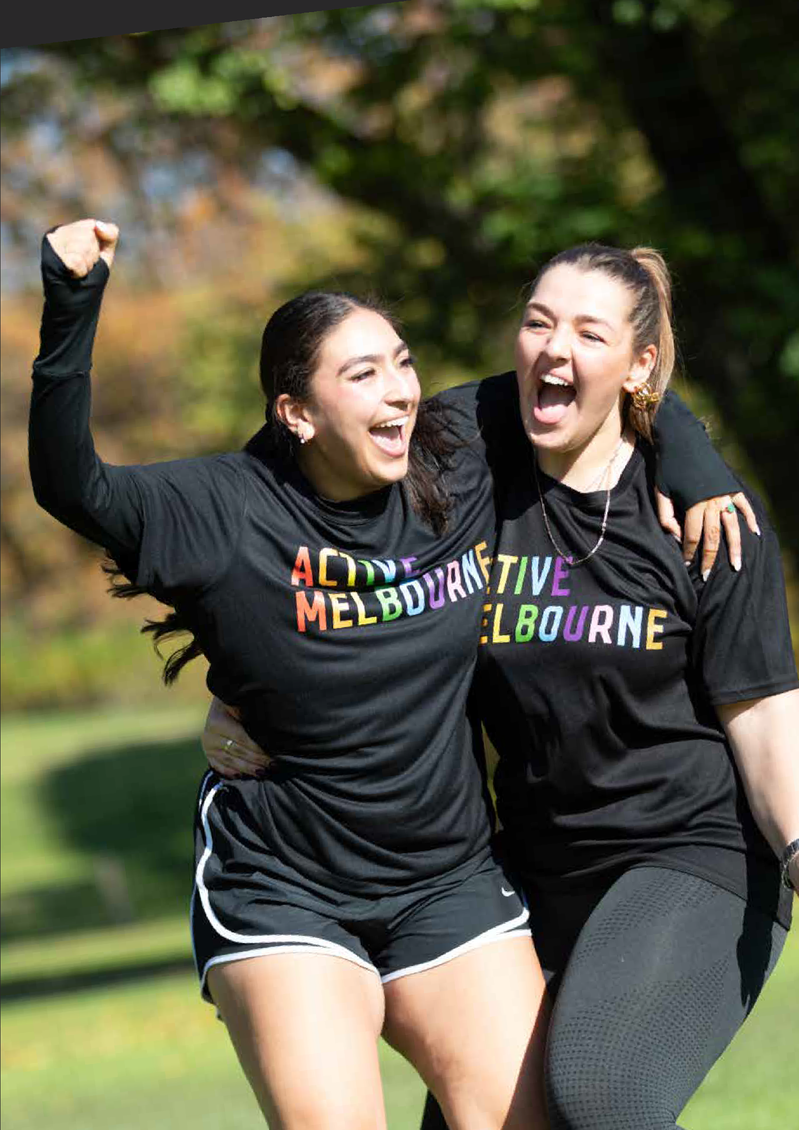
FAIR ACCESS
SPORT AND RECREATION ACTION PLAN
2024-2027

2 melbourne.vic.gov.au

Acknowledgement of Traditional Owners
The City of Melbourne respectfully acknowledges the Traditional Owners of the land we govern, the Wurundjeri Woi-wurrung and Bunurong / Boon Wurrung peoples of the Kulin and pays respect to their Elders past and present. We acknowledge and honour the unbroken spiritual, cultural and political connection they have maintained to this unique place for more than 2000 generations.

We accept the invitation in the Uluru Statement from the Heart and are committed to walking together to build a better future.

Council Plan 2021-25
The Council Plan 2021-25 sets out our strategic direction and commitment to the community for the next four years. Based on six strategic objectives for our city, this is our detailed plan for our city’s revitalisation and considers
the needs of all people who access and experience the City of Melbourne municipality. For more information visit melbourne.vic.gov.au/council-plan





Economy of the future
Melbourne’s unique identity and place
Safety and wellbeing
City of Possibility
Aboriginal Melbourne
Access and afordability
Climate and biodiversity emergency

Safety and wellbeing
Ensuring the city is safe, and that people feel safe when they come into the city is our priority. We will plan and design for the safety and health and wellbeing of all people in Melbourne, and we are committed to strengthening community social connections.

melbourne.vic.gov.au

CONTENTS

Background 7
Guiding Principles 8
Objectives 8
Key Findings 9
Purpose 9
Content and Alignment 11
Actions 12
Appendix A: Community sport and recreation facilities 17
Appendix B: Glossary 19

July 2024
Cover Image: Five women in Alexandra Gardens. Photo Credit: Active Melbourne 2024.
Disclaimer
This report is provided for information and it does not purport to be complete. While care has been taken to ensure the content in the report is accurate, we cannot guarantee it is without flaw of any kind. There may be errors and omissions or it may not be wholly appropriate for your particular purposes. In addition, the publication is a snapshot in time based on historic information which is liable to change. The City of Melbourne accepts no responsibility and disclaims all liability for any error, loss or other consequence which may arise from you relying on any information contained in this report.
To find out how you can participate in the decision-making process for City of Melbourne’s current and future initiatives, visit melbourne.vic.gov.au/participate

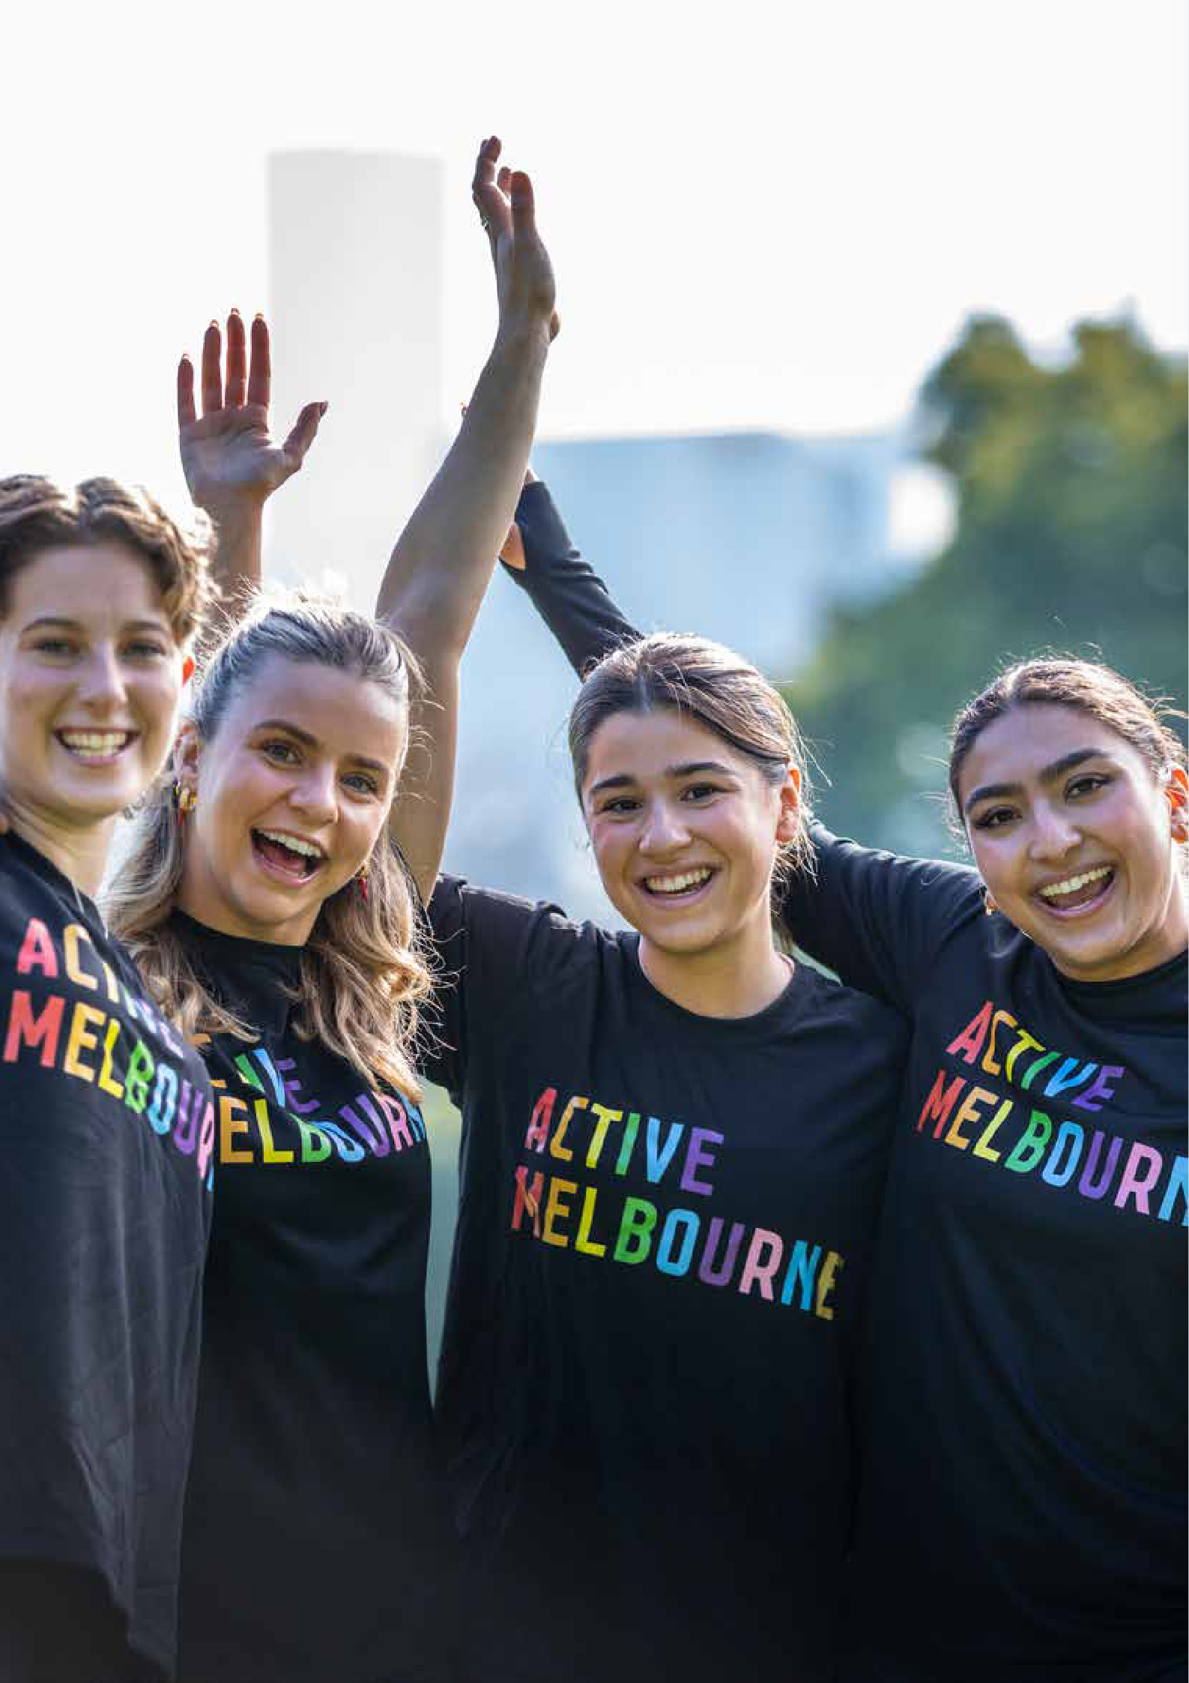

6 melbourne.vic.gov.au

BACKGROUND

Our city is where people of all cultures, backgrounds, ages, genders, sexualities, beliefs, and abilities are welcomed, celebrated, and protected. As a result, our urban communities are fair, sustainable, safe, affordable, and inclusive, drawing people from around the world to visit, work and live. We are proud of the vibrancy this diversity brings to every aspect of city life.
- Inclusive Melbourne Strategy 2022–32

Sport and active recreation are highly visible and valued features of the City of Melbourne’s culture and identity. Our community sport and recreation facilities (facilities) enrich our communities through supporting physical and mental wellbeing and the promotion of respect and fair-mindedness. These facilities are made available to various organisations, including sporting clubs, associations, community groups, schools, commercial operators and others (user groups) to provide a range of participation opportunities.

Our diverse and fast-growing population, the expansion of existing sports and recreation activities, and the emergence of new participation opportunities are increasing the demand for infrastructure and open spaces.
To support the health and wellbeing of our community, now and in the future, it’s imperative that we carefully plan and manage these resources.

A Fair Access Policy Roadmap (Roadmap) was developed by the Victorian Government’s Office for Women in Sport and Recreation, Sport and Recreation Victoria and VicHealth and released in August 2022. It aims to improve women’s
and girls’ access to and use of community sports infrastructure. The Roadmap addresses Recommendation 6 from the Victorian Government’s Inquiry into Women and Girls in Sport and Active Recreation (2015), which seeks to “deliver female-friendly environments and equitable facility usage policies”.
Fair Access in the City of Melbourne has a primary focus on women and girls and acknowledges the multiple interacting experiences of individuals that need to be considered to improve participation in
community sport and recreation. These include, but are not limited to, cultural and ethnic background, sexuality, age, gender, socio- economic status, education level, occupation, ability, faith, and beliefs. We also seek to improve participation opportunities for other underrepresented groups where possible.

Our response to the Roadmap aims to build capacity to identify and eliminate systemic causes of gender inequality, ableism and cultural bias in policy, programs, communications, and community sports and recreation services delivery. We acknowledge that a number
of user groups already provide a range of inclusive participation opportunities and we are committed to supporting and mentoring all groups to achieve fair access for all.

We have developed a Fair Access Sport and Recreation Allocation and Use Policy (policy) and Fair Access Sport and Recreation Action Plan (action plan). The action plan and policy both seek to improve the access and use of the City of Melbourne’s community sports and recreation facilities.

Fair Access Sport and Recreation Action Plan 7

GUIDING PRINCIPLES AND OBJECTIVE

2. Guiding Principles
Our Fair Access guiding principles are:
- Community sports infrastructure and environments are genuinely welcoming, safe and inclusive.
- Women and girls can fully participate in all aspects of community sport and active recreation, including as players, coaches, administrators, officials, volunteers and spectators.
- Women and girls will have equitable access to and use of community sports infrastructure:
  - of the highest quality available and most convenient
  - at the best and most popular competition and training times and locations
  - to support existing and new participation opportunities and a variety of sports.
- Women and girls will be equitably represented in leadership and governance roles.
- Encourage and support all user groups to understand and adopt gender-equitable access and use practices.
- Prioritise access, use and support to all user groups who demonstrate an ongoing commitment to gender-equitable access and use of allocated community sports infrastructure.

The guiding principles will strengthen a culture of inclusion, care and respect at the community sport and recreation facilities in the City of Melbourne.

Objectives
Our Fair Access objectives are to:
  - Provide fair and equitable access to increase participation for women and girls in recreation and physical activity.
  - Increase the number and diversity of women and girls participating in recreation and physical activity and benefit from the associated physical,
mental, social and wellbeing outcomes.

8 melbourne.vic.gov.au

KEY FINDINGS AND PURPOSE

Key Findings
City of Melbourne undertook research and community engagement to identify the barriers women, girls and other underrepresented groups face to participation in sport and recreation. We identified barriers to involvement by users and non-users, as well as motivators for participating in sport and recreation.

The key findings were that women and girls:
  - want to feel safe getting to and from and while participating in community sports and recreation facilities at night
  - want sport and recreation facilities that are well designed and maintained to meet their needs
  - want to feel welcome and included at community sports and recreation facilities
  - want to participate in sport and recreation in different ways, including activities that are more social, fun, non- competitive/routine, modified, culturally appropriate and family friendly
Other key findings were that women and girls need easily accessible information on
participating in community sport and recreation and want people like them in leadership and facilitation roles. Women and girls also said they would benefit from the promotion of the
opportunities and advantages of participating in community sport and recreation.

Our research and community engagement also found that women and girls who experience financial barriers need suitable pricing to participate in sports and recreation. Another key finding was that women and girls want sport and recreation staff, facilitators and players to be respectful and welcoming to all people.

Purpose
This action plan outlines the high impact initiatives to achieve Fair Access improvements at sport and recreation facilities in the City of Melbourne.

  - want easier introductions to sports and recreation activities that are non-
threatening, build skills and confidence, and provide a range of pathways
  - want access to sports and recreation facilities and activities at convenient times and locations
  - want nearby facilities that enable them to participate in the sports and
recreation activities they are interested in.

Fair Access Sport and Recreation Action Plan 9

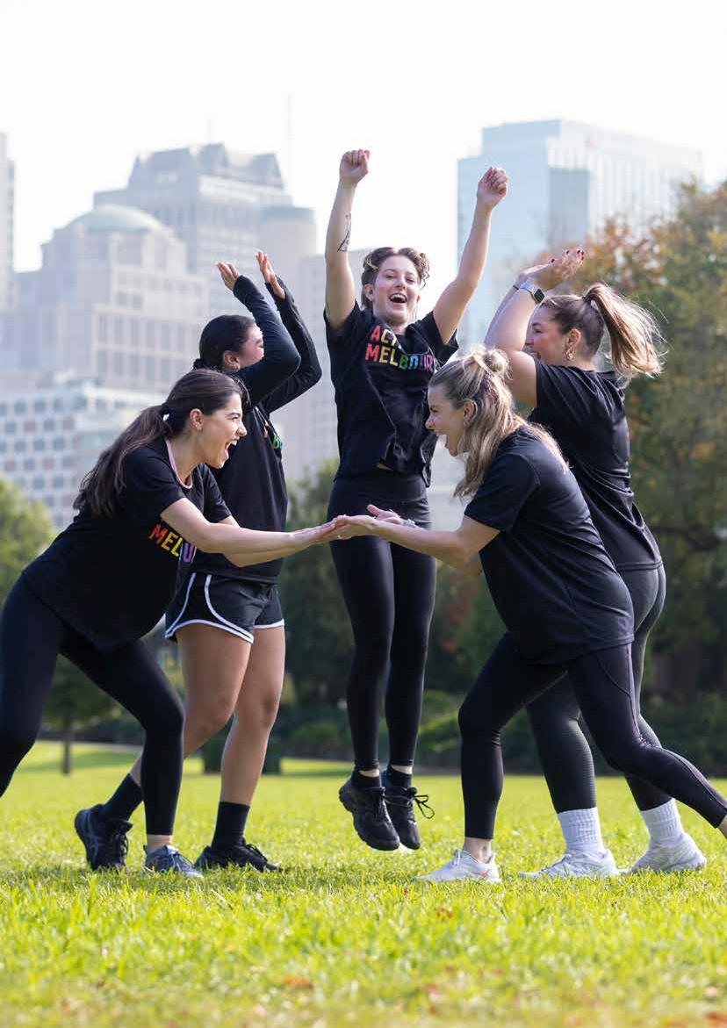

10 melbourne.vic.gov.au

CONTEXT AND ALIGNMENT

Context and Alignment
The action plan and policy aligns with other City of Melbourne plans and strategies, and relevant state government legislation including its Fair Access Policy Roadmap.










4 year council documents
Revenue and Rating Plan
Council Plan
Including Municipal Health and Wellbeing Plan
Budget
Workforce Plan
Inclusive Melbourne Strategy
Fair Access Sport and Recreation Allocation and Use Policy and Action Plan
Recreation Facilities Provision Framework
Open Space Strategy
Public Health and Wellbeing Act 2008
Local Government Act 2020
Gender Equality Act 2020
Fair Access Policy Roadmap 2022
Victorian State Government
Municipal Community Infrastructure Plan
(in preparation)
Sustainable Development Goals
U.N
Asset Plan
Financial Plan
Municipal Planning Strategy
Community Vision
10 year council documents

Community and Stakeholder Engagement

Fair Access Sport and Recreation Action Plan 11

ACTIONS

Actions
The Fair Access guiding principles are a framework for the detailed action plan below. The action plan includes 13 outcomes, informed by research and community consultation.

We have created specific actions for each outcome to minimise the barriers to participation experienced by women and girls.

City of Melbourne will work with stakeholders, including state sporting associations, peak bodies, community organisations, neighbouring councils, facility operators, clubs and users, to achieve the desired outcomes from the action plan.

We will progressively implement the action plan starting on 1 July 2024. It applies
to the City of Melbourne’s current and future community sport and recreation facilities, including sporting fields, pavilions, recreation centres, and leased and licensed facilities.

The plan covers an initial three-year period to July 2027. It will be reviewed and updated after two years or as required.

12

INFRASTRUCTURE AND ENVIRONMENT
OUTCOMES ACTIONS TO ACHIEVE PROGRESS TIMEFRAME INDICATORS OF SUCCESS ALIGNED
PRINCIPLES
1. Women and girls feel safe getting to and from, and participating at community sports and recreation facilities at night. | 1.1 Identify and prioritise public lighting improvements at, to and from community sport and recreation facilities aimed at current and future use by women and girls. | Year 1-2 | A review of public lighting at all community sport and recreation facilities is completed and  recommendations for improvements are identified. | 1
 | 1.2 Identify and prioritise sports lighting improvements at community sports and recreation facilities aimed at current and future use by women and girls. | Year 1-2 | A review of sports lighting at all community sport and recreation facilities is completed and  recommendations for improvements are identified. | 1
2. Women and girls have sports and recreation facilities that are well designed and maintained to meet their needs. | 2.1 Undertake an audit and develop a plan to upgrade and increase the capacity of existing community sport and recreation facilities to ensure these locations are suitable, high quality and available at convenient times for women and girls. | Year 1-2 | Develop a priority list of proposed capacity and fa- cility upgrades to community sport and recreation locations to inform Council planning and funding processes. | 1, 3
3. Women and girls feel welcome and included at community sports and recreation facilities. | 3.1 Develop and communicate the City of Melbourne’s requirements for community sport and recreation facility use, including a commitment to a culture of safety, respect and inclusion for women, girls and others. | Year 1-3 | Expectations for the use of community sport and recreation facilities are created and communicated to user groups.  Appropriate signage, memorabilia displays and decorations are maintained in accordance with the facility use requirements. | 1
 | 3.2 Provide advice and training to community sport and recreation user groups on how to create an inclusive and welcoming environment that is culturally and psychologically safe for staff, players and spectators. | Year 1-3 | Provide training and education opportunities twice a year. | 1, 5
4. Women and girls can access sports, recreation facilities, and activities at convenient times and locations. | 4.1 Develop and implement a Fair Access Sport and Recreation Allocation and Use Policy to facilitate equitable access to community sport and recreation facilities. | Year 1-3 | A Fair Access Sport and Recreation Allocation and Use Policy is developed and implemented. | 3
 | 4.2 Ensure additional capacity at community sport and recreation facilities is available for programs and activities that encourage the participation of women and girls. | Year 1-3 | Implementation of the Fair Access Policy.  Increased participation of women and girls as a percentage of total bookings. | 3
 | 4.3 Work with neighbouring councils to advocate to State Sporting Associations and peak bodies about scheduling community sports and recreation to achieve equitable access for women and girls. | Year 2-3 | Attend meetings with State Sporting Associations and peak bodies. | 3
5. Women and girls have nearby facilities that enable them to participate in  the sports and recreation activities they are interested in. | 5.1 Work with neighbourhood partners to identify the types of sports and recreation activities, structured and unstructured, that women and girls want to participate in in their local area and complete a gap analysis with the existing facilities. | Year 1-2 | Community engagement and research are undertaken to identify preferred activities, identify gaps in provisions and make recommendations to inform Council planning and funding processes. | 3
 | 5.2 Identify opportunities for the development of new community sports and recreation facilities that align with activities in demand by women and girls. | Year 2-3 | Develop a priority list of proposed new community sport and recreation facilities to inform Council planning and funding processes. | 3

Fair Access Sport and Recreation Action Plan 13

OUTCOMES ACTIONS TO ACHIEVE PROGRESS TIMEFRAME INDICATORS OF SUCCESS ALIGNED PRINCIPLES
ACTIVITIES
6. Women and girls can participate in sports and recreation in different ways, including more social,  fun, non-competitive/ routine activities, modified, culturally appropriate and family friendly. | 6.1 Work with the community, sporting clubs, commercial operators, State Sporting Associations and other agencies to offer more sport and recreation activities that are non-competitive, accessible, modified, social, culturally appropriate and family and age friendly. | Year 2-3 | An increase in alternative activities offered by sporting clubs, commercial operators and other providers. | 2
7. Women and girls have easier introductions into sports and recreation activities  that are non-threatening, build skills and confidence, and provide a range of pathways. | 7.1 In partnership with user groups and State Sporting Associations, host and promote a minimum of two annual events that invite women and girls to try a range of sport and recreation activities. | Year 1-3 | At least two annual events are hosted and promoted. | 2
 | 7.2 Encourage and support all community sports and recreation facilitators to implement introductory activities, including Come and Try and skill building sessions. | Year 2-3 | The number of introductory activities held at City of Melbourne facilities. | 2
8. Women and girls experiencing financial barriers have suitable pricing to participate in sports and recreation. | 8.1 Develop a community sport and recreation fees and charges policy and community grant guidelines that considers and addresses financial barriers experienced by women, girls and others. | Year 1-2 | The adoption of a community sport and recreation fees and charges policy and the introduction of updated community grants guidelines. | 2
9. Women and girls see people like them in leadership and facilitation roles. | 9.1 In collaboration with State Sporting Associations, key stakeholders and clubs provide training and education to encourage and upskill women and girls to fulfil administration, management and leadership roles in sport and recreation clubs and facilities. | Year 2-3 | Two training sessions are facilitated for community sport and recreation user groups to enhance leadership capabilities for women and girls.  Number of women and girls in leadership and facilitation roles at sport and recreation clubs and facilities. | 4
10. Women and girls view sport and recreation staff, facilitators and players as  respectful and welcoming to all people. | 10.1 Review and update community sport and recreation leases, licenses and user agreements to incorporate adherence to all elements of the Fair Access Policy. | Year 1 | The leases, licenses and user agreements are updated and include all relevant elements of the Fair Access Policy. | 5
11. Women and girls have equitable access to sports and recreation facilities to increase participation. | 11.1 Create a Fair Access knowledge bank to provide information and support to community sport and recreation user groups to assist with increasing the participation of women, girls and others. | Year 1 | Information, advice and resources are made available to community sport and recreation user groups. | 6
 | 11.2 Ensure that regular participation data is provided by all community sport and recreation user groups in order to measure participation from women and girls. | Year 1-3 | All user groups are supplying the required participation data on a regular basis. | 6
 | 11.3 Ensure sport and recreation activities and programs capture feedback and program satisfaction from women and girls. | Year 2-3 | Feedback is collected on program satisfaction. | 6
 | 11.4 Develop and complete an annual Fair Access performance scorecard to monitor and report on progress. | Year 1-3 | A Fair Access performance scorecard developed and completed annually. | 6
14 melbourne.vic.gov.au

INFORMATION, ENGAGEMENT AND PARTNERSHIP
OUTCOMES ACTIONS TO ACHIEVE PROGRESS TIMEFRAME INDICATORS OF SUCCESS ALIGNED PRINCIPLES

12. Women and girls have easily accessible information on participating in community sports and recreation. | 12.1 Consult with the community to better understand the ways women and girls who currently don’t participate would like to receive information about sports and recreation opportunities. | Year 1-3 | Consultation activities are undertaken with community members and key agencies to identify preferred communication methods about available community sport and recreation activities. | 2
 | 12.2 Create and promote a dedicated Active Melbourne information source that provides information about sport and recreation opportunities, including options for searching by age group, gender, social sport or club competition, first-time participants, location and access provisions. | Year 1-2 | An Active Melbourne information source is developed and promoted that is easily understood and searchable. | 2
13. Women and girls know the opportunities and  advantages of participating in community sports and recreation. | 13.1 Work with stakeholders and leverage key calendar events to increase and promote the participation of women and girls in sport and recreation activities within the municipality. For  example events could include This Girl Can, International Women’s Day and International Day of Persons with Disabilities. | Year 1-3 | Promotional materials is developed and distributed to promote key events. | 2, 5
 | 13.2 Identify Fair Access role models and champions with different lived experiences to promote community sports and recreation opportunities and benefits to user groups and the broader community. | Year 1-3 | Facilitate the attendance of suitable role models at meetings and events for user groups and the broader community. | 2

Fair Access Sport and Recreation Action Plan 15

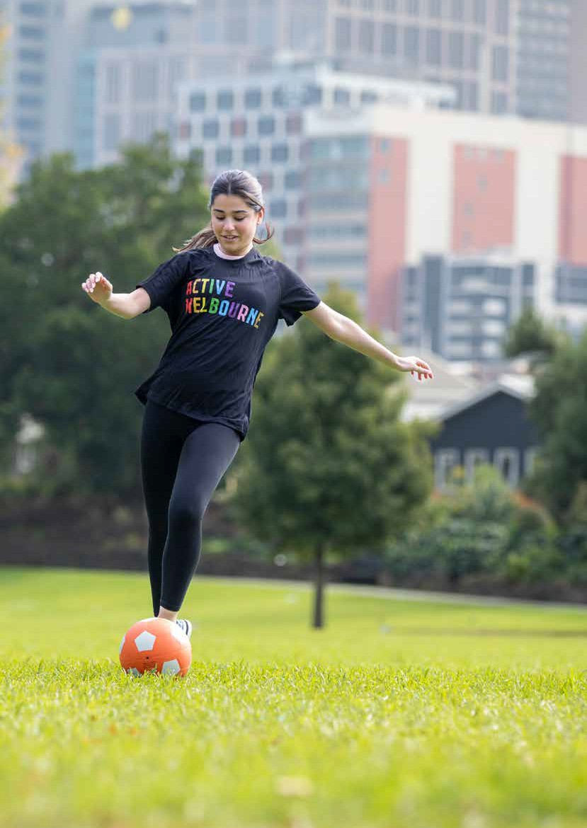

16 melbourne.vic.gov.au

APPENDICES

Appendix A - Community Sport and Recreation Facilities
The Fair Access Recreation and Sport Allocation and Use Policy applies to all current and future City of Melbourne community sports facilities, including but not limited to the following:

AREA |  |  |  | FACILITY NAME | LOCATION
1 | Sporting | fields | and | Royal Park facilities: | Parkville
 | pavilions |  |  | - Western Oval
 |  |  |  | - Western Pavilion
 |  |  |  | - Ransford Oval
 |  |  |  | - McAlister Oval
 |  |  |  | - Ryder Oval
 |  |  |  | - Ryder Pavilion
 |  |  |  | - Poplar Oval
 |  |  |  | - Poplar Pavilion
 |  |  |  | - Walker East Oval
 |  |  |  | - Walker West Oval
 |  |  |  | - Smith Oval
 |  |  |  | - Brens Oval
 |  |  |  | - Brens Pavilion
 |  |  |  | - Flemington Road Oval
 |  |  |  | - Flemington Road Oval Pavilion
 |  |  |  | - Ross Straw North Oval
 |  |  |  | - Ross Straw South Oval
 |  |  |  | - Ross Straw Pavilion
2 | Sporting | fields | and | Princes Park facilities: | Carlton
 | pavilions |  |  | - Crawford Oval
 |  |  |  | - Southern Fields
 |  |  |  | - Oval 1
 |  |  |  | - Northern Pavilion
 |  |  |  | - Southern Pavilion
3 | Sporting | fields | and | JJ Holland Park: | Kensington
 | pavilions |  |  | - Oval 1
 |  |  |  | - Oval 2
 |  |  |  | - Synthetic
 |  |  |  | - Bill Vanina Pavilion
4 | Sporting | fields | and | Fawkner Park facilities | South Yarra
 | pavilions |  |  | - Cordner Oval
 |  |  |  | - Lawn 13
 |  |  |  | - Lawn 15
 |  |  |  | - Lawn 16
 |  |  |  | - Lawn 17
 |  |  |  | - Lawn 18

Fair Access Sport and Recreation Action Plan 17

AREA |  |  | FACILITY NAME | LOCATION
4 | Sporting fields and pavilions |  | Fawkner Park facilities  - Lawn 19  - Lawn 22  - Southern Sports Area  - Northern Pavilion  - Southern Pavilion | South Yarra
5 | Sporting fields and pavilions |  | Newmarket Reserve facilities  - Newmarket Lawn  - Newmarket Reserve Pavilion | Kensington
6 | Sporting fields and pavilions |  | Ron Barassi Snr Park facilities  - Ron Barassi Snr Park Lawn  - Ron Barassi Snr Pavilion | Docklands
7 | Sporting fields and pavilions |  | Edmund Herring Oval  - Edmund Herring Pavilion | Melbourne
8 | Recreation centres |  | Melbourne City Baths | Melbourne
9 | Recreation centres |  | Carlton Baths | Carlton
10 | Recreation centres |  | Kensington Community Recreation Centre | Kensington
11 | Recreation centres |  | North Melbourne Community Centre | North Melbourne
12 | Recreation centres |  | North Melbourne Recreation Centre | North Melbourne
13 | Recreation centres |  | Riverslide Skate Park | Melbourne
14 | Recreation centres |  | Kensington Skate Park and BMX Track | Kensington
15 | Recreation centres |  | Flagstaff Gardens Multisport Courts | Melbourne
16 | Recreation centres |  | Docklands Multisport Courts | Docklands
17 | Recreation centres |  | Royal Park Golf Course | Parkville
18 | Leased / licensed |  | Rowing facilities | Alexandra Gardens
19 | Leased / licensed |  | Boating facilities | Docklands
20 | Leased / licensed |  | Carlton Gardens Tennis Courts | Carlton
21 | Leased / licensed |  | North Park Tennis Courts | Parkville
22 | Leased / licensed |  | Kensington Banks Tennis Courts | Kensington
23 | Leased / licensed |  | Princes Hill Tennis Courts | Carlton
24 | Leased / licensed |  | Parkville Tennis Courts | Parkville
25 | Leased / licensed |  | Fawkner Park Tennis Courts | South Yarra
26 | Leased / licensed |  | Powlett Reserve Tennis Courts | East Melbourne
27 | Leased / licensed |  | Royal Park Tennis Courts | Parkville
28 | Leased / licensed |  | Flemington Kensington Bowling Greens | Kensington
29 | Leased / licensed |  | Princes Park Carlton Bowling Greens | Carlton
30 | Leased / licensed |  | Flagstaff Gardens Bowling Greens | Melbourne
31 | Leased / licensed |  | North Melbourne Football Club | North Melbourne
32 | Leased / licensed |  | Carlton Football Club | Carlton
33 | Leased / licensed |  | State Fencing Centre | North Melbourne

18 melbourne.vic.gov.au

APPENDICES

Appendix B - Glossary
City of Melbourne: the local government body responsible for the municipality of Melbourne.

Community sport and recreation facilities: refer to City of Melbourne-owned or managed sport and recreation infrastructure operated and maintained primarily to facilitate community sport and recreation activities. These facilities include sporting grounds and pavilions, aquatic and recreation centres, and other sports and recreation locations.

Fair Access: refers to making community sports and recreation facilities more equitable and inclusive to increase the participation of women and girls. Opportunities to improve participation for other underrepresented groups will also be considered.

Gender equality: is where people of all genders have equal rights and opportunities. Equality does not mean that all people will become the same. Instead, their rights, responsibilities and opportunities will not depend on their gender.
Gender equity: is the provision of fairness and justice to achieve gender equality. It recognises that each person has different circumstances and allocates resources and opportunities to reach equal rights and outcomes. It means that some people might be given extra resources and opportunities to achieve outcomes equal to others.

Gender Impact Assessment: a requirement under the Gender Equality Act 2020 to be carried out on policies, programs and services that directly and significantly impact the public. The assessment must evaluate a policy, program or service’s effects on people of different genders.

The community: includes Traditional Owners, people who work, live, study, visit, pay rates or own a business in the municipality.

Underrepresented groups: groups that have lower participation rates in community sport and recreation, including women and girls, Aboriginal peoples, people with disability, multicultural communities, LGBTIQA+ and gender diverse communities.

User groups: organisations, including sporting clubs, associations, community groups, schools, commercial operators and others.

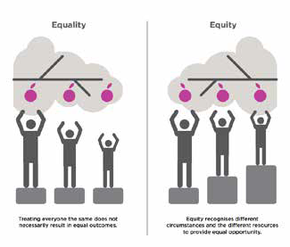
Fair Access Sport and Recreation Action Plan 19

City of Melbourne, Gender Equity Action Plan 2022-2025

How to contact us
Online:
melbourne.vic.gov.au
In person:
Melbourne Town Hall - Administration Building 120 Swanston Street, Melbourne
Business hours, Monday to Friday (Public holidays excluded)
Telephone:
03 9658 9658
Business hours, Monday to Friday (Public holidays excluded)
Fax:
03 9654 4854
In writing:
City of Melbourne GPO Box 1603
Melbourne VIC 3001 Australia
Interpreter services
We cater for people of all backgrounds Please call 03 9280 0726

03 9280 0717 | Jl-J!U!
03 9280 0719 | Bahasa Indonesia
03 9280 0720 | Italiano
03 9280 0721 | ¾iffi..i:E
03 9280 0722 | Soomaali
03 9280 0723 | Espanol
03 9280 0725 | Vi t NgC/
03 9280 0726  03 9280 0726 | o,
039280 0726
03 9280 0726 | All other languages
National Relay | Service:







If you are deaf, hearing impaired or speech-impaired,
call us via the National Relay Service: Teletypewriter (TTY) users phone 1300 555 727 then ask for 03 9658 9658
9am to 5pm, Monday to Friday (Public holidays excluded)

