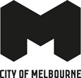
University Square
Master Plan Refresh
October 2023
Cover image: University Square Stage 1 – Photo by David Hannah
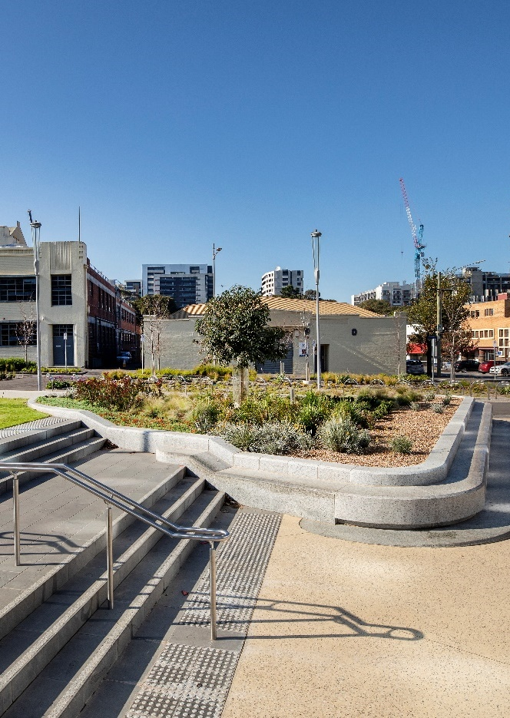

Acknowledgment of Country
University Square is located on Wurundjeri Woi-wurrung Country.
The City of Melbourne respectfully acknowledges the Traditional Owners of the land we govern, the Wurundjeri Woi-wurrung and Bunurong Boon Wurrung peoples of the Eastern Kulin and pays respect to their Elders past, present and emerging. We acknowledge and honour the unbroken spiritual, cultural and political connection the Wurundjeri, Bunurong, Dja Dja Wurrung, Taungurung and Wadawurrung peoples of the Eastern Kulin have to this unique place for more than 2000 generations. We are committed to our reconciliation journey, because at its heart, reconciliation is about strengthening relationships between Aboriginal and non-Aboriginal peoples, for the benefit of all Victorians.

Council Plan 2021 to 2025
The Council Plan 2021 to 2025 sets out our strategic direction and commitment to the community for the next four years. Based on six strategic objectives for our city, this is our detailed plan for our city’s revitalisation and considers the needs of all people who access and experience the City of Melbourne municipality. For more information visit melbourne.vic.gov.au/council-plan.
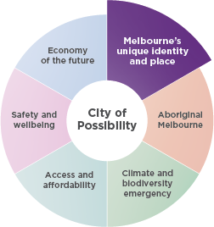

Melbourne’s unique identity and place
Melbourne is a city defined by its places, people and cultures, assets we want to celebrate and protect. Driven by our creative, entertainment and education sectors we will ensure Melbourne remains a unique, vibrant and creative city with world-leading liveability.
Contents
Foreword from the Lord Mayor of Melbourne 7
Introduction 8
Context 8
Purpose of this Master Plan Refresh 8
Community snapshot 8
What is driving the Master Plan Refresh? 9
The 2016 Master Plan 10
What has been implemented at University Square since the Master Plan was endorsed in 2016? 11
The Master Plan Refresh 13
Master Plan Refresh Actions 16
Uses and Activities 24
Master Plan Refresh Outcomes 25
Implementation Plan 30
Issue 02 – University Square Master Plan Refresh
October 2023
Disclaimer
This report is provided for information and it does not purport to be complete. While care has been taken to ensure the content in the report is accurate, we cannot guarantee it is without flaw of any kind. There may be errors and omissions or it may not be wholly appropriate for your particular purposes. In addition, the publication is a snapshot in time based on historic information which is liable to change. The City of Melbourne accepts no responsibility and disclaims all liability for any error, loss or other consequence which may arise from you relying on any information contained in this report.
To find out how you can participate in the decision-making process for City of Melbourne’s current and future initiatives, visit our website

Image 1: University Square Stage 1 – Photo by David Hannah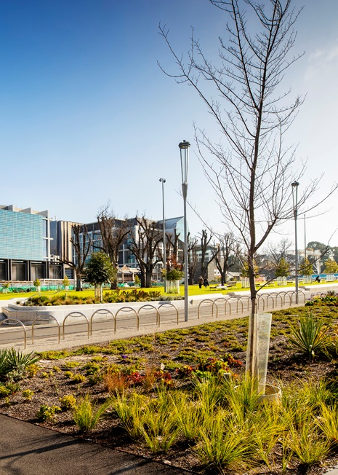

Foreword from the Lord Mayor of Melbourne and Councillor
Image 2: Lord Mayor Sally Capp

Image 3: Councillor Rohan Leppert



University Square Master Plan Refresh
University Square is one of Carlton’s oldest and most-loved public squares. It sits within a well-established and growing neighbourhood that enjoys a mix of uses – education, health, research, commercial and residential.
We’re transforming University Square to create a world-class space on the doorstep of one of the city’s newest public transport hubs. Once complete, our new-look University Square will be a lush green area for the community to enjoy. It will deliver more than 6500 square metres of public open space, garden beds, new lawns and hundreds of new trees.
We will improve connections between the new Parkville Station and University Square through Barry Plaza. The community can also dwell and enjoy barbecue areas, shady spaces and a multi-purpose sports court.
Stormwater will be redirected and reused, while cooling infrastructure and an increased tree canopy cover will reduce the urban heat island effect, all part of our ongoing response to the changing climate.
The City of Melbourne launched the original Master Plan for University Square in 2016. Since then, the Metro Tunnel Project’s Parkville Station and the 2019 MPavilion installation have significantly changed University Square and the surrounding area.
The first stage of the original master plan was completed in 2019, and delivered a large new open space with additional trees, a biodiverse garden, seating and terrace spaces. Stage 2 was paused to allow work on the Metro Tunnel Project. With this work almost complete, we’re refreshing the Master Plan to pick up where we left off with Stage 2 of University Square – and to update our community to make sure we deliver on your aspirations for this significant public space.
We’re working closely with residents, businesses and stakeholders, including the University of Melbourne, and Wurundjeri elders, as we plan for the future of this important community space. We’re also releasing a draft concept design for Stage 2; and we’ll seek feedback in October and November ahead of a final concept design in early 2024. Please let us know what you think about the future of your public square.

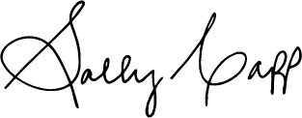
Sally Capp
Lord Mayor

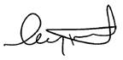
Councillor Rohan Leppert
Environment Portfolio Lead

Introduction

Context
University Square (the Square) is of significant strategic and community value. It is located within the diverse suburb of Carlton, adjacent to the Central City and Parkville neighbourhoods.
Located in the ‘City North’ precinct, University Square sits within a well-established, globally-renowned and growing area of mixed uses including educational, health, research, commercial and residential. It is part of a broader network of parks in the area including Lincoln Square and Argyle Square. The Square is immediately surrounded by University of Melbourne landholdings.
University Square is classified as a ‘Neighbourhood open space’ within the City of Melbourne Open Space Strategy 2012. This classification means that the Square should function for “neighbourhood use within walking distance of home with a diversity of character and facilities that appeal to the local community at a neighbourhood level. This means a family or groups of people can visit the park for an extended time, with a suitable range of facilities to meet their different needs….”. Over 80 per cent of dwellings in Carlton are apartments or flats, placing additional demand on the role of public open space to serve as a high-quality place to meet, gather and rest.

Purpose of this Master Plan Refresh
The Master Plan Refresh is guided by the engagement, vision, principles and actions identified and endorsed in the 2016 Master Plan.
The purpose of this Refresh is to update the University Square Master Plan 2016 in light of three drivers:
- The site context has evolved
- City of Melbourne policies and strategies have progressed over the past seven years
- The University Square Master Plan 2016 reached the end of its implementation plan in 2022.
These drivers are discussed further on page 9.
This document updates the actions, outcomes and implementation plan in relation to the three drivers. It is to be read in conjunction with the 2016 Master Plan.

Community snapshot
Carlton is set to grow significantly over the next 20 years...
Currently, 17185 people live in Carlton (SGS Economics, 2021).
In 2041, the population is forecast to grow to 35877 (SGS Economics, 2021).
27 is the median age of the Carlton population compared to 30 for the City of Melbourne (ABS, 2021).
81 per cent of dwellings are apartments or flats (ABS, 2021).
The number of households between 2021 and 2041 will grow by 83 per cent (SGS Economics, 2021).
The number of jobs between 2021 and 2041 will grow by 82 per cent (SGS Economics, 2021).
The adjacent neighbourhoods of the Central Business District and Parkville are set to grow by 104 per cent and 65 per cent respectively in population by 2041 (SGS Economics, 2021).

What is driving the Master Plan Refresh?
1. The site context has evolved
Since the 2016 Master Plan’s endorsement, two major developments have occurred within University Square - Metro Tunnel’s Parkville Station and installation of the 2019 MPavilion.
The development of the new Parkville Station has introduced buildings and rail infrastructure into the Square. It will also increase demands on the Square as both a transport hub and the nearest public open space serving the surrounding university and health precinct. Rail infrastructure has been accounted for in the Master Plan Refresh to ensure that the immediate and long-term needs of the site and community are addressed.
In 2022, City of Melbourne granted a licence to the University of Melbourne to install the 2019 MPavilion in University Square. Its purpose is to provide “a public structure of general architecture interest that can be used for events and activities and is available for public use”. The licence was granted for a ten year term from January 2022 to January 2032. At the completion of the licence, the pavilion will be removed and the area reverted to lawn.
2. City of Melbourne policies and strategies have progressed over the past seven years
The 2016 Master Plan recognised the critical role of University Square in responding to contextual changes of the site while also building on its layers of history. Since the 2016 Master Plan, a number of City of Melbourne documents have been endorsed which set updated targets for the Square.
Policies and strategies relevant to the Refresh include:
- The Municipal Integrated Water Management Plan (2017)
- The Nature in the City Strategy (2017) which aims to create and maintain healthy ecosystems and thriving biodiversity within the city.
- Skate Melbourne Plan (2017-2027)
- Melbourne Innovation Districts City North Opportunities Plan (2020)
- Public Art Framework (2021-2031)
- Design and Construction Standards (2022)
- Innovate Reconciliation Action Plan (2021-2023)
- Disability Access and Inclusion Plan (2020-2024)
3. The University Square Master Plan 2016 reached the end of its implementation plan in 2022
The 2016 Master Plan set the vision for University Square and included a short and medium-term implementation plan, up to the year 2022.
This document ensures relevance and continuity of the vision. It also assesses the implementation status of the Master Plan actions to ensure momentum for years to come.

The 2016 Master Plan
The Master Plan 2016 outlines the vision for University Square. It was developed from years of community engagement and is guided by three overarching principles, which are still relevant today. Ten major actions were identified to realise the vision. An implementation plan outlined projected delivery phases.

2016 Master Plan Principles
- A connection to the past
- Meeting the needs of the future
- Balancing priorities in a limited space
Figure 3: 2016 Master Plan Diagram
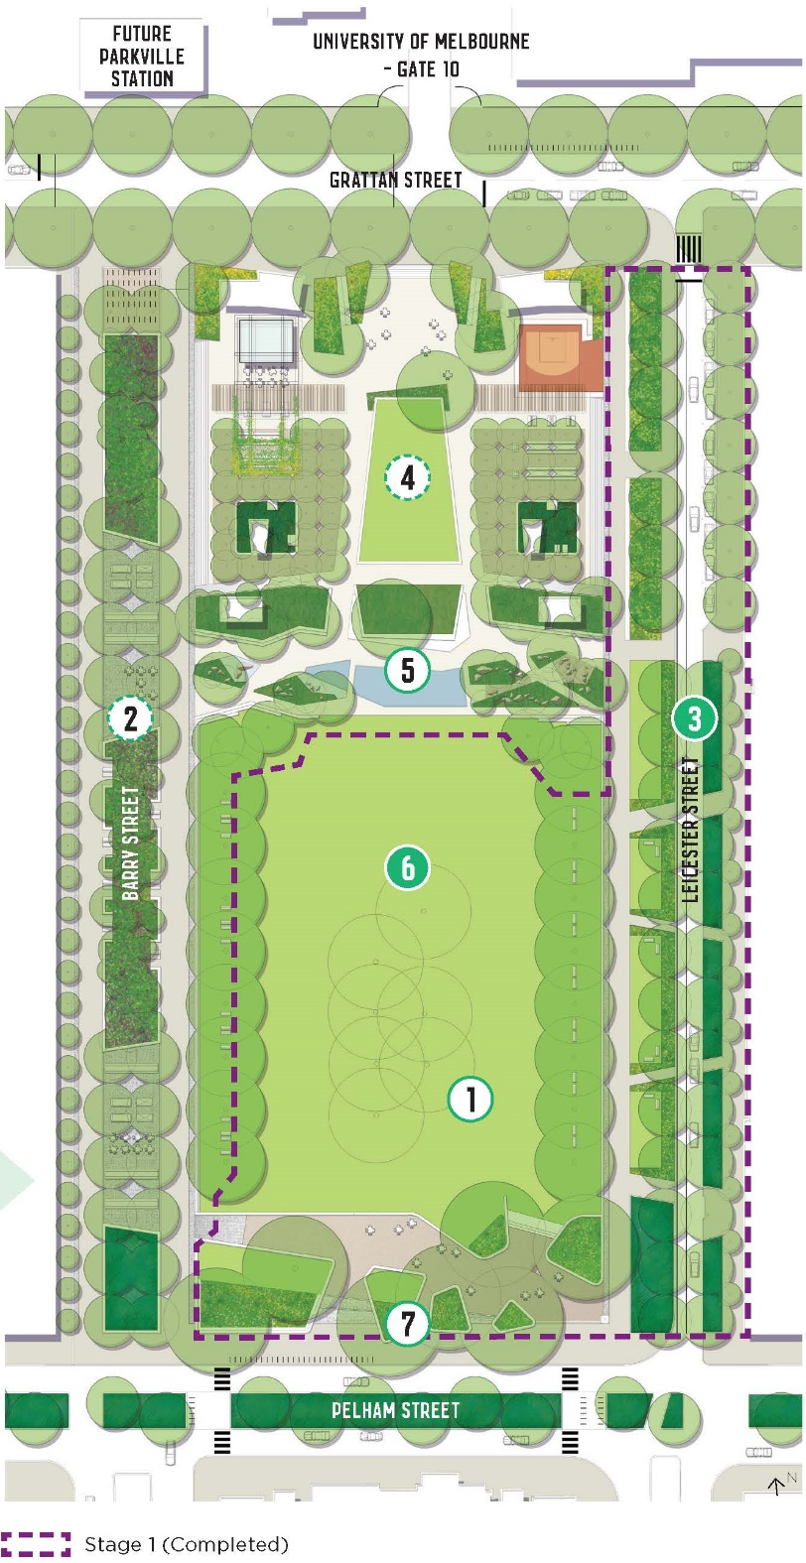

What has been implemented at University Square since the Master Plan was endorsed in 2016?
Since the 2016 Master Plan was endorsed, several actions have been progressed. Two of the ten main actions have been fully implemented. In 2019, Stage 1 of the University Square delivery installed approximately 3600m2 of new public open space. The following is a summary of the actions and their corresponding items that have been delivered since 2016.
2016 Master Plan Actions | Progress
1. Tree planting and succession | Partially implemented - 85 trees planted in 2019
2. Barry Street new park spaces | Not yet implemented
3. Leicester Street road within a park | Implementation complete  - Approximately 3,600m² of new public open space installed in 2019
4. Plaza and Grattan Street | Not yet implemented
5. Water Terrace | Partially implemented  - Installation of underground storm water storage tank for irrigation, which is linked to Lincoln Square
6. The Green | Implementation complete  - Creating a unified lawn
7. Pelham Street parkfront and biodiversity corridor | Partially implemented  - New central park entrance at Pelham Street installed in 2019
8. Creating social spaces | Partially implemented  - Implementation of seating and gathering spaces  - Installation of the 2019 MPavilion serving as a venue for public and educational events
9. Building a living laboratory | Partially implemented  - Australian Native Grassland and Wildflower planting trial  - Water sensors installed to understand water movement  - Materiality trials, including permeable pavement treatments
10. Integrated public art vision | Partially implemented  - Two temporary public art commissions were installed across 2021-22. Sean Lynch’s installation, ‘Distant Things Appear Suddenly Near’, will remain in the northern plaza for a period of up to five years (2026)

The Master Plan Refresh
The Master Plan Refresh adopts the three principles from the 2016 Master Plan. Actions have been updated in response to the drivers of this Master Plan Refresh and are informed by the principles.
The updated actions build on what has already been implemented to achieve a cohesive and high-quality public open space.
Master Plan Refresh Drivers
- The site context has evolved
- City of Melbourne policies and strategies have progressed over the past seven years
- The Master Plan 2016 reached the end of its implementation plan in 2022
The Master Plan Refresh will aim to deliver:
- Over 6500m² of additional public open space
- Over 3500m² of new garden beds
- Over 2200m² of new lawn
- 41 per cent tree canopy cover
Master Plan Refresh Principles
- A connection to the past
- Meeting the needs of the future
- Balancing priorities in a limited space
Master Plan Refresh Actions | Progress
1. Tree planting and succession | To further deliver
2. Barry Street new park spaces | To further deliver
3. Leicester Street road within a park | Complete/mostly complete
4. Plaza and Grattan Street | To further deliver
5. Water Story | To further deliver
6. The Green | Complete/mostly complete
7. Pelham Street parkfront | Complete/mostly complete
8. Creating social spaces | To further deliver
9. Building a living laboratory | To further deliver
10. Integrated public art vision | To further deliver
Figure 4: The Master Plan Refresh Diagram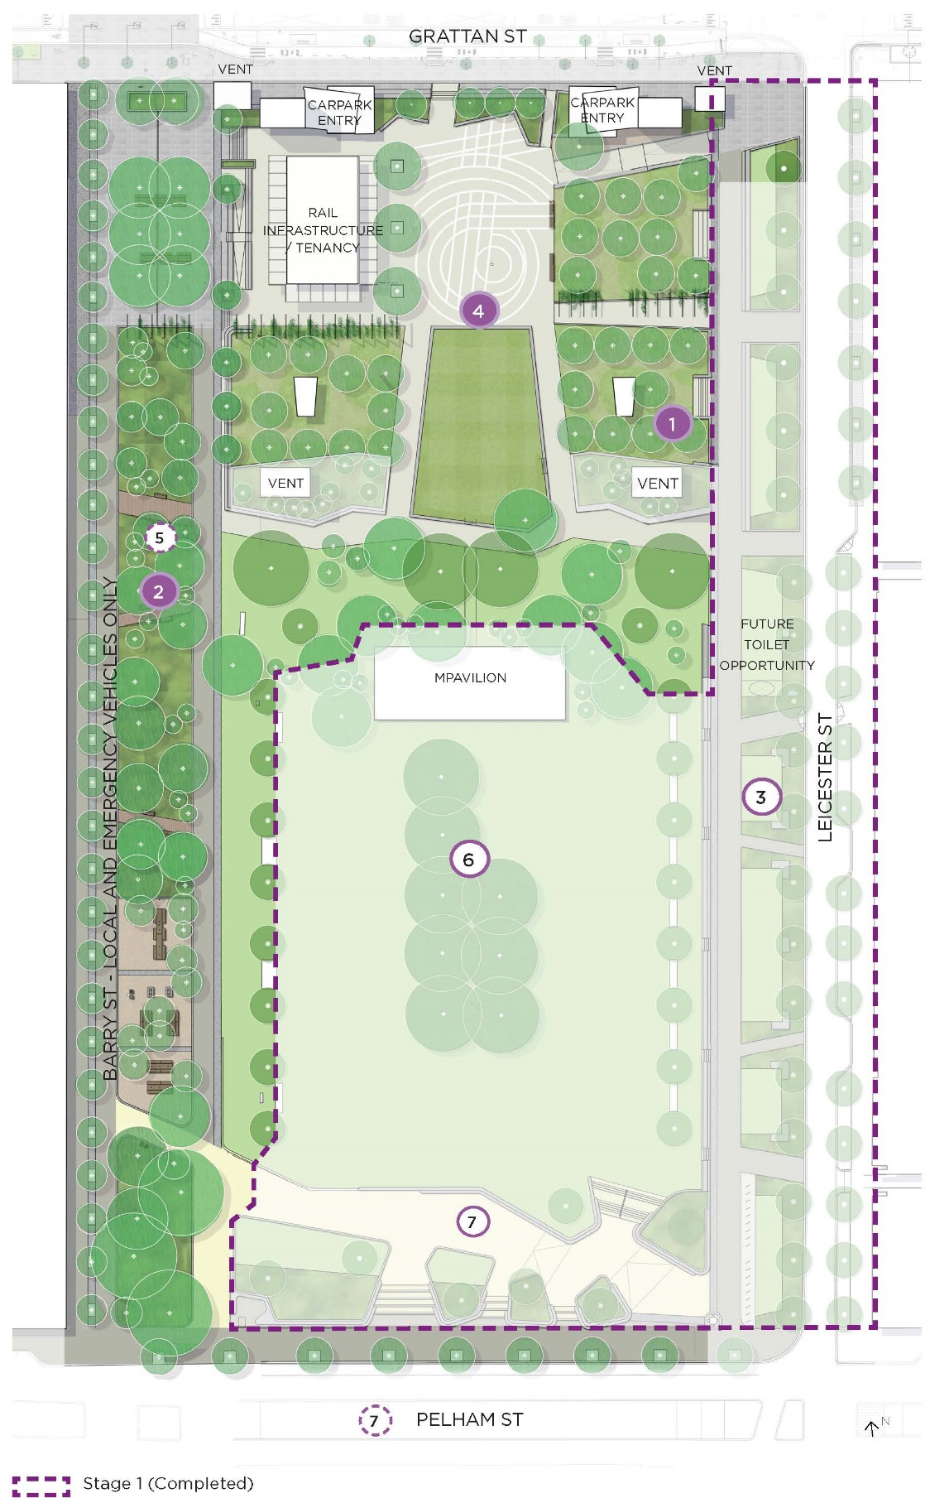

Image 5: University Square garden bed - Photo by David Hannah
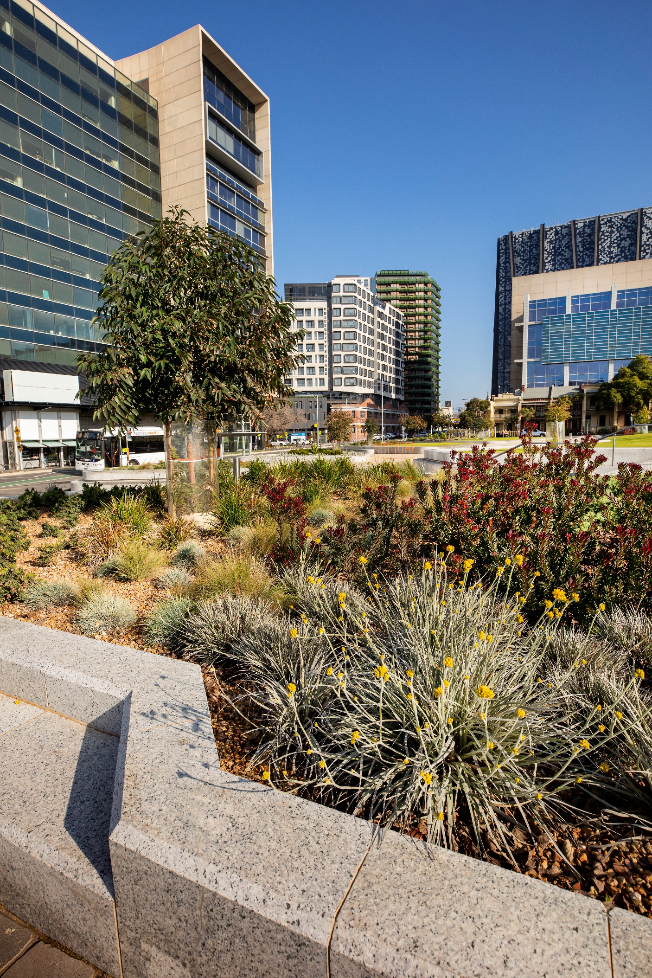

Master Plan Refresh Actions
Action | 2016 Master Plan Actions Summary | 2023 Master Plan Actions Summary
- Tree planting and succession Image 6: Tree planting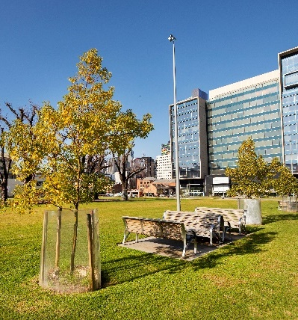 | Create a new urban forest at University Square, with the addition of almost 250 new trees (48 per cent overall canopy cover). To maintain the square’s distinctive leafy profile, we must strike a balance between retaining and removing the declining mature Elm trees in order to start planting new trees to keep the park looking green for generations to come. | Create a new urban forest at University Square by increasing overall canopy cover to 41 per cent.  Reasons for change: canopy cover measures are more impactful than counting the total number of trees (City of Melbourne Urban Forest Strategy 2012). The mature Elm trees retained within the Green have been kept short term for canopy and habitat value, and will be replaced with grass at the end of their lifespan.
- Barry Street New Park Spaces Image 7: Barry Street - artist impression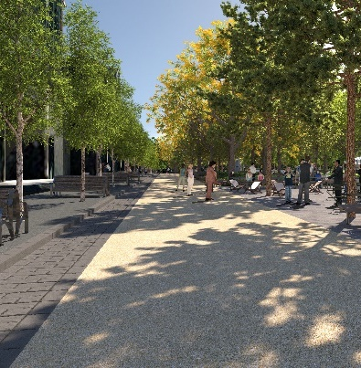 | Increase the size of the square by closing Barry Street to traffic and car parking. Expand the lawn, plant new trees, establish new gardens beds and create ‘new park spaces’ with additional seating, communal tables and movable furniture. These spaces can be suitable for small events, food vans and public art installations. | Increase the size of the square by closing Barry Street to general traffic and car parking - only allowing emergency vehicles and approved maintenance access. Ensure the extension is seamlessly integrated with the existing Square and new Metro Tunnel context. The extension will:  - Increase vegetation and create new social spaces  - Celebrate water and investigate opportunities to bring it to the surface  - Explore the opportunities to advance the goals of the Nature in the City Strategy (2017).  Reasons for change: The celebration of water has been relocated to this area as it can no longer be accommodated in the 2016 Master Plan location due to installation of the 2019 MPavilion and new Metro Tunnel station.
- Leicester Street Road within a Park Image 8: Leicester Street road within a park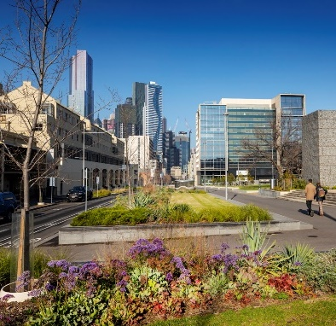 | Reduce the width of Leicester Street and maintain northbound traffic only to retain essential bus services, bicycles and traffic while enlarging the square. Leicester Street will become a ‘road within a park’ that can be easily crossed by pedestrians and is lined with trees. The smaller road will also allow space for new shared perimeter paths and a dedicated bike lane. | This action was completed in 2019.
- Plaza and Grattan Street Image 9: Aerial view of the central plaza – artist impression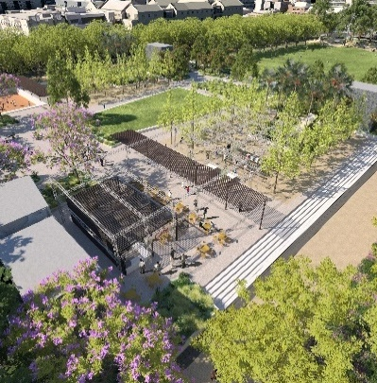 | Build a new heart for University Square in a re-designed plaza. New features include diverse trees and gardens, a recessed basketball half-court, table tennis and chess boards. Communal tables with Wi-Fi and charging points will create an outdoor study space, while barbecues and picnic tables provide space for socialising and relaxation beside a new cafe. | Build a new heart for University Square in a re-designed plaza. New features include diverse trees and gardens, a multi-purpose informal sports court, table tennis, chess boards, informal recreation and places to socialise and study. Metro tunnel infrastructure including the ‘chiller building’ will be tenanted to activate the square and may include innovation, social and/or food and beverage uses.  Reasons for change: multi-purpose informal sports court provide more uses for diverse people and will replace the 2016 proposed basketball half court. The path network, some social amenities, barbeque and public toilet will be located in other areas of the Square, in response to the new Metro Tunnel Train Station Chiller Building and tenancy, ventilation shafts and associated infrastructure.
- Water Story Image 10: Water story – precedent image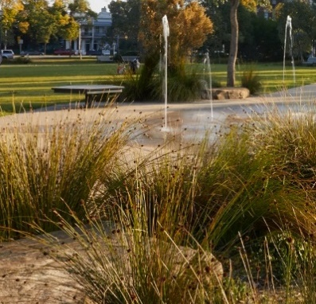 | Water terrace: A transition from the Plaza to The Green will be created with a Water Terrace. The new space will include trees, gardens and aquatic plantings with a focus on water.  The space will feature water jets and misters, public art and play. | Water story: University Square sits on the ‘headwaters’ of the Elizabeth Street catchment, just north of the fork between the historical watercourse of Bouverie and Elizabeth Street Creeks. These creeks represent biodiversity and knowledge pathways to the Wurundjeri People, the traditional owners of the land. Wurundjeri are also known as freshwater people, due to the environment they manage of their Country.  Water story will be represented and celebrated at University Square through:  - Exposed water elements in the Barry Street Park extension, featuring native and indigenous planting  - Utilise Integrated Water Management strategies where possible, including understanding of Elizabeth Street catchment and use of indigenous planting to cleanse water  - Continued engagement with Wurundjeri  - Continued use of recycled water sources for irrigation on site  Reasons for change: Installation of the 2019 MPavilion in University Square has necessitated the relocation of the water element. The Master Plan Refresh pivots the 2016 action to better represent the historical use and significance of water on the site to the Wurundjeri People and to reflect the Municipal Integrated Water Management Plan (2017).
- The Green Image 11: The green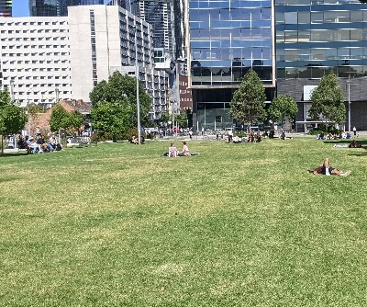 | Expand and improve the square’s much-loved lawn area. Remove the existing central and diagonal paths to create a single unified lawn space. Build new perimeter paths along Leicester and Barry streets to become new pedestrian thoroughfares for access through the park from Grattan Street, the new Parkville Station and to adjacent sites and buildings. | This action was completed in 2019.
- Pelham Street Parkfront Image 12: Pelham Street parkfront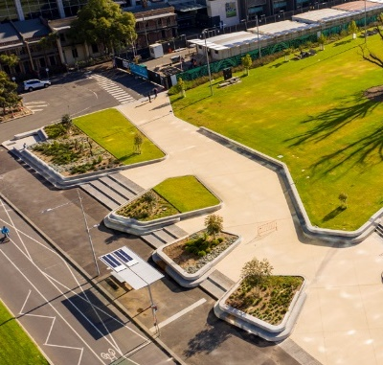 | Pelham Street Parkfront and Biodiversity Corridor: Replace the current single central entrance with a new park entrance and address at Pelham Street. Pelham Street itself will be transformed into a green corridor linking University and Lincoln Squares, by replacing central street parking with new trees. The median strip will also be reconfigured as a water sensitive garden. | Pelham Street Parkfront: The central entrance along Pelham Street was completed in 2019.  Pelham Biodiversity Corridor reasons for change: Pelham Street Biodiversity Corridor extends from Rathdowne Street to Elizabeth Street, linking University Square, Argyle Square and Lincoln Square (Carlton Urban Forest Precinct Plan 2013-2023). To ensure a holistic network approach to the Corridor, it has been removed from this Master Plan Refresh and be considered at an Urban Forest Precinct Pan level.
- Creating Social Spaces Image 13: Social space bordering the green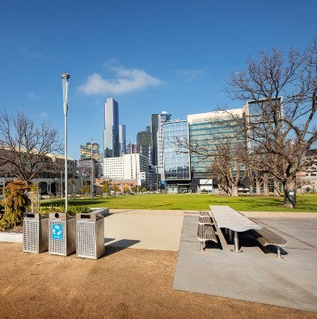 | Design and locate park elements that meet the needs of social, accessible and connected spaces in the new park including seating, lighting, bicycle infrastructure, picnic, barbecue facilities, drinking fountains and bins. Focus on both permanently fixed and movable park elements and incorporate technology to meet the needs of an education and innovation precinct. | Design and locate park elements that foster social, accessible and connected spaces. Provide park elements (furniture, facilities, lighting, bicycle infrastructure, picnic, barbecue facilities, drinking fountains, bins and technology infrastructure etc.) that enhance the Square’s role within the Melbourne Innovation District City North precinct.  Management:  - Investigate opportunity for sports equipment library at Chiller Building tenancy.  - Monitor the use of the barbeques and park furniture for the proposed Barry Street social spaces.  - Monitor the use of the informal active recreation equipment proposed in the plaza such as basketball / netball ring.  - Maintain amenity assets to a good standard, and provide new seats, drinking fountains, signage and public lighting as required.  - Minor upgrades, additions or adjustments to the current open space facilities may be considered if community need or demand is demonstrated and the changes do not impact on the amenity value or presentation of University Square.
- Building a Living Laboratory Image 14: Urban cooling precedent image – misting.   | Provide opportunities and infrastructure that encourages research and prototyping in fields such as alternative energy sources, biodiversity, air quality, heat-island-effect, and connect with the University of Melbourne’s research aspirations. | Provide opportunities and infrastructure for research and prototyping that aligns with Melbourne Innovation Districts City North Opportunities Plan (2020) and supports City of Melbourne sustainability investigations, including cooling infrastructure interventions.  Reasons for change: Established in 2017, Melbourne Innovation Districts is a partnership between the City of Melbourne, Royal Melbourne Institute of Technology University, and the University of Melbourne, to develop urban innovations in Melbourne, for the benefit of the whole city. University Square is located within the Melbourne Innovation District City North area. To maximise impact, this Action will align with Melbourne Innovation District ambitions.
- Integrated Public Art Vision Image 15: Public art installation in the northern plaza of University Square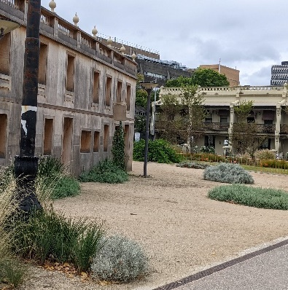 | Integrate art into University Square from the design phase through a strategic creative vision that enables art to be a fundamental component of the site’s design, grounded in the essential values and priorities underlying the re-imagination of the space. Implement an art program that is inclusive, coherent, well-considered in relation to the evolving context, and that produces suitably innovative works capable of animating public awareness and imagination. | Integrate art into University Square that is responsive to its context and aligns with City of Melbourne’s Public Art Framework (2021-2031).  Reasons for change: The Public Art Framework (2021-2031) provides guiding principles, priorities and deliverables for public art in the municipality, including University Square.

Image 16: Leicester Street road within a park - Photo by David Hannah
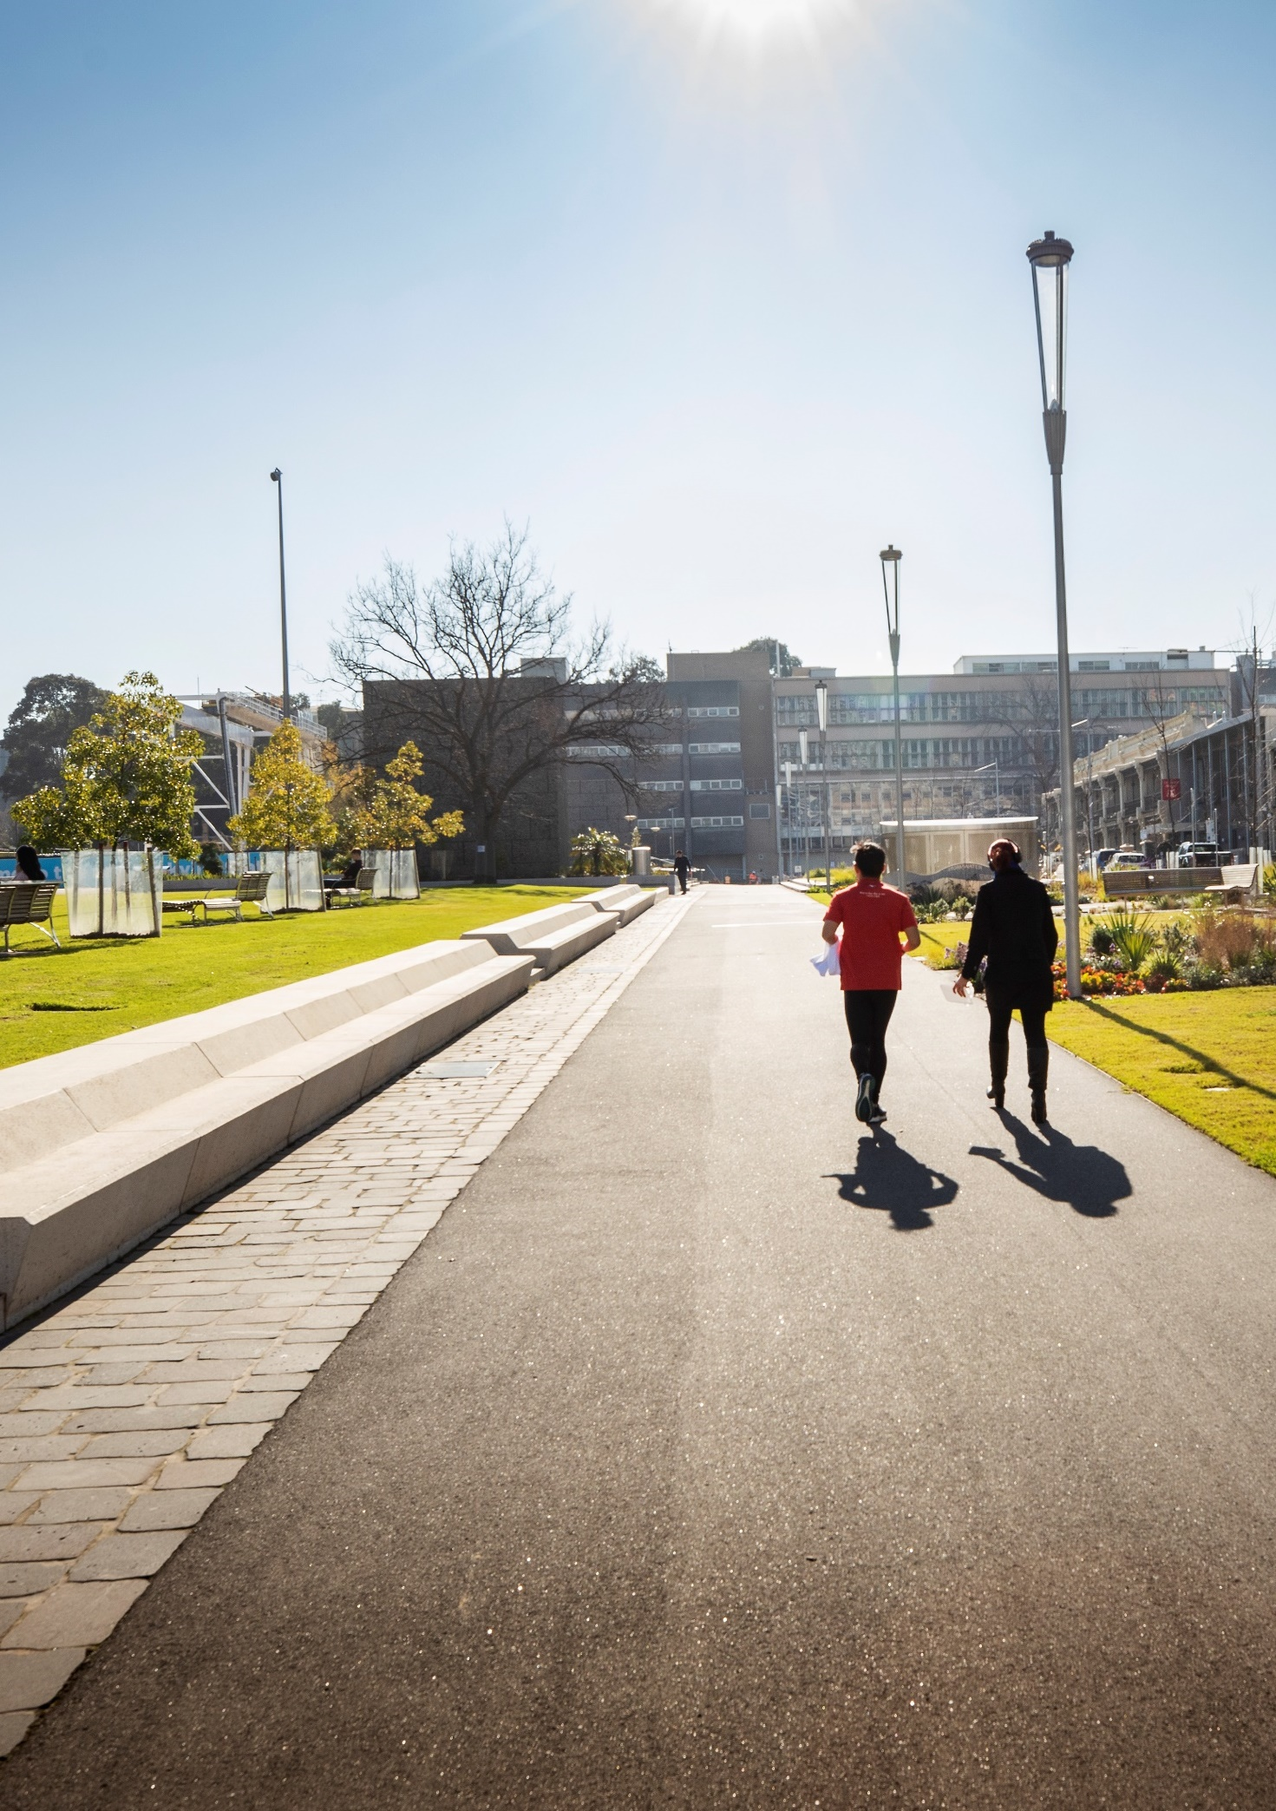
Image 17: Pelham Street parkfront - Photo by David Hannah
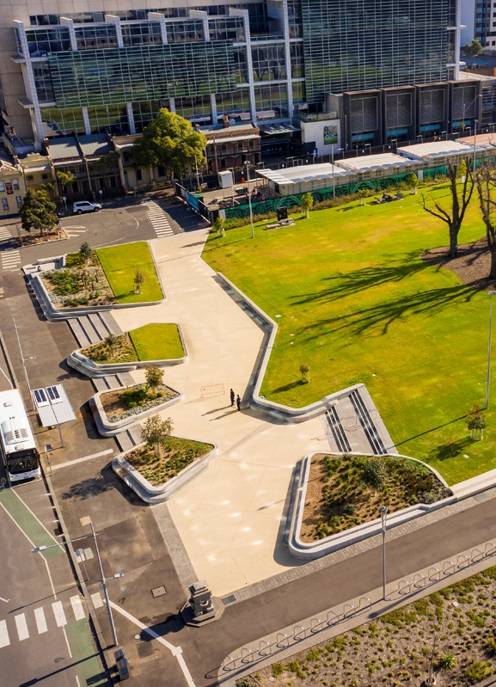

Uses and Activities
This chapter has been added to the Master Plan Refresh to provide clarity of the expected types of use at University Square.
As a neighbourhood open space, University Square supports a range of passive and informal recreational uses, along with booked activities. The Master Plan Refresh proposes an expansion of informal active recreation offerings, social gathering opportunities, increased use as a movement corridor and provision for booked activities.
Events are managed by both the City of Melbourne (for the Square) and University of Melbourne (for MPavilion). It is envisaged that event and other permit bookings will continue at University Square in line with standard City of Melbourne management and booking procedures. Larger activities on the plaza are not encouraged given the load limits for the University of Melbourne carpark structure underneath, and the need to maintain access to the informal recreation facilities.
Bookings for the MPavilion are coordinated by the University of Melbourne, with notification provided to the City of Melbourne. No other temporary structures would be considered in University Square, beyond those utilised during events.
The Skate Melbourne Plan (2017) recognises skating as a legitimate activity, with a range of benefits to the city, general community and individuals. It is particularly popular amongst young people, who form a larger than average proportion of the surrounding Carlton population. Skating use safely integrated into areas at University Square is supported to create vibrant, inclusive and multi-use spaces.

Recommendations:
General
- Continue to manage University Square as primarily a passive recreation space, to meet the open space needs of the Carlton community, with a particular focus on tertiary students and staff, nearby residents, health precinct staff and area commuters.
- Encourage the use of the plaza area as an informal active recreation space, with a multipurpose court and relocated outdoor table tennis tables. Formal, organised active recreation activities or sports are not supported.
- Acknowledge skating as a welcomed activity in some areas of the square, recognising it as an inclusive and accessible activity providing health, social and economic benefits, to be managed in line with council policies.
Bookings
- Continue to manage University Square for events and other permitted activities, avoiding impact on regular passive and active recreational opportunities.
- Event bookings for the plaza should not be considered to ensure general public availability of this informal active open space at all times, unless by exception and subject to load limits (e.g. University Open Day).
- Continue to coordinate bookings for the MPavilion with the University of Melbourne, ensuring the pavilion and adjacent lawn are not booked for separate events at any one time (see section ‘Facilities’).

Master Plan Refresh Outcomes
The combined actions of the University Square Master Plan Refresh will deliver the following outcomes from 2019 onwards.

Park expansion
Figure 18: Diagram of park expansion and land tenure
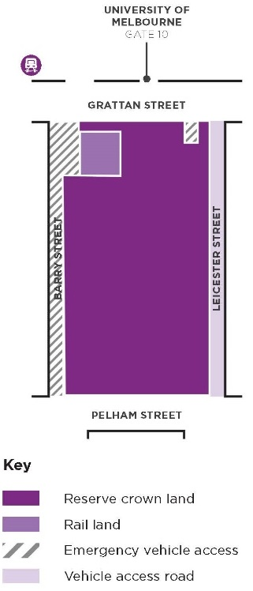
The Master Plan Refresh includes:
- Over 6500m² of new public open space, unlocking Leicester Street and Barry Street from streetscape to more open space
- Over 600m² of beautified rail land

Car parking and traffic
Figure 19: Diagram of traffic routes and stops
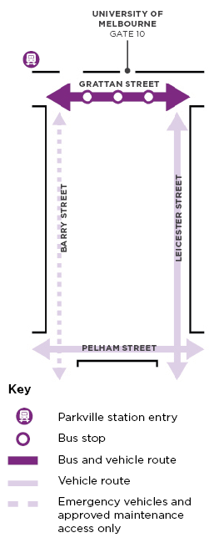
The Master Plan Refresh includes:
- Grattan Street as a bus corridor with new traffic function to integrate with Parkville Station
- Barry Street for emergency vehicles and approved maintenance access only
- Leicester Street for north bound local traffic only

Prioritising pedestrians
Figure 20: Diagram of pedestrian routes
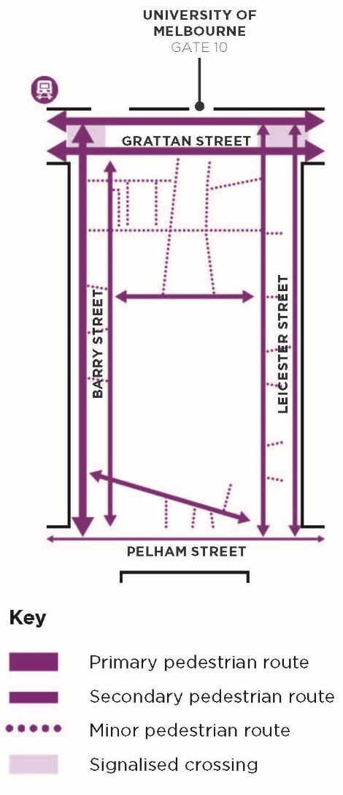
The Master Plan Refresh includes:
- Clear hierarchy of pedestrian routes of all sizes and uses
- Signalised crossings across Grattan Street
- Provide accessible routes where possible

Urban forest
Figure 21: Diagram of tree canopy cover
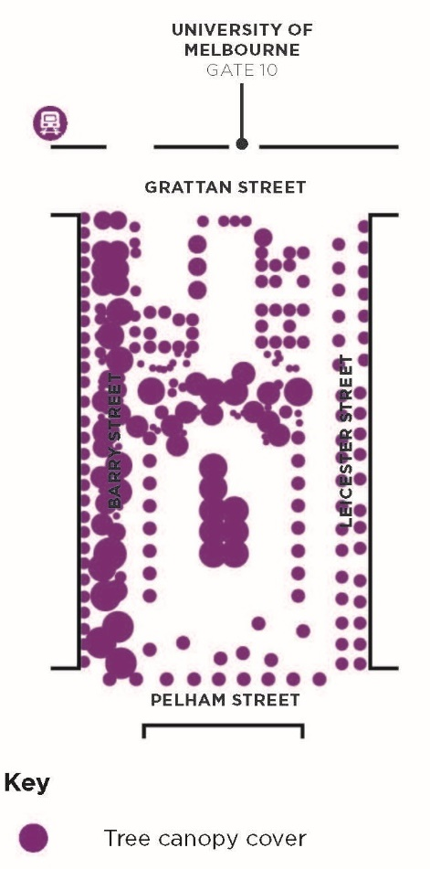
The Master Plan Refresh includes:
- 41 per cent tree canopy cover
- Diverse mix of exotic, native, evergreen and deciduous species

Urban heat island and biodiversity
Figure 22: Diagram of lawn and plant areas
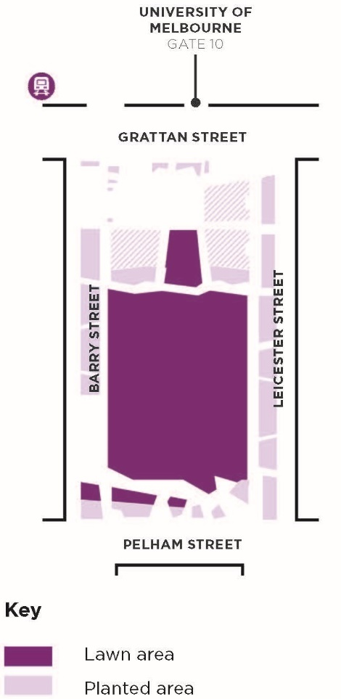
The Master Plan Refresh includes:
- Over 2200m² of new lawn
- Over 3500m² of new garden beds

Implementation Plan
The Master Plan Refresh actions are proposed along the following timeline, subject to relevant approvals and detail design:
Action | Timeline
3 - Leicester Street road within a park | Completed 2016 to 2022. Constructed in 2019
6 - The Green | Completed 2016 to 2022. Constructed in 2019
7 - Pelham Street parkfront | Pelham Street parkfront completed 2016 to 2022. Biodiversity corridor removed from scope.
Release Master Plan Refresh and consult community on Draft Concept Design | 2023 to 2024. Completed by early 2024
Rail Projects Victoria Land reinstatement by other (Refer Appendix 1 for land ownership distributions across University Square) | 2023 to 2024. Completed by late 2024
2 - Barry Street new park spaces | 2023 to 2025
5 - Water Story | 2023 to 2025
4 - Plaza and Grattan Street | 2024 to 2026
1 - Tree Planting and succession | Started 2016 and ongoing into the future
8 - Creating social spaces | Started 2016 and ongoing into the future
9 - Building a living laboratory | Started 2016 and ongoing into the future
10 - Integrated public art vision | Started 2017 and ongoing into the future

Appendix 1 – Current and Proposed Land Management Arrangement
Figure 23: Diagram of current and proposed land management
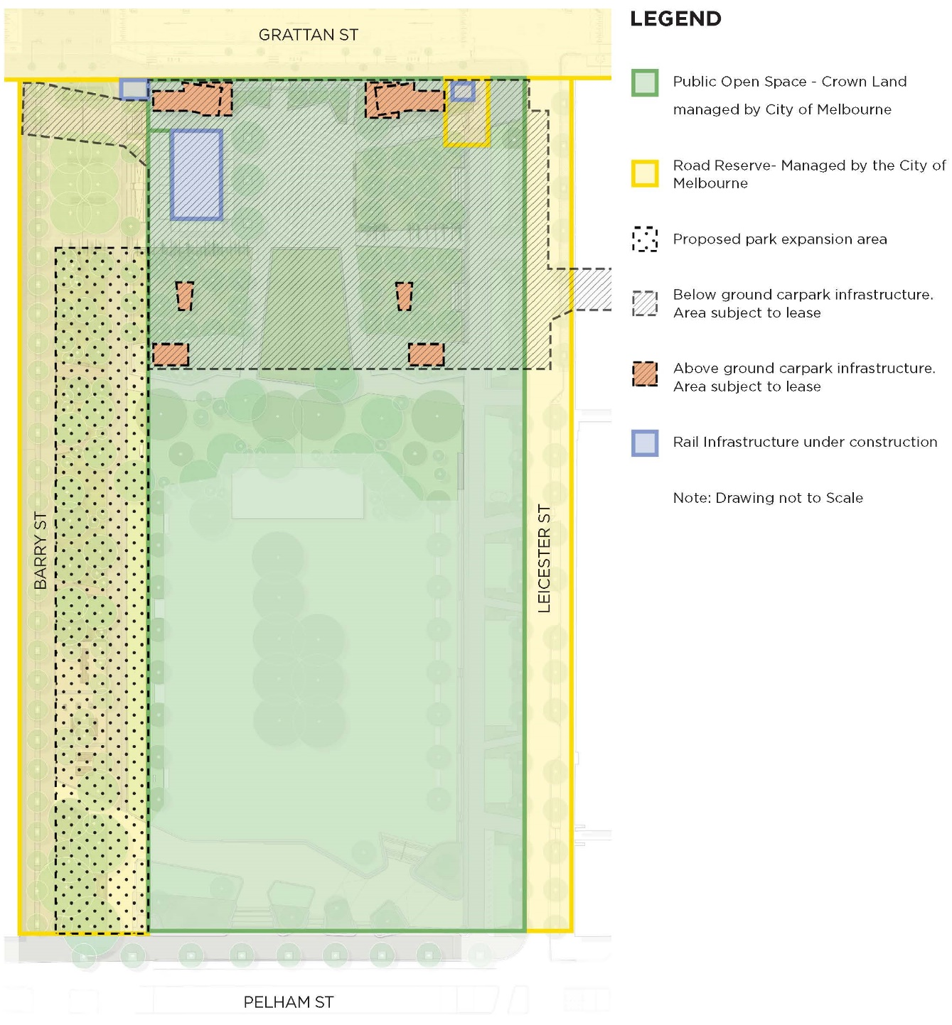

Appendix 2 – References
ABS (Australian Bureau of Statistics), 2021, 2021 Census of Population and Housing [TableBuilder], ABS website, accessed 16 June 2023. [ABS format]
City of Melbourne, 2021, Council Plan 2021-25, accessed 16 June 2023. https://www.melbourne.vic.gov.au/about-council/vision-goals/Pages/council-plan.aspx
City of Melbourne, 2021, Council Plan 2021-25, accessed 16 June 2023. https://www.melbourne.vic.gov.au/about-council/vision-goals/Pages/council-plan.aspx
City of Melbourne, 2012, Open Space Strategy 2012, accessed 16 June 2023. https://www.melbourne.vic.gov.au/community/parks-open-spaces/policies-plans/pages/open-space-strategy.aspx
City of Melbourne, n.d., University Square Master Plan 2016, accessed 16 June 2023. https://participate.melbourne.vic.gov.au/universitysquare
City of Melbourne, 2016, University Square Master Plan 2016, accessed 16 June 2023. https://participate.melbourne.vic.gov.au/universitysquare
City of Melbourne, 2017, Municipal Integrated Water Management Plan 2017, accessed 16 June 2023. https://www.melbourne.vic.gov.au/about-council/vision-goals/eco-city/Pages/municipal-integrated-water-management.aspx
City of Melbourne, 2017, Nature in the City Strategy 2017, accessed 16 June 2023. https://www.melbourne.vic.gov.au/community/greening-the-city/urban-nature/pages/nature-in-the-city-strategy.aspx
City of Melbourne, 2017, Skate Melbourne Plan 2017-2027, accessed 16 June 2023. https://participate.melbourne.vic.gov.au/skate
City of Melbourne, 2020, Melbourne Innovation Districts City North Opportunities Plan 2020, accessed 16 June 2023. https://participate.melbourne.vic.gov.au/melbourne-innovation-districts/city-north-opportunities-plan
City of Melbourne, 2021, Public Art Framework 2021-2031, accessed 16 June 2023. https://www.melbourne.vic.gov.au/arts-and-culture/strategies-support/pages/public-art-framework.aspx
City of Melbourne, 2022, Design and Construction Standards 2022, accessed 16 June 2023. https://www.melbourne.vic.gov.au/building-and-development/standards-specifications/pages/design-standards.aspx
City of Melbourne, 2012, Urban Forest Strategy: Making a Great City Greener 2012-2032, accessed 16 June 2023. https://www.melbourne.vic.gov.au/community/greening-the-city/urban-forest/pages/urban-forest-strategy.aspx
City of Melbourne, 2013, Carlton Urban Forest Precinct Plan 2013-2023, accessed 16 June 2023. https://www.melbourne.vic.gov.au/community/greening-the-city/urban-forest/pages/urban-forest-precinct-plans.aspx
SGS Economics, 2021, City of Melbourne Population Forecasts by Small Area 2021-2041 [OpenData], City of Melbourne Open Data website, accessed 16 June 2023. [OpenData format]

Appendix 3 – Photo References
Cover image. University Square, David Hannah
Image 1. University Square, David Hannah
Image 5. University Square, David Hannah
Image 6. University Square, David Hannah
Image 8. University Square, David Hannah
Image 12. University Square, David Hannah
Image 13. University Square, David Hannah
Image 16. University Square, David Hannah
Image 17. University Square, David Hannah

https://participate.melbourne.vic.gov.au/

