CITY OF MELBOURNE
SAFE CITY CAMERAS
PROGRAM

SAFE CITY CAMERAS PROGRAM AUDIT COMMITTEE
REPORT
1 January 2022 – 31 December 2022

CITY OF MELBOURNE
SAFE CITY CAMERAS PROGRAM
AUDIT COMMITTEE

Mr Dean Robertson
Director, City Safety, Security and Amenity
City of Melbourne
PO Box 1603M
MELBOURNE VIC 3000

Dear Mr Robertson

SAFE CITY CAMERAS PROGRAM AUDIT COMMITTEE REPORT

In accordance with the Safe City Cameras Program Audit Committee Terms
of Reference, we submit our Report for the review period 1 January 2022 to
31 December 2022.

Yours sincerely,

Bill Horman AM APM | Margaret Rode | Paul Ryan
Consultant | Governance Professional | Barrister & Solicitor
Chairman | Member | Member
Appointed Chairman in 2018; (appointed to Committee in 2011). | Appointed to Committee on 18/01/2018. | Appointed to Committee on 21/02/2018.

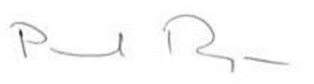
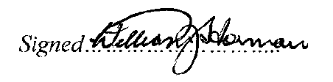
Signed……..………………

CONTENTS

- ESTABLISHMENT OF SAFE CITY CAMERAS PROGRAM (SCCP) AUDIT COMMITTEE………………………………………………………………………….…….....3

- SCCP OPERATIONS DURING 2022 ………………………………………………………4
Cameras in Operation …4
Mobile Camera Vehicle …………………………………………………………………….. 5
Control Room, Footage & CCTV Product………………………………………………… 5
Product provided to Victoria Police………………………………………..…………..……6
Dedicated Police Radio Base Station……………………………………………………... 6
CCTV Product – Dissemination, Tracking and Destruction……………………………...6
Control Room………………………………………………………………………………….6
Security ………………………………………….…… ………………………….. 6
Alternative Arrangement to Protect Continuity of Operations………………………...7
Police Acknowledge Value Partnership with SCCP……………………………………7
MOUs…………………………………………………………………………………………. 8
Public Address Speakers…………………………………………………………………… 8
Control Room contact with Victoria Police Monitoring Assessment Centre 9
Sharing Infrastructure with Other Parties’ Cameras…………………………………….. 9
RMIT……………………………………………………………………………………………9
City Safety - the Counter-Terrorism Environment and the SCCP……………………….10
Disparity between Program’s Aims &c Operating Procedures…………………………..10
Complaints……………………………………………………………………………………. 10
Freedom of Information………………………………………………………………………10
Victorian Auditor-General's Review of CCTV Camera Operations …………………...11
- SCCP AUDIT COMMITTEE…………………………………………………………………..11
Establishment………………………………………………………………………………….11
Membership 2022…………………………………………………………………………. . 12
Meetings of SCCP Audit Committee in 2022……………………………………………. 12
Support to the SCCP CCTV Audit Committee ……………………………………………..12
- SCCP AUDIT COMMITTEE – EXECUTIVE SUMMARY 2022…………………………….13
CoM Response to 2021 Review’s Recommendations……………………………… … 13
Summary of SCCP activity in 2022………………………………………………………… 14
Findings 2022…………………………………………………………………………………..14
Relationship with Victoria Police………………………………………… ………………… 15
- SCCP AUDIT COMMITTEE RECOMMENDATIONS ……………………..………………..16
- APPENDICES……………………………………………………………………………..……. 17-29

1. ESTABLISHMENT OF THE SAFE CITY CAMERAS PROGRAM & AUDIT COMMITTEE
On 6 December 1995, the City of Melbourne (CoM) resolved to establish a closed-circuit television system in Melbourne’s Central Business District to be known as the “Safe City Cameras Program” (the Program or SCCP). The CoM SCCP became operational on 27 February 1997.
From its inception, a SCCP CCTV Audit Committee was established consisting of representatives of Victoria Police, the City of Melbourne and with three “independent” members one of whom is appointed as the Chairperson.
The inaugural Chairperson was the late Mr Norman Geschke OBE the then immediate past State Ombudsman. The independent members include a lawyer and a community representative.
The SCCP helps create a safer environment and reduce crime levels by deterring potential offenders, helping in crime detection and providing evidence to assist in investigations and/or in Court.
The Program’s aims are set out in the Safe City Cameras Program Manual and include:
- aiding in the provision of a safer physical environment in the Melbourne CBD
- assisting police to reduce crime levels by deterring potential offenders
- aiding in early identification of criminal offences
- generally assisting in emergency response.
The operation of the Program is regulated by “Standard Operating Procedures (SOP’s), the “Training Manual” and a Memorandum of Understanding (MOU) with Victoria Police.
The Program Manual incorporates a Code of Practice, Privacy Principles, Product (i.e. copy of CCTV footage) tracking and release provisions and general management processes.
The Program uses closed circuit cameras (CCTV) positioned throughout the Melbourne Central Business District (CBD).
The Program is one aspect of the CoM’s strategy for a safer city. Others include:
- The sites of the Safe City Taxi Ranks are still monitored by the camera network.
- Melbourne Liquor Licensees Accord with Melbourne liquor licensees and coordinates and supports meetings of the Melbourne Liquor Forum
- Victoria Police and CoM lighting audits
- Promotion of visible police presence throughout the CBD
- Improved transport at night to and from the CBD
- Prohibition of consumption of alcohol in CBD public places
- Education, information and awareness campaigns.
- Various resident associations in the municipality.
- Local Safety Committee meeting - Neighbourhood Policing (Melbourne East and Melbourne West)
- Southbank Safety and Security Committee
- Annual Municipal Emergency Management Exercise
- Assisting Building Emergencies as part of council’s municipal building surveyor functions.
- Assisting emergency services and statutory agencies during emergency incidents as part of follow up or live investigations

2. SCCP OPERATIONS DURING 2022 AUDIT PERIOD

Cameras in Operation
There were 228 cameras at 2022 year end comprising:
- 106 Pan Tilt Zoom Cameras
- 102 Fixed Cameras
- 08 Taxi Rank and Help Point Cameras
- 01 Safe City CCTV Mobile Vehicle
- 11 private cameras (Salvation Army and Hosier Lane)
During 2022 the Victorian Government lifted COVID 19 restrictions and encouraged people to return to the Central Business District for work and leisure.
Reports showed one fewer incident compared to the same periods in 2021, but more footage was provided to police, due largely to more cameras that create more likelihood of capturing footage. The introduction of Evidence.Com created savings on materials, and greater efficiency on the timeliness of supply of footage to Victoria Police as it enables police to request footage electronically rather than having to attend the Control Room.
Requests for information regarding the Safe City Cameras’ statistics of incidents may be directed to the Melbourne City Council.
The CoM’s SCCP website provides a map of locations of the SCCP cameras. (However, it should be noted that the location of cameras is subject to ongoing review and change).

Mobile Camera Vehicle
The Melbourne Safe City Cameras Program has, in addition to fixed cameras, a Mobile Camera Vehicle, introduced in 2009. Footage from cameras in the Mobile Camera Vehicle is now directly fed to the SCCP Control Room as a result of an initiate during 2022 and the independent members of the Audit Committee viewed the effectiveness of the live-feed. During 2022 the independent members of the Committee viewed the Mobile Camera Vehicle and the cameras in action.

Control Room, Footage & CCTV Product
All fixed cameras feed footage, in real time, to screens located in the SCCP Control Room. Footage is recorded on the Video Management System (“VMS”). VMS screens are monitored 24 hours per day by Control Room Operators.
Control Room Operators may transfer incoming footage, in real time to dedicated monitors and control cameras to ensure detailed recording of any event. Control Room Operators notify police of incidents that they see unfolding and feed footage in real-time to Police Operation Centres.
When major events occur in Melbourne with the State Police Operations Centre (SPOC) in operation, the police can select what cameras they want to view - but the Safe City Operators retain actual control of the cameras.
Control Room Operators make electronic or hand-written notes, “running sheets” which are used for inputting the incident report in the Incident Management System. Such documents aid subsequent interrogation of the Incident Management System in relation to specific events and retrieval of relevant product (ie footage provided to police or others).
Footage in relation to an event is retained on the Council server for a minimum of 28 days (the Holding Period) after the event. In the absence of a request from police or other relevant agencies or individuals, it is then copied over. Should the Council receive a request for product from a relevant agency or individual within the Holding Period, two copies of the requested footage are made. One copy is provided to the requesting party and the other copy retained by Council for a minimum of two years, after which it is destroyed.
Product provided to Victoria Police
In 2016, Victoria Police and CoM agreed that police to whom product was provided would be responsible for its safe storage and ultimate destruction, when the product was no longer required by them.
Subsequently a copy of the Victoria Police instructions and procedures was provided to the Audit Committee and the SCCP Program Manual amended to incorporate the agreement.
During the 2022 review period no misuse or problem associated with product provided to Victoria Police was reported and inspection by the independent members of the Audit Committee verified compliant receipt and disposal of product by Melbourne East Police Station (one of the most frequent requesters for product).
Dedicated Police Radio Base Station
The operational benefits for the Safe City Camera Program in having a dedicated police radio base station is evidenced by the increasing number of incidents the Control Room is alerted to via the police radio network.

CCTV Product - Dissemination Tracking and Destruction
Product continues to be made available only to those authorised under relevant provisions of the Program Manual and release of product occurs only upon acceptance by applicants of necessary confidentiality, tracking, storage and destruction obligations.
The Audit Committee noted in 2018 that confirmation of destruction of 61 released product to non-police applicants remained outstanding. Concerted efforts were made during subsequent audit periods to follow up through communication with relevant lawyers. The Audit Committee is now satisfied that no further action is required and requested that appropriate amendments be made to the Program Manual to reduce this risk in future. The City of Melbourne accepted the recommendation and the Application form has been appropriately amended.

Control Room

Security
Access to the Control Room is strictly limited and controlled in accordance with provisions of the Safe City Camera Program Manual. In 2022 the independent members of the Audit Committee visited the Control Room and satisfied themselves on compliance with the security arrangements for signing in and out of visitors and product as well as storage of footage.
It is interesting to note that the storage areas is a a Chubb Safe which had been part of the Victoria Police Melbourne Town Hall Police Station located at Melbourne Town Hall.
In view of increasing cyber security risk, the members sought, and received from City of Melbourne management in consultation with Victoria Police, specific reassurance that appropriate protection from hacking or other interference is in place.
Alternative Arrangements to Protect Continuity of Operations
In 2018 the SCCP Control Room underwent a major refurbishment which included change to structure, design and layout of the room and major upgrades to hardware.
Police communications via the service provider were upgraded to all Safe City 900 Base Stations and Speakers, which allow the SCCP Operators to work more effectively at their respective workstations.
In March 2021, City of Melbourne Management closed a second temporary Control Room set up in May 2020 in response to social distancing and other safety requirements due to COVID. The Committee in its 2021 Report noted the importance of the SCCP to city safety generally and of having alternative arrangements in place in the event of a threat to continuity of operations. The Report recommended the City of Melbourne advise the Audit Committee on its Business Continuity Plan with regard to Disaster Recovery and continuity of the Safe City Camera operations in the event to the SCCP Control Room being rendered inoperative.
During 2022 City of Melbourne Management provided assurance that appropriate provisions are in place. In view of its importance, this Report recommends City of Melbourne again provides throughout 2023 any updates and reassurance to the Audit Committee regarding security and business continuity.
At the time of preparing the Report, the media reported security concerns of the Federal government required the removal from various Federal Departments of over nine hundred CCTV cameras due to being manufactured by two Chinese providers. As an illustration of the role of the SCCP CCTV Audit Committee, this matter was immediately raised and the City of Melbourne (bearing in mind the 24/7 nature of the SCCP operation) and at the February 2023 CCTV Audit Committee Meeting the City of Melbourne assured the Committee none of the SCCP CCTV cameras had been provided by the named two Chinese providers.

Police Acknowledge Valued Partnership with Safe City Camera Program
Control Room Staff are in direct radio contact with police. SCCP Mobile Camera Vehicle staff are in direct contact with Control Room staff. The Audit Committee’s reports consistently note there is a very close working relationship between the Control Room Operators and police. There is also a close working relationship between Victoria Police and the City of Melbourne management generally in regard to planning and operational matters, particularly relating to safety, security and counter-terrorism strategies and management of emergency responses.
This year the Audit Committee is particularly pleased to record the exceptional honour and recognition given by the Victorian Chief Commissioner of Police Shane Patton APM to Mr Craig Buckingham, Team Leader, Security Services, and the Control Room Operators formally acknowledging the value of their work.
The inaugural award of the Victorian Police Company/Business Commendation to the City of Melbourne Safe City Cameras Program was presented in person by Chief Commissioner Patton, in the presence of the Lord Mayor Sally Capp, police representatives, City of Melbourne management, a number of SCCP Operators and members of the Audit Committee (both past and present members) on 27 October 2022 in the Melbourne Town Hall Commons area.
The citation reads:
“In recognition of the exemplary working partnership with Victoria Police
to improve community safety in Melbourne”.
The independent members of the CCTV Audit Committee were impressed by the fact that within a short period of time almost 150 messages of congratulations and support appeared on Linked-In in response to a post of Manager Craig Buckingham.
On 23rd December 2022, award-winning crime journalist Mr John Silvester for his weekly page “Naked City”, wrote an article “Keeping an eye out across the city, on 222 cameras”, focusing on the Melbourne Safe City Camera Program. This was the first time the SCCP was the subject of such detailed media coverage with access to Lord Mayor Sally Capp, SCCP Management and the SCCP Control Room. The initiative was discussed in Audit Committee meetings and was strongly supported by the Audit Committee.
MOUs
Current in 2022 were CoM Memoranda of Understanding (MOU) with Victoria Police and separately, the Independent Broad-based Anti-Corruption Commission and Emergency Management Victoria.
Public Address Speakers for Emergency Situations
A Memorandum of Understanding between Victoria Police and Emergency Management Victoria (EMV) was signed in 2017 utilizing the SCCP hardware with public address speakers fitted onto cameras at CBD locations to be used in emergency situations.
The speakers can be used to provide an audible warning sound and a message from police to the public in an emergency situation. The speakers were not required to be used during 2022 other than for testing purposes.

Control Room Contact with Victoria Police Monitorong Assessment Centre
Since December 2016, the Victoria Police Monitoring Assessment Centre (MAC) has been able to select live-feeds from CCTV cameras in the CBD.
In view of the importance of the role of the Victoria Police MAC, its relationship with the SCCP and the live-use of SCCP footage, the Audit Committee maintains its interest in being kept informed as to any relevant impacts on the arrangements.
The Chairman and Audit Committee members visited the Victoria Police Monitoring Assessment Centre in 2018 and in 2019 and were provided with a detailed overview of its operations, access and use of the live SCCP camera coverage. COVID restrictions prevented further site visits, but the independent members of the Committee intend to accept an invitation to revisit in 2023.
In 2022 all three independent members of the Audit Committee received a comprehensive tour of the Melbourne East Police Station, including viewing the interaction between the Station and the SCCP Operation Centre.
In 2022 City of Melbourne procured an extra five years Agreement for the use of optic-fibre cable from a telecommunications company from 2023 to 2028. This fibre is used to connect thirty-nine different points in the field of coverage back to the Safe City Control Room, and one of those links is the main link into City West Police Station. The independent members of the Audit Committee have accepted an invitation to visit City West Police Station in 2023.
Sharing Infrastructure with Other Parties’ Cameras
In 2022 City of Melbourne projects works were completed to implement seven fixed cameras around the perimeter of the Salvation Army Building at 69 Bourke Street, Melbourne. The area of Westwood Place has been a significant black spot to the network for many years.
City of Melbourne provided the IT network and camera software whilst the Salvation Army provided the cameras. Both parties along with Victoria Police have benefitted from savings in time and cost through this sharing arrangement.
RMIT
During 2022 the City of Melbourne commenced discussions with RMIT in relation to the possibility of mutual benefits arising from the possibility of some arrangement between RMIT and the SCCP increasing the SCCP coverage in the CBD. This Reports contains a Recommendation that the Committee be kept update with regards to the discussions with RMIT.
City Safety, Counter-Terrorism and the SCCP
Major incidents in past years involving vehicles posing a threat to the lives and safety of CBD users, demonstrated the importance of the SCCP in prevention, deterrence, critical incident response and providing footage to form part of the police investigation as well as evidence when matters are before the Coroner or criminal prosecutions proceed to Court from any acts of terrorism or serious incidents.
COVID restrictions meant reduced pedestrian and vehicle activity as well as other public safety threats throughout much of 2020 and 2021. Over the course of 2022, as COVID restrictions eased, pedestrian and vehicle activity began to return to previous levels. While the number of incidents was fewer, the amount of footage requested by police increased.
Police representatives have commented very favourably on the improved speed of communication and supply of footage following the introduction of “Evidence.Com” software and online procedures.
Disparity between Program’s Aims &c Operating Procedures
During the reporting period, the Audit Committee did not become aware of any allegation or complaint claiming or suggesting there was a disparity between the Program’s Aims and Operating Procedures.
Complaints
The CoM website provides advice for members of the public to facilitate complaints about the Program operation.
The SCCP Manual also sets out a process by which complaints can be made about the operation of the Program.
Any complaint lodged against the SCCP is the subject of focus by the Audit Committee.
No complaint was received in 2022.
Freedom of Information
FOI requests lodged relevant to the SCCP are a subject of focus by the Audit Committee.
One Freedom of Information request was lodged on 11/10/22 during 2022 requiring attention notification to the Committee with no further action required.
Federal Government footage provided on two occasions in June 2022

Victorian Auditor-General’s 2018 Review of CCTV Camera Operations

During 2018 the Victorian Auditor-General’s Office (VAGO) carried out an extensive review of the Public Safety and Corporate CCTV cameras of a number of local governments including the City of Melbourne’s Safe City Cameras Program.
The VAGO report “Security and Privacy of Surveillance Technologies in Public Places - September 2018” can be found here:
https://www.audit.vic.gov.au/sites/default/files/2018-09/20180919-Surveillance-Technologies-in-Public-Places.pdf
While the VAGO report was generally favourable, the Audit Committee noted there were areas where the SCCP (Public Safety CCTV) was not fully compliant and made recommendations addressing those issues. The recommendations have been progressively implemented and reported on.
The independent members of the Audit Committee are mindful that the Auditor General may revisit local government operations of CCTV in light of rapid changes in technology and the challenge of managing community expectations regarding safety, security and privacy.
This Report recommends that in 2023 the Audit Committee, in conjunction with City of Melbourne, review the Program’s manuals and operating procedures to ensure it is up-to-date with current practices and procedures.
3. SCCP AUDIT COMMITTEE
Establishment
CoM made the operation of the Safe City Cameras Program operation subject to audit against its protocols and operating procedures by an independent committee called the Melbourne Safe City Camera Audit Committee. The Audit Committee is required to report to the CoM annually pursuant to the Committee’s Terms of Reference. The Report is available to the public.
Independent auditing of the Program’s operation is intended to:
- ensure congruence between the Program’s operation and the parameters set out in the Operations and Training Manual and the Program Manual;
- promote public confidence in the Program by making its operation transparent and accountable;
- ensure the Program’s efficient, effective operation and management;
- support continuous improvement of the program through consideration and implementation of Audit Committee recommendations; and
- identify any incidents of non-compliance with the terms of the Operations and Training Manual or the Program Manual.
From inception, the CoM SCCP Audit Committee has been and continues to be independent of the Program operation.
Membership 2022
During the 2022 audit period, the SCCP Audit Committee’s three “independent” members were long-serving member Mr Bill Horman AM APM who was appointed Chairman, with 2018 appointees, Ms Margaret Rode (Governance Professional and Community Representative) and Mr Paul Ryan (Solicitor). Chairman Mr Bill Horman was a member of the then Melbourne Safe City Executive when the Safe City Cameras Program was conceived and established,
Meetings of SCCP Audit Committee 2022
During 2022 the SCCP Audit Committee met on the following dates:
- 15 February 2022
- 10 May 2022
- 14 June 2022
- 9 August 2022
- 11 October 2022
- 13 December 2022.
The Audit Committee was pleased to resume face-to-face meetings on 10 May 2022 after almost two years relying on electronic meetings because of COVID related restrictions.
Between formal Committee meetings, the Chairman communicated with the independent and other members of the Audit Committee. The independent members consider their regular meetings and discussions to be valuable and resumed meeting face-to-face on a regular basis from May 2022.
A schedule of meetings and attendees is attached.
Support to SCCP Audit Committee
The Audit Committee wishes to express its appreciation for support throughout the audit period, provided by:
- Mr Dean Robertson, City of Melbourne Director City Safety, Security and Amenity
- Ms Christine Drummond, City of Melbourne Emergency Management Coordinator
- Mr Craig Buckingham, City of Melbourne Security Manager
- Victoria Police, the biggest single-user of the Program’s product, was represented at all meetings of the SCCP Audit Committee, significantly enhancing discussions, and providing valuable feedback on police use of Product and police interaction with the Control Room. The Police representatives report at each meeting outlining some aspects of crime and particular incidents involving the police and SCCP and Control Room.
The Police representatives were:
- Senior Sergeant Mick Wilmott - representing Melbourne West
- Senior Sergeant Andrew Brady, and Inspector Jamie Templeton – representing Melbourne East
- Other police members who attended meetings during 2022 were:
  - Acting Senior Sergeant Emily Squires
  - Senior Sergeant Cynthia Suhan
  - Acting Senior Sergeant Helena Brien.
Continuity of police representation is viewed as important by the Audit Committee members and involvement was consistent throughout 2022. The Audit Committee is pleased to acknowledge the significant contributions of Senior Sergeant Andrew Brady, wished him well in his new role and welcomed Inspector Jamie Templeton.
Of particular value to the Committee throughout the audit period were Mr Buckingham’s monthly Program Management Reports containing statistics, comparisons, commentary on notable incidents, as well as reports containing statistics on hits on the website provided by Ms Drummond.
The monthly Program Management Reports regularly featured expressions of police appreciation of the professionalism of the SCCP Operators and comments as to their good work in particular instances and specific incidents.
The Audit Committee noted the regular police praise and appreciation of the very timely assistance and expertise of the SCCP Operators.
- SCCP AUDIT COMMITTEE – EXECUTIVE SUMMARY 2022

CoM Response to Recommendations in the 2021 Audit Report
At each Audit Committee meeting, the CoM reported on the progress and completion of each of the 2021 Report’s recommendations, including a satisfactory resolution of outstanding footage provided to non-police applicants, enabling the Audit Committee to request that the Minutes record that the matter was closed. Following this time-consuming task, the Audit Committee recommended that further details be provided as part of the Application for footage and the City of Melbourne accepted the Recommendation.
Summary of SCCP activity in 2022
The CCTV Audit Committee found that the Safe City Camera Program operated efficiently and effectively throughout the review period.
During the review period, the SCCP recorded a total of 5587, down from 5588 (record amount) in the same period in 2021.
The five (5) most reported incident categories during 2022 were:
Incident Category | 2022 | 2021
Assault | 1,103 | 895
Public Order | 877 | 1,050
Theft/Attempted Theft | 844 | 643
Traffic-related matters | 727 | 668
Welfare Checks | 582 | 698
Note: Drug-related matters | 162 | 147

As Covid restrictions lifted and the city’s pedestrian and vehicle numbers increased spikes in incident types were noted in the areas of Assault, Burglary, Criminal Damage, Drunk (Impaired) or Erratic Driver, Theft from Motor Vehicle and Traffic Matters.
In 2022 the SCCP produced a new record of 1,487 copies of footage with 1,161 true copies collected. The ratio of footage to incidents is 5,587 incidents / 1,161cases = 4.8 incidents for every one true copy – which is an excellent result.
Findings 2022
The Safe City Cameras Program Audit Committee reviewed the operation of the Melbourne Safe City Cameras Program for the period 1 January 2022 to 31 December 2022 in accordance with its Terms of Reference and the relevant provisions of both the Program Manual and the Training Manual.
Besides site visits already referred to, Management reported regularly to Committee meetings and provided assurances that:
    - No instances of disparity between the Program’s aims, protocols and operating procedures.
    - No complaints about the Program were made during 2022.
    - No evidence of failure by SCCP staff to observe security protocols and standard operating procedures as set out in the Training Manual.
    - The Program and its operations were effectively and efficiently managed and coordinated.
    - There were no new major events requiring the supply of cameras into either the Melbourne Events Operations Centre or the State Government Operations Centre.
    - No evidence that Control Room Operators’ entries on the Program Management System failed to comply with the requirements set out in the provisions of the Operations and Training.
    - No evidence of access to the Control Room outside the scope of the standard operating procedures and security protocols.
    - Program staff maintained professional, cordial, efficient and effective interaction with authorised persons including police, other stakeholders and members of the public who visited the SCCP Control Room.
    - No evidence of improper dissemination or use made of any Product.
    - No members of the public or stakeholders raised any public interest issues.
    - No Freedom of Information requests were received.
Relationship between Victoria Police and SCCP Personnel
The relationship between Victoria Police and the SCCP is crucial to its effectiveness and, ultimately, city safety and security. This report has already referred to Victoria Police’s award to the Safe City Cameras Program for its exemplary service – unique testimony to the success of this relationship.
The Audit Committee commends the high level of professionalism, communication and co-operation between Control Room Operators and members of Victoria Police and other emergency services personnel.
The Audit Committee particularly commends the Program staff and City of Melbourne Management on the way they adapted to changed circumstances and requirements resulting from COVID 19 and its disruption to people’s working and personal lives in 2020, 2021 and 2022, while keeping the Safe City Camera Program operational throughout the period.

5. 2022 SCCP AUDIT COMMITTEE’S RECOMMENDATIONS
The following recommendations are put forward by the Audit Committee in 2022 for consideration by the City of Melbourne, Victoria Police and the SCCP Audit Committee in 2023.
- The Audit Committee, with City of Melbourne, review SCCP manuals and procedures to ensure they reflect any changes and are up-to-date.
- City of Melbourne report to the Safe City Cameras Program Audit Committee with confirmation of the effectiveness of security measures in place to protect the camera system, including from hacking and other interference.
- City of Melbourne to continue to provide the Audit Committee with information and regular updates on its strategic plan for improving city safety, security and amenity.
- The independent members of the Audit Committee to explore with the City of Melbourne aspects of the communication and liaison with community groups with regards to the operations of the SCCP.
- City of Melbourne to update the Audit Committee on its Business Continuity Plan with regard to any changes impacting on Disaster Recovery and continuity of the Safe City Camera operations in the event of the SCCP Control Room being rendered inoperative.
- The independent members of the Audit Committee to revisit Melbourne West Police Station and check procedures with regard to requesting, recording, storage and disposal of product.
- The independent members of the Audit Committee to revisit the Victoria Police Monitoring Centre (MAC) to review the direct live-feed from the Safe City Cameras.
- The independent members to seek assurance from the City of Melbourne with regards to CCTV cameras from specific overseas suppliers of security concerns of the Federal Government.

ATTACHMENTS:
Appendix A: Photograph of the Chief Commissioner’s Partnership Award
Appendix B: Victoria Police Chief Commissioner Shane Patton presenting
the Award to City of Melbourne SCCP Security Manager
Craig Buckingham
Appendix C: Chief Commissioner Patton; Lord Mayor Hon. Sally Capp,
Craig Buckingham and members of the SCCP team.
Appendix D: Schedule of CCTV Audit Committee Meetings and Membership
Appendix E: Naked City article, “Keeping an eye out across the city on 220
cameras”, Sunday Age, 23rd December 2022.

APPENDIX A:

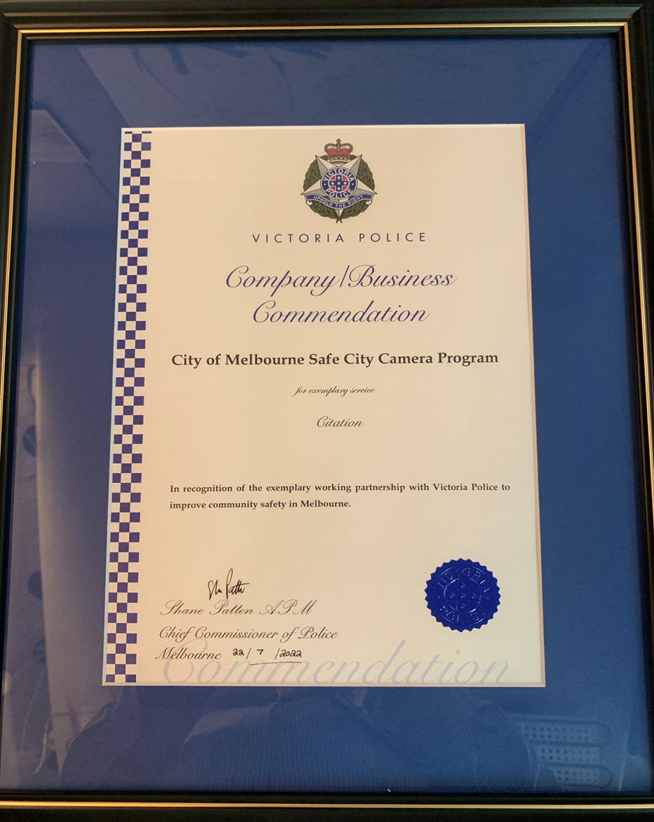

APPENDIX B:
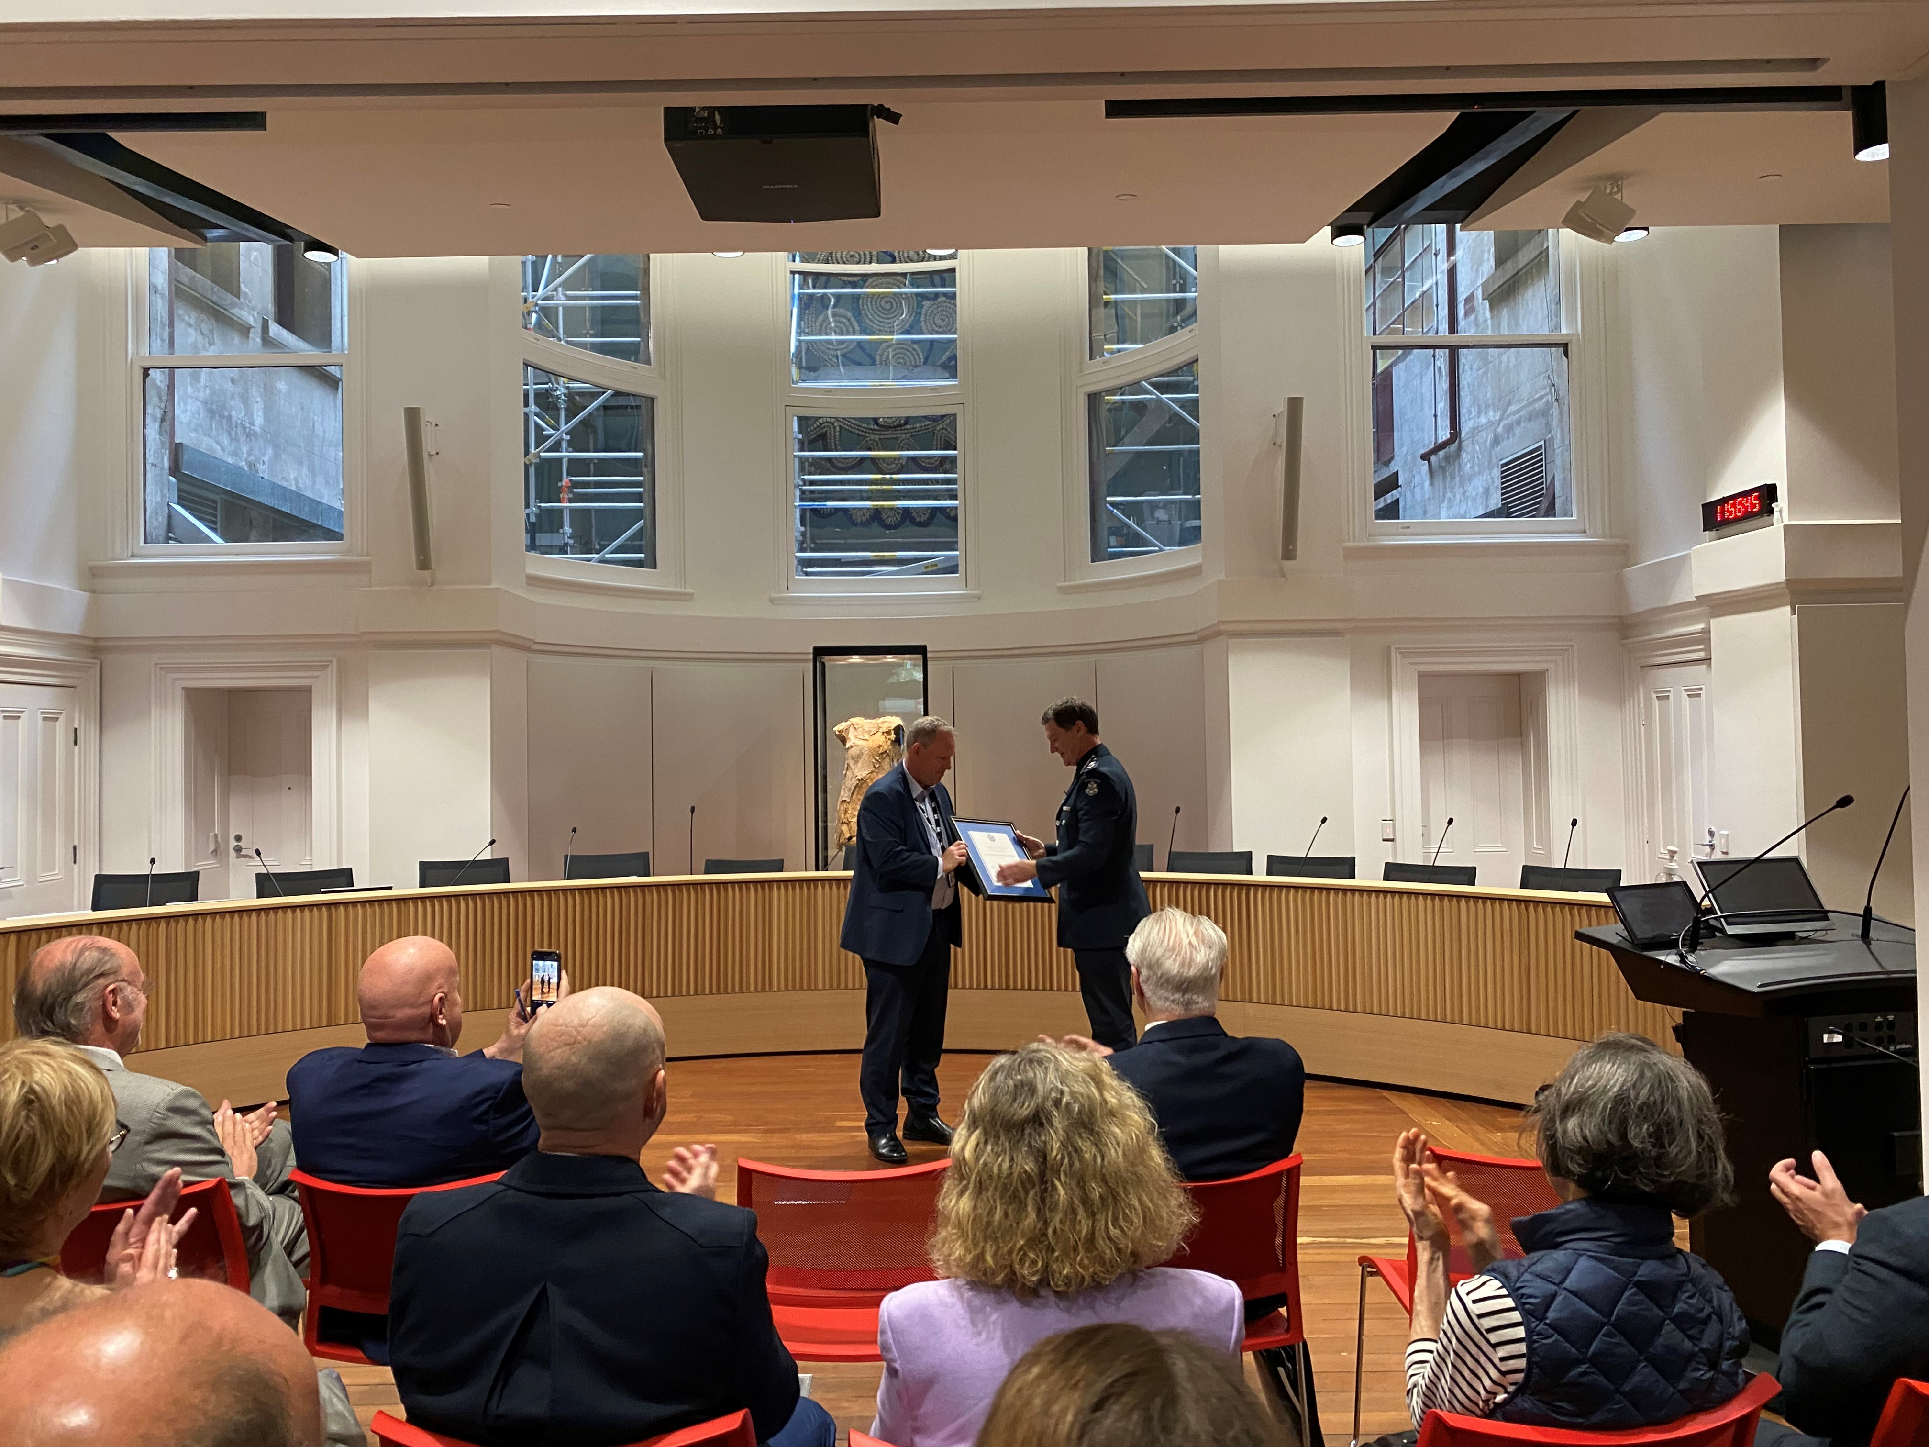

APPENDIX C:

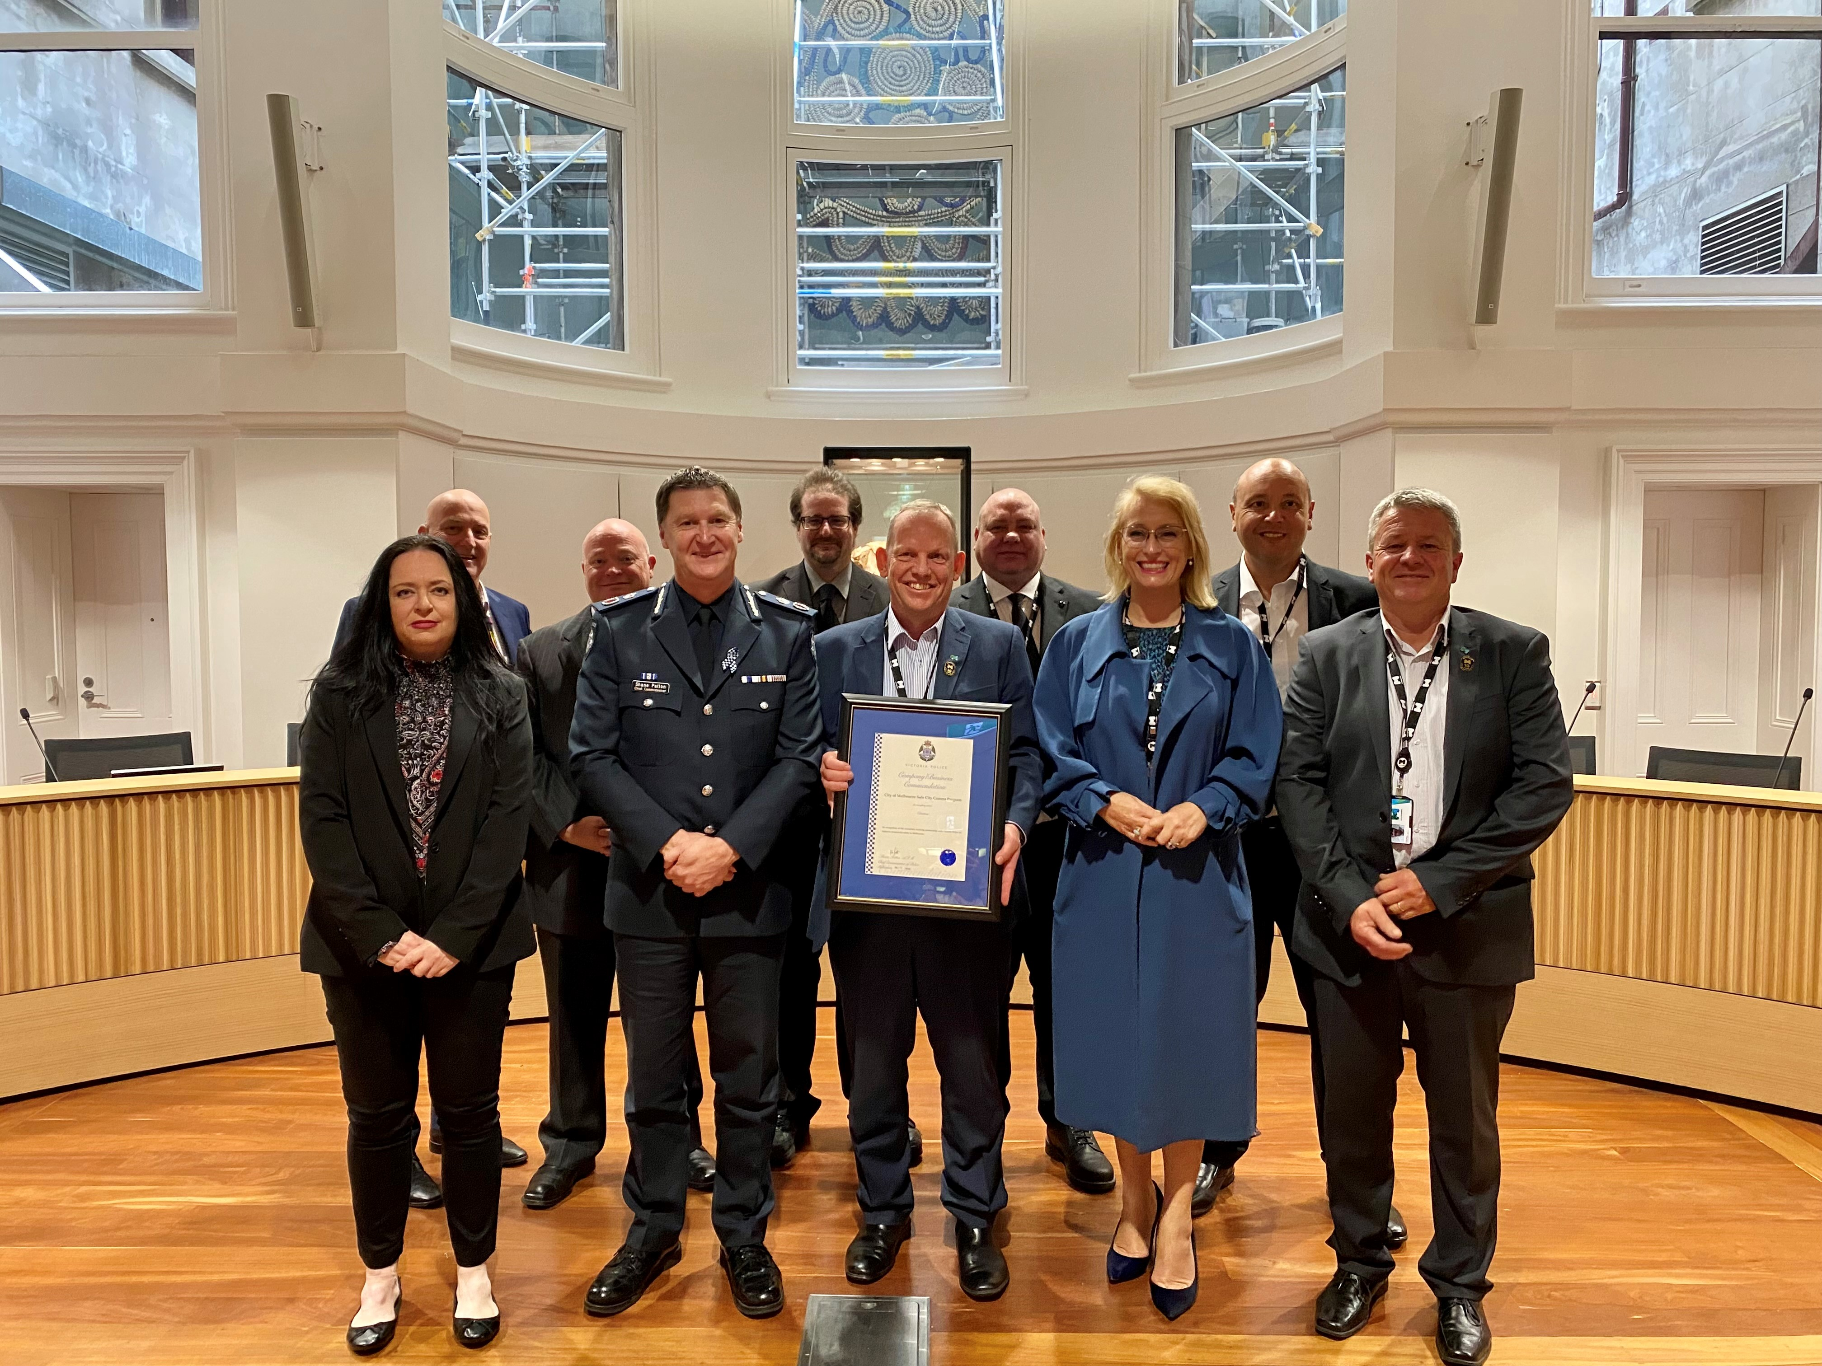

APPENDIX D:

SCHEDULE OF MEETINGS 2022 – DATES AND ATTENDANCE

Dates of Meeting

Member | 15/02/22 | 10/05/22 | 14/06/22 | 09/08/22 | 11/10/22 | 13/12/22
BH | Y | Y | Y | Y | Y | Y
MR | Y | Y | Y | Y | Y | Y
PR | Y | Y | N | Y | N | Y
CD | Y | Y | Y | Y | Y | Y
CB | Y | Y | Y | Y | N | Y
DR | N | Y | N | Y | Y | Y
MW | Y | N | Y | Y | N | N
AB | N
ES | Y |  |  | Y
JT |  | Y | N | N | Y
OF |  |  |  | Y
CS |  |  |  | Y
HB |  |  |  |  | Y

INDEPENDENT MEMBERS
BH BILL HORMAN (Chair)
MR MARGARET RODE
PR PAUL RYAN

CITY OF MELBOURNE
CH CHRISTINE DRUMMOND
CB CRAIG BUCKINGHAM
DR DEAN ROBERTSON

POLICE
MW Senior Sergeant MICHAEL WILMOTT
AB Senior Sergeant ANDREW BRADY
ES Acting Senior Sergeant EMILY SQUIRES (for ANDREW BRADY)
JT Inspector JAMIE TEMPLETON (replacing ANDREW BRADY)
OF Acting Inspector OLIVIA FREEMAN (for JAMIE TEMPLETON)
CS Senior Sergeant CYNTHIA SUHAN
HB Acting Senior Sergeant HELENA BRIEN (for MICHAEL WILLMOTT)

APPENDIX E:

Keeping an eye out across the city, on 220 cameras
Here the Spirit of Christmas takes a back seat, which is why a giant blow-up koala had to be deflated to avoid blocking cameras.
ByJohn Silvester
Sunday Age – NAKED CITY - DECEMBER 23, 2022
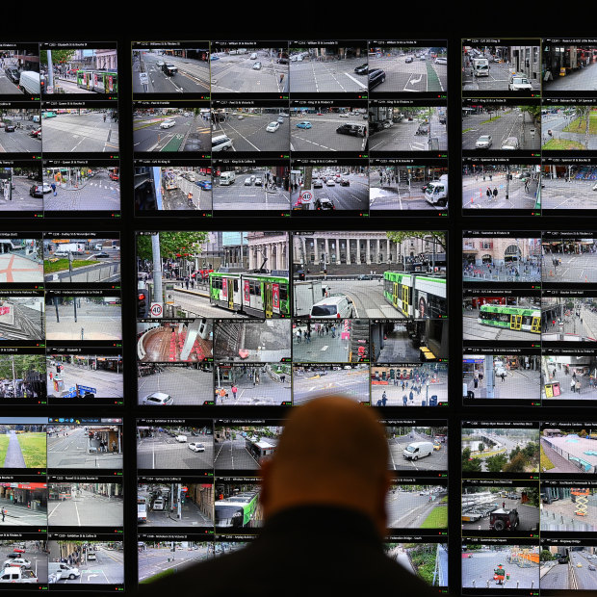
The number of monitoring screens was tripled after the 2017 Bourke Street tragedy.CREDIT:JOE ARMAO
Hidden inside Melbourne’s 155-year-old town hall sits a secure, high-tech room where two experienced security officers scan their computer screens, expecting the unexpected.
On the front wall is a bank of more than 100 screens showing images beamed from 220 security cameras dotted around the city.
On one, we see an ambulance pull up, lights flashing. On the electronic wall, triple-zero operators patch in to see if more help is needed.
The screens show live shots down St Kilda Road to the Shrine, people leaving Flinders Street Station and workers going about their daily business.
Just outside is a high-profile council-controlled private security vehicle — equipped with five fixed cameras and one 360-degree camera to patrol Melbourne lanes not covered by the cameras attached to buildings and poles.
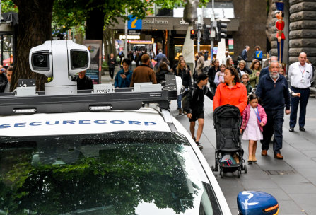
The Safe City camera car that puts electronic eyes down blind spots.CREDIT:JOE ARMAO

One night when an idiot tried to mount the footpath to run someone over, the intended victim was able to jump on the camera car for safety. It was designed to deter crime, but not that way.

To the side of the room is Victoria’s oldest gold safe, now transformed into the electronic engine room, filled with blinking computers and thousands of hours of video recordings.
This is the command centre of Melbourne’s Safe City operation — designed as an early alert for everything from exuberant crowds to a terrorist assault.
Following the 2017 Bourke Street attack that killed six and injured 27, the camera network was tripled and a public address system added to warn of future threats.

After last week’s shameful soccer pitch invasion, police went to the room to look at footage of the hooligans as they entered and left the stadium. It will be part of the eventual evidence packages presented in court, proving what morons ignore: you can run, but you can’t hide.
Next week on New Year’s Eve, when an estimated 500,000 people will roll into Melbourne for the fireworks, the cameras will look for crowd crushes and alert police and council crowd controllers to divert people from dangerous bottlenecks.
With five major celebration points, the cameras will scan for lost kids and dangerous flashpoints as well as the over-refreshed and the under-prepared.
Here, the spirit of Christmas takes a back seat, which is why a giant blow-up koala had to be deflated to avoid blocking cameras. Trees are also pruned to make sure there are no blind spots.
The cameras pinpoint violence, with operators immediately alerting police. They know the city by heart and don’t need to look at a map, knowing not only the street but the exact number of the location.
In 1995, the City of Melbourne resolved to set up the Safe City program by installing 23 cameras. It is now central to all public events.
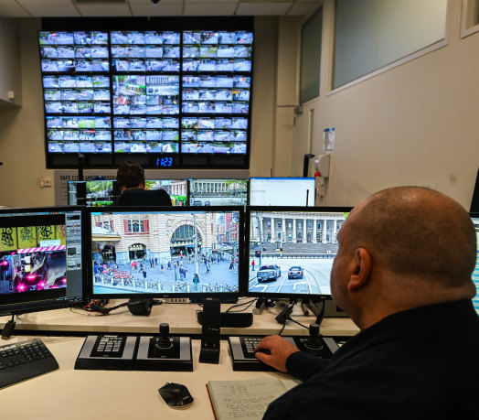
Looking for trouble. Inside the monitoring room.CREDIT:JOE ARMAO

Lord Mayor Sally Capp says: “It is making a big difference and is now absolutely fundamental to the security and safety of Melbourne.”
It is now a way of life. There are hundreds of private security cameras in the city and the first instinct of many is to whip out their phones to record anything that moves. Even private cameras around the Salvation Army’s Project 614 support centre in Bourke Street can be patched in when needed.
Compare that to the outcry when a handful of cameras were installed in 1981, supposedly to monitor traffic, before the Commonwealth Heads of Government Meeting.
City police Inspector Jamie Templeton says the cameras are part of an investigator’s bag of tricks and provide real-time intelligence.
This year, there have been 5012 incidents in the city, with police receiving valuable footage in 1444 cases.
In the past decade, the Safe City Cameras Program recorded 43,427 incidents, and provided 8025 copies of footage.
In the same time, it provided triple-zero operators with live vision nearly 30,000 times.
There can be no more tragic and graphic example of the use of CCTV in a criminal investigation than the 2018 murder of Eurydice Dixon, who was stalked for nearly five kilometres before being attacked in Princes Park, Carlton.
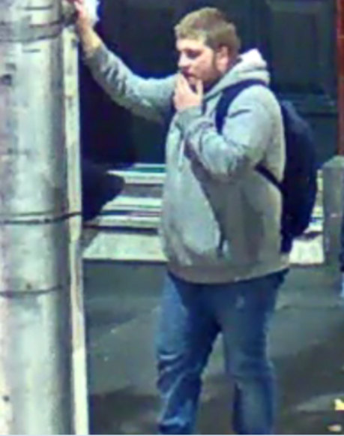
Jaymes Todd on the night he killed Eurydice Dixon. He was caught on multiple cameras as he stalked her for nearly an hour.CREDIT:VICTORIA POLICE

The offender, Jaymes Todd, then 20, spotted her outside Flinders Street Station and followed her for nearly an hour.
He trailed about 15 seconds behind her, occasionally stopping and pretending to roll a cigarette to conceal his real intentions.
He handed himself in within 12 hours after police released images of the suspect, and Todd’s friends contacted him.
The cameras couldn’t save Dixon, but they did stop Todd from reoffending.
Increasingly CCTV is becoming the central plank to prosecutions because the camera doesn’t lie.
A few weeks ago, Aaron Ong was found guilty of the 2019 ambush murder of fruiterer Paul Virgona (his co-offender Josh Rider had earlier pleaded guilty) in a case where the prosecution relied heavily on CCTV.

Templeton says if the footage does not capture the crime, it can still identify the offender through clothing and car registration details. And tattoos can be a cop’s best friend.
It can be the alibi-buster when the suspect says they weren’t there. “There you are walking from Flinders Street Station or getting out of your car,” Templeton says.
The experienced operators become electronic time travellers, working back from the incident frame by frame to see the exact movement of suspects from the time they enter the city until they commit a crime.
Even when a crime is not captured, the offenders can be. If there are a series of burglaries, the cameras are used to check car registrations to identify potential suspects.
Templeton says when police are called, the live feed is patched through to the officers’ computer tablets, ensuring they are better prepared for what they will confront. “It gives us situational awareness and lets us know how many people we need.”
A veteran of city policing, Templeton uses the cameras during protests to get police to potential trouble spots.
The cameras, he says, stop crime because many would-be offenders know their images will be captured. “It covers every corner and has been a game changer.”
He says it is also valuable when there have been complaints against police because it provides more comprehensive coverage than body-worn cameras — a little like going upstairs at a Test match for a video review.
The cameras are just one club in the bag and, Templeton says, police can’t rely on them exclusively. You need to talk to people, gather facts and make your own judgments.
At the back of the room are two old-fashioned blue folders, one marked Missing Persons and the other POI (Persons of Interest).
Craig Buckingham, Security Manager for the City of Melbourne, says they are contacted “every second day” about runaway wards of the state and have a 75 per cent pick-up rate: “We know where to look.”
Dean Robertson, the council’s Director of City Safety, Security and Amenity, says a regular complaint of city residents and regulars is the lack of visible police patrolling.
He says the cameras add a constant presence and send police to where they are needed, leading to less wasted resources.
Instead of a call from the public followed by general duties police arriving to assess a violent incident, specialist units such as the Critical Incident Response Team can immediately be dispatched when seconds matter.
It is a world away from the old days, when detectives would leave the Russell Street “Bullring” to go to the View Room, a theatrette where the freshly arrested would be paraded catwalk-style and told to turn left and right, so the cops would be able to recognise them if they saw them in the street.
The best cop was the legendary Reg “Eagle-Eye” Henderson, who carried a book with hundreds of photos of the most wanted. He managed to arrest more than 300 simply by recognising them in the street.
Now police can look at image after image captured on the screens and produce absolute evidence to present in court.

Norman Geschke OBE (1924-2018), State Ombudsman 1980-1984.
3 SCCP Executive Report 01/12.2022 to 31/12.2022
Photograph of the Safe City Mobile Camera vehicle and camera as appeared in the Sunday Age article on 23rd December 2022 – see Appendix C.
See Appendix A
See Appendix C
Safe City Cameras Program Manual p.16
See Appendix B.
CCTV recorded material.
SCCP Executive Report 01/12/2022 to 31/12/2022
Ibid
The Training Manual includes Standard Operating Procedures
See Appendix A.

