
Melbourne City Council Submission
Victorian Parliamentary Inquiry into the 2022 Flood Event in Victoria
Submitted to floodinquiry@parliament.vic.gov.au

Participating Members
Sonja Terpstra (Committee Chair)

*Endorsed by City of Melbourne Future Melbourne Committee 2 May 2023

Contents
1. Introduction 3
2. Flood – Causes and contributors 4
3. Early warning systems - Adequacy and effectiveness 7
4. 2016 Victorian Floodplain Management Strategy – Implementation and effectiveness 10
5. Engineered structures - Location, funding, maintenance and effectiveness 12
6. Flood event as a whole 18
7. Flood wall around Flemington Racecourse 19
8. Implications for future planning decisions 20
9. Other relevant matters 22
10. Key recommendations 23

Introduction
Melbourne has always been a water city, with low lying areas prone to flooding. As Melbourne grows, planning for the impacts of climate change and safeguarding our city against potential flooding is integral to ensuring a sustainable future.
The latest report from the Intergovernmental Panel on Climate Change makes it abundantly clear that climate change is intensifying extreme weather events, including rainfall and flooding events like this one, and their frequency is increasing.
The cost of extreme weather disasters in Australia has more than doubled since the 1970s. Unless urgent action is taken, floods in Australia could cost $40 billion per year by 2060. Capital cities like City of Melbourne have high value assets and are vulnerable to disasters. The scale and value of properties and land in cities at risk to climate related impacts is unfathomable. Cities need consistent and standard climate risk forecasts to enable proper land use planning that reduces these risks to properties and removes people from harm's way.
Local governments are working together with communities to take action against climate change and build resilience. However, we need more support from other levels of government to be able to better prepare for future flood events. This includes increasing funding sources to respond to flood, investment in better flood management data and up-to-date modelling and investment in preparing communities before disasters strike.
While this submission is focused on the 2022 Flood Event and follows the Legislative Council Environment and Planning Committee’s Terms of Reference (ToR) for this inquiry into the 2022 Flood Event in Victoria, City of Melbourne has provided additional insights into the importance of building community resilience, the need for innovative flood solutions and governance to reduce the risk of future flood events.

Flood – Causes and contributors
ToR (1): causes of and contributors to the Flood Event
Cities around the world are no strangers to riverine flooding. Previous large floodplains are now urban waterways confined within margins that may not be enough to accommodate river flooding. The impact of this type of flood event is especially felt by communities near riverbanks.
Lower reaches of waterways can experience the additional impacts of coastal flooding or storm surge increasing the extent of the flood event. With climate change, intense and more frequent events can be expected.
The location and design of urban development is critical to reducing the impacts of flood. Consideration not only needs to be given to the potential for inundation but also for the potential of new buildings or infrastructure to exacerbate flooding. City of Melbourne also recognises that is it essential to balance these factors with good design and equitable access.
While City of Melbourne can influence positive outcomes in new development through planning controls and design guidelines, there is limited ability to reduce the risk posed by riverine flooding in a constrained urban setting. The municipality is also highly susceptible to the action taken further upstream.
Maribyrnong River Flood 2022
On Thursday 13 October 2022, significant flooding occurred within the urban catchment of the Maribyrnong River. A section of the lower reaches of the Maribyrnong River is within the City of Melbourne and it is one of the city’s key waterways.
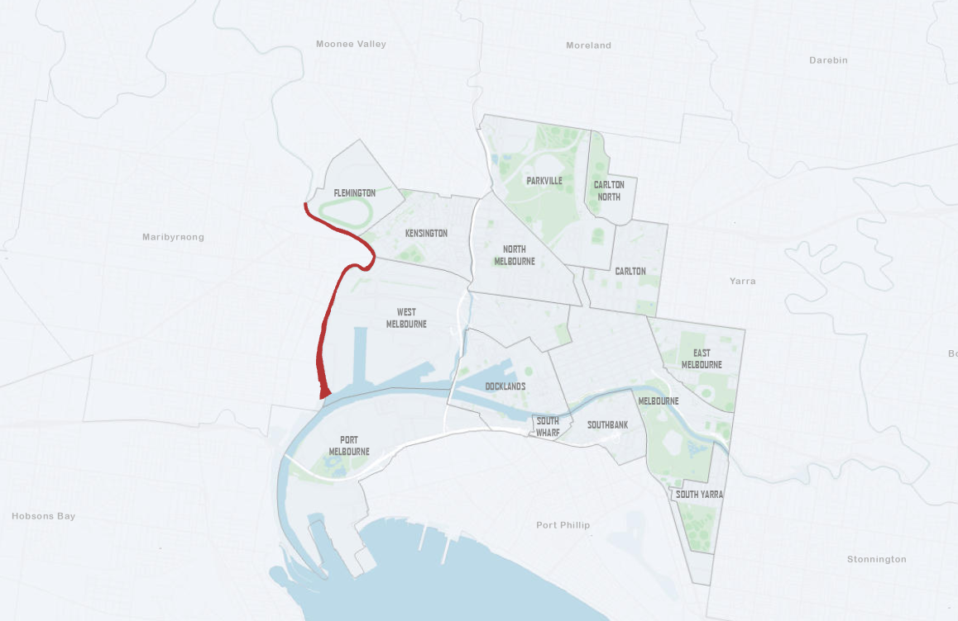
Figure 1 - Map of the City of Melbourne with the Maribyrnong River identified in red.
The main cause of the flooding in the City of Melbourne in October 2022 was the water level rise in Maribyrnong River’s lower reach, close to the bay. This was due to high intensity rainfall in the upper catchment of Maribyrnong River. Stormwater from the local catchments of Dynon Road, Kensington Road, Childers Street, Hobsons Road and Smithsfield Road also contributed to the flooding as the stormwater could not discharge to the Maribyrnong River due to stormwater river outfall pipes being fully submerged by the high water level of the river.
There are a number of City of Melbourne underground outfall drains to the Maribyrnong River from Smithfield Road up to Dynon Road including Dynon Road and Smithfield Road open canals (Figure 2).
All these outfall drains allow free gravity flow to the river, including the drain on Riverside Park, which has a non-return valve fixed to avoid river water backflow. During the flood event, noting the City of Melbourne does not have empirical evidence, there may have been river water backflow along the Council outfall drains which contributed to and/or exacerbated the flooding in the local catchments of Dynon Road, Kensington Road, Childers Street, Hobsons Road and Smithsfield Road.
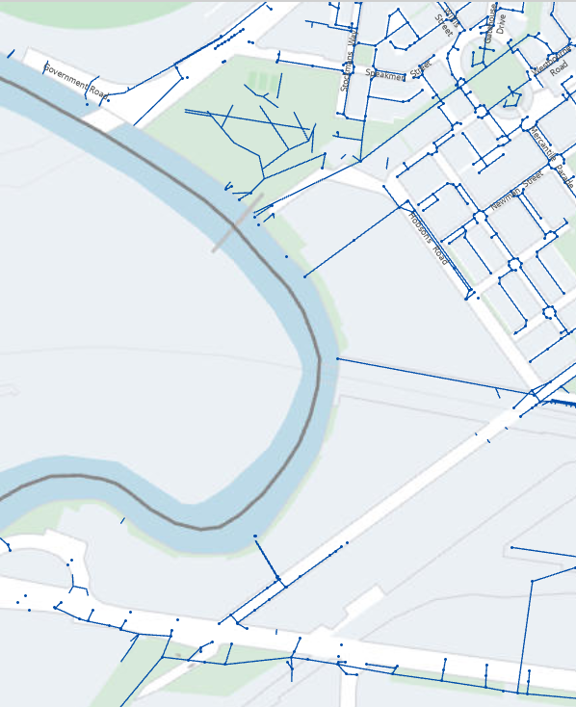
Childers Street Drain
Dynon Road Canall
Hobsons Road Drain
Riverside Park Drain
Smithsfield Road Canal
Figure 2 - City of Melbourne map showing Outfall Drains from Smithfield Road to Dynon Road, 2023.
During the October 2022 flood event, the City of Melbourne experienced some damage to infrastructure, properties and businesses; however, the proactive measures taken by the City of Melbourne as well as the topography of the area, meant the City of Melbourne was spared from the worst of the flooding.
In the City of Melbourne three businesses were severely impacted, five businesses had light to medium impact and there was one residential apartment block in Hobsons Road where the basement flooded, and approximately 80 vehicles were damaged and residents’ personal belongings in the storage cages in the basement were also damaged.
The City of Melbourne supported these businesses by successfully advocating to the Victorian State Government for Kensington and West Melbourne to be listed as flood affected area, informed each business that Victorian Government grants were available and assisted businesses in disposing of damaged property.

Early warning systems - Adequacy and effectiveness
ToR (2): adequacy and effectiveness of early warning systems

In response to the 2022 Flood event, City of Melbourne’s community has raised concern about lack of notification and emergency warnings for the Kensington and West Melbourne areas in the lead up to the flooding incident. The following was submitted by a local community member to our Participate Melbourne engagement platform:

“The whole of Hobsons Road (Kensington) was badly affected by flooding in October 2022 - far more than the usual standing water after heavy rain - but no notifications from emergency apps were given that action was required.”

Many community members have indicated that they relied on State Emergency Service’s (SES) Local Flood Guide for ‘Kensington and North Melbourne’. The Guide was last reviewed in 2021.

Community members have expressed concern about information presented in this guide which seems to indicate that in a 1 in 100 year flood event, Riverside Park would not flood and that Flemington Racecourse would, which is incorrect (see figure 3).
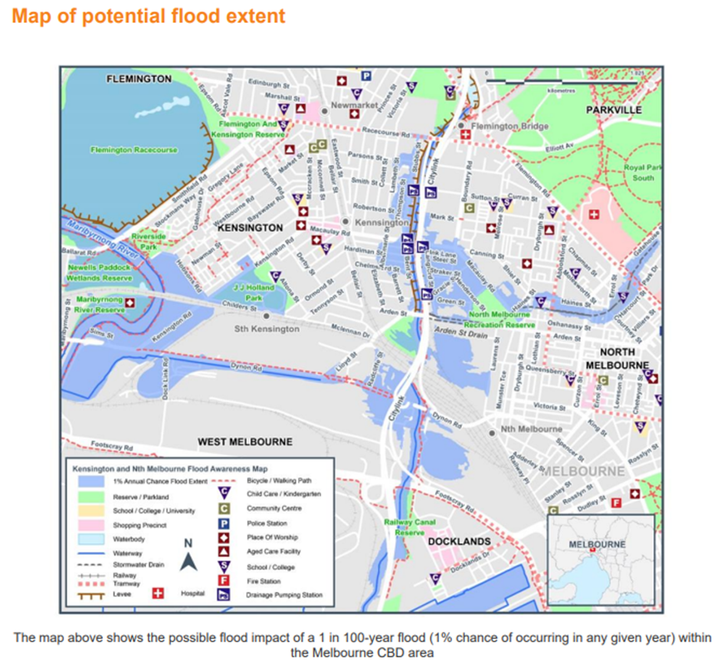

Figure 3 - Map from SES Local Flood Guide for ‘Kensington and North Melbourne’

Additionally, one of the most impacted areas in the municipality was West Melbourne, yet the flooding guide is titled only for ‘Kensington and North Melbourne’ areas.

It is recommended that this document be updated to include more accurate modelling and renamed to help ensure greater awareness of flooding risks for West Melbourne businesses and residents.

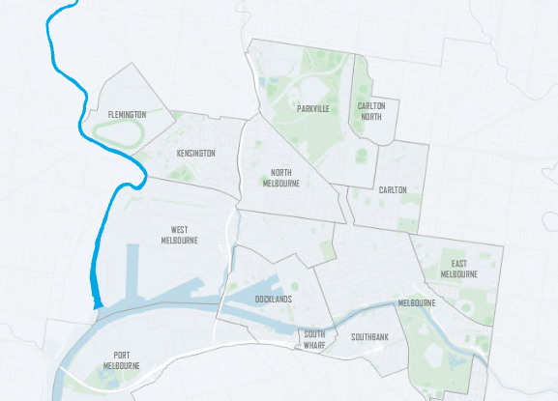
Figure 4 - Map of City of Melbourne showing where Flemington, Kensington and West Melbourne adjoin the Maribyrnong River

In addition to notification and emergency warnings, the community is also asking for more transparent flood risk information.

2016 Victorian Floodplain Management Strategy – Implementation and effectiveness
ToR (4): implementation and effectiveness of the 2016 Victorian Floodplain Management Strategy in relation to the Flood Event
The Victorian Floodplain Management Strategy (VFMS) 2016 sets the directions for floodplain management in Victoria. The Flood Management Strategy Port Phillip and Westernport 2021–2031 (the strategy) and the related Action Plan 2021–2026 (the action plan) were delivered in 2021 as part of the VFMS action plan. The strategy and action plan have been prepared by Melbourne Water together with key partners, including City Melbourne.
The strategy and action plan cover the strategic directions in the VFMS with a focus on the Melbourne Water service area. For this reason, Council draws on the strategy and action plan for flood management directions for the City of Melbourne and broader drainage catchment.
The strategy recognises that the costs of flooding are estimated to increase substantially, and that collective action is required to address the problem of flooding. The strategy is aligned to City of Melbourne’s needs and strategic direction, in particular Planning Scheme Amendment C384 Inundation Overlays and use of integrated water management to reduce flood risk. City of Melbourne is particularly supportive of the greater emphasis on:
- Working to expand the suite of tools to manage flood risk.
- Looking for opportunities and efficiencies in land use planning.
- Empowering the community to become flood resilient; and
- Embedding climate change into decision making.
The strategy also includes a commitment to leverage the Integrated Water Management Forums to better incorporate flood outcomes into integrated water management projects across Victoria. This event was an example of how flood travels beyond the local LGA’s catchment and how its impacts are felt along the river catchment. Local government relies on the state government and Melbourne Water to accelerate whole of catchment strategy and investment to minimise flood risk.

While the strategy and action plan set a solid direction for floodplain management and community preparedness, there is a need to focus on implementation of actions over the next 10 years. Immediate priorities to address are:

- Municipal Urban Stormwater Institutional Arrangements
The rule for catchments under 60 hectares to be the responsibility of local government will not be sufficient in managing flood in inner urban areas where land is constrained, and more innovative flood solutions are required.

These inner urban areas are an example of where local governments require Melbourne Water’s guidance and active involvement in the planning and delivery of flood management projects.
- Municipal and Local Flood Plans
An area that can also be strengthened is collaborating on the development and implementation of flood plans. More specifically, on the development of municipal wide flood plans to set up clear municipal direction and projects to manage flood in the medium and long term, and the implementation of local flood plans to ensure they are on track. Actions in local flood plans are reliant on annual budget bids and may not always get the funding required.

There would be great benefit in local governments working with Melbourne Water to investigate funding models that would ensure actions are rolled out at the appropriate time for hotspot areas.
The Moonee Ponds Creek Strategic Opportunities Plan outlines opportunities to revitalise Moonee Ponds Creek with a chain of parklands, new open spaces and wetlands that have the potential to play a flood management role. These opportunities align with the holistic approach for land and flood management in the Flood Management Strategy. The City of Melbourne recommends the implementation of the Moonee Ponds Creek Strategic Opportunities Plan.
The Creek corridor is largely controlled by Victorian Government agencies and City of Melbourne’s role is that of an advocate for the current and future residents and communities along the creek corridor. City of Melbourne welcome the opportunity to work in partnership with the Victorian Government, neighbouring councils, community groups and other partners to revitalise the Moonee Ponds Creek corridor.
City of Melbourne is represented on Melbourne Water Flood Leadership Committee and will continue to collaborate and provide strategic oversight of implementation of the Flood Management Strategy.

Engineered structures - Location, funding, maintenance and effectiveness
ToR (5): location, funding, maintenance and effectiveness of engineered structures, such as floodwalls, rural levees and culverts, as a flood mitigation strategy
Solutions to riverine flood include the implementation of river basin plans, infiltrating and retaining water in upper catchment areas, re-naturalising rivers and creating buffer protection for rivers.
The City of Melbourne considers that this inquiry will confirm that river basin structural solutions are required and therefore there is a need for commitment from federal and state government moving forward.
Urban development in Melbourne has continued to intensify, especially in the inner city, with most of the developments being infill. The nature of this infill type of development combined with the impacts of climate change poses pressure on the old drainage systems. Some of Melbourne Water’s drainage networks are 100 years old and will require update through staged programs to deliver innovative and climate change resilient major drainage.
The City of Melbourne has implemented drainage infrastructure to minimise the impact of flooding on the surrounding communities. During the October 2022 flood event the City of Melbourne observed that:
- the levees prevented flood water overtopping from the Maribyrnong River.
- the non-return valves prevented river water backflow along the stormwater drains into the Riverside Park.
- Riverside Park and the adjacent areas were flooded as the non-return valves closed and stormwater could not drain under gravity into Maribyrnong River due to high water level in the river.
- Riverside Park is a flood retarding basin and has a levee bank along the eastern side of Maribyrnong River (figure 05 and 10).
- Stormwater drains from the Riverside Park retarding basin are connected to large underground outfall drain which discharges into the river. This drain has a non-return valve which prevents river water from flowing back into the drain when the river level rises due to flooding.
- Kensington pump station operated and pumped the flood water back to the river.
During this event the City of Melbourne experienced significant rainfall and following sections of roads at various locations within the municipality were flooded, as stormwater could not drain under gravity into Maribyrnong River due to elevated water level in the river:
- A section of Hobsons Road close to the river (see figure 06 and 9)
- A section of Smithfield Road close to the river and Government Road
- Kensington Road closer to Mercantile Parade including railway underpass (figure 6 and 13)
- A section of Childers Street adjacent to newly constructed rain garden and JJ Holland Park(figure 6,12 and 13); and,
- A section of Dynon Road west of Dock Link Road including the railway underpass (figure 6 and 14);.
A recently completed raised road section (bund) in Hobsons Road close to the riverbanks has prevented flood water overtopping this section of the road. This bund was constructed by the developer of adjacent land (71 Hobsons Road) as part of development works. It was a planning permit requirement by Melbourne Water for the developer to provide a safe pedestrian access / eagres across Hobsons Road during a flood event (flood events up to 1 per cent AEP) to the existing flood free pathway within the Riverside Park. This bund performed as intended and provided a safe access on to the flood free pathway in the Riverside Park during this flood event. It also prevented flood water from the river overtopping the bund as overland flow. The underground storm water drains connecting Hobsons Road to the river do not have any non-return valves. This caused storm water back flow through the drains into the inland section of the Hobsons Road bund contributing to localised flooding. In addition to that, flood water from the local catchment in Hobson Road contributed to the flooding in Hobsons Road due to reliance of gravity drains and the high water level in the river.
Construction of this bund is a part of the wider flood management strategy proposed by Melbourne Water for Hobsons Road and Kensington Road. There is another similar road bund and a new Pump Station/drain and some levee banks along the river proposed to be constructed in Kensington Road as part of the Melbourne West Waterfront development works. As per the Melbourne Water flood management strategy, implementation of the full flood management strategy will reduce flooding in Hobsons Road and Kensington Road.
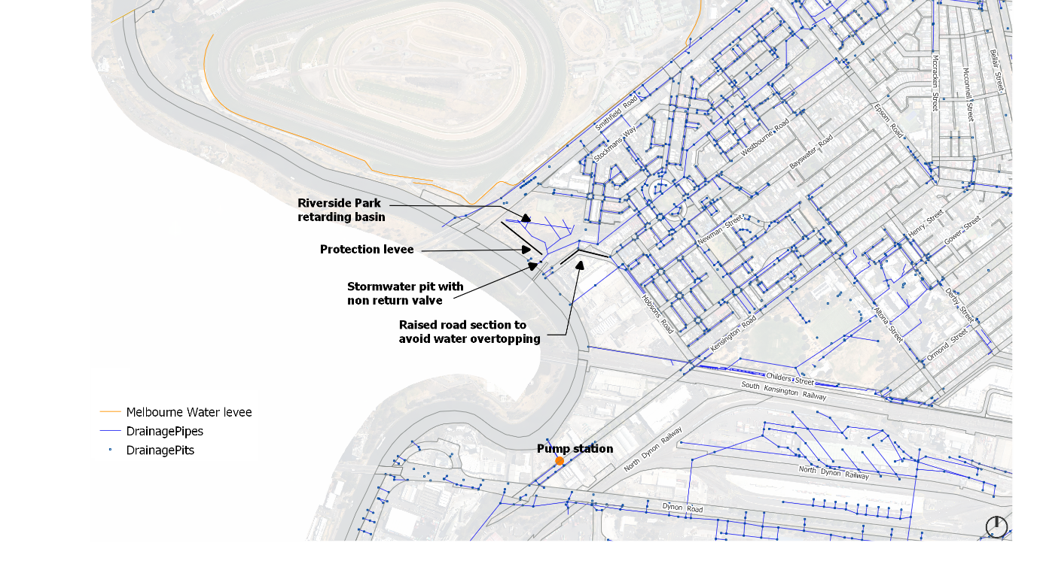Figure 5 - City of Melbourne map showing Flood mitigation structures, 2023

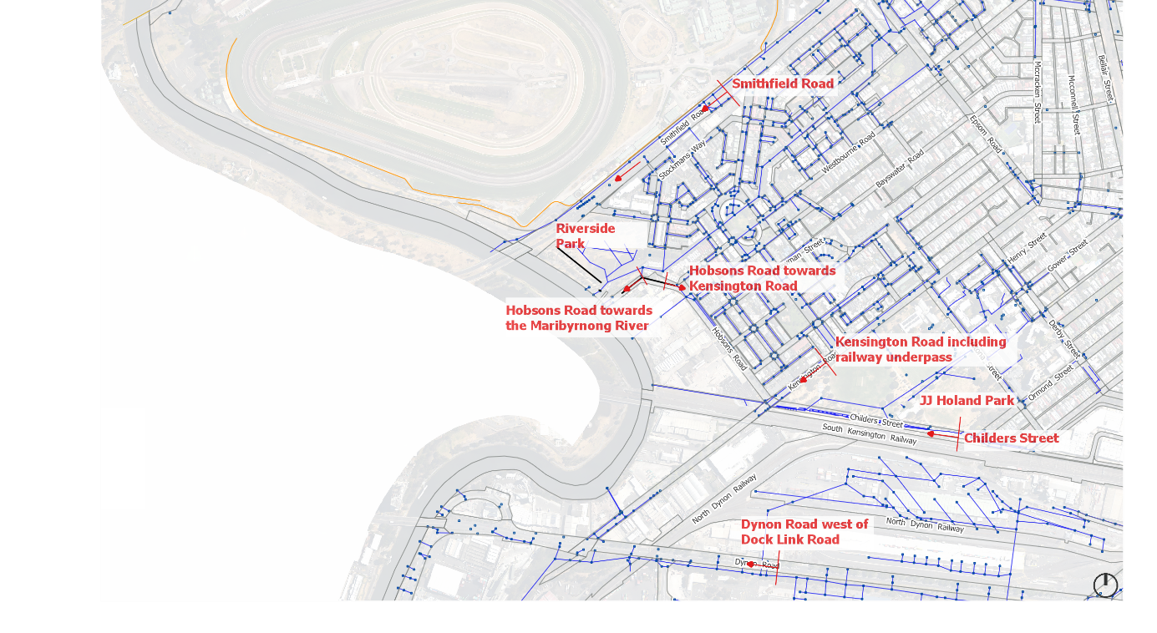
Figure 6 - City of Melbourne map showing flooded areas, 2023

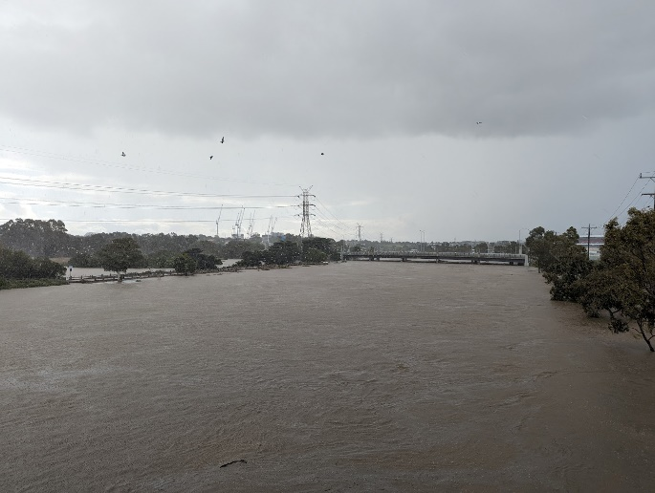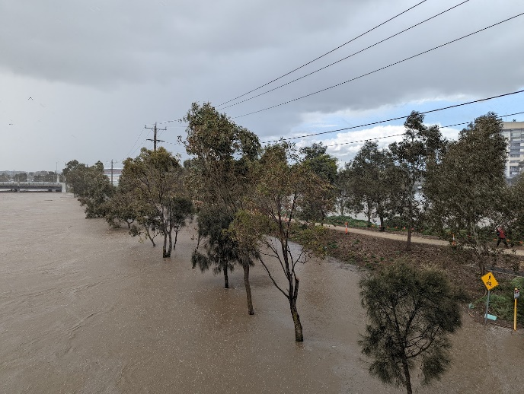

Figure 7 Maribyrnong River looking upstream from Angliss Stock Bridge with Newells Paddock (wetlands reserve) on the left (left photo) & Riverside Park on the right (right photo) - 14 October 2022

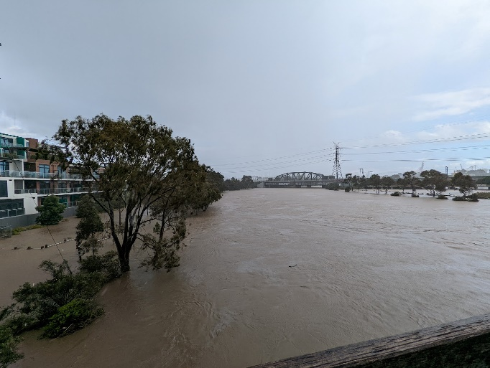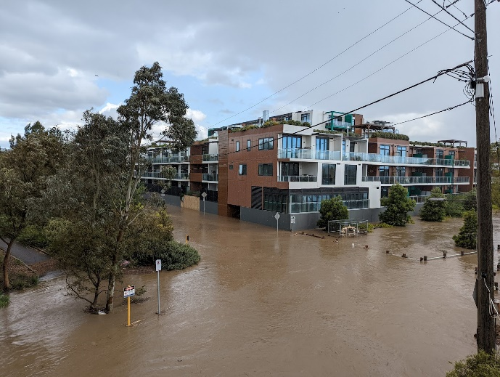
Figure 8 Maribyrnong River looking downstream from Angliss Stock Bridge and Hobsons Road - 14 October 2022

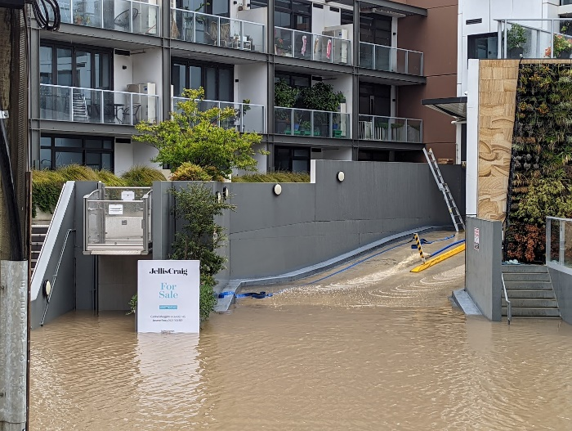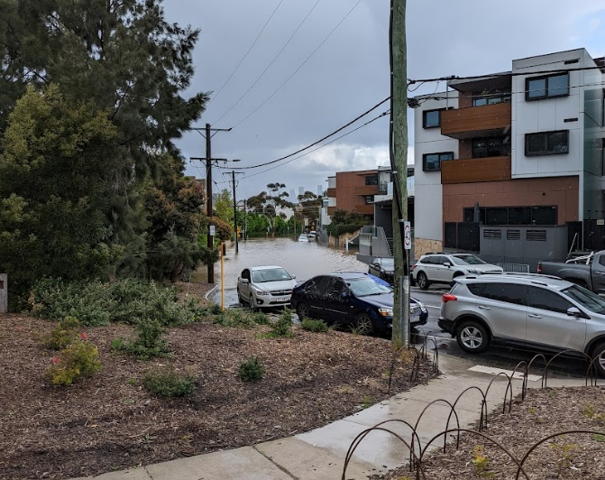

Figure 9 Hobsons Road, south of Riverside Park, Kensington - 14 October 2022

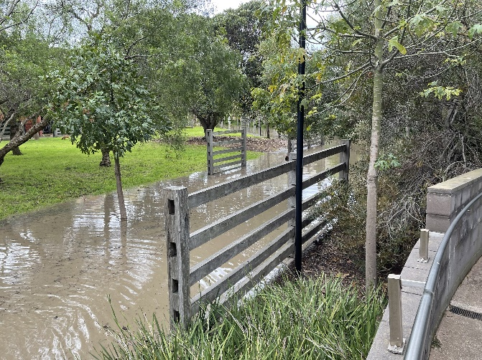 | 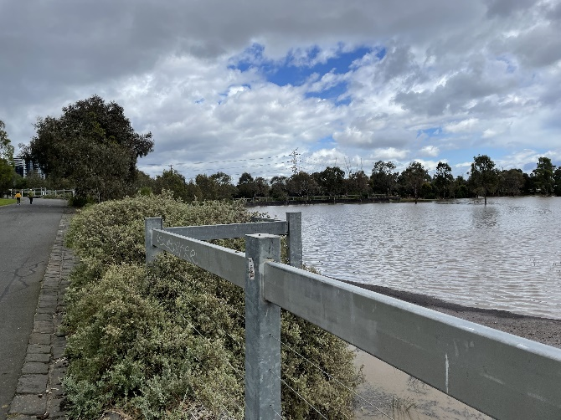
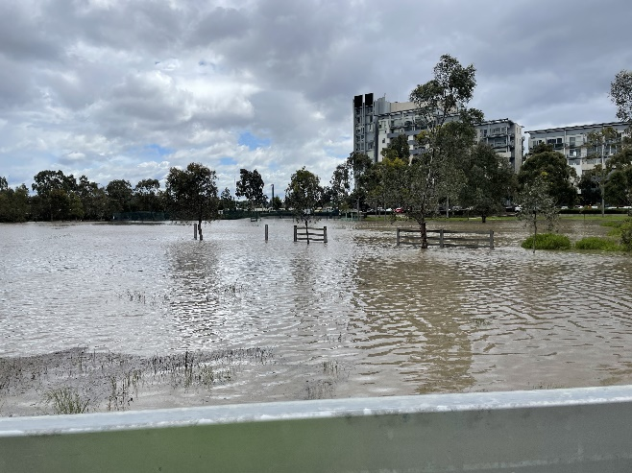 | 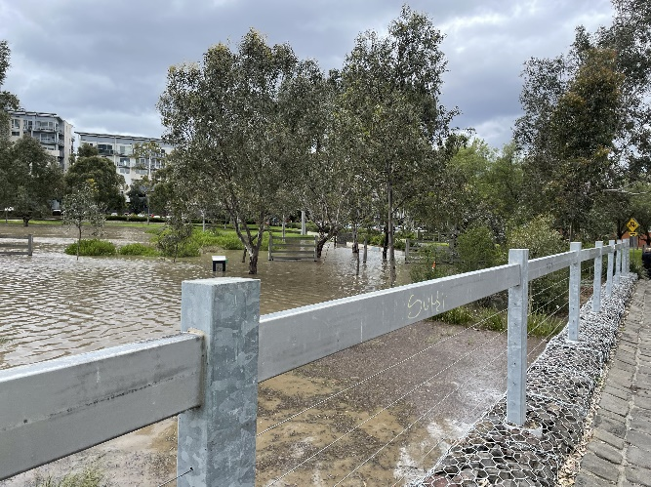
Figure 10 - Flooding on Riverside Park, Kensington -14 October 2022

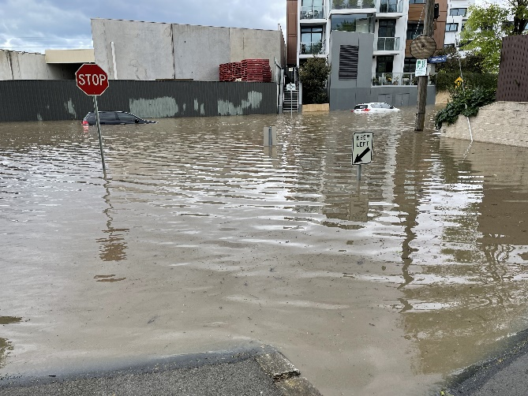 | 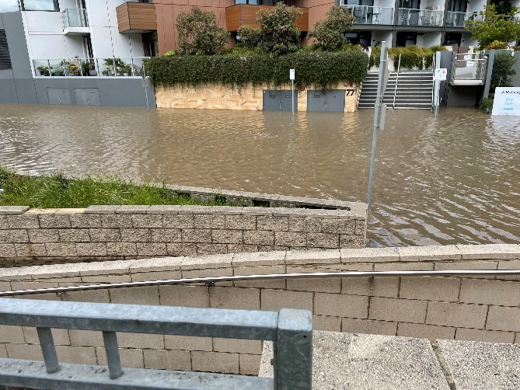
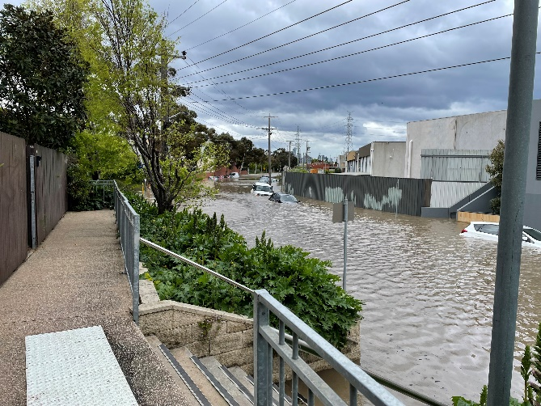 | 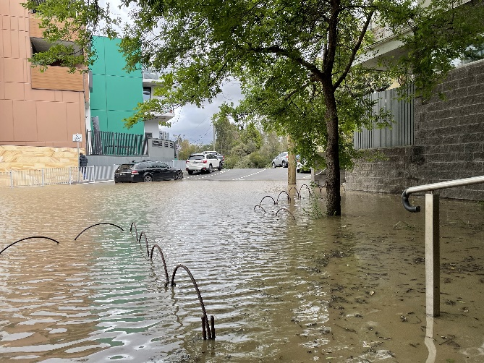
Figure 11 - Flooding on Hobsons Road (section between the Kensington Road towards the bund), - 14 October 2022.

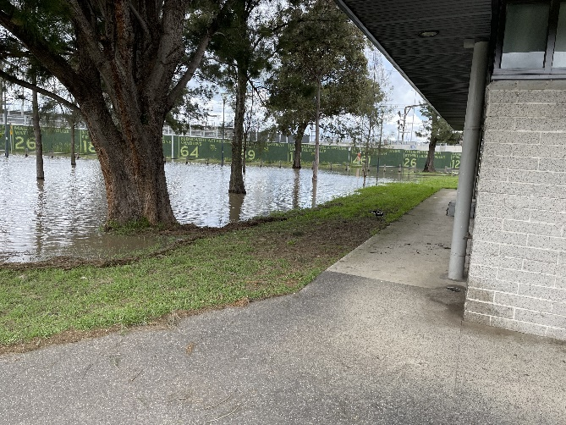 | 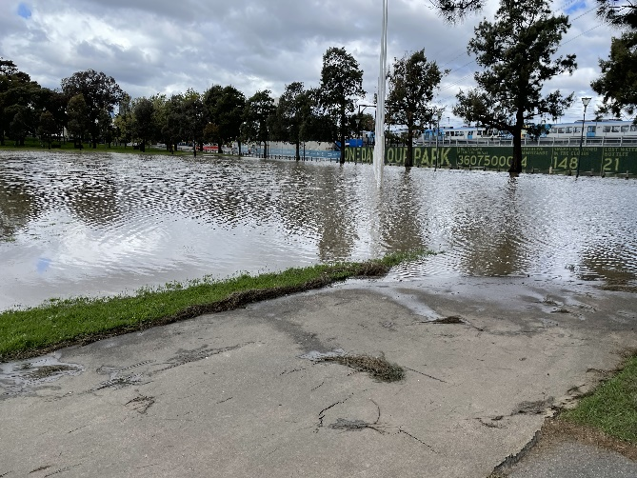
Figure 12 - Flooding on JJ Holland Park (south side), flood event - 14 October 2022.

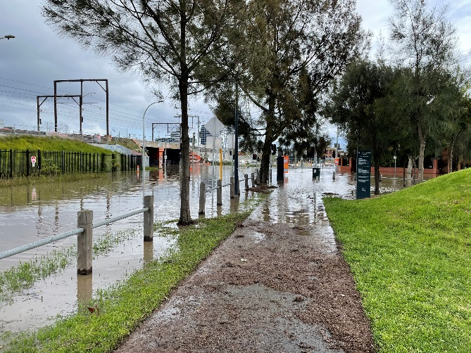 | 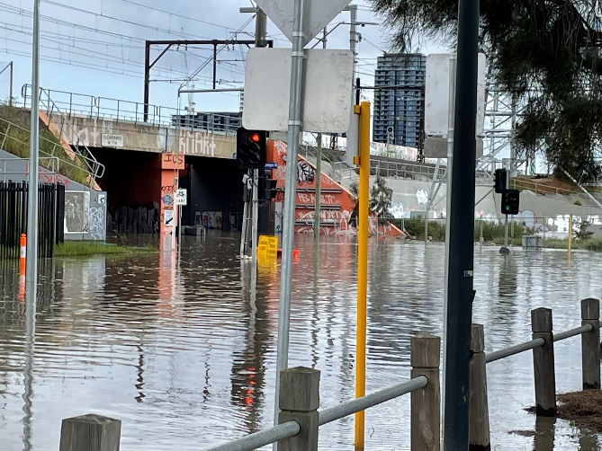
Figure 13 - Flooding on Childers Street and Kensington Road underpass, - 14 October 2022.

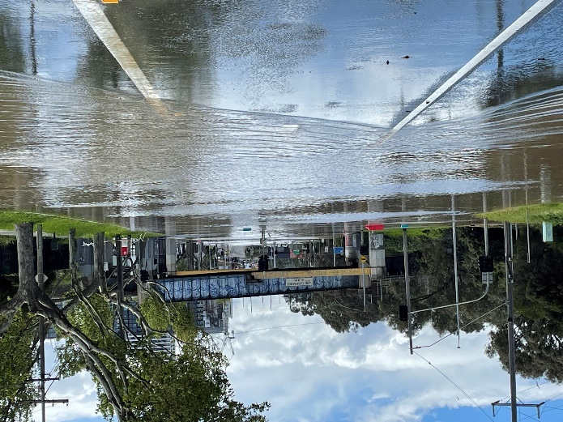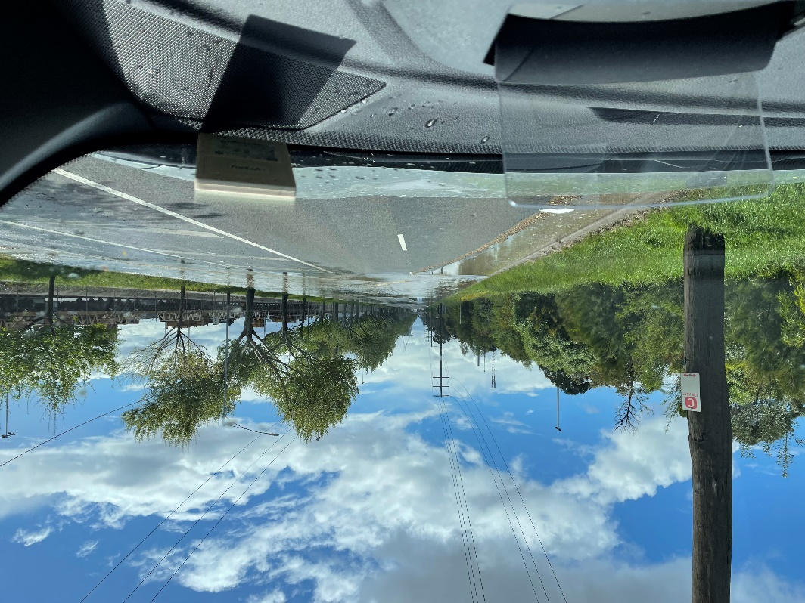
Figure 14 - Flooding on Dynon Road and railway underpass, - 14 October 2022.

Flood event as a whole
ToR (6): Flood Event as a whole, including but not limited to, the catchments and floodplains of the — (a) Avoca River; (b) Barwon River; (c) Broken River; (d) Campaspe River; (e) Goulburn River; (f) Loddon River; (g) Maribyrnong River; (h) Murray River.
City of Melbourne sits in a unique location with the convergence of three important waterways in metropolitan Melbourne – the Yarra River, the Moonee Ponds Creek and the Maribyrnong River.
This flood event was an example of how our municipality is highly susceptible to the impacts from upstream events.

City of Melbourne recognises that governance arrangements for waterways are complex and involve multiple stakeholders. Our Municipal Integrated Water Management Plan, Moonee Ponds Creek Strategic Opportunities’ Plan and Yarra River – Birrarung Strategy direct a collaborative approach to achieve the outcomes our community seek for waterways – balancing flood risk with creating places for people.

There are lessons to be drawn from this event for managing flood in other inner urban areas where land is constrained. Particularly, in urban renewal areas such as Arden and Fishermans Bend, which also face significant flood risk. Besides being in low lying areas, the presence of contaminated soils due to their history in land use pose flood mitigation challenges not seen before in greater Melbourne. These challenges will be exacerbated by climate change.

New challenges require novel stormwater conveyance and flood mitigation approaches such as new road and open space design to keep stormwater on the surface as well as classic infrastructure consisting of pipes and pumps. This type of approach heavily relies on flood management at the various scales of the developments – site, street, neighbourhood and whole of precinct and catchment.

Local governments have limited resources to ensure there are appropriate measures in place to respond to flooding, therefore Melbourne Water, as our water authority, must lead the development, implementation and operation of such approaches for the future. The current recommendation from the review of Municipal Urban Stormwater Institutional Arrangements is that a 60 hectare rule should be considered in planning and governance of flood infrastructure. While this rule could be suitable for Greenfield and regional areas, it will not be effective at reducing flood risk in constrained urban renewal. City of Melbourne recommends that Melbourne Water considers the challenges listed in this review in determining exceptions to the 60 hectare rule or even the suitability of the rule at all.

Flood wall around Flemington Racecourse
ToR (7): the 2007 decision of the Minister for Planning to approve the construction of a flood wall around Flemington Racecourse and whether the growing impacts of climate change were considered

The Minister for Planning was the responsible planning authority for determining five planning applications, including the proposed flood wall along the Maribyrnong River and Smithfield Road frontages of Flemington Racecourse, two new buildings, and the construction of a tunnel for vehicles and horses. The applications constitute the major elements of the Flemington Racecourse Masterplan and were referred to the City of Melbourne by the former Department of Sustainability and Environment for comment. The growing impacts of climate change were not addressed in the application process.

The City of Melbourne’s former Planning, Development and Services Committee considered at its meeting on 9 October 2003 these five planning applications. The Committee resolved to:

- acknowledge the strategic significance of the VRC Flemington Racecourse and Royal Agricultural Society Showgrounds sites to the culture of Melbourne life;
- inform the appropriate State Government Minister that the Council cannot support the VRC Flemington Racecourse Masterplan
- request the Minister to undertake a comprehensive strategic plan for the Maribyrnong valley area, including the Showgrounds area, before the VRC Flemington Racecourse Masterplan can be reconsidered and
- note that this decision is being made by the Committee under delegation from the Council and is subject to the referral notice process.
The impacts of the flood wall need to be further investigated and any modelling needs to take into account the impacts of climate change and surrounding development that has occurred since the wall was built.

Implications for future planning decisions
Approach to flood modelling and predictions

The Victoria Planning Provision objectives for Floodplain management at Clause 13.03-1S, of the Planning Scheme is:

To assist the protection of:
- Life, property and community infrastructure from flood hazard, including coastal inundation, riverine and overland flows.
- The natural flood carrying capacity of rivers, streams and floodways.
- The flood storage function of floodplains and waterways.
- Floodplain areas of environmental significance or of importance to river, wetland or coastal health.

The key to making sound planning decisions in relation to all of the objectives, is the availability of accurate best practice data.

The Planning Institute of Australia has recommended that a framework be established for a consistent and publicly accessible dataset for coastal and riverine flooding to inform land use decisions.

In the City of Melbourne’s submission to the Melbourne Water Flood Strategy for Port Phillip and Westernport, Council raised the issue that flood information is currently difficult to navigate. There is a need to provide fit-for purpose information, including up to date flood modelling and mapping to our community and to ensure appropriate development in flood plains.

A key question that should be addressed by this inquiry is whether the flood data in relation to the Maribyrnong River and all other catchments in the State is up to date and whether in light of climate change there are sufficient measures in place to mitigate the impacts of flooding. This is a matter for the agency for all the catchment management authorities and Melbourne Water.

The City of Melbourne in partnership with Melbourne Water recently exhibited planning scheme amendment C384 (inundation overlays) to introduce up to date flood modelling for some catchments in the city. This data had last been updated about 20 years ago. The process has been long and complex and did not include all catchments. Notably, the Maribyrnong River was not part of the review.

The City of Melbourne is of the view that because of the impact of climate change, there should be a requirement for catchment management authorities and Melbourne Water to update flood data and review the mitigation measures which are in place. This should occur at least every five years.

There is a need to streamline planning scheme amendments using the best available information about future conditions, including sea level rise and increased climate change rainfall intensity. In high-risk areas, flood models need to be updated regularly as knowledge advances.

The City of Melbourne is of the view that because of the risk to life and property, the Department of Transport and Planning should consider introducing updated flood data into planning schemes using an alternative process to that outlined under S.19 of the Planning and Environment Act, 1987. If the standards used to generate the data meet best practice guidelines and are scrutinised by a public process, then a more streamlined process than the standard planning scheme amendment process may be a more appropriate planning pathway.

There should also be consistency with flood data and the timing of its application used in the building permit system.

Strategic planning

Flood mitigation measures that meet current standards for the protection of lives and property, sustainability and urban design need to be implemented by the planning authority or rezoning proponent, before any development is allowed. As more flood prone areas in metropolitan Melbourne are developed this is becoming more and more important. Development in these areas should always be required to ensure that the land can be made safe as part of the development process.

Additionally, urban design consideration ought to be integrated within the land management overlay to give proper effect to a balancing exercise of design with mitigating flood risk. It is noted that the typical approach to managing food risk is to require the entire floor level of a building to be raised above the Australian Height Datum, which is not always a practical or desirable outcome in an inner urban setting.

Referral authorities including Melbourne Water, should be encouraged to work proactively with developers to deliver alternative urban design solutions, other than a blunt raising of floor levels. This is required to avoid blank walls and large retaining walls at public interfaces in inner urban environments.

The Melbourne Water Flood Strategy for Port Phillip and Westernport recognises that agencies will need to work together to reduce flood risk. These inner urban areas are an example of where Melbourne Water’s guidance and active involvement in the planning and delivery of flood management projects is required.

Other relevant matters
The City of Melbourne recommends that, as a part of this Inquiry, the Legislative Council Environment and Planning Committee consider the level of community resilience to flood events and the capacity of local governments to deliver necessary flood management projects.
Community resilience
City of Melbourne acknowledges that early warning systems are a critical component of flood management and protecting communities. However, there is an important need to build community resilience to flooding.
In the Council Plan 2021-2025, City of Melbourne has committed to engage and prepare residents and communities to enhance their resilience to hazards, disasters and the health impacts of climate change. This work is currently underway and involves direct engagement with all neighbourhoods across the municipality.
City of Melbourne carried out a survey in 2020 to understand our community's awareness and preparedness for extreme weather, including flooding. The results provide a rich data set and insight into what our community is doing to prepare for floods. The results emphasised the need to identify vulnerable groups likely to be disproportionately impacted by flooding including elderly people, people experiencing homelessness, renters and those who speak a language other than English. Our research showed communities with higher incidences of not being prepared for flooding include those who lived in Docklands / Southbank (44%) and the northern suburbs of the municipality (43%), and those who speak a language other than English (43%). A quarter (25%) said they had home and contents insurance that covered flooding. We found the following communities are less likely to be insured for flooding:
- 14–34 year olds (48% uninsured)
- those who speak a language other than English (49%)
- renters – across all house types (53%)
- those who live in high-rise apartments (8+ stories, 50%).

The City of Melbourne is currently conducting Neighbourhood Community Resilience Assessments as a methodology to better understand the localised vulnerabilities and opportunities for building community resilience to disasters. In the four workshops conducted so far, the community is asking for better information on the disaster risks that may impact on them so that they may be better prepared in advance of an event occurring. The information needs to be provided in a prominent and trusted place, in multiple languages and socialised with the community in a strategic manner.
In Kensington, the community has requested a physical Hub where they can learn more about disaster risk, build community connection and agency to be better prepared to support each other in the event of a disaster occurring, such as flooding. Early warning systems and technology to support effective communication with the community, needs to be underpinned by community awareness and resilience. This needs to be built over time along with trusted relationships.

Key recommendations
City of Melbourne’s the key recommendations for future flood mitigation and management are:
- The requirement for Melbourne Water to consider the challenges identified by the inquiry, including determining governance models for flood management asset delivery and ownership.
- The need for Melbourne Water to play a lead role in establishing clear floodplain and catchment management to inform, support and coordinate local government collaboration on respective Municipal Floodplain Management Plans. This would involve:
- undertaking municipal wide flood modelling, preparing flood maps, developing flood mitigation/management strategies for the whole municipality
- identifying flood mitigation projects and prioritising the projects based on the level of protection each project provides to the most vulnerable communities
- developing funding and delivery strategy for adapting and mitigating flood.
- The need to encourage Melbourne Water to work proactively with developers to deliver alternative urban design solutions, other than a blunt raising of floor levels.
- Continue building community resilience against climate change.
- Streamline the process for flood-related planning scheme amendments.
- The need for a thorough investigation into the impacts of the Flemington Racecourse flood wall and the role of racecourse land in floodwater retardation.

https://citiespowerpartnership.org.au/wp-content/uploads/2022/03/Mayor-and-Councillor-Flood-Statement_March-2022.pdf
Adaption and resilience - CCCLM September 2022.pdf
Inquiry into the 2022 Flood Event in Victoria (parliament.vic.gov.au)
Good_Design_Guide_for_Buildings_in_Flood_Affected_Areas_Exhibition_Final.pdf (amazonaws.com)
b90a8d4d-6eb2-e9e8-eb33-8e6b7fa0cc4e (ses.vic.gov.au)

