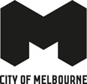
Experience Melbourne 2028
A destination management plan for Melbourne’s visitor economy

Acknowledgement of Traditional Owners
The City of Melbourne respectfully acknowledges the Traditional Owners of the land we govern, the Wurundjeri Woi-wurrung and Bunurong / Boon Wurrung peoples of the Kulin and pays respect to their Elders past and present. We acknowledge and honour the unbroken spiritual, cultural and political connection they have maintained to this unique place for more than 2000 generations.
We accept the invitation in the Uluru Statement from the Heart and are committed to walking together to build a better future.

Council Plan 2021-25
The Council Plan 2021-25 sets out our strategic direction and commitment to the community for the next four years. Based on six strategic objectives for our city, this is our detailed plan for our city’s revitalisation and considers the needs of all people who access and experience the City of Melbourne municipality. For more information visit melbourne.vic.gov.au/council-plan
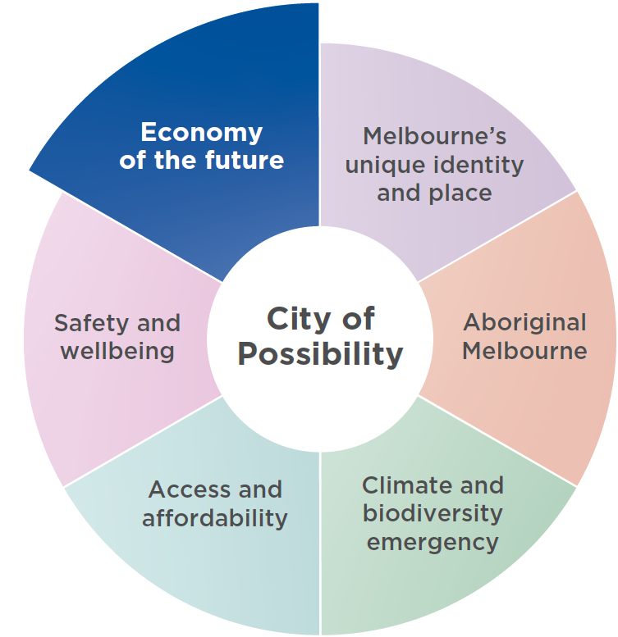

Economy of the future
Driving economic recovery is one of our chief objectives, to ensure the central city maintains a strong reputation as a destination to do business, visit, study and live. We will support a diverse mix of industries and jobs by creating conditions for a sustainable and thriving future economy.

Contents
Acknowledgement of Traditional Owners 3
Council Plan 2021-25 4
Economy of the future 4
Foreword 8
Melbourne’s strong visitor economy fuels the city’s economic growth and vitality. 8
Executive Summary 9
Introduction 13
Purpose of Experience Melbourne 2028 13
What is a destination management plan? 14
Strategic Context 16
City of Melbourne 16
City of Melbourne policy context 18
State and federal context 20
Greater Melbourne context 20
How City of Melbourne supports the visitor economy 22
Defining The Visitor Economy 23
Managing the destination 24
Visitor Markets 27
Top visitor origin markets 27
Types of visitors 28
Forecast top markets 2028 29
Visitor segments 31
The Importance of The Visitor Economy 32
Why Invest in Melbourne 34
The Vision for Melbourne’s Visitor Economy 37
Our vision 39
Guiding Principles 40
Aboriginal focused 40
Experience centric 40
Inclusive and welcoming 40
Sustainable and regenerative 40
Collaborative and connected 40
Melbourne’s Experience Pillars 41
Iconic experience 44
Renowned experience 50
Emerging experience 56
Experience Essentials 64
Transport and connectivity 64
Safety and cleanliness 64
Accessibility 66
Strategic Priorities 67
Stimulate visitation to the city 68
Enhance visitor servicing 69
Build industry capacity 70
Facilitate tourism development 70
Defining Success 72
Measuring our progress 72
Other success factors 73
Acknowledgements 75
Bibliography 80

August 2024
Cover image photo: Allan Wilkinson

Disclaimer
This report is provided for information and it does not purport to be complete. While care has been taken to ensure the content in the report is accurate, we cannot guarantee it is without flaw of any kind. There may be errors and omissions or it may not be wholly appropriate for your particular purposes. In addition, the publication is a snapshot in time based on historic information which is liable to change. The City of Melbourne accepts no responsibility and disclaims all liability for any error, loss or other consequence which may arise from you relying on any information contained in this report.
To find out how you can participate in the decision-making process for City of Melbourne’s current and future initiatives, visit melbourne.vic.gov.au/participate

Foreword

Melbourne’s strong visitor economy fuels the city’s economic growth and vitality.
As Australia’s premier destination for events, sports and culture, Melbourne is renowned for its captivating visitor experiences. Experience Melbourne 2028 is our ambitious blueprint to elevate this legacy, weaving the city’s dynamic tapestry of experiences into a cohesive and compelling narrative.
This goes beyond major events to embrace our world-class food and dining scene, our vibrant retail precincts, our renowned arts and culture offering, the city’s iconic green spaces and our Aboriginal culture and heritage.
At its core, this plan is about celebrating and amplifying Melbourne’s unique identity across the breadth of our visitor economy.
Experience Melbourne offers a strategic vision for key stakeholders across the sector to play to these strengths and elevate their offerings with what makes Melbourne unique.
It seeks to create a world-class, unique and memorable visitor experience.
Our goal is to entice more visitors to Melbourne, encourage them to stay longer and support the economy of our vibrant city.
Based on extensive research and comprehensive stakeholder engagement, Experience Melbourne 2028 captures the views and aspirations of more than 200 organisations spanning the breadth of the visitor economy. That wide-reaching input and support is vital.
In the year ending December 2023, Melbourne welcomed 14.3 million visitors who collectively added more than $11 billion into the city’s economy. This positive trajectory is expected to continue into 2028, with an anticipated 18 million visitors who will spend $16.8 billion, representing a significant growth opportunity.
Together, we have the power to realise Melbourne’s full potential.
Join us in this exciting journey as we unlock an extraordinary opportunity to propel Melbourne to new heights of global prominence and local prosperity.
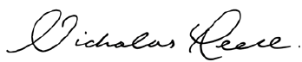

Nicholas Reece
Lord Mayor


Roshena Campbell
Councillor
City Activation Portfolio Lead

Executive summary
Experience Melbourne 2028 outlines a strategic vision for Melbourne’s visitor economy. It brings together the perspectives and aspirations of stakeholders across the visitor economy, and articulates a shared vision for the Melbourne experience in 2028. This builds on Melbourne’s success as one of the world’s most liveable cities and a capital of culture, sport and events.
The visitor economy is a significant driver of growth, prosperity and wellbeing for Melbourne. A thriving visitor economy contributes to the city’s prosperity. It also makes Melbourne an attractive destination for talent and business investment, and an enviable place to live. By 2028, itis anticipated that Melbourne will welcome more than 18 million visitors who will contribute $16.8 billion to the city’s economy (Tourism Research Australia, 2023a). Experience Melbourne 2028 aims to prepare the city for this rising demand and ensure the visitor experience is unique and unforgettable.
Melbourne’s visitor economy is entering a phase of transformation. In 2023, markets like China and Japan were still recovering from the pandemic, while others such as India had already surpassed 2019 levels. Strong growth is also anticipated from markets such as Hong Kong, Malaysia, Indonesia, and Vietnam.
Today’s post-pandemic travellers are eager for unique and authentic experiences, offering new opportunities for innovation and engagement. At the same time, the global competitiveness of the tourism industry is intensifying, with destinations ramping up their efforts and investments to attract visitors. With these industry shifts, it is more important than ever for the industry to come together with a unified vision and strategy to thrive in this “new normal”.
Experience Melbourne 2028 defines a vision for the Melbourne visitor experience. It provides direction to stakeholders across the visitor economy and guides ways to develop and promote their product. It identifies key themes for City of Melbourne and the sector to ensure we can sharpen our focus and avoid homogeneity by investing in what makes Melbourne distinctive.
By 2028, it is anticipated that Melbourne will welcome more than 18 million visitors who spend $16.8 billion.
A concerted, collaborative and strategic effort to grow Melbourne’s visitor economy will result in significant economic uplift for the city. Success is measured in positive visitor sentiment and the extent to which we can increase visitor yield. Success also depends on the entire sector working together to realise the goals of this plan. City of Melbourne has assumed a leadership role in fostering and connecting various facets of the visitor economy to establish Experience Melbourne 2028 as a shared vision. To bring this vision to fruition, collaboration is imperative among all key stakeholders, including various levels of government.
Experience Melbourne 2028 closely aligns with broader tourism strategies from both the Victorian and Australian governments. It has been developed in alignment with the statewide tourism plan, Experience Victoria 2033, and the national Thrive 2030 strategy. Experience Melbourne 2028 aims to enhance the city’s unique offerings while contributing to the state and national goals of increasing tourism and boosting economic growth.
Experience Melbourne 2028 has been developed for the visitor economy within the municipality of City of Melbourne. For clarity this plan uses the term Melbourne to refer to the local government area governed by City of Melbourne.

Experience Melbourne 2028 on a page

Vision
Melbourne is a city that captivates and welcomes the kind of visitors who are looking to connect deeply with the psyche of a place.
We invite spirited adventurers in to discover eclectic experiences just beneath the surface.
Our status as the cultural, events and sporting capital of the southern hemisphere is firmly established. Now we can turn our attention to other uniquely Melbourne experiences such as culinary delights, urban nature, Aboriginal culture, and knowledge and innovation. We will seamlessly integrate these pillars into the overall visitor experience.

Melbourne’s experience pillars

Sports and events capital
From the tent poles of the sporting calendar to the tapestry of community events throughout the year, sports and events play a major role in Melbourne’s visitor economy.

Ground-breaking creativity
Melbourne’s creative scene is renowned for its originality, independent spirit and commitment to pushing boundaries.

Vibrant people and places
Melbourne’s welcoming people and vibrant public realm are fundamental parts of the city’s identity.

Culinary kaleidoscope
In Melbourne, food is not just eaten: it is celebrated, discussed and savoured.

Eclectic shopping haven
The experience of shopping in Melbourne is much like the city’s unique style – diverse and eclectic.

Aboriginal culture in the city
Melbourne presents a unique opportunity to experience Aboriginal heritage and culture in an urban environment.

World-class knowledge hub
Melbourne’s reputation as a knowledge capital attracts business events and international students.

Green urban oasis
Melbourne is a city where nature is an integral part of the urban landscape.

Experience essentials

Transport and connectivity
Efficient transport infrastructure and digital connectivity enables visitors to get around the city with ease.

Safety and cleanliness
Visitors need to feel safe and secure to fully enjoy their experience of Melbourne.

Accessibility
It is important to ensure that all visitors can fully participate in Melbourne’s experiences.

Strategic priorities

Stimulate visitation to the city
By embedding a consistent brand narrative, ensuring diversity in our visitor markets and having a strong roster of events.

Enhance visitor servicing
By ensuring they are dynamic, personalised and consistent across the visitor economy.

Build industry capacity
By improving cultural competency of the sector, sharing data and insights, and attracting industry workers.

Facilitate tourism development
By encouraging innovative and complementary tourism products and experiences.

Guiding principles
We are Aboriginal focused.
We take an experience centric approach.
We foster an inclusive and welcoming destination.
We are committed to being sustainable and regenerative.
We are a collaborative and connected sector.

Visitor markets

Domestic
1. Regional VIC
2. Sydney
3. Regional NSW
4. Brisbane
5. Adelaide

International
1. China
2. New Zealand
3. USA
4. India
5. United Kingdom

Growth markets (international)
1. Hong Kong
2. Singapore
3. Malaysia
4. Vietnam
5. Indonesia

Visitor segments
City of Melbourne takes the lead on promoting the city to greater Melbourne and regional Victoria. We focus on the following segments:
- Cultured advocates
- Eager explorers
- Family focused
Visit Victoria and Tourism Australia are responsible for driving visitation from interstate and internationally. While they attract all visitors, their focus is on the following segments:
- Lifestyle leaders
- High-value travellers

Introduction
A thriving visitor economy is at the heart of Melbourne’s economy.
The visitor economy is more than tourism. It encompasses the web of interactions between visitors and a destination, along with the direct and indirect impacts arising from their activities.
Melbourne’s visitor economy is a significant driver of growth, prosperity and wellbeing. Melbourne’s visitor economy was enjoying unprecedented success in 2019, generating more than $13 billion in total tourism sales and creating more than 57,000 jobs (economy.id, 2023).
The shockwaves of the pandemic reverberated through Melbourne’s visitor economy, temporarily disrupting the bustling rhythm of our streets.
Yet Melbourne’s resilience is remarkable. Rising from the challenges posed by the pandemic, the city has recovered and is now poised for a new era. By 2028, it is anticipated that Melbourne will welcome more than 18 million visitors who will contribute $16.8 billion to the city’s economy (Tourism Research Australia, 2023a).
“It has been a much-needed boost to the tourism and events industry in Melbourne to see City of Melbourne undertaking this critical piece of work in outlining a strategic vision for the destination’s visitor economy to 2028. Importantly, the creation of this document has engaged deeply with industry and was developed in collaboration with key stakeholders across the city.” – Felicia Mariani, CEO, Victorian Tourism Industry Council.
As we set our sights on the future, it is important to acknowledge the headwinds that may impact the sector. Cost of living pressures, driven by inflation and high interest rates, coupled with a volatile geopolitical landscape, add unease to consumer confidence.
Despite these headwinds, Melbourne’s visitor economy remains robust. By adapting to evolving consumer preferences and staying aware of market dynamics, we can collectively navigate the challenges ahead and capitalise on opportunities for sustainable growth.
Experience Melbourne 2028 is the culmination of extensive research, thoughtful deliberation and comprehensive stakeholder and community engagement. Organisations spanning the breadth of the industry have played a pivotal role in contributing to the plan. Experience Melbourne 2028 reflects the collective wisdom and diverse perspectives of those who understand Melbourne’s unique character and have a shared interest in its prosperity.
As we progress collectively, we recognise the challenges ahead and the need for united efforts to overcome them. This plan is designed to spark the necessary action to guide us towards 2028 and beyond.
Thank you to members of the Experience Melbourne 2028 advisory group who have contributed their extensive knowledge, and to every individual and organisation that has taken part in the development of the plan.

Purpose of Experience Melbourne 2028
Experience Melbourne 2028 is a framework that enables City of Melbourne and the broader visitor economy to work together towards a shared vision for the Melbourne experience, as well as respond to immediate challenges.
The plan weaves together the aspirations of its diverse communities and dynamic industries. It sets a clear ambition for what the visitor economy can and should be for our city – a driving force for sustainable, resilient and inclusive growth.
It is a catalyst for innovation and collaboration, urging us to evolve and enhance the city’s offerings to meet the ever- changing needs of travellers. In a global tourism landscape marked by fierce competition, continuous innovation is essential to maintain a competitive edge.
Experience Melbourne 2028 was developed within the scope of City of Melbourne’s local government area. However, City of Melbourne acknowledges the seamless nature of visitor experiences that transcend municipal boundaries, and is committed to partnering with neighbouring councils and key stakeholders across greater Melbourne.

What is a destination management plan?
Tourism is a highly fragmented sector, encompassing various independent industries such as hotels, restaurants, retailers, arts and cultural institutions, and entertainment venues. A destination management plan brings these diverse industries together by creating a unified vision aimed at enhancing the overall visitor experience. It offers an organised and structured framework for the development and promotion of tourism in the city. Specific actions and initiatives will be detailed in future implementation plans.

Strategic context
Experience Melbourne 2028 complements and extends a range of policies, plans and strategies, both within City of Melbourne and at a state and federal level. Together, these plans help decision-makers and guide the sector to create a vibrant and sustainable visitor economy in Melbourne.

City of Melbourne

Council Plan 2021–25
Experience Melbourne 2028 was developed in the context of the Council Plan 2021–25. It responds to the ‘Economy of the Future’ strategic objective, with an increase in the number of visitors to the municipality a key measure of success. The Council Plan 2021–25 prioritises a central city that is a magnet for events and has a strong reputation as a destination to visit, do business, study and live. A coordinated effort in the visitor economy will increase economic participation, provide more jobs and attract talent and investment to the city.
Experience Melbourne 2028 also supports the other goals in the Council Plan 2021–25. It prioritises the activation and protection of Aboriginal culture as a key driver of economic growth. It works to ensure City of Melbourne’s creative, entertainment and education sectors are supported and nurtured. It supports innovative initiatives that aim to reduce emissions and waste in the sector, and contributes to making sure everyone feels safe and included when visiting the city.
Experience Melbourne 2028 is designed to adapt and align with future Council Plans, ensuring it remains responsive to evolving priorities and goals for the City of Melbourne.

Other City of Melbourne plans
The visitor economy has touchpoints across many work areas for City of Melbourne, with many strategies and plans contributing to a positive visitor experience and thriving visitor economy.
- Economic Development Strategy 2031 aims to position Melbourne as the premier international and domestic visitor destination in Australia.
- Creative Strategy 2028 supports artists and creatives who contribute to Melbourne’s status as a cultural capital.
- Transport Strategy 2030 ensures visitors can traverse the city with ease.
- Greenline Master Plan will transform the north bank of the Yarra River – Birrarung into one of the city’s leading attractions.
- Nature in the City Strategy protects Melbourne’s vibrant urban nature experiences.
- Inclusive Melbourne Strategy 2032 champions the diversity of Melbourne’s visitors and locals alike.
- Reconciliation Action Plan supports the voice and ambition of Aboriginal communities.
- International Engagement Framework highlights the priority of promoting Melbourne as one of the world’s most innovative and multicultural cities - a great place to live, visit, study, work and do business.

Sustainable Development Goals
The development and implementation of Experience Melbourne 2028 aligns with the Sustainable Development Goals (SDGs), a United Nations framework supported by City of Melbourne. These 17 goals were established to address pressing global challenges by 2030, encompassing a broad spectrum of social, economic and environmental issues.
City of Melbourne was the first local government in Australia to undertake a Voluntary Local Review Declaration to report its progress towards the Sustainable Development Goals. The review identified key performance indicators to monitor how City of Melbourne is tracking against the goals. Experience Melbourne 2028 will contribute to achieving these goals, in particular target 8.9: Promote sustainable tourism that creates local jobs and promotes local culture and products.
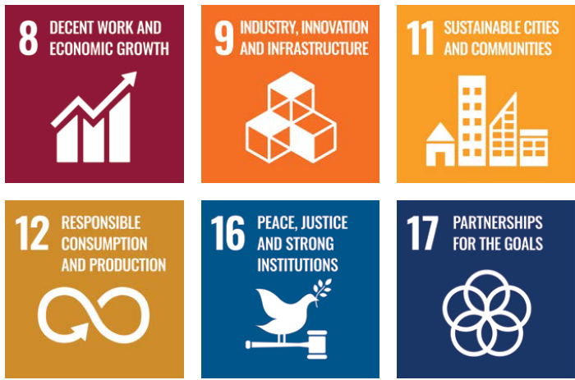

City of Melbourne policy context
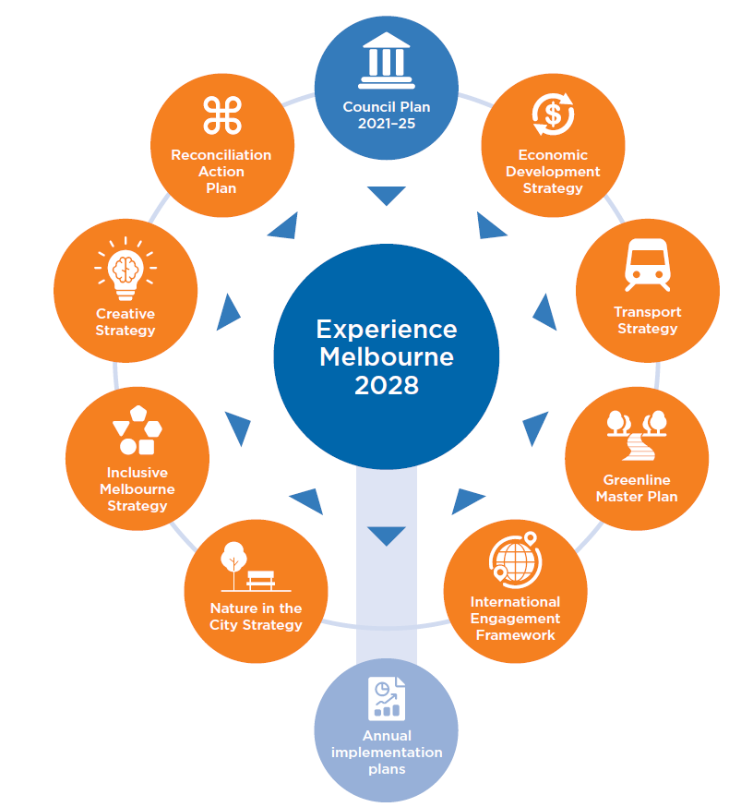
Experience Melbourne 2028 links many elements across these plans to foster a whole-of-organisation approach to ensure a seamless and enjoyable visitor experience.

State and federal context
Experience Melbourne 2028 is a comprehensive plan that closely aligns with broader tourism strategies designed by the Victorian and Australian governments.
Under the umbrella of the statewide tourism plan Experience Victoria 2033 and the national Thrive 2030 strategy, Melbourne’s approach is tailored to enhance the city’s unique offerings while contributing to the overarching goals of increasing tourism, boosting economic growth, and enhancing visitor experiences at the state and national levels.
This alignment ensures a cohesive and unified effort across different levels of government, maximising the impact of initiatives and investments.

Greater Melbourne context
Experience Melbourne 2028 was developed within the scope of City of Melbourne’s local government area. We acknowledge the seamless nature of visitor experiences that transcend municipal boundaries.
Recognising the critical role of collaboration, we are committed to partnering with neighbouring councils and key stakeholders across greater Melbourne. This unified approach aims to foster a cohesive visitor experience and bolster the overall visitor economy, ensuring greater Melbourne thrives as a harmonious, interconnected destination.
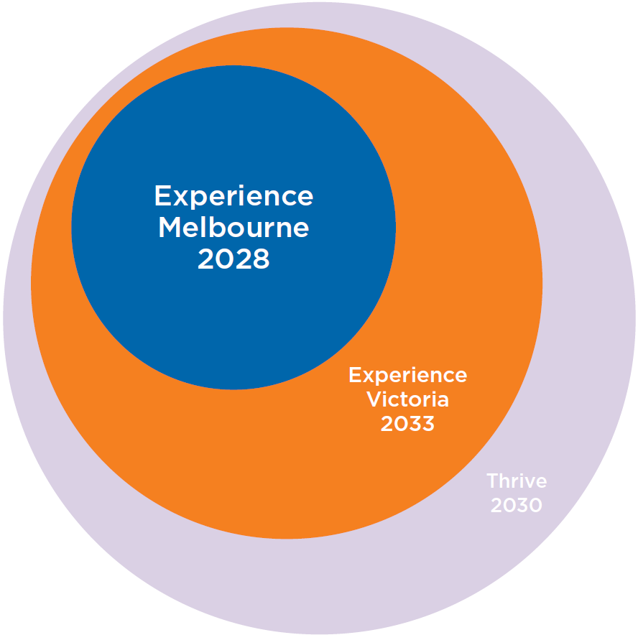
Visitor economy policy context

How City of Melbourne supports the visitor economy

Destination marketing
We drive visitation from greater Melbourne and regional Victoria through strategic marketing campaigns and initiatives that highlight the city’s unique experiences.

Events
We produce our own events that drive visitation to the city and support other events to take place through sponsorship and operational and planning support.

Visitor services
We welcome visitors and enhance their experience in Melbourne by providing expert advice and personalised service.

Business support
We support visitor economy businesses through grants, investment attraction, advocacy and our Business Concierge service.

Sector leadership, industry support and partnerships
We build industry capacity and foster strong connections to drive growth and innovation in the visitor economy.

Wayfinding
We assist visitors to move around through clear and accessible signage and digital tools.

International students
We provide a range of programs, events and support for international students.

Placemaking
We create a unique sense of place in the city, including urban planning, arts and culture, transport, safety and cleanliness, and sustainability.

Defining the visitor economy
Experience Melbourne 2028 adopts a progressive perspective that extends beyond the conventional boundaries of the tourism industry.
This plan recognises the broad and transformative concept of the visitor economy, with a diverse array of visitors and businesses contributing to the end-to-end experience. This strategic evolution aims to capture the whole visitor landscape, acknowledging the diverse range of visitors and the multitude of businesses that shape the Melbourne experience.

Visitors are diverse
Melbourne attracts a diverse array of visitors from around the world, who come to the city for many reasons. Visitors may arrive from greater Melbourne, regional Victoria, other parts of Australia or overseas, with trips spanning from day visits, overnight trips to months-long stays. The purposes of these trips include:
- Holiday: For rest and recreation, participating in or attending sports and cultural events, festivals, or shopping.
- Visiting friends and relatives: Primarily for visiting friends and relatives, including attending events such as weddings.
- Business: Travel related to employment, including meetings, conferences, conventions, and training. While office workers are not classified as visitors, they do often support visitor economy businesses and contribute to the overall vibrancy of the city.
- Education: International students who stay in Australia for less than 12 months are classified as visitors. Also includes training through vocational education, language colleges and work-based training.

Stakeholders are equally diverse
The visitor economy is graced with diverse stakeholders, including hotels and accommodation providers, cultural institutions, attractions, tour operators, retail establishments, restaurants and bars, transport providers, event organisers, venues, universities and research institutions. These elements collectively form a crucial part of the Melbourne experience.
A key objective of this plan is to foster positive interactions within the visitor economy ecosystem, enhancing their synergy and overall impact on the city. Achieving this objective will require collaboration between participants, strategies that are carefully aligned, and stronger forms of cooperation.

Geographic focus
The overarching goal of Experience Melbourne 2028 is to position Melbourne as a welcoming and attractive destination for a broad spectrum of local, domestic and international audiences. By addressing the needs and interests of a range of visitors, the plan aims to create a dynamic and inclusive destination that is accessible and appealing to everyone. This approach recognises the unique contributions each type of visitor makes to the city’s economic, cultural and social vitality.
- Locals and greater Melbourne residents: Encouraging residents from the broader metropolitan area to explore the city, fostering a sense of local pride, enthusiasm and energy.
- Intrastate visitors: Recognising the significance of visitors from within Victoria, ensuring that Melbourne remains an attractive destination for regional travellers.
- Interstate visitors: Attracting visitors from other states, showcasing Melbourne as a place of diversity, passion and creativity with unique offerings that set it apart on a national scale.
- International visitors: Acknowledging the global appeal of Melbourne, the plan aims to elevate the city’s reputation on the international stage.
Melbourne’s visitor economy ecosystem is populated by the various types of visitors and the stakeholders who interact with them. The infographic on page 17, by renowned Melbourne illustrator Oslo Davis, maps the many players in our visitor economy.

Managing the destination
The visitor economy has two primary revenue drivers — demand and supply. Creative marketing efforts strive to generate demand for a destination and create immediate urgency for people to want to visit. Destination management focuses on the supply side of tourism by creating a compelling visitor experience to attract new visitors and entice repeat visitation.

Tourism drivers
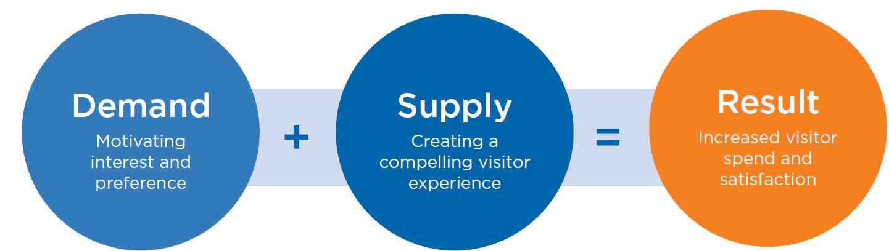
In a world where people can quickly share their experiences via social networks and rate their experiences on third-party platforms, the quality of the destination and its experiences is an essential element of the marketing toolbox.

Destination management
Destination management happens when industry and government plan and work together to enhance the quality of the visitor’s experience by ensuring tourism products, services, amenities, and practices meet and exceed visitor expectations over the long term. The overarching purpose is to increase destination competitiveness and maximise visitor spend.
There are many dimensions to supply that are considered in destination management to enhance the visitor experience, including:
- The setting in which visitor experiences take place and how visitors access them.
- Policies that establish and maintain growth opportunities.
- Investment in products and experiences matched to consumer interests, including infrastructure and amenities.
- Visitor servicing programs that meet and exceed guest expectations.
- Industry capability, skills and training.

Destination marketing
Destination marketing involves the positioning and promotion of a destination to attract visitors. There are many stakeholders at each level of government that contribute to driving visitation to Melbourne.
At the federal level, Tourism Australia is the government agency responsible for nationwide strategies that market the country as a prime destination globally for leisure travel and business events.
Visit Victoria is the government agency at the state level responsible for driving leisure visitation and expenditure to Victoria through destination marketing and the acquisition and support of major events. Visit Victoria’s campaign Every Bit Different is the master brand framework for Melbourne and Victoria; a creative marketing platform that is leveraged by City of Melbourne and industry.
Other bodies are also responsible for promoting Melbourne to visitors. The Melbourne Convention Bureau leads the acquisition and delivery of national and global business events for Melbourne. Study Melbourne is a Victorian Government initiative that promotes Melbourne as a leading destination to study.
At the local level, City of Melbourne brings people to the city from greater Melbourne and regional Victoria. We showcase the unique and varied experiences the city offers through targeted campaigns, while the What’s On Melbourne digital platforms connect visitors with local events and businesses.

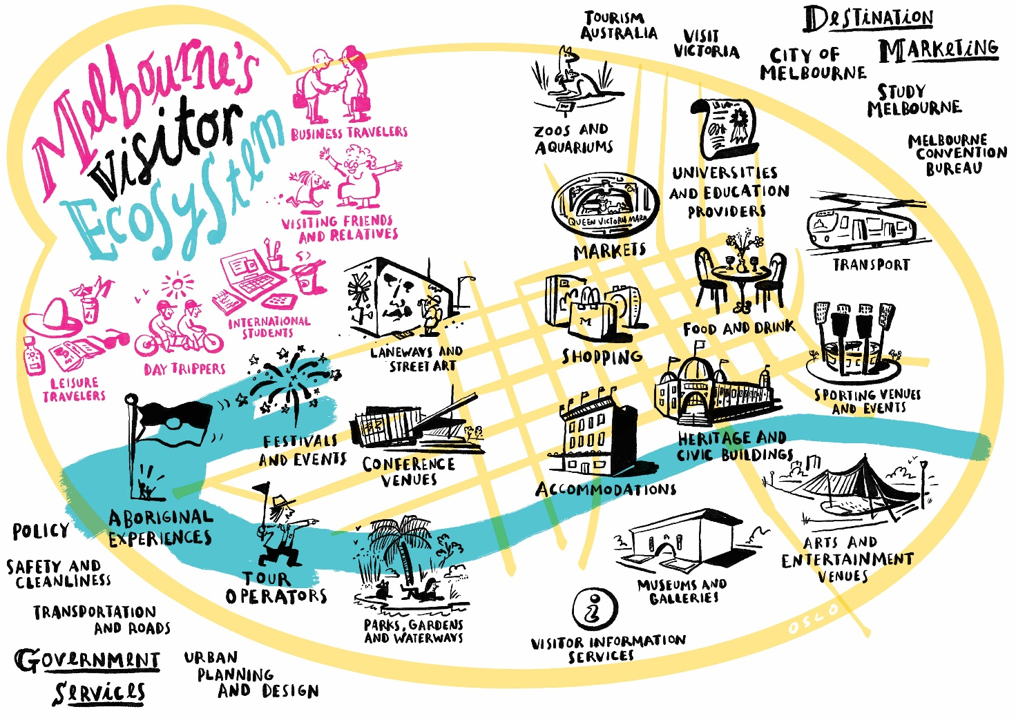

Visitor markets
Experience Melbourne 2028 takes a market-led approach to destination management. We welcome all visitors to Melbourne, but it is important to understand and respond to the needs of our key visitor markets and segments. While promoting Melbourne to interstate and international visitors is primarily the role of Visit Victoria and Tourism Australia, understanding these markets enables us to develop experiences that align with these visitors’ preferences.

Top visitor origin markets
On average in 2023, approximately 3.1 million residents from greater Melbourne visited the city each month. In 2023 Melbourne welcomed 6.4 million domestic overnight visitors who spent approximately $6.5 billion.
There were 1.3 million international overnight visitors to Melbourne in 2023, spending a total of $3.5 billion. The top markets were New Zealand and mainland China, followed by the United States and United Kingdom.

Greater Melbourne visitation to City of Melbourne
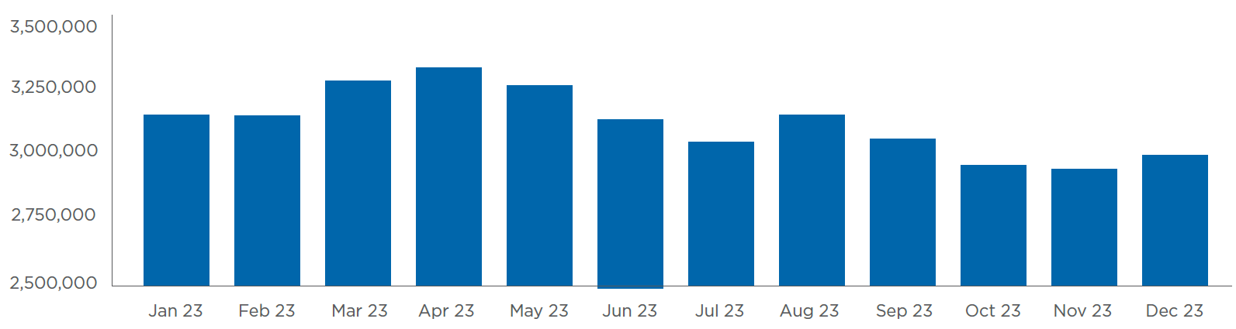
Source: City of Melbourne brand and sentiment tracking 2024, Whereto

City of Melbourne domestic origin markets
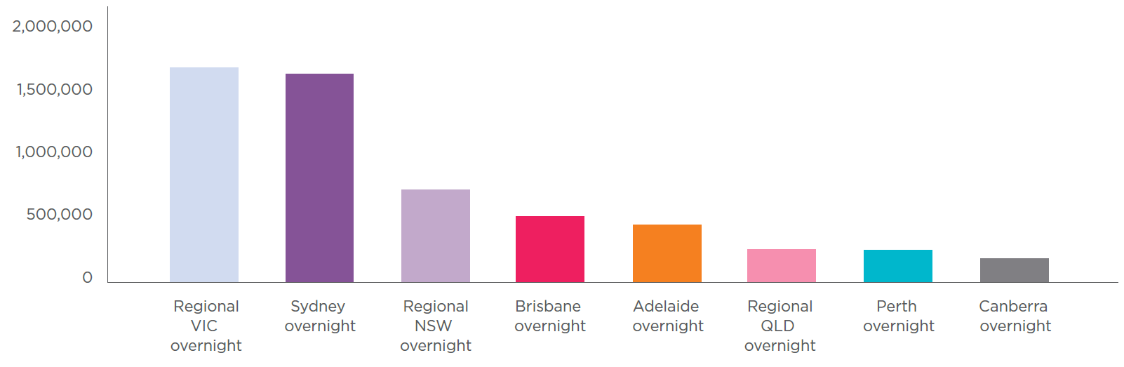
Source: National visitor survey, YE December 2023, Tourism Research Australia

City of Melbourne international origin markets
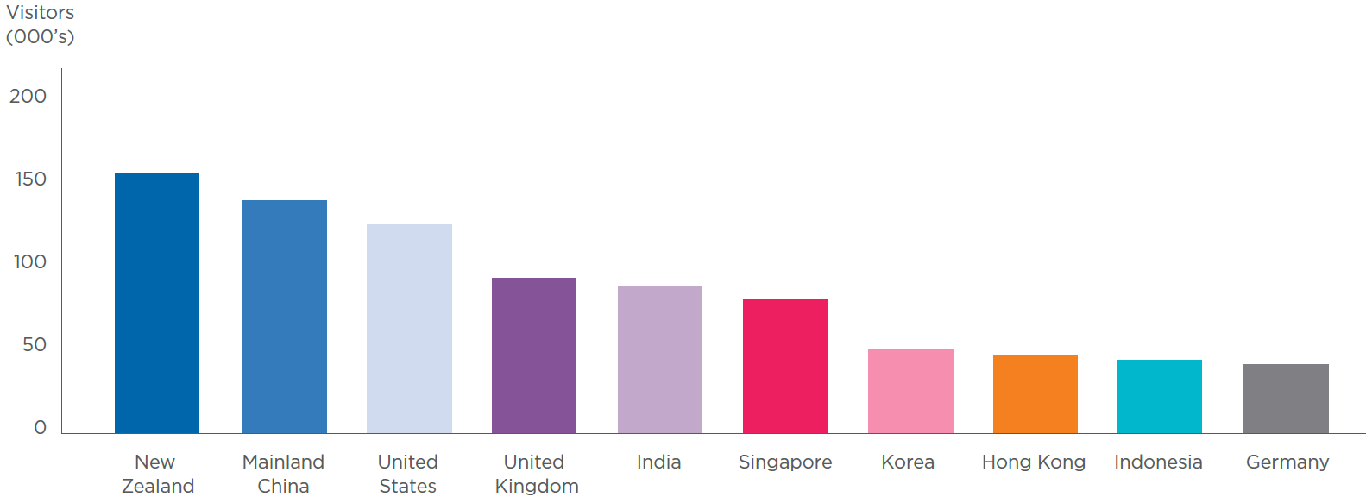
Source: International visitor survey, YE December 2023, Tourism Research Australia

Types of visitors
The most popular reason for visiting Melbourne for both domestic and international visitors is for a holiday. Business travel is the second most popular reason for domestic visitors, while visiting friends and relatives is the second most popular reason for international visitors.

Domestic visitors by type
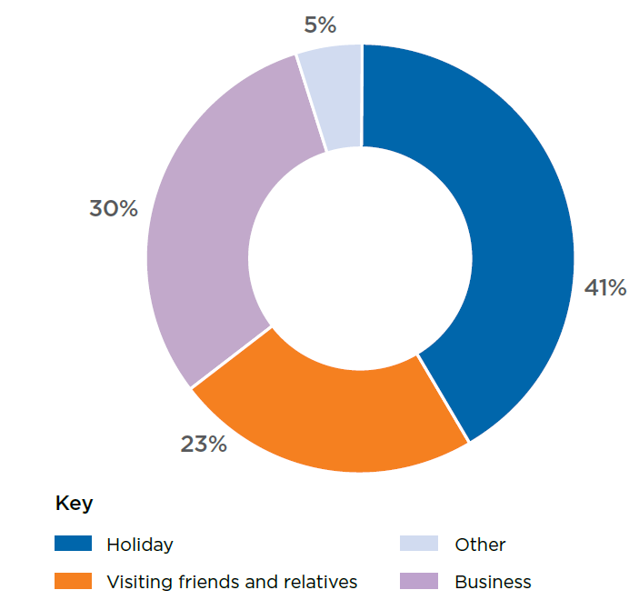
Source: National visitor survey and International visitor survey, YE March 2024, Tourism Research Australia

International visitors by type
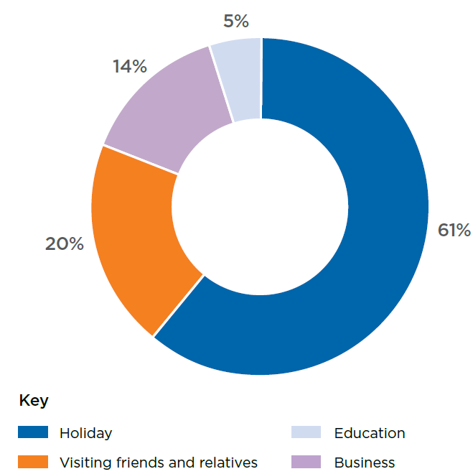
Source: National visitor survey and International visitor survey, YE March 2024, Tourism Research Australia

Forecast top markets 2028
Domestic overnight spend is expected to be the largest generator of visitor spend in Melbourne by 2028 at $8 billion. However, growth in this sector is projected to be moderate after a period of strong recovery due to pent up demand as Australians embraced travel post COVID-19 restrictions. International overnight spend is expected to generate $7.21 billion by 2028, up from $3.54 billion in 2023, reflecting the importance of the international sector.
Internationally, high growth is expected in key markets such as China, India and South-East Asia. The top five international markets in 2028 are expected to be China, New Zealand, the United States, India and the United Kingdom.

Projected visitor spend in City of Melbourne 2023–28
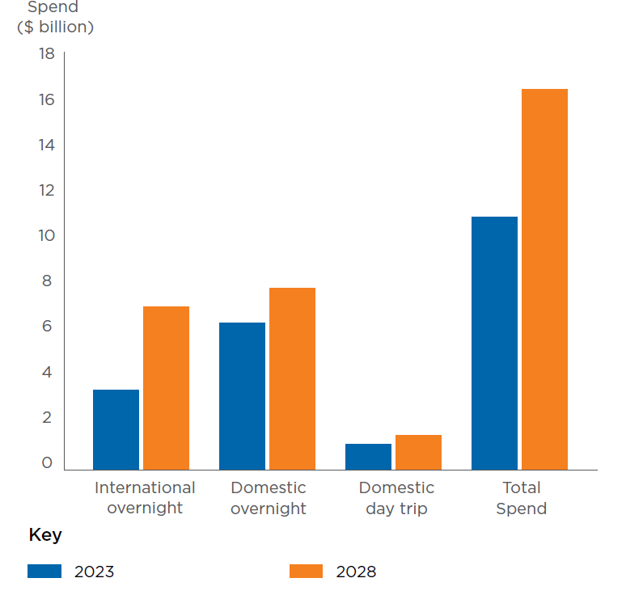
Source: Tourism forecasts for Australia 2023-2028, Tourism Research Australia

International visitors to Victoria to 2028 (000s) – top 15 market
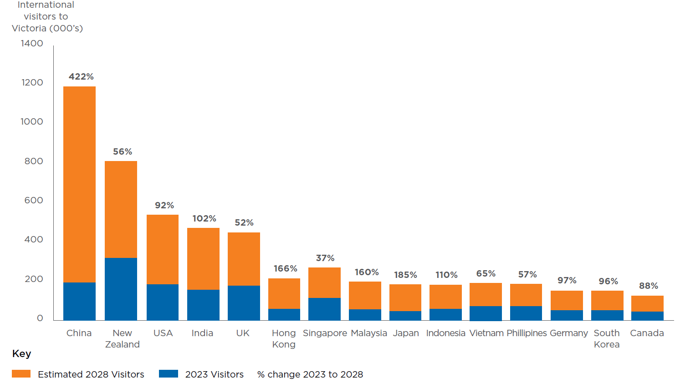
Source: Tourism Forecasts for Victoria, Victorian Government Department Jobs, Skills, Industry and Regions

Visitor segments

Greater Melbourne and regional Victoria
City of Melbourne’s destination marketing efforts have a broad reach in greater Melbourne and regional Victoria that are targeted towards three key segments. These segments have been identified as having the highest propensity to visit based on a mix of demographics, behaviours and attitudes to the city:
- Cultured advocates: Skew slightly older (aged 40+) and love everything about the city, specifically arts, culture and food. Live close to the city, very high visitation, high spend.
- Eager explorers: A younger group (aged 18-39) who are less concerned with the city’s cultural offerings but love exploring and will visit without a plan. Live a moderate distance from city, high visitation, high spend.
- Family focused: Have children living at home and their visit revolves around catering to their children’s needs and interests. Live a moderate to outer distance from city, medium visitation and high spend.

Interstate and international
Visit Victoria is primarily responsible for driving visitation to Melbourne and Victoria. It has identified two key segments for demand-driven marketing activity: Lifestyle leaders in the domestic market and high-value travellers internationally. These two segments can travel for holiday, business or to visit friends and relatives.
- Lifestyle leaders: Making up more than 30 per cent of the Australian population, lifestyle leaders travel more often and spend more while away from home than the average population. They are more likely to travel independently and like to experience the local culture.
- High-value travellers: Travel long haul on a regular basis, have above average trip expenditure, and are more likely to stay longer and disperse outside of tourist hotspots. This is also Tourism Australia’s target audience when promoting Australia internationally.
Interstate and international visitors are considered a lateral audience for City of Melbourne’s destination marketing activity. They may discover What’s On Melbourne while searching online and are reached once in Melbourne via in-destination marketing channels.

The importance of the visitor economy
Melbourne’s visitor economy plays a pivotal role in shaping the city’s identity, fostering economic growth and enhancing its global standing.
The influx of domestic and international visitors contributes significantly to the city’s economic prosperity. It also enriches the quality of life in the city, making Melbourne an attractive destination for talent and business investment, and an enviable place to live.
As a truly global city, the loss of domestic and international visitors, conferences and events during the pandemic hit our visitor economy hard. Domestic visitor spending fell from $5.9 billion in 2019 to $1.7 billion in 2021 (Tourism Research Australia 2020, 2022a). International visitor spending was almost non-existent. This downturn led to significant economic challenges and momentarily hushed the vibrant cultural and cosmopolitan lifestyle that defines Melbourne.
The city has rebounded, but the pandemic serves as a reminder of the need for a strong and resilient visitor economy into the future.

Economic impacts of tourism
Melbourne’s visitor economy supports businesses across the city, from hotels and restaurants to retail and entertainment.
It also generates substantial revenue: Melbourne welcomed more than 14 million visitors in 2023 (Tourism Research Australia, 2023b). These visitors spent more than $11 billion, providing a substantial boost to local businesses.
Direct spending by visitors carries a multiplier effect on the local economy. For example, money spent in hotels helps pay salaries, which are then spent in other sectors, further stimulating economic activity.
With growth in the visitor economy comes a corresponding increase in employment opportunities. This increase isn’t limited to direct tourism services such as hotels and tour guides – it also extends to sectors indirectly linked to tourism, such as food production and transportation. More than 48,000 workers were either directly or indirectly employed by Melbourne’s tourism sector in 2023 (economy.id, 2023).
“Melbourne attracts a powerful mix of business, leisure and event-based travellers, who sustain a robust year-round visitor economy. And with greater Melbourne now Australia’s most populous city, the visiting friends and family market is another key travel segment.” – Richard Crawford, Vice President of Hotel Development in Australia, NZ and Pacific, Marriott

Attracting talent to the city
Melbourne’s appeal as a visitor destination contributes to the city’s ability to attract talent, helping to fuel the city’s knowledge economy. The visitor economy often acts as a gateway for potential talent to experience Melbourne’s culture, lifestyle and opportunities firsthand. In today’s interconnected world, global talent mobility has reached unprecedented levels. With remote working technologies and increased connectivity, skilled professionals are no longer bound by geographical constraints, which leads to a dynamic global talent pool. In 2020, for example, Melbourne was in the top 10 of Savill’s global list of Tech Lifestyle Cities, as well as topping their Digital Nomad Essentials Index.
This shift emphasises the importance of creating environments that are socially and culturally enriching as well as economically vibrant. Attracting and retaining a diverse and skilled workforce is essential for innovation and economic growth.

Attracting investment to the city
Melbourne’s vibrant visitor economy makes it an attractive destination for investment. A consistent flow of visitors ensures a stable market for businesses in the hospitality, entertainment and retail sectors.
The city’s status as a popular tourist destination attracts global brands and international hotel chains, further boosting the economy. These investments create jobs and support improved public services and infrastructure.
Businesses also see the benefits of establishing a presence in a city that is globally recognised and has robust tourism infrastructure. Melbourne’s status as a top-tier destination makes it an attractive location for international conferences, trade events and business meetings, further boosting the local economy and enhancing the city’s reputation as a global business hub.

Infrastructure benefits
The visitor economy necessitates and drives infrastructure development. Major investments in public transport, such as the Metro Tunnel project, as well as airports, roads and pedestrian areas improve the visitor experience. They also enhance the quality of life for residents.
Tourism also inspires big plans for public spaces, parks, museums and galleries, all of which enrich the city’s cultural landscape. Fed Square, for example, is Melbourne’s premier meeting place, visitor destination and event venue. Since opening in 2002, it has seen more than 110 million visits. The Melbourne Arts Precinct Transformation is the largest cultural infrastructure project in Australia’s history and will transform the precinct into one of the great creative and cultural destinations in the world.

Socio-cultural benefits
An influx of visitors from diverse backgrounds contributes to the cultural mosaic of Melbourne, offering residents and visitors alike the opportunity to engage with an array of cultures, languages, and beliefs. Through exposure to different cultures, locals and visitors gain a deeper understanding and appreciation of diversity. This cultural exchange promotes tolerance, respect and a broader worldview.
A successful visitor economy can also instil a sense of pride and identity within the local community. As Melbourne becomes renowned for its visitor economy, residents take pride in their city’s global appeal, contributing to a positive and confident local identity. Shared experiences promote social cohesion through events such cultural festivals, art exhibitions and sporting events. As people come together to celebrate and enjoy these activities, a sense of unity and togetherness is fostered, breaking down barriers and contributing to a more tightly knit community.
“As Melbourne continues its strong post-pandemic recovery, its critical stakeholders across our vibrant visitor economy collaborate effectively to ensure this momentum is maintained.
Faced with increased competition for the discretionary dollar, a coherent vision for Melbourne’s visitor economy will continue to position our city as a preferred destination of choice, showcasing the breadth and diversity of the visitor experience our city is world renowned for.” – Dougal Hollis, General Manager, Accommodation Australia (Victoria)

Why invest in Melbourne
Melbourne’s blend of cultural diversity, vibrant lifestyle and a thriving business environment make it an appealing destination for investors in the visitor economy.
Australia was rated sixth best country in the world to invest in 2023, with Melbourne being the top investment location in the country and the seventh-best metro location in the world (Bruns, 2023).

We have a strong, reliable domestic market
Melbourne is undoubtedly the destination of choice for Australians travelling domestically. Interstate overnight spend in Melbourne continued its lead over all other capital cities in Australia to reach $6.4 billion in 2023 (Tourism Research Australia, 2023b). Melbourne also held the lead position as the city with the most interstate visitors in Australia.
Research from Roy Morgan (2023) shows Melbourne is poised to hold onto its position as the top domestic destination for the foreseeable future. More than 2.7 million Australians said they would like to stay at least one night in the city on a trip in the next two years, more than any other destination in the country. Almost 2.3 million of those who mentioned a trip to Melbourne were coming from interstate locations – a higher number of interstate visitors than any other destination – while a further 500,000 Victorians also said they would like to spend at least a night in their capital city in the next two years.
Robust interest from the domestic market lends resilience to Melbourne’s visitor economy, particularly during periods of international uncertainty.
“Melbourne has a robust and growing tourism industry, with a steady increase in visitor numbers year after year. Overall, the combination of Melbourne’s attractive cultural offerings, strong tourism industry and excellent infrastructure make it an attractive destination for hotel operators and investors seeking long-term growth and success.” – Adrian Williams, Chief Operating Officer PME, Pacific, Accor
International visitors to Victoria are projected to increase to 4.4 million in 2028, with a growth of 11.5 per cent per annum.

We’re well placed to welcome international travellers
The growth outlook for international visitors to Victoria is favourable, with high growth expected in key markets such as China, India and South-East Asia. International overnight visitors to Victoria are projected to be above pre-pandemic levels in 2024. This is ahead of Australia overall, due to Victoria’s unique market mix of visitors with a strong growth profile including large shares of Chinese and Indian visitors (Victorian Government, 2023a). International visitors to Victoria are projected to increase to 4.4 million in 2028 with growth of 11.5 per cent per annum, above the national growth rate of 10.6 per cent (Victorian Government, 2023a).
To explore ways to expand Australia’s tourism market, the Australian Government’s international trade promotion, investment and visitor attraction agency Austrade performed a detailed market analysis. It pinpoints 10 international markets as particularly significant in terms of diversification potential. Notably, India, Vietnam, Indonesia and Malaysia showed ‘strong potential’ for growth (Austrade, 2023). Melbourne’s significant diaspora communities and its cultural ties to South-East Asia place it in an advantageous position to attract visitors from these rapidly developing markets. Reinforcing this market analysis, consumer demand research conducted by Tourism Australia indicates a high level of interest and intent to travel to Melbourne from these identified markets.

We have unique competitive advantages
Melbourne is officially now Australia’s largest hotel market, with 21 new hotels and 4889 rooms opening in less than four years (JLL, 2023), including the Ritz-Carlton, Le Meridien and The Dorsett Melbourne. In 2023, the city boasted around 26,500 rooms in total, representing a 23 per cent increase in four years (JLL, 2023). Melbourne has a proven track record of successfully absorbing new hotel supply, thanks to the size of the market and the breadth of travel segments drawn to the city.
Melbourne is well connected to Australia and the world. More than 35 million travellers used the airport’s four terminals in the 2023-24 financial year, including more than 24 million domestic passengers and more than 11 million international travellers (Melbourne Airport, 2024). Melbourne Airport has the largest number of international carriers in its history, with a total of 39 (Melbourne Airport, 2023). Our sea passenger terminal is operating at record capacity, doubling the number of cruise ships docking at the pier in the past decade (Victorian Ports Corporation, 2023). The Victorian Government in early 2023 capped the price of regional public transport fares at the same price as a daily metro ticket, making it more affordable to travel across the state.
Once visitors are in the city there is a well-connected transport network, with the Free Tram Zone allowing visitors to traverse the central city easily. Infrastructure projects such as the Metro Tunnel (due for completion in 2025) will transform the city’s train network, enhancing efficiency and connectivity.
Melbourne is the cultural capital of Australia and was named one of the top 10 best cities in the world for culture by Time Out in 2023. This bodes well for attracting international visitors seeking to immerse themselves in a new culture. It also appeals to domestic visitors: in Booking.com’s Sustainable Travel Report 2021, 65 per cent of Australians said they were looking for authentic experiences that are representative of the local culture when they travel (Coulton, 2021).
Melbourne has more hotel rooms than any other city in Australia, with 26,500 rooms as of 2023.
Melbourne is a premier destination for events. It is the only city in the world to host both a tennis Grand Slam and a Formula 1 Grand Prix. It’s no surprise then that Melbourne has been named the sporting capital of the world on four occasions (Sydney Morning Herald, 2016).
The city also features the largest conference and exhibition centre in Australia and the highest concentration of conference facilities, conveniently located in the central city. Melbourne was named ‘Oceania’s leading meetings and conference destination’ for the ninth time by the World Travel Awards in 2023.
Melbourne’s commitment to sustainability and green initiatives positions the city to make the most of a growing number of visitors who prioritise sustainability. Melbourne’s tram network is 100 per cent offset by renewable energy (Victorian Government, 2023b). City of Melbourne’s operations were first certified as carbon neutral in 2012 (City of Melbourne, 2018). The Melbourne Convention and Exhibition Centre is Australia’s largest event facility and the first in the world to achieve a six-star Green Star environmental rating (MCEC, 2023). Melbourne was named the world’s most sustainable city according to Euromonitor International’s 2023 Sustainable Travel Index.

We’re planning and investing for growth
Crucially, Melbourne is actively investing in the future to ensure sustained growth and resilience. Transformational projects such as Metro Tunnel, the Melbourne Arts Precinct Transformation and the Greenline Project underscore this commitment.
The Metro Tunnel is an $11 billion major public transport project from the Victorian Government that will enable the city’s train network to cater for Melbourne’s population growth. The new cross-city rail tunnel will see the creation of five new underground stations in the central city and change the way people travel in Melbourne.
The Victorian Government is also investing $1.7 billion to transform the Melbourne Arts Precinct into one of the great creative and cultural destinations in the world. The Fox: NGV Contemporary will be Australia’s largest gallery of contemporary art and design. The transformation will deliver 18,000 square metres of new public spaces, featuring restaurants, bars, lush green spaces and public art. The parklands will connect existing assets in an immersive cultural experience designed to host around 3000 performances and exhibitions each year (MAPCo, 2023).
The Greenline Project is a once-in-a-lifetime opportunity to create a new internationally recognisable destination in the centre of our city. The project aims to reposition the Yarra River – Birrarung as the heart of Melbourne’s culture, economy and liveability, revitalising the river’s north bank and transforming it into an inspiring and rejuvenated public waterfront. The river will be recognised as ‘an integrated living entity’ and its surrounding environment will be re-established as an ecological corridor.

The vision for Melbourne’s visitor economy
Experience Melbourne 2028 defines a collective identity that builds on Melbourne’s reputation as a world-class visitor destination.
To help us achieve our vision for the visitor economy, we must work together as a sector to solidify and share a compelling narrative.
Our vision extends beyond the five-year horizon outlined in the plan, embracing the collaborative journey toward a future that we will shape and cultivate together.

Our vision
Melbourne is a city that captivates and welcomes the kind of visitors who are looking to connect deeply with the psyche of a place. We invite spirited adventurers in to discover eclectic experiences just beneath the surface.
Our status as the cultural, events and sporting capital of the southern hemisphere is firmly established. The city beats proudly with the promise of transformational experiences delivered in a uniquely Melbourne way – carefully crafted with integrity, creativity and a touch of the offbeat.
Every street and laneway is home to a thousand stories, told by the city’s artists, designers and thinkers. Our creative scene is distinctive and celebrated, renowned for its original and risk-taking artistic experiences.
We are a beacon for visitors who seek an enriching and profound Aboriginal experience in the city. We reflect the ancient history and ongoing thriving culture and connection to this land.
A year-round calendar of international events and homegrown offerings activates the entire city.
Our inventive foodie culture and diverse culinary influences make this city a global leader in food and drink.
Melbourne’s effortless style emanates from the diverse cast of characters who embody the city. Our eclectic retail offerings make shopping in the city an iconic experience that can’t be replicated elsewhere.
The city’s abundance of green spaces and natural gems are nurtured and thriving, tantalising visitors and offering respite from the hustle and bustle.
Our curious nature fuels our reputation as a hub for knowledge and innovation. We attract the world’s brightest minds to study at our renowned universities and deliver meaningful change through inspiring conferences and events.
From every angle, Melbourne shines with the potential of delightful discoveries. The city invites visitors to immerse themselves in its vibrant culture, offering experiences that resonate long after their visit.

Guiding principles
Experience Melbourne 2028 is underpinned by five guiding principles.
The guiding principles provide a framework for decision-making, ensuring our actions align with the core values and priorities of the plan. They provide a common language among the many stakeholders of the visitor economy, preventing fragmentation and fostering a unified approach.

Aboriginal focused
As part of our commitment to reconciliation we acknowledge that all tourism in Melbourne occurs on Aboriginal land. Although Aboriginal experiences are identified as a distinct component of Melbourne’s visitor economy, acknowledging and respecting the traditional ownership and deep connection of Aboriginal people to Country is a fundamental principle guiding all tourism development in Melbourne. We support Aboriginal people and businesses’ right to self-determination, respecting intellectual property rights, cultures and practises. Partnerships with Aboriginal organisations will be equitable, sustainable and mutually beneficial.

Experience centric
Melbourne’s visitor economy is rooted in an experience- centric approach, prioritising the richness of every encounter to elevate Melbourne as a premier global destination. The essence of tourism lies in the visitor’s experience, and this plan interweaves every city element into a cohesive, memorable journey. Success is measured in more than numbers. It is measured in the quality of experiences for both visitors and the local community.

Inclusive and welcoming
Experience Melbourne 2028 adopts an inclusive approach that prioritises equity and justice for people of all identities, genders, cultures, beliefs, ages and abilities. By fostering an environment that celebrates diversity, we can ensure that visitors and locals alike feel welcomed, celebrated and valued in the city, contributing to a harmonious visitor experience.

Sustainable and regenerative
Experience Melbourne 2028 is committed to sustainability and regeneration, seeking to minimise the environmental impact of the visitor economy and promote responsible tourism practices. The plan focuses on preserving the city’s natural resources, supporting initiatives that contribute to the long-term health and resilience of the city and ensuring visitors have a positive impact on the destination. Beyond the environment, we recognise the importance of cultural sustainability, preserving and celebrating Melbourne’s rich cultural heritage alongside its natural assets.

Collaborative and connected
Experience Melbourne 2028 champions collaboration among the various stakeholders who make up the visitor economy. By brokering partnerships and fostering a united effort, we aim to create a synergistic approach to destination management, ensuring that decisions and actions are coordinated and respond to emerging trends in the local and global market.

Melbourne’s experience pillars
Experience Melbourne 2028 plays a key role in shaping Melbourne’s identity and reputation. At the centre of the plan are eight experience pillars: thematic areas that serve as the foundation for the visitor experience in Melbourne. The eight pillars assist in creating and affirming a distinct identity for Melbourne’s visitor economy, guiding strategic efforts and aligning messaging by stakeholders.
Within each pillar is a set of key directions that serve as a guide for the sector to focus their energies over the life of the plan. Detailed actions for each of the key directions will be developed in implementation plans. Underpinning the experience pillars are three experience essentials, foundational blocks required for a seamless visitor experience.
The experience pillars do not exist in isolation. A visitor can explore Melbourne’s iconic laneways filled with street art while discovering a local boutique selling one-of-a-kind pieces. A family can spend the day exploring the Royal Botanic Gardens while learning about traditional uses of plants for food, medicine and tools on the Aboriginal Heritage Walk. One of Melbourne’s key drawcards is that many of its best experiences are clustered conveniently in the central city, allowing visitors to explore with ease.
These pillars have been identified through extensive stakeholder consultation with government, industry and community via focus groups, one-on-one interviews and survey responses. They are also informed by Tourism’s Australia’s Future of Demand research that globally mapped the experiences driving tourism demand now and into the future. Some pillars represent iconic experiences where Melbourne holds a leadership position, and the goal is to maintain the current level of success. Some pillars are renowned experiences but require further development and attention to consolidate their position. Other pillars have untapped potential that with concerted efforts can significantly elevate Melbourne’s visitor experience.

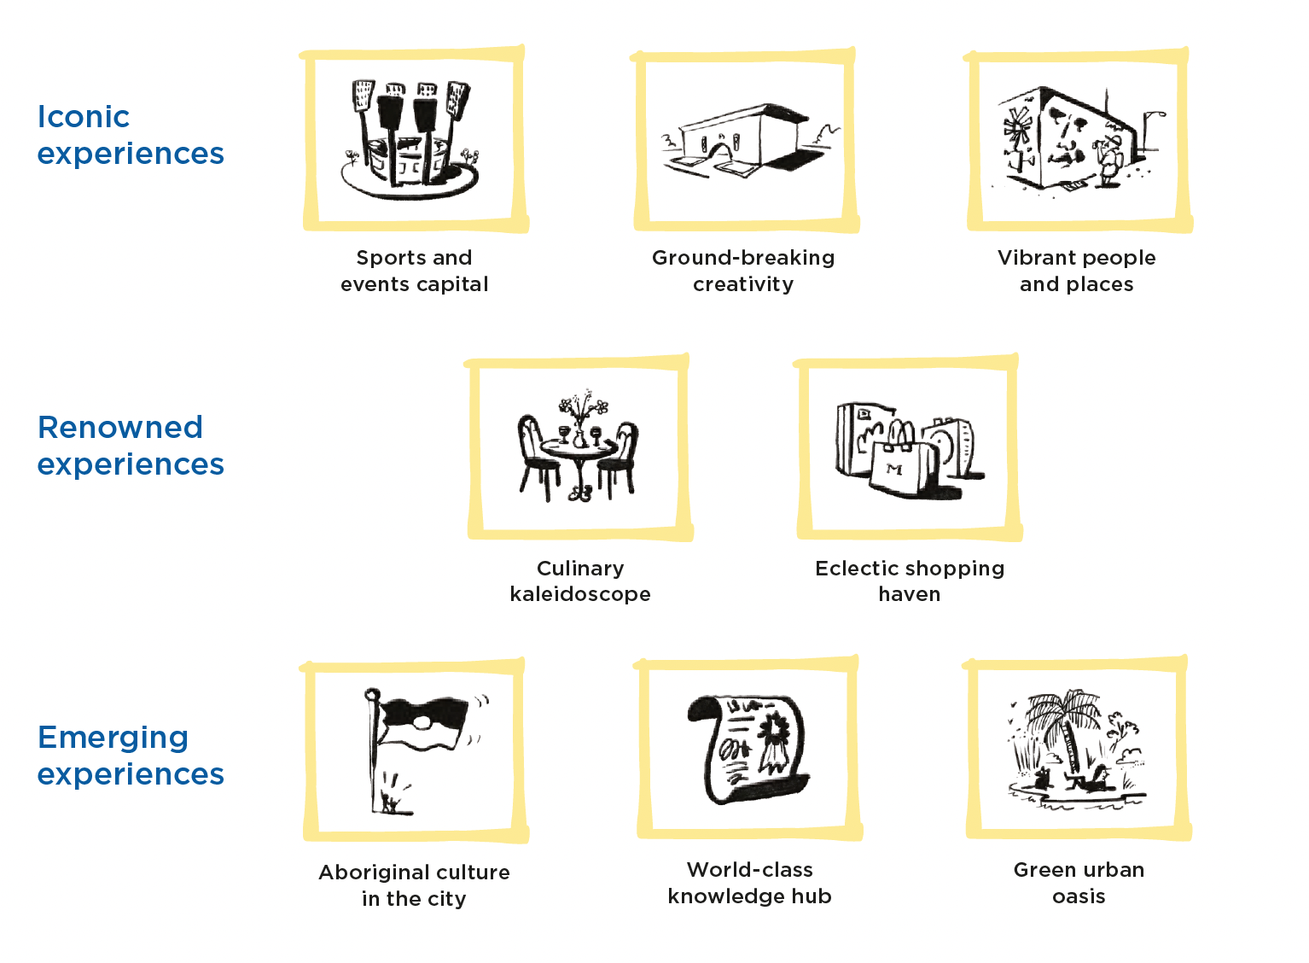

Iconic experience

Sports and events capital
Melbourne is a city of sports and events. From the tentpoles of the sporting calendar to an abundance of iconic events and community gatherings, there’s always a spectacle to be shared.
Our sporting culture is deeply ingrained in the city’s identity: from the birthplace of test cricket at the legendary Melbourne Cricket Ground and to the thousands of roaring fans who watch a live AFL clash. The city fills with finery for the Melbourne Cup, and the atmosphere is electric with the global allure of the Australian Open and the adrenaline of Formula 1 Australian Grand Prix.
Festivals of all flavours take place almost every week of the year, covering international arts and film, food and wine, fashion and community celebrations. Blockbuster music events electrify the city with local and global talent. Melbourne is unique in its sheer concentration of event venues in the heart of the city. Easy access to the city’s hospitality and retail offerings entices attendees to spend before and after the event, increasing their economic impact.
Sports and events play a significant role in Melbourne’s visitor economy. They are one of the primary motivators for tourism, with people from across Australia and internationally coming to Melbourne for its events.
Events are drivers of economic activity, encouraging spend both at the events themselves and in businesses before and after attendance. According to Visit Victoria, events contributed $3.3 billion to Victoria in 2023. Beyond economic benefits, events strengthen the city’s identity and encourage social cohesion.
City of Melbourne plays an important role in the events industry, delivering a suite of premier events to encourage visits to various precincts, particularly in shoulder seasons. We support independently produced events to take place in the city throughout the year through grants and sponsorship programs. We also assist event organisers to deliver events through support with permitting and logistics.
Melbourne’s events calendar is spread evenly throughout the year. The volume of events presents an opportunity for creative thinking, as individual activations seek new ways to stand out and shine in a busy schedule. City of Melbourne has a role to play as facilitator to connect the visitor economy and events sectors.

2028 aspiration
Melbourne’s position as the events capital is embedded in the city’s DNA, boasting a year-round calendar of enviable major international events
and homegrown offerings that attract visitors from around Australia and the world. Events are a highly visible part of life in Melbourne, showcasing the very best of the city, and activating new and established public spaces and venues throughout the year.

Key directions
Together we will…
Priority direction: Improve the approvals process for organisers delivering events in Melbourne.
- Maximise opportunities to raise the visibility of sporting and cultural events across Melbourne.
- Invest in an effective portfolio of events that drive visitation and spend that contribute to Melbourne’s status as an events capital.
- Support event organisers to activate public spaces throughout the city.

Global demand for experiences
Experience | Global interest | Market size (‘000) | Top markets
Food and drink festivals | 52% | 61,800 | Vietnam, South Korea, Thailand, Canada, Malaysia
Carnivals | 31% | 34,387 | Indonesia, Hong Kong, Taiwan, Thailand, Malaysia
Dance / music festivals | 29% | 33,925 | India, Philippines, Canada, USA, South Korea
Sports events | 25% | 31,352 | China, South Korea, Japan, UK, Indonesia
Source: Future of Global Tourism Demand 2022, Tourism Australia

Ground-breaking creativity
Melbourne’s creative scene is distinctive and celebrated, renowned for its originality, independent spirit and commitment to pushing boundaries.
The city’s dynamic artistic landscape is manifested in our galleries, theatres, street art and cultural events, making it a haven for art and culture enthusiasts. Melbourne has a rich independent arts ecosystem with a culture of risk-taking, complemented by a year-round calendar of blockbuster exhibitions and musicals. In 2019 Melbourne was recognised as having more live music venues per capital than any other city in the world (Music Victoria, 2023). The National Gallery of Victoria is the most visited gallery in Australia (NGV, 2024). The transformation of the arts precinct, including the development of The Fox: NGV Contemporary, will further invigorate the creative soul of the city.
A vibrant street art scene and engaging public art turns the city into an open-air gallery. High-quality free offerings are available to everyone regardless of their financial means. Exciting contemporary work from Aboriginal artists continues a culture of storytelling and creativity that has taken place on this land for thousands of generations. The city is considered an international leader in contemporary design. Creative programs and spaces for children and families at our major galleries are popular and renowned. A commitment to inclusion and equity actively reduces barriers to accessing the arts for both artists and audiences.
While Melbourne holds a leadership position in this space, sustaining this creative ecosystem requires ongoing efforts. It is crucial to provide affordable spaces for artists to live, create, develop and present their work in the city. This in turn creates a pipeline of new works for enjoyment by local and international audiences. Especially post-pandemic, it is essential to support organisations and venues that champion the next generation of artists and artmaking.
Creative experiences are one of the top three reasons people visit Melbourne for both Australian and international visitors. And yet, competition for creative and cultural tourism is strong. While Melbourne is perceived as a creative hub within Australia, there is an opportunity to amplify this reputation internationally. The city’s advantage lies in its original, edgy and risk-taking work. We have an opportunity to highlight these qualities and capture the imagination of international creative visitors.

2028 aspiration
Melbourne’s unique creative scene is a magnet for local artistic innovators and international blockbusters. Curious audiences are drawn to Melbourne as a city filled with exhilarating art experiences that reflect the city’s independent and progressive spirit.

Key directions
Together we will…
Priority direction: Facilitate collaboration between the creative sector and the visitor economy.
- Invest in art and artists that build on our reputation as a leader in original, ground-breaking work.
- Enhance the visibility of the city’s creative experiences and precincts for visitors.

Global demand for experiences
Experience | Global interest | Market size (‘000) | Top markets
Museums / galleries | 41% | 48,044 | Italy, USA, Philippines, Japan, UK
Theatre, concerts, performing arts | 26% | 32,834 | Canada, Japan, South Korea, UK, New Zealand
Source: Future of Global Tourism Demand 2022, Tourism Australia

Vibrant people and places
Melbourne’s welcoming people and vibrant public realm are fundamental parts of the city’s identity.
Melbourne is home to one of the world’s most harmonious and multicultural communities, with 54 per cent of people born overseas and 46 per cent using a language other than English at home (Australian Bureau of Statistics, 2021). More than 100 languages are spoken by the city’s residents (City of Melbourne, 2024a). Melbourne has always been a significant meeting place for the people of the Kulin, and each successive wave of migration has contributed to the city’s rich tapestry of cultural diversity.
Melbourne boasts established neighbourhoods with distinct cultural identities, from the Italian enclave of Lygon Street to the longest continuing Chinatown in the Western world. The city blends well-preserved Victorian architecture with cutting-edge modern landmarks. From the iconic Flinders Street Station to the world heritage-listed Royal Exhibition Building and the contemporary marvels of Fed Square, the city’s architecture mirrors its evolving cultural narrative.
Our vibrant streets and iconic laneways invite exploration, support businesses and contribute to the character of the city. Outdoor dining, a long-held strength of Melbourne’s cafe culture, has grown even more popular since the pandemic. And our elevated rooftops and hole-in-the-wall venues charm visitors and locals alike.
What truly sets Melbourne apart is our people. We are progressive and inclusive, embodying a collective spirit that fosters creativity and acceptance. Awarded the world’s friendliest city in 2022 (William Russell, 2022) and ranked as the fourth most LGBTIQA+ friendly city globally (Big 7 Travel, 2022), Melburnians welcome people of all genders, cultures and identities. Lonely Planet in 2023 described Melbourne as one of Australia’s most family friendly destinations. Melbourne’s cultural experiences shine with myriad influences, including heritage, architecture and the inclusive spirit of our people.

2028 aspiration
Melbourne’s multicultural mix attracts visitors who want to experience the authentic and diverse character of the city. The city’s rich cultural heritage and distinct neighbourhoods are celebrated and preserved, welcoming visitors from all walks of life.

Key directions
Together we will…
Priority direction: Create and affirm distinct stories and narratives for our diverse neighbourhoods, celebrating their unique sense of place and culture.
- Celebrate and preserve the city’s diverse cultural heritage.
- Ensure Melbourne’s diversity is a key feature when promoting the city.
- Create a welcoming environment for visitors from diverse backgrounds and communities.

Global demand for experiences
Experience | Global interest | Market size (‘000) | Top markets
Historical / cultural sites | 46% | 53,181 | Italy, Germany, France, UK, Japan
Architecture / monuments | 43% | 49,786 | Malaysia, South Korea, France, Indonesia, Japan
Local stories / culture | 29% | 33,229 | France, Italy, Thailand, Malaysia, Germany
Source: Future of Global Tourism Demand 2022, Tourism Australia

Renowned experience

Culinary kaleidoscope
In Melbourne, food is not just eaten: it is celebrated, discussed and savoured. The city’s culinary offering extends beyond the plate. It is also about the experience, an adventure that stretches from the first sip of morning coffee to the call for last drinks.
Melbourne is a city where culinary artistry meets cultural diversity. Influences from across the globe converge here, inspired by a gloriously multicultural population. Melbourne’s food scene is unique for its diversity coupled with a commitment to experimentation. Chefs in Melbourne constantly push the boundaries, blending traditional flavours with innovative techniques to create extraordinary and memorable dining experiences.
The city is closely connected to its regional food system. The journey from farm to table is shorter than in most other major cities. Our exceptional chefs have access to Victoria’s fresh, sustainably grown produce, and there has been a notable rise in the use of native ingredients. Our wine regions have achieved global acclaim, and our craft breweries and distilleries have earned distinguished awards.
Melbourne’s culinary scene isn’t just about the food; it’s also renowned for its unique drink offerings. The city is arguably home to some of the best coffee in the world. As the sun sets the city transforms, revealing a different kind of vibrancy. Down a laneway, on a rooftop or behind an unmarked door – Melbourne’s bar scene rewards the intrepid. The city’s night-time economy has recovered strongly from the impacts of the pandemic. According to City of Melbourne data, night-time spending was 12 per cent higher in 2023 than it was in 2019.
As the demand for culinary and nightlife experiences continues to grow, the importance of supporting the city’s chefs, makers and entrepreneurs grows too. Melbourne’s reputation as a haven for food lovers is built on its diverse flavours and vibrant nightlife. It’s also rooted in the creativity, passion and innovation of the individuals behind each dish and dining experience. To maintain and grow Melbourne’s status as a culinary and night-time capital, it is essential to foster an environment where diversity, entrepreneurialism and innovation continue to thrive.

2028 aspiration
Gastronomic delights fill the plates of hungry visitors to Melbourne, affirming the city’s reputation as a culinary capital. The city’s chefs, baristas and mixologists are supported to create and innovate across all cuisines, and visitors to Melbourne can have their tastebuds and epicurean curiosity sated at any time of the day and night.

Key directions
Together we will…
Priority direction: Foster innovation in the culinary sector and support new and innovative culinary businesses to prosper.
- Promote the diversity of the city’s food culture to position Melbourne as a global leader in food and drink.
- Support the development of new culinary tourism experiences.
- Promote Melbourne as a vibrant and stimulating night-time city.

Global demand for experiences
Experience | Global interest | Market size (‘000) | Top markets
Dining out | 63% | 72,872 | USA, India, UK, New Zealand, Malaysia
Indigenous food experiences | 40% | 44,989 | Vietnam, Thailand, Indonesia, Singapore, India
Tasting trails | 37% | 44,919 | South Korea, Vietnam, Taiwan, China, Thailand
Meet the maker food / drink tours | 32% | 34,553 | Hong Kong, Philippines, Vietnam, Thailand, Taiwan
Source: Future of Global Tourism Demand 2022, Tourism Australia

Eclectic shopping haven
Melbourne’s retail and fashion offerings are as eclectic as the city itself, with an alluring mix of high-end boutiques, international brands, independent designers and unique specialty stores.
Whether you’re looking for avant-garde fashion, artisanal treasures, exclusive brands or the best bargains, the city has it all. Each neighbourhood in Melbourne has a distinct character, appealing to a range of tastes and preferences. Flinders Lane and the city’s many arcades host a thriving boutique culture, while the Queen Victoria Market is a bustling hub for fresh produce, local artisanal products and clothing. The central city is home to some of Australia’s oldest and most iconic department stores, forming part of an end-to-end undercover shopping precinct stretching from Melbourne Central to Bourke Street Mall. Bargain hunters can score deals at the DFO in South Wharf or at the Spencer Outlet Centre.
The shopping experience in the city reaches beyond each transaction, inviting visitors to explore our laneways and enjoy diverse food and drink offerings while they shop. Shopping centres and department stores have become must-do tourist attractions by extending the retail experience with expansive food offerings, cinemas and interactive activations. Myer’s Christmas windows have been drawing crowds for more than 70 years. Melbourne Central’s Monopoly Dreams store is a fully immersive tourist attraction.
Melbourne has earned its reputation as Australia’s most stylish city. Beyond the uniform of Melbourne black, our fashion scene embraces influences that reflect the city’s diverse culture. A thriving community of emerging designers and independent boutiques couples with a commitment to creativity and innovation. Melbourne’s fashion is constantly evolving, challenging norms and celebrating individuality. Events such as the Melbourne Fashion Festival and Melbourne Fashion Week showcase the latest trends and provide a stage for both established and emerging designers to exhibit their creativity.

2028 aspiration
The experience of shopping in Melbourne is as eclectic and effortlessly stylish as the city itself. Shopping hubs across our precincts are a mosaic of independent boutiques and world-class brands that together give Melbourne (and those who shop here) a one-of-a-kind edge.

Key directions
Together we will…
Priority direction: Encourage visitation to the city’s shopping districts through innovative incentives, activations and events.
- Revitalise the city’s independent fashion and boutique culture by strengthening support for local designers, artists and businesses.
- Enhance key shopping districts in the city through improved infrastructure and trading conditions.
- Position the city as an exciting and must-visit shopping and fashion destination.

Global demand for experiences
Experience | Global interest | Market size (‘000) | Top markets
Shopping | 56% | 62,761 | Singapore, Japan, Malaysia, Thailand, UK
Source: Future of Global Tourism Demand 2022, Tourism Australia

Interest in shopping experiences
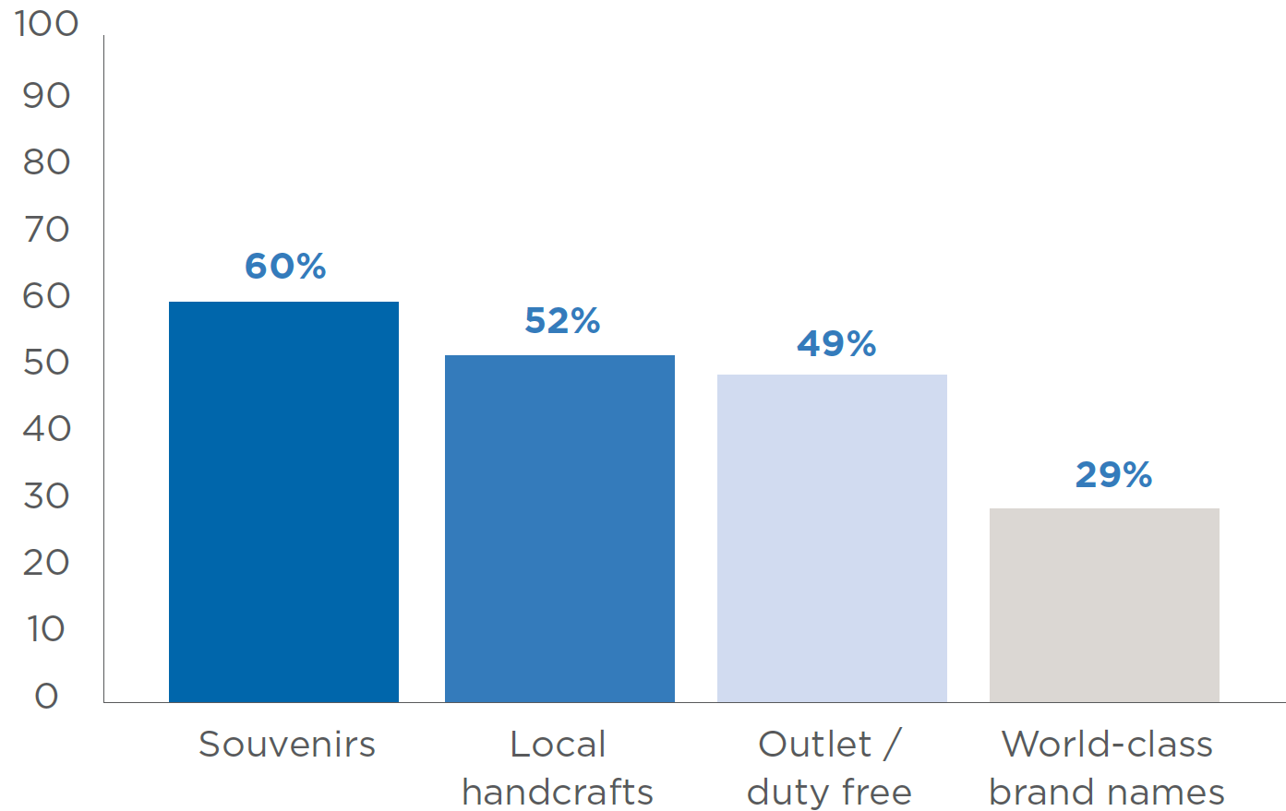

Emerging experience

Aboriginal culture in the city
Melbourne presents a unique opportunity to experience Aboriginal heritage and culture in an urban environment. The city is a gateway to Victoria’s rich Aboriginal culture.
Melbourne offers a variety of authentic and unexpected Aboriginal experiences, challenging visitor perceptions that they need to look to remote locations for Aboriginal experiences. Visitors can gain insight into the rich history and thriving culture of First Nations people on an Aboriginal Heritage Walk at Royal Botanic Gardens, discovering deep connections to the environment and exploring the traditional uses of plants for food, medicine and tools. They can savour native flavours at Mabu Mabu Big Esso at Fed Square.
The Koorie Heritage Trust presents an extraordinary collection of Aboriginal art and cultural artefacts, and contemporary exhibitions, across 1700 square metres at Fed Square. The Bunjilaka Aboriginal Cultural Centre at Melbourne Museum tells the story of survival and celebrates the vibrant cultures of Aboriginal people through performances, storytelling, artwork and more. YIRRAMBOI, one of the country’s leading First Nations arts festivals, provides a stage for local and international First Nations voices to be heard, and celebrates the breadth of evolutionary First Nations artistic expressions.
Victoria welcomed 459,000 visitors in 2019 who participated in Aboriginal experiences, generating $1.1 billion in revenue (Victorian Government, 2020). Yet, the rate of participation in Victoria (7 per cent) was notably lower than the national average (17 per cent), highlighting a significant opportunity to expand engagement in Aboriginal experiences. Indeed, Aboriginal-led experiences have been identified by industry as a key priority, reflected in the Victorian Government’s Experience Victoria 2033 strategic plan. A long-term, sustained commitment from all stakeholders is required to develop a diverse, thriving Aboriginal tourism sector, positioning Melbourne as a leader in Aboriginal tourism.
Embedding Aboriginal culture, heritage and stories into the public realm can ensure visitors understand that they are on Country and transform the very essence of the Melbourne experience. Opportunities exist to feature Aboriginal language and art across the city and incorporate Aboriginal culture in the city’s architecture and urban design. Reflecting Aboriginal values of respect and stewardship for the land across the tourism industry will foster a more sustainable and regenerative visitor economy.

2028 aspiration
Melbourne is establishing itself as a beacon for visitors seeking enriching and profound Aboriginal experiences in the city. Visitors to Melbourne can easily access Aboriginal cultural activities within the city’s urban environment, driven by Aboriginal-led tourism businesses and communities. Aboriginal languages and cultures are a visible and notable part of the city experience.

Key directions
Together, alongside Traditional Owners, we will…
Priority direction: Support the development of Aboriginal products and experiences, as well as experiences that align with caring for Country.
- Grow Melbourne’s position as an enticing destination for Aboriginal experiences in an urban environment.
- Protect, recognise and embed Aboriginal culture and heritage across the city.
- Ensure the protection of Aboriginal intellectual property and prioritise authentic, locally-made souvenirs and products for sale in the city.

Global demand for experiences
Experience | Global interest | Market size (‘000) | Top markets
Visiting Indigenous sites or communities | 30% | 33,096 | Germany, Thailand, Vietnam, Philippines, France
Indigenous art, craft or cultural displays | 29% | 31,844 | Indonesia, Italy, Thailand, China, Malaysia
Indigenous guided tours | 27% | 28,815 | Thailand, Vietnam, Singapore, France, Philippines
Indigenous performances | 23% | 27,649 | China, Vietnam, Indonesia, Malaysia, Thailand
Source: Future of Global Tourism Demand 2022, Tourism Australia

World-class knowledge hub
Melbourne is a vibrant hub where creativity intersects with innovation, fostering a rich environment where ideas flourish and shape the future.
Melbourne’s knowledge economy is thriving and accounted for 70 per cent of Gross Regional Product in 2023 (City of Melbourne, 2023). Most skilled jobs in Melbourne now belong to knowledge-based sectors, reflecting a highly skilled workforce. The city is home to State Library Victoria, the fourth-most visited library in the world (State Library Victoria, 2020), as well as a network of state-of-the-art libraries managed by City of Melbourne. In 2008 Melbourne joined the UNESCO Creative Cities Network as a City of Literature, only the second in the world (Melbourne City of Literature, 2024).
At the core of Melbourne’s growth as a knowledge capital is its exceptional university sector. Seven universities in Melbourne featured in the QS World University Rankings 2024, the highest-ranked of which is the University of Melbourne at 14th in the world. This academic prowess, combined with an outstanding lifestyle and a diverse, multicultural community, is why Melbourne consistently ranks as the top student city in Australia and one of the best worldwide (Study Melbourne, 2024a). More than 235,000 international students from over 175 countries chose to study in Melbourne and Victoria in 2023 (Study Melbourne, 2024b). International students play a crucial role in Melbourne’s visitor economy, as their presence attracts a significant number of friends and relatives who come to visit.
Melbourne is a premier destination for conferences and business events. The city features the largest conference and exhibition centre in Australia and the highest concentration of conference facilities. The Melbourne Convention Bureau has an unrivalled reputation for hosting high-quality business events, both meeting and transcending the needs and expectations of event organisers. Business events bring together local experts with global leaders to share groundbreaking ideas and research, showcase the city’s expertise in critical knowledge sectors and attract investment in the city’s broader economy.
Strengthening Melbourne’s reputation as a knowledge and innovation hub is essential to enhance the city’s appeal for business events and international students. It also creates stronger alignment between Melbourne’s visitor economy and its burgeoning knowledge sector.

2028 aspiration
The creativity for which Melbourne is famous expands to encompass its position as a knowledge and innovation capital. We attract the world’s brightest minds to study at our renowned universities and deliver meaningful change through inspiring conferences and events.

Key directions
Together we will…
Priority direction: Strengthen Melbourne’s standing as a premier business events destination and enhance awareness of the value of business events.
- Capitalise on the international student market to increase the impact of visiting friends and relatives.
- Connect business events with the visitor economy to encourage business travellers to experience all Melbourne has to offer.
- Position Melbourne as a knowledge capital and innovation hub.

Global demand for experiences
Top Markets for International Students in Victoria | What International Students Seek In A Study Destination
India | It is a safe and welcoming place for international students
China | Cost of living
Vietnam | It has good lifestyle and leisure opportunities
Colombia | It has universities with high quality teaching
Sri Lanka | It has affordable rental accommodation
Source: Victorian Department of Education | Source: Global International Student Survey 2024, QS

Green urban oasis
Melbourne is a city where nature is an integral part of the urban landscape. This blend of the built and natural environments enhances quality of life for residents and presents an immersive experience for visitors.
Melbourne is a biodiverse region with 239 species of birds, 12 species of reptiles, 18 species of mammals, 7 species of frogs, at least 1500 species of insects and 31 species of fish (City of Melbourne, 2017). The municipality is also home to nearly 480 hectares of internationally acclaimed parks and gardens (City of Melbourne, 2024b), offering serene green spaces amid the urban landscape.
The Yarra River – Birrarung has great cultural and environmental significance for Melbourne. To the Wurundjeri Woi-wurrung people it has always been a place of spiritual and cultural importance, a life source and meeting place. The transformational Greenline Project aims to reposition the Yarra River – Birrarung as the centre of our culture, economy and civic life, revitalising the river’s north bank, transforming it into an inspiring and rejuvenated public waterfront.
Melbourne’s waterways offer numerous opportunities for visitor experiences on the water, from hiring a self- skippered boat and kayaking by moonlight to exploring history with the heritage fleet or catching the ferry to the Bellarine Peninsula.
City of Melbourne’s approach to integrating nature extends beyond traditional parks and rivers. We are focused on supporting green infrastructure, using green roofs, walls and facades to increase the amount of vegetation in the city. The city’s laneways, famous for their street art and cafes, are increasingly becoming sites for urban greening projects. These iconic spaces are being transformed into green corridors, featuring vertical gardens and sustainable installations, contributing to the city’s biodiversity and enhancing the visitor experience.
Victoria’s abundance of natural beauty is easily accessible from Melbourne, making the city a perfect starting point for exploring nature in the region. Whether it’s hiking in the Yarra Ranges, relaxing on the beaches of the Mornington Peninsula, or driving along the Great Ocean Road, Melbourne is graced with natural wonders right at its doorstep.
By thoughtfully showcasing the city’s array of urban nature and proximity to natural wonders, Melbourne can establish itself as an attractive destination for visitors looking to immerse in nature, providing a distinctive mix of urban vibrancy and serene natural landscapes.

2028 aspiration
Melbourne’s reputation as a green city is building as a destination for incredible urban nature experiences. The city’s stunning natural gems are nurtured and thriving, tantalising visitors and providing respite from the hustle and bustle of the city.

Key directions
Together we will…
Priority direction: Create compelling opportunities to connect with and experience a revitalised Yarra River – Birrarung.
- Position Melbourne as a city filled with urban nature, home to a world-renowned network of parks, gardens and streetscapes.
- Improve connection between the city and Docklands waterfront with appropriate planning and development.

Global demand for experiences
Experience | Global interest | Market size (‘000) | Top markets
Viewing natural landmarks and wonders | 48% | 54,217 | Italy, France, Singapore, UK, USA
Exploring wilderness / nature | 41% | 48,565 | Germany, France, USA, UK, Canada
Zoos, wildlife parks, aquariums | 41% | 47,245 | India, Hong Kong, New Zealand, Philippines, Malaysia
Hiking / walking | 33% | 41,417 | Germany, France, USA, Canada, Italy
Source: Future of Global Tourism Demand 2022, Tourism Australia

Experience essentials
Three experience essentials form the cornerstone of a successful visitor economy: transport and connectivity, safety and cleanliness, and accessibility. Visitors expect these fundamentals so they are free to enjoy the city’s attractions and experiences.

Transport and connectivity
As Melbourne’s visitor economy grows, how visitors move around must be enhanced to support a vibrant, safe and inclusive visitor experience.
Transport and connectivity play a pivotal role in fostering the growth of the visitor economy in Melbourne, creating a seamless and accessible environment for visitors to get to, and get around, the city.
High-quality transport infrastructure and streets extend the reach and appeal of a destination, and enable visitors to traverse the city with ease. Good transportation enhances the overall visitor experience by offering convenience and reducing logistical pain points.
Connectivity extends beyond physical transportation and into the digital realm. Visitors increasingly rely on digital devices to access information, find local services, make bookings and stay connected with the world. Mobile apps, micro-mobility services, navigation tools and virtual guides capitalise on digital connectivity to make it easier for visitors to navigate unfamiliar surroundings and discover hidden gems. The next generation of the myki public transport ticketing system will have a range of new payment options including tap and go with credit cards and devices. Initiatives such as NaviLens on tram routes improve the accessibility of our transport system. It is vital that we invest in technology and offer reliable digital connectivity to attract and retain visitors.

Key directions
Together we will…
Priority direction: Connect Melbourne’s precincts, neighbourhoods and businesses through continued wayfinding expansion, and explore digital technologies that improve the visitor experience.
- Foster collaboration between transport providers and the visitor economy to improve the experience for visitors.
- Support initiatives that create high-quality, amenable streets for efficient short-distance travel.
- Advocate for improved infrastructure development to support the arrival and dispersal of visitors in the city, including airport rail and Station Pier.

Safety and cleanliness
Safety and cleanliness are crucial to sustaining and enhancing Melbourne’s visitor economy. They are at the foundation of the city’s appeal. When visitors feel secure, they are more likely to explore a wider range of attractions, participate in local events and engage with the community.
Visitors need to feel safe and secure to fully enjoy their experiences. Melbourne’s reputation as a safe city greatly contributes to its attractiveness as a tourism destination. Melbourne was rated as one of the top ten safest cities in the world for travellers in 2024, according to Forbes Advisor.
A clean city creates a pleasant and healthy environment for visitors, and also reflects the city’s pride and commitment to high standards. Clean public spaces, well-maintained facilities and litter-free streets enhance the overall experience for visitors.
The economic benefits of maintaining safety and cleanliness are substantial. Visitors who have positive experiences are more likely to recommend Melbourne to others, contributing to an increase in tourism. This in turn boosts local businesses, creates jobs and generates revenue for the city.

Key directions
Together we will…
Priority direction: Invest in initiatives that build a cleaner, safer and more caring community.
- Use placemaking, design and activation strategies to improve safety across the city.
- Support initiatives that promote the safety of women and people from marginalised communities.

Accessibility
Accessibility in Melbourne’s visitor economy is about ensuring that people of all abilities can fully experience and enjoy everything the city has to offer.
One in six people in Australia have a disability (Australian Institute of Health and Welfare, 2022), and almost a quarter of travellers to Australia have accessibility needs (Tourism Australia, 2022). This extends beyond physical disability and includes deaf and blind people, neurodiverse people and those with hidden disabilities. Accessibility is also important for older visitors and people with temporary disabilities such as injuries, and those with young children and prams.
Travellers with accessibility needs have similar motivations for travel and seek similar experiences to those without. However, their accessibility needs have a big influence on their choice of destination, experiences while travelling, accommodation and transport.
Melbourne has a large range of accessible and inclusive experiences. Attractions including the MCG, Melbourne Museum and SEA LIFE Melbourne Aquarium offer sensory rooms or low sensory sessions. Many visitor services and event frontline staff are trained in the Sunflower Initiative for people with hidden disabilities. The Australian Open hosts an All Abilities Day to showcase and celebrate the range of opportunities for athletes with a disability.
Providing accessible visitor experiences presents a significant business opportunity for businesses to welcome all visitors and increase their revenues. In 2021, travellers with disability accounted for 17 per cent of the total domestic market, spending $13.5 billion (Tourism Research Australia, 2022b). They travel for longer periods and are more likely to have premium accommodation budgets (Tourism Australia, 2022).

Key directions
Together we will…
Priority direction: Prioritise accessibility in the development of new product and experiences.
- Upskill the sector to enhance their awareness and benefits of accessibility in the visitor economy.
- Ensure marketing materials demonstrate Melbourne’s credentials as an accessible destination.

Strategic priorities
In advancing Melbourne’s visitor economy, our strategic priorities are the roadmap guiding us towards the realisation of our vision.
These priorities show how we get there – essential steps between our present efforts and the future we envision. They represent our commitment to ensuring that the journey towards our vision is as enriching as the destination itself.
These actions will unfold across three timeframes:
- immediate – the next 12 months
- medium term – the next 3 years
- long term – beyond 3 years
We also indicate how City of Melbourne will implement these actions: delivering ourselves (deliver), collaborating with others (partner) or advocating for change (advocate).

Stimulate visitation to the city
Paris. London. New York. Berlin. Tokyo. Each of these cities evokes feelings uniquely associated with that place. It’s more than a tagline or slogan, more than a marketing campaign. It’s the way you feel when you’re there. It’s an emotional relationship with the destination.
As Melbourne strides forward, it becomes essential for all involved – from local businesses to government bodies – to align under a unified brand narrative. This alignment helps us with consistency in communication. It’s also about crafting a compelling, unified story that resonates across platforms, cutting through the clutter of global destination marketing.
Building a resilient visitor economy means ensuring diversity in our visitor markets, attracting local, domestic and international visitors. Each of these segments presents unique opportunities and challenges. Locals and greater Melbourne residents drive consistent, year-round visitation.
Domestic visitors offer potential for repeat visitation and word-of-mouth advocacy. International visitors represent the highest-yielding market in terms of spend, and spread the global reach of Melbourne’s brand. While various agencies are responsible for promoting Melbourne to specific markets and segments, our messaging must align, and the experience must deliver on the marketing promise.
Events are a significant driver of visitation to the city and play a key role in Melbourne’s positioning on the global stage. Strategically scheduled events drive visitation during off-peak seasons, helping to balance visitor numbers throughout the year.
Action | Timeframe | City of Melbourne’s Role
Priority action: Embed a brand framework for City of Melbourne that complements the Visit Victoria brand framework, ensuring consistency across both entities. | Immediate | Deliver and partner
Work with government agencies including Visit Victoria, Study Melbourne, Invest Victoria and Melbourne Convention Bureau to align positioning of Melbourne as a desirable place to visit, study and invest. | Ongoing | Deliver and partner
Target new audience segments within Victoria to increase reach and visitation to the city. | Immediate | Deliver
Deliver and support events that drive visitation to the city, particularly during periods that traditionally have low visitation. | Ongoing | Deliver and partner

Enhance visitor servicing
Melbourne is a city of discovery, and with the right information at the right time, visitors can unlock a surprising array of experiences.
High-quality visitor servicing is integral to Melbourne’s success as a premier destination, enhancing the overall visitor experience and contributing to the city’s allure. City of Melbourne plays a central role in welcoming and engaging visitors while they are in the municipality. An extensive network of services including the Melbourne Visitor Hub at Melbourne Town Hall, the Fitzroy Gardens Visitor Centre, the Melbourne Visitor Booth in Bourke Street Mall, the City Ambassador Program and other services inspire and influence visitors. In 2023 these City of Melbourne programs attracted more than 630,000 visitor engagements.
All aspects of the visitor economy, including frontline accommodation and hospitality workers, tour operators and attractions are responsible for welcoming and supporting visitors while in the city. It’s important for all stakeholders to work together to create a seamless visitor experience.
The landscape is changing as visitors increasingly rely on digital information during their visit. To interact more effectively with visitors, we need a considered, collaborative and comprehensive approach. Many bodies and organisations are responsible for engaging visitors in Melbourne. We see this as an opportunity for more collaboration to provide dynamic, representative and personalised services to visitors.
Action | Timeframe | City of Melbourne’s Role
Priority action: Enhance our visitor services to ensure they are dynamic, customer-centric, accessible and reflect the diversity of the city, including our Aboriginal heritage. | Immediate | Deliver and partner
Provide visitors with real-time information and personalised recommendations through a hybrid model of face-to-face and enhanced digital touchpoints. | Medium | Deliver
Facilitate collaboration across frontline services in the visitor economy to ensure an integrated and comprehensive visitor experience. | Medium | Deliver
Use data and analytics to make informed decisions that meet the evolving needs of visitors. | Medium | Deliver and partner

Build industry capacity
The vitality of Melbourne’s visitor economy is deeply rooted in the strength and proficiency of its tourism sector.
Tourism is a dynamic industry, with emerging global trends increasingly shaped by shifts in consumer interests. By providing businesses with skills, connections and insights, we can sustain our status as a top tourism destination while adapting to the changing needs of the global travel market.
Action | Timeframe | City of Melbourne’s Role
Priority action: Improve the sharing of data and insights among industry stakeholders. | Immediate | Deliver
Improve the cultural competency of the industry to welcome visitors from diverse and emerging markets. | Medium | Deliver and partner
Deliver education and training on key industry topics such as sustainability, accessibility and artificial intelligence. | Immediate | Deliver and partner
Advocate and partner with government and peak bodies to ensure the attraction and capacity of industry workers is a key priority. | Immediate | Advocate and partner

Facilitate tourism development
Melbourne is poised for substantial growth in both international and domestic visitation. Key to this expansion is the development of innovative and complimentary tourism products and experiences.
City of Melbourne has a role to play in encouraging product development that aligns with Melbourne’s experience pillars. The city has a strong sports and events calendar, however we need to work with industry to build products across all experience pillars to ensure a well-rounded visitor experience.
As Melbourne’s traditional inbound markets evolve, we need to align our products and experiences with the preferences of future visitors. Market research can provide insight into shifting trends and emerging interests.
Action | Timeframe | City of Melbourne’s Role
Priority action: Develop guidelines to assist businesses in understanding the changing needs and expectations of travellers, enabling them to design and deliver exceptional visitor experiences. | Immediate | Deliver
Advocate to state and federal governments on behalf of Melbourne operators for funding to foster new and innovative tourism experiences. | Immediate | Advocate
Conduct and share research to enhance understanding of visitor preferences and emerging trends. | Medium | Deliver and partner

Defining success
Success in Melbourne’s visitor economy means creating an enriched visitor experience, increasing visitor yield, upholding our commitment to sustainability, and strengthening collaboration across the visitor economy.
Each of these elements play a vital role in shaping a thriving, sustainable and globally competitive Melbourne. The successful realisation of this plan is dependent on many stakeholders, and can only be achieved through a collaborative approach.

Measuring our progress
Progress against the Experience Melbourne 2028 goals will be tracked using the following performance measures. Achieving these targets relies on factors that are within City of Melbourne’s sphere of influence as well as external factors outside our control.

Enhancing the visitor experience
At the heart of Experience Melbourne 2028 lies a fundamental goal – to elevate the visitor experience. Success is about enriching the quality of every visitor’s journey through our vibrant city. Although many industry stakeholders monitor visitor sentiment and customer satisfaction with individual experiences, there are presently no established metrics for evaluating the visitor experience on a city-wide scale. In 2024, City of Melbourne will commission comprehensive research to benchmark visitor sentiment across the city.
“Melbourne’s competitive edge in the visitor economy is the power of working and contributing as a collective. There is incredible value in building equity in the key pillars that drive Melbourne’s attraction as a place to live, study and visit. Having one central plan allows all players, large or small, to unite in their investment and together champion Melbourne as a premier destination.” – Natalie O’Brien AM, Chief Executive, Melbourne Convention and Exhibition Centre
Key performance indicator | 2019 | 2023 | 2028 Target
Visitor sentiment | Benchmarking to occur in 2024

Increasing visitor yield
Along with increasing visitor numbers, another key indicator of success is the extent to which we can encourage visitors to extend their stay and increase their spending in Melbourne. Extended visits and higher expenditure signal a deeper engagement with Melbourne, and add significantly to the economic vitality of our city. Increased visitor yield will come from a diverse range of appealing attractions, events and activities. Easy access and mobility across the city will help too.
Key performance indicator | 2019 | 2023 | 2028 Target
Tourism expenditure* | $10.1 billion | $11.2 billion | $16.8 billion
Average length of stay | 4.75 nights | 5.11 nights | 6 nights
*Data is based on Tourism Research Australia’s Forecast 2023 release. City of Melbourne spend and visitor projections are based on market share (National visitor survey and International visitor survey, December 2023) and assumes constant market share for the forecast period. All expenditure estimates are in nominal terms.

Continuing our commitment to sustainability
In line with global trends and our responsibility to future generations, success in Melbourne’s visitor economy is also measured by our commitment to sustainability. This is where our participation in the Global Destination Sustainability-Index (GDS-Index) becomes essential. It evaluates the sustainability performance of destinations across four key areas: environmental, social, supplier and destination management.
Melbourne’s ranking in the GDS-Index serves as a crucial barometer of our progress in sustainable practices and allows us to benchmark against other destinations to drive better decision making and change. Our goal is to embed sustainable practices in every aspect of the visitor experience and improve our standing in this global ranking.
Key performance indicator | 2019 | 2023 | 2028 Target
GDS-Index | 74.26% | 77.53% | 85%

Other success factors
The success of this plan is not solely linked to meeting numerical benchmarks. It also focuses on ensuring Melbourne’s preparedness for expected growth, prioritising the delivery of exceptional experiences that enhance the city’s enduring appeal.

Strengthening collaboration across the visitor economy
While the visitor economy ecosystem is complex and involves numerous stakeholders, our mutual success depends on working together toward common goals. This “Team Melbourne” approach means building Melbourne’s visitor economy in lockstep with our partners for greater impact. It means bringing together diverse data sources and leveraging shared platforms to better inform both demand- and supply-side decisions. It includes producing joint strategies and pooling resources to extend the impact of our collective investments. It means looking more broadly at the many complex factors that influence our sector’s ability to succeed and helping create shared long-term value for a broader range of stakeholders.
City of Melbourne will play a pivotal role in facilitating this collaboration. We will connect diverse sectors such as events, creative and culinary, and create platforms for dialogue and partnership. We will consider the visitor economy in the context of broader urban policies, such as transport and infrastructure, ensuring that the visitor economy is integrated into the city’s overall development. We will continue to gather and distribute data, aiding stakeholders in making informed strategic decisions. We will work closely with Victorian and Australian government agencies to ensure a unified effort across different levels of government.

Acknowledgements
City of Melbourne thanks the industry leaders who contributed to the Experience Melbourne 2028 advisory group. Their expertise, leadership and unwavering support played a pivotal role in shaping the development of this plan.

Advisory group members
- Jacqueline Berry, (former) Director Strategy, Portfolio and Executive Communications, Department of Transport and Planning
- Michael Cullen, Head of Airline Business Development, Melbourne Airport
- Caroline Hartnett, Director, Study Melbourne & International Education, Department of Jobs, Skills, Industry and Regions, Victorian Government
- Dougal Hollis, General Manager, Accommodation Australia (Victoria)
- Felicia Mariani, Chief Executive Officer, Victoria Tourism Industry Council
- Natalie O’Brien AM, Chief Executive, Melbourne Convention and Exhibition Centre
- Natalie Phillips, Executive Director, Tourism and Events Strategy and Reform, Department of Jobs, Skills, Industry and Regions, Victorian Government
City of Melbourne is also grateful to the numerous stakeholders who contributed their expertise and perspectives, playing a key role in the formulation of this plan.

Government
Auckland City Council
Barcelona Turisme
Creative Victoria
Department of Jobs, Skills, Industry and Regions
Department of Transport and Planning
Development Victoria
Marketing Manchester
Melbourne Convention & Exhibition Centre
Melbourne Convention Bureau
Parks Victoria
Tourism Australia
Visit Victoria

Accommodation
Accor
Crown Melbourne
Hyatt Place Melbourne Caribbean Gardens
InterContinental Melbourne
Jones Lang LaSalle (JLL)
Le Meridien Melbourne
Quest Hotels
Radisson on Flagstaff Gardens Melbourne
RACV Resorts
Rydges Melbourne
Smith Travel Research (STR)
TFE Hotels

Creative
APHIDS
Arts Access Victoria
Footscray Community Arts Centre
Marriner Group
Melbourne Arts Precinct Corporation
Michael Cassel Group
Music Victoria
Patrick Donovan Creative Consulting
Polyglot Theatre
University of Melbourne Arts and Culture (UMAC)

Culinary
Assemble Communities (Cassette)
Foodie Trails
Grossi Restaurants
Lucy Lui
Melbourne Food & Wine Festival
Merivale
Mörk Chocolate
Trader House\

Cultural Institutions and Attractions
ACMI
Arts Centre Melbourne
Koorie Heritage Trust
Melbourne Immigration Museum
Museums Victoria
National Gallery of Victoria
Old Treasury Building
Queen Victoria Market
Royal Botanical Gardens
SEA LIFE Aquarium
Shrine of Remembrance
Zoos Victoria

Festivals and Events
Melbourne Comedy Festival
Melbourne Fashion Festival
Melbourne Fringe Festival
Melbourne International Film Festival
Open House Melbourne
RISING
YIRRAMBOI

Peak Bodies
Australian Hotels Association (Victoria)
Australian Retailers Association
Australian Tourism Export Council
Committee for Melbourne
Victoria Tourism Industry Council
Young Tourism Network

Sports
AFL
Australian Grand Prix Corporation
Cricket Victoria
Golf Australia
Melbourne and Olympic Parks
Melbourne Cricket Club
National Basketball League
Netball Victoria
Tennis Australia
Victoria Racing Club

Retail
Dexus Retail Properties
District Docklands
Emporium
Spencer Outlet
Melbourne Central

Tour Operators
Blue Tongue Bikes
Hidden Secrets Tours
Intrepid
Melbourne By Bike
Melbourne River Cruises
Melbourne Street Tours
Walk Melbourne Tours
Waterbikes Australia

Traditional Owner Groups
Bunurong Land Council Aboriginal Corporation
Wurundjeri Woi-Wurrung Cultural Heritage Aboriginal Corporation

Transport
Carnival Cruise Line
Melbourne Airport
Metro Trains Melbourne
Yarra Trams

Other
City Precinct Inc
Melbourne Maritime Heritage Network
Disability Advisory Committee (City of Melbourne)
Night-time Economy Advisory Committee (City of Melbourne)
Yarra River Business Association Inc.

Bibliography
Austrade, 2023, International diversification strategy for Australia’s visitor economy – discussion paper, https://www.austrade.gov.au/en/how-we-can-help-you/working-groups-and-engagement/international-diversification-strategy-for-australias-visitor-economy-consultation
Australian Bureau of Statistics, 2021, Census of Population and Housing 2021, https://www.abs.gov.au/census
Australian Institute of Health and Welfare, 2022, People with disability in Australia, https://www.aihw.gov.au/reports/disability/people-with-disability-in-australia/contents/about
Bruns, 2023, Global best to invest 2023, https://siteselection.com/issues/2023/may/global-best-to-invest-2023-cover.cfm
City of Melbourne, 2017, Nature in the city strategy, https://www.melbourne.vic.gov.au/nature-city-strategy
City of Melbourne, 2018, Climate change mitigation strategy, https://www.melbourne.vic.gov.au/climate-change-mitigation-strategy
City of Melbourne, 2022, ‘Better transport options to get city workers back’, https://www.melbourne.vic.gov.au/media/better-transport-options-get-city-workers-back
City of Melbourne, 2023, Economy Snapshot – 30 November 2023, https://www.melbourne.vic.gov.au/melbourne-economy-snapshot
City of Melbourne, 2024a, Melbourne Profile, https://www.melbourne.vic.gov.au/resident-and-community-profiles
City of Melbourne, 2024b, Major parks and gardens, https://www.melbourne.vic.gov.au/parks-and-gardens
Coulton, 2021, ‘Study: Most Aussie travellers crave deeper cultural experiences within their native land’, https://www.travelweekly.com.au/article/study-aussie-travellers-crave-deeper-cultural-experiences-within-native-land/
Department of Education, Australian Government, 2023, International student numbers by country, by state and territory, https://www.education.gov.au/international-education-data-and-research/international-student-numbers-country-state-and-territory
Economy.id, 2023, City of Melbourne tourism value, https://economy.id.com.au/melbourne/tourism-value
Euromonitor International, 2023, ‘Travellers will pay 10% extra for sustainable travel despite cost of living crisis: Euromonitor report’, https://www.euromonitor.com/press/press-releases/august-2023/travellers-will-pay-10-extra-for-sustainable-travel-despite-cost-of-living-crisis-euromonitor-report
Forbes Advisor, 2024, ‘The Most (And Least) Risky Cities For Tourists, Ranked’, https://www.forbes.com/advisor/travel-insurance/best-travel-insurance/#most-risky-cities-for-tourists
Isaacs, Y 2023, ‘Milestone: first test trains run through Metro Tunnel’, Infrastructure Magazine, https://infrastructuremagazine.com.au/2023/07/25/milestone-first-test-trains-run-through-metro-tunnel/
JLL, 2023, 1H 2023 Highlights – Australian Hotel Market, https://www.jll.com.au/content/dam/jll-com/documents/pdf/research/apac/australia/jll-australian-hotel-market-1h- 2023-highlights.pdf
Lonely Planet, 2023, ‘Australia’s top 10 family-friendly destinations’, https://www.lonelyplanet.com/articles/melbourne-with-kids
MAPCo, 2023, Melbourne Arts Precinct Transformation, https://artsprecinct.melbourne/
Melbourne Airport, 2024, ‘Melbourne Airport passenger performance June 2024 and FY24’, https://www.melbourneairport.com.au/corporate/melbourne-airport-passenger-performance-june-2024-and-fy24
Melbourne Airport, 2023, ‘New airline record as Asiana connects Melbourne Airport with Seoul’, https://www.melbourneairport.com.au/corporate/new-airline-record-as-asiana-connects-melbourne-airport-with-seoul
MCEC, 2023, Our history, https://www.mcec.com.au/who-we-are/our-history
Melbourne City of Literature, 2024, About, https://cityofliterature.com.au/about/
Music Victoria, 2023, ‘Melbourne Live Music Census 2022’, https://www.musicvictoria.com.au/wp-content/uploads/2023/07/Melbourne-Live-Music-Census- Report-2021-2022_Exec-Summary.pdf
National Gallery of Victoria (NGV), 2024, About the NGV, https://www.ngv.vic.gov.au/about
QS Top Universities, 2024, QS world university rankings 2024, https://www.topuniversities.com/world-university-rankings
Roy Morgan, 2023, ‘Melbourne retains top spot as preferred holiday destination as Sydney overtakes Gold Coast for second place’, https://www.roymorgan.com/findings/9313- australian-holiday-destinations-june-2023
Savills, 2020, ‘Tech Cities’, https://www.savills.com/landing-pages/tech-cities/tech-lifestyle-cities.aspx
State Library Victoria, 2020, ‘Vision 2020 fun facts’, https:// www.slv.vic.gov.au/interact-with-us/media-centre/vision-2020-fun-facts
Study Melbourne, 2024a, ‘Australia’s best student city’, https://www.studymelbourne.vic.gov.au/why-melbourne/australias-best-student-city
Study Melbourne, 2024b, Choose Melbourne, https://www.studymelbourne.vic.gov.au/choose-melbourne
Sydney Morning Herald, 2016, ‘Melbourne named world’s sporting capital’, https://www.smh.com.au/sport/melbourne-named-worlds-sporting-capital-20160421- gobebk.html
Time Out, 2023, ‘The world’s most LGBTQ+-friendly cities, according to LGBTQ+ travellers’, https://www.timeout.com/travel/lgbtq-friendly-cities
Time Out Melbourne, 2023a, ‘Can you guess which city has been named the world’s most sustainable?’, https://www. timeout.com/news/can-you-guess-which-city-has-been-named-the-worlds-most-sustainable-082323
Time Out Melbourne, 2023b, ‘Melbourne has just been named the world’s tenth best city for culture right now’, https://www.timeout.com/melbourne/news/melbourne-has-just-been-named-the-worlds-tenth-best-city-for-culture-right-now-112323
Tourism Australia, 2022, Future of global tourism demand, https://www.tourism.australia.com/en/insights/consumer-research/future-of-demand.html
Tourism Research Australia, 2020, National visitor survey YE December 2019.
Tourism Research Australia, 2022a, National visitor survey YE December 2021.
Tourism Research Australia, 2022b, The accessibility tourism opportunity, https://www.austrade.gov.au/en/news-and-analysis/analysis/the-accessible-tourism-opportunity
Tourism Research Australia, 2023a, ‘Tourism forecasts for Australia, 2023-2028’, https://www.tra.gov.au/en/economic-analysis/tourism-forecasts
Tourism Research Australia, 2023b, National visitor survey and international visitor survey, YE December 2023.
Tourism Research Australia, 2023c, Tourism workforce report, https://www.tra.gov.au/en/economic-analysis/tourism-workforce-report
Victorian Ports Corporation (Melbourne), 2023, Cruise shipping statistics, https://www.vicports.vic.gov.au/cruise- shipping/Pages/cruise-ship-schedule-1.aspx
Victorian Government, 2020, Aboriginal Activities in Victoria, https://business.vic.gov.au/data/assets/pdf_file/0004/1950997/Aboriginal_Activities_in_Victoria_year_ending_December_2019.pdf
Victorian Government, 2023a, Tourism Forecasts for Victoria, https://tourism.vic.gov.au/data/assets/pdf_file/0007/2233942/Victorias-Tourism-Forecast-for-2023-to-2028.pdf
Victorian Government, 2023b, Solar-powered trams, https://www.vic.gov.au/solar-powered-trams
Visit Victoria, 2024, Victorian visitor economy sets new record, https://corporate.visitvictoria.com/news/victorian-visitor-economy-sets-new-record
William Russel, 2022, ‘The friendliest cities in the world’, https://www.william-russell.com/blog/worlds-friendliest-cities/#friendliest-cities
World Travel and Tourism Council, 2023, Global Retail Tourism Report, https://researchhub.wttc.org/product/global-retail-tourism-trends-insights-executive-summary
World Travel Awards, 2023, Oceania’s Leading Meetings & Conference Destination 2023, https://www.worldtravelawards.com/award-oceania- leading-meetings-and-conference-destination-2023

