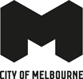
Experience Melbourne 2028
Industry Toolkit

Acknowledgement of Traditional Owners
The City of Melbourne respectfully acknowledges the Traditional Owners of the land we govern, the Wurundjeri Woi-wurrung and Bunurong / Boon Wurrung peoples of the Kulin and pays respect to their Elders past and present.
We acknowledge and honour the unbroken spiritual, cultural and political connection they have maintained to this unique place for more than 2000 generations.
We accept the invitation in the Uluru Statement from the Heart and are committed to walking together to build a better future.

Contents
Acknowledgement of Traditional Owners 2
Introduction 7
Experience Melbourne 2028 on a page 8
Vision - a shared aspiration for the Melbourne experience 8
Melbourne’s experience pillars - what makes Melbourne unique 8
Sports and events capital 8
Ground-breaking creativity 8
Vibrant people and places 8
Culinary kaleidoscope 8
Eclectic shopping haven 8
Aboriginal culture in the city 8
World-class knowledge hub 8
Green urban oasis 8
Experience essentials - the cornerstone of a successful visitor economy 8
Strategic priorities - focus areas for investment 9
Guiding principles - a framework for decision making 9
Visitor Markets 10
International visitors to Victoria to 2028 (000s) – top 15 market 10
Guiding Principles 11
Melbourne’s Experience Pillars 11
Iconic experiences 11
Renowned experiences 11
Emerging experiences 11
Experience essentials 11
Iconic experiences 12
Sports and Events Capital 12
Ground-Breaking Creativity 12
Vibrant people and places 12
Renowned experiences 13
Culinary Kaleidoscope 13
Eclectic Shopping Haven 13
Emerging experience 13
Aboriginal Culture in The City 13
World-Class Knowledge Hub 14
Green Urban Oasis 14
Experience Essentials 15
Transport and connectivity 15
Safety and cleanliness 15
Accessibility 15
Strategic Priorities 16
Stimulate visitation to the city 16
Enhance visitor servicing 16
Build industry capacity 17
Facilitate tourism development 17
City of Melbourne 18
Destination Storytelling Framework 18
Introduction 18
Background and context 18
Audience Focus 18
Tourism Australia 18
Visit Victoria 18
City of Melbourne 18
Key Ingredients 19
Visitation Drivers 19
Our Promise 19
Storytelling Pillars 19
Proof Points 19
Personality Traits 19
The Storytelling Framework 20
Visitation Drivers 20
Our Promise 20
Personality traits 21
Visitation Drivers 22
Surprise & Delight 22
Inspiration 22
Experience The Best 22
Feel The Vibe 22
Our Promise 22
Storytelling Pillars 22
Retail Therapy 22
Culinary Delights 23
Unique Culture 23
Endless Creativity 23
Shared Spectacles 24
Personality Traits 24
Creative 24
Proud 24
Curious 24
Progressive 24
Bringing The Brand to Life 25
Market Segments 25
Core segments 25
Cultured Advocates 25
Eager Explorers 25
Family Focused 25
High growth segments 25
Casual Convenience 25
Special Occasioners 25
Low growth segments 26
Locally Bound 26
Sports Fanatics 26
Distant Dreamers 26
City Cynics 26
Market Segments – Core Audience 27
Cultured Advocates 27
Eager Explorers 29
Information sources 29
Attitudes 29
Demographics 29
Age distribution 29
Distance from city 30
Behaviours 30
Family Focused 31
Information sources 31
Attitudes 31
Demographics 31
Distance from city 32
Behaviours 32
Market Segments – High Growth Opportunity 33
Casual Convenience 33
Information sources 33
Attitudes 33
Demographics 33
Age distribution 33
Distance from city 34
Behaviours 34
Special Occasioners 35
Information sources 35
Attitudes 35
Demographics 35
Age distribution 35
Distance from city 36
Behaviours 36

Introduction
A thriving visitor economy is at the heart of Melbourne’s economy.
The visitor economy is more than tourism. It encompasses the web of interactions between visitors and a destination, along with the direct and indirect impacts arising from their activities.
The visitor economy is a significant driver of growth, prosperity and wellbeing for Melbourne. By 2028, it is anticipated that Melbourne will welcome more than 18 million visitors who will contribute $16.8 billion to the city’s economy.
Experience Melbourne 2028 is a framework that enables City of Melbourne and the broader visitor economy to work together to respond to immediate challenges and work together through a shared vision to create the Melbourne experience.
It is a catalyst for innovation and collaboration, urging us to evolve and enhance the city’s offerings to meet the ever-changing needs of travellers. In a global tourism landscape marked by fierce competition, continuous innovation is essential to maintain a competitive edge.
This toolkit provides industry with a concise and actionable summary the essential insights and strategies needed to effectively contribute to and benefit from Experience Melbourne 2028.

Experience Melbourne 2028 on a page

Vision - a shared aspiration for the Melbourne experience
Melbourne is a city that captivates and welcomes the kind of visitors who are looking to connect deeply with the psyche of a place. We invite spirited adventurers in to discover eclectic experiences just beneath the surface.
Our status as the cultural, events and sporting capital of the southern hemisphere is firmly established. Now we can turn our attention to other uniquely Melbourne experiences such as culinary delights, urban nature, Aboriginal culture, and knowledge and innovation. We will seamlessly integrate these pillars into the overall visitor experience.

Melbourne’s experience pillars - what makes Melbourne unique

Sports and events capital
From the tent poles of the sporting calendar to the tapestry of community events throughout the year, sports and events play a major role in Melbourne’s visitor economy.

Ground-breaking creativity
Melbourne’s creative scene is renowned for its originality, independent spirit and commitment to pushing boundaries.

Vibrant people and places
Melbourne’s welcoming people and vibrant public realm are fundamental parts of the city’s identity.

Culinary kaleidoscope
In Melbourne, food is not just eaten: it is celebrated, discussed and savoured.

Eclectic shopping haven
The experience of shopping in Melbourne is much like the city’s unique style – diverse and eclectic.

Aboriginal culture in the city
Melbourne presents a unique opportunity to experience Aboriginal heritage and culture in an urban environment.

World-class knowledge hub
Melbourne’s reputation as a knowledge capital attracts business events and international students.

Green urban oasis
Melbourne is a city where nature is an integral part of the urban landscape.

Experience essentials - the cornerstone of a successful visitor economy
- Transport and connectivity
- Safety and cleanliness
- Accessibility

Strategic priorities - focus areas for investment
- Stimulate visitation to the city
- Enhance visitor servicing
- Build industry capacity
- Facilitate tourism development

Guiding principles - a framework for decision making
- We are Aboriginal focused
- We take an experience centric approach
- We foster an inclusive and welcoming destination
- We are committed to being sustainable and regenerative
- We are a collaborative and connected sector

Visitor Markets
Experience Melbourne 2028 takes a market-led approach to destination management. We welcome all visitors to Melbourne, but it is important to understand and respond to the needs of our key visitor markets and segments.
Domestic overnight spend is expected to be the largest generator of visitor spend in Melbourne by 2028 at $8 billion. However, growth in this sector is projected to be moderate after a period of strong recovery due to pent up demand as Australians embraced travel post COVID-19 restrictions. International overnight spend is expected to generate $7.21 billion by 2028, up from $3.54 billion in 2023, reflecting the importance of international visitors in driving the sector’s growth.
Internationally, high growth is expected in key markets such as China, India and South-East Asia. The top five international markets in 2028 are expected to be China, New Zealand, the United States, India and the United Kingdom.

International visitors to Victoria to 2028 (000s) – top 15 market
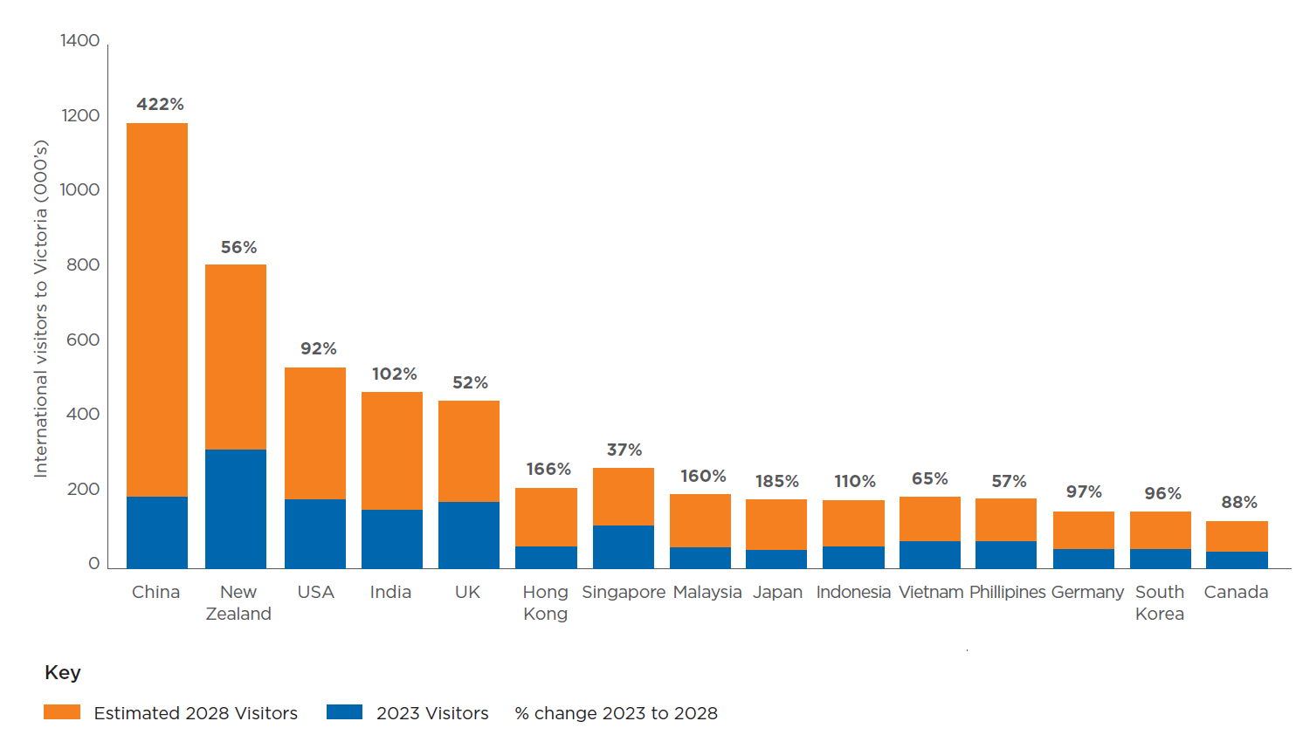
Source: Tourism Forecasts for Victoria, Victorian Government Department Jobs, Skills, Industry and Regions

Guiding Principles
Experience Melbourne 2028 is underpinned by five guiding principles.
The guiding principles provide a framework for decision-making, ensuring our actions align with the core values and priorities of the plan. They provide a common language among the many stakeholders of the visitor economy, preventing fragmentation and fostering a unified approach.
Our guiding principles are:
- Aboriginal focused
- Experience centric
- Inclusive and welcoming
- Sustainable and regenerative
- Collaborative and connected

Melbourne’s Experience Pillars
Experience Melbourne 2028 plays a key role in shaping Melbourne’s identity and reputation. At the centre of the plan are eight experience pillars: thematic areas that serve as the foundation for the visitor experience in Melbourne. The eight pillars assist in creating and affirming a distinct identity for Melbourne’s visitor economy, guiding strategic efforts and aligning messaging by stakeholders.
The experience pillars do not exist in isolation. A visitor can explore Melbourne’s iconic laneways filled with street art while discovering a local boutique selling one-of-a-kind pieces. A family can spend the day exploring the Royal Botanic Gardens while learning about traditional uses of plants for food, medicine and tools on the Aboriginal Heritage Walk. One of Melbourne’s key drawcards is that many of its best experiences are clustered conveniently in the central city, allowing visitors to explore with ease.

Iconic experiences
- Sports and events capital
- Ground-breaking creativity
- Vibrant people and places

Renowned experiences
- Culinary kaleidoscope
- Eclectic shopping haven

Emerging experiences
- Aboriginal culture in the city
- World-class knowledge hub
- Green urban oasis

Experience essentials
- Transport and connectivity
- Safety and cleanliness
- Accessibility

Iconic experiences

Sports and Events Capital
Melbourne is a city of sports and events. From the tentpoles of the sporting calendar to an abundance of iconic events and community gatherings, there’s always a spectacle to be shared.
Our sporting culture is deeply ingrained in the city’s identity, and festivals of all flavours take place almost every week of the year. Our major sporting and event venues are located in the heart of the city, meaning the economic benefits of events spread far beyond the court or the field.

Key directions
Together we will…
Priority direction: Improve the approvals process for organisers delivering events in Melbourne.
- Maximise opportunities to raise the visibility of sporting and cultural events across Melbourne.
- Invest in an effective portfolio of events that drive visitation and spend that contribute to Melbourne’s status as an events capital.
- Support event organisers to activate public spaces throughout the city.

Ground-Breaking Creativity
Melbourne’s creative scene is distinctive and celebrated, renowned for its originality, independent spirit and commitment to pushing boundaries.
The city’s dynamic artistic landscape is manifested in our galleries, theatres, studios and street art, making it a haven for art and culture enthusiasts.
The city’s advantage lies in its original, edgy and risk-taking work. We have an opportunity to highlight these qualities to set ourselves apart as other cities increasingly turn to creative tourism.

Key directions
Together we will…
Priority direction: Facilitate collaboration between the creative sector and the visitor economy.
- Invest in art and artists that build on our reputation as a leader in original, ground-breaking work.
- Enhance the visibility of the city’s creative experiences and precincts for visitors.

Vibrant people and places
Melbourne’s welcoming people and vibrant public realm are fundamental parts of the city’s identity.
Melbourne boasts established neighbourhoods with distinct cultural identities. The city blends well-preserved Victorian architecture and cutting-edge modern landmarks, and our iconic laneways encourage exploration.
What truly sets Melbourne apart is our people. We are progressive and inclusive, embodying a collective spirit that fosters creativity and acceptance.

Key directions
Together we will…
Priority direction: Create and affirm distinct stories and narratives for our diverse neighbourhoods, celebrating their unique sense of place and culture.
- Celebrate and preserve the city’s diverse cultural heritage.
- Ensure Melbourne’s diversity is a key feature when promoting the city.
- Create a welcoming environment for visitors from diverse backgrounds and communities.

Renowned experiences

Culinary Kaleidoscope
In Melbourne, food is not just eaten: it is celebrated, discussed and savoured. The city’s culinary offering extends beyond the plate. It is also about the experience, an adventure that stretches from the first sip of morning coffee to the call for last drinks.
Melbourne is a city where culinary artistry meets cultural diversity. Influences from across the globe converge here, inspired by a gloriously multicultural population.
Melbourne’s culinary scene isn’t just about the food; it’s also renowned for its unique drink offerings. As the sun sets the city transforms, revealing a different kind of vibrancy.
Down a laneway, on a rooftop or behind an unmarked door - Melbourne’s bar scene rewards the intrepid.

Key directions
Together we will…
Priority direction: Foster innovation in the culinary sector and support new and innovative culinary businesses to prosper.
- Promote the diversity of the city’s food culture to position Melbourne as a global leader in food and drink.
- Support the development of new culinary tourism experiences.
- Promote Melbourne as a vibrant and stimulating night-time city.

Eclectic Shopping Haven
Melbourne’s retail and fashion offerings are as eclectic as the city itself, with an alluring mix of high-end boutiques, international brands, independent designers and unique specialty stores.
The shopping experience in the city reaches beyond each transaction, inviting visitors to explore our laneways and enjoy diverse food and drink offerings while they shop. Activations and events extend the retail experience.
Melbourne has earned its reputation as Australia’s most stylish city. Beyond the uniform of Melbourne black, our fashion scene embraces influences that reflect the city’s diverse culture.

Key directions
Together we will…
Priority direction: Encourage visitation to the city’s shopping districts through innovative incentives, activations and events.
- Revitalise the city’s independent fashion and boutique culture by strengthening support for local designers, artists and businesses.
- Enhance key shopping districts in the city through improved infrastructure and trading conditions.
- Position the city as an exciting and must-visit shopping and fashion destination.

Emerging experience

Aboriginal Culture in The City
Melbourne presents a unique opportunity to experience Aboriginal heritage and culture in an urban environment, challenging visitor perceptions that they need to look to rural and remote locations for Aboriginal experiences.
Victorian participation in Aboriginal experiences remains below national levels. A long-term, sustained commitment from all stakeholders is required to develop a diverse, thriving Aboriginal tourism sector, positioning Melbourne as a leader in Aboriginal tourism.

Key directions
Together we will…
Priority direction: Support the development of Aboriginal products and experiences, as well as experiences that align with caring for Country.
- Grow Melbourne’s position as an enticing destination for Aboriginal experiences in an urban environment.
- Protect, recognise and embed Aboriginal culture and heritage across the city.
- Ensure the protection of Aboriginal intellectual property and prioritise authentic, locally-made souvenirs and products for sale in the city.

World-Class Knowledge Hub
Melbourne is a vibrant hub where creativity intersects with innovation, fostering a rich environment where ideas flourish and shape the future.
At the core of Melbourne’s growth as a knowledge capital is its exceptional university sector. International students play a crucial role in Melbourne’s visitor economy, as their presence attracts a significant number of friends and relatives who come to visit.
Melbourne is a premier destination for conferences and business events. The city features the largest conference and exhibition centre in Australia and the highest concentration of conference facilities.

Key directions
Together we will…
Priority direction: Strengthen Melbourne’s standing as a premier business events destination and enhance awareness of the value of business events.
- Capitalise on the international student market to increase the impact of visiting friends and relatives.
- Connect business events with the visitor economy to encourage business travellers to experience all Melbourne has to offer.
- Position Melbourne as a knowledge capital and innovation hub.

Green Urban Oasis
Melbourne is a city where nature is an integral part of the urban landscape. This blend of the built and natural environments enhances quality of life for residents and presents an immersive experience for visitors.
By thoughtfully showcasing the city’s array of urban nature and proximity to natural wonders, Melbourne can establish itself as an attractive destination for visitors looking to immerse in nature, providing a distinctive mix of urban vibrancy and serene natural landscapes.

Key directions
Together we will…
Priority direction: Create compelling opportunities to connect with and experience a revitalised Yarra River – Birrarung.
Position Melbourne as a city filled with urban nature, home to a world-renowned network of parks, gardens and streetscapes.
Improve connection between the city and Docklands waterfront with appropriate planning and development.

Experience Essentials
Three experience essentials form the cornerstone of a successful visitor economy: transport and connectivity, safety and cleanliness, and accessibility. Visitors expect these fundamentals so they are free to enjoy the city’s attractions and experiences.
- Transport and connectivity
- Safety and cleanliness
- Accessibility

Transport and connectivity
As Melbourne’s visitor economy grows, how visitors move around must be enhanced to support a vibrant, safe and inclusive visitor experience.
Transport and connectivity play a pivotal role in fostering the growth of the visitor economy in Melbourne, creating a seamless and accessible environment for visitors to get to, and get around, the city.

Key directions
Together we will:
- Connect Melbourne’s precincts, neighbourhoods and businesses through continued wayfinding expansion, and explore digital technologies that improve the visitor experience.
- Foster collaboration between transport providers and the visitor economy to improve the experience for visitors.
- Support initiatives that create high-quality, amenable streets for efficient short-distance travel.
- Advocate for improved infrastructure development to support the arrival and dispersal of visitors in the city, including airport rail and Station Pier.

Safety and cleanliness
Safety and cleanliness are crucial to sustaining and enhancing Melbourne’s visitor economy. They are at the foundation of the city’s appeal.
A clean city creates a pleasant and healthy environment for visitors, and also reflects the city’s pride and commitment to high standards. Clean public spaces, well-maintained facilities and litter-free streets enhance the overall experience for tourists.

Key directions
Together we will:
- Invest in initiatives that build a cleaner, safer and more caring community.
- Use placemaking, design and activation strategies to improve safety across the city.
- Support initiatives that promote the safety of women and people from marginalised communities.

Accessibility
Accessibility in Melbourne’s visitor economy is about ensuring that people of all abilities can fully experience and enjoy everything the city has to offer.
Providing accessible visitor experiences presents a significant business opportunity for businesses to welcome all visitors and increase their revenues.

Key directions
Together we will:
- Prioritise accessibility in the development of new product and experiences.
- Upskill the sector to enhance their awareness and benefits of accessibility in the visitor economy.
- Ensure marketing materials demonstrate Melbourne’s credentials as an accessible destination.

Strategic Priorities
In advancing Melbourne’s visitor economy, our strategic priorities are the roadmap guiding us towards the realisation of our vision. These priorities show how we get there – essential steps between our present efforts and the future we envision.

Stimulate visitation to the city
Building a resilient visitor economy means ensuring diversity in our visitor markets, attracting local, domestic and international visitors. This can be done through destination marketing strategies and events that drive visitation. To ensure consistent and compelling communication to visitors, all players in Melbourne’s visitor economy who promote the city must unite under a unified brand narrative. As an action of this plan City of Melbourne has developed a storytelling framework. This framework forms the second half of this toolkit and can be viewed on page 18.
Stimulate visitation to the city – action | Timeframe | City of Melbourne’s role
Priority action: Embed a brand framework for Melbourne that complements the Visit Victoria brand framework, ensuring consistency across both entities. | Immediate | Deliver and partner
Work with government agencies including Visit Victoria, Study Melbourne, Invest Victoria and Melbourne Convention Bureau to align positioning of Melbourne as a desirable place to visit, study and invest. | Ongoing | Deliver and partner
Target new audience segments within Victoria to increase reach and visitation to the city. | Immediate | Deliver
Deliver and support events that drive visitation to the city, particularly during periods that traditionally have low visitation. | Ongoing | Deliver and partner

Enhance visitor servicing
Melbourne is a city of discovery, and with the right information at the right time, visitors can unlock a surprising array of experiences. High-quality visitor servicing is integral to Melbourne’s success as a premier destination, enhancing the overall visitor experience and contributing to the city’s allure.
Enhance visitor servicing – action | Timeframe | City of Melbourne’s role
Priority action: Enhance our visitor services to ensure they are dynamic, customer-centric, accessible and reflect the diversity of the city, including our Aboriginal heritage. | Immediate | Deliver and partner
Provide visitors with real-time information and personalised recommendations through a hybrid model of face-to-face and enhanced digital touchpoints. | Medium | Deliver
Facilitate collaboration across frontline services in the visitor economy to ensure an integrated and comprehensive visitor experience. | Medium | Deliver
Use data and analytics to make informed decisions that meet the evolving needs of visitors. | Medium | Deliver and partner

Build industry capacity
Tourism is a dynamic industry, with emerging global trends increasingly shaped by shifts in consumer interests. By providing businesses with skills, connections and insights, we can sustain our status as a top tourism destination while adapting to the changing needs of the global travel market.
Build industry capacity – action | Timeframe | City of Melbourne’s role
Priority action: Improve the sharing of data and insights among industry stakeholders. | Immediate | Deliver
Improve the cultural competency of the industry to welcome visitors from diverse and emerging markets. | Medium | Deliver and partner
Deliver education and training on key industry topics such as sustainability, accessibility and artificial intelligence. | Immediate | Deliver and partner
Advocate and partner with government and peak bodies to ensure the attraction and capacity of industry workers is a key priority. | Immediate | Advocate and partner

Facilitate tourism development
Melbourne is poised for substantial growth in both international and domestic visitation. Key to this expansion is the development of innovative and complimentary tourism products and experiences.
Facilitate tourism development – action | Timeframe | City of Melbourne’s role
Priority action: Develop guidelines to assist businesses in understanding the changing needs and expectations of travellers, enabling them to design and deliver exceptional visitor experiences. | Immediate | Deliver
Advocate to state and federal governments on behalf of Melbourne operators for funding to foster new and innovative tourism experiences. | Immediate | Advocate
Conduct and share research to enhance understanding of visitor preferences and emerging trends. | Medium | Deliver and partner

City of Melbourne

Destination Storytelling Framework

Introduction
This framework aligns all stakeholders under a single destination brand for City of Melbourne. It outlines how to communicate the city experience to build a strong reputation for the local visitor economy and support the long-term prosperity of our city.
Through the adoption of a consistent storytelling framework across key agencies responsible for contributing to ‘brand Melbourne’, we aim to ensure maximum impact of our collective efforts through all communication.

Background and context
In 2021, the Victorian Government released the Visitor Economy Recovery and Reform Plan. The plan outlined the need for a new brand framework to differentiate Victoria against its competitors and unify the industry behind a single positioning. This provided an opportunity for Visit Victoria to articulate the differentiated unique selling propositions of Victoria and each region including Melbourne.
The statewide-brand framework was developed based on a reflection of past performance, external and internal consultation, domestic consumer research and international consumer research.
Further research was conducted to develop an aligned framework specifically for City of Melbourne’s destination brand. This included a monthly consumer brand tracker that monitors the drivers, challenges and sentiment of local visitors to the city.

Audience Focus
There are many stakeholders at each level of government that contribute to driving visitation to Melbourne.
At the federal level, Tourism Australia is the government agency responsible for nationwide strategies that market the country as a prime destination globally for leisure travel and business events.
Visit Victoria is the government agency at the state level responsible for driving visitation and expenditure to Victoria through destination marketing and the acquisition and support of major events. Visit Victoria’s campaign Every Bit Different is the master brand framework for Melbourne and Victoria; a creative marketing platform that is leveraged by City of Melbourne and industry.
At the local level, City of Melbourne brings people to the city from greater Melbourne and regional Victoria. We showcase the unique and varied experiences the city offers through targeted campaigns, while the What’s On Melbourne digital platforms connect visitors with local events and businesses.

Tourism Australia
Driving visitation to Australia from international markets

Visit Victoria
Driving visitation to Melbourne and Victoria from interstate, international and local markets

City of Melbourne
Driving visitation to Melbourne from local markets

Key Ingredients
Visit Victoria created sub-brand frameworks with a key promise for each region in the state, including Melbourne. When promoting the city nationally and internationally, its promise is that Melbourne is Australia’s cultural heart.
This framework articulates the unique point of difference for City of Melbourne in this context, as the number one, locally loved and globally recognised destination.
It consists of the following key ingredients to ensure a comprehensive approach to defining and communicating Melbourne’s unique brand identity:

Visitation Drivers
The underlying universal motivations that drive leisure visitation to the city

Our Promise
The answer to the question, ‘why visit the city?

Storytelling Pillars
Telling the story of what we are famous for

Proof Points
Products, services and experiences that substantiate our promise and bring our pillars to life

Personality Traits
The style traits that define how our brand expresses itself

The Storytelling Framework

Visitation Drivers
The underlying universal motivations that drive leisure visitation to the city.
- Surprise and delight
- Inspiration
- Experience the best
- Feel the vibe

Our Promise
The answer to the question, ‘why visit the city?’
Melbourne is Australia’s cultural heart. The city is its soul, with experiences that energise your spirit.
Storytelling pillars  The unique selling points that deliver on our brand promise. | Proof points  specific experiences that fall into each pillar.
Retail Therapy  Shopping to meet every need, with an inimitable sense of discovery and adventure. | - precincts  - centres  - arcades  - independent boutiques  - flagship stores  - markets
Culinary Delights  A diverse, innovative and multicultural food and drink scene to tantalise taste buds day or night. | - new openings  - old favourites  - collabs and pop-ups  - diverse food culture  - coffee  - famous chefs  - late night dining
Unique Culture  A city that’s crafted by its diverse and creative passions and people, who always strive for best in class. | - laneways, rooftops and hidden gems  - iconic architecture  - knowledge capital  - multiculturalism  - aboriginal melbourne  - sustainability
Endless Creativity  A back catalogue that never gets old while the city creates a canvas for new ideas and innovation. | - public spaces  - galleries  - museums  - libraries  - street art  - the arts precinct  - pop up venues
Shared Spectacles  Special events and spectacles for all cultures make this city truly unique. | - world-class events  - sport  - community events  - festivals  - theatre  - live music  - stand-up comedy

Personality traits
Guide clear and consistent expression of brand communication.
- Creative
- Proud
- Curious
- Progressive

Visitation Drivers
The underlying universal motivations that drive leisure visitation to the city.

Surprise & Delight
The feeling of excitement that something new brings me. To be more spontaneous, be surprised by what could be found around the corner.

Inspiration
For a much needed break from routine to open my mind, feel creative and energised from the mundane state the day to day keeps me in.

Experience The Best
Accessing something I can’t get locally. Experiences that are bigger, better, world-class versions of the things that I’m passionate about.

Feel The Vibe
To embrace the vibrancy only the city projects. Experience the beating heart of Melbourne. The hustle and bustle, energy and feel of the world’s greatest city.

Our Promise
The answer to the question, ‘why visit the city’?
Melbourne is Australia’s cultural heart. The city is its soul, with experiences that energise your spirit.

Storytelling Pillars
The storytelling framework is built on five storytelling pillars that highlight our unique selling points to deliver on our brand promise.

Retail Therapy
Only in the city does shopping provide a true sense of adventure and discovery. Be surprised and delighted as you walk amongst iconic architecture, open-air precincts, multi-level centres and flagship stores. Then seek out unique treasures from independent boutiques as you hop between urban laneways and historic arcades. Plus, a shopping itinerary isn’t complete without the diverse food and exciting events right next door.

Example Experiences:
- Precincts
- Centres
- Arcades
- Independent boutiques
- Flagship stores
- Markets

Culinary Delights
Indulge your taste buds with world-class restaurants and bars, or surprise them with the endless diversity of food options available. Food in the city is not just sustenance, but a gateway to new experiences, connections, and memories shared over communal tables. The city boasts a melting pot of food and drink to tantalise taste buds from day to night.

Example Experiences:
- New openings
- Old favourites
- Collabs and pop-ups
- Diverse food culture
- Coffee
- Famous chefs
- Late night dining
- Bars and clubs

Unique Culture
Awe-inspiring, heritage architectural wonders. Spaces used one day for live music, that transform into a pop- up exhibition the next. A soundscape of trams, buskers and the feeling of being at the centre of the soul of Melbourne. Laneways, hidden holes in the wall, and bustling boulevards filled with the energy of the diverse people going about their day contribute to the fabric of the city. A proud connection to its Aboriginal history and a commitment to sustainable and innovative spaces.

Example Experiences:
- Laneways, rooftops and hidden gems
- Holes in the wall and pop-ups
- Iconic, historic architecture
- Buskers and busy boulevards
- Innovation and knowledge capital
- Multiculturalism
- Aboriginal Melbourne
- Sustainability and social enterprise

Endless Creativity
Whether you’re an art enthusiast, a history buff, or just woke up feeling a little curious, the city is full of inspiration and innovation at every turn. Where laneways are enveloped in art, galleries host renowned exhibitions and acclaimed productions take centre stage at grand theatres. Open your eyes, widen your ears and broaden your horizons in Australia’s cultural hub. Connect with community, past and present, or seek to question the status quo.

Example Experiences:
- Public spaces
- Galleries
- Museums
- Libraries
- Street art
- The Arts Precinct
- Pop up venues

Shared Spectacles
Melbourne is home to a vibrant and diverse calendar of celebrations all year round. These shared spectacles are cultural moments for you to connect with strangers, celebrate, commiserate, reflect and learn together. Feel the power of collective applause, gasp or laugh. Where major events have a magnetic draw, taking over the city, and community events gather people from far and wide.

Example Experiences:
- World-class events
- Sport
- Community events
- Festivals
- Theatre
- Live music
- Stand-up comedy
Personality Traits

Personality Traits
The way we communicate is a reflection of our brand. These four tonal themes are the measuring stick for all communications.

Creative
We do things differently in Melbourne. Our creative spirit results in unconventional and innovative experiences in everything we do.

Proud
Melburnians know their city is the best in Australia. We’re never over-confident, but not shy about shouting it from the rooftops.

Curious
Twists and turns reveal a maze of new and old that awaken the senses. We bring to life the sense of adventure of a visit to the city.

Progressive
We embrace a sense of optimism for the future, inclusive attitudes, and the never-ending sense of possibility that the city offers.

Bringing The Brand to Life
The storytelling framework is expressed to consumers through the campaign platform Only in the City. Only in the City delivers a consistent set of brand colours, typography, language, photography, tone and more across all marketing activity.
It conveys what the city promises and authentically connects people to the value they can expect to receive. This platform showcases all the experiences available in the City of Melbourne that just can’t be replicated anywhere else.
The beating heart of Melbourne is the city. And only in the city.
Only in the city can you find endless creativity, world-class theatre, shopping, and dining.
Only in the city can you wander down a laneway and stumble into an unsigned speakeasy bar flaunting live jazz into the early hours.
Only in the city can you cut the tension in the air with a knife at the footy or tennis final.
Only in the city can you experience a melting pot of cultures from every corner of the globe.
Only in the city can you feel exactly what makes Melbourne, Melbourne.

Market Segments
City of Melbourne has undertaken a refresh of its leisure target audiences to ensure destination marketing activity reflects changes in visitor behaviour since the pandemic. The updated segmentation supports the new storytelling framework and identifies nine audience groups that consider the city a destination for leisure. This includes three core audiences, two high growth opportunities and four low growth markets.
The classifications have been based on segment size, attitudes, behaviours, spend and potential to increase spend, with core and high growth markets prioritised as the focus of our efforts.

Core segments

Cultured Advocates
They love everything the city has to offer and know the city better than any other segment. They feel Melbourne aligns with their personal values.

Eager Explorers
Young and passionate, they embrace the city’s vibe and atmosphere. They love exploring the city – coming in without a plan and seeing where they end up.

Family Focused
They have children living at home, so their choice to visit the city often revolves around catering to their children’s needs and interests.

High growth segments

Casual Convenience
The ‘tag-alongs’ – rarely the social instigators but will happily accompany those who are. The city is a convenient place to spend leisure time.

Special Occasioners
They live much further away from the city but do enjoy coming in for a special treat and spend big, usually staying in a hotel with a jam-packed itinerary.

Low growth segments

Locally Bound
They have a strong preference for spending time in their neighbourhood or places other than the city. They do not love the hustle and bustle and find the city unsafe.

Sports Fanatics
The city isn’t their favourite place but their passion for sport (usually the footy) keeps them near and connected.

Distant Dreamers
Living far away, they make each visit to the city into an event to remember. Their love for the city fuels their frequent visits.

City Cynics
They dislike the hustle and bustle of the city, finding it dangerous, dirty, and crowded. They only come into the city when they absolutely must.

Market Segments – Core Audience
Three core audiences, who already love and frequently visit the city for leisure, are Cultured Advocates, Eager Explorers and Family Focused.

Cultured Advocates
Cultured Advocates are a core segment, and the city is their playground.
They love everything the city has to offer, immersing themselves in a mosaic of arts, culture and culinary delights.
They know the city better than any other segment, and their affinity runs deep – they have a strong sense of belonging, and feel Melbourne aligns with their personal values.

Information sources
Find out what’s happening in the city via word of mouth (64%), walking around the city (54%), What’s On (51%) and social media (51%).
Instagram is their preferred social media platform.

Attitudes
Very high love for and sense of belonging to the city.
Drivers include the city’s atmosphere, events, culture, entertainment and culinary choices.
Consider the city…
Exciting (82%), Fun (81%), Diverse (75%).

Demographics
54% Female
45% Male
20% CALD*
29% City workers
21% Children at home
Higher income – 54% earn more than $100k annually (household)
Slightly older and live in inner city
* CALD (culturally and linguistically diverse): speak a language other than English at home

Age distribution

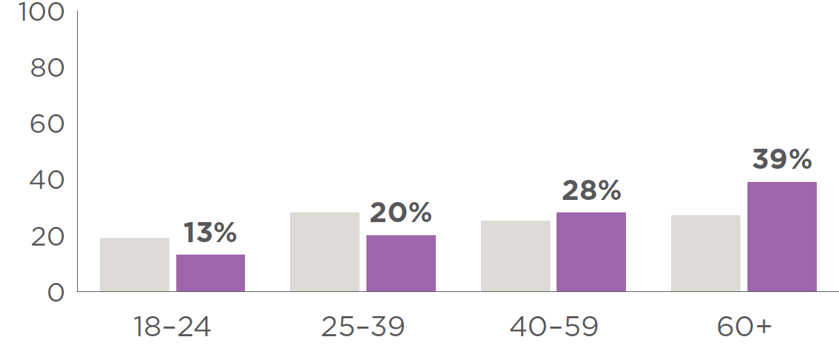

Distance from city

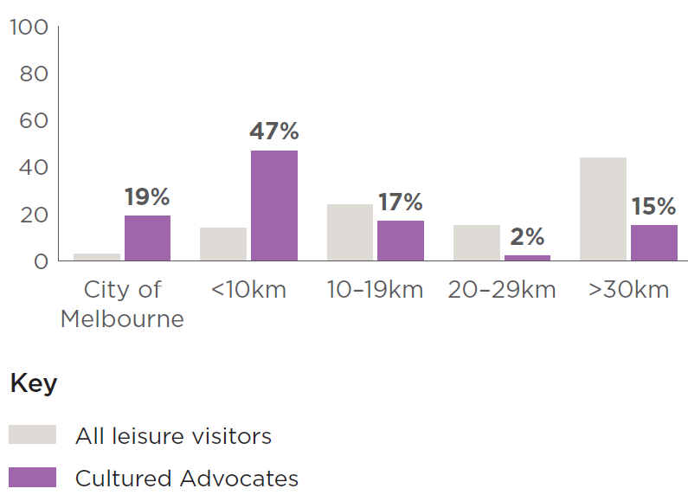

Behaviours
Cultured Advocates are a higher value segment.
Though they spend a similar amount to other visitors ($306), they visit far more often.
58% visit the city for fun a few times a month.
They are more likely to get the tram (66%) or walk (38%) into the city than other segments.

Eager Explorers
Eager Explorers are a younger cohort who are passionate about the city.
They aren’t as plugged into the city’s sophisticated cultural offerings as Cultural Advocates, but they do embrace the city’s vibe and atmosphere.
They love exploring the city – coming in without a plan and seeing where they end up.

Information sources
Find out what’s happening in the city via social media (68%), word of mouth (62%), What’s On (52%) and Visit Melbourne (42%).
Instagram and Facebook are their preferred social media platform, but they use a range.

Attitudes
Very high love for and high sense of belonging to the city.
Drivers include the city’s atmosphere, events, entertainment and culinary choices.
Consider the city…
Fun (81%), Exciting (78%), Diverse (75%)

Demographics
60% Female
40% Male
29% CALD*
24% City workers
30% Children at home
Lower income – 47% earn less than $100k annually (household)
Youngest segment, live 10km+ from the city

Age distribution
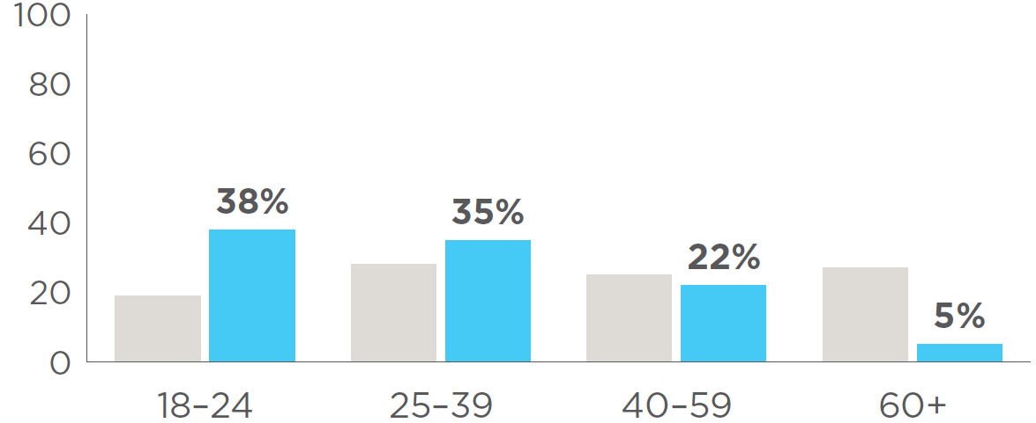

Distance from city
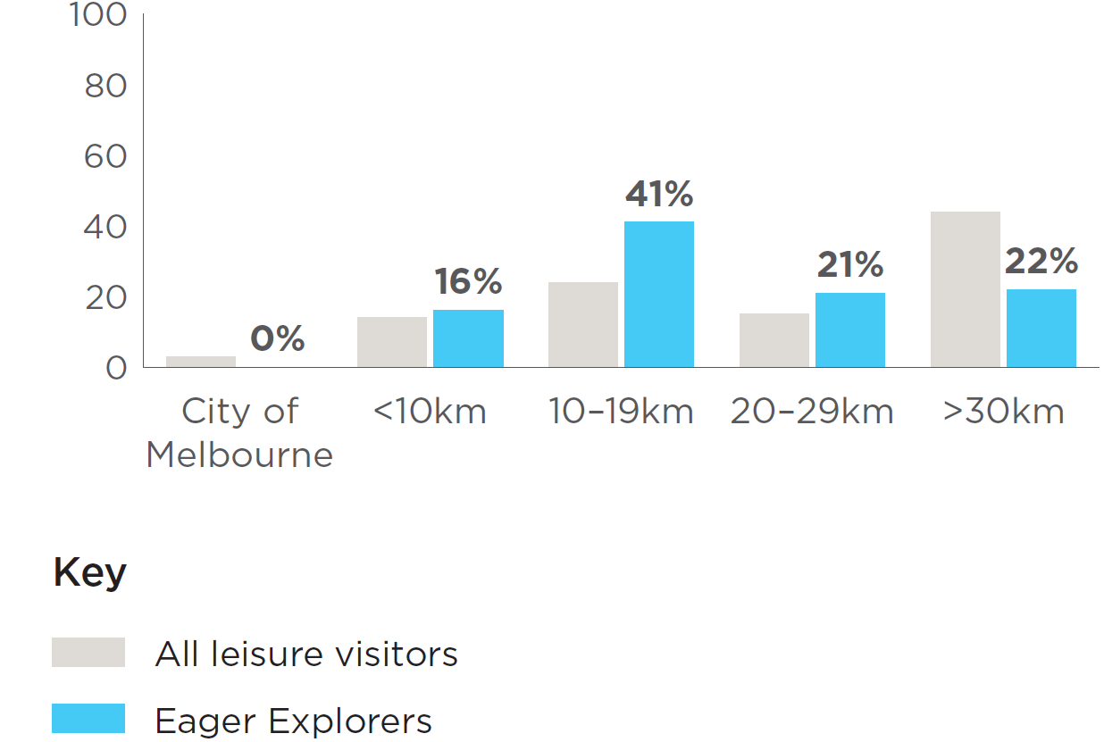

Behaviours
Eager Explorers are a higher value segment.
They spend the second highest of all the segments ($362) and visit very often.
50% visit the city for fun a few times a month.
They are most likely to use trains (72%) or rideshares (32%) among all segments.
* CALD (culturally and linguistically diverse): speak a language other than English at home

Family Focused
Family Focused have children living at home, primarily young kids.
Their choice to visit the city often revolves around catering to their children’s needs and interests, and many view the city through their children’s eyes.
While they do hold affection for the city, their children make it less convenient for them to visit as often as before.

Information sources
Find out what’s happening in the city via social media (64%), word of mouth (57%), What’s On (49%) and Visit Melbourne (35%).
Facebook is their preferred social media platform.

Attitudes
High love for but moderate connection with the city.
Drivers include hospitality, retail, as well as spectacles and creative experiences for their children.
Consider the city…
Exciting (77%), Fun (76%), Diverse (71%)

Demographics
55% Female
44% Male
24% CALD*
16% City workers
100% Children at home
Moderate income – 60% earn more than $100k annually (household)
Slightly older and live beyond 10km from the city
* CALD (culturally and linguistically diverse): speak a language other than English at home

Age distribution
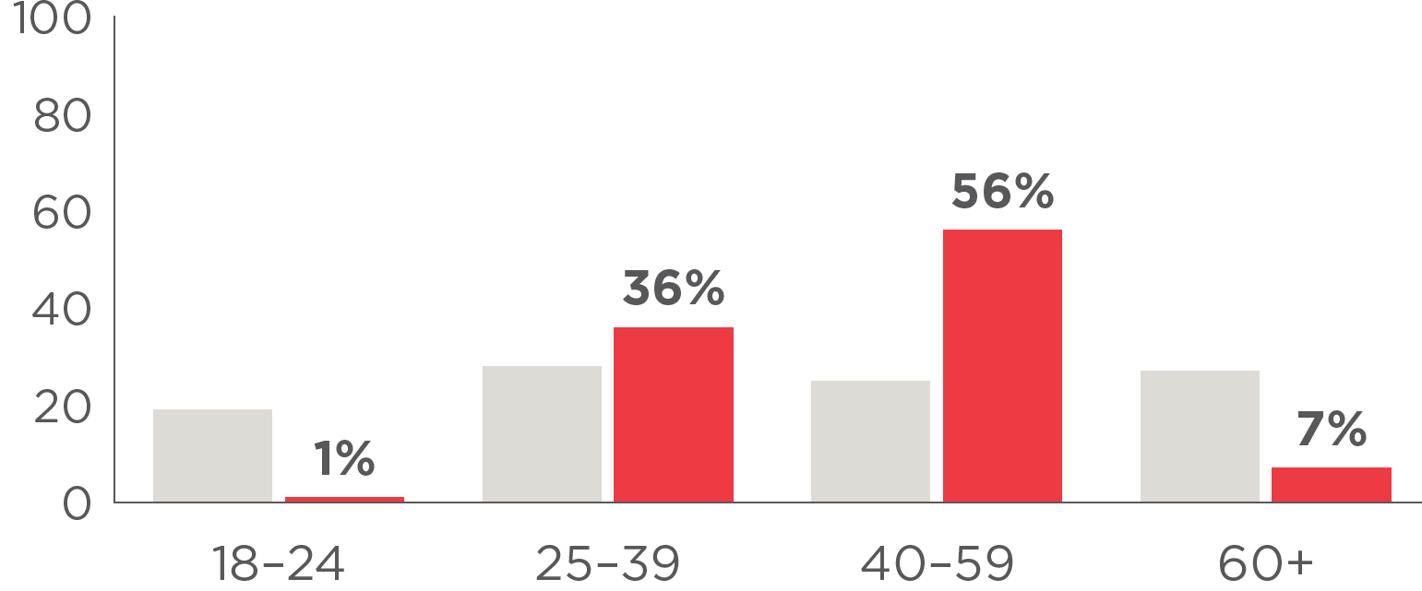

Distance from city
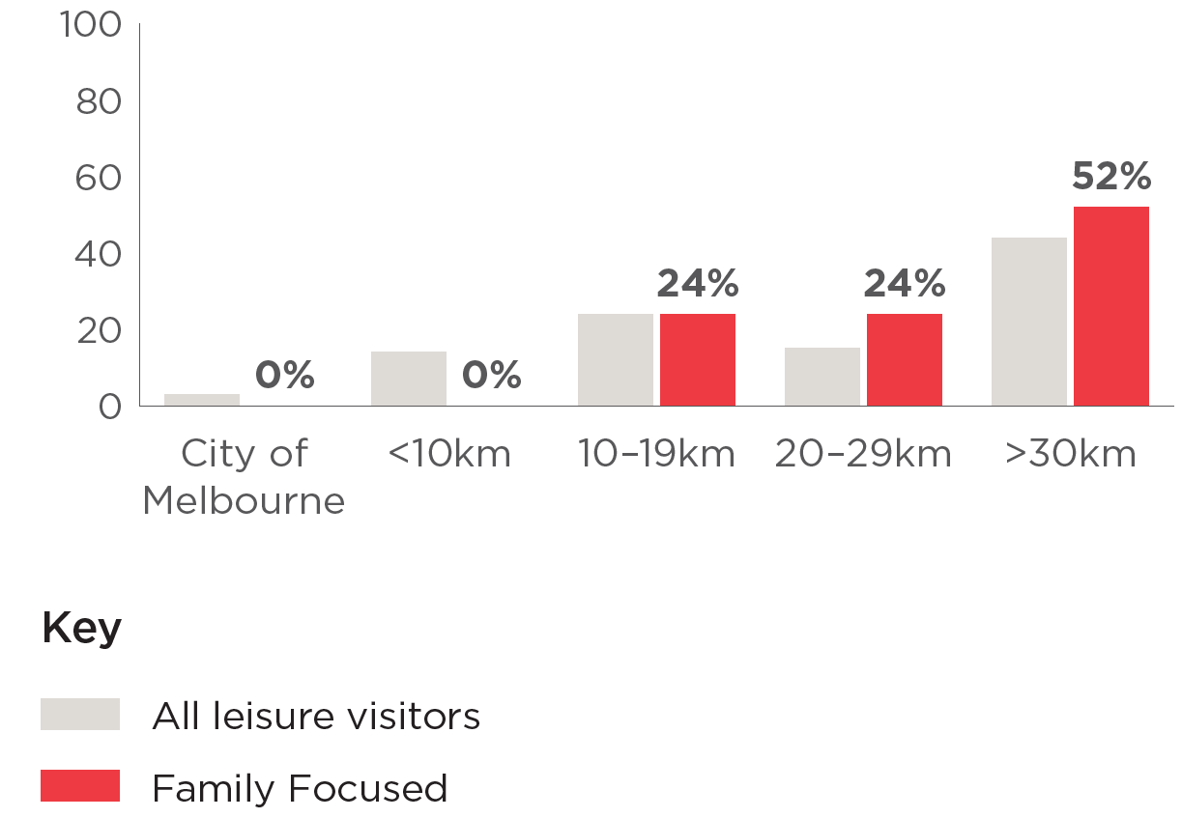

Behaviours
Family Focused are a lower value segment.
They spend more than most other visitors ($341) but they visit the least frequently.
13% visit the city on a monthly basis and none visit more frequently than this.
They are significantly more likely to drive their private cars (75%) than any other segment.

Market Segments – High Growth Opportunity
Two high growth opportunities have been identified, with potential to increase visitation among Casual Convenience and Special Occasioner segments.

Casual Convenience
Casual Convenience are ‘tag-alongs’.
Rarely the social instigators that are in the know about the latest things happening in town but will happily accompany those who are.
They don’t love the city, instead they have a more functional relationship – for many it’s where they work, which makes the city a convenient place to spend leisure time.

Information sources
Find out what’s happening in the city via social media (40%), word of mouth (38%), What’s On (30%) and walking around the city (28%).
Facebook is their preferred social media platform, but they use a range.

Attitudes
Lower love for and connection to the city.
Drivers include retail, hospitality, and (for some) niche creative hobbies.
Consider the city…
Crowded 55%, Diverse (53%), Fun (50%)

Demographics
34% Female
65% Male
21% CALD*
40% City workers
47% Children at home
Moderate income – 53% earn more than $100k annually (household)
Slightly younger and live in inner city
* CALD (culturally and linguistically diverse): speak a language other than English at home

Age distribution
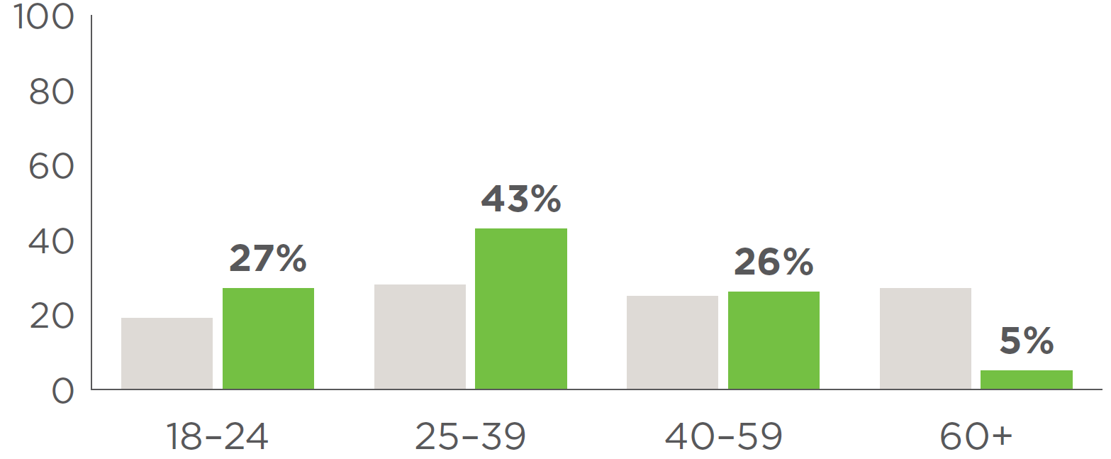

Distance from city
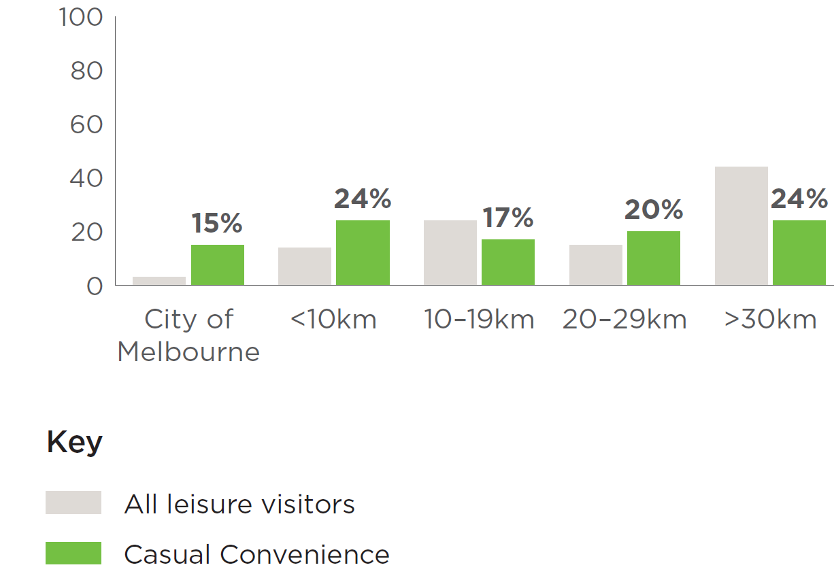

Behaviours
Casual Convenience are a moderate value segment.
They spend a similar amount to other visitors ($314) but visit more often.
48% visit the city for fun a few times a month or more.
Over half use the train (59%) or a private vehicle (51%) to get into the city.

Special Occasioners
Special Occasioners live much further away from the city, almost all hailing 30km or more from the CBD.
They don’t feel a strong sense of connection to the city but do enjoy coming in for a special treat – either for a particular show / event, or a personal milestone, like a birthday or anniversary.
When they come in, they spend big, usually staying in a hotel with a jam-packed itinerary.

Information sources
Find out what’s happening in the city via word of mouth (57%), social media (51%), advertising (36%) and What’s On (33%).
Facebook is by far their preferred social media platform.

Attitudes
Medium love for and low sense of belonging to the city.
Drivers include the shared spectacles like special events, but they will enjoy all aspects of the city when they are here.
Consider the city…
Crowded (74%), Diverse 66%, Fun (64%)

Demographics
57% Female
43% Male
6% CALD*
2% City workers
34% Children at home
* CALD (culturally and linguistically diverse): speak a language other than English at home
Lower income – 58% earn less than $100k annually (household)
Slightly older and live a significant distance from the city

Age distribution
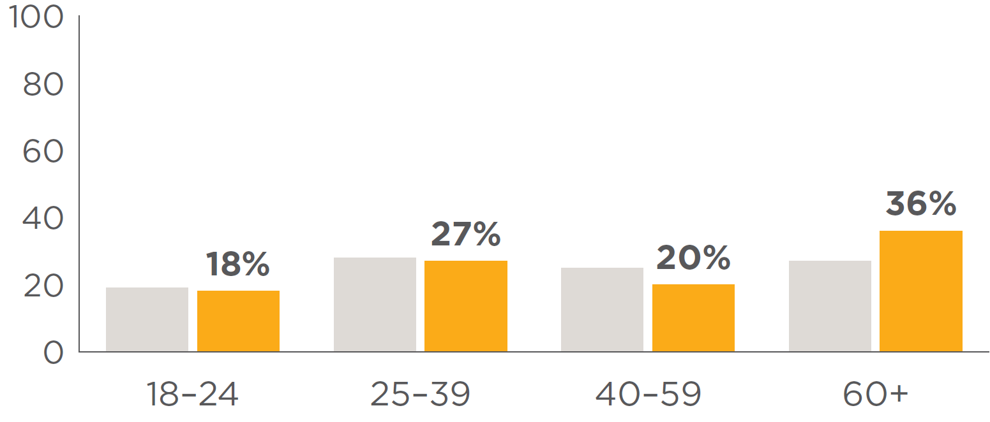

Distance from city
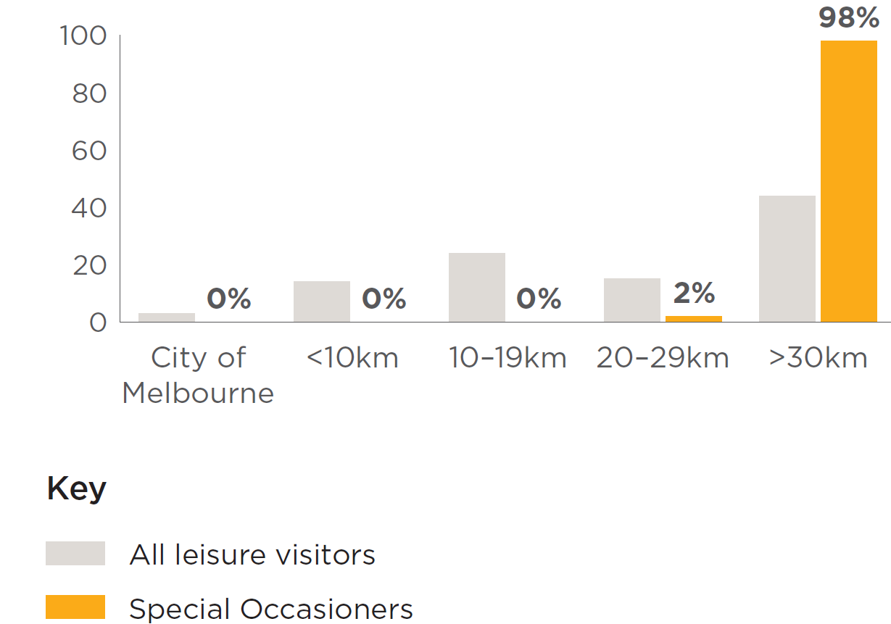

Behaviours
Special Occasioners are a moderate value segment.
They spend the highest amount compared to other segments ($380) but visit far less often than other segments.
3% visit the city for fun a few times a month.
Most people in this segment use a car (60%) or train (49%) to get into the city.

Tourism forecasts for Australia 2023-2028, Tourism Research Australia
Tourism forecasts for Australia 2023-2028, Tourism Research Australia

