

Heat Lab Evaluation Report

Prepared for
City of Melbourne

Company information
First Person Consulting Pty Ltd
ABN 98 605 466 797
www.fpconsulting.com.au
Tenancy 3, Level 4, 224 Queen Street
Melbourne VIC 3000
First Person Consulting (FPC) is a Melbourne-based consulting firm where staff specialise in social research, evaluation and design. Staff at FPC have conducted a wide variety of projects across a range of sectors, including disaster recovery, emergency management and resilience.

Document details
Title: | Heat Lab evaluation report
Authors: | Niamh Donohoe, Maeva Bennetto, Miriam McGarry
Version: | Draft V06
Revision date: | 14/05/2024
Client: | City of Melbourne

Contents
1 Introduction 5
1.1 Background 5
1.2 Objectives and scope 5
1.3 Methodology 6
1.4 Evaluation limitations 6
2 Key findings and recommendations 8
2.1 Key findings 8
2.2 Recommendations 9
3 Appropriateness 12
3.1 The lab model 12
3.2 Target audiences, locations and settings 13
4 Effectiveness and outcomes 16
4.1 Awareness raising 16
4.2 Engagement and outreach 20
4.3 Provision of Cool Places 25
4.4 Infrastructure 30
4.5 Governance – HeatSens 31
5 Efficiency 34
6 Sustainability and scalability 36
6.1 Which interventions can/should be replicated or scaled for future summers and which interventions need adjustments? 36
6.2 Lessons for other councils implementing similar interventions 37
Appendix 1 – Evaluation framework 39
Appendix 2 – Physical Cooling Interventions 44
Section 1: Analysis of cooling interventions 44
Section 2: Concepts and pilots 47
Section 3: Monitoring and Evaluation of pilots 52
Appendix 3 – Cool kit items 54
Appendix 5 – Collateral that was developed 55
Appendix 6 – Heat Smart Session feedback form 56
Appendix 7 – HeatSens objectives and contributions to Head Lab strategy 58
Appendix 8 – Community Cool Places Grant Overview 59
Tables
Table 1. Summary of intervention target audiences and how they were engaged 13
Table 2. Types of brochures updated or developed through the intervention 16
Table 3. Summary of brochure distribution over the 3-month period 16
Table 4. Number of activation days and attendees at each Cool Place organisation (as per project acquittal reports). 26
Table 5. Allocation of program funds 34
Table 6. Evaluation framework 39
Table 7. Data collection approaches and sources for each intervention 41

Acronyms and abbreviations
CRC Cool Relief Centre
CoM City of Melbourne
FPC First Person Consulting
KEQ Key Evaluation Question
TAG The Adaptation Game
EMV Emergency Management Victoria

Introduction

Background
To reduce the risks from extreme heat the City of Melbourne established the ‘Heat Lab’ project, an innovation sandbox addressing heat vulnerability and risk in urban neighbourhoods. The lab experimented on community focused, place-based interventions to address severe heat impacts. The City of Melbourne received funding from Emergency Management Victoria to deliver the Heat Lab project in the 2023-24 financial year.
The Heat Lab project underwent a design and delivery phase of a range of design interventions, and is now complete. The identification and design of these interventions have been informed by community engagement, heat risk and social vulnerability data. Interventions include:
- provision of cool kits
- distributing information via brochures and heat smart sessions
- shading infrastructure trials
- provision of ‘Cool Places’ for community members and;
- public art as an awareness raising tool.
FPC was engaged to undertake an evaluation of the Heat Lab to understand the effectiveness of the lab model, lessons for delivery, which interventions have impact and which interventions can and should be rolled and scaled in future summers.

Objectives and scope
The objectives of this evaluation were to:
- understand the effectiveness of a ‘lab’ model at reducing risks
- understand how effective each intervention is at reducing heat vulnerability i.e., asking the question if the chosen actions are resulting in the desired outcomes or not
- understand the efficiency of the interventions
- understand community experience and the impact of interventions of reducing heat risk and vulnerability
The following components of the project were in scope for this monitoring and evaluation program:
- The Lab Model (approach taken to develop interventions)
- Pilot infrastructure and service interventions:
  - Awareness raising:
    - Heat Safe Collateral
    - Public Art
  - Engagement and outreach:
    - Creative Engagement – The Adaptation Game
    - Cool Kits
    - Heat Smart Sessions
  - Provision of Cool Places:
    - Cool Places in Libraries
    - Facilitation of Cool Places
  - Retrofitting public space Assessment of the impact of this intervention was out of scope for this evaluation and is being completed by RMIT University.

Methodology
Our approach to this evaluation involved the following components:
- An inception meeting - held on 20 November 2023 between FPC and the City of Melbourne team to discuss the objectives of the evaluation, the background and context of the Heat Lab pilot, agree on the evaluation approach, identify key documents, and confirm project management processes.
- Development of a project plan – building on discussion at the inception meeting, an evaluation plan was prepared, including a refined evaluation framework, data collection methods and analysis strategies and confirmed timelines and deliverables.
- Document review and gap analysis – of key program records, plans and documents provided to gain an in depth understanding of the Heat Lab interventions.
- Data collection, which consisted of:
  - Surveys of community members using Cool Places
  - Interviews with key stakeholders (17 in total) - Interviews were in-depth and semi-structured. Each interview was around 45-60 minutes in duration and facilitated over Zoom or phone, depending on interviewees preference.
- Analysis – of all data sources, including acquittal reports collected by City of Melbourne, survey responses provided by some of the Cool Places grant recipients, monitoring data (including web analytics) and additional data collected by FPC through interviews.
- Reporting – Qualitative and Quantitative evidence was collated and synthesised in response to the evaluation questions and a report (this document) was developed and provided to Council for review.
The evaluation framework that was developed to guide this piece of work is included in Appendix 1.

Evaluation limitations
The following contextual factors and limitations should be considered in relation to the findings and recommendations presented in this evaluation report:
- The findings in this report are largely reliant on the perspectives of City of Melbourne staff and delivery partner stakeholders provided through interviews. Where possible, we have triangulated qualitative data with quantitative data from available sources.
- There were less heat events triggered during the pilot period than anticipated, and therefore, the overall scale of data collected is less than anticipated.
- There were varying levels of data and evidence available for each of the interventions included in the scope of this evaluation, which has made it difficult to determine which of the interventions should be scaled or replicated for next summer.
- We did not receive data from some of the online surveys that were developed (i.e., the surveys developed to be included in brochures and collateral, and the surveys developed for artists to use). As such we have had to rely on anecdotal evidence from interviews and information provided in acquittal reports to report on some of the interventions.

Key findings and recommendations

Key findings

Appropriateness
Overall, evidence suggests the Heat Lab pilot has been well designed to enable City of Melbourne to pilot multiple different interventions aimed at reducing the risks of heat waves for vulnerable community members.
Key strengths of the lab model include:
- The pilot program team embraced experimentation, allowing the council to think outside the box, particularly regarding how to engage communities in conversations about heat-related issues. All interviewed stakeholders considered the pilot to be successful in allowing council to expand on the existing creative culture at CoM and trial various innovative ideas that wouldn’t typically fit within standard budgets or project plans.
- The program was flexible and adaptable to changing circumstances when necessary.
- The collaborative approach to the program, with various council teams and external delivery partners engaged in the design and delivery of various initiatives.
However, the evaluation has highlighted that while a three-month ‘living lab’ trial can provide valuable insights into the potential effectiveness of different interventions in addressing climate risk for heat-vulnerable communities, it may not capture the full complexity and impacts of each initiative or allow for comprehensive assessment of intervention effectiveness and scalability.

Effectiveness and outcomes
The program resulted in a range of tangible outcomes, including:
- The distribution of 4105 brochures, including 2000 visitor brochures
- 435,231 social media impressions
- 110 attendees at public screenings of films and panel discussions
- 300 attendees at the Zine Library Project
- 582 audience members for the KINGS ARI initiative
- The roll out of The Adaptation Game
- Reported 28 water bottles handed to rough sleepers in parks
- 11 Heat Smart Seminars held and 1225 Cool Kits distributed
- Approximately 847 people accessing Cool Places
- 18 CoM staff trained and participating as Heat Champions, and 47 staff actively using the HeatSens platform
Across a range of initiatives, feedback highlighted the value of collaboration and openness within the Council and across different teams, which helped produce the outcomes of the program.
However, across the Head Lab pilot, it appears that the interventions with the greatest impact or community participation/engagement were those which had previously been delivered and amplified through the Heat Lab program.

Efficiency
Overall, interviewed stakeholders noted that the Heat Lab pilot has been managed efficiently and delivered value for participating teams, delivery partners and the community.
A total of $475,000 in funds was committed to the project. EMV provided $285,000 in funding. The funding agreement was matched with cash and in-kind contributions from CoM. Of this, $120,000 consisted of CoM cash contribution. Over the course of the program, CoM contributed an additional $70,000 cash as part of delivery. The project funds were distributed across eight interventions, the evaluation and staff resourcing (the Heat Lab Coordinator).
Of the total program budget, almost 30% was spent on Heat Lab Coordination, which could be considered slightly higher than expected. However, the activities of the Heat Lab Coordinator extended beyond coordination of delivery. It included several months of program design and development prior to delivery coordination and several months of evaluation oversight and stakeholder engagement after program delivery. Also, importantly, we note the value of the strong support provided by the Heat Lab Coordinator to each of the project teams, council staff and delivery partners and the contribution of this to the program’s overall success.

Sustainability and Legacy
There are a range of lessons identified through the Heat Lab that will be useful for other councils implementing similar interventions. These include:
- The difficulty of the trigger mechanism for the activation of places and opening hours to operationalise
- Resourcing required for staffing on weekends and extended hours of Cool Places initiatives
- Future opportunities to expand activities into school or disability groups and service providers
- Opportunities to balance agility and adaptiveness with longer-term planning and sustainability
- The challenges on monitoring and evaluation when relying on community feedback

Recommendations
Based on the evidence and findings presented in this evaluation report, we recommend that the City of Melbourne and other councils delivering similar interventions should:
- Reconsider the heat wave trigger for activation of Cool Places services. The unpredictability of climate means that a program like this needs to be designed to be flexible in its activation trigger. This might mean adjusting the definition of a heat wave to a lower temperature or considering extending delivery out to the end of March.
- Continue to develop and provide cool kits and cold waters to community members on hot days as these were well received and directly contribute to increased safety and reduced health risks during heat events. Key points here include:
  - Considering whether there are alternative or additional products that could be added to cool kits that would be beneficial to community members (e.g., hats)
  - Providing more cool kits to Cool Places and services who regularly interact with vulnerable members of the community to distribute.
- Specifically related to data collection, monitoring and reporting, future iterations of these interventions or similar should further consider the most appropriate and effective way to collect data from community members. This may include:
  - developing simplified or translated surveys to increase accessibility of data collection tools for people with a disability, CALD groups and people with low English literacy levels
  - providing paper surveys to accommodate senior members of the community
  - more effective communication to delivery partners around the value and need for the evidence of outcomes to further encourage them to distribute surveys and collect data at events
- Consider expanding and targeting sessions to other vulnerable groups next summer, including
  - international students,
  - schools
  - disability groups.
- Continue to work with partner organisations to promote Heat Lab events, with the potential to train external staff to hold Heat Smart Sessions.
- Ensure the clarity of outcomes for each intervention align with the overall Heat Lab objectives and prioritise funding towards those interventions. There is potentially also scope to review the impact of each intervention, and target funding towards interventions with the most significant community value.
- Cool Places programming was overall successful but could be strengthened by
  - Considering the inclusion of pools in the ‘Cool Places’ programming to fund extended opening hours, or resourcing for increased shade installation.
  - Ensuring partnering organisations have the resources required to staff the Cool Places during extended periods
  - Continuing to promote and advertise the Cool Places, so that the extended hours are utilised by people in need of a cool environment.
- Future programs could consider how externally driven initiatives are included within the program. This particularly refers to infrastructure-based initiatives or activities delivered by University partners, who often work to different timeframes. This would allow Heat Lab delivered initiatives to be evaluated against the key objectives within the evaluation period, while allowing flexibility for externally aligned initiatives to contribute towards Heat Lab Goals – without having to work to a Heat Lab schedule.
  - Considering how CoM timelines align with the capacities of smaller organisations, such as artist run spaces, should also be considered in future programs. Longer lead times would also allow greater time to advertise events and potentially increase the number of people engaging with the initiatives.
  - Future programs could also consider where it is possible for longer-term planning to enable initiatives to continue beyond the pilot period.
- The HeatSens tool offered strong opportunities but would benefit from greater collaboration across the organisation, and may be limited by staff’s time to fully engage with the tool. There is also opportunity to use the tool for strategic planning of cooling infrastructure into the future.
- Future initiatives could further consider the communications and promotion of each initiative and ensure that the communications platform, approach, and content for each initiative helps CoM to reach its target audience.

Appropriateness

The lab model
The Heat Lab pilot was designed as a ‘living lab’ model to allow for experimentation and learning. The vision of the Heat Lab was for City of Melbourne to demonstrate leadership in heat resilience through rapid prototyping of new and different ways to reduce heat risk across the municipality. While the council had prior experience with piloting projects through the Smart City Incubator, the Heat Lab pilot represented a new endeavour in addressing heat-related issues through a living lab approach, reflecting a broader culture of innovation and experimentation within the City of Melbourne.
Evidence provided through the evaluation has highlighted that the lab model is an effective approach to test interventions aimed at reducing risks from climate change hazards.
- The pilot program team embraced experimentation, allowing the council to think outside the box, particularly regarding how to engage communities in conversations about heat-related issues. Importantly, the initiative drew upon previous work and research that CoM had undertaken the previous year to inform the prioritisation of interventions across various categories including services, community engagement and infrastructure. More specifically, the pilot was underpinned by the findings from community engagement focussed on ‘a heat safe city’, and also a design sprint that the Resilience team at CoM ran around heat safety and response.
Through a series of community engagement, internal knowledge, existing knowledge, best practice, and around the issues of heat, all of that came together to inform those four categories [(awareness raising, engagement and outreach to vulnerable groups, providing cool places and infrastructure)] and then the particular service and infrastructure interventions that we could deliver under the four categories. (Council stakeholder interview)
- The program was flexible and adaptable to changing circumstances when necessary. Unlike previous approaches, which typically involve lengthy project development processes, the living lab approach prioritised quick testing and piloting of interventions, allowing for rapid adaptation and adjustment based on real time feedback. Some examples of this were some libraries and Cool Places lowering the activation trigger for extending hours because of less heat wave events than anticipated over the summer period.
- Program design and delivery was dependent on effective partnerships and collaboration with internal and external stakeholders and delivery partners. The lab approach encouraged Council to explore alternate models of engagement and intervention delivery, such as partnering with artists to increase community engagement, or testing scalable infrastructure solutions.
It allowed us to try something quite different and I think it’s been quite successful so far…thinking outside the box in terms of how we bring people together for these types of conversations. (Council stakeholder interview)
We were then in meetings with other areas of [Council] who really do focus on engagement. So when we brought that up and they [gave suggestions]. And…we spoke with our creative area and they gave the idea of artists grants as something that we could do versus…we spoke to our health and wellbeing area and they suggested a couple of different options. So I guess it was also being opportunistic. (Council stakeholder interview)
- In interviews, delivery partners provided overwhelmingly positive feedback on working with the CoM Heat Lab team, noting their openness to discussion, flexibility and clear communication of expectations.
They were excellent. You know, they were very organised. They were in touch with us in a timely fashion. They gave us clear guidelines in terms of what they were expecting, and they listened to what we had to say, our constraints as well. (Delivery partner interview)
Despite the positive feedback, it should be noted that implementing a lab model approach in this context also presented some limitations:
- Limited time for observation – pilot interventions often require time for implementation and adjustment. A three-month timeframe may not have allowed sufficient time for delivery partners to trial and adapt interventions. The short timeframe may also have impacted the ability to rigorously assess the effectiveness of the interventions and adaptations, and accurately capture social and infrastructure issues that may have arisen. This is particularly relevant to the infrastructure projects which took longer than anticipated to deliver.
- Limited ability to capture feedback – the three-month timeframe likely did not allow sufficient time to gather comprehensive feedback from participants, limiting the ability to make informed decisions which interventions should be replicated and scaled.

Target audiences, locations and settings
A key objective of the pilot was to ensure that the interventions targeted sections of the community who were most vulnerable to heat wave conditions, and those who may have been traditionally under-engaged. Evidence captured through the evaluation suggests that most interventions targeted at least one of the vulnerable groups that were identified, with many engaging multiple vulnerable community groups (See Table 1).
Table 1. Summary of intervention target audiences and how they were engaged
Target group | Interventions that targeted this cohort | Evidence of engagement
People sleeping rough and experiencing chronic homelessness | Cool Places in Libraries  Cool Places in Pools  Micro pop-ups  Cool kits  Heat Smart Sessions | - In collaboration with Cohealth, a dedicated Cool Place was established for this cohort  - More than 200 cool kits were distributed to the Bourke St Salvation Army outreach centre  - Park Rangers handed out cold water and sunscreen to rough sleepers in parks
Senior citizens | Heat Smart Sessions  Cool Kits  Cool Places in Libraries  Cool Places Community Grants | - Many of the attendees at the Cool Places were elderly members of the community  - Heat Smart Sessions engaged with older community members residing in public housing estates, and from registered cultural and social community groups, as well as senior volunteers who participate in the Red Ambassador’s program
CALD groups | Heat Smart Sessions  Cool Kits  Cool Places in Libraries  Cool Places Community Grants  Heat Safe collateral | - The videos used in Heat Smart Sessions were available in 9 different languages (English, Arabic, Cantonese, Greek, Italian, Mandarin, Somali, Turkish & Vietnamese)  - Brochures were also provided in different languages  - The Cool Places targeted CALD groups
Visitors to Melbourne | Heat Safe collateral | - Brochures were provided in different languages and distributed to international visitors  - Visitor brochures were targeted
Students | Cool Places Community Grants  The Adaptation Game  Heat Smart Sessions | - Some of the attendees of Cool Places were international students who did not have air conditioning in their accommodation  - The co-design group of the Adaptation Game included a student representative
Young people | Public Art  Heat Safe collateral | - Web promotion targeted people aged 18-54 living or working in the selected areas (Carlton, CBD and North Melbourne).  - Two of the Public art projects specifically targeted young people and young artists

While a considerable effort was made to target groups most at risk, not all vulnerable community groups were successfully engaged through the Heat Lab pilot. Potential groups to focus on and target for next summer include:
- People with a disability - a key opportunity here would be to consider how to run events such as Heat Smart Sessions that are more accessible.
- Women and young children – There is likely potential to collaborate with Council’s family services to target women and young children who are at risk.
- Schools – there may be opportunities to bring tailored Heat Smart Sessions to schools to increase awareness of how to manage health risks on hot days. The Adaptation Game also presents an opportunity for broader roll-out within schools as an educational tool.
- International students – while international students were engaged and attended some of the Cool Places provided, there may be an opportunity to more specifically target this group further. Additionally, Heat Smart Sessions were run for students through RMIT, but there is potential to reach other groups of internation students through the University of Melbourne as well.

Effectiveness and outcomes

Awareness raising

Heat Safe collateral
Brochures
The City of Melbourne already provided advice and information to the community to assist them with staying safe during extreme weather events, however, funding was provided through the Heat Lab pilot to update education and information materials tailored to different audiences (residents and visitors). A total of 4105 brochures were distributed, including 2000 visitor brochures distributed to information and visitor centres and handed out by City Ambassadors (See
Table 3).
Table 2. Types of brochures updated or developed through the intervention
Audience | Communication objective | Collateral product updated or developed
Residents | Translated neighbourhood Cool Places maps, general heat health information and links to resources (e.g., the Cool Routes tool) | Foldable brochure
Municipality visitors (international, interstate, regional, local visitors) | Focus on ‘cool attractions’ – things to do in the city on a hot day to reduce sun exposure  Includes link to Cool Routes tool, but generally focusses on the CBD and surrounds where most of the tourism activity occurs | Pocket style brochure

Table 3. Summary of brochure distribution over the 3-month period
Organisation | Initiative/audience | Quantity | Version
cohealth | People sleeping rough | 100 | Resident
CoM | See Heat Smart Sessions brief | 1255 | Resident
cohealth | 55yo + public housing tenants | 150 | Resident
cohealth | Cool Place - people sleeping rough | 50 | Resident
CoM | Visitors | 2000 | Visitor
Kensington Neighbourhood House | Community Cool Place | 50 | Resident
Carlton Neighbourhood Learning Centre | Community Cool Place | 50 | Resident
Youth Projects | Community Cool Place | 100 | Resident
NM Language and Learning | Community Cool Place | 50 | Resident
Housing First | Community Cool Place | 50 | Resident
NM and WM Community Centre | Community Cool Place | 50 | Resident
cohealth | Cool Place - people sleeping rough | 100 | Resident
Various | Public health professionals | 100 | Resident
Web promotion
Between 12 January and 28 February 2024, Council’s Meta campaign which spanned Facebook and Instagram delivered over 435,231 impressions with 1,821 clicks. This translates to a click through rate (CTR) of 0.42% and a strong cost per click (CPC) of $0.77.
The 25-34 age group took the lead in click volume with 671 clicks, followed by the 35-44 group with 478 clicks, respectively. Interestingly, the 45-54 age group exhibited the highest CTR at 0.47%, which suggests the older demographic were more responsive to the messaging and should be targeted for future campaigns. In terms of gender, females dominated the audience, with over 78,832 reached, compared to 57,972 males, as well as females delivering 1,022 clicks vs 780 clicks for males.
The campaign was switched on and off to coincide with the hot weather which may have impacted exposure, however, this ensured the posts were shown at relevant times.
Three locations were targeted – Carlton, CBD and North Melbourne. Comparing the different locations, the CBD delivered the most clicks with 783 and the average CTR of 0.41% suggesting the audience were more engaged with the CBD location.

Lessons
Lessons to consider for future campaigns include:
- Extending live dates of social media posts and online promotion to increase clicks (whilst also noting the importance of timing posts in the build up to heat waves)
- Increasing the budget for online campaigns targeted at the CBD, as this was the most engaged population.

Public art
The public art intervention aimed to creatively boost public engagement with heat risk through artistic programming, delivered in partnership with the Sticky Institute, KINGS Artist-Run and the Melbourne Women in Film Festival. A summary of each of these projects and the outcomes achieved are provided below.
Melbourne Women in Film Festival – 48hr Film Challenge
The 48hr Film Challenge shoot weekend took place from Friday 8th December, 5pm to Sunday 10th December, 5pm. While there were 16 team registrations for the challenge, a total of five films were received by the deadline. Information in the project acquittal report highlighted:
- A total of 24 artists were involved in the project
- A total of 110 attendees were engaged at public screenings of the five films over three weekends (one each in December, January and February) and at a panel discussion and awards event in February.
- The public screenings were held at:
  - Library at the Dock
  - Testing Grounds Emporium
  - narrm ngarrgu Library and Family Services
  - Federation Square main screen
- The panel discussion brought together experts in urban design and climate, science communication and public health to respond to the question ‘How can we better communicate the urgency of extreme heat as a climate threat?’.
Achievements and outcomes included:
- The panel discussion highlighted both the need to appreciate the challenge posed by extreme heat, but also how creative and complex storytelling, learning from Indigenous traditions, and thinking wholistically to reach out across our different communities could help us prepare for the challenges that extreme heat brings.
- The response to this event was incredibly positive, with the majority of audiences staying to engage in a lively and active discussion at the end of the screenings.
- Many people noted that the event had raised issues and information about extreme heat that they had not previously thought about.
- Filmmakers involved in the film awards and competition have indicated that they intend to use the prize money to pursue future film projects and to think more about how they can tell stories that reflect the issues discussed in the panel and relating to extreme heat as a growing concern.
Sticky Institute
In December, Sticky Institute presented the Zine Library Project where 12 zinemakers were approached to produce zines to the theme of a Heat Safe City. This involved a launch event, two workshops and an online zine discussion. In January, Sticky Institute presented the exhibition Everyday Alchemy x Heat Safe City which presented the experimental analogue photography of Natalie Blom with a focus on the environmental implications of alternative image making. Events included a launch, an artist talk, an online discission and a two-hour Experimental Analogue Techniques workshop. In February, Sticky Institute presented a four-day Tabletop Role Playing Zine launch of the zine Ol' Sol. The game revolved around facing extreme heat in the city of Melbourne, participants finding ways to cool off to continue in the game.
Information in the project acquittal report highlighted:
- A total audience of 300, predominantly made up of people aged under 25, children and families and LGBTQIA+ community members
- A total of 24 artists involved in the project
- A total of 13 events held over the three pilot months
Achievements and outcomes included:
- All workshop sessions, launches and online discussions were well attended.
- The online discussions attracted attendees from all around Australia as well as a large number of overseas participants
- The launch at the Town Hall felt like a big deal for younger artists to be part of a large and important event
KINGS Artist Run Initiative
In December KINGS explored the lineage of climate change and extreme heat across film and documentary and aimed to raise awareness of heat risk through the launching of a resource room, a new video commission, alongside Reading Conversations with filmmakers and artists. In January, KINGS focussed on Writing in Heat, with a focused reading of Naomi Oritz' 'Rituals for Climate Change: A Crip Struggle for Ecojustice' with the queer ecology and writing workshops. In February, the project focussed on Heat and art, with an exhibition, artist talk and music and creative performances. Information in the project acquittal report highlighted:
- A total of 24 artists involved in the project
- A total of 582 audience members engaged in the initiatives over three months
Achievements and outcomes included:
- Positive feedback from artists involved in the initiative
Artists were excited to be able to do things over the summer and engage with our space which is ordinarily closed for this period. Everybody brought a wonderful energy to the program and approached the theme with a fresh energy and sensitive poetics. (Project acquittal report)
- A high level of engagement with the general public, with new audiences attending the writing and artists book workshops over the Summer

Challenges
- All three organisations identified the short amount of time between being approached to be a part of the initiative and delivering the outcomes as a key challenge.
Developing 12 days of distinct and discrete outcomes/engagement turned out to be a difficult brief to follow from the onset. For an event of this size, perhaps 6 months of lead-time would have been helpful… (Project acquittal report)
- The December timing was too close to Christmas and the holiday period and likely impacted how many people were engaged in each of the projects.
Based on feedback, we should have looked to hold the challenge weekend earlier, as well as begin communications about the challenge earlier as well. This would have hopefully meant increased participation from filmmakers (Project acquittal report)
- The Melbourne Women in Film Festival project identified that engaging audiences across four days each month with the same program of films as a specific challenge.

Lessons
- For future events, more lead time to organise and advertise events may lead to increased artist participation and audience engagement.
- There is potential to work more closely with venues to advertise events and shows and increase engagement with their communities.
- Consider timing of events to increase participation and engagement:
If we were to hold events again in the two library venues, we would aim to have them during the library's open hours, rather than after hours, with the aim of increasing attendance from library patrons (Project acquittal report).
- If multiple smaller organisations are to be approached for initiatives like these that run over multiple months, responsibility for a month each may help to diversify the program and reengage audiences across the duration of the initiative, rather than repeating screenings or events over three months.

Engagement and outreach

The Adaptation Game
CoM partnered with Amble Studio to localise and run The Adaptation Game (TAG). TAG is a facilitated table-top game simulating how players can respond to climate change in their local area.
The intervention was designed as a way for facilitators or game guides (both from within Council and from the community) to run TAG sessions as an ongoing activity. The ambition of TAG is for each new game played to inspire new game hosts who want to run their own games with family, friends, or neighbourhood groups.
To date, delivery of this intervention has included:
- Establishing a reference group of 12 (comprised of community members and staff across CoM) to help co-design the game and its sustainable roll-out in the community
- An initial meeting of the reference group in January 2024 to play the game with critical eyes and provide focused feedback and ideas for its roll out.
- Following this, a 90-minute online game guide session was facilitated in February 2024 to train the first cohort of TAG facilitators (the reference group)
- Conversations have been pursued across City of Melbourne to begin rolling out the game to the community.
Following the pilot period, two more game play sessions will be held in June which are open to anyone in the local community, and additional facilitator training will be held in June.
The roll out of TAG at CoM was promoted through various internal and external communications channels. Internal channels included Yammer and emails; external channels included Green Leaflet newsletter, Neighbourhood Portals and the ‘Love Your Neighbourhood’ program. Both internal partners and external organisations have expressed interest in organising game play sessions, with potential opportunities to roll-out TAG across the following cohorts:
- First Nations (through Aboriginal Melbourne)
- Local library users, creatives, gamers, families (through Library Services)
- Senior citizens and youth for intergenerational play (through Healthy Ageing)
- Universities and schools (through Uni Lodge and local primary schools)

What worked well
- The co-design approach and engaging a diverse range of community groups – The design phase of the project engaged representatives from targeted vulnerable community cohorts, including an international student, a migrant community member and a First Nations community member. The participants were engaged through existing relationships, making recruitment for the co-design group easier.
To recruit the different community members, we tapped into the existing connections that the different members of the team already had. And so, for instance, some of the community members who participated, [we] had met them through previous community resilience workshops that we ran in the past (Council staff interview)
- A strong emphasis on collaboration and openness within Council and across different teams, and in particular, with the Heat Lab coordination team
We have a very collaborative culture in our branch. We're very open to exploring opportunities together, problem solving, working through what this might look like, drawing on networks, drawing on our collective resources and strengths. And I do think that that's a really important thing for getting something up and running that is a little bit experimental because people were very open to what this might look like, how we develop this together (Council Staff interview)
- The Heat Lab model has provided the opportunity to trial an innovative idea that wouldn’t typically fit within standard budgets or project plans.

Challenges
- Managing other non-Heat Lab projects and transitions in TAG project management leads posed challenges to program delivery timeframes and has resulted in some delays in the broader roll-out of the game.
- Securing ongoing resources and support to roll the game out beyond the grant period was identified as a challenge which may affect the momentum of the initiative.

Lessons
- The importance of co-design – Involving a range of perspectives and stakeholders in the design process is crucial for designing a product like TAG that aims to target specific cohorts within the community. Identifying and involving vulnerable communities in the design phase can ensure that programs address their specific needs effectively.
- There may be a need to factor in longer-term planning to ensure that the initiative be sustained and continue to be rolled out following the pilot period.
- Initiatives like TAG likely need to further explore options to ensure that products are accessible to various vulnerable groups. For example, there may be opportunities to translate the game into different languages.

Cool Kits
The objective of this intervention was to provide practical resources to community members most vulnerable to extreme heat. There were two versions of this kit available:
- A standard kit that was distributed at sessions and via partner agencies (such as at libraries, at Cool Places, and via tourism customer service operators). This kit included water bottles, cooling towels, sunscreen, a tote bag, hydralyte, handheld fans, brochures, a ‘Summer Sense’ fact sheet and a Cool Places map.
- A customised kit for Park Rangers to give to those sleeping rough. These were generally not made-up kits, but materials ready to be handed out, which included sunscreen, refrigerated water bottles and a Cool Places map/brochure.
A total of 28 water bottles were recorded as being provided to people sleeping rough in parks, however this is thought to be well below actual numbers provided due to inconsistencies in monitoring. Park Rangers themselves also accessed the water bottles on hot days when they required.

What worked well
- The distribution of Cool Kits and vouchers through the Heat Smart Sessions and at the Community Cool Places and Micro Labs pop-up was well-received by the attendees, with some attendees at the Micro-Labs pop up even taking a kit for other community members in need.
- Utilising established partnerships to broaden the reach of engagement and distribution of Cool Kits helped reach different community cohorts.
- Cold waters were well received by those sleeping rough. Park Rangers reported that at times, providing these have acted as a conflict diffuser.
- Anecdotal feedback from community members highlighted the usefulness of the kits to people, including international students newly arrived to Melbourne who aren’t used to the weather, and people who don’t have or can’t afford to run air conditioning in their homes.

Challenges
- Assembling the kits takes considerable staff time. Meeting the demand for kits at various points of time across the project period were dependent on staff availability to assemble.
- There were inconsistencies with recording how many water bottles were handed out to rough sleepers by Park Rangers.
- Ensuring that the water bottles were kept cold was sometimes a challenge for Park Rangers who had to carry eskies with them – however, providing cold rather than room temperature water was noted as a key strength of the initiative.

Lessons
- People sleeping rough were grateful to receive water bottles when temperatures were less than 30 degrees, highlighting that the effects of mid-20s degree heat can still be felt when outside without shade, and that even when not hot at all, water is useful to those experiencing homelessness.
- Additional items could be included in the Cool Kits. Items suggested through the Heat Smart Sessions feedback include hats and handheld water misting fans would be useful items.
- Partnering with community organisations is an effective way to distribute Cool Kits and reach more vulnerable community members. Expanding the network of agencies involved in this initiative would help reach different cohorts in the community.

Heat Smart Sessions

Delivery and outcomes
A series of in-person seminars and pop-up conversations with vulnerable cohorts were delivered across the City of Melbourne. This was not the first time the Heat Smart Sessions were delivered – over the 2022-23 Summer, the sessions were delivered to vulnerable cohorts in the community and were well received. The key objectives of the sessions were to:
- raise awareness of the danger of heat-related illness during the Melbourne summer
- educate target audiences on clear tips on how to modify behaviour to prevent heat-related illness during extreme heat periods to build community resilience
- provide cool kits as a supportive tool.
A total of 11 sessions were run, including pop up sessions and stalls, with between 10-60 participants booked per heat smart session. Additionally, as part of the Keep Cool – Heat Smart Awareness campaign, 1225 cool kits were also distributed through pop up stands at City Library, Kathleen Symes and narrm ngarrgu library.
Translators participated in the sessions to support communication with participants in Spanish, Arabic, Vietnamese, Cantonese and Mandarin. Evaluation forms were also translated into Mandarin, Cantonese, Vietnamese, Arabic, Somali, Spanish, Italian and Greek to enable the opportunity to collect feedback from participants.
Feedback from 98 participants who completed the evaluation form highlighted an increase in overall knowledge of heat risk and preparedness after the session, with 50% of participants rating their knowledge as ‘excellent’ after the session compared with 12% before. All participants were positive about the quality of the resources provided in the Cool Kits, with 51% reporting they were ‘excellent’ and 44% reflecting that they were ‘good.’
Participant feedback highlighted the value of the sessions in changing their behaviour during days of extreme heat, including
- checking in with neighbours
- drinking water to keep cool
- starting up a heatwave emergency kit
- making a checklist and planning ahead

What worked well
- Overall, the Heat Smart Sessions and Cool Kits were well received by the different cohorts in the community and resulted in new knowledge about how to manage on days of extreme heat for participants.
It's not just about giving them the resources, but knowing where to find information, what actions they can do to build up this social resilience. So that's where a lot of that engagement has been around you, supporting them, to take their own actions or where to find resources so that they can make an informed decision. (Council staff interview)
- Engaging multicultural groups and community groups that are registered with community centres was a successful way to make the program accessible to participants and helped build knowledge and resilience.
- Using translators for some Heat Smart Sessions to increase the accessibility of the events
- Having an adequate budget through partnering with the Heat Lab team to be able to deliver the events and reach more people.
It’s been a great partnership [with the Heat Lab team], and it's also been a great co-funded project I've had budget. We've had budget. But putting those 2 budgets together. It's been more effective and more outreaching. (Council staff interview)

Challenges
- There were no significant challenges identified for this initiative, beyond continuing to develop strategies to engage with harder-to-reach communities and ensuring translation services to make the program accessible for participants.

Lessons
- Staff reflected on the labour-intensive nature of the initiative, which requires direct engagement by the facilitator. Council staff identified an opportunity to develop a ‘train the trainer’ model, where engaged organisations are trained to deliver the program to their community groups, as well as extend the ongoing engagement and outreach.
Direct engagement is very valuable. But it's labour intensive, and that and that's what that's the other challenge…So how do we do that more effectively or efficiently, with the limited resources and outreach that we want to do?...How do we train others [to facilitate sessions]? (Council staff interview)
- The initiative benefited from working with established partners, and should continue to develop new partnerships into the future.

Provision of Cool Places

Cool Places in libraries
Three CoM libraries were included in the pilot, to extend opening hours until 9pm and offer a space for community members to seek respite when a severe or extreme heatwave was forecasted. The three libraries participating were:
- Kathleen Syme
- Library at the Dock
- narrm ngarrgu

Library staff activated a space with chairs, materials, activities, food and drinks for community members to access.

Data from one library indicated that the largest uptake in utilising the extended hours were on a weekend, when the space extended its closing hours from 4pm until 6pm when ‘the sun was still shining.’ However it was noted that there was not an increase in overall attendance at the library, but people who were already in the space remained for a longer period. This is also reflected in attendance numbers when compared with the previous week, when the weather was cooler. Staff reflected that people were less likely to come into the library on extremely hot days.

We stayed open on a Monday night until 09:00 p.m. one day instead of 07:00 p.m. But we did realize or notice that there weren't that many people taking us up on the offer of coming in. They were probably already in the building studying, and they just didn't go home at seven. (Stakeholder interviewee)

Successes of the Cool Places in libraries initiatives were noted by library staff in three areas:
- High levels of enthusiasm for the free treats and drinks provided
- People requesting showers
There are a lot of vulnerable people already in our libraries because they already use our libraries as cool places. What we did notice at narrm ngarrgu was a couple of people were asking to come in, particularly on those hot days, for showers, because we do have a shower. (Stakeholder interviewee)

- Visitors were excited about the Cool Places handout showbags
If our concierge staff, who we had welcoming people when they came in, noticed that someone looked a bit hot and bothered, they would offer them one of the cool kits (Stakeholder interviewee).

Cool Places Community Grants
The purpose of the Cool Places grant was to facilitate community organisations and groups to establish and operate cool safe spaces on behalf of their local community. Grants of $2000 were provided to seven community organisations (Table 4).
The grant money was generally used to:
- Provide cold drinks to attendees (6)
- Install cooling fan systems, blinds or run air conditioning (4)
- Provide snacks to attendees (3)
- Provide entertainment or activities as an incentive to visit the Cool Place (3)
- Cover staffing costs to extend opening hours (2)
- One organisation also made the decision to change their opening hours to the hottest part of the day.
One organisation noted that they used the activation days as an opportunity to provide heat education and increase awareness and knowledge of heat health by speaking with the attendees on these days:
We provided education around heat for a lot of our participants. They might not necessarily have been aware. Obviously, heat is uncomfortable, but people might not be aware that it's actually a health issue. So that information about checking on family members and your neighbours and staying inside where it's air conditioned and drinking water, just really basic health information related to staying cool (Delivery partner interview)
Another organisation highlighted the value of the program for the communities they were serving, and were eager for further funding to be able to expand their services for future summers.
The initiative could be improved with additional funding next year to enable us to increase the number of days that we can extend our opening hours over summer. The ability to extend hours is a positive initiative for our rough sleeping community. Our clients can still be heat affected and need assistance past 4pm. (Delivery partner interview)
All seven organisations reported that they had received positive feedback from the community, particularly via emails, phone calls and online. One organisation mentioned that they had received calls from other neighbourhood houses asking about the initiative.
Table 4. Number of activation days and attendees at each Cool Place organisation (as per project acquittal reports).
Location | Number of days activated | Number of attendees
Empower | 4 | 600
Carton Neighbourhood Learning Centre | 4 | 160
Housing First | 4 | ~20-60
Kensington Neighbourhood House | 5 | none outside usual programs
North Melbourne Language and learning | 6 | 35
North and West Melbourne Neighbourhood House | 5 | 32
Youth Projects | 5 | Approximately 500
TOTAL |  | ~1347

Cool Places in pools
While pools and recreation spaces weren’t initially included in the scope of the Provision of Cool Places stream of the Heat Lab pilot, towards the end of the Summer, it became apparent that there was some funding available (due to less than anticipated hot days over the Summer). $2,500 in resourcing was therefore provided to the Recreation team at CoM to extend opening hours at the Carlton and North Melbourne pools over the Labour Day weekend.
This initiative was developed in collaboration with the Recreation and Waterways branch of CoM, who helped to identify appropriate sites. There was limited opportunity to determine the demographic of attendees over the Labour Day weekend, but anecdotally the team suggested that people who did not usually attend the pool were unlikely to make a specific visit during extended hours.
The Recreation and Waterways team suggested future heat strategies could include investment in infrastructure to provide shade to visitors. However this would require a significant budget and longer-term planning for installation.
The team also suggested offering free passes to people sleeping rough, with a focus more on access to a shower, rather than swimming in the pool.
A swim might not be top on their priorities, but they might think: oh, I can take this and go and wash and have a cold shower and freshen up and things because I'm stuck out in the heat (Stakeholder interviewee)
Access to showers in already provided when an attendee request a shower from staff, however it is not widely know as an option for people.

Micro Lab pop up
In addition to the Cool Places in Libraries and the Cool Places Community Grant, a Cool Relief Centre (CRC) was established and facilitated by Cohealth. This pop-up intervention offered respite from extreme heat within the CBD area for individuals experiencing homelessness, rough sleeping conditions, and those residing in substandard accommodations.
The CRC was operational for a total of eight days, although some of these days did not have temperatures surpassing 35 degrees Celsius. Furthermore, similar to some of the Cool Places community grant organisations, certain activations occurred during weekends and public holidays, and most notably on days outside the contract date.
There were approximately 40 attendees over the course of the service activation period. These attendees were predominantly middle-aged men, ranging from people sleeping rough to individuals residing in substandard living conditions.
A range of amenities were provided, including fruit salad, cold snacks, and refreshing beverages, alongside material aids such as basic underwear, sun protective hats, sunscreen, and hygiene products. Additionally, movie ticket vouchers, Boost Juice and 7/11 gift cards, television entertainment, and health promotion materials – i.e., brochures, pamphlets, flyers were provided. The City of Melbourne contributed cool kit packs, two portable industrial air conditioners, and some health promotion materials to the initiative.

What worked well
- The distribution of cool kit packs and vouchers were well-received by the attendees and items such as cold drinks and snacks garnered considerable popularity.
- The project demonstrated the importance of libraries in particular as community hubs.
- Utilising various channels such as social media, posters, and library websites helped in communicating the extended hours to the community.
- Delivery partners noted that clear guidance and communication from Council was provided. Collaboration with the Heat Lab team and being involved in the program design conversations in the early stages was also appreciated by delivery partners
At the outset, they wanted to understand what our service was so that they could fit the program to the service (Delivery partner interview)

Challenges
- The 2023-24 summer did not have many ‘heat wave’ events during the pilot period, meaning that Cool Places were not activated as often as anticipated. This led to some Cool Places, libraries and pools activating and extending their hours on hot days but where the trigger had not been reached, and also for heat events that fell outside of the initial planned project period of December- February (i.e., the Labour Day weekend).
- There were not as many attendees as anticipated on some activation days. Additionally, while the majority of attendants were vulnerable community members, some organisations found that they didn’t get a lot of traction with community members who would not have been at the location anyway. This was thought to have been because of:
  - Vulnerable people experiencing barriers to travelling to Cool Places on hot days
  - Promotional activities not effectively reaching the target groups. E.g., for many organisations, promotional efforts primarily relied on word-of-mouth dissemination, some social media posts, engagement of the cohealth outreach team, and participation in service coordination meetings.
- Limited notice for some activations posed challenges in securing staff willing to work extended hours for both libraries and community organisations. This was compounded with administrative complexities of managing payroll and logistical issues such as overtime payments and scheduling, particularly for organisations who wouldn’t normally be open on a weekend. Related to this one community organisation in particular felt that they weren’t adequately resourced to increase staff hours or open on a weekend or public holiday.
There was some stress on the team around planning for the Christmas holiday period, and similar with weekends. So we had to put in place initial plans around who's around on the weekends to come in. But we're not typically open on the weekend. Because to be open on a public holiday or be open on a weekend because of our employment award and paying double time does make that financially challenging, unless the resourcing is there to support it. (Delivery partner interview)
- The participant feedback surveys were not appropriately accessible for a majority of the participants attending the Cool Places. More specifically, online surveys were not appropriate for elderly citizens, and similarly, as the surveys were only provided in English, this was not appropriate for many of the CALD community members. In response to this challenge, some organisations adapted the survey questions to make it easier to collect some data.
Because many of the people who attend our centre have low levels of English we did a very basic survey with sticky dots. (Delivery partner)
- At some locations, there was minimal interest in the health promotion materials (e.g., brochures).

Lessons
- Libraries present a great option for providing a cool space on hot days because of the existing infrastructure and human resources. They are generally already considering how they can act as a broader place of connection for communities, and particularly more vulnerable members of communities.
- Ageing infrastructure, including issues with air conditioning in some library branches, highlights the importance of maintaining public facilities to ensure their suitability as cool spaces during heatwaves.
- Pools and recreational spaces are in need of increased shade infrastructure, which may be a more beneficial use of funding than extending hours at a pool.
Should we drive people to an outdoor pool on a 38 degree day when they will sit out and there's no shade? (Council staff interview)
- Increased marketing and promotion of Cool places may lead to increased attendance and engagement. Promotion needs to better consider how to engage the different target audiences.
- A key benefit of some of the Cool Places for vulnerable members of the community such as those sleeping rough getting access to a shower. For venues that offer showers, there may be potential to include a small towel in the cool kits handed out.
- There may be specific health and safety considerations when providing food and drinks to the public as part of an initiative
In their food and beverage provision, things have to be individually wrapped. Some of the items that [the Heat Lab team] provided, as far as the refreshments go, were bulk packets of treats, those types of things. And when you're dealing with the public, they have to be individually wrapped, just as a health and safety type of issue. (Delivery partner interview)

Infrastructure
Research studies and pilots explored small-scale cooling infrastructure interventions in the City of Melbourne, in collaboration with RMIT University. The research component included the introduction of shading and surface treatment at two sites in the City of Melbourne
- Deli Lane in the Queen Victoria Market
- Drummond Street Social Spaces Chair in Carlton
The concept and pilot projects focused on cooling infrastructure were
- RMIT Earl Street Urban Heat Adaptation Retrofit Study Concepts
- CoolSeal with Yarra Trams Pilot
- Shading the Social Spaces Chair Pilot
The Deli Lane surface treatment intervention resulted in a minimal impact on the thermal comfort of the lane during the day. Similarly, the modelling on the surface treatments and social spaces chair in Drummond Street produced insignificant thermal results. However, at both Deli Lane and Drummond Street shading provided improved thermal comfort. Of the modelled cooling interventions, the PVC shading materials were the most effective small-scale intervention to provide improved thermal comfort at Drummond Street. Details about what factors that contributed to these results are documented in Appendix 2.
Of the projects that piloted cooling infrastructure, feedback from Yarra Trams Passenger experience staff produced limited data, with some comments from staff that they had noticed a positive impact. The Social Spaces Chair pilot resulted in requests from community for a shade element to be added, which will be implemented in June 2024. Details of the shading and future monitoring plans are documented in Appendix 2.

What worked well
- CoM were able to align these research and piloting projects with the work of RMIT experts and students, and maximise the reach and impact for both organisations
- Progressing an understanding of 'tactical cooling' infrastructure opportunities, including criteria for site selection and material choice

Challenges
- The key benefits of the Deli Lane intervention were not captured in the data, as they were predominately experienced in the evenings.
- The scale of some interventions (e.g. surface treatments) made it difficult to determine if there were thermal benefits, as the size of the installation was relatively small.
- There were significant delays to delivering the infrastructure interventions, which resulted in limited data collection at the sites of intervention.

Lessons
- Council staff noted the opportunity for these localised services to inform structural settings for precincts, and help to identify what infrastructure should be planning for, and designed, to build resilience streets and neighbourhoods.
- Although rapid prototyping hasn't been found to be suitable for testing physical interventions, the related Heat Lab projects and process have enabled City of Melbourne to refine how to plan and develop a pipeline of heat mitigation infrastructure projects for the future.

Governance – HeatSens
The objective of this intervention was to pilot HeatSens – a data visualisation and analysis tool combining a variety of environmental datasets (City of Melbourne’s and others’) with social vulnerability data to understand where heat risk is highest and support teams in the organisation that plan, prepare and respond to impacts of heat events in the city. Further descriptions of the HeatSens objectives and how these contributed to the broader Heat Lab are detailed in Appendix x.
The pilot saw 18 staff members participate as Heat Champions, and 47 staff actively using the platform to inform services, events and communications for heat events over summer. Activities completed during the pilot included:
- HeatSens training sessions for pilot Champions.
- Collaboration through online tools like Teams and Miro to share training resources, tips and tricks and ways the data was being used.
- Summer stand-up halfway through the pilot, this was an opportunity to meet collectively, share ideas, reflect on how the pilot is progressing and prepare for future heat events through a scenario-based exercise
- Stand-up meetings in response to heat alert. At these stand-ups Champions shared their proposed response and requests for assistance if required.
- An Open HeatSens session to demonstrate the tool and data to CoM staff.
- Retrospective session with Champions to reflect on the pilot.
A range of lessons were learnt through the delivery of the HeatSens pilot. Lessons learnt related to the tool and its usefulness, the pilot approach, operational processes and knowledge and capability within the organisation.

What worked well
- The Champion approach brought together people from across different areas of the organisation to collaborate on preparing and responding to a heat event.
- Data extraction from the tool and uploading the heat risk data into COMPASS, CoM’s internal mapping system. This has proved useful to be able to compare to other CoM spatial data and information.
- Partnering with a local start-up to build a tool that is fit-for-purpose for council.
- The tool has allowed CoM to explore trigger points for when operations need to be notified and heat action plans activated.

Challenges
- Even though training sessions were run for Champions, increasing user capability was challenging. People’s capacity is limited, and more time is required to learn how to use the tool to its full effect.
- The tool was relatively easy to use but some improvements to the UX would enable more intuitive use of the tool. Feedback on UX was shared with the HeatSens developers to make updates to the UX throughout the pilot.
- There are some limitations to what the tool can provide, due to ABS data only going to SA1.
- Sharing data with external agencies who manage or operate CoM facilities e.g. YMCA who manage Pool facilities.
  - This challenge was identified by both CoM staff and partnering organisations. For the partners, there was both a limit to the relevance of the data which was perceived as specific enough to their sites beyond what the Bureau of Meteorology website could provide.
…I'd set a reminder, but it's not necessarily much difference to Googling or, you know, the BoM weather thing to check and see. It was just more because it was coming in an email and it was broken down into the suburbs. It worked well, but I could have set a reminder in my calendar to look on Mondays for the week's forecast. So, yeah, it's in terms of just weather and things, not like it worked out well for us. (Partner interviewee)
  - Partnering pool also identified that their governance model also meant they did not have direct access to the HeatSens system, and were reliant on information being passed on, which limited their engagement with the tool and its impact on their planning.
The challenge for us in the way that we manage the pools is that we have a third party operator. So the third party isn't able to access that system. (Partner interview)

Lessons
- The tool stimulated understanding of localised heat risk across the municipality, as well as collaboration and operational coordination for preparing and responding to heat events.
- The tool provides multiple services. Importantly it provides early warning, spatial risk analysis and prediction of future risk. The tool helped us understand an extreme heat definition in more detail and different methods to measure heat risk.
- Tools like HeatSens need experts and active users. The champions network helped to bridge the gap between tool and user, but will require continued collaboration across the organisation.
- People want risk data and information but can struggle to turn it into insights and then action. When investing in the development and use of technology tools, it is important to also invest in people, the users of the tool, to ensure they can use it and draw insights from the data. Increased knowledge is a direct result of sustained engagement and communication about the data.
- There are possibilities for tools like this to be tested across a range of phases and time scales i.e. not just in response but also in the strategic planning of cooling infrastructure.

Efficiency
Overall, interviewed stakeholders noted that the Heat Lab pilot has been managed efficiently and delivered value for participating teams, delivery partners and the community.
A total of $475,000 was provided in funding from EMV and distributed across 8 interventions, the evaluation and staff resourcing (the Heat Lab Coordinator) (See Table 5 below). Of the total program budget, almost 30% was spent on Heat Lab Coordination, which could be considered slightly higher than expected. However, importantly, we note the value of the strong support provided by the Heat Lab Coordinator to each of the project teams, council staff and delivery partners and the contribution of this to the program’s overall success.
In terms of the efficiency of a ‘lab’ model, some noted that the rapid prototyping of services allowed them to address issues with limited resources and provided valuable insights for informing future budget bids and internal policies.
I think another lesson is that rapid prototyping of services can be quite effective when addressing a new issue with quite a small amount of money. Because of what we did this summer, we’ll be able to ask for operational budget next financial year, rather than needing bespoke grant funds to enable it to happen. (Council staff interview)
Conversely, as highlighted earlier in the report in Section 4.3, while Cool Places and Libraries appreciated the resources provided, some felt that the resourcing could have been increased to more sufficiently cover staff costs for extended hours and other offerings (such as cool drinks and snacks) for the community.
Table 5. Allocation of program funds
Intervention/Output | Total | Breakdown of funds spent
Public art | $31,500 | - 3 x $10,000 grant  - $1,500 promotion (included in grant funding agreement with artist)
Heat Safe Collateral and communications | $12,000 | - $3,000 design fees  - $3,000 translation fees  - $3,000 printing  - $3,000 targeted communications and promotion
Cool Kits + outreach | $32,500 | - $31,000 on Cool Kit items  - $1,500 on other outreach items
Heat Smart Sessions | - | In-kind contribution
Creative Engagement – The Adaptation Game | $19,000 | - $10,000 Phase 1 localisation  - $9,000 Phase 2 rollout
Cool Places in Libraries/Pools | $10,000 | - $6,500 Library Services  - $2,500 Pools  - $1000 equipment
Community Cool Places | $29,500 | - $14,000 in grants to Community Organisations  - $12,500 to Cohealth (includes $5,000 contribution from Homes Melbourne branch)  - $3,000 ancillary supplies/equipment
Physical Interventions | $114,500 | - $67,000 shade infrastructure  - $4,500 microclimate sensor  - $5,500 RMIT design studio  - $37,500 RMIT research
HeatSens technology pilot | $35,000 | Fees for HeatSens risk tool
Evaluation report | $50,000 | Consultant fees for data collection, analysis and project evaluation
Heat Lab Coordinator | $140,000 | Includes on-costs
Total | $475,500

Sustainability and scalability

Which interventions can/should be replicated or scaled for future summers and which interventions need adjustments?
Intervention | Strengths | Challenges | Limitations/existing gaps in evidence
Heat Safe collateral | Provides information on Cool Places and things to do in the city on hot days  Increases awareness of how to stay safe and cool during hot weather events  Translated versions are available which increases accessibility for multicultural community members | Brochures and tool likely need to be updated every year with new links, locations, maps and information  Online promotion is likely not targeting the most vulnerable members of the community (e.g., Senior citizens, visitors, people with English as a second language) | Only anecdotal feedback received on the usefulness of the brochures
Public Art | Provides a good opportunity to engage a segment of the community who may be under engaged (younger population) and increase awareness of climate risks | Connection to supporting people on extreme weather days is tenuous  Longer lead time for planning is required | No demonstrable evidence or feedback was collected from community members on impact of this intervention.
The Adaptation Game | Opportunity to engage the community more broadly in thinking about how to manage heat risks | May need to consider how to increase accessibility of this game so that the most vulnerable members of the community are engaged (e.g., could it be adapted to different languages?) | Has not yet been rolled out to the broader community
Heat Smart Sessions | Participants reported increased awareness about preparing for days of extreme heat, and were positive about the quality of resources received in their Cool Kits. | Continuing to develop strategies to engage harder-to-reach communities, and ensuring translation services are available. | Scaling could involve ‘training the trainer’ at partnering organisations, to alleviate the time investment by the CoM facilitator. There was a reported appetite for ongoing engagement and outreach.
Cool Kits | Very well received from community members  People sleeping rough appreciate the cold water and other items provided  Can be easily replicated and updated every year | Potential to include hats or other items to provide further comfort during extreme heat | May need to improve consistency in reporting to get accurate outputs (e.g., how many water bottles in total were provided by Park Rangers)
Provision of Cool Places – Libraries | People who were already in the libraries stayed longer on the hot days  Visitors were appreciative of the drinks and treats, as well as taking the Cool Kits | No evidence of increased library attendance on hot days  Significant staffing costs, for a relatively limited number of visitors | There is opportunity to increase the marketing of this initiative
Facilitating Cool Places | Community grants allowed for cool drinks, cooling systems, snacks, activities and staffing for organisations. | Not as effective at reaching community members who wouldn’t already be utilising the space.  May require further promotion and marketing to reach more community members, and particularly the target groups.  May need increased resourcing to cover administration burden for planning and staff costs for extended hours. | Future opportunities may require analysis of the cost-benefits of the initiatives, to ensure the level of resourcing required is met with marketing/outreach than enables greater participation from community members.
Shading Infrastructure | CoM were able to align their initiatives with research and pilots undertaken by RMIT staff and students. | Due to delays in infrastructure delivery, there was limited data collection to determine the success of these interventions. | Results from current monitoring and evaluation should inform the scaling opportunities for these initiatives.
HeatSens | The Champion approach allowed for collaboration across CoM and for the sharing of data via the COMPASS mapping system.  HeatSens also allowed CoM to explore trigger points to activate heat action points. | The tool requires time and training from staff, who do not always have capacity.  There were also some UX challenges, and limitations of the level of localised data available.  Sharing data with external organisations could also be streamlined into the future. | Further user/roll out of HeatSens will require the investment of staff time, as well as buy-in from partner organisations. There is also an opportunity to use the tool within CoM for the strategic planning of cooling infrastructure, as well as in response to heat events.

Lessons for other councils implementing similar interventions
Through interviews, council staff, grant recipients and delivery partners reflected on the overall lessons from the Heat Lab, including:
- The trigger mechanism (severe or extreme heatwave) for the activation of places and hours was difficult to operationalise. The intention was for the Heat Lab pilot to be run between December – February, however, the main heatwave event occurred over the Labour Day weekend (9-11 March). Some Cool Places activated over this weekend even though it was outside the originally planned delivery dates. Further, while there were no major heatwave events over the summer period, there were hot weather days where libraries and Cool Places chose to activate their extended hours. This highlights the need to consider increased flexibility with intervention dates and activation temperatures.
- Staffing and operations - Staffing on weekends and extended hours was identified as a challenge for all ‘Cool Places’ interventions. If this was to be replicated next summer, increased resourcing may be required, commensurate with how many activation days occur.
- There are likely opportunities to target other vulnerable community groups who were not as engaged in this pilot, for example, schools or disability groups and services.
- Planning for longevity – balancing agility and adaptiveness with long-term planning is necessary for ensuring the sustainability and continuity of pilot initiatives beyond the initial funding phase.
- The importance of collaboration and partnering with the ‘right’ organisations. Leveraging pre-existing relationships was found to be most beneficial (including ‘internal’ council delivery partners such as libraries) and led to effective partnerships, however there are some lessons around considering the nature of the partner organisations carefully and their resources, capacity, and own internal timelines.
- Monitoring and Evaluation lessons- there were challenges in collecting data from community members engaged in many of the interventions, mainly due to the fact that many of the vulnerable cohorts that were targeted were from CALD communities, elderly or international students. This meant that the online surveys that were developed were not easily accessible or appropriate, and there are key data gaps in terms of feedback from the community members and end users of the interventions.
- Infrastructure projects were more difficult to rapidly design than service interventions and require a longer timeframe for planning and installation. This resulted in limited monitoring and evaluation data, or reportable outcomes.

Appendix 1 – Evaluation framework
Table 6. Evaluation framework
Focus area | Key Evaluation Question | Sub-questions | Indicators/ performance measures /Evidence to consider | Data sources/data inputs
Appropriateness | Is the Lab model appropriate in addressing complex issues quickly? | To what extent is the ‘lab’ model an effective approach in reducing risks from climate change hazards? | Adoption of new/novel interventions at CoM and other councils  Comparison to alternative approaches  High quality data and information was collected to inform the design  Relevant stakeholders are involved in the program’s design, implementation and evaluation  The program is flexible and adaptable to changing circumstances | Program documentation  Semi-structured qualitative interviews with council staff
Appropriateness | To what extent did council prioritise appropriate locations/ groups/ settings? |  | Review of intended and actual community members targeted by interventions  Council staff feedback | Semi-structured qualitative interviews with council staff
Effectiveness | Was the program delivered as intended? | What did each intervention deliver and when? | Alignment of intended interventions and delivered interventions | Semi-structured qualitative interviews with council staff  Program documentation
Effectiveness |  | Were there any factors (barriers or enablers) that influenced delivery? If so, what impact did this have?  What worked well and what didn’t work well? | Identification of lessons to repeat, or of changes to make in the future  Community feedback on the interventions | Community member feedback  Semi-structured qualitative interviews with delivery partners and council staff
Effectiveness | How effective was the Heat Lab in achieving its intended outcomes? | To what extent was each intervention effective at reducing heat vulnerability? | See Table 7 | See Table 7
Effectiveness |  | What was the overall community experience of the Heat Lab and its interventions? | Community perceptions of the interventions  Community feedback on the interventions | Intercept surveys conducted with community members onsite using tablets  Online survey (QR code)  Place audit and/or observations  Feedback forms for organisational staff to complete
Effectiveness | Were there any unintended / unexpected outcomes from the interventions? |  | Community members, council staff and design partners report unintended outcomes | Semi-structured qualitative interviews with delivery partners and council staff  Community member feedback
Efficiency | Did the program demonstrate cost efficiency? | What was the cost of each intervention? | Cost breakdown of each intervention | Budget / expenditure documentation
Efficiency | Did the program demonstrate cost efficiency? | Was each intervention delivered in the easiest, most inexpensive and least resource-intensive way? |  | Council staff feedback  Budget / expenditure documentation
Sustainability/Scalability | To what extent is the program scalable and replicable? | Which interventions can/should be replicated or scaled for future summers and which interventions need adjustments? | Comparison of the effectiveness and efficiency of each intervention  Council, partner and community members provide feedback on potential changes required to interventions | Stakeholder interviews  Stakeholder surveys
Sustainability/Scalability | To what extent is the program scalable and replicable? | What are the lessons for other councils implementing similar interventions? | Summary of lessons from implementing each intervention | All evaluation data

Table 7. Data collection approaches and sources for each intervention
Intervention |  | What do we want to know? | What data will be collected and used?
Awareness raising | Heat Safe Collateral | - Reach of the brochures  - Are people using the QR code to visit the website and access further resources?  - Do community members have an increased awareness of heat risks and actions they can take (as a result of this information)? | - Number of education materials updated and distributed  - Number of hits to website from the QR code  - Responses to a short pop-up survey on website?  - Responses from existing feedback form (used at seminars)
Awareness raising | Public Art | - Engagement - how many people are interacting with/viewing the art?  - Attendance  - Social media engagement  - Who is the art reaching? (Is it reaching under-engaged / target groups?)  - Does the art raise community members’ awareness of heat risks? | - Engagement stats reported by artists in acquittal report  - QR code for short online survey displayed on signage for community members to complete – questions would focus on whether the art has raised their awareness of heat risks etc.
Engagement and outreach | Creative Engagement | - Demographic composition of attendees (e.g., youth and parents)  - What was the experience of the facilitators?  - Did it make participants think more about how they would respond to climate change in their areas?  - Do participants intend to play this game with other people? | - Engagement data (who attends)  - Short paper-based or online survey available for participants to complete  - Feedback forms for workshop facilitators to complete  - Semi-structured qualitative interviews with delivery partners / potentially Amble Studios
Engagement and outreach | Heat Health Kits | - How many kits have been distributed and to who?  - How useful are the kits’ contents for recipients?  - Are there any other items that would be beneficial to include in future kits? | - Distribution stats (how many kits, summary of CoM channels and networks used for distribution etc.)  - Semi-structured interviews with partner agencies  - Question on existing feedback from for Heat Smart Seminars  - Potential to add a QR code for online survey included in heat health kit for community members to complete
Engagement and outreach | Heat Smart Seminars | - Were the most heat-vulnerable groups reached?  - What are the benefits of the seminars for attendees?  - Do attendees intend to change behaviour as a result of what they have heard? | - Existing feedback form available for seminar attendees to complete  - Attendance/Engagement stats - Demographic composition of attendees (e.g., ‘heat vulnerable and isolated communities’ measured through postcode, age or similar)  - Semi-structured qualitative interviews with delivery partners
Provision of Cool Places | Cool places in libraries | - Are there more visitors to libraries during extreme heat events?  - Who is using the libraries? (demographics)  - What are the benefits for community members?  - Are people using the libraries on these days to keep cool?  - Have library staff observed changes in attendance and demographics on these days? | - Intercept surveys conducted with community members onsite using tablets  - QR code for online survey displayed on signage for community members to complete  - Library staff observations  - Visitor number information  - Count of libraries/community hubs (target: 2)  - Semi-structured qualitative interviews with delivery partners
Provision of Cool Places | Facilitation of Cool Places | - Are there more visitors to these sites during extreme heat events?  - Are people using the places on these days to keep cool?  - Who is using these places of respite? (demographics)  - Have staff observed changes in attendance and demographics on these days?  - What are the benefits for community members? | - Intercept surveys conducted with community members onsite using tablets  - QR code for online survey displayed on signage for community members to complete  - Staff observations  - Visitor numbers  - Semi-structured qualitative interviews with grant recipients
Infrastructure | Shading Infrastructure | - Project insights from RMIT – what has worked well and not so well with delivery | - Semi-structured qualitative interviews with RMIT delivery partners and council staff

Appendix 2 – Physical Cooling Interventions
To understand the feasibility of different cooling interventions within the City of Melbourne various research, concept and pilot projects were completed. The below outlines activities delivered and next steps.

Section 1: Analysis of cooling interventions
Physical Interventions Research Project Summary
Project background
The purpose of this study was to explore small-scale cooling infrastructure interventions that can be installed in constrained public spaces with limited greening opportunities. Specifically, this study assessed through modelling and field monitoring, the thermal performance of shading and surface treatment interventions in two different sites: within the City of Melbourne: Deli Lane in Queen Victoria Market and Drummond Street Social Spaces Chair in Carlton.
What cooling interventions did we focus on?
The two main cooling typologies that were studied through this project were shading and surface treatment. Microclimate parameters (such as air temperature, relative humidity, wind speed) and thermal indices (Mean Radiant Temperature (MRT), Physiological Equivalent Temperature (PET) and Universal Thermal Climate Index (UTCI)) were measured in the field and interventions were modelled to understand how cool pavement and shading structures would impact the microclimate of the two sites.
- Surface Treatment
Cool pavements encompass a range of materials and techniques designed to reduce heat absorption by reflecting a greater portion of solar radiation. Light-colored aggregates, reflective coatings, and innovative pavement designs contribute to surface temperature reduction and, consequently, cooler urban areas. The cool pavement intervention that was focused on in this study was surface treatment.
- Surface Treatment: Applying reflective coatings to existing pavements and roads increases solar reflectance and reduces heat absorption. Using high-albedo coatings in pavements and roads helps minimize heat absorption and lower ground-level temperatures.

- Shading
Shading interventions can play a crucial role in addressing the UHI effect for several reasons:
- Temperature Reduction: Effective shading reduces the direct exposure of surfaces to solar radiation, lowering local temperatures and providing relief from extreme heat.
- Public Health: Shaded areas offer safe spaces for outdoor activities, encouraging physical well-being and social interaction while minimizing heat-related health risks.
- Environmental Quality: Shading interventions contribute to improved air quality, enhanced biodiversity, and increased urban comfort.
Shading materials such as PVC shade cloth and Aluminium were modelled as part of this study.

What did we find?

Deli Lane, Queen Victoria Market
The thermal modelling results indicated the surface treatment had minimal impact on the thermal comfort of Deli Lane during the day. This is due to the small area of the lane when compared to the surrounding urban context.
Surface treatments typically reduce the radiation absorbed during the day by urban materials such as asphalt, concrete and bricks, which reduces the urban heat island effect at night. As such, the surface treatment benefits have not been captured within the scope of this study.
PVC shading provided improved thermal comfort for people in the laneway with all thermal indices showing a reduction in temperature during the day. The ability of the shading intervention to improve thermal comfort was lessened by approximately 0.5°C, when compared between a typical summer day (28°C) and an extreme summer day (38°C).
Mean Radiant Temperature is used to quantify the exchange of radiant heat between a human and their surrounding environment. MRT within Deli Lane was reduced by up to 4.7°C with a PVC shading intervention, a significant improvement in thermal comfort. The thermal modelling results from Deli Lane can be seen in table 1.
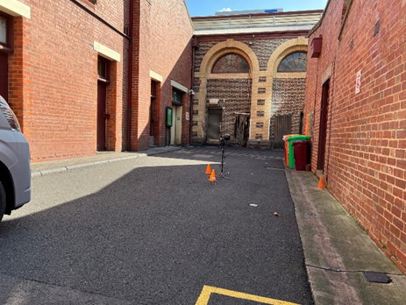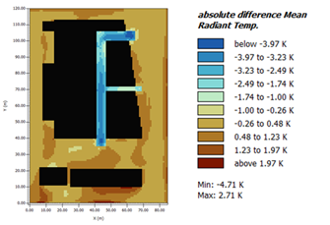
Figure 1 – Field Measurements Deli Lane Figure 2 – Change in MRT Deli Lane
Table 1: Deli Lane
Cooling Intervention | MRT | PET | UTCI | Air Temperature
Surface Treatment | -1.7°C | Not significant | Not significant | Not significant
Shading PVC | -4.7°C | -1.4°C | -0.8°C | Not significant

Drummond Street, Carlton
Modelling the use of surface treatments to cool the social spaces chair on Drummond Street provided similar results to Deli Lane. The change in thermal comfort due to surface treatment was insignificant, this result may have been due to size of the of the installation only being 12m².
Aluminium shade structures were also modelled at the social spaces site. These shading interventions resulted in a significant decline in thermal comfort for users of the social spaces chair. Although air temperature was not impacted by aluminium shading, the thermal indices increased significantly. For example MRT increased by 13°C for a typical summer day and 15°C for an extreme summer day.
Meanwhile, PVC shading interventions improved thermal comfort at the Drummond Street site with all thermal indices showing a reduction in temperature during the day. Shading reduced MRT by 3.3°C at the social spaces chair on a typical summer day. On an extreme summer day the cooling ability of the PVC shade structure was reduced slightly by about 0.2°C when compared with a typical summer day.
Of the modelled cooling interventions the PVC shading materials were the most effective small-scale intervention to provide improved thermal comfort at Drummond Street.
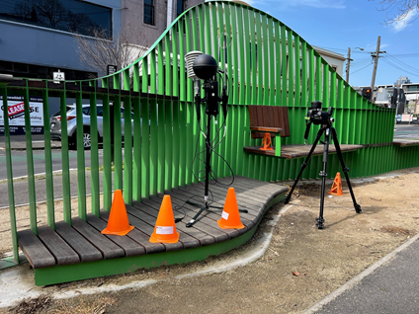
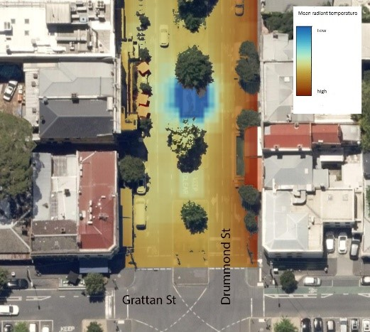
Figure 3 - Change in MRT Drummond St Figure 4 - Field measurements Drummond Street
Table 2: Drummond Street
Cooling Intervention | MRT | PET | UTCI | Air Temp
Surface Treatment | Not significant | Not significant | Not significant | Not significant
Shading PVC | -3.3°C | -1°C | -0.8°C | -0.5°C
Shading Aluminium | +13.3°C | -5.3°C | +3.3°C | Not significant

Section 2: Concepts and pilots
Three projects were delivered that developed concepts and piloted cooling infrastructure:
- RMIT Earl Street Urban Heat Adaptation Retrofit Study Concepts
- CoolSeal with Yarra Trams Pilot
- Shading the Social Spaces Chair Pilot

RMIT Earl Street Urban Heat Adaptation Retrofit Study Concepts
Author: Dr. Olivier Cotsaftis (© RMIT University, 2024)

Background
Between February and April 2024, RMIT University conducted multidisciplinary design research to identify practical and scalable urban heat adaptation solutions through the speculative retrofitting of Earl Street — a strategically significant ‘little street’ located on the RMIT University City campus in Carlton. This exploratory research spanned two design studios and included additional researcher-led activities.
The first studio, a three-week design sprint led by Dr. Olivier Cotsaftis from the RMIT School of Design, engaged 16 industrial design students to develop retrofitting concepts. The subsequent six-week studio, led by Dr. Heike Rahmann from the RMIT School of Architecture and Urban Design, built upon these concepts with 16 landscape architecture students to formulate design propositions. From this initial phase of research, seven concepts (presented herein) have been selected for further possible investigation.
From this exploratory research, seven urban heat adaptation concepts have been selected for further possible investigation.

Urban heat adaptation concepts
Cooling surfaces: CoolSeal | 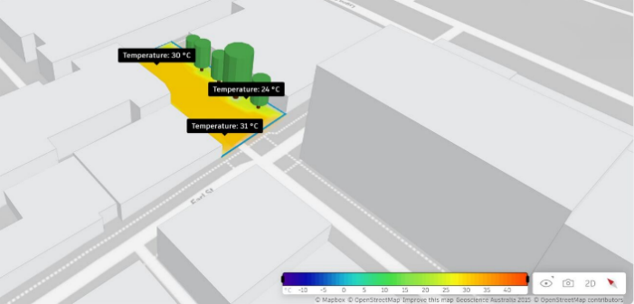  Micro-Climate simulations (Sun and Wind) of O’Grady Place (Material: Asphalt Concrete; Period: February). Ambient temperatures range from 24 degrees under the trees to 31 degrees at the most exposed end of O’Grady Place. Analysis performed using Autodesk Forma plugin for Revit 2024  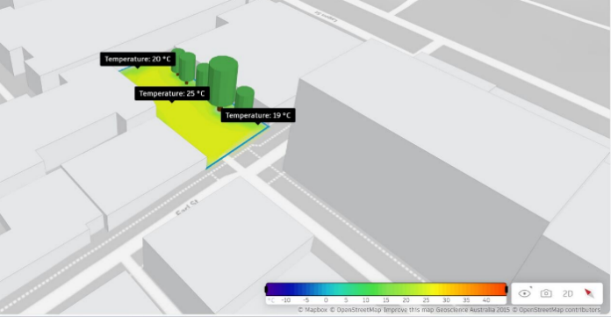  Micro-Climate simulations (Sun and Wind) of O’Grady Place (Material: Asphalt Concrete treated with CoolSeal; Period: February). Ambient temperatures range from 19 degrees under the trees to 25 degrees on O’Grady Place. Analysis performed using Autodesk Forma plugin for Revit 2024
CoolSeal by Guardtop is designed for application on asphalt and was therefore selected for ambient temperature modelling of O’Grady Place, a dead-end laneway just off Earl Street currently sealed with asphalt.
Micro-Climate simulations were performed using Autodesk Forma plugin for Revit 2024, using average local temperatures and wind patterns for February (the hottest month in Melbourne). CoolSeal performances were inserted in the material section of Revit 2024, with 33% reflectivity as per manufacturer’s website and RGB colour code 247 247 241 (HEX code f7f7f1).
The analysis shows that CoolSeal-enabled cooling of O’Grady Place resulted in ambient temperatures decreasing by up to 11 degrees above the treated surface and by 5 degrees in the adjacent pocket park (see images). This indicates that the cooling effect of CoolSeal extends beyond the immediate area treated by the cooling agent.

Cool furniture: Hempcrete | 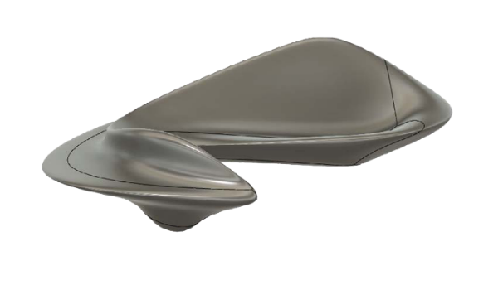
Hempcrete is known for its excellent thermal properties, providing natural insulation that helps regulate temperature. Unlike traditional materials such as concrete or metal, which absorb and retain heat, hempcrete’s insulating properties help keep surfaces cooler to the touch, even on hot days.

Image: Form study for a hempcrete bench by Industrial Design student Kar Yen Lim (supervision by Dr. Olivier Cotsaftis, RMIT School of Design)

Evaporative cooling |  | 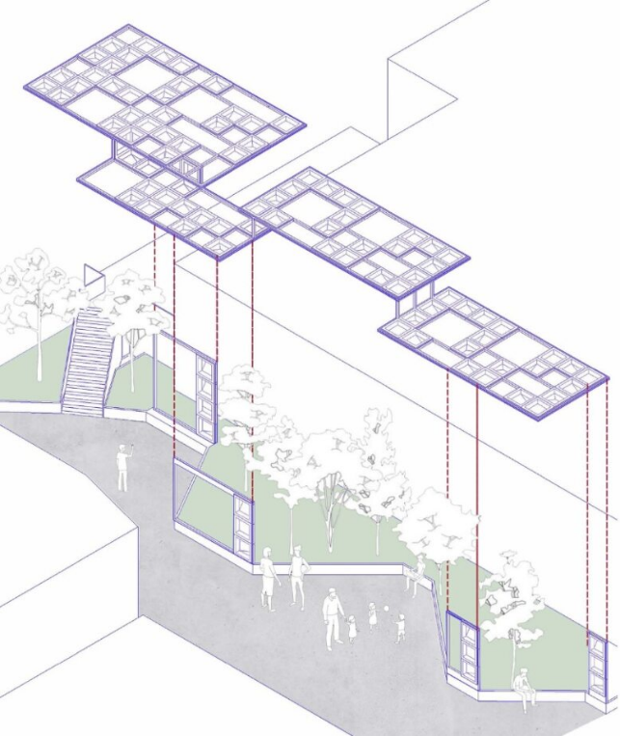  Images: Evaporative Cooling Structure on O’Grady Place by Industrial Design students Ashwathi Suresh, Mengjie Li, Kexin Li and Lang Gu (supervision by Dr. Olivier Cotsaftis, RMIT School of Design)
Features such as courtyards, wind towers and water features have long been integral to vernacular designs, harnessing the cooling power of evaporation to create comfortable indoor and outdoor environments without relying on mechanical (now technological) cooling systems.

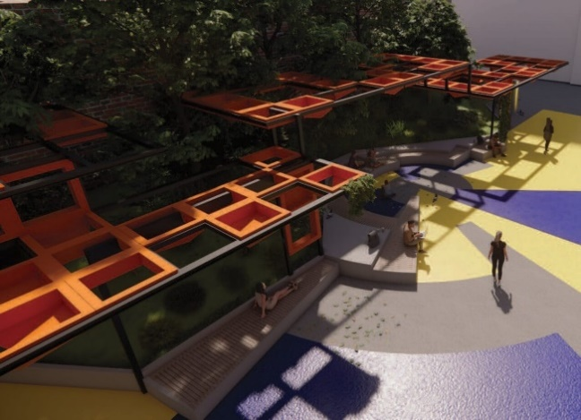
Shading structures | 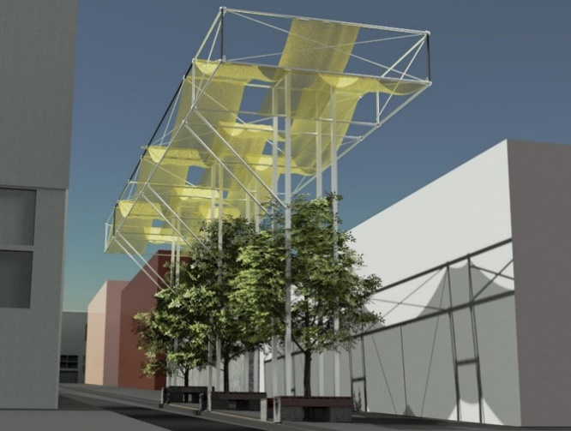
In hot climates, shade helps reduce the impact of direct sunlight, lowering surface temperatures and creating more pleasant environments for pedestrians, cyclists and wildlife. Shade also protects people from harmful ultraviolet (UV) rays, reducing the risk of sunburn and heat-related illnesses.

Image: Shading Structure on Earl Street by Industrial Design students Zoë Ryan-Ferdowsian, Yuchen (Yulie) Wu and Kristian SlatterJensen (supervision by Dr. Olivier Cotsaftis, RMIT School of Design)

Misting systems | 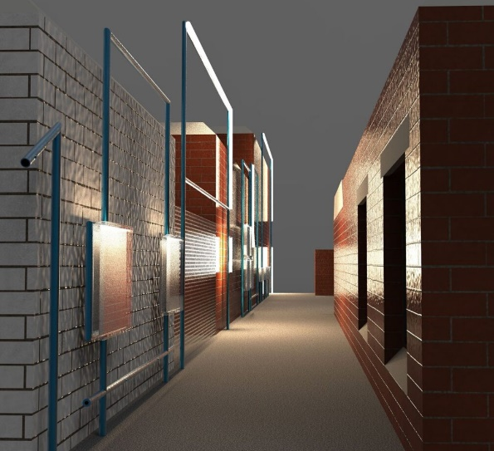
Misting systems offer a simple yet innovative approach to mitigating the effects of heatwaves in urban contexts, providing a refreshing and cooling experience for outdoor spaces. By releasing fine water droplets into the air, these systems can significantly lower ambient temperatures, making hot days more bearable for both humans and nonhumans.

Image: Visual research using generative AI (Midjourney)

Planted permeable pavements | 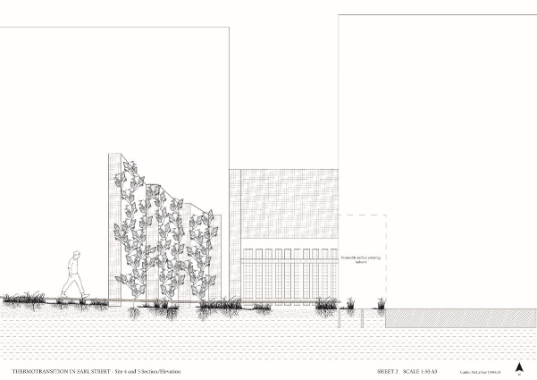  Image: Planted Permeable Pavements topped with a grated metal walkway, O’Grady Place, by Landscape Architecture students Caitlin McCaffrey, Alex Tsaketas-Chiu, Linxue Zhang and Fangyu Chen (supervision by Dr. Heike Rahmann, RMIT School of Architecture and Urban Design)
Unlike traditional surfaces like concrete or asphalt, planted permeable pavements allow water to infiltrate through the surface, reducing runoff and generating water catchments for reuse in times of need. This natural infiltration process helps to cool the pavement and the surrounding air through evaporation, lowering surface temperatures and mitigating the urban heat island effect. In addition, the vegetation and porous materials can absorb and store moisture, further enhancing the cooling effect and providing a more comfortable outdoor environment.

Psychological cooling | 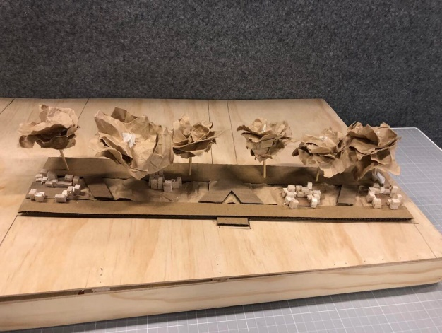
Designing public spaces that cater to the senses can significantly enhance the perceived temperature, making hot environments feel more comfortable and inviting. Sight, sound and smell are key senses that contribute to this cooling effect. Visual elements like greenery, shade-providing natural or manufactured structures, and water features can create a sense of coolness and tranquility.

Image: Concept model and drawing for a Psychological Cooling intervention based on sound and smell, Earl Street, by Landscape Architecture students Allie Carberrie, Agata Pytka and Lachlan Stacey (supervision by Dr. Heike Rahmann, RMIT School of Architecture and Urban Design)

CoolSeal with Yarra Trams pilot
In collaboration with Yarra Trams CoolSeal is being tested at two tram stop platforms. CoolSeal is a water-based asphalt surface treatment that is applied on top of the existing asphalt pavement. CoolSeal works by reflecting the sun’s energy to produce cooler surface temperatures through increased reflectivity. It is applied like conventional sealcoats to asphalt surfaces, to protect and maintain the quality and longevity of the surface.
Federation Square, and Rod Laver Arena stops were identified by Yarra Trams customer service employees to be particularly “hot” stops with minimal shading and high traffic (particularly during the Australian Open tennis tournament). CoolSeal was identified as a possible treatment option to address the impact of heat at these locations. At Federation Square CoolSeal was applied to the tram tracks (pit), whereas at Rod Laver Arena stop it was applied to the platform surface. These two locations will be used as test sites, a third site, stop 7C has been selected as a a control site to understand the impact the treatment has on cooling the local environment.
The following three locations are part of this study:
- Federation Square/Swanston Street #13
- 7B-Rod Laver Arena/MCG Gates 1-3
- 7C-MCG Gates 4-7/John Cain Arena (control site)
The City of Melbourne has installed three microclimate sensors (one at each stop) to monitor the impact the treatment has on the thermal comfort of tram stops. The sensor data will be collected over an 18-month period (February 2024-July 2025) to provide enough data to draw conclusions about the impact the surface treatment has on cooling the spaces.
Surveys with Yarra Trams Passenger experience staff were completed in January-February 2024. Initial feedback from Passenger Experience staff working at these tram stops has been inconclusive with a combination of some staff expressing they’ve noticed a positive impact e.g., feeling cooler or that radiant heat was not as present, some staff responded that they felt no substantial change.
Further analysis over an extended period will be completed to understand the effectiveness of CoolSeal.
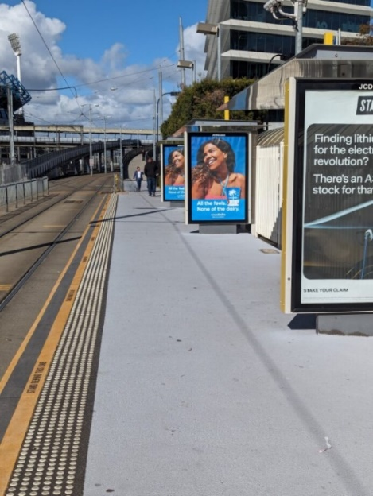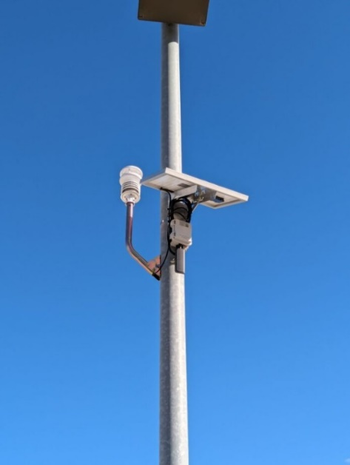
Images: CoolSeal at stop 7B-Rod Laver Arena/MCG Gates 1-3 and microclimate sensor.

Shading the Social Spaces Chair pilot
Since the wavy green chair known as “Social Spaces” was installed on Drummond Street in Carlton, we have been collecting data to help understand how the space is used and valued by the community. With sensors used to collect data, we are continuing to explore how we can best provide heat safe spaces in the city for the community to dwell and connect.
We have heard that shade was a popular request from the community during online surveys and observational audits across several months. Social Spaces is an example where we need to design alternative ways to provide safe respite for our community in the warmer months.
The design for a shade structure was informed by community data and environmental research which showed that PVC shading materials were the most effective small-scale intervention to provide improved thermal comfort at Drummond Street (see Section 1: Analysis of Cooling Interventions).
We expect to install the shade structure in June 2024, with preliminary works starting in May. The shade will be in place for a minimum of 12 months and tested across different seasons to measure its impact on the space. The lessons from this investigation will inform future approaches to providing shade in the city.
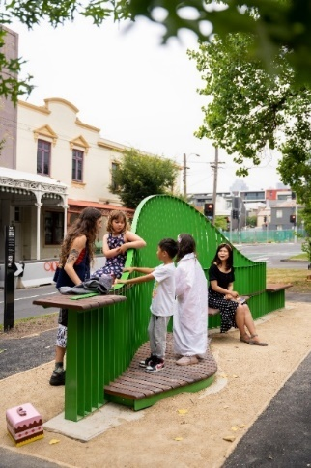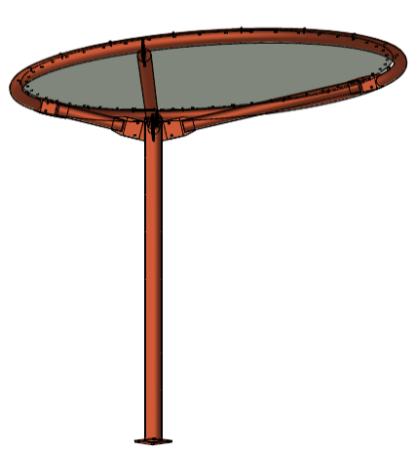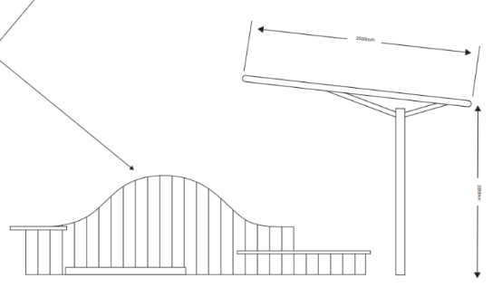
Images: Social Spaces Chair (credit Laina Hardy) and artist impression of shade structure.

Section 3: Monitoring and Evaluation of pilots
To understand the full effect of the concepts and pilots further monitoring and evaluation will be completed over the next 12 months until June 2025. The data enables us to plan and design cooling interventions that are appropriate for places and communities. Different spaces have different uses and constraints. The outcomes of these pilots will inform design recommendations for constrained spaces that respond to microclimatic conditions and cooling opportunities.
The table below outlines what monitoring and evaluation will consist of for the two intervention pilots.
Pilot intervention | Monitoring and evaluation activities
CoolSeal with Yarra Trams | - Collection and analysis of microclimate data (air temperature, relative humidity, wind speed and particulate matter). This data will be collected via onsite sensors at three tram stops.  - Analysis of Passenger Experience Staff to understand perceptions of thermal comfort at the tram stops.  - The data collected by the microclimate sensors will provide analytics for not only the City of Melbourne but also third parties and be available through the Open Data Portal.
Shade at social spaces | - Collection and analysis of temperature data.  - Collection and analysis of observational data collected via place audits. This data will help identify usage patterns in the space.  - Analysis of data collected from Yabby sensors installed at the Social Spaces Chair to identify usage patterns. This data can be compared to data collected prior to the installation of the shade structure to assess if the use of the chair in summer changes because of shade being provided.  - Updates on the project will be made on the Participate Melbourne page. An example of the data available on the Participate Melbourne page is below.  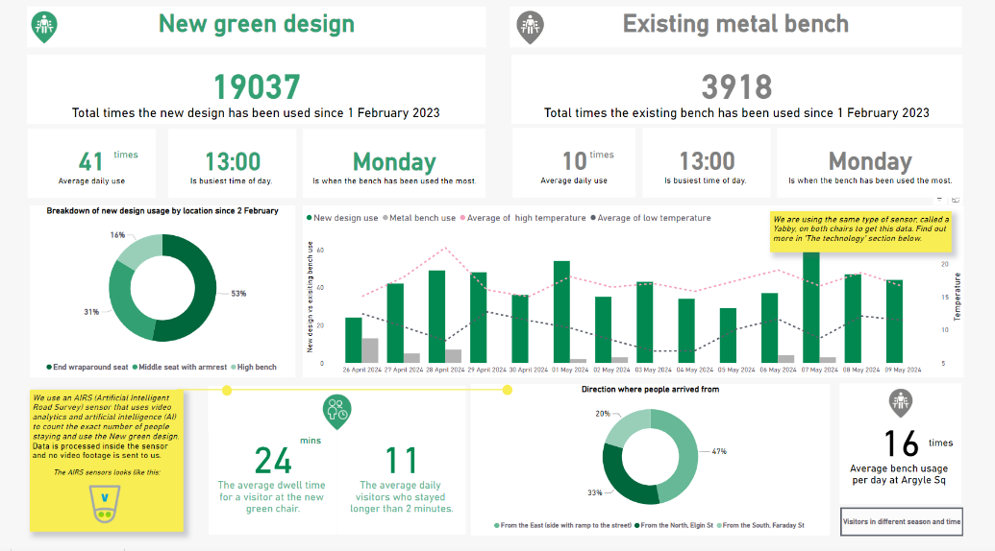

Appendix 3 – Cool kit items

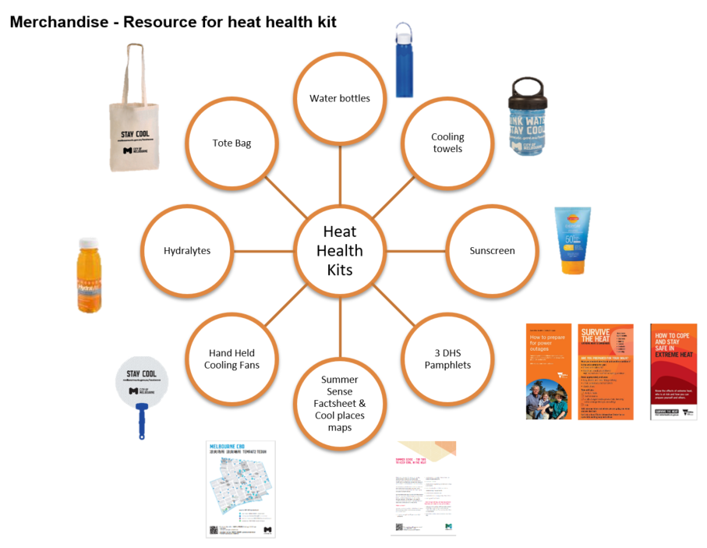

Appendix 5 – Collateral that was developed

Heat Safe City brochure
Four Seasons in One Day brochure
Heat Safe City brochure (Chinese Simplified)
Heat Safe City brochure (Chinese Traditional)
Heat Safe City brochure (Vietnamese)
Visitor resources brochure (Chinese Simplified)
Visitor resources brochure (Spanish)

Appendix 6 – Heat Smart Session feedback form
Date:
Community Group:
Venue:

We want to hear from you! To share your feedback on today’s Heat Smart Session and to help improve future events, we invite you to complete this evaluation form
Please indicate the most appropriate response:
How would you rate the… | Poor   | Fair   | Satisfactory   | Good   | Excellent  
How would you rate the quality of the presentation and speaker(s) at the event?
How would you rate the usefulness of the resources provided in the Heat Kits?
How would you rate your knowledge of heat risk and preparedness BEFORE this session?
How would you rate your knowledge of heat risk and preparedness AFTER this session?

What is your age group?
Under 19 years old
20-29 years old
30-39 years old
40 - 49 years old
50-59 years old
60-69 years old
Over 70 years old
What language do you speak at home? _____________________________

What suburb do you reside/live within Melbourne City Council?

CBD Melbourne 󠆯 □ Kensington □ Port Melbourne □
Parkville □ East Melbourne □ Southbank □
Carlton □ North Melbourne □ South Wharf □
North Carlton □ Flemington □ South Yarra □
West Melbourne □ Docklands □ Other: _______________

Do you have suggestions for how your neighbourhood could be better prepared for extreme heat?
______________________________________________________________________________________________________________________________________________________
After what you've heard today, will you do anything differently on days of extreme heat? If yes, please tell us what you will do:
______________________________________________________________________________________________________________________________________________________ ___________________________________________________________________________
Are there any other items that you can suggest would be useful for you in a heat kit?
______________________________________________________________________________________________________________________________________________________ ___________________________________________________________________________
General comments (we’d love your thoughts on this session):

_________________________________________________________________________________________________________________________________________________________________________________________________________________________________

Appendix 7 – HeatSens objectives and contributions to Head Lab strategy
The objectives of the HeatSens pilot were:
- Use HeatSens to facilitate an informed, strategic response to extreme heat events in Melbourne for the 2023-24 summer period.
- Equip the City of Melbourne with real-time heat risk insights
- Capture insights so we can grow as an organisation and improve our approach to using data in heat response
- Test a new digital data platform to understand if CoM should adopt the tool in the future.
Data and technology were an important part of developing and delivering the interventions piloted through the Heat Lab. The HeatSens pilot contributed to the broader Heat Lab project through:
- Identification of neighbourhoods with the highest heat risk enabled:
  - Prioritisation of locations for Cool Places
  - Geotargeted communications with tips and resources to the neighbourhoods with the highest heat risk.
- Real-time email alerts which provided warnings about upcoming heat events for each neighbourhood 7 days in advance. This allowed CoM to promptly activate:
  - Opening of Community Cool Places and extended hours at libraries
  - Heat health communications
  - Outreach activities

Appendix 8 – Community Cool Places Grant Overview

Community Cool Places Grant
Purpose
The purpose of the Community Cool Places Grant is to facilitate community organisations and groups to establish and operate cool safe spaces on behalf of their local community.
Not everyone has access to air conditioning or can afford to operate air conditioning and cooling systems due to potentially high electricity costs. Providing cool safe spaces is important to provide relief from extreme heat and help prevent heat-related illnesses and deaths. It is also important that spaces or those who operate services are trusted and people feel comfortable accessing them.
Objectives and outcomes of Community Cool Places Grants
- Reduce the community's heat exposure by providing safe and accessible spaces for community members to go when a severe or extreme heat health warning has been issued by the Victorian Chief Health Officer.
- Increase community participation, connection, equity, diversity and inclusion during times of extreme heat.
- Empower the community to identify, prepare and respond to local climate change issues and priorities.
What are we seeking from a Cool Place?
- Cool Places are indoor, air conditioned spaces that community members can access to seek respite when a severe or extreme heat health warning has been issued.
- They should be a safe and accessible space for any community member. However, they may be especially targeted to support those community members that your organisation has strong links to.
- They are spaces that provide the population with thermal comfort, while at the same time maintaining other uses and functions. They should provide comfortable rest areas (chairs and benches) free water, and access to toilets. They may be programmed with activities (for example movies, board games, arts and craft, reading materials etc.).
- It is NOT for people that need medical care, who must go to the appropriate health centre.
What are heat health warnings and how frequently are they issued?
- Based on the Bureau of Meteorology’s heatwave warning system, the Victorian Government issues a heat health warning.
- A heat health warning notifies the community, local governments, hospitals, health and community services of the risk and likely impact on people's health. City of Melbourne uses its communication channels to alert service and community organisations in the municipality when a heat health warning has been issued.
- A heat health warning includes a category of heat risk:
  - Low-intensity heatwaves - Most people can cope
  - Severe heatwaves - Vulnerable people at risk
  - Extreme heatwaves - everyone is at risk, even people who are healthy
- A heat health warning also includes a duration of concern. For instance, ‘Friday 16th February to Saturday 17th February 2024’.
- On occasion, the Victorian Chief Health Officer may issue a heat health warning independent of the Bureau of Meteorology for a single day of extremely high temperatures.
- In a hot summer, Melbourne will typically experience 1 to 3 severe or extreme heat health warnings, each lasting 1 to 3 days. These tend to occur between December and February.
What are the expectations of providing a cool place when a severe or extreme heat health alert has been issued?
- During the period of 1 December through to 28 February, Cool Places are open for at least the hours of 12pm-5pm of the period of the severe or extreme heat health warnings
  - Note, no activation is required when a low intensity heat health warning has been issued.
  - Note, weather is unpredictable, but we expect that this will equate to between 4 and 8 days of activation based on there being 1-3 severe or extreme heat health warnings issued over summer, with each lasting between 1-3 days.
- Warnings are typically issued between 24-48 hours ahead of severe or extreme heat period.
- Participating organisations will be added to our mailing list to receive an alert from City of Melbourne when a heat health warning has been issued.
- Share communications with your networks about the availability of a community cool place. City of Melbourne will also share information through its communication channels.
- Record how many people use the cool place to seek respite (see ‘Acquittal’ section below).
What funding is available?
The Community Cool Places Grants are $2,000 each. If more than two severe or extreme heat health warnings are issued, a top up grant of $1,000 available. Funds can be used for:
- Running costs, including utilities for a cool place.
- Additional staff costs.
- Purchasing food, beverages and other resources.
- Promotion with local community and stakeholders.
- Programming spaces with activities.
- Other reasonable activities outlined in a grant application that help to deliver on the ‘objectives and outcomes’ outlined above.
What if no severe or extreme health warnings are issued by 28 February?
- If this occurs we will discuss other ways your organisation can utilise grant funds to reduce heat risk in your community.
How will the grants process be run?
- As this is a pilot initiative, we are running this as an invitation only grants process. Only organisations invited to apply are eligible to submit a grant application.
- City of Melbourne has identified a shortlist of organisations to invite. The shortlist includes organisations that we have an established relationship with, and considers exposure and vulnerability to heat risk across the municipality.
- This is not designed to be a competitive grants process. Applications will be assessed against eligibility criteria to determine suitability. If criteria are met, we anticipate issuing the grant.
- The grant application process will be run through the SmartyGrant portal. The portal will be open to receive application from Monday 6 November through Friday 24 November. Outcomes of the grant process will be shared within one week of the portal closing.
Acquittal
This project is a pilot to be delivered through the City of Melbourne Heat Lab project. The aim of the pilot is to trial the facilitation of community led Cool Places through the provision of grants funding.
The Heat Lab is a twelve-month project testing community focused and placed based heat resilience solutions. The City of Melbourne received funding from Emergency Management Victoria to deliver this project.
As part of the Heat Lab, several pilot service and infrastructure interventions to reduce heat risk will be delivered over the 2023-24 summer period.
To evaluate the effectiveness of community led Cool Places a one-page acquittal report should be submitted at the end of the project. The report should capture data on:
- What funds were used for
- Number of community members who interacted with the project
- If possible, demographics
- Sentiment from community members on the space and activities
We also ask the grant recipients to provide feedback on the initiative and how it could be improved in the future, including participating in a research interview as part of the program evaluation.

It is estimated this number is significantly lower than what was delivered, however there was limited data recovered for this initiative.
https://www.coolroutes.com.au/

