
Checklist for planning applications
Externally Paint a Building in a Heritage Overlay
Background Information
This checklist provides information about what you need to provide Council when applying for a permit to externally paint a building if the schedule to the Heritage Overlay specified the heritage place as one where external paint controls apply. In addition a permit is required to externally paint an unpainted surface in a Heritage Overlay.
The application will be assessed to ensure that any proposed painting is respectful of the heritage place and streetscape
You may need this checklist if you are:
- Externally painting a house or building in a Heritage Overlay.
- Proposing to externally paint an unpainted surface in a Heritage Overlay
For further guidance about whether you will need to use this checklist, please consider booking a pre-application meeting.
To be accepted for assessment, your application MUST include:
☐ A completed application form, including a signed declaration
☐ A recent copy of the title for the land (dated no more than 30 days prior to the application) including a copy of the diagram or relevant plan of subdivision and the Register Search Statement which lists any encumbrances or restrictive covenants that may affect the land. A Certificate of Title may be obtained online from LANDATA or by contacting the Land Information Centre
☐ The prescribed application fees
☐ An electronic copy of plans, fully dimensioned and drawn to scale, including:
- Site Plan, including:
  - The title boundaries of the site
  - The location, length, height and design of the proposed fence
- Elevation drawings to scale showing the height, colour and materials of all proposed buildings and works. Sample plans are provided below.
Note: An application fee is requested by the Responsible Officer after the application is lodged. Please ensure the section of the application form titled “Cost of Works” is completed when you lodge your application to prevent delays in calculating the correct fee.

Sample plans
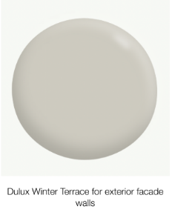

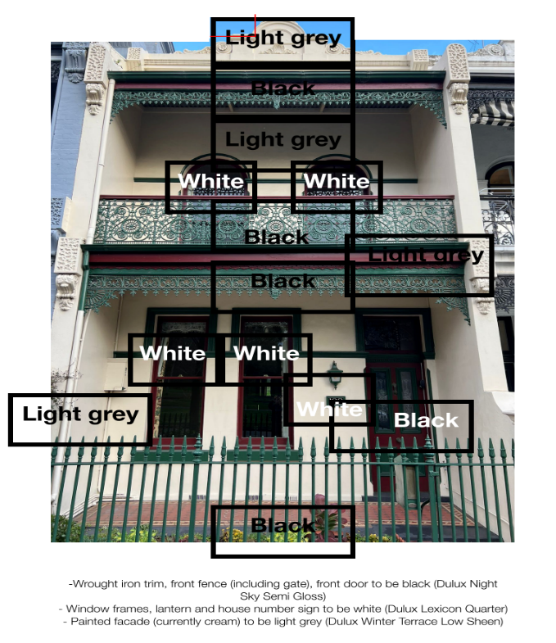
Below is a sample site plan and elevation drawing from an approved Front Fence in a Heritage Overlay application.
Note: Hand-drawn plans or annotated photographs which shows the extent of painting may be acceptable for your application. Alternatively, you may wish to engage a person suitably qualified to prepare architectural plans which often tends to show your proposal more clearly

The following information may assist Council Planners to assess your application by providing a better understanding of the context and heritage value in support of your proposal):
Note: A Site Analysis Plan is a clear drawing that shows your site and all bordering sites, including the location of buildings and their uses.
☐ Photographs (2-3) of other buildings or dwellings within the immediate surrounding area to provide context for your proposal
☐ Written justification for the proposed painting. In addition how the proposal responds to the following from the Melbourne Planning Scheme:
- Clause 15.03-1L-02 - Heritage
- Clause 43.01 - Heritage Overlay

Helpful Hints
- This checklist outlines the standard information required for application lodgment. Additional information may be requested by the assessing planning officer.
- If you would like to discuss your proposed licensed premises, you can arrange a pre-application meeting at Planning pre-application advice
- For information about fees, please refer to the Schedule of fees. Please note, you may require other permits, and these may incur additional fees.
- The City of Melbourne’s Heritage Places Inventory lists sites within a Heritage Overlay as being categorised as either ‘significant’, ‘contributory’ or ‘non-contributory’. If your address is not located on the inventory, the site is considered a “Non-contributory” place. Different requirements or restrictions may apply based on the heritage category of your dwelling. The most up to date Heritage Places Inventory can be found under Incorporated Documents
- The following may be useful documents when preparing any application:
- Heritage Owner's Guide
- A Guide to Victoria's Housing Styles
Disclaimer: Whilst you can lodge a planning permit application for consideration it does not always mean the proposal will be supported. For example painting of previously unpainted surfaces will not normally be permitted.
Council’s Heritage Policy also looks to encourage removal of paint from original unpainted masonry or other surfaces, provided it can be undertaken without damage to the heritage place
Application lodgement guidelines
Please submit your application electronically – by email, online file sharing service or USB. Your email should include the complete application as a single PDF document, optimised to reduce file size and not encrypted or password protected. Alternatively, you may lodge the application via our online portal Lodge a planning application. For other lodgement options, please contact Council.
To get in touch with Council about your application
Telephone: (03) 9658 9658
Email: planning@melbourne.vic.gov.au
Online: Contact us

https://www.landata.vic.gov.au/
https://www.land.vic.gov.au
https://planning-schemes.app.planning.vic.gov.au/Melbourne/ordinance/15.03
https://www.melbourne.vic.gov.au/building-and-development/planning-and-building-services
https://www.melbourne.vic.gov.au/SiteCollectionDocuments/planning-schedule-of-fees
https://planning-schemes.app.planning.vic.gov.au/Melbourne/docs
https://www.melbourne.vic.gov.au/building-and-development/heritage-planning
https://www.heritage.vic.gov.au
https://www.melbourne.vic.gov.au/building-and-development/planning-and-building-services/planning-applications
https://www.melbourne.vic.gov.au/pages/contact-us.aspx

